Child Care and Development Fund Tribal Annual Report

(ACF-700) Manual:

Guide for CCDF

Tribal Lead Agencies

Revised November 2019

For ACF-700 Reports for Federal Fiscal Year (FY) 2020 and Later

Table of Contents
I. Introduction and Overview of the ACF-700 CCDF Tribal Annual Report 3
Ia. New Changes to the ACF-700 CCDF Tribal Annual Report 3
Ib. Overview of the ACF-700 CCDF Tribal Annual Report 3
II. Preparing Introduction: Program Characteristics of the ACF-700 CCDF Tribal Annual Report 5
III. Preparing Part 1: Administrative Data of the ACF-700 CCDF Tribal Annual Report 6
IIIa. New Changes to the Part 1: Administrative Data Form 6
IIIb. Tips for Reporting Part 1: Administrative Data 6
IIIc. Manual Preparation of Part 1: Administrative Data 10
IIId. Computer Preparation of Part 1: Administrative Data 21
IV. Preparing Part 2: Tribal Narrative of the ACF-700 CCDF Tribal Annual Report 23
V. Submitting the Annual Report 25
Va. Accessing and Using the ACF-700 Submission Site 26
Vb. Submission of Introduction – Program Characteristics 27
Vc. Submission of Part 1: Administrative Data 27
Vd. Submission of Part 2: Tribal Narrative 29
VI. Resources 31
Appendix A – ACF-700 Form 32
Appendix B – Glossary of Commonly Used Child Care Terms 37
Appendix C – Internet Submission Registration Form 40

I. Introduction and Overview of the ACF-700 CCDF Tribal Annual Report
On an annual basis, Tribal Lead Agencies for the Child Care and Development Fund (CCDF) are required to submit aggregate information on services provided via the CCDF Tribal Annual Report, also known as the ACF-700. The ACF-700 report offers the Office of Child Care (OCC) a glimpse into how CCDF program dollars are being spent. The submitted report helps to tell the CCDF Tribal child care “story.” The data help to document the work being done and are essential for demonstrating the accomplishments of Tribal child care programs.
The information submitted on the ACF-700 report provides the United States Congress with information on Tribal programs, and serves to inform policy and fiscal decisions. The data gathered for the ACF-700 report are also a rich source of information that can be used for a variety of program needs including informing your Tribal Council about your program, assessing needs, evaluating your program, training staff, resource development, and community education.

Ia. New Changes to the ACF-700 CCDF Tribal Annual Report
The OCC made several changes to the ACF-700 report beginning with the Federal Fiscal Year (FFY) 2020 report cycle to reduce the reporting burden to Tribal grantees and streamline the ACF-700 report. Also, OCC incorporated changes as a result of the reauthorization of the Child Care and Development Block Grant (CCDBG) Act of 2014 and the publication of the final rule in 2016 (for example, categorizing Tribal Lead Agencies by their funding allocation as small, medium, or large). These changes include:

- The addition of the Introduction: Program Characteristics section to the ACF-700 report,

- The deletion of and changes to several questions on the Part 1: Administrative Data report, and

- The deletion of several questions on the Part 2: Tribal Narrative report.

Ib. Overview of the ACF-700 CCDF Tribal Annual Report
The ACF-700 report consists of the following parts:
Introduction: Program Characteristics – Details information about the Tribal Lead Agency’s use of CCDF and non-CCDF funds, which children are reported on Part 1 - Administrative Data, and how small allocation programs administer their programs.
Part 1: Administrative Data – Reports data on children and families that received CCDF child care services, and on services that were provided.
Part 2: Tribal Narrative – Describes general child care quality activities and actions in the Tribal Lead Agency’s reservation or Tribal service area.
The data reported on the ACF-700 form should reflect services provided during the Federal fiscal year (October 1 through September 30). For example, Part 1-Administrative Data should reflect services provided during the Federal fiscal year, regardless of whether the services were paid for with CCDF funds from that year or a previous year, and regardless of whether the funds used were Tribal Mandatory Funds or Discretionary Funds. OCC prefers that Tribal grantees limit their ACF-700 reports to include only those families and children served with CCDF funds. If a Tribal grantee is unable to only report CCDF funded families and children, it is acceptable to report families and children served regardless of funding. In this instance, Tribes should indicate the use of those funds and identify the funding source in the Introduction: Program Characteristics section of the ACF-700 report.

The CCDF Tribal Annual Report is due by DECEMBER 31

NOTE: CCDF Tribal grantees with an approved Pub. L. 102-477 Plan are not required to complete the ACF-700 form. For further details refer to the CCDF-ACF-PI-2019 program instruction available at https://www.acf.hhs.gov/sites/default/files/occ/ccdf_acf_pi_2019_04.pdf. Contact your OCC Regional Office (see https://www.acf.hhs.gov/occ/resource/regional-child-care-program-managers) for additional information.

II. Preparing Introduction: Program Characteristics of the ACF-700 CCDF Tribal Annual Report
The newly added Introduction: Program Characteristics section of the ACF-700 report seeks to capture information about how Tribal Lead Agencies administer their child care program, and what population of children are reported on Part 1: Administrative Data. Several of the questions featured in this new section were previously included in Part 2: Tribal Narrative, but since they impact how OCC may conduct the analysis of the administrative data reported, the questions were moved to the Introduction section. More specifically, the questions detail whether Tribal Lead Agencies:
- Supplement the CCDF grant with dollars from other sources, and if so, require Tribal Lead Agencies to identify the other sources of funding;
- Report only CCDF funded children served (preferred), but acceptable to report all children served (regardless of funding) if Tribal grantees do not have the capability to identify just CCDF funded children; and
- (Applicable to Tribes with small allocations only) Provide direct child care services or use dollars instead to support quality initiatives, thereby exempting the Tribal Lead Agencies from reporting Part 1: Administrative Data.

The Program Characteristics section must be completed electronically via the ACF-700 submission site (see additional information in Section Va).

III. Preparing Part 1: Administrative Data of the ACF-700 CCDF Tribal Annual Report

IIIa. New Changes to Part 1: Administrative Data

Part 1: Administrative Data has been newly amended to include the following changes:
- For element #2, removing the distinction between licensed and non-licensed provider care types, as with the regulatory changes Tribal Lead Agencies are exempt from establishing licensing requirements;
- For elements #3-#7, removing the reporting of data characteristics by provider care type (for example, age of children will be reported only by age category, and not by age category and care type);
- For element #4, removing federal emergency as a reason for receiving care, and adding the following two new reasons for care: (i) both employment and training/education, and (ii) use of categorical eligibility, applicable to Tribes that have been approved to use categorical eligibility because their Tribal Median Income is below the level established by the Secretary (currently 85% of State Median Income), and the Indian children in the Tribe’s service area would be considered eligible regardless of the family’s income, work, or training status; and
- Removing the reporting of the number of children served by family income categories based on the Federal Poverty Level (formerly element #7 on the previous ACF-700 report).

IIIb. Tips for Reporting Part 1: Administrative Data

NOTE for Small Allocation Tribes: If you are a small allocation tribal grantee (less than $250,000 in FY2016) and only conducted quality activities and did not provide direct services during the fiscal year you should SKIP Part 1: Administrative Data, and COMPLETE Part 2: Tribal Narrative.

Part 1: Administrative Data can be prepared manually with all of the arithmetic calculations performed by hand, or it can be prepared automatically using computer software (i.e., the Child Care Data Tracker program). Regardless of the method used to calculate the report, you must keep track of certain information on a regular basis (monthly tracking is recommended). Even though the ACF-700 report is due at the end of each Federal fiscal year (by December 31st), the information required to prepare the report must be gathered on an ongoing basis throughout the year.
Administrative data should be prepared using information collected at a family’s initial intake and information collected on an ongoing basis as services are provided. At initial intake, child care programs should collect demographic information about the families and children they serve. As services are provided, programs should capture information on each child’s hours of care, the payment they make on behalf of each child, and each family’s assigned co-payment. All of this information is used to summarize data for the annual ACF-700 report.
You should include information about children/families whose direct child care services were provided during the Federal fiscal year and who met CCDF eligibility, regardless of which year’s CCDF funds paid for those services. Note that child care services should be reported whether paid for wholly or in part with CCDF funds. Child care services include those services that you offer directly through your own CCDF program, or services that you pay for with your CCDF grant but are offered by other programs and providers. Guidance for what is included in direct services for Tribally Operated Centers (TOC) can be found in Technical Bulletin #14, available at https://www.acf.hhs.gov/occ/resource/current-technical-bulletins. Child care services include slots purchased through contracts/grants, services purchased through certificates/vouchers, services purchased through cash payments, and services provided in a tribally-operated facility. See Appendix B for definitions.
Refer to the general instructions in Table 1 below to report data for all of the elements in Part 1 of the ACF-700 form. Section IIIc features guidance on how to perform quality assurance checks to ensure data accurately reflect your program. Table 2 provides additional information regarding the data quality assurance checks to review prior to submitting your report to OCC.

Table 1: General Instructions for Data Elements in Part 1: Administrative Data
NOTE: Lower case letters (a, b…f) represent sub-elements.
Subject | Explanation
Report Period – Federal Fiscal Year | The Federal fiscal year (FFY) begins on October 1 and ends on September 30 of each year. The ACF-700 report should only include information about CCDF activities that occurred during this time frame.
Allowable Values | Generally, the fields should only contain numbers or letters. Do not use decimals, dollar signs, dashes, or other characters.
What to Report –  Counts or Averages | Some data elements require that you provide counts (for example, counts of families or children) while others require that you provide averages.  Counts are required for data elements 1, 2, 2a-e, 3a-h, 4a-e, and 7a-d.  Averages are required for data elements 5, 6a, and 6b. To calculate averages, refer to the guidance included in this document for each individual data element.
Counting Children not Families | There is only one data element that requires a family count – Element 1: Total number of families that received child care services this fiscal year.  All other data elements requesting counts of who received services are counts of children (2, 2a-e, 3a-h, 4a-e, and 7a-d). Even if you collect information at the family level (for example Element 4, reason for care), the data should be reported as a count of children within those families.
Unduplicated Counts | For Elements 1, 2, 3a-3h, and 4a-e, you should count a child only once for each element, regardless of how many times the child may have entered and exited service during the Federal fiscal year, or if the child received services from more than one provider during the year.  (This rule does not apply to Elements 5, 6a, and 6b, as these elements ask for averages.)
Duplicated Counts | The numbers of children reported by provider type (Elements 2a-2d) and payment type (elements 7a-7d) may be more than the total being reported in Element 2. However, the number may not be less than Element 2.
Blank Fields | DO NOT LEAVE ANY BLANK FIELDS. Every field should have either a count (a number) or a zero (0).
Rounding | Please round all numbers up or down to the nearest whole number. If the number immediately to the right of the decimal point is 4 or less, round the number down. If it is 5 or more, you should round up. For example, a value of 66.4 or less should be rounded down to 66, while 66.5 or greater should be rounded up.
Data Accuracy Checks | Please see the guidance included with each data element in Section IIIa to check the accuracy of the numbers you are reporting. Note that some numbers must add up to and equal numbers reported in other fields. Likewise, some numbers should be less than numbers reported in other fields. If your numbers do not meet the data accuracy check, there may be an error that you need to fix. See Table 2 for a summary of the checks.
Comments Field | Use the comments field to explain any unusual or inconsistent data. For example, if the number of families and children you served changed drastically from your prior year’s report, you may want to indicate the reason for the change. You should also use the comments box to provide footnotes explaining when any missing data will be submitted.  You are not able to attach documents in the comments field of the online submission form.

Table 2: Summary of Data Accuracy Checks for Part 1: Administrative Data
You can find more detail on the Data Accuracy Checks for each data element in Section IIIc. All consistency checks marked with an asterisk (*) indicate checks that are conducted on the ACF-700 Internet Submission Site. See Section V for more information).
Data Element | Consistency Check
Element 1 | Element 1 should be less than or equal to Element 2*
Element 2 | Element 2 should be greater than or equal to Element 1*
Elements 2a-e | The total of Elements 2a-e should be equal to or greater than Element 2*
Elements 3a-h | The total of Elements 3a-h should be equal to Element 2*
Elements 4a-e | The total of Elements 4 a-e should equal the number in Element 2*
Element 5 | Generally, full-time care is about 160 hours per month. If most of your children are receiving full-time care, your reported average monthly hours of service per child would not likely be substantially higher or substantially lower than 160 hours.  If, however, you primarily operate a Before or After School program, your average hours per month may be substantially lower. The average hours should be representative of the program that you operate and the services that you provide.
Elements 6a and 6b | In most cases, the subsidy amount (6a) will be larger than the co-payment amount (6b). If your reported co-payment is higher than your reported subsidy, you may have an error in your data.
Elements 7a-d | The total of Elements 7a-d must be equal to, or greater than the number reported in Element 2*

IIIc. Manual Preparation of Part 1: Administrative Data
If you choose to complete your Administrative Data report manually, you will have to be prepared to do the required arithmetic calculations yourself. This can be as simple as counting the number of families and children you served, or as complex as the calculation of monthly averages. Depending upon the number of clients that a program serves, the calculations of averages for Elements 5, 6a, and 6b required for the ACF-700 report can be time-consuming and preparing the report can be a tedious process. Again, although this is an annual report, many of the calculations have to be completed for each month of the year.
Following are detailed instructions for manually calculating the administrative data. These instructions include definitions, guidance on manual calculation, and data accuracy checks for each data element. If you are completing Part 1 - Administrative Data with the Child Care Data Tracker software, you may skip this section of the guide because all of the calculations are automatically completed by the Tracker software when you generate your ACF-700 report. Table 3 below provides guidance on submitting Tribal Lead Agency contact information.

Table 3: Tribal Lead Agency Contact Information Data Elements
Tribal Lead Agency Data Elements | Definition | Allowable Values | Guidance
Complete Name of Tribal Lead Agency | Name of the CCDF Tribal Lead Agency | Text
Address | Mailing address of the CCDF Tribal Lead Agency | Text, Numbers
Tribal Lead Agency City | City of the mailing address of the CCDF Tribal Lead Agency | Text
Tribal Lead Agency State | Two-letter postal State abbreviation of the mailing address of the CCDF Tribal Lead Agency | Valid postal State abbreviations | A list of state abbreviations is available at:  https://about.usps.com/who-we-are/postal-history/state-abbreviations.pdf
Tribal Lead Agency ZIP Code | Numerical code assigned by the US Postal Service to designate a local area or entity for the delivery of mail | Accepts all valid ZIP codes:  5 digits required.  4 digit extension option (do not include hyphen). | You can search for valid ZIP codes at: https://tools.usps.com/go/ZipLookupAction!input.action
Contact Person | Full name of individual whom the Office of Child Care should contact in regard to this report | Text
Phone | Area code and telephone number for the contact person | Numbers | Include area code
E-mail | Electronic mail address for the contact person | Text, Numbers | Be sure that the entered e-mail address is complete and clearly legible

DATA ELEMENT 1: Total number of families that received child care services this fiscal year
Definition: Unduplicated count of families who received subsidized child care services during the Federal fiscal year.
Child care services include those that you offer directly through your own CCDF program, or services that you pay for with your CCDF grant but are offered by other programs and providers, to children whose families meet CCDF eligibility requirements. Child care services include slots purchased through contracts/grants, services purchased through certificates/vouchers, services purchased through cash payments, and services provided in a tribally-operated facility. See Appendix A for definitions.
Data Accuracy Check: Element 1, number of families receiving services, should be less than or equal to Element 2, the total number of children receiving services.
Guidance: Each family should be counted once, regardless of the number of days care was provided, and even if the family has exited and re-entered the program.
Example 1: A family leaves the program in March but is reinstated in August. The family is counted one time in Element 1.
Report the number of families for whom you provided services during the reporting period October 1 – September 30, regardless of when the payment for the service was made, or which fiscal year's funds paid for the service.
Example 2: A child received care in August only. The Tribal Lead Agency paid for that care in October. Count the family because the service was received during the report period.
When data are applicable but not available, provide a footnote in the comment section explaining when the missing data will be submitted.

DATA ELEMENT 2: Total number of children that received services this fiscal year
Definition: An unduplicated count of children who received child care services for the Federal fiscal year regardless of the type of care.
Data Accuracy Checks:
Check 1: Element 2, the total number of children receiving services, should be greater than or equal to Element 1, the total number of families receiving services.
Check 2: Element 2, the total number of children receiving services, should be less than or equal to the total of Elements 2a-e, the number of children receiving care in various provider care types.
Guidance: Each child who received services should be counted only once, regardless of the number of days care was provided or if the child exited and re-entered the program.
Example 1: A child leaves the program in March, but is reinstated in August. The child is counted one time in Element 2.
Count all children who met CCDF eligibility requirements and received direct services paid for fully or partially with CCDF funds during the Federal fiscal year. Child care services are defined as slots purchased through contracts/grants, services purchased through certificates/vouchers, services purchased through cash payments, or services provided in a tribally-operated facility funded under CCDF. See Appendix A for definitions.
Example 2: A Tribal Lead Agency provides child care certificates/vouchers to 100 families to receive child care services at a program of their choice. The total unduplicated number of children should be counted in Element 2. For Element 2, enter the number of children receiving child care through certificates/vouchers regardless of their setting type.
Example 3: A Tribal Lead Agency contracts with a center for 50 full-time slots for the Federal fiscal year. The total unduplicated number of children receiving child care through agency contracts with centers should be reported in Element 2. If you contracted for 50 slots, the number of children served through these slots will depend on the utilization rate.
Do not count children or families who only generally benefited from services such as when your program 1) receives a grant or contract to establish, expand, or conduct an early childhood school readiness enrichment program (i.e., not specific slots); or 2) you initiate an expansion of quality activities funded under the CCDF. Your use of quality dollars to improve the quality of care should be explained in the Part 2: Tribal Narrative report.
Example 4: A Tribal Lead Agency contracts with a resource and referral agency to provide professional staff development training at a Center serving 78 children. The Tribal Lead Agency does not contract for slots with the center and no children there receive CCDF certificates. Do not count the children because they did not receive direct child care services from the CCDF funds expended.
When data are applicable but not available, provide a footnote in the comment section explaining when the missing data will be submitted.

DATA ELEMENTS 2a-e: Total number of children that received services this fiscal year by category/type of child care
Definition: An unduplicated count of children who received child care services during the Federal fiscal year for each provider type. See the Definitions section below for detailed definitions of care types.
Data Accuracy Check: Add the number of children being served in each care type (Elements 2a-e). This number should be equal to or greater than the total unduplicated number of children reported in Element 2.
Guidance: A child may be counted in more than one provider type row if the child received care from more than one provider type for different portions of the typical day, week, or month. However, the child should NOT be counted more than once within a single provider type row.
Example 1: A child attends a family child care home before school hours and a child care center after school hours. The child would be counted under provider types of both family home and center based child care.
When a child changes the category of provider during the report period, count the child separately in each care type.
Example 2: A child receives care in a family child care home from September to March, uses an in-home provider during April and a center from May through October. The child would be counted under each provider type – family home, child’s home, and center care.
Provider types are broken up into three types of providers: child’s home, family home, and centers. Additionally, child’s home and family home provider types are also broken down into relative and non-relative care.
DEFINITIONS
- Child’s Home: Care provided by a caregiver in the child’s own home.
- Family Home: Care provided in the family home of the provider (i.e., care provided by an individual in their own private residence). Generally, family home care is provided only to a limited number of children at any one time (e.g. 3-5).
- Center-Based: Care provided in a center-based setting, including programs in schools or churches.
- Relative Care: Care by a provider who is a grandparent, great-grandparent, aunt or uncle, or sibling living outside the child’s home.
When data are applicable but not available, provide a footnote in the comment section explaining when the missing data will be submitted.

DATA ELEMENTS 3 a-h: Total number of children receiving services that fall into each age category
Definition: Breakdown by age of children receiving child care services.
Data Accuracy Check: Add the total number of children in each age bracket for Elements 3a-h. Compare your answer to the number in Element 2. If they are not the same, there is an error in the data which should be corrected.
Guidance: Report the child’s age as of the end of the Federal fiscal year, or the date that the child exited the program, whichever occurred first. Each child that received services should be counted only once, regardless of the number of days care was provided and even if the child has exited and re-entered the program.
Example 1: A child leaves the program in March, but is reinstated in August. The child is counted one time in Elements 3a-h.
The age of the child is reported as of the end of the report period (or the date of exit from the CCDF program).
Example 2: A 2-year-old child received services starting in March. On September 15, she turned 3 years old and continued to receive services through the reporting period. The child should be reported as a 3-year-old on line 3d.
When data are applicable but not available, provide a footnote in the comment section explaining when the missing data will be submitted.

DATA ELEMENTS 4 a-e: Number of children who received child care services because of each specified reason for care
Definition: An unduplicated count of children receiving child care services by reason for care. This element separates reason for care into five categories:
4a. Their parents worked
4b. Their parents were in training or an educational program
4c. Child received or needed Protective Services
4d. Their parents worked AND were in training/educational program* (*new category)
4e. Program has implemented categorical eligibility and employment or training status is not an eligibility criterion* (*new category)
Categorical eligibility means the Tribal Lead Agency has been approved to use categorical eligibility because its Tribal Median Income is below the level established by the Secretary (currently 85% of State Median Income), and the Indian children in the Tribe’s service area would be considered eligible for services regardless of the family’s income, work, or training status.

Data Accuracy Check: Add the number of children recorded for Elements 4a-e. This answer and the number in Element 2 should be the same. If they are not the same, there is an error that should be corrected.
Guidance: This is a count of children, NOT families. Each child may be counted only once.
When a family receives care for more than one reason (e.g., the parent works and the child is in need of Protective Services), count only the activity in which the parent (or child, in the case of Protective Services) spends the most time and is the primary reason for needing subsidized child care – that is, the reason the family is eligible to receive a subsidy.
Element 4 entries should be unduplicated counts.
When a child’s reason for needing care changes during the report period, report the reason as of the end of the report period (or date of exit from the program).
Example 1: A child received care in October because of her parents' employment. From November through September, child care was provided because the child was in Protective Services. Count the child in line 4c only – Protective Services.
NOTE: Each Tribal Lead Agency defines the terms "working," "job training and educational program” and “protective services" in Sections 5.1.3 and 5.1.4 of its Tribal Plan.
When data are applicable but not available, provide a footnote in the comment section explaining when the missing data will be submitted.

DATA ELEMENT 5: Average number of hours of child care service provided per child per month
Definition: The average number of hours of child care service provided per child per month.
Data Accuracy Check: Generally, full-time care is about 40 hours per week for 4 weeks (160 hours per month). If most of your children are receiving full-time care, your reported average monthly hours of service per child would not likely be substantially higher or substantially lower than 160 hours.
If, however, you primarily operate a Before or After School program, your average hours per month may be substantially lower. The average hours should be representative of the program that you operate and the services that you provide.
Guidance: This is a monthly average, NOT a yearly average. One method to calculate the average number of hours of care per child per month is:
- Begin by counting the total number of hours of care for all children for the first month you provided service during the fiscal year (month X, for example October).
- Count the total number of children served during month X.
- Divide the total number of hours from step 1 by the total number of children from step 2 to get the average number of hours of care provided per child for month X.
- Repeat steps 1 – 3 for each month services were provided.
- Add together each of the monthly average hours to get a sum.
- Divide the sum from step 5 by the total number of months services were provided during the year to get the average number of hours of care provided per child per month.
Some Tribal Lead Agencies do not pay for (or keep records for) the actual number of hours of service per child. Rather, they reimburse by "full" or "part" days of service (or other increments). These Tribal Lead Agencies can still calculate the average number of hours of child care per child per month based on the program’s definitions or estimate of the number of hours that “full” or “part” days represent.
For example, a Tribal Lead Agency may define a “part” day as 4 hours or fewer per day (and estimate a “part” day at 4 hours of care), and define a “full” day as more than 5 hours (and estimate a “full” day at 8 hours of care). In step #1 of the above calculations, the Tribal Lead Agency would count 4 hours of care for each “part” day and “8” hours for each “full” day they paid for child care services in order to get the total number of hours of care for all children for month X.
When data are applicable but not available, provide a footnote in the comment section explaining when the missing data will be submitted. Tribal Lead Agencies should also describe in a footnote how they calculated the average number of hours.

DATA ELEMENT 6a: Average monthly CCDF program subsidy per child
Definition: The average monthly cost that your CCDF program paid for child care services per child. This does not include the parent’s co-payment.
Data Accuracy Check: Except in rare circumstances, Element 6a, the average monthly subsidy paid per child, will be greater than Element 6b the average monthly parent co-payment paid per child.
Guidance: This is a monthly average, NOT a yearly average. Tribal Lead Agencies should use the same method for calculating the average monthly subsidy amount paid in Element 6 as used to calculate the average number of hours of care for Element 5.
One method to calculate the average monthly CCDF subsidy paid for child care services per month per child is:
- Begin by counting the total amount of CCDF subsidy paid for child care services for all children for the first month you provided service during the fiscal year (month X, for example October).
- Count the total number of children served during month X.
- Divide the total amount from step 1 by the total number of children from step 2 to get the average amount of CCDF subsidy paid for child care services for month X.
- Repeat steps 1 – 3 for each month services were provided.
- Add together each of the monthly averages to get a sum of averages.
- Divide the sum from step 5 by the total number of months services were provided during the year to get the average subsidy amount paid for child care services per child per month.
Guidance for Tribally-Operated Centers
Some Tribal Lead Agencies run their own center(s) and do not technically “pay” a provider. Such agencies can still estimate the “average” monthly CCDF subsidy amount paid per child for child care services provided using the record of expenditures that is submitted annually on the required ACF-696T, the Tribal financial report. Additional information is available in Technical Bulletin #14 (updated in March 2018) available at https://www.acf.hhs.gov/occ/resource/current-technical-bulletins.

- Calculation to estimate the average monthly subsidy per child for programs with a Tribally Operated Center (TOC) when you only provide services in your TOC:
- Add the Tribal Mandatory, Discretionary, and Discretionary Funds Base Amount expenditures (not including expenditures for construction and renovation) that your Tribe reported on Line 4 of the ACF-696T – Expenditures for Child Care Services. During the Federal fiscal year, if you expended funds from more than one grant year, you must add the appropriate expenditures from each of the reports submitted regardless of the year that the grant was awarded.
- Divide the above total by the number of months that you provided services during the year (ranging from 1 to 12 months) to get an overall monthly subsidy amount.
- Divide the monthly subsidy amount by the average number of children served per month (calculate it separately) to estimate the average monthly subsidy per child in your center.
- Calculation to estimate the average monthly subsidy per child for programs with a TOC when you support both a TOC and other provider types:

- Add the Tribal Mandatory, Discretionary, and Discretionary Funds Base Amount expenditures (not including expenditures for construction and renovation) that your Tribe reported on Line 4 of the ACF-696T – Expenditures for Child Care Services. (During the Federal fiscal year, if you expended funds from more than one grant year, you must add the appropriate expenditures from each of the reports submitted regardless of the year that the grant was awarded.)
- Add together all of the CCDF Subsidy payments you have made to all non-TOC providers during the report year.
- Subtract this total of CCDF subsidy payments made to all non-TOC providers from the total you arrived at in step 1 above.
- Divide the remaining subsidy amount from step 3 by the number of months that you provided services in your TOC during the year (ranging from 1 to 12 months) to get a total monthly TOC subsidy amount.
- Divide the monthly amount from step 4 by the average number of children served per month (calculate it separately) in the TOC payment type (data Element 7d) to estimate the average monthly subsidy per child for your TOC.

When data are applicable but not available, provide a footnote in the comment section explaining when the missing data will be submitted.

DATA ELEMENT 6b: Average monthly parent co-payment amount paid per child for child care service
Definition: The average monthly cost that the family/parent was assessed to pay toward the cost of care per child.
Data Accuracy Check: Generally, the parent co-payment is less than the subsidy amount (Element 6a). If your co-payment is larger than the reported subsidy, check to be sure that your numbers are correct.
Guidance: This is a monthly average, NOT a yearly average. Tribal Lead Agencies should use the same method for calculating the average monthly parent co-payment on Element 6b as used to calculate the average number of hours of care for Element 5.
One method to calculate the average monthly parent co-payment amount paid for child care services per month per child for each category/type of child care is:
- Begin by calculating the total amount of CCDF co-payments paid by all families for child care services for the first month you provided service during the fiscal year (month X, for example October).
- Count the total number of children served during month X.
- Divide the total amount from step 1 by the total number of children from step 2 to get the average CCDF co-payment paid per child for child care services for month X.
- Do steps 1 – 3 for each month services were provided.
- Add together each of the monthly co-payment averages to get a sum.
- Divide the sum from step 5 by the total number of months services were provided during the year to get the average parent co-payment amount paid for child care services per month per child.
When data are applicable but not available, provide a footnote in the comment section explaining when the missing data will be submitted.

DATA ELEMENT 7a-d: Number of children served by payment type this fiscal year
Definition: This is a duplicated count of children served by various types of payment.
This element separates payment type into four categories:
7a. Grant/Contract with provider
7b. Certificate or voucher to parent and/or provider
7c, Cash payment to parent
7d. CCDF funding to a Tribally-Operated Center for direct services.
See the Definitions section below for information on the various payment types.
Data Accuracy Check: The sum of 7a-d must be equal to or greater than Element 2. If the sum is not equal to or greater than Element 2, there is an error that should be corrected.
Guidance: This is a count of children, NOT families.
Each child should be counted once for each payment type used to serve the child throughout the year. If payment type for services for a child changes during the reporting period, report the child as being served with each payment type.
Example: From October through February you paid for a child’s services with cash payments to the applicant. Beginning in March and through the remainder of the fiscal year, the child’s services were paid through a grant or contract with a provider. This child should be counted in both 7a (grant/contract with provider) and 7c (cash payment to parent).
If services for the child were paid for with two types of payment at the same time during the reporting period, report both payment types.
Example: For the entire Federal fiscal year, a child received services from an in-home provider for 2 hours a day in the early morning, and this provider was paid with cash (paid to the parent). At the same time, this child received services for the rest of the day in a Tribally-operated center for 8 hours each day. You would report this child under both 7c (cash payment to parent) and 7d (Tribally-Operated Center).
Definitions:
- Grant/Contract with Provider: A legally binding agreement (usually via a competitive bid) with a child care provider to deliver services, defining the terms and conditions of those services.
- Certificate or Voucher to Parent and/or Provider: A certificate (that may be a check or other form) that is issued by a State, Tribal or local government directly to a parent to verify their eligibility for subsidized services.
- Cash Payment to Parent: Money paid to parents in the form of cash or checks to cover the cost of child care services. (This does not include two-party checks to parents and providers, or cash to providers). Note that the term “parent” includes any individual operating in loco parentis, as defined in the Tribe’s CCDF plan.
- CCDF funding to a Tribally-Operated Center for direct services: A child care center operated by the Tribal Lead Agency. The center is usually located on the Tribal reservation or in the Tribal Lead Agency’s service area. A Tribally-operated center payment differs from a grant or contract in that a Tribal Lead Agency pays the operational costs of the Center (including teacher salaries).
When data are applicable but not available, provide a footnote in the comment section explaining when the missing data will be submitted.

IIId. Computer Preparation of Part 1: Administrative Data
To facilitate the preparation of administrative data for the ACF-700 report, some Tribal grantees use automated systems to capture and manage the required information. The Office of Child Care (OCC) recognized that many Tribal grantees did not have access to information systems that would allow for the capture and management of information for the required ACF-700 report, and developed the Child Care Data Tracker (Tracker) to facilitate the reporting process. The use of this software is optional for the Tribal grantees.

Tribal Child Care Data Tracker (referred to as Tracker)
The Tracker is a Microsoft Access-based software tool that is installed and used on any computer that supports Microsoft Access. It is a comprehensive case management tool that can help you to maintain all of your client records and allows you to record a broad range of information about clients including demographics, eligibility reviews, services received, and payments made. The Tracker can also automatically generate a variety of reports, including the Part 1: Administrative Data of the ACF-700 report, based on the required data that you enter. The software is available free of charge to CCDF Tribal Grantees. Over time, several versions of the Tracker have been developed, each of which has made the software more user-friendly and allowed it to function more efficiently.
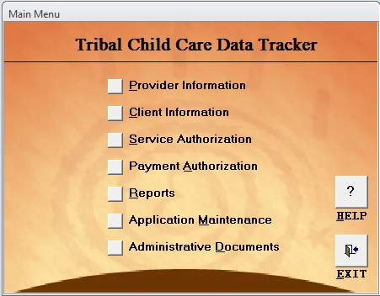
Child Care Data Tracker Main Menu

The Tracker functions generally parallel the activities used by child care program staff with the families they serve. There are several data entry modules in the Tracker that allow you to keep track of your children and families, providers, service authorizations and payments. Part 1 - Administrative Data of the ACF-700 report is based on the information that you enter in these modules. Program information that is required for the ACF-700 report also is required by the software when you use the Tracker. This feature of requiring certain data ensures that you will be able to generate the administrative data at the end of the year. In addition to generating the Part 1 - Administrative Data, the Reports module in the Tracker allows you to generate applicant, provider, service, and payment reports with a variety of sorting options. To learn more about the Child Care Data Tracker, please visit the OCC website at: https://www.acf.hhs.gov/occ/resource/child-care-data-tracker, for hardware and software requirements and for a downloadable copy of the User’s Guide.

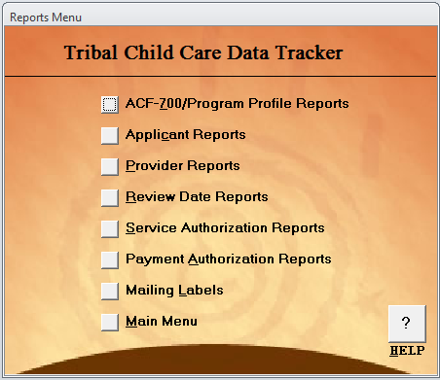
Child Care Data Tracker Reports Menu

IV. Preparing Part 2: Tribal Narrative of the ACF-700 CCDF Tribal Annual Report
Part 2: Tribal Narrative requests descriptions of the results of specific CCDF-funded activities available on the Tribal Lead Agency’s reservation or Tribal service area. The Tribal Narrative allows OCC the ability to more easily generate aggregate information and therefore better understand Tribal quality activities, as well as training and support activities offered to providers and families. The questions Tribal grantees are required to answer are detailed on the ACF-700 form in Appendix A. Guidance is provided below for each of the questions included in Part 2: Tribal Narrative.

Question 1: What quality improvement efforts did the Tribal Lead Agency fund this fiscal year?

Guidance: Tribes must spend quality funds on at least one of the 10 allowable quality activities listed, such as training and professional development, early learning and development, quality evaluation, and other measurable quality activities including culturally responsive activities such as language immersion. In responding to this question, the Tribal Lead Agency should check all the activities that apply that are funded either entirely, or in part, with CCDF dollars.

Question 2a: What trainings did the Tribal Lead Agency provide for child care caregivers, teachers and directors?

Guidance: Tribal Lead Agencies are required to have in place pre-service and/or orientation training requirements and ongoing training requirements for caregivers, teachers and directors that address health and safety requirements as well as child development. In responding to this question, the Tribal Lead Agency must
- check all the training topics that were available to caregivers, teachers and directors;
- describe the trainings that were available during the fiscal year; and
- list how many caregivers, teachers and directors were trained during the fiscal year.

Question 2b: Did the Tribal Lead Agency support child care caregivers, teachers, and directors in achieving any of the following along a career pathway?

Guidance: Tribal Lead Agency should select and describe all the support (for example through funding, scholarships, etc.) along the career development pathway that were made available to its child care workforce during the fiscal year. In the narrative, Tribal Lead Agencies are encouraged to incorporate the number of caregivers, teachers and directors who received support to obtain credits, credentials or degrees.

Question 2c: How did the Tribal Lead Agency assist providers in meeting health and safety standards?

Guidance: Tribal Lead Agencies are required to establish health and safety standards for all types of child care programs (i.e., center based care, including Tribally operated centers, or home based care) serving children receiving CCDF assistance, as appropriate to the provider setting and age of the children served. In responding to this question, Tribal Lead Agencies should check all that apply and describe how they assisted providers meet the established health and safety standards.

Question 2d: How did the Tribal Lead Agency support and provide culturally appropriate activities to children, parents, and providers?

Guidance: Tribal Lead Agencies must spend quality funds on at least one of 10 allowable quality activities, including culturally responsive activities such as language immersion. In responding to this question, Tribal Lead Agencies should check all the activities that apply and describe how they provided culturally appropriate activities to children, parents and providers during the fiscal year.

Question 2e: How did the Tribal Lead Agency provide consumer education to parents and providers?

Guidance: Tribal Lead Agencies must identify and describe the consumer education activities they invested in during the fiscal year.

Question 2f: Did any CCDF child care providers participate in the following?

Guidance: A quality rating and improvement system (QRIS) is a systemic approach to assess, improve, and communicate the level of quality in early and school-age care and education programs. Similar to rating systems for restaurants and hotels, QRIS award quality ratings to early and school-age care and education programs that meet a set of defined program standards. By participating in their State or Tribe’s QRIS, early and school-age care providers embark on a path of continuous quality improvement. Even providers that have met the standards of the lowest QRIS levels have achieved a level of quality that is beyond the minimum requirements to operate. In responding to this question, Tribal Lead Agencies should identify and describe the QRIS used during the fiscal year. If a Tribal Lead Agency selected “None”, an explanation is required for why no quality rating and improvement system is being used.

Question 2g: Describe any other significant quality activities that occurred during the past fiscal year
Guidance: Describe any other activities to improve the quality of child care services, besides the activities included in previous questions, the Tribal Lead Agency implemented during the fiscal year.
Part 2: Tribal Narrative can be completed electronically via the ACF-700 submission site (see additional information in Section Va). Contact your OCC Regional Office (see https://www.acf.hhs.gov/occ/resource/regional-child-care-program-managers) for any questions related to Part 2: Tribal Narrative.

V. Submitting the Annual Report
Each Tribal Lead Agency must submit the information requested on the ACF-700 Annual Report by December 31, covering the services provided during the period from October 1 through September 30 for the preceding Federal fiscal year (FFY). ACF Regional Offices are responsible for monitoring compliance with timeliness of submissions. Tribal Lead Agencies anticipating problems in complying with the reporting requirement should contact the OCC Regional Office (see https://www.acf.hhs.gov/occ/resource/regional-child-care-program-managers).
The OCC instructs grantees to submit all parts of the Tribal Annual Report using the ACF-700 internet submission site on the OCC web site. Tribal grantees should enter the details of the Introduction: Program Characteristics, Part 1: Administrative Data, and Part 2: Tribal Narrative at https://extranet.acf.hhs.gov/acf700/login/login700.jsp. This page contains a password-protected, web-based form that checks the administrative data for compliance with data standards at the time of submission. These built-in, edit-checking features make it easier for Tribes to identify and correct errors. Use of the paperless Internet data entry site streamlines submission processing and improves data quality. When you submit the ACF-700 report via the web site, you do not have to send additional paper copies via mail or fax. You should, however, notify your OCC Regional staff when you have completed your report submission.
The submission web page requires a login and password. Some Tribes have already designated individuals to access the ACF-700 Internet Submission site. The login and password carry over each new reporting period, so there is no need to register each year to use the submission site. To register new staff or otherwise modify registration information, submit the ACF-700 Internet Submission Registration Form in Appendix C by email, mail, or fax to:
National Center on Child Care Data and Reporting (NCDR)
6003 Executive Blvd., Suite 400
Rockville, Maryland 20852
NCDR@ecetta.info
Fax: 240-514-2601
NCDR will contact the staff identified on the form to provide further instructions and guidance. The Tribal Lead Agency may contact NCDR at their toll-free number: 877-249-9117, weekdays from 9:00 a.m. to 5:00 p.m. (Eastern Time), or by email at: NCDR@ecetta.info.

Va. Accessing and Using the ACF-700 Submission Site
To submit your ACF-700 report (or to access and/or edit previously submitted data) using the OCC internet submission site (https://extranet.acf.hhs.gov/acf700/login/login700.jsp), you must first access the web page using the Internet. Once there, enter your username and password (assigned by NCDR) in the “Username” and “Password” fields and click the SUBMIT button.

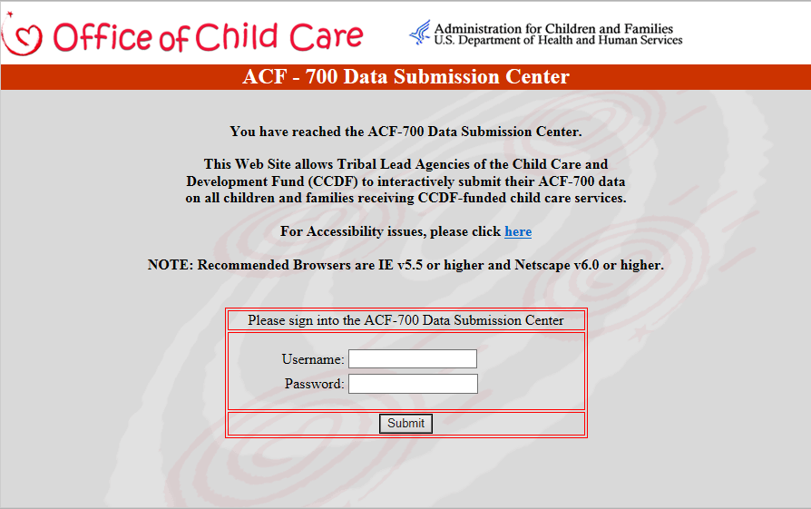

ACF-700 Submission Site Login Page

The U.S. Government disclaimer will display. Click the “OK” button to accept the conditions for using the site.

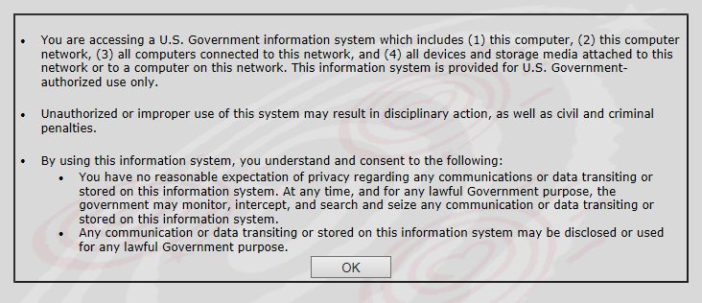

The welcome page will open displaying your name. This indicates that you have successfully entered the submission site.

Vb. Submission of Introduction – Program Characteristics
After accessing the site, select the appropriate fiscal year of the data that you would like to enter from the “Federal Fiscal Year” drop-down list. Next, click on the “ACF-700 Form (Data Entry)” button to access the form.

NOTE: A text version of the ACF-700 form is available through the “Text Version” button for persons with visual impairments in accordance with Section 508 standards.

[TO BE UPDATED WITH SCREENSHOT WHEN SYSTEM CHANGES ARE INCORPORATED]

Vc. Submission of Part 1: Administrative Data
After you complete the Introduction: Program Characteristics section of the form, depending on your response to Question 2, Part 1 or Part 2 buttons will display on the screen for you to continue entering data.

Note that when the form is first opened and before any data is entered, all of the fields are red. When you begin to enter information, all of the cells will change to white or yellow, and the colors of the fields may continue to change as you enter information. This color coding helps you to identify and correct any potential data problems.

[TO BE UPDATED WITH SCREENSHOT WHEN SYSTEM CHANGES ARE INCORPORATED]

The Internet Submission site checks for two types of errors (see Table 2 for additional details): if the field has been left blank (red cells), and if the data in specific fields are inconsistent (yellow cells) with information in related fields. Meeting the system quality checks does not guarantee that the information is correct. You must still review your own report carefully to ensure that the data you submit to the OCC accurately reflects the families and children you serve, and the services you provide.

[TO BE UPDATED WITH SCREEN SHOT WHEN SYSTEM CHANGES ARE INCORPORATED]

If the system notes a potential error, a red arrow button will be shown by the data element in question. You can click the red arrow to display an explanation of the possible error and use the guidance to make corrections to your report.

[TO BE UPDATED WITH SCREEN SHOT WHEN SYSTEM CHANGES ARE INCORPORATED]
Be sure to first save your data and then check your entered data for errors. To check for errors, click the Error Check Results button located at the bottom of the page. A page will open that lists the errors for your submitted data or indicates that no errors were found.
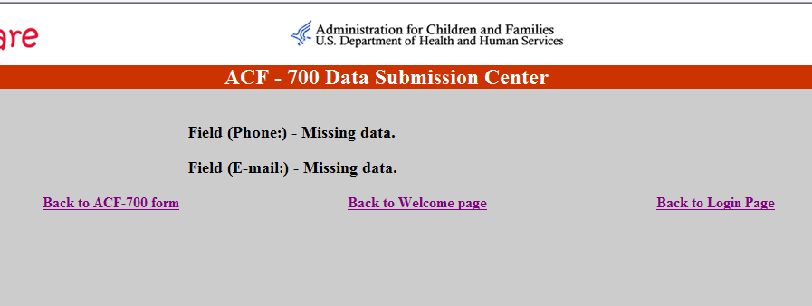

Things to Remember:
You must enter information in each of the cells in Introduction: Program Characteristics. If you are required to report Part 1: Administrative Data do not leave any cells blank. Each cell should have a number. You should use the “Comments” field to enter information that would help clarify any special reporting circumstances or to explain any peculiarities in your data (See Table 1 for further information).
When you have completed entering and checking information, click the Save/Submit Form button at the bottom of the screen to save your information and submit it to OCC. If you exit the form without saving it, all of the information you entered will be lost.
If you need to stop data entry and finish entering information at another time, you should still click the Save/Submit Form button. Everything that you have entered to that point will be saved and available when you return later to complete the form. It is acceptable to submit a partially completed form as long as you remember to return and complete it in a timely manner. Upon saving your data, the next screen will indicate that you have successfully uploaded the data. After 15 minutes of inactivity, the site will close and any unsaved data entry will be lost.
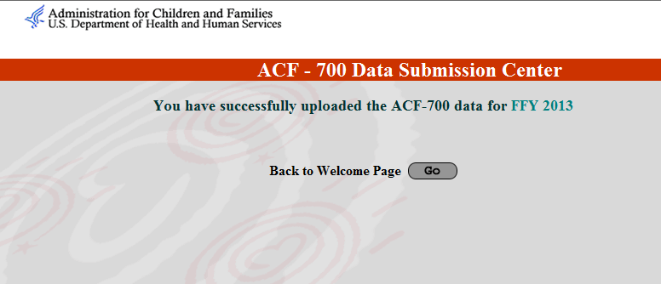

Upon returning to the ACF-700 form (after saving the data), a print option will display on the bottom left hand corner of the screen. To print your report, click the Print this Form link. We recommend that you always keep a hard copy of each year’s report for future reference.
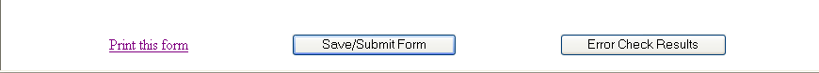

Vd. Submission of Part 2: Tribal Narrative
The Part 2: Tribal Narrative can be accessed from the ACF-700 form at the bottom of Introduction: Program Characteristics. To access and respond to questions, click the “Part 2” button.

[TO BE UPDATED WITH SCREEN SHOT WHEN SYSTEM CHANGES ARE INCORPORATED]

Indicate Tribal program details and activities by checking the appropriate boxes to respond to the questions and provide further details in the “Describe” boxes. The “Describe” boxes have a 4,000 character limit (including spaces). Answer all of the questions on both Pages to complete your Narrative portion of the report. Do not leave any questions blank.

[TO BE UPDATED WITH SCREEN SHOT WHEN SYSTEM CHANGES ARE INCORPORATED]

Click the Save/Submit Form button at the bottom of the form to save all entered information before navigating to the next page. A message will display indicating that your information has been uploaded. At any time, you can return to the site to make edits or to complete the form if you left it unfinished. If you exit the form without saving, your information will be lost.

[TO BE UPDATED WITH SCREEN SHOT WHEN SYSTEM CHANGES ARE INCORPORATED]

From the successful upload page, you can go to ACF-700 form, the Part 1: Administrative Data, or to the Welcome Page, where you can access a different fiscal year or generate your Story Page.

[TO BE UPDATED WITH SCREEN SHOT WHEN SYSTEM CHANGES ARE INCORPORATED]

VI. Resources

National Center on Data and Reporting
If you have questions or need additional assistance completing the ACF-700 report or using the Child Care Data Tracker software, contact the National Center on Data and Reporting (NCDR). The NCDR was established by the Office of Child Care to provide technical assistance related to the grantee reporting requirements. You may contact NCDR by e-mail, phone, fax, or mail. The NCDR staff is available Monday-Friday, 9:00 am to 5:00 pm, prevailing Eastern Time. All voice-mail messages left during or outside of those hours are returned promptly.

National Center on Data and Reporting (NCDR)
6003 Executive Blvd., Suite 400
Rockville, MD 20852
Phone: 877-249-9117 (toll-free)
Fax: 240-514-2601
E-mail: NCDR@ecetta.info
Regional Office Contact information
If you have questions regarding policy issues, contact your Regional Office.
List of Regional Office addresses and phone numbers
https://www.acf.hhs.gov/occ/resource/regional-child-care-program-managers

Appendix A – ACF-700 Form

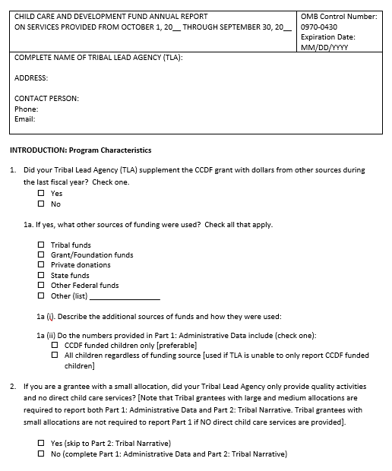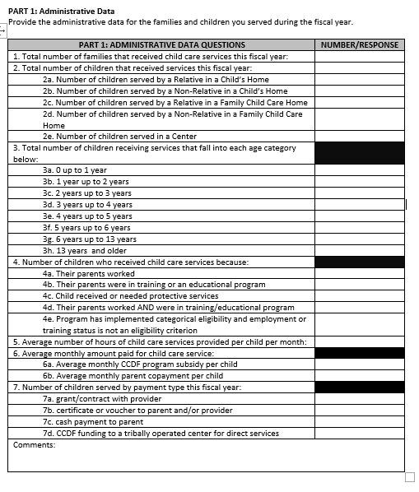

TRIBAL NARRATIVE QUESTIONS | RESPONSE/NARRATIVE
- What quality improvement efforts did the Tribal Lead Agency fund this fiscal year? Check all that apply. Tribal Lead Agencies must fund quality efforts in at least one of the following 10 activities (98.53(a)): | - Supporting the training and professional development of the child care workforce  - Improving on the development or implementation of early learning and developmental guidelines  - Developing, implementing, or enhancing a tiered quality rating and improvement system for child care providers and services  - Improving the supply and quality of child care programs and services for infants and toddlers  - Establishing or expanding a system of child care resource and referral services  - Supporting compliance with requirements for licensing, inspection, monitoring, training, and health and safety  - Evaluating the quality of child care programs, including evaluating how programs positively impact children  - Supporting providers in the voluntary pursuit of accreditation  - Supporting the development or adoption of high-quality program standards related to health, mental health, nutrition, physical activity, and physical development  - Carrying out other activities determined by the Tribal Lead Agency to improve the quality of child care services provided, and for which measurement of preparedness, child safety, child well-being, or entry to kindergarten is possible. This can include activities and services related to tribal language, culture, and consumer education activities.
2a.What trainings did the Tribal Lead Agency provide for child care caregivers, teachers and directors? Check all that apply. | -  Prevention and control of infectious diseases (including immunizations)  -  Prevention of sudden infant death syndrome (SIDS) and use of safe sleeping practices  -  Administration of medication, consistent with standards for parental consent  -  Prevention of and response to emergencies due to food and allergic reactions  -  Prevention of shaken baby syndrome and abusive head trauma  -  Emergency preparedness and response planning for emergencies resulting from a natural disaster or a human-caused event (such as violence at a child care facility)  -  Handling and storage of hazardous materials and the appropriate disposal of bio contaminants  -  Building and physical premises safety, including identification of and protection from hazards that can cause bodily injury such as electrical hazards, bodies of water, and vehicular traffic  -  Precautions in transporting children (if applicable)  -  First aid and cardiopulmonary resuscitation (CPR) certification  -  Family engagement  -  Access to physical activity  -  Nutrition  -  Promotion of child development  -  Language and literacy  -  Caring for children with special needs  -  Fiscal management  -  Administration and program management  -  Curriculum development and instruction  -  Child care as a business  - Other topic(s) (List):__________________________________________________  - None
 | Describe the trainings the Tribal Lead Agency provided during the fiscal year. In your narrative, please also include the number of caregivers, teachers and directors trained during the fiscal year:
2b.Did the Tribal Lead Agency support child care caregivers, teachers, and directors in achieving any of the following along a career pathway? | - Credit towards required training hours  - Certificate  - Credential  - Degree  - Other (list) ______________________________________________  - None
 | Describe the support given to providers in achieving credits, credentials, or degrees. In your narrative, please also include the number of caregivers, teachers and directors who received support from the Tribal Lead Agency to obtain credits, credentials or degrees:
2c.How did the Tribal Lead Agency assist providers in meeting health and safety standards? Check all that apply. | - Provide health and safety equipment/materials  - Grants/mini-grants for health and safety equipment/materials  - Classroom materials and resources  - Financial assistance in meeting licensing requirements  - Other (list) ______________________________________________  - None
 | Describe how the Tribal Lead Agency assisted providers in meeting health and safety standards:
2d.How did the Tribal Lead Agency support and provide culturally appropriate activities to children, parents, and providers? Check all that apply. | - Incorporation of Tribal language into child care settings  - Modified curriculum to reflect Tribal culture  - Served traditional Tribal foods in facilities  - Culturally-based training opportunities for parents and providers  - Culturally-based training to non-Tribal providers  - Other (list) ______________________________________________  - None
 | Describe the Tribal Lead Agency’s support and provision of culturally appropriate activities:
2e.How did the Tribal Lead Agency provide consumer education to parents and providers? Check all that apply. | - Written materials, including newsletters, brochures, booklets, checklists, or handbooks about child care topics  - Local/Tribal media  - Social media such as Facebook, Twitter, Instagram  - Guidance and Education from Child Care Resource and Referral agencies  - Internet, including electronic media, publications, and webcasts about child care topics  - Postings on community bulletin boards  - Other (list): ______________________________________________  - None
 | Describe the consumer education the Tribal Lead Agency provided to parents and child care providers:
2f. Did any CCDF child care providers participate in the following? Check all that apply. | - State system of assessing and improving quality, such as Quality Rating and Improvement System (QRIS)  - Tribal system of assessing and improving quality, such as QRIS  - Nationally-recognized accreditation  - Other (list) ______________________________________________  - None
 | Describe the quality rating and improvement system used. If none was selected, please explain why no quality rating and improvement system is being used:
2g. Describe any other significant
quality activities that occurred during the past fiscal year:

Appendix B – Glossary of Commonly Used Child Care Terms
Term | Definition
ACF | The Administration for Children and Families, an agency of the Department of Health and Human Services (HHS). ACF is responsible for Federal programs that promote the economic and social wellbeing of families, children, individuals, and communities.
ACF-696T | The financial report required to be submitted by Tribes receiving Child Care and Development Fund (CCDF) grants.
ACF-700 | An annual report required to be submitted by Tribal grantees, which contains several parts: Introduction – Program Characteristics, Part 1 - Administrative Data, and Part 2 - Tribal Narrative. The report contains data related to families and children receiving assistance through the CCDF and information related to the administration of the CCDF program.
Applicant | A family or individual who is applying to receive a child care subsidy and who must meet defined eligibility requirements. An applicant may be a member of a family group (usually a parent) or a single child in protective custody.
Average | One single number that arithmetically represents a group of numbers.
CCDF | Child Care and Development Fund. CCDF provides funding for low-income families, families receiving temporary public assistance, and those transitioning from public assistance, to obtain child care so they can work or attend training and/or education activities.
Cash Payment | Money paid to parents in the form of cash or checks to cover the cost of child care services. (This does not include two-party checks to parents and providers, or cash to providers).
Categorical Eligibility | A reason for care option that may be used by approved Tribes because their Tribal Median Income is below the level established by the Secretary (currently 85% of State Median Income), and the Indian children in the Tribe’s service area would be considered eligible regardless of the family’s income, work, or training status.
Center Care | Service that is provided in a facility other than a private home. Center-based care also would include such providers as churches and schools.
Certificate/Voucher | A certificate (that may be a check or other form) that is issued by a State or local government directly to a parent to verify their eligibility for subsidized services.
Child/Children | Those persons who are receiving subsidized child care services.
Child’s Home Care | Services that are provided in the home of the child receiving services.
Contact Person | The grantee staff person who is familiar with the ACF-700 information and will be able to answer questions and provide clarifications. This may or may not be the Program Director.
Contract/Grant | A legally binding agreement (usually via a competitive bid) with a child care provider to deliver services, defining the terms and conditions of those services.
Co-payment | The dollar amount the lead agency determines the family should pay. Lead agencies are required to calculate the assessed co-payment amount based, at a minimum, on the family’s income and size.
Education | School or work-related information and training activities intended to prepare individuals to obtain and keep a paying job that will allow them to achieve financial independence.
Eligibility Income | The total amount of money a family/applicant receives (earned or unearned) that is included when eligibility for the CCDF program is being determined.
Family | The applicants who apply for, and must qualify for CCDF subsidy assistance. A family may be represented by birth, adopted, or foster parents, and children in need of child care. The ACF-700 requires an annual unduplicated family count.
Family Home Care | Service that is provided by one person in a residence of someone other than the child(ren) receiving care. Usually a family home is the residence of the child care provider.
Grant | See: Contract/Grant
Hours of Care | The number of hours each day that a child actually attends and participates in child care services.
NCDR | National Center on Data and Reporting. A team of technical assistance specialists who help grantees to meet grant reporting requirements. NCDR’s toll free number is 877-249-9117 and the e-mail address is NCDR@ecetta.info.
Non-Relative Provider | A provider who does not meet the description of a relative (see below).
OCC | Office of Child Care in ACF. The OCC is dedicated to enhancing the quality, affordability, and availability of child care for all families. The Office administers Federal funds to States, Territories, and Tribes to assist low-income families in accessing quality child care for children when the parents work or participate in education or training. The OCC web site is https://www.acf.hhs.gov/occ.
Protective Services | Public program designed to provide safe care for children who are victims of abuse or neglect, or whose parents are otherwise unable to adequately care for them (temporarily or permanently).
Relative Provider | An “adult” who is by marriage, blood relationships, or court decree, a grandparent, great-grandparent, aunt or uncle, or sibling living outside the child’s home.
Subsidy | The amount of money that is paid by the CCDF lead agency on the family’s behalf to allow them to receive child care services they might not otherwise be able to afford. In this case, the subsidy (based on CCDF and non-CCDF funds) is the dollar amount used to support the child care costs for an eligible family’s children.
TA | Technical assistance. Help that is provided to grantees, Central and Regional ACF staff, and other stakeholders to support program operations and the collection, management, and reporting of high quality CCDF data. TA related to reporting requirements is provided by the NCDR.
Technical Bulletins | Publications, available on the OCC web site at https://www.acf.hhs.gov/occ/resource/current-technical-bulletins that provide technical guidance to grantees receiving CCDF funds.
Training | Activities designed to prepare individuals to obtain and keep a paying job that will allow them to achieve financial independence.
Tribal Lead Agency | The organization that applied for, received, and is responsible for administering the Tribal CCDF grant. The lead agency may be different from the organization that directly provides the child care services.
Tribally-Operated Center | Tribal grantees who use CCDF funds to operate a center-based child care business are said to have a Tribally Operated Center (TOC). The Tribe oversees all operations of the program: paying facility costs (e.g. rent and utilities), hiring and managing staff, purchasing equipment and supplies, and screening families for eligibility.
Voucher | See: Certificate/Voucher
Work | Paid employment. This employment may include full- time or part- time work. It also may include sporadic, seasonal work.

Appendix C – Internet Submission Registration Form

CHILD CARE AND DEVELOPMENT FUND
Tribal Annual Report (ACF-700) Internet Submission
To ensure appropriate authorization for submitting information via the Internet, please provide the following information
Name:
Title:
Agency:
Mailing address:
Phone:
Fax:
E-mail:
Please complete this form for each authorized individual.
Then email your completed form to NCDR@ecetta.info. You can also fax or mail to:

National Center on Data and Reporting (NCDR)
6003 Executive Blvd., Suite 400
Rockville, MD 20852
Fax: 240-514-2601
A National Center on Data and Reporting Technical Assistance Specialist will contact you to provide additional information and instructions about submitting the ACF-700.
They can be reached at 877-249-9117 or via email at NCDR@ecetta.info.

