Social Science Program  National Park Service  U.S. Department of the Interior | OMB Control Number: 1024-0224  Expiration Date: __________

Canyonlands National Park Visitor Study

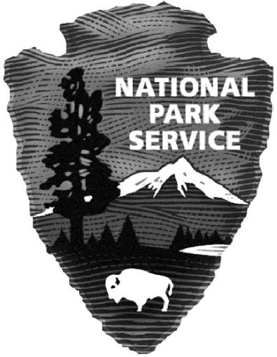

PAPERWORK REDUCTION ACT STATEMENT: The National Park Service is authorized by 54 U.S.C. 100701 to collect this information. This information will be used by park managers to understand the visitor use and the perceptions of recreation management at Canyonlands National Park. Responses to this request are voluntary and anonymous. Your name will never be associated with your answers, and all contact information will be destroyed when the data collection is concluded. No action may be taken against you for refusing to supply the information requested. An agency may not conduct or sponsor, and a person is not required to respond to, a collection of information unless it displays a currently valid OMB control number and expiration date.

BURDEN ESTIMATE STATEMENT: Public reporting burden for this form is estimated to average 20 minutes per response. Direct comments regarding the burden estimate or any other aspect of this form to: to the Social Science Program Chief, National Park Service, 1201 Oakridge Drive, Fort Collins, CO, 80525-5596.

 | United States Department of the Interior  NATIONAL PARK SERVICE  1849 C Street, N.W.  Washington, DC 20240 | 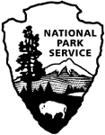
Dear Canyonlands National Park Visitor:

Thank you for participating in this study. Our goal is to learn about the expectations, opinions, and interests of visitors to Canyonlands National Park. This information will assist us in understanding how visitors experience Canyonlands National Park and the surrounding area, motivations for visiting, and will be used to inform planning and management efforts to better serve you.

This questionnaire is only being given to a select number of visitors, so your participation is very important. It should take about 20 minutes to complete and return after your visit.

When your visit is over, the adult in your group who will have the next birthday should complete this questionnaire. Seal it in the postage-paid envelope provided and drop it in any U.S. Postal Service mailbox.

If you have any questions, please contact Name, Title, Organization/company, address, phone number, email.

We appreciate your help.

Sincerely,

SIGNATURE NEEDED

Patricia Trap

Superintendent

DIRECTIONS
At the end of your visit:

- Please have the adult in your group (at least 18 years old) who has the next birthday complete this questionnaire. That will help give us a statistically reliable sample.
- For questions that use circles (O), please mark your answer by filling in the circle with black or blue ink. Please do not use pencil.
- Seal it in the postage-paid envelope provided.
- Drop it in a U.S. Postal Service mailbox.

DIRECTIONS
Please have the adult in your group (at least 18 years old) having the next birthday complete this questionnaire.
In this questionnaire, your personal group is defined as you and anyone with whom you visited Canyonlands National Park on this trip, such as a spouse, family, friends, etc. This does not include the larger group that you might have traveled with, such as a school, church, scout, or tour group.
A visit is defined as the day you were contacted to complete this questionnaire. A trip is defined as the total extent of time away from your personal residence that could include multiple visits to Canyonlands National Park.

1. Trip Description
First, we’d like to ask some questions about your trip away from home that included this visit to Canyonlands National Park, and the time you might have spent in the local area around Canyonlands National Park.
The local area around Canyonlands National Park includes Grand and San Juan counties. Within these counties, the communities of Blanding, Bluff, Green River, Mexican Hat, Moab, and Monticello are shown, along with major roadways and other features within about a one-hour drive of the park. The local area is shown on the map below.
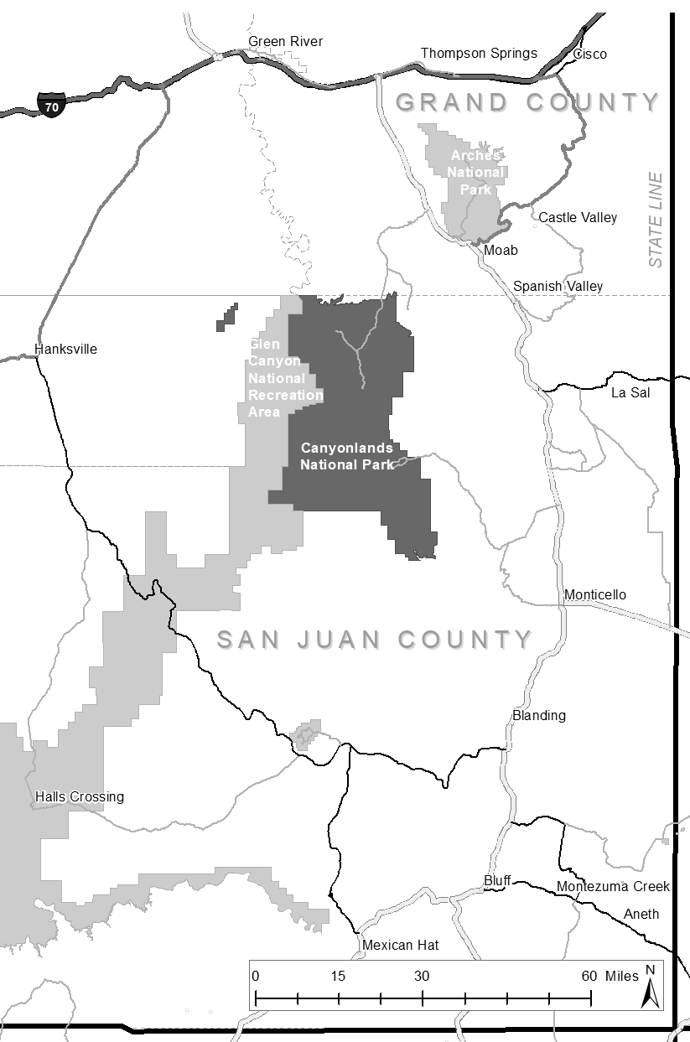
LOCAL AREA
LOCAL AREA

- Are you a permanent or seasonal resident of the local area around Canyonlands National Park? Please mark (●) one.
O Yes, I am a permanent resident GO TO QUESTION 3
O Yes, I am a seasonal resident GO TO QUESTION 3
O No
- Was your visit to Canyonlands National Park the primary purpose for your overall trip away from home? Please mark (●) one.
O Yes
O No Was your visit to Canyonlands National Park…?
Please mark (●) one.
O The primary reason you came to the local area
O One of two or more equally important reasons you came to the local area
O An incidental or spontaneous stop in the local area

- On this trip away from home, have you stayed, or will you stay overnight in Canyonlands National Park and/or within the local area? Please mark (●) one.
O Yes
O No GO TO QUESTION 4

- Please list the number of nights you stayed in Canyonlands National Park and/or in the local area.
Accommodation | Number of Nights
Backcountry camping in Canyonlands National Park | nights
Camping in Canyonlands National Park |  |  |  | nights
Camping outside Canyonlands National Park in local area |  |  |  | nights
Lodging outside Canyonlands National Park in local area (e.g., hotels, cabins, vacation rentals) |  |  |  | nights
Unpaid accommodations (e.g., friends, relatives) |  |  |  | nights
- If you camped overnight in Canyonlands National Park, what time of day did you arrive on your first day in the park? Please mark (●) one.
O Early morning (before 9 am)
O Mid-morning (9am-12pm)
O Mid-day (12pm-3pm)
O Afternoon (3pm-6pm)
O Evening (after 6pm)

- If you camped overnight in Canyonlands National Park, what time of day did you leave on your last day in the park? Please mark (●) one.
O Early morning (before 9 am)
O Mid-morning (9am-12pm)
O Mid-day (12pm-3pm)
O Afternoon (3pm-6pm)
O Evening (after 6pm)

- Which communities did you visit while in the local area? Please mark (●) all that apply.
O Moab O Bluff O Green River
O Spanish Valley O Monticello O Blanding
O Other __________________
Expenditures
The National Park Service is interested in the relationship between parks and their local economy. In this section, we ask about goods and services that you and your personal group may have purchased on this trip to Canyonlands National Park and the local area.
- Including yourself, how many people were in your personal group when you visited Canyonlands National Park?
Note: Your personal group is you and companions with whom you visited Canyonlands National Park on this trip, such as a spouse, family, friends, etc. This does not include the larger group that you might have traveled with, such as a school, church, scout, or tour group.

Adults (18 years or older)

Children (under 18 years)

- Was some or all of your trip away from home booked as a package vacation?
O Yes
O No GO TO QUESTION 7

- What was the total cost of the package vacation for your personal group?
$ |  |  | , |  |  |  | .0 | 0

- What was the total length of your package vacation?
Days

- How many days of the package vacation did you spend in the local area?
Days

- Please estimate how much total money you and your personal group spent in Canyonlands National Park and the local communities surrounding the park during your time in the park and its local area.
Local Area Residents: If you are a permanent or seasonal resident, please only include expenses that were directly related to your visit to Canyonlands National Park on the day you were contacted for this survey.
Package vacationers: If some or all of your trip away from home was booked as a package vacation, please do not include expenses that you already reported in the previous question.
Expense Category | Dollar Amount Spent in Canyonlands and Local Area
Park entrance fee
  $ |  | , |  |  |  | .0 | 0
Gas and oil (e.g., auto, RV, boat, etc.)
  $ |  | , |  |  |  | .0 | 0
Rental cars rented in the local area
  $ |  | , |  |  |  | .0 | 0
Taxis, shuttles, and public transportation
  $ |  | , |  |  |  | .0 | 0
Restaurants and bars
  $ |  | , |  |  |  | .0 | 0
Groceries and convenience foods
  $ |  | , |  |  |  | .0 | 0
Hotels, motels, resorts
  $ |  | , |  |  |  | .0 | 0
Specialty lodging (e.g., B&Bs, hostels, cabins, vacation rentals)
  $ |  | , |  |  |  | .0 | 0
Camping fees (tent, RV)
  $ |  | , |  |  |  | .0 | 0
Recreation and entertainment expenses (e.g., movies, bowling, miniature golf, etc.)
  $ |  | , |  |  |  | .0 | 0
Souvenirs, clothing, supplies, other retail
  $ |  | , |  |  |  | .0 | 0
Equipment rental
  $ |  | , |  |  |  | .0 | 0
Guides and tour fees
  $ |  | , |  |  |  | .0 | 0
Any other items not listed above
  $ |  | , |  |  |  | .0 | 0
If you did not list any expenses above in Question 7, please indicate why you did not answer. Please mark (●) one:
O I did not spend any money within Canyonlands National Park or the local area
O I do not know how much money I spent in Canyonlands and the local area (I don’t remember/I didn’t keep track)
O I prefer to not answer the question

3. Canyonlands National Park Visit
- Please indicate all forms of transportation you personally used to travel from your home to Canyonlands National Park on this trip. Please mark (●) all that apply.
O Car, truck, or SUV
Number of people in vehicle, including yourself

O Recreational vehicle or motorhome
O Airplane
O Tour bus or tour van
O City bus or subway
O Train or long-distance passenger bus
O Water-based transportation (Please mark (●) all that apply)
O Cruise ship
O Ferry
O Tour boat
O Other water-based mode (Please specify) ____________
O Taxi/Uber/Lyft
O Bicycle
O Walk/hike
O Other (Please specify):______________________________

- How much time did you spend within Canyonlands National Park on this trip?
Number of hours, if you only spent 1 day at Canyonlands National Park.

If you entered Canyonlands National Park multiple times on the day of your visit, how many times did you enter the park?
Times entered Canyonlands National Park

OR

Number of days, if you spent more than 1 day at Canyonlands National Park.

If you spent multiple days at Canyonlands National Park, how many different days did you enter the park?
Different days entered Canyonlands National Park

- On this trip, in which of the following activities did you personally participate within Canyonlands National Park? Please mark (●) all that apply.
O Viewing wildlife
O Viewing natural features, scenery, wildflowers, etc.
O Creative arts (photography/drawing/painting/writing)
O Visiting a cultural or historic site
O Nature study
O Driving for pleasure
O 4-wheel driving
O Walking/short hike (less than 1 hour)
O Day hiking (1 hour or more)
O Bicycling
O Running/jogging
O Viewing the night sky
O Listening to the sounds of nature
O Fishing
O Non-motorized water travel (rafting, kayaking, canoeing, tubing, etc.) Please specify: ___________________________________
O Motorized water travel (boating, jet skiing, etc.) Please specify: ___________________________________________________
O Camping in developed sites
O Overnight backpacking
O Family gathering/reunion
O Picnicking
O Rock climbing/bouldering
O Canyoneering
O Other (Please specify):__________________________________
O Other (Please specify):__________________________________

- Of the activities listed in Question 10, which was your primary activity during your visit to Canyonlands National Park on the day you were contacted for this survey?
_______________________________________________________
OR
O I did not have a primary activity on this visit to Canyonlands National Park

- How important to you was each of the following reasons for visiting Canyonlands National Park on this trip? Please mark (●) one for each row.
 | Extremely Important | Very Important | Moderately Important | Slightly Important | Not at All Important
To visit a National Park Service site | O | O | O | O | O
To spend time with friends / family | O | O | O | O | O
To view wildlife | O | O | O | O | O
To view natural scenery | O | O | O | O | O
To get physical exercise | O | O | O | O | O
To relax | O | O | O | O | O
To learn more about American history and culture | O | O | O | O | O
To learn more about nature | O | O | O | O | O
To attend a special event (Please specify): ______________________ | O | O | O | O | O
To hear the sounds of nature/quiet | O | O | O | O | O
To experience solitude | O | O | O | O | O
To be outdoors | O | O | O | O | O
To view dark night sky/stars | O | O | O | O | O
Other (Please specify):  _____________________________ | O | O | O | O | O

- Of the reasons listed in Question 12, which was the most important reason for you to visit Canyonlands National Park on this trip?
_______________________________________________________

4. Canyonlands National Park Management

- Prior to this trip, how did you obtain information about Canyonlands National Park? Please mark (●) all that apply.
O Did not obtain information prior to this visit
O Previous visits
O Friends/relatives/word of mouth
O Inquiry to park via phone, mail, or email
O Canyonlands National Park website (nps.gov/cany)
O Other website (Please specify): __________________________
O Local businesses (hotels, motels, restaurants, etc.)
O Maps/brochures
O Newspaper/magazine articles
O Other units of the National Park System (NPS)
O School class/program
O Social media (such as Facebook, Twitter, etc.)
O State welcome center/visitors bureau/chamber of commerce
O Moab Information Center
O Television/radio programs/DVDs
O Travel guides/tour books (such as AAA, etc.)
O Other (Please specify): _________________________________

- Did you have the information about Canyonlands National Park you needed on this trip? Please mark (●) one.
O Yes
O No Please specify information you needed but didn’t have on this trip.
__________________________________________
__________________________________________

- To what extent do you agree or disagree with each of the following statements? Please mark (●) one for each row.
 | Strongly Agree | Agree | Neither Agree nor Disagree | Disagree | Strongly Disagree | Do Not Know/ Not Sure
Canyonlands National Park is a safe place to visit | O | O | O | O | O | O
Canyonlands National Park is too crowded | O | O | O | O | O | O
Natural resources in Canyonlands National Park are in pristine condition | O | O | O | O | O | O
Graffiti and litter are not a problem in Canyonlands National Park | O | O | O | O | O | O
Canyonlands National Park is not accessible to persons with physical disabilities | O | O | O | O | O | O
Historical and cultural features in Canyonlands National Park are well maintained/preserved | O | O | O | O | O | O
Development of adjacent areas outside the park detracts from visitors’ experiences at Canyonlands National Park | O | O | O | O | O | O

- Did anyone in your personal group have a physical condition that made it difficult to access or participate in park activities or services, during your visit to Canyonlands National Park? Please mark (●) one.
O Yes
O No

What activities, services, or facilities did the person(s) have difficulty participating in or accessing? Please be specific:
___________________________________________
___________________________________________

Because of the physical condition, which specified difficulties did the person(s) have? Please mark (●) all that apply.
O Hearing (difficulty hearing ranger programs, bus drivers, audio-visual exhibits or programs, or information desk staff even with hearing aid)
O Visual (difficulty in seeing exhibits, directional signs, visual aids that are part of programs even with prescribed glasses or due to blindness)
O Mobility (difficulty in accessing facilities, services, or programs even with walking aid and/or wheelchairs)
O Other (Please specify): ___________________
______________________________________

- Did your visit to Canyonlands National Park, on this trip, meet your expectations? Please mark (●) one.
O Yes
O Not entirely Please explain: _________________________
_____________________________

O Not at all Please explain: _________________________
_____________________________

- How familiar are you with “Leave No Trace” guidelines for outdoor recreation? Please mark (●) one.
O Extremely familiar
O Quite familiar
O Moderately familiar
O Slightly familiar
O Not at all familiar

- When did you make the decision to visit Canyonlands National Park on this trip? Please mark (●) one.
O On the same day of the visit
O Couple of days before the visit
O A week before the visit
O 1 month before the visit
O 2-6 months before the visit
O More than 6 months but less than a year before the visit
O A year or more before the visit
O Don’t know/can’t recall

- Did you use Recreation.gov to make a campground reservation or to pay your entrance fee for your visit to Canyonlands National Park? Please mark (●) one.
O Yes Please rate the quality of your experience using
O No Recreation.gov. Please mark (●) one for each item.
 | Very good | Good | Average | Poor | Very Poor
Sufficiency of information provided | O | O | O | O | O
Efficiency of service | O | O | O | O | O
Ease of use | O | O | O | O | O
Accuracy of reservation | O | O | O | O | O

- Did you obtain a permit through the Canyonlands Backcountry Permit Reservation Office during your visit to Canyonlands National Park? Please mark (●) one.
O Yes Please rate the quality of your experience using
O No the Canyonlands Backcountry Permit Reservation
Office. Please mark (●) one.
O Very good
O Good
O Average
O Poor
O Very poor

- On this trip, did you visit the backcountry in Canyonlands National Park (defined here as at least 1 mile down a trail, or at least ½ mile from an improved road if not on a trail)? Please mark (●) one.
O Yes
O No GO TO QUESTION 26

  - The following is a list of characteristics commonly associated with backcountry and wilderness areas. Please indicate how important each of the items listed below was to you as a reason to visit the backcountry in Canyonlands National Park on this trip. Please mark (●) one for each item.

 | How important?
Wilderness/backcountry characteristic | Extremely | Very | Moderately | Slightly | Not at all
Remoteness | O | O | O | O | O
Solitude | O | O | O | O | O
Primitive recreation/few facilities | O | O | O | O | O
Pristine natural environment | O | O | O | O | O
Physically challenging/demanding | O | O | O | O | O
Unconfined recreation/free from rules/regulations | O | O | O | O | O
Requires self-reliance | O | O | O | O | O
Fostering a sense of humility toward nature | O | O | O | O | O
Fostering spiritual connection | O | O | O | O | O
Fostering immersion in nature | O | O | O | O | O

- Please indicate the extent to which you would support or oppose each of the following potential management actions at Canyonlands National Park. Please mark (●) one response for each management action.
Management action | Strongly Support | Support | Neither Support nor Oppose | Oppose | Strongly Oppose | Do Not Know/ No Opinion
Advance timed entry reservation system to the park to reduce crowding | O | O | O | O | O | O
Advance timed entry reservation system to specific areas within the park (I.e. site-specific permits) | O | O | O | O | O | O
Implement limits on commercial recreation activities in wilderness areas | O | O | O | O | O | O
Additional signs and rock cairns along backcountry trails (permanent installations) | O | O | O | O | O | O
Not allow commercial use in wilderness areas | O | O | O | O | O | O
Short-term closures of parking areas when they are full | O | O | O | O | O | O
Expand parking lots. If so where: ________________________ | O | O | O | O | O | O
Expand trail system to increase recreation access | O | O | O | O | O | O
Increase campground capacity | O | O | O | O | O | O
Create more ADA-accessible trails | O | O | O | O | O | O

5. Background Information
In this final section we would like to learn more about you and your background.

- What type of group were you with during your trip to Canyonlands National Park on the day you were contacted for this survey? Please mark (●) all that apply.
O Alone
O Friends
O Family
O Organized group (Please specify): ____________________________
- What is your zip code, or home country if not U.S.?

OR _____________________________
- Are you a first-time visitor to Canyonlands National Park? Please mark (●) one.
How many trips have you taken to Canyonlands National Park in the last 12 months, including this trip?

O Yes
O No
Trips

- How many trips have you taken to other NPS sites in the last 12 months?
Trips

- What is your age?
Years

- What is your gender? Please mark (●) one.
O Male
O Female

- Are you of Hispanic or Latino origin? Please mark (●) one.
O Yes
O No

- What is your race? Please mark (●) all that apply.
O American Indian or Alaska Native
O Asian
O Black or African American
O Native Hawaiian or other Pacific Islander
O White
- What is the highest degree or level of school you have completed? Please mark (●) one.
O Less than high school
O Some high school
O High school graduate or GED
O Some college, business, or trade school
O College, business, or trade school graduate
O Some graduate school
O Master’s, doctoral, or professional degree

- Which category best describes your household income last year, before taxes? Please mark (●) one.
O Less than $24,999
O $25,000 - $34,999
O $35,000 - $49,999
O $50,000 - $74,999
O $75,000 - $99,999
O $100,000 - $149,999
O $150,000 - $199,999
O $200,000 or more

- Including yourself, how many people contribute to your annual household income?
People

- Including yourself, how many people are in your household?
People

- When visiting an area such as Canyonlands National Park, what language do you personally prefer to use? Please mark (●) one for speaking and one for reading.
 | Speaking | Reading
English | O | O
Spanish | O | O
Other (Please specify) _________________ | O | O

- Is there anything else you would like to tell us about Canyonlands National Park’s facilities, services, or recreational opportunities?
_______________________________________________________
_______________________________________________________
_______________________________________________________

Thank you for your help!

Please place the questionnaire in the envelope provided and drop it in any U.S. Postal Service mailbox.

