OMB Control No. 2060-0347
Expiration Date: XX/XX/XXXX
Approved while under OMB review

The data on this form is used for generating certification materials, which includes a certificate for each plant and a letter to the Corporate Energy Manager (CEM) and Chief Executive Officer (CEO). Complete this form with company and plant names and contact information as it should be referenced on certification materials. The letters to the CEO will reference the plants that received certification and will acknowledge the CEM for helping reduce energy use. If any other staff should be acknowledged, please write their names and titles at the end of the form. For multiple plants that fall under the same CEO and CEM input additional plants on page 2. For multiple plants with a different CEO or CEM use a separate form.

 | Corporate Energy Manager | Organization’s Chief Executive Officer
Name
Title
Company
Address 1
Address 2
City
State
Zip code
Email
Phone
 | Plant Owner (complete if different from CEO contact information)
Company
Address
City, State, Zip
Email

Plant 1
Plant name
Company name
Address 1
Address 2
City
State
Zip code
Decal type (see below) | Cyan and white☐ Etched☐

ENERGY STAR Decals |  | NOTE: Unless specified otherwise, all recognition materials will be addressed and sent to the Corporate Energy Manager at the location specified above. The congratulatory letter for the CEO will be sent directly to the address provided for the CEO. Please specify any other information/requests for distribution of recognition materials in the space below.
Cyan and White  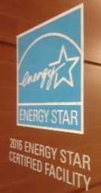 | Etched  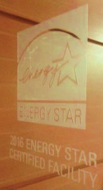
Plant 2
Plant name
Company name
Address 1
Address 2
City
State
Zip code
Decal type | Cyan and white☐ Etched☐

Plant 3
Plant name
Company name
Address 1
Address 2
City
State
Zip code
Decal type | Cyan and white☐ Etched☐

Plant 4
Plant name
Company name
Address 1
Address 2
City
State
Zip code
Decal type | Cyan and white☐ Etched☐

Plant 5
Plant name
Company name
Address 1
Address 2
City
State
Zip code
Decal type | Cyan and white☐ Etched☐

