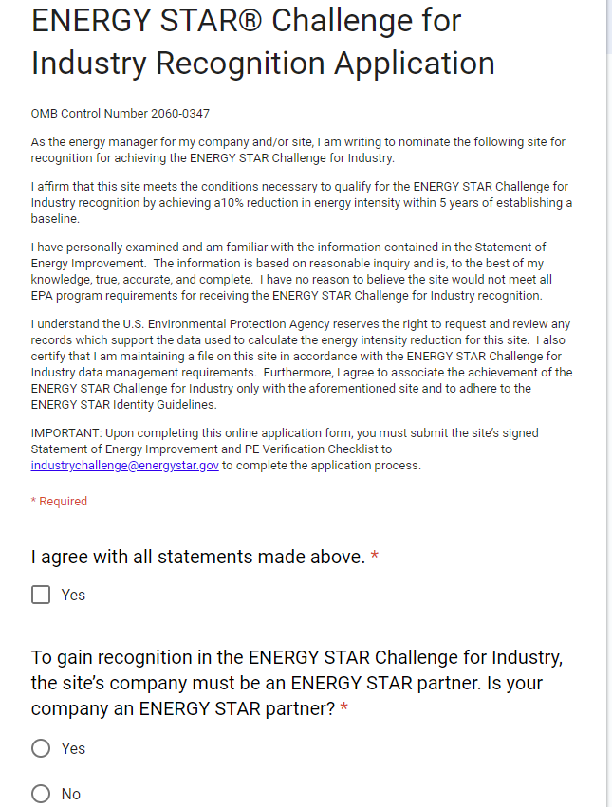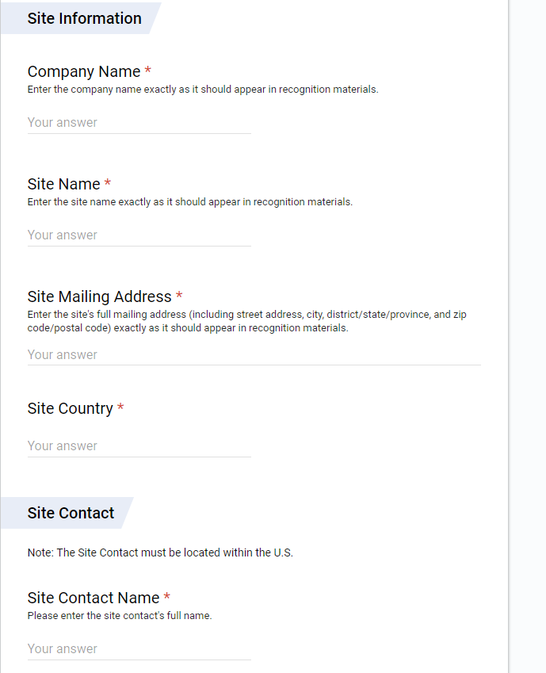
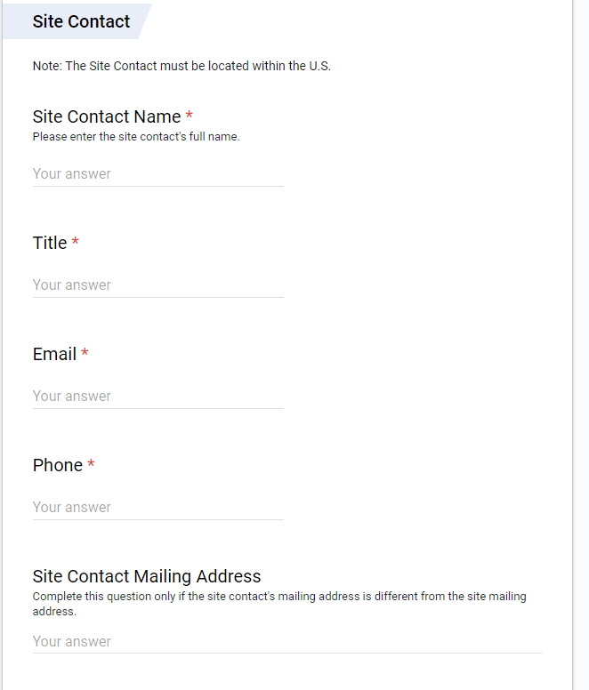
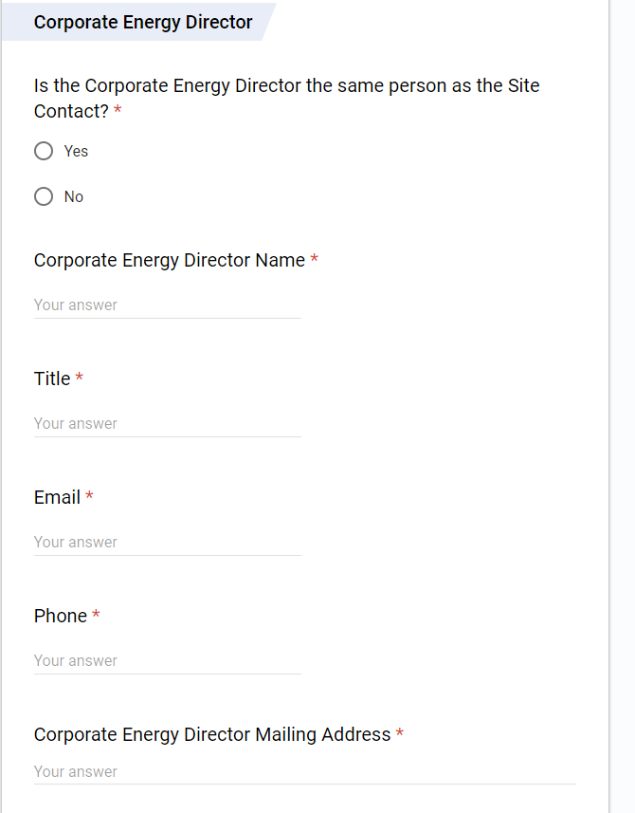

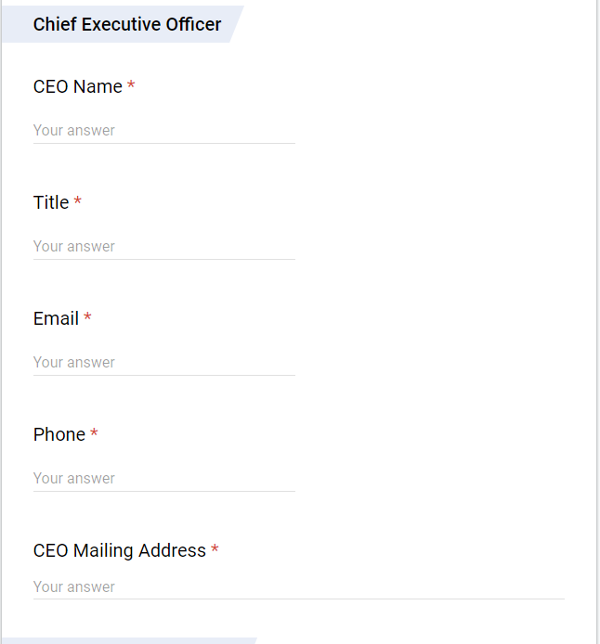
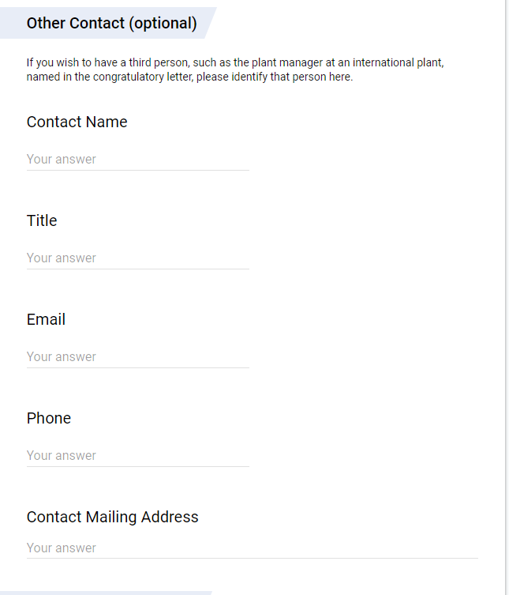
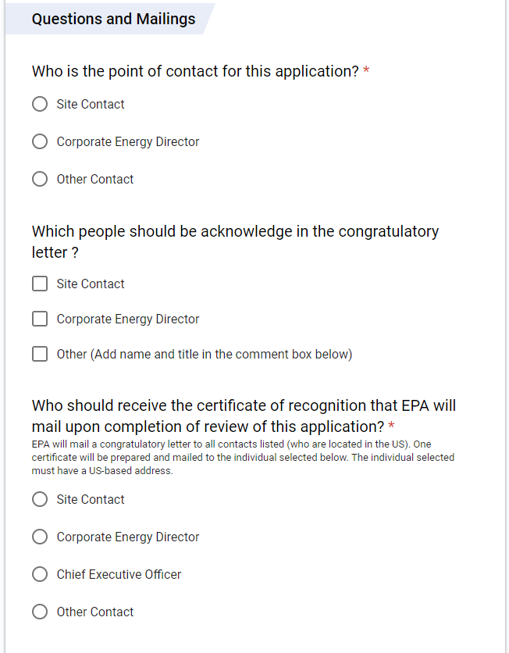
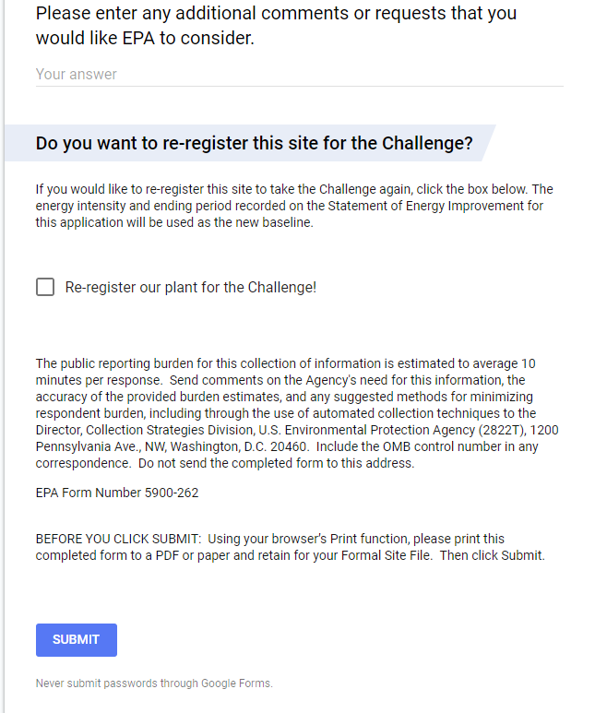
This collection of information is approved by OMB under the Paperwork Reduction Act, 44 U.S.C. 3501 et seq. (OMB Control No. 2060-0347). Responses to this collection of information are voluntary (Section 103(g) Clean Air Act). An agency may not conduct or sponsor, and a person is not required to respond to, a collection of information unless it displays a currently valid OMB control number. The public reporting and recordkeeping burden for this collection of information is estimated to be 10 minutes per response. Send comments on the Agency’s need for this information, the accuracy of the provided burden estimates and any suggested methods for minimizing respondent burden to the Regulatory Support Division Director, U.S. Environmental Protection Agency (2821T), 1200 Pennsylvania Ave., NW, Washington, D.C. 20460. Include the OMB control number in any correspondence. Do not send the completed form to this address.

