Attachment F1

State Unintentional Drug Overdose Reporting System (SUDORS)

Introduction
This document displays the screens that abstractors use to enter required data elements for the SUDORS module. Each section of the module is shown separately, with a screenshot of the previous version on the left and the new version on the right. Variables that have not changed are indicated with black text with the same number on both the right and the left, and the corresponding variable name is given below the screenshot. Any new variables on the righthand side are flagged in red with additional numbers, and the corresponding variable names given below. Any changes are highlighted in a text box below both screenshots.

SUDORS Tab: Drug Overdose and Substance Abuse Sections
Previous SUDORS Version Proposed SUDORS Version
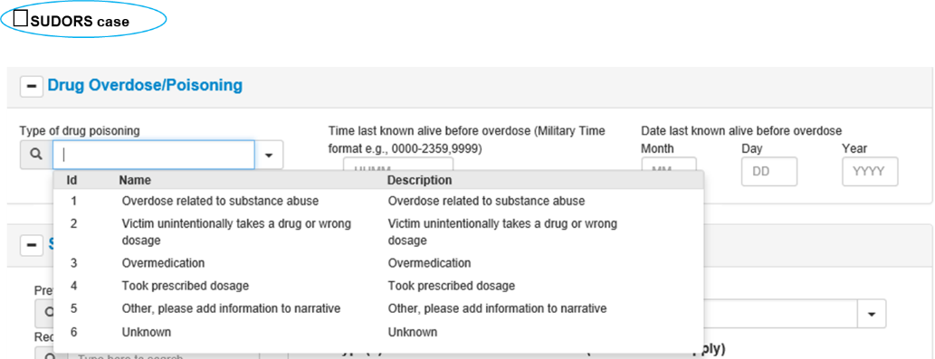
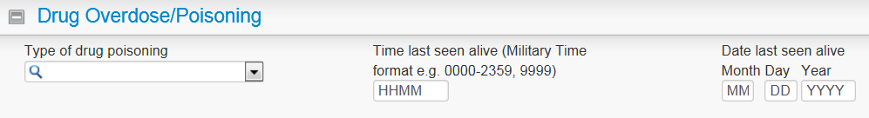
6
5
4
3
2
1

5
4
3
2
1
1 Typeofpoisoning
2 LastSeenAliveTime
3 LastSeenAliveMonth
4 LastSeenAliveDay
5 LastSeenAliveYear

1-5 Retained fields 6 SUDORSCase

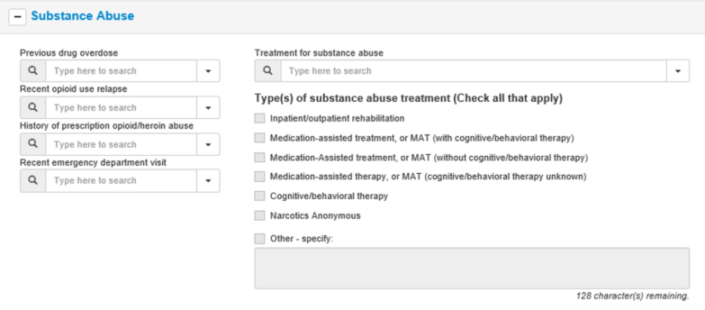
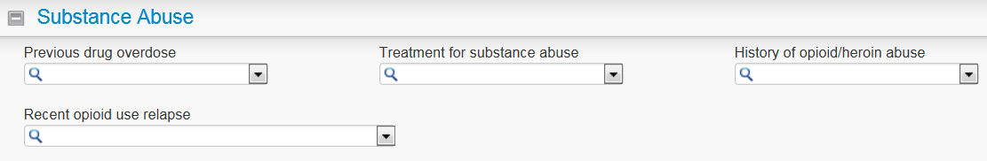
3
2
1
2
1
4
2a
4
2c
2b
3
1 PreviousOverdose
2d
5
2 TreatmentForSubstanceAbuse
2e
3 HistoryOpioid
2f
4 RecentOpioidUse
2g

1 PreviousOverdose
2 TreatmentForSubstanceAbuse 2f SubsTx_NA
2a SubsTx_rehab 2g SubsTx_Other
2b SubsTx_MATcog 3 HistoryOpioid
2c SubsTx_MAT_nocog 4 RecentOpioidUse
2d SubsTx_MAT 5 RecentED
2e SubsTx_CogTherapy
Changes to Drug Overdose and Substance Abuse Sections:
- Additional data element added to Drug Overdose/Poisoning section (#6) that allows the abstractor to identify unintentional/undetermined drug overdose deaths. This facilitates preliminary counts of drug overdose deaths
- 1 additional question added to capture recent emergency department visit (#5). This identifies an opportunity for a public health intervention.
- 7 response categories added (#2a – #2g) that are designed to detect the type of substance abuse treatment the decedent received. This data can provide important data to treatment providers and public health officials tracking the effectiveness of different treatment approaches.

SUDORS Tab: Scene Indications of Drug Use Sections

Previous SUDORS Version Proposed SUDORS Version
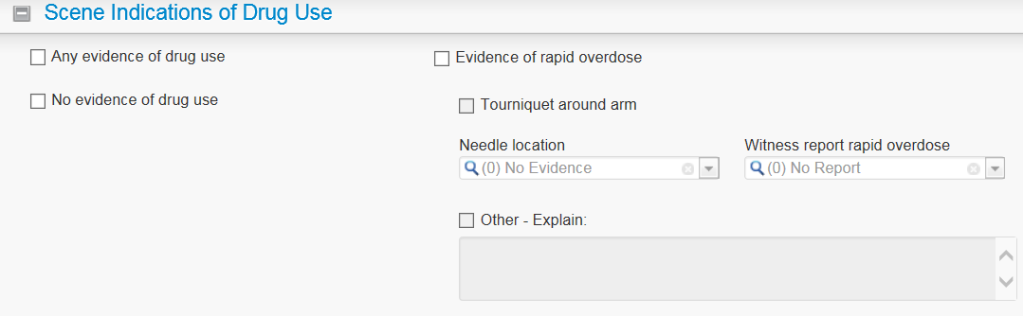
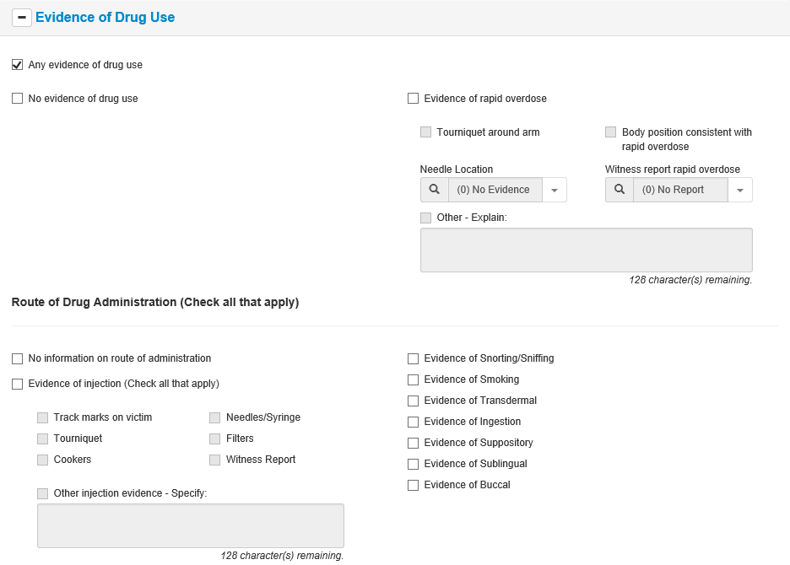
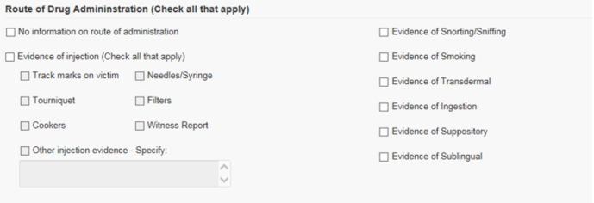
1a
4
1a
4a
1b
4
1b
4a
4c
4b
4e
4d
4c
4b
4d

5v
2
6
3
5v
2
3e
3a
7
7
6
3
3f
3b
8
8
3e
3a
3g
3c
10
9
3g
3f
3c
3b
3d
9
13
10
3d

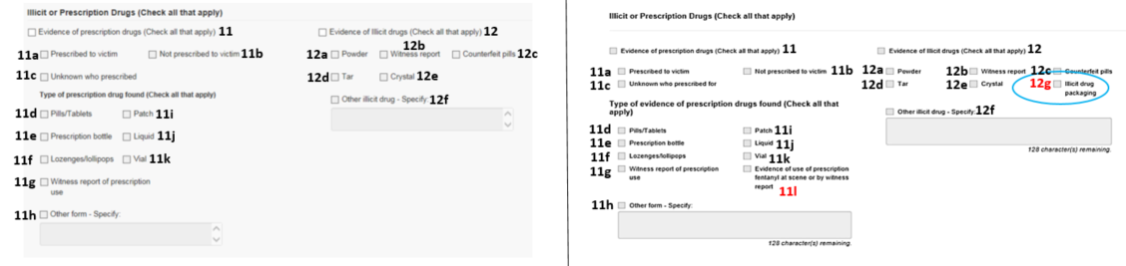

1a IndicationsDrugPara  1b IndicationsNone  2 RouteUnknown  3 RouteInjection  3a IndicationsTracks  3b HasEvidenceOfInjectionTourniquet  3c HasEvidenceOfInjectionCooker  3d HasEvidenceOfInjectionOther  3e HasEvidenceOfInjectionNeedle  3f HasEvidenceOfInjectionFilter  3g HasEvidenceOfInjectionWitnessReport  4 HasRapidOverdoseEvidence  4a IsTourniquetAroundArm  4b NeedleLocation  4c RapidOverdoseWitnessReport  4d RapidOverdoseOther  5 RouteSnorting  6 HasRouteSmoking  7 HasRouteTransdermal  8 RouteIngestion  9 RouteSuppository  10 HasRouteSublingual  11 HasEvidenceOfPrescriptionDrug  11a IsPrescribedToVictim  11b IndicationsRxDrugs  11c IsUnknownWhoPrescribed  11d IsPrescriptionPill  11e IsPrescriptionBottle  11f IsPrescriptionLozenge  11g HasEvidenceOfWitnessReportRxUse  11h IsPrescriptionOther  11i IsPrescriptionPatch  11j IsPrescriptionLiquid  11k IsPrescriptionVial  12 IndicationsDrugsatScene  12a HasEvidenceOfIllicitPowder  12b HasEvidenceOfIllicitWitnessReport  12c IsPrescriptionCounterfeit  12d HasEvidenceOfIllicitTar  12e HasEvidenceOfIllicitCrystal  12f IndicationsOther | 1a IndicationsDrugPara  1b IndicationsNone  2 RouteUnknown  3 RouteInjection  3a IndicationsTracks  3b HasEvidenceOfInjectionTourniquet  3c HasEvidenceOfInjectionCooker  3d HasEvidenceOfInjectionOther  3e HasEvidenceOfInjectionNeedle  3f HasEvidenceOfInjectionFilter  3g HasEvidenceOfInjectionWitnessReport  4 HasRapidOverdoseEvidence  4a IsTourniquetAroundArm  4b NeedleLocation  4c RapidOverdoseWitnessReport  4d RapidOverdoseOther  4e BodyPosition  5 RouteSnorting  6 HasRouteSmoking  7 HasRouteTransdermal  8 RouteIngestion  9 RouteSuppository  10 HasRouteSublingual  11 HasEvidenceOfPrescriptionDrug  11a IsPrescribedToVictim  11b IndicationsRxDrugs  11c IsUnknownWhoPrescribed  11d IsPrescriptionPill  11e IsPrescriptionBottle  11f IsPrescriptionLozenge  11g HasEvidenceOfWitnessReportRxUse  11h IsPrescriptionOther  11i IsPrescriptionPatch  11j IsPrescriptionLiquid  11k IsPrescriptionVial  11L IsPrescriptionFentanyl  12 IndicationsDrugsatScene  12a HasEvidenceOfIllicitPowder  12b HasEvidenceOfIllicitWitnessReport  12c IsPrescriptionCounterfeit  12d HasEvidenceOfIllicitTar  12e HasEvidenceOfIllicitCrystal  12f IndicationsOther  12g HasEvidenceOfIllicitPackage  13 HasRouteBuccal
Changes to Scene Indications of Drug Use Sections:
- For rapid overdoses (#4), the response option “body position” (#4e) was added based on feedback from medical examiner/coroners and SUDORS abstractors that rapid overdose could be determined by the position of the body.
- Buccal was added to route of drug administration (#13) because it was identified as a route in opioid overdose deaths that was not on the previous list.
- For evidence of illicit drug use (#12), illicit drug packaging (#12g) was added because it occurred in a sufficient number of drug overdose deaths to track. This will also improve the identification of drug overdose deaths involving illicit drugs.
- Scene or prescription evidence of fentanyl (#11L) was added because SUDORS abstractors indicated this information was available and it is critical to determine whether the fentanyl contributing to the overdose was prescribed versus illicitly manufactured.

SUDORS Tab: Response to Drug Overdose and Medical History Sections
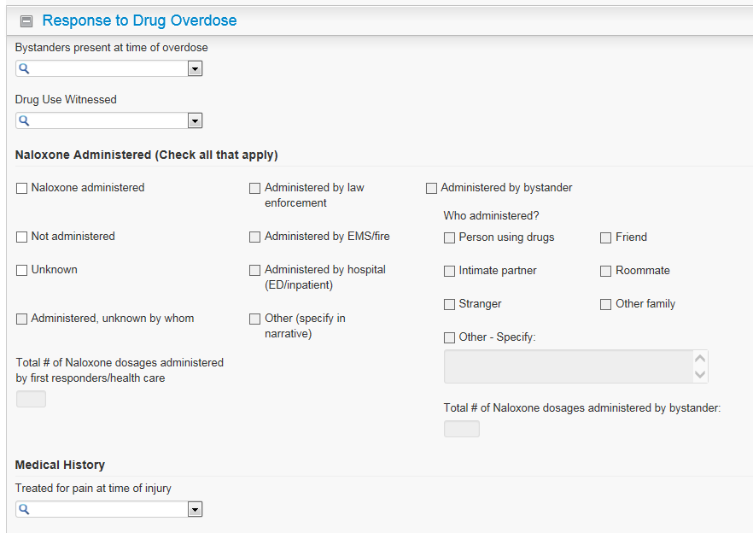
Previous SUDORS Version Proposed SUDORS Version
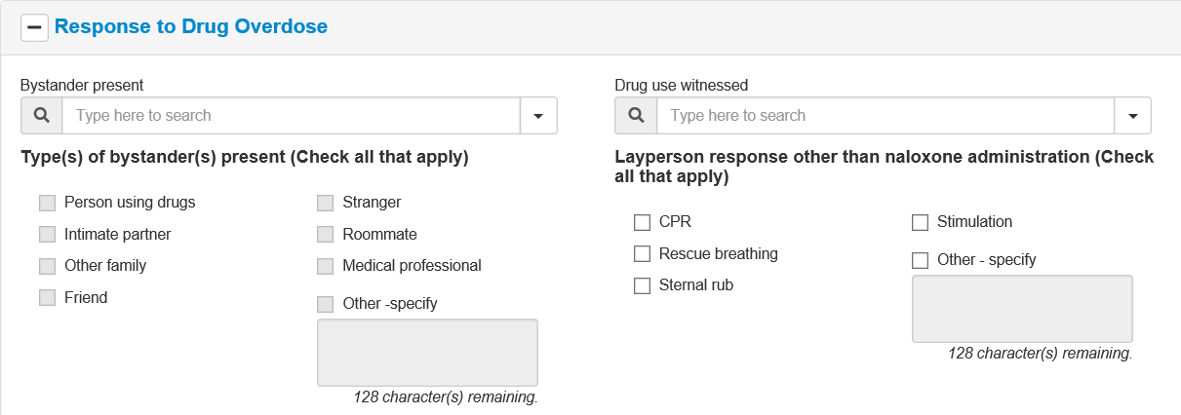
2
1
1
1l
1i
1f
1e
1a
1b
2
1m
1k
1j
1h
1g
1c
1d
13
9
3
18
14
10
4
20
19
16
15
11
5
17
12
6
7
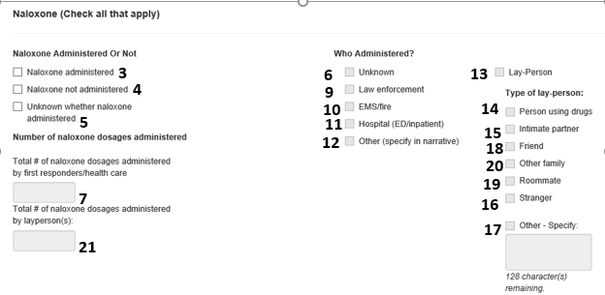
21

8

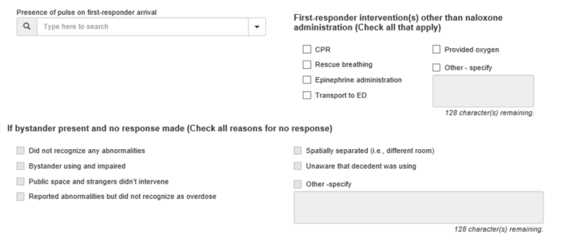
23f
23e
23d
23c
23b
23a
30
29
28
27
26
25
24
22
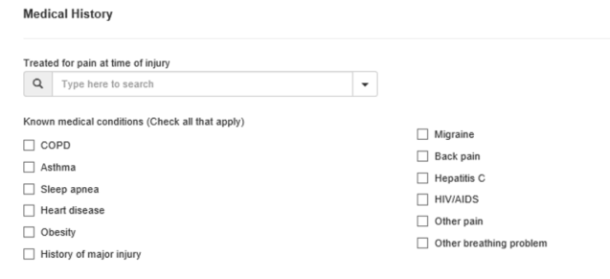
8h
8i
8g
8l
8k
8j
8f
8e
8d
8c
8b
8a
8

- BystandersPresent  - WitnessedDrugUse  - NaloxoneAdministered  - IsNaloxoneNotAdmin  - IsNaloxoneUnknown  - IsNaloxoneAdminUnknown  - NaloxoneTotalResponder  - TreatedforPain  - IsNaloxoneAdminLaw  - IsNaloxoneAdminEMS  - IsNaloxoneAdminHospital | - IsNaloxoneAdminOther  - IsNaloxoneAdminBystander  - IsNaloxoneWhoPerson  - IsNaloxoneWhoPartner  - IsNaloxoneWhoStranger  - IsNaloxoneWhoOther  - IsNaloxoneWhoFriend  - IsNaloxoneWhoRoommate  - IsNaloxoneWhoOtherFamily  - NaloxoneTotalBystander | - BystandersPresent  1a BystanderUser  1b BystanderPartner  1c BystanderFamily  1d BystanderFriend  1e BystanderStranger  1f BystanderRoomate  1g BystanderMedical  1h BystanderOther  1i BystanderCPR  1j BystanderBreathing  1k BystanderSternal  1l BystanderStim  1m BystanderIntOther  - WitnessedDrugUse  - NaloxoneAdministered  - IsNaloxoneNotAdmin  - IsNaloxoneUnknown  - IsNaloxoneAdminUnknown  - NaloxoneTotalResponder  - TreatedforPain  8a MedHx_COPD  8b MedHx_Asthma  8c MedHx_Apnea  8d MedHx_Heart  8e MedHx_Obesity  8f MedHx_Injury  8g MedHx_Migraine  8h MedHx_BackPain  8i MedHx_HepC  8k MedHx_OtherPain  8l MedHx_OtherBreathing | - IsNaloxoneAdminLaw  - IsNaloxoneAdminEMS  - IsNaloxoneAdminHospital  - IsNaloxoneAdminOther  - IsNaloxoneAdminBystander  - IsNaloxoneWhoPerson  - IsNaloxoneWhoPartner  - IsNaloxoneWhoStranger  - IsNaloxoneWhoOther  - IsNaloxoneWhoFriend  - IsNaloxoneWhoRoommate  - IsNaloxoneWhoOtherFamily  - NaloxoneTotalBystander  22---HadPulse  23a FirstResponderCPR  23b FirstResponderBreathing  23c FirstResponderEpinephrine  23d FirstResponderED  23e FirstResponderOxygen  23f FirstResponderOther  - BystanderNotRecognize  - BystanderUsing  - BystanderPublic  - BystandernoOD  - BystanderSeparated  - BystanderUnaware  - BystanderReasonOther

Changes to Response to Drug Overdose and Medical History Sections:
- 8 additional data elements (#1a – #1h) capture more detail on the bystanders of the fatal overdose. This information can be critical in allocating naloxone and other training resources to people who are likely to be present during fatal opioid overdoses.
- 6 additional data elements (#1i – #1n) expand the list of bystander’s response to the overdose and emerge from state abstractors work on SUDORS. This will increase information on bystanders responses to fatal overdose and can inform training of bystanders likely to respond to overdoses.
- 12 additional data elements capture information on decedent’s pre-existing conditions that: 1) may have contributed to the fatal overdose (#8a – #8e and #8l), 2) be related to injection drug use (#8i and #8j), or 3) explain the decedent’s use and/or prescription of opioid pain relievers (#8f – #8h and #8k).
- 7 additional data elements (#24 – #30) capture reasons bystander’s response to an overdose were delayed. Identifying these reasons can provide critical knowledge in improving responses to potentially fatal drug overdoses.
- 1 additional data element (#22) was added to capture the condition of the decedent when first responders arrived. This informaiton is important because the appropriate medical response may vary depending on whether the decedent had a heart beat when first responders arrived.
- 6 additional data elements (#23a – #23f) were added to capture the full array of treatments first responders administred to drug overdose decedents. This can inform training for future responses to potentially fatal drug overdoses.
SUDORS Tab: Prescription Information Section
Previous SUDORS version Proposed SUDORS version
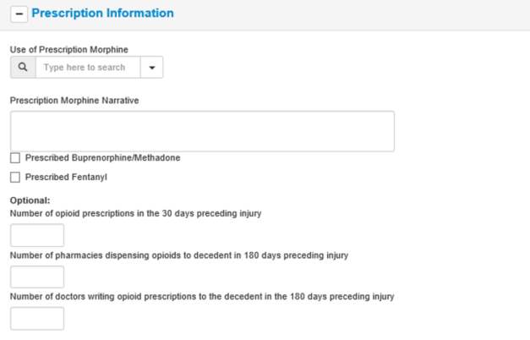
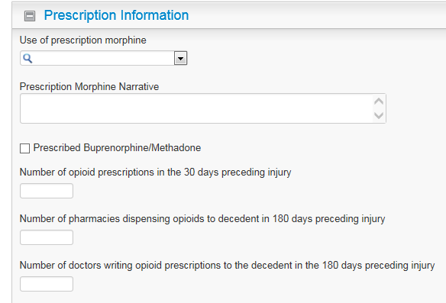
1
1

2
2
3
7
3
4
4
5
5

6
6

- PrescriptionMorphine  - PrescriptionMorphineNarrative  - IndicationsBuprenorphine  - NumScripsPast30Days  - NumPharmaciesPast30Days  - NumDoctorsPrescribing30Days | - PrescriptionMorphine  - PrescriptionMorphineNarrative  - IndicationsBuprenorphine  - NumScripsPast30Days  - NumPharmaciesPast30Days  - NumDoctorsPrescribing30Days  7- FentanylRx
Changes to Prescription Information Section:
- 1 additional variable added to capture evidence that the decedent was prescribed fentanyl. This information is critical in determining whether the death was most likely linked with prescription fentanyl versus illicitly manufactured fentanyl.

