OMB CONTROL NUMBER: 0710-XXXX
OMB EXPIRATION DATE: XX/XX/XXXX
2019 Agricultural Shipper Transportation Needs Survey:
Ohio River System
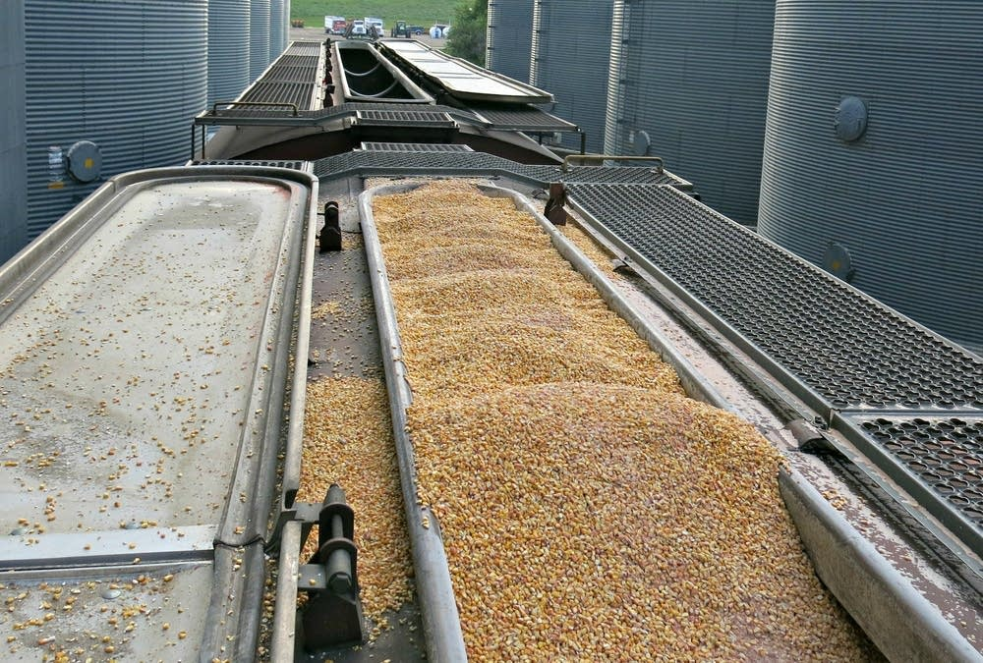
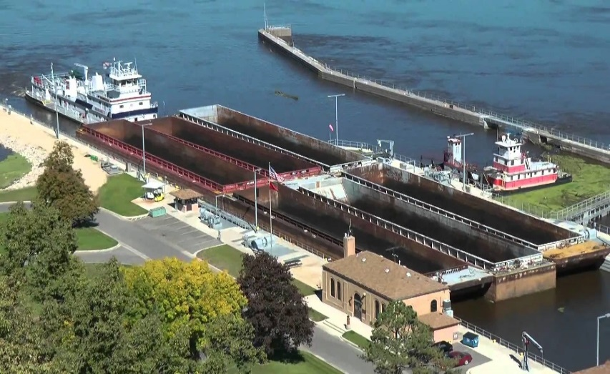

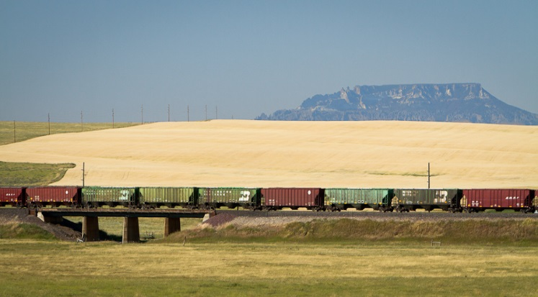
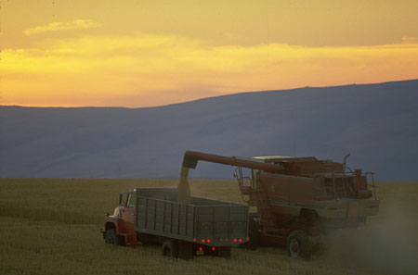

Sponsored by:
United States Army Corps of Engineers and Washington State University

Your responses to this survey will help us determine the need for transportation investments in your region. This information will be used by Federal and State Transportation agencies to evaluate and support public provision of transportation infrastructure improvements. The survey should take only about 15 minutes.

RETURN YOUR COMPLETED QUESTIONNAIRE TO:

Social & Economic Sciences Research Center
Washington State University
PO Box 641801
Pullman, WA 99164-1801

Privacy Act Statement

Authority: Water Resources Planning Act of 1965 (Public Law 89-80), as amended (42 USC 1962a-2 and d-1). Principles and Guidelines for Water Related Land Resources Implementation Studies (U.S. Water Resources Council, 1983), Engineering Regulation 1105-2-100

Principal Purpose: The information you provide will be combined with other respondents to update demand models associated with use of USACE managed waterways

Routine Use: No personally identifiable information is collected as part of this survey. For more information on DOD routine uses, visit http://dpcld.defense.gov/Privacy/SORNsIndex/Blanket-Routine-Uses/

Disclosure: Participation in this survey is voluntary and there are no penalties for refusing to provide any information. If you do not provide a response, it may affect the completeness and accuracy of the statistical results.

For more information visit
http://www.iwr.usace.army.mil/Missions/Navigation/Navigation-Economics-Technologies-NETS/

Agency Disclosure

The public reporting burden for this collection of information, 0710-XXXX, is estimated to average 15 minutes per response, including the time for reviewing instructions, searching existing data sources, gathering and maintaining the data needed, and completing and reviewing the collection of information. Send comments regarding the burden estimate or burden reduction suggestions to the Department of Defense, Washington Headquarters Services, at whs.mc-alex.esd.mbx.dd-dod-information-collections@mail.mil. Respondents should be aware that notwithstanding any other provision of law, no person shall be subject to any penalty for failing to comply with a collection of information if it does not display a currently valid OMB control number.

Shipment Information

«NAME»
Choice: Consider your last shipment from this elevator: «ADDRESS1»
«CITY», «STATE» «ZIP»

Q1. What is the primary commodity you ship from this elevator? _____________ commodity

Q2. At this location, do you have loading capabilities for…

Yes No
▼ ▼
- Trucks ₁ ₂
- Rail Cars ₁ ₂
c. Barges ₁ ₂

Q2b. If YES to Rail loading capability, what is your rail car loading capacity?

______ # of cars

Q2c. If NO to Rail loading capability, how close is the nearest rail loading facility to this elevator?

_______ miles

Q2d. If NO to Barge loading capability, how close is the nearest barge loading facility to this elevator?

_______ miles

Your last Freight Shipment

Q3. What commodity was shipped in your last shipment? _____________ commodity

Q4. Where was this commodity shipped to? ____________________________ city ___________ state

Q4b. What type of destination is this?

₁ River terminal ₂ Another Elevator ₃ Railroad terminal ₄ Processing Plant
₅ Other (specify): ________________________

Q5. How large was this shipment (payload weight)?

_____________________________ payload weight, in

₁ Tons ₂ Hundred Weight (Cwt)* ₃ Gallons
₄ Bushels ₅ Shipment ₆ Other (specify): _________________

* Cwt used throughout

Q6. What type of transportation was used for this shipment, approximately what
distance did each travel (in miles), and what was the transportation rate?

Mode Distance Transportation Per Unit type for commodity
(check if used) Traveled Rate Tons Cwt Gallons Bushels Shipment Other (specify)
▼ ▼ ▼ ▼ ▼ ▼ ▼ ▼ ▼
Truck __________ miles $_________ rate ₁ ₂ ₃ ₄ ₅ ₆ _________
Rail __________ miles $_________ rate ₁ ₂ ₃ ₄ ₅ ₆ _________
Barge __________ miles $_________ rate ₁ ₂ ₃ ₄ ₅ ₆ _________

Total Distance
Traveled Total Cost Tons Cwt Gallons Bushels Shipment Other (specify)
▼ ▼ ▼ ▼ ▼ ▼ ▼
Total Shipment _________ miles $_________rate ₁ ₂ ₃ ₄ ₅ ₆ _________

Q7. What do you estimate was the shipment time (include scheduling time, wait for equipment and transit time)?

_________ days + _________ hours.

Q8. How reliable is the service? That is, for shipments like this one, what percent of the time do you expect them to arrive on time?

__________ percent on-time arrivals

Q9. What price did you receive for your commodity at the destination terminal?

__________ dollars per unit

₁ Tons ₂ Cwt ₃ Gallons ₄ Bushels ₅ Shipment ₆ Other (specify): _________________

Shipping Alternatives

We want to know what options you could take if the mode and destination you used for your last shipment had not been available and would never be available. For example, if the rail system were shut down, shippers who used rail could use truck instead of rail, or could use barge with truck access to a barge loading facility, or could have sent the shipment to a different destination. We need to know what these alternatives are for you. Nearly everyone has some kind of shipping alternatives. If not, then the only alternative is to shut down and go out of business. Please provide us with information on these alternatives for you.

Q10. If the mode and destination you used for your last shipment had not been available and would never be available, what would you do?

₁ Shut down and go out of business skip to Q25
₂ Continue your operations but in a different, perhaps costlier way

First Shipping Alternative

Q11. Where would this commodity be shipped to? ____________________ city _______ state

Q11b. What type of destination is this?

₁ River terminal ₂ Another Elevator ₃ Railroad terminal ₄ Processing Plant
₅ Other (please specify): ________________________

Q12. What transportation would be used for this shipment, approximately what distance would each travel (in miles) and what would be the transportation rate?

Mode Distance Transportation Per Unit type for commodity
(check if used) traveled rate Tons Cwt Gallons Bushels Shipment Other (specify)
▼ ▼ ▼ ▼ ▼ ▼ ▼ ▼ ▼
Truck __________ miles $________ rate ₁ ₂ ₃ ₄ ₅ ₆ _________
Rail __________ miles $________ rate ₁ ₂ ₃ ₄ ₅ ₆ _________
Barge __________ miles $________ rate ₁ ₂ ₃ ₄ ₅ ₆ _________

Estimate of
Total Distance Estimate of Per Unit type for commodity
Traveled Total Cost Tons Cwt Gallons Bushels Shipment Other (specify)
▼ ▼ ▼ ▼ ▼ ▼ ▼ ▼
Total Shipment ________ miles $________rate ₁ ₂ ₃ ₄ ₅ ₆ _________

Q13. What do you estimate would be the shipment time (include scheduling time,
wait for equipment and transit time)?

_________ days + _________ hours.

Q14. How reliable would the service be? That is, for shipments like this one, what percent
of the time would you expect them to arrive on time?

__________ percent on-time arrivals

Q15. How large would your shipment be (payload weight)?

_____________________________ payload weight, in

₁ Tons ₂ Cwt ₃ Gallons ₄ Bushels ₅ Other (specify): ____________________

Q16. What price would you receive for your commodity at the destination terminal?

__________ dollars per unit

₁ Tons ₂ Cwt ₃ Gallons ₄ Bushels ₅ Shipment ₆ Other (specify): __________________

Other Shipping Alternatives

Please complete the table below for your other shipping alternatives. If you have no other alternatives, skip to Q24

 | Second Alternative | Third Alternative
Q17. Where would it be shipped to? | ______________ city _______ state | ______________ city _______ state
Q18. What type of destination is this? | ₁ River terminal ₂ Another Elevator  ₃ Rail terminal ₄ Processing Plant  ₅ Other (specify): _______________ | ₁ River terminal ₂ Another Elevator  ₃ Rail terminal ₄ Processing Plant  ₅ Other (specify): _______________
Q19a. What type of transportation modes would be used for this shipment? | Mode Distance Transportation  (Check if used) traveled rate  ▼ ▼ ▼  Truck _____miles ____rate  Rail _____miles ____rate  Barge _____miles ____rate  ₁ Tons ₂ Cwt ₃ Gallons  ₄ Bushels ₅ Shipment  ₆ Other (specify):__________________ | Mode Distance Transportation  (Check if used) traveled rate  ▼ ▼ ▼  Truck _____miles ____rate  Rail _____miles ____rate  Barge _____miles ____rate  ₁ Tons ₂ Cwt ₃ Gallons  ₄ Bushels ₅ Shipment  ₆ Other (specify):__________________
Q19b. What is the total distance and total cost for this shipment? | Total Total  Distance Cost  Total  Shipment ________Miles $ _______rate  ₁ Tons ₂ Cwt ₃ Gallons  ₄ Bushels ₅ Shipment  ₆ Other (specify):__________________ | Total Total  Distance Cost  Total  Shipment ________Miles $ ______  ₁ Tons ₂ Cwt ₃ Gallons  ₄ Bushels ₅ Shipment  ₆ Other (specify):_________________
Q20. What do you estimate would be the shipment time? | _____ days + _____ hours | _____ days + _____ hours
Q21. How reliable would the service be? | _____% on-time arrivals | _____% on-time arrivals
Q22. How large would the shipment be? | __________ payload weight  ₁ Tons ₂ Cwt ₃ Gallons  ₄ Bushels ₅ Other (specify):  _____________________ | __________ payload weight  ₁ Tons ₂ Cwt ₃ Gallons  ₄ Bushels ₅ Other (specify):  ______________________
Q23. What estimated price would you receive for your commodity at the destination terminal? | __________ dollars  ₁ Tons ₂ Cwt ₃ Gallons  ₄ Bushels ₅ Shipment  ₆ Other (specify): | __________ dollars  ₁ Tons ₂ Cwt ₃ Gallons  ₄ Bushels ₅ Shipment  ₆ Other (specify):

Best Alternative Choice

Q24. Of the alternative shipments, if any, what is your “preferred alternative”? That is, if you could not make the shipment you made what shipment would you have made?

₁ First Alternative
₂ Second Alternative
₃ Third Alternative
₄ Other Alternative (specify): _____________________

Transportation Rates

In each of the next three questions relating to rate and service changes, please regard the changes as permanent changes. Also, if you marked you have no alternatives in Q10, page 3, please consider “out-of-business” as your alternative.

Q25. For your last shipment, if the transportation rate increased «Percent_change1»%, would you continue with the original mode and destination or switch to your best alternative choice?

₁ Continue to use Original mode
₂ Switch to Best Alternative Choice Skip to Q26
₃ Go out-of-business Skip to Q26

Q25b. If you would continue to use your Original mode, what percentage increase in the transportation rate would be necessary to cause you to switch to the Alternative transportation mode?

______ % increase

Transit Time

Q26. For your last shipment, if the transit time (including scheduling and wait for equipment) for the original option increased «Percent_change2»%, would you continue with the original mode and destination or switch to the alternative at this location?

₁ Continue to use Original mode
₂ Switch to Best Alternative Choice Skip to Q27
₃ Go out-of-business Skip to Q27

Q26b. If you would continue to use your Original mode, what percentage increase in the transit time would be necessary to cause you to switch to the Alternative transportation mode?

______ % increase

Reliability

Q27. For your last shipment, if the reliability (percentage of time shipments arrived on-time) of the original option decreased «Percent_change3»%, would you continue with the original mode and destination or switch to the alternative at this location?

₁ Continue to use Original mode
₂ Switch to Best Alternative Choice Skip to Q28
₃ Go out-of-business Skip to Q28

Q27b. If continue to use Original mode, what percentage decrease in the reliability would be necessary to cause you to switch to the Alternative transportation mode?

______ % decrease

Volume

Q28. If the average transportation rate you pay increased by «Percent_change4»%, would your annual volume shipped decrease (assume the rate increase applies to BOTH you and to your competitors)?

₁ Yes
₂ No Skip to Q29

Q28b. If yes, by how much would the volume decrease (assuming the rate increase applies to both you and to your competitors)?

__________ volume decrease

Q29. If the average transportation rate you pay increased by «Percent_change5»%, would your annual volume decrease (assume that the rate increase applies ONLY to your firm and NOT to your competitors)?

₁ Yes
₂ No Skip to Q30

Q29b. If yes, by how much would the volume decrease (assuming that the rate increase applies ONLY to your firm and NOT to your competitors)?

__________ volume decrease

Q30. If the average time in transit increased by «Percent_change6»%, would your annual volume decrease?

₁ Yes
₂ No skip to Q31

Q30b. If yes, by how much would the volume decrease?

__________ volume decrease

Q31. If the average time that shipments arrive on-time decreased by «Percent_change7»%, would your annual volume decrease?

₁ Yes
₂ No skip to Q32

Q31b. If yes, by how much would the volume decrease?

__________ volume decrease
Shipper Characteristics

Q32. How long has this elevator been at its current location?

_____ years

Q33. How large is your elevator?

__________________ Total Amount of Annual Units Shipped

please check the type of unit for this elevator
₁ Tons ₂ Cwt ₃ Gallons ₄ Bushels ₅ Other (specify): __________________

__________________ Total Amount of Storage Capacity

₁ Tons ₂ Cwt ₃ Gallons ₄ Bushels ₅ Other (specify): __________________

Q34. Does your firm (or parent firm) own export or import facilities?

₁ Yes
₂ No

Q35. How many facilities such as this one does your firm own and/or operate?

_______________ number of elevators.

Q36. Thank you for your help with this study. We would welcome any additional comments you would like to provide about shipping.

Please return your completed questionnaire to:

Social & Economic Sciences Research Center
Washington State University
PO Box 641801
Pullman, WA 99164-1801
(Form: ELVA-17 20170718)
«ID» - 1

