ATTACHMENT 2a

FEDERAL REGISTER NOTICE

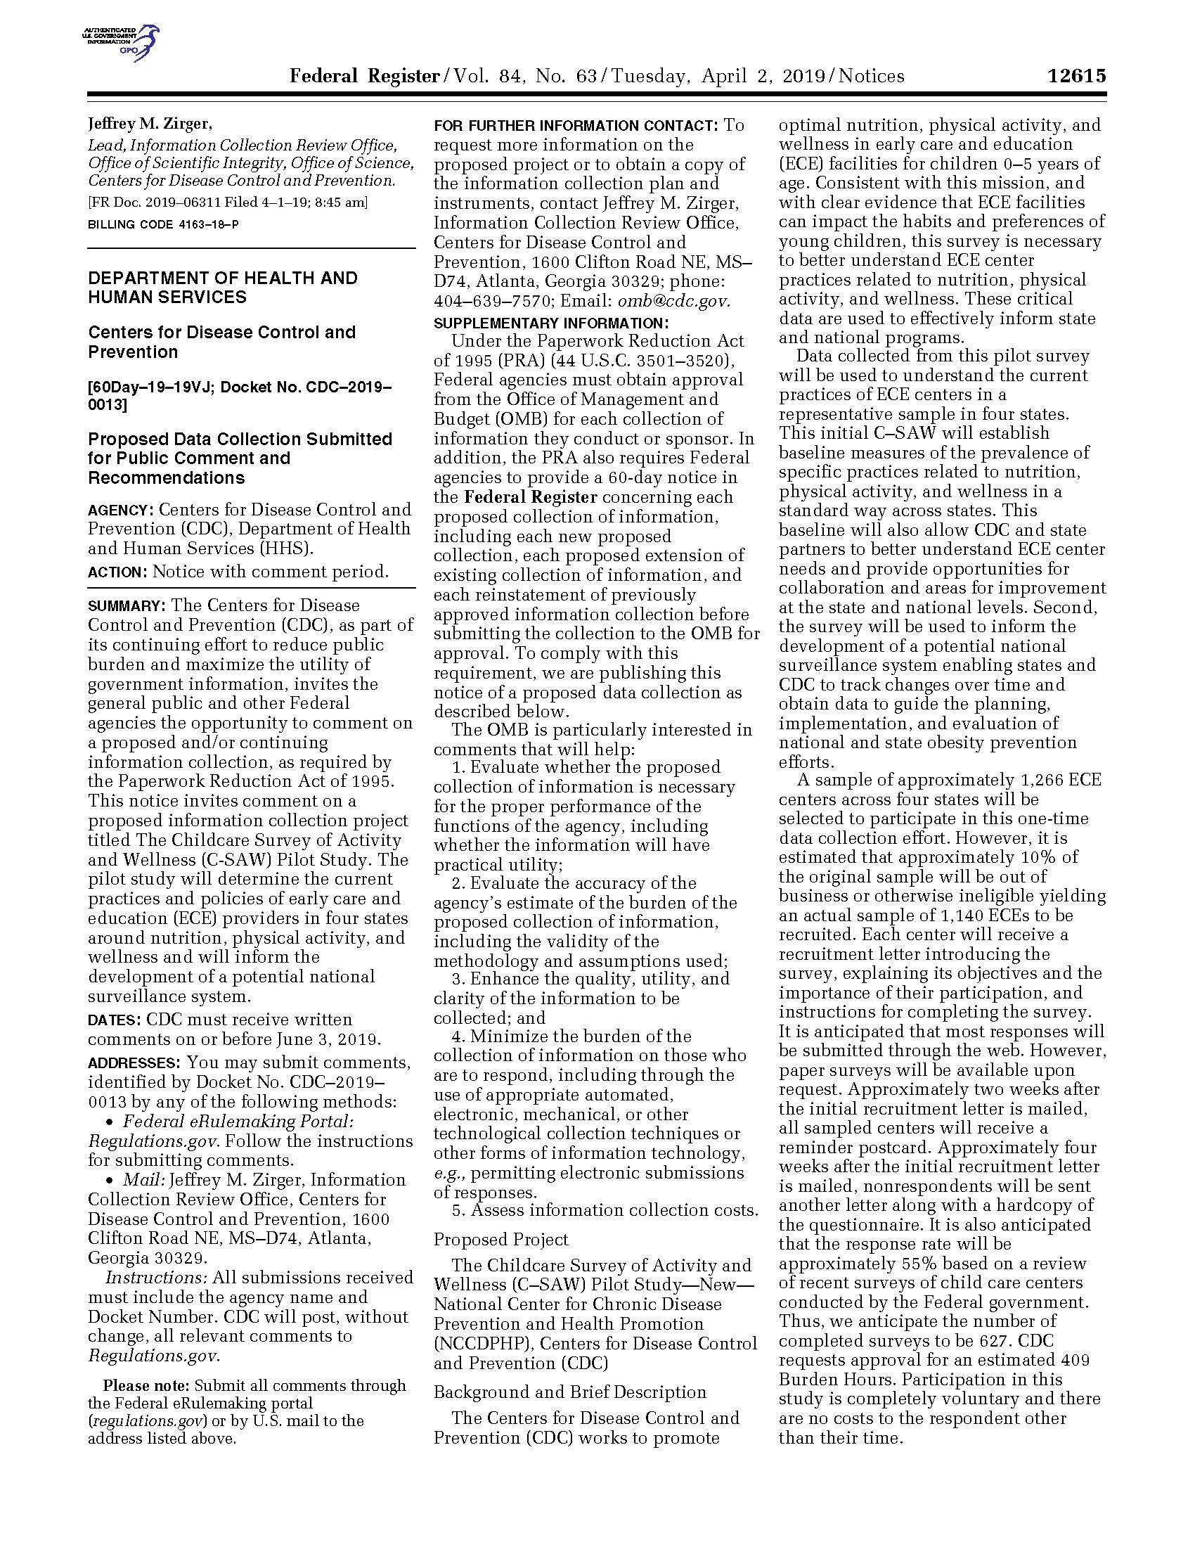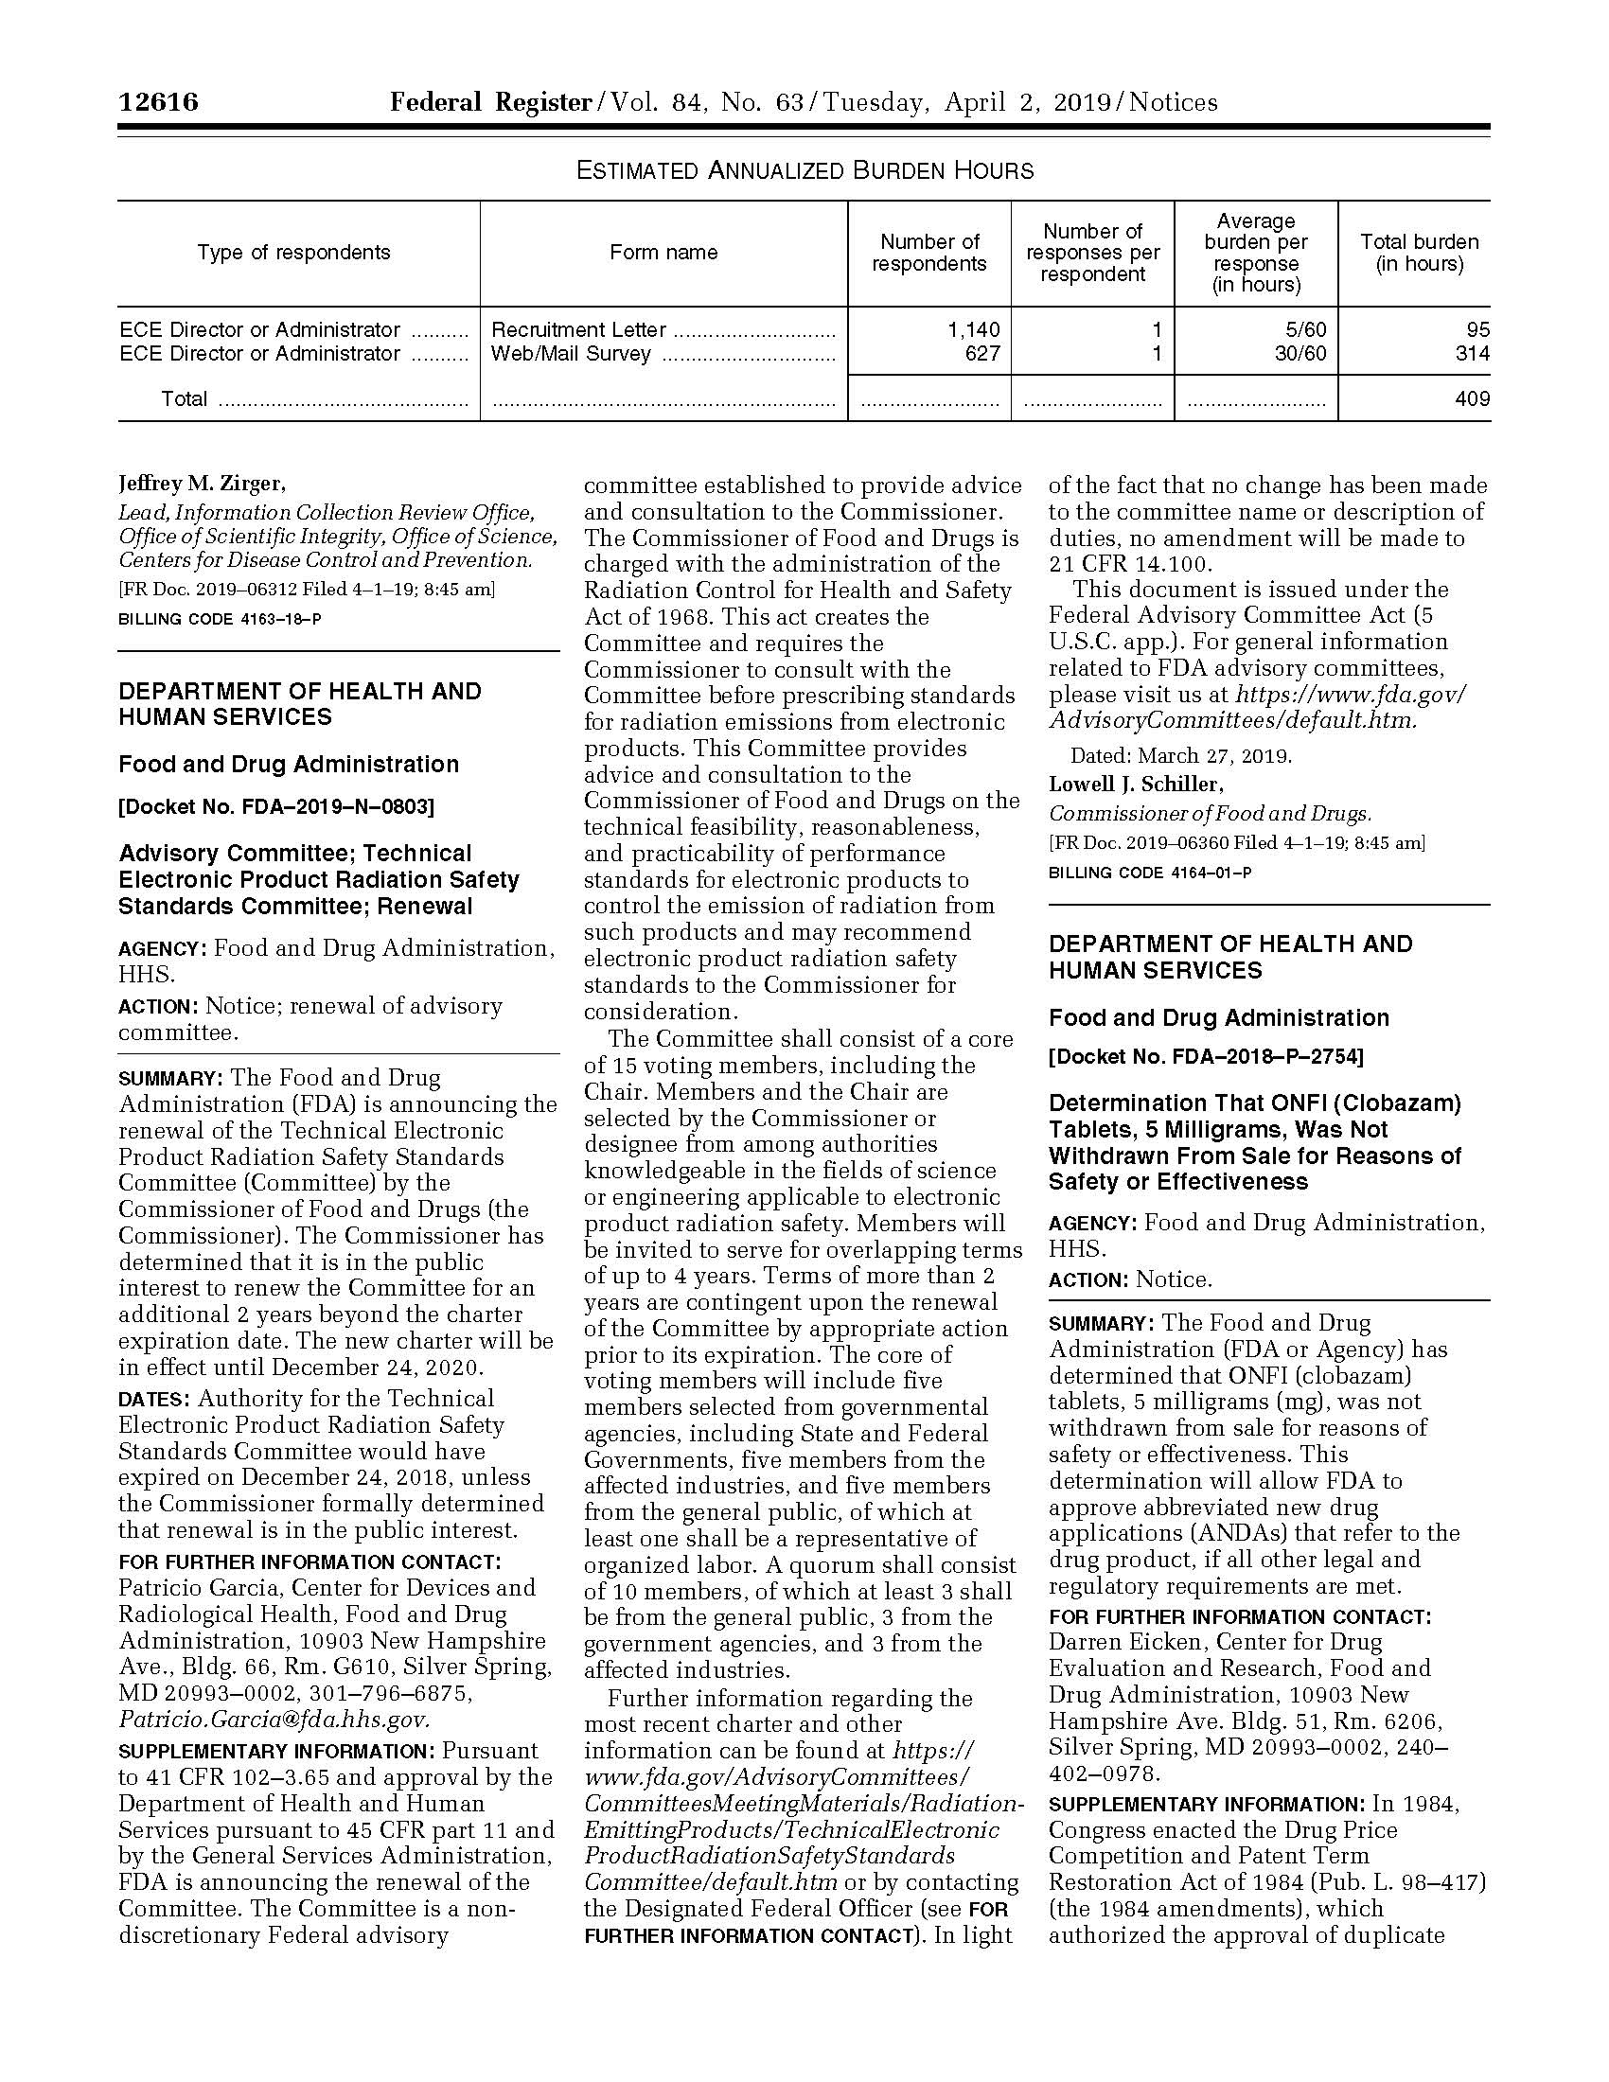

ATTACHMENT 2B

Childcare Survey of Activity and Wellness (C-SAW) Pilot Study

Docket No. 2019-06312

Public Comments and CDC Response

Federal Register Notice: A 60-Day Notice was published in the Federal Register on April 2, 2019, Vol. 84, No. 63, pp. 12615-12616.

Two public comments were submitted to CDC for consideration. This attachment includes all comments and a summary of actions taken by CDC in response to the comments.

Public Comment #1

May 24, 2019

Jeffrey M. Zirger
Information Collection Review Office,
Centers for Disease Control and Prevention
1600 Clifton Road NE
MS-D74
Atlanta, Georgia 30329

RE: The Childcare Survey of Activity and Wellness (C-SAW) Pilot Study (CDC-2019-0013)

Dear Mr. Zirger:

The Academy of Nutrition and Dietetics (the “Academy”) appreciates the opportunity to submit comments to the Centers for Disease Control and Prevention related to its request for feedback on the Childcare Survey of Activity and Wellness (C-SAW) Pilot Study (CDC-2019-0013), originally published in the Federal Register on April 2, 2019 (84 FR 1261). Representing more than 104,000 registered dietitian nutritionists (RDNs), nutrition and dietetic technicians, registered (NDTRs), and advanced-degree nutritionists, the Academy is the largest association of food and nutrition professionals in the United States. We are committed to accelerating improvements in the nation’s health and well-being through food and nutrition.

The Academy supports efforts to study the current practices and policies of early care and education (ECE) providers in four states around nutrition, physical activity, and wellness to inform a potential national surveillance system.

- Importance of Studying the Early Childhood Education Environment

Approximately 7.5 million children, from newborns to five-year-olds not yet in kindergarten, are enrolled in ECE centers as their primary care arrangement and children birth to three-years-old spend, on average, 32 hours a week at these centers. With such a wide reach, the ECE environment is an excellent place to promote nutrition, physical activity and wellness initiatives to children.
Policy based approaches to promoting healthy eating and physical activity in ECE are becoming more common in the United States. A number of states and cities have made licensing and administrative regulatory changes targeting child-care programs., Cross-sectional studies have evaluated the presence of healthy eating regulations targeting ECE through legal research methods and found wide variation among states. However, because causality cannot be determined in these regulatory reviews, additional studies are needed. By establishing a national surveillance system, it will help facilitate the measurement of impact for all interventions by collecting a baseline of practices and measuring change over time.
- Estimate of the burden of the proposed collection

After examining the proposed study survey, the Academy notes some areas for consideration: 1) the time necessary to complete the survey may be too long and we suggest examining ways to reduce survey fatigue; 2) more explicit direction should be given to reviewers at the beginning of the instructions including: expected length of survey, the characteristics of an ideal respondent and the materials needed to answer the questions; and 3) survey questions should include an option for “not sure" or “I don’t know,” since many of the questions require a comprehensive understanding of the entire child care operation. By providing better expectations and instructions, the researchers can help ensure more reliable responses.

- Suggestions for enhanced quality, utility and clarity of the information to be collected.

Upon review of the survey instrument, the following is a list of suggested changes that may enhance the quality, utility and clarity of the information being collected.

Table 1: Detailed Comments on the Childcare Survey of Activity and Wellness Instrument

Question | Comment
A5 | Suggest change in wording to “administers childcare at a single site.”
A8 | Consider including volunteer hours in this question to compare centers with more adult resources to those with fewer adult resources.
A11c | In many states, the subsidy program has a name that providers are more likely to recognize. Suggest rewording this question to ask what percentages of the children’s parents are getting help from the government to pay for child care or specifically naming the program in the state where the survey is being administered.
B4 | Consider including registered dietitian or other credentialed nutrition expert to the list of responses.
B10 | Consider dividing responses into fresh and other.
B11 | Consider dividing responses into fresh and other.
B15 | Some of these foods are allowable under CACFP—what’s the intent of question?
Section B | Consider including questions regarding drinking water.  Using the response options of always, often, sometimes, never and don’t know, the following are suggested questions in priority order:  Water is available throughout the day  Water is available for self-serve throughout the day  At least 3 times/day, we proactively ask if child would like water  We provide water on the table at meals  We provide water on the table with snacks  Our tap water has been tested for lead in the past 3 years
Section C | Throughout the section on physical activity the word “provided” is confusing. Suggest changing to “how much time are children given the opportunity to participate in physical activity.”
E1a | The category is too vague. Consider including examples such as menu planning and importance of nutrition in childhood.
E2a | The category is too vague. Consider providing examples to clarify intended responses.
F1b | Consider separating into two different questions: one about nutrition and the other about physical activity.
F1C | This could be easily misinterpreted by programs. Some state QRIS contain HEPA best practices and programs may confuse a QRIS recognition with a designation.
H1 | Suggest rewording question to: “In response to challenging behaviors (such as kicking, biting or hitting), which of the following actions has the child care center taken in the past 12 months.” In the responses, consider rewording “behavior problems” to “challenging behaviors;” it currently sounds like a question for school aged programs, not ECE settings.

- Conclusion

The Academy appreciates the opportunity to submit comments related to the request for feedback on the Childcare Survey of Activity and Wellness Study. We urge CDC to make adjustments to the survey in order to best solicit quality responses that support the intent of the data collection efforts. Please contact either Jeanne Blankenship at 312-899-1730 or jblankenship@eatright.org, or Liz Campbell at 202-775-8277 ext. 6021 or ecampbell@eatright.org with any questions or requests for additional information.

Sincerely,

Jeanne Blankenship, MS, RDN Liz Campbell, MA, RDN
Vice President Senior Director
Policy Initiatives and Advocacy Legislative & Government Affairs
Academy of Nutrition and Dietetics Academy of Nutrition and Dietetics

Public Comment #2

Submitted by Jean Publieee
This is a new spending. the fact is millions of american children are turning into autistic children under the cdc policies and this lousy agency doesnt give a rats ass about it. i see no reason to allow this new survey when we have l out of 25 nj kids with autism needing millions if not trillions of dollars in extra care because they are autistic.their parents saw the shots turn them into unhealthy kids.they saw them. they were there with them 24/7 and then this outrageous agency wants to ignore the harm they have done to these millions of children and spend tax dollars on this survey that they will then use it to propagandize in some way. the fact is this agency is a sneaky agency that never comes out of the shadows for public questioning. there are millions of parents who have been studying this aggressive vaccine schedule and know what questions they need answered of this aggressive scheduling of injecting crap into children and wanting everyone in the usa to get this crap injected into their own bodies and this agency will use this survey to propagandize and lie tot he people of america. that is what this agency does. it sneaks behind, never allows questioning and then lies about what it does. we do know the people working there are very careless - we read about the antrax that almost got loose from this agency and which is in the pocket of those who work there.i do not favor putting more money into th ehands of this agency. this agency deserves an f minus for its work. it needs to be shut down and we need to start fresh. this is too corrupt at the present time.it is fat cat bureaucracy carried to an outrageous length.

Summary of Public Comments and CDC Responses
CDC received two public comments in response to the April 2, 2019 (84 FR. 12615) notice outlining a pilot survey that will be used to understand the current practices and policies of a representative sample of early care and education (ECE) centers in four states. One comment was considered nonsubstantive because it was outside the scope of the docket. A second comment was supportive of CDC’s planned pilot. However, the commenter expressed some concerns about survey length and also provided some suggestions for changes to the survey instrument. Summaries of these comments, as well as HHS/CDC’s responses, are provided below. CDC thanks the commenter for their supportive remarks and suggestions.

Recommendations for reducing burden: One commenter suggested that the time necessary to complete the survey may be too long and that CDC may wish to examine ways to reduce survey fatigue.

Response: We pretested a self-administered hardcopy version of the questionnaire with eight childcare center directors selected for diversity in their geography, urbanicity, enrollment size and ages, and QRIS rating (where available). The median and mean completion time was 31 minutes. Because the majority of the pilot participants will respond using a web-based instrument, the burden will be further reduced by programmed skip patterns, consistency and data range checks. Additionally, respondents will have the option of completing the survey in multiple sessions, should they desire.

If we learn through this pilot that sampled providers found the instrument to be too burdensome, then we will examine the option of providing a survey that is shorter, but also less comprehensive, for the national surveillance system.

Recommendations for providing explicit direction at the beginning of the instructions: One commenter suggested including: expected length of the survey, characteristics of an ideal respondent, and the materials needed to complete the survey at the beginning of the instructions.

Response: The one-page recruitment letter that will be mailed to each sampled ECE center introduces the survey and its importance, identifies who should complete the survey, the estimated amount of time and materials needed to do so. It also contains the website URL and the personalized access code needed to begin the survey.

This information is also included on the introductory screen for the survey. It is provided in bulleted format and labelled “IMPORTANT”.

Recommendation for including an option for “not sure” or “don’t know” responses. One commenter suggested including an option for “not sure” or “don’t know” responses for each survey question, since many of the questions require a comprehensive understanding of the ECE operations.

Response: We have included a “don’t know” option for some of the questions that relate to licensing and the organization that administers the site where the respondent works. However, it is emphasized in the instructions on the introductory screen of the survey that if the person who is completing the survey does not know the answer to a question, they should contact the appropriate person (e.g., their menu planner) to get the needed information. Providing a “don’t know” response option for many questions might discourage respondents from seeking out the needed information about center policies and practices.

We also reviewed other health surveys such as Temple University’s 2008 Study of Health Activity and Eating Practices and Environments in Head Start (SHAPES), and the CDC’s School Health Profiles principal and teacher questionnaires. “Don’t Know” response options were not included in these surveys.

We do not plan to include additional “don’t know” options to the questionnaire at this time.

Recommendations for enhanced quality, utility, and clarity of the information to be collected. The following table contains one commenter’s suggested changes to the instrument and CDC’s response.

Suggestions for Survey Instrument Revisions

Question | Comment (Summarized) | Response
A5- | Suggest change in wording in first response option to “administers childcare at a single site” | CDC agrees with this recommendation and the question has been revised accordingly.
A8 | Consider including “volunteer hours” in this question. | While we recognize that many centers have adult volunteers in the classroom, this question is designed to focus on the center’s staffing and enable the determination of an overall center level staff to child ratio (using the response to this question and the number of typical daily attendees provided in response to question A2). Thus, this question will remain unchanged.
A11c | Consider rewording to ask what percentages of the children’s parents are getting assistance from the government to pay for child care or specifically naming the program in the state where the survey is being administered. | This question cannot include the name of a particular childcare subsidy program in a State because there may be more than one such program within a State. Additionally, it is important to maintain the focus of this question on the percent of children who have subsidized child care rather than percent of parents. This both ensures inclusion of children who are in foster care, a ward of the State, or otherwise not being provided parental support and if there are more than one child from one family at the center each child rather than parent is counted.  At the same time, this comment appropriately recognizes that childcare subsidies are funding linked to individual children not an allotment to a center. We will edit this question as follows: “About what percent of the children enrolled at this childcare center are funded (completely or partly) by a government childcare subsidy?”
B4 | Consider including registered dietitian or other credentialed nutrition expert as a response option. Add additional response option. | CDC agrees with this recommendation and the response option “Registered dietitian or other credentialed nutrition expert” has been added to question B4.
B10 | Consider dividing responses into fresh and other fruit. | This question is designed to determine how often fruit is served in any form on a typical day at the center site. Dividing this question into fresh vs other, while interesting, would require the addition of another question which is beyond the priority topics for this pilot study.
B11 | Consider dividing responses into fresh and other vegetables. | See response as above to comment on B10.
B15 | CACFP does not disallow some of these foods. Clarify intent of this question. | The intent of this question is not to determine compliance with CACFP nutrition standards. The question was designed and tested to determine how often any salty snacks are provided. We will add the word “salted” before the word chips and before the words crackers to clarify that we are only interested in salted varieties of those snack items.
Section B | Add questions regarding drinking water availability and provision. | The draft pretested survey instrument included 5 questions that inquired about the availability and provision of drinking water. During cognitive testing, the respondents did not clearly or consistently interpret the words “water is available.” At that time, we determined that asking about water availability would require the addition of several new questions and that we could find no existing validated questions that are simple and easy to interpret. To minimize the respondent burden for this pilot survey, CDC decided not to develop and test a new series of questions to clearly obtain responses on the centers policy regarding offering and availability of drinking water.
Section C | Change wording of Questions C1-C7 to ask “how much time are children given the opportunity to participate in physical activity...” instead of how much time “is usually provided...” | All of the questions in section C of the pilot instrument tested very well during cognitive interviewing. Cognitive interview respondents clearly understood the intended meaning and wording of questions C1 – C7. When asked about the words “time is usually provided” it was interpreted consistently to mean the amount of time that is usually made available for children to participate in physical activity –regardless of whether any individual child took the opportunity. Thus, we will keep the wording of questions in this section as they are.
E1a | The category of “child nutrition” as a training topic is too vague. Consider including examples such as menu planning and importance of nutrition in childhood. | This training topic was clearly understood by respondents during cognitive testing. Adding examples would change the question intent by making it more specific than it is intended to be. Further, training on menu planning and other questions on menu planning practices were determined to be a lower priority for this surveillance system and thus were purposively not included in this pilot study. Therefore, the question is unchanged.
E2a | The category of “child nutrition” is too vague | Same response as above to comment on E1a.
F1b | Consider asking separately about curricula regarding healthy eating and curricula regarding physical activity | CDC agrees with this suggestion. The question is now divided into two:  F1b Used a curriculum or lesson series whose focus is healthy eating  (New) F1c Used a curriculum or lesson series whose focus is to get the children moving
F1d | Question could be misinterpreted, for example to include a QRIS designation. | Only respondents from States that had a special designation program and had such a designation answered “yes” in the pretest. Although several of the pretest respondents had high QRIS ratings, when asked for what they believed would be included as a designation for this question, none thought that it could include their QRIS rating. The question is unchanged.
H1 | Revise question to read : “In response to challenging behaviors (such as kicking, biting or hitting) which of the following actions has the childcare center taken in the pasts 12 months; and in response options consider rewording “behavior problems” to “challenging behaviors” –it currently sounds like a question for school-aged programs, not ECE settings. | CDC agrees with this recommendation and the question has been revised accordingly.

The Academy approved the optional use of the credential “registered dietitian nutritionist (RDN)” by “registered dietitians (RDs)” to more accurately convey who they are and what they do as the nation’s food and nutrition experts. The RD and RDN credentials have identical meanings and legal trademark definitions.
Early Childhood Program Participation, Results from the National Household Education Surveys Program of 2016: First Look National Center for Education Statistics Web site External. Accessed April 2, 2019.
Early Care and Education Usage and Households’ Out-of-Pocket Costs: Tabulations from the National Survey of Early Care and Education (NSECE) OPRE Report #2016-09 | August 2016 [PDF-2.41MB]External Accessed April 2, 20.
Benjamin Neelon SE, Duncan DT, Burgoine T, Mayhew M, Platt A. Promoting breastfeeding in child care through state regulation. Matern Child Health J. 2015;19(4):745-754.
Kim J, Kaste LM, Fadavi S, Benjamin Neelon SE. Are state child care regulations meeting national oral health and nutritional standards? Pediatr Dent. 2012;34(4):317-324
Mersky RM, Dunn DJ. Fundamentals of Legal Research. 8th ed, revised. New York, NY: Foundation Press; 2002.
2008 Study of Health Activity and Eating Practices and Environments in Head Start (SHAPES). Temple University, Center for Obesity Research and Education, funded by a grant from Robert Wood Johnson Foundation. Conducted by Mathematica Policy Research, Inc.
Centers for Disease Control and Prevention 2018 School Health Profiles, Principal and Teacher questionnaires: https://www.cdc.gov/healthyyouth/data/profiles/questionnaires.htm. External Accessed June 27, 2019.

