Florida Boating and Fishing Survey Pilot Study
0648-0769
Results
David W. Carter, NOAA Southeast Fisheries Science Center
April 11, 2019

Overview of the Florida Boating and Fishing Survey
The objective of the Florida Boating and Fishing Survey (FBFS) is to understand how anglers respond to changes in trip costs and fishing regulations (e.g., bag limits) in the Gulf of Mexico (GOM) with a specific focus on gag grouper. The FBFS will collect information on actual trips and trips under hypothetical cost and regulation situations. The data will be used to estimate a trip demand model that can predict how fishing and/or boating effort will change when trip costs change and when the gag grouper fishing regulations change (Alberini et al. 2007 and Whitehead et al. 2012).
The FBFS will be a mixed-mode survey with two general sampling strategies. The first is an all-email and web survey strategy that makes all contacts (invitations, reminders, etc.) via email. In this strategy, respondents click a link in the email to take the survey online. The second sampling approach is a mail-push strategy that makes all contacts via the mail and includes a $2 incentive with the survey invitation letter. In the mail-push strategy respondents are directed to use a URL and a unique identification code to complete the survey online. The mail-push strategy also sends a paper version of the survey to those who do not respond after a reminder postcard (Messer and Dillman 2011).

Purpose of the Pilot Study
The pilot study was designed to test the FBFS survey instrument and the two sampling strategies. Specifically, we were interested in using the results of the pilot study to:
- Compare the actual and expected response rates. Based on typical mixed-mode survey response rates for surveys of this type, the expected response rate is approximately 30% (Messer and Dillman 2011). However, we are expecting different response rates between the email-only contact mode with no incentive and the web-push mode with an incentive.
- Assess whether fishing avidity (number of trips) of the respondents are significantly different from the average avidity in the study region.
- Assess whether gag grouper fishing prevalence of the respondents is significantly different from the prevalence assumed in the study region.
- Identify unusual patterns, such as the majority of respondents always choosing zero trips in the contingent behavior questions. This could indicate the potential for a large number of unusable protest responses.
- Examine response rates for individual survey questions and evaluate whether adjustments to survey questions are required to promote a higher response rate.

Overview of the Survey Design

Construction of Sample Frame
The target population for the FBFS is any Florida resident who might potentially fish in the GOM from West Florida (WFL) during November and December. We are especially interested in anglers fishing for gag grouper. There is no specific list for this type of angler. We constructed a sample frame from two lists of Florida residents. The first is the list of registered Florida boat owners (FBO) and the second is the list of licensed saltwater anglers in Florida (FLSA). The FBO list contains anglers missing from the saltwater license list due to exemptions, especially adults 65 and over which make up nearly 20% of the Florida population and by some accounts around 15% of the angling population (USFWS and USCB 2014). We are interested in the subset of the FBO list that includes Florida residents with recreational power boats at least 20 feet long. Approximately 23% of this target FBO population is aged 65 or older.
The FBO and FLSA lists are narrowed geographically to counties where WFL GOM trips are most likely to originate in November and December. The FBFS statement of work and Supporting Statement for OMB Control No. 0648-0769 provide a list of all the relevant counties in Florida. For the pilot study we sampled from Hillsborough and Pinellas counties. The former has a relatively low grouper fishing prevalence rate whereas the latter has a relatively high grouper fishing prevalence rate. Together, 16% of trips from Hillsborough and Pinellas counties are associated gag grouper. This suggests that every 6th angler from these counties is associated with gag grouper. Consequently, we planned for around 6 times as much sample to reach gag grouper anglers in these two counties.

Target Completes and Sample Size
The goal for the FBFS pilot study was to have at least 50 surveys completed by anglers with gag grouper experience. We needed to contact a sufficient number of addresses to meet this goal given the relatively small population of gag grouper anglers and the expected response rate. As described above, we expected, roughly, that every 6th angler living in the pilot study counties (Hillsborough and Pinellas) has experience with gag grouper. This was likely a conservative estimate of the prevalence of gag grouper anglers in our more focused FBO subset, especially for those addresses that are also in the saltwater license list. However, we proceeded with this prevalence estimate (16%) to ensure that we had an adequate number of gag grouper anglers in our pilot study sample.
Based on the number of gag grouper angler responses required and the assumed gag grouper prevalence, we proposed a target complete size of 50/0.16=312 to be achieved via email and mail contacts. The actual number of addresses required from the FBO list also depended on the prevalence of email addresses in the combined FBO-license lists; and the email and mail response rates. Previous experience suggested that email addresses can be obtained for around 20% of observations in the FBO list and about half of the observations in the saltwater license list. For the combined (matched and unmatched sample), we assumed that 40% of observations would have email addresses. Therefore, of the 312 completes, we assumed that 125 will have email addresses and 188 will not.
We assumed that the FBFS will achieve two different response rates depending on mode: 0.1 for email invitations with 3 reminder emails and no incentive, and 0.3 using a web-push strategy, a $2 incentive, and a mail option for those not completing the web version of the pilot survey (Messer and Dillman 2011). The email response rate was based on rates typically achieved with email contacts from fishing license frames in the Southeastern US (e.g., Wallen et al. 2016). Recent experience using mail surveys to push respondents to web surveys suggested that mail, web-push response rates of around 30 to 40 percent can be expected for a carefully designed survey, especially with a mail follow-up option (Dillman 2017).
Based on the assumed relative response rates and email prevalence, we proposed initial target sample sizes of 0.4 * 312 / 0.1 = 1,250 for email contacts and (1-0.4)*312/0.3=625 for mail contacts. The combined email and mail target sample size was 1,875. However, we needed to start with a larger sample from the FBO list to account for the difference between the actual and required rate of matching for the FBO list and the saltwater license list.
The general sampling strategy was to draw a random sample from the focused FBO subset with addresses in Hillsborough and Pinellas counties and then match as many addresses as possible to the fishing license frame from the same counties. We assumed that a match would be found for 55% of addresses from the FBO list. Following Brick et al. (2016) we then sampled the addresses from the FBO that did not match the license list until we hit the target sample size. We wanted to have 20% (instead of 45%) of the final mailing sample to be unmatched to cover anglers 65 and over, the FBO sample was 2,727 addresses (1,875 * (1-0.2) / 0.55). This sample was then matched to the license list to achieve the target sample size of 1,875 that contained 80% matched records. Any member of this list with an email proceeded with the email contact protocol and all others proceeded with the mail web-push protocol. As noted above, we anticipated that 1,250 members of the list would have emails and 625 members would not. The general sampling strategy is summarized in Figure 1.

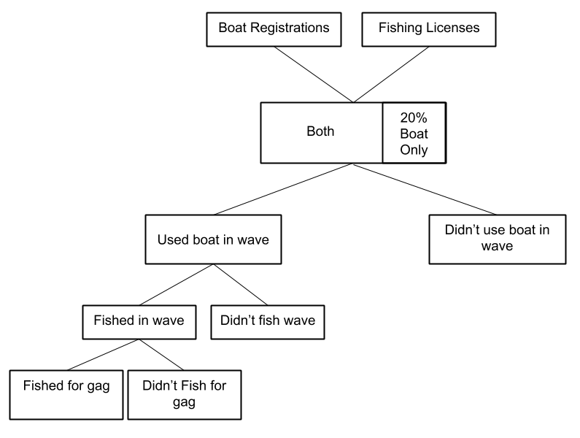
Figure 1: Overview of Sampling Strategy

Record Matching and Sampling Schedule
We matched, by exact address and telephone number, the FBO sample to the list of anglers in Hillsborough and Pinellas counties who were licensed to participate in saltwater fishing in Florida at the beginning of November 2018. After the matching was completed, we sub-sampled within the unmatched addresses at a rate needed to achieve target sample sizes.
The FBO list and FLSA were matched on full name and full address. There were 21 records from the FBO without a clear match in the FLSA. In these cases there were two distinct people on the FLSA with the same name and address as the FBO, but different ages. Phone numbers and email addresses were not helpful in distinguishing which of the duplicate FLSA records matched the FBO list. For the final sample we randomly selected one of the licensees.
The first FBFS sampling strategy was an email-contact web survey with the invitation email sent in the last week of January 2019. Reminder emails were sent 3, 6, and 13 days after the initial email.
The second FBFS sampling strategy used a mixed-mode, mail-push web survey approach, including a prenotice letter, an incentive with the URL letter, and 2 mail follow-ups with the final a paper copy of the pilot survey included in the final mailing (Messer and Dillman 2011 and Dillman 2017). The prenotice letter (first contact) was sent during the third week of December 2018. The survey invitation (second contact) was supposed to be mailed during the first week of January 2019. However, this was delayed until the last week of January 2019 due to a Federal Government shutdown. The survey invitation contained a letter with a URL address for a web survey, a unique code that identifies each respondent (address), and a $2 incentive. Research suggests that the incentive can significantly increase response rates in the mail web-push strategy (Messer and Dillman 2011). The respondents were instructed to go to the URL, enter their unique code and complete the pilot survey. Based on Messer and Dillman (2011) we expected about 60% of final returns (188*0.6 = 113) to occur after the first mailing (second contact). A thank you/reminder postcard (third contact) was sent 2 weeks after the invitation letter was mailed. The reminder postcard also had the URL and the unique code. Contacts who still did not respond online within 3 weeks of the reminder postcard were be sent (forth contact) a paper copy of the pilot survey and a business reply envelope along with a letter including the URL and unique code.
Table 1: Survey Schedule
Item | Date | Addresses
Prenotice letter (mail contact mode only) | 12/21/18 | 626
Email invitation with URL | 1/28/18 | 1,250
Letter with $2 incentive, URL, and unique respondent id code | 1/29/19 | 624
Email reminder 1 with URL | 1/31/19 | 1155
Email reminder 2 with URL | 2/3/19 | 1103
Email reminder 3 with URL | 2/10/19 | 1060
Reminder/Thank you postcard with URL, and unique respondent id code | 2/12/19 | 624
Letter with paper survey, URL, and unique respondent id code (to addresses who have not responded to the web survey | 2/26/19 | 493

Pilot Study Results

Summary of Returns
The data collection took place from January to March 2019. Figure 2 shows the returns over time by contact mode. The key contact dates are also shown in the figure as vertical lines where green lines indicate email invitation or reminder dates and the red lines indicates dates when mail contacts were made. The responses over time fit the typical pattern of spikes just after contact dates in the case of emails and a few days after contact dates in the case of mail contacts. The responses per day rapidly declines following the initial spikes.

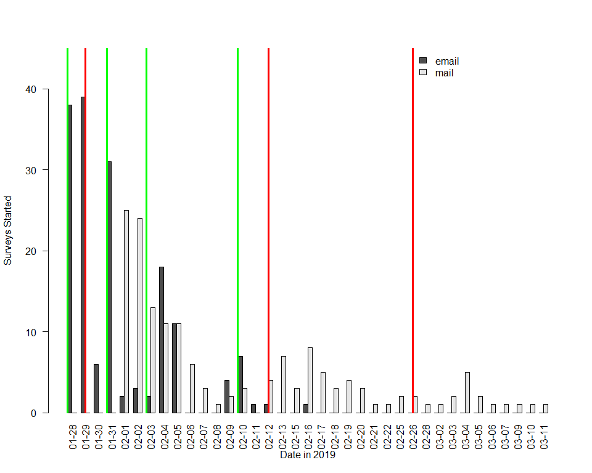
Figure 2: Returns Over Time by Contact Mode: The green and red lines are email and mail events, respectively.

The sample allocation among FBO records with FLSA matches and those with and without emails is shown in Table 2 along with the actual returns and completes for each sample category. Note that we show the population not included in the sample as a reminder that the sample does not cover the complete population of FBO or license lists. This number is based on the total number of 16 to 110 foot recreational boat registrations in Hillsborough and Pinellas counties during 2018 (57,963). Also, the ‘expected’ population numbers shown in the table are “guesses” we made before obtaining the FBO by applying the assumed FBO-license match rate (0.55) and the assumed share of records with email addresses (0.4) to the (57,963) count.
Note that there were only 125 boat registration records that had a saltwater fishing license, but did not have an email address which was not enough to draw the requisite 502 from this strata. As a result we used all 125 records and then drew 377 from the 846 remaining records (1,847-1,001) after the license-with-email strata was sampled.
Table 2: Expected and Actual Sample Allocation for Hillsborough and Pinellas Counties
Selected Boats | Match | Email | Expected Population | Actual Population | Sample | Expected Returns | Actual Returns | Completes
Yes | Yes | Yes | 12,752 | 1,847 | 1,001 | 100 | 165 | 146
Yes | Yes | No | 19,128 | 125 | 502 | 151 | 191 | 186
Yes | No | Yes | 10,433 | 1,744 | 250 | 25 | 20 | 18
Yes | No | No | 15,650 | 1,178 | 125 | 38 | 50 | 47
No | Any | Any | 0 | 53,069 | 0 | 0 | 0 | 0
 |  |  | 57,963 | 57,963 | 1,878 | 313 | 426 | 397
We obtained more returns than expected overall and in every strata, except the registered boaters without a fishing license who received the survey via email-only contact. The breakdown of responses by source and disposition is shown in Table 3. Very few emails or mail addresses bounced or were returned as invalid. Also, more than 90% of respondents who started the survey actually completed.
Table 3: Summary of Sampling Results by Mode of Contact
 | Email | Mail | Total
Sent | 1251 | 626 | 1877
Bounced | 45 | 2 | 47
Delivered | 1206 | 624 | 1830
Returns | 185 | 241 | 426
Completes | 164 | 233 | 397

Are the actual response rates at least as high as the expected response rates?
We expected a response rate of 0.1 for the email-only strategy, 0.3 for the mail web-push strategy, and an overall response rate of 0.17. Table 4 shows the actual response and complete rates calculated by dividing the returns and completes, respectively, by the number of delivered surveys by mode of contact. Consistent with the results in Table 2, both the email-only contact and mail-push strategy response rates were higher than expected. Overall, we achieved the overall response rate goal for both general responses and completes. For reference, Table 5 shows the results calculated for the entire sample using the AAPOR standard definitions for response, cooperation, refusal, and contact rates. The numbers in the table refer to the numbered definitions shown in the section titled “Calculating Outcome Rates from Final Disposition Distributions” on pages 61 through 65 in the AAPOR Standard Definitions report (AAPOR 2016).
Table 4: Response and Complete Rate by Mode of Contact
 | Email | Mail | Total
Response | 0.153 | 0.386 | 0.233
Completes | 0.136 | 0.373 | 0.217
Table 5: AAPOR Rates
 | Rate
Response 1 | 0.208
Response 2 | 0.224
Response 3 | 0.208
Response 4 | 0.224
Response 5 | 0.208
Response 6 | 0.224
Cooperation 1 | 0.214
Cooperation 2 | 0.229
Cooperation 3 | 0.214
Cooperation 4 | 0.229
Refusal 1 | 0.752
Refusal 2 | 0.752
Refusal 3 | 0.752
Contact 1 | 0.975
Contact 2 | 0.975
Contact 3 | 0.975

Is the avidity respondents in the pilot study the same as the average avidity in the study area?
The pilot survey collected information about boating and fishing activity from 397 people during November and December of 2018 in the Gulf of Mexico. Respondents were asked how many days they used their boat and how many days they used their boat for fishing. The average number of days fished in November and December of 2018 is 2.8 over all respondents and 5.1 days over respondents who took at least one fishing trip during this period. Note we don’t know whether the 125 respondents who did not use their boat in the Gulf of Mexico during November and December of 2018 ever use their boat to fish. Therefore, we omitted these respondents from the fishing avidity calculations. The 32 respondents who used their boat in the Gulf of Mexico during November and December of 2018 without fishing and indicated that they don’t usually fish from their boat were also omitted from the fishing avidity calculations.
It is difficult to find an existing avidity estimate that corresponds with the same population and time period that the FBFS pilot study covered. MRIP does not produce official avidity estimates. However, the MRIP Fishing Effort Mail Survey (FES) asks about how many days respondents went recreational saltwater fishing from a private or rental boat in Florida (and other coastal states) during November and December of 2019 (and other periods). Based on answers to this question, Rob Andrews at the MRIP provided an estimate of 3.48 boat trips for anglers (including kids) in Florida who took at least one boat trip and who live in households with either a registered boat or a someone with a fishing license. This estimate is lower than the estimate generated from the pilot study, possibly, because the FES samples from the general household address frame in all counties in FL while the pilot study only sampled from Tampa and Hillsborough counties. Anglers in these two coastal counties are likely to fish more in marine waters than anglers in the interior.
There is also a question on the MRIP dockside intercept survey that asks how many trips the respondent took in the previous 2-months. An average over the responses to this question during January and February of 2019 for anglers fishing in the GOM from WFL could approximate the mean avidity estimate for November and December of 2018 for those who took at least one trip. As of this writing, the MRIP intercept data for January and February of 2019 is not available. Based on the data from January and February of 2018, the mean avidity is 9.5 days fished. This number is considerably higher than the estimate from the FBFS pilot study data. The problem of avidity bias is well known in intercept surveys like the MRIP dockside interview (Thomson 1991).

Is gag grouper fishing prevalence in the pilot study at least as large as the assumed prevalence in the study area?
One of the main objectives of the FBFS is to collect information about gag grouper fishing from private boat anglers. A relatively high prevalence gag grouper fishing rate among survey respondents makes obtaining gag grouper fishing information more efficient, i.e. more responses are directly related to the main survey objective.
We assumed that 16% of anglers from Hillsborough and Pinellas counties are associated with gag grouper. This estimate was actually based on the prevalence of gag grouper trips among all trips in the MRIP for Florida anglers who took at least one trip. The 191 respondents in the pilot study survey who took at least one fishing trip in the Gulf of Mexico during November and December of 2018 took an average of 5.1 trips. The average number of gag grouper trips for these respondents was 2.7 giving gag grouper trip prevalence of 0.55. This prevalence is more than 3 times the assumed rate for the sample based on the MRIP data which is to be expected because the MRIP estimate is prevalence among Florida trips from the top gag grouper counties to anywhere off the Florida coast. Whereas, the pilot study gag grouper trip prevalence is among only trips from Pinellas and Hillsborough counties to the Gulf of Mexico.
For the FBFS we are actually interested in the prevalence of gag grouper anglers (i.e., those who take gag grouper trips) in the sample frame. We were not able to calculate this prevalence using the MRIP data so we reported the prevalence of gag grouper trips among all trips as noted in the previous paragraph. However, with the pilot survey data we can calculate the prevalence of gag grouper anglers among the entire sample frame and among those who took at least one fishing trip. Roughly, 32% of all survey respondents and 67% of those who took at least one fishing trip, fished for gag grouper in November and December of 2018. Going forward, then, the most appropriate prevalence to use for sampling purposes would be the rate of 32% which suggests that every 3rd sampled respondent will be a gag grouper angler. This new gag grouper angler prevelance estimate will significantly reduce the required overall sample size to achieve the target sample size of anglers to answer the gag grouper fishing questions. The higher prevalence rate in the pilot study resulted in 128 usable responses for the gag grouper portion of the survey which is more than double the 50 observation target for the pilot study.

Are there unusual patters in the contingent behavior questions?
We are primarily interested in respondents who used their boat for fishing so the results in this section will focus on the 191 responses in this subset. The remaining respondents either did not fish from their boat during November or December or did not use their boat at all during this period. There are two types of contingent behavior (CB) questions in the pilot study survey. The first type of CB questions were designed to measure how anglers would behave if trip costs changed, i.e. to determine how many trips they would take during November and December under different trip cost scenarios. The second type of CB questions were intended to measure how anglers would behave if the bag limits gag grouper were different than they experienced in November and December of 2018. The full set of scenarios are summarized in Table 6 where the first row represents actual conditions in November and December of 2018, the second two rows represent the cost (price) scenarios, and the last three rows represent the gag grouper bag limit scenarios.
The first cost scenario asks for the number of trips if the cost doubles and the second cost scenario asks for the number of trips if the cost halves. According to the law of demand, the number of trips stated when trip cost doubles should be lower than the number of trips stated in the base scenario. The opposite should be true when the trip cost is cut in half. We can examine the pilot study responses to determine if these results hold on average. The average actual number of fishing trips taken in the Gulf of Mexico during November and December of 2018 was 5.1 days for respondents who took at least one trip. The average number of days fished at double the actual cost was 3.1 and was 6.7 days at half the actual cost, suggesting that the results are consistent with the law of demand. Furthermore, there were no respondents who stated more trips at double the cost (0) or fewer trips at half cost (0.0052).
Checking the consistency of the bag limit scenarios is more complicated because there is no clear theory regarding the direction of change in the number of trips in response to bag limit changes (Woodward and Griffin 2003). If, however, we assume that more fish are preferred to fewer fish and that there is no (reasonable) limit on the number of fish that anglers want during the study period, then we would expect more (fewer) trips to be stated at higher (lower) bag limits. The actual bag limit during November and December of 2018 was 2 gag groupers and anglers fished 5.1 days on average. The average stated number of trips was 6.3 days with the 3 fish bag limit, 4.1 days with the 1 fish bag limit, and 2.8 days with the 0 fish bag limit (closed season). These results are consistent with the hypothesis that trip quality is positively related to the gag grouper bag that anglers take more (fewer) trips as the quality of each trip increases (decreases).

Table 6: Trip Scenarios
Scenario | Price ($p$) | Trips ($d$) | Bag ($r$)
Base (Actual) | p0 | r0 | 2
Double price | p1=p0*2 | r1 | 2
Half price | p1=p0/2 | r2 | 2
Bag 3 | p0 | r3 | 1
Bag 1 | p0 | r4 | 3
Bag 0 (closed) | p0 | r5 | 0

Are there item nonresponse issues for any of the survey questions?
All questions were required in the internet version of the survey. Therefore, the respondent had to enter a response to continue with the survey. The 78 respondents who returned the paper version of the survey could skip questions. There do not seem to be any questions that suffered consistent nonresponse. Table 7 shows the count of the 191 respondents not answering each question in the fishing portion of the survey. The last three rows of the table show 87 missing values. This is the number of fishing respondents who did not target gag grouper in the Gulf of Mexico during November and December of 2018. These respondents were not asked the series of three bag limit contingent behavior questions.
Table 7: Number of Missing Values for Key Variables in the Sample of Fishers
 | missing
Nov-Dec Days Fished | 0
Cost of Typical Trip ($) | 0
People on a Typical Trip | 0
Duration of Typical Trip (Hours) | 0
Annual Income ($000) | 0
Days Boated without Fishing | 0
Days Fished with Cost Doubled | 0
Days Fished with Cost Halved | 0
Target Gag Grouper | 0
Days Fished with 3 Fish Bag Limit | 87
Days Fished with 1 Fish Bag Limit | 87
Days Fished with 0 Fish Bag Limit | 87

Are the averages for key survey variables the same between the email-only and mail-push contact Modes?
The results in this section also focuses on the 191 respondents who used their boat for fishing. As described above, two approaches were used to recruit respondents for the pilot survey. The email-only approach invited responses and sent three reminders all via email. The mail-push approach used a prenotice letter; an invitation letter with a $2 incentive, code, and URL; a postcard reminder; and a paper survey follow-up. The mail-push approach represents the state-of-the-art in mixed-mode surveys that involve web and paper surveys. However, the mail push is also more expensive than the email-only approach. It makes sense to compare the responses between these two approaches.
Table 8 shows the means and t-tests of significant differences between key variables and important calculated measures for the two contact approaches in the pilot study. A detailed discussion of the estimates is beyond the scope of this pilot study summary. Here we simply highlight any significant differences between the two contact approaches as indicated by the p.value in the final column of the table.
The first six rows are direct responses to questions in the survey. The reported mean number of days fished in the Gulf of Mexico during November and December of 2018 is not statistically different between the two contact modes. However, the average cost of a typical trip reported by email and mail contact samples is statistically different at the .10 significance level. Indeed, the mean cost of a typical trip reported email-contact respondents is more than 25% higher than the mean cost of a typical trip reported by mail-contact respondents. Other typical trip characteristics (people and duration), angler income, and days boated without fishing are not statistically different between the two contact modes.
Mail-contact respondents also appear more than twice as likely on average to change the reported number of days fished in response to changes in trip costs (row 7). This difference is statistically significant at less than the .01 level. However, the expected number of trips with the trip cost doubled was only statistically different between the email only and mail contact modes at the .10 significance level and there was not a significant difference in the expected number of trips with the trip cost halved between the two contact modes.
We also calculated the arc price elasticity of trip demand based on the days reported with the doubling and halving trip cost questions. Price elasticitiy of trip demand measures the percent change in the number of trips taken for each percent change in trip cost. Mathematically, the price (arc) elasticity of demand is given by $(cost_{0}+cost_{1})/(trips_{0}+trips_{1})⋅(trips_{0}-trips_{1})/(cost_{0}-cost_{1}))$ where the subscripts 0 and 1 denote the base levels and the new levels, respectively. Those contacted via email only were nearly twice as responsive to price changes as those contacted via mail. However, the difference in price elasticity between contact modes is only statistically significant for the measure based on doubling trip cost.
There is no statistically significant difference between contact modes for the mean values of the remaining variables in the table. These variables include the choke prices (calculated by the survey software) based on their response to trip cost scenario questions and an assumed linear demand equation. The choke price is the level of trip cost beyond which the angler would not use their boat for fishing which, in a linear demand equation, is the y-axis intercept of the line.
Also, among the remaining variables in the table is the share of anglers who said that they would still fish when presented with the calculated choke price. If trip demand were truly linear in prices, then we would not expect any anglers to still take trips at the choke price presented. As it is, less than a third of respondents (in both contact modes) said that they would still take a trip at the choke price. The information regarding the estimated change in trips taken in response to changes in trip cost is summarized in Figure 3 where there are two linear demand lines shown. The figure illustrates another way the data can be used and displayed. Full discussion of the figure is beyond the scope of this report.

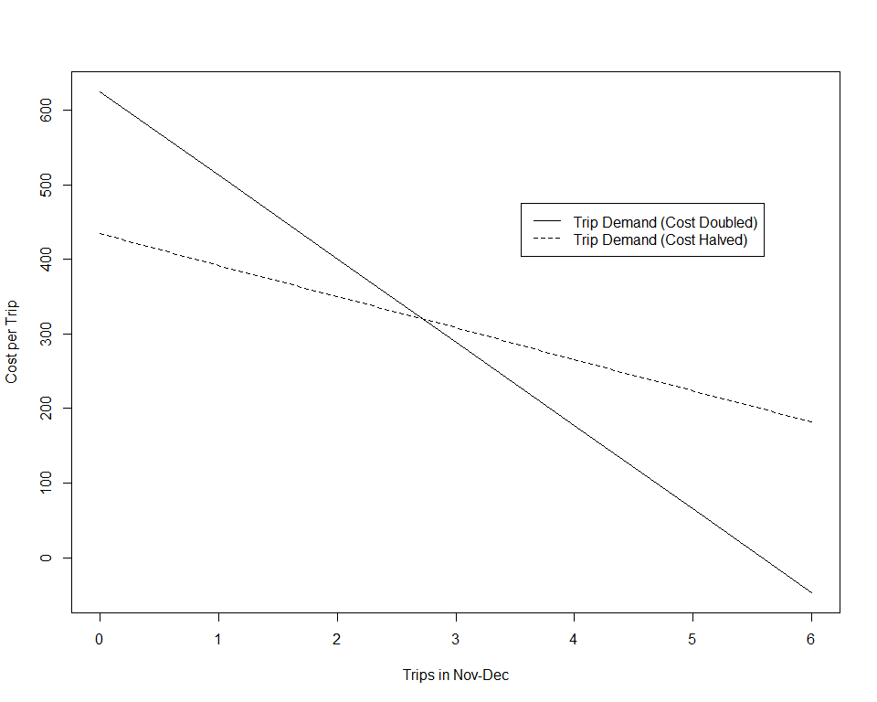
Figure 3: Linear Trip Demand based on the Cost Doubling and Cost Halving Contingent Behavior Questions (Full Sample)

The last four rows in the table relate to gag grouper fishing. Row 15 shows the share of fishers who targeted gag grouper in November and December of 2018. For gag grouper anglers, the final 3 rows show the number of days that they would fish with a 3, 1, or 0 fish bag limit instead of the 2 fish bag limit actually in effect at the time.
Table 9 shows the summary statistics over the entire sample. The variables are defined in Table 10. Note that the missing values for the choke price variables occur for the cases where the respondent reported no change in the number of trips they would take with a change in cost (doubled or halved). In these cases, the choke price cannot be calculated.
Table 8: Difference Between Email and Mail Contact Samples on Key Variables
 | Email | Mail | Difference | Statistic | P.value
Nov-Dec Days Fished | 5.14 | 5.08 | 0.06 | 0.10 | 0.92
Cost of Typical Trip ($) | 212.34 | 200.71 | 11.63 | 0.35 | 0.73
People on a Typical Trip | 3.12 | 3.14 | -0.03 | -0.16 | 0.87
Duration of Typical Trip (Hours) | 6.95 | 7.00 | -0.05 | -0.13 | 0.90
Annual Income ($000) | 165.05 | 155.88 | 9.18 | 0.70 | 0.48
Days Boated without Fishing | 2.23 | 2.82 | -0.59 | -1.11 | 0.27
No Price Response | 0.21 | 0.39 | -0.18 | -2.73 | 0.01
Days Fished with Cost Doubled | 2.74 | 3.41 | -0.67 | -1.71 | 0.09
Days Fished with Cost Halved | 6.78 | 6.54 | 0.24 | 0.33 | 0.74
Arc Elasticity (Doubled) | -1.10 | -0.70 | -0.41 | -2.87 | 0.00
Arc Elasticity (Halved) | -0.41 | -0.34 | -0.07 | -0.95 | 0.35
Linear Choke Price (Doubled) | 568.94 | 696.47 | -127.53 | -1.08 | 0.28
Linear Choke Price (Halved) | 429.35 | 439.75 | -10.40 | -0.11 | 0.91
Share Fishing at Choke (Web only) | 0.21 | 0.15 | 0.07 | 1.20 | 0.23
Share Targeting Gag Grouper | 0.72 | 0.62 | 0.10 | 1.54 | 0.12
Days Fished with 3 Fish Bag Limit | 6.52 | 6.09 | 0.43 | 0.49 | 0.63
Days Fished with 1 Fish Bag Limit | 3.93 | 4.26 | -0.33 | -0.47 | 0.64
Days Fished with 0 Fish Bag Limit | 2.83 | 2.83 | 0.00 | 0.00 | 1.00
Table 9: Summary Statistics for Key Variables for the Fishers
 | N | Missing |  | Mean | SD |  | Min | Q1 | Median | Q3 | Max
Nov-Dec Days Fished | 191 | 0 |  | 5.11 | 3.75 |  | 1 | 2.00 | 4.00 | 7.0 | 20
Cost of Typical Trip ($) | 191 | 0 |  | 206.43 | 230.53 |  | 10 | 70.00 | 140.00 | 260.0 | 1600
People on a Typical Trip | 191 | 0 |  | 3.13 | 1.16 |  | 1 | 2.00 | 3.00 | 4.0 | 8
Duration of Typical Trip (Hours) | 191 | 0 |  | 6.97 | 2.80 |  | 1 | 5.00 | 7.00 | 8.0 | 30
Annual Income ($000) | 191 | 0 |  | 160.39 | 90.16 |  | 10 | 90.00 | 125.00 | 300.0 | 300
Days Boated without Fishing | 191 | 0 |  | 2.53 | 3.68 |  | 0 | 0.00 | 1.00 | 4.0 | 20
No Price Response | 191 | 0 |  | 0.30 | 0.46 |  | 0 | 0.00 | 0.00 | 1.0 | 1
Days Fished with Cost Doubled | 191 | 0 |  | 3.08 | 2.71 |  | 0 | 1.00 | 2.00 | 4.0 | 15
Days Fished with Cost Halved | 191 | 0 |  | 6.65 | 4.96 |  | 1 | 3.00 | 5.00 | 9.0 | 30
Arc Elasticity (Doubled) | 191 | 0 |  | -0.90 | 0.99 |  | -3 | -1.29 | -0.69 | 0.0 | 0
Arc Elasticity (Halved) | 191 | 0 |  | -0.38 | 0.52 |  | -2 | -0.73 | 0.00 | 0.0 | 1
Linear Choke Price (Doubled) | 117 | 74 |  | 624.53 | 594.27 |  | 70 | 200.00 | 450.00 | 800.0 | 3200
Linear Choke Price (Halved) | 86 | 105 |  | 434.19 | 422.62 |  | 0 | 150.00 | 300.00 | 530.0 | 2100
Stated Choke Price (Paper only) | 19 | 172 |  | 485.79 | 522.11 |  | 40 | 150.00 | 300.00 | 500.0 | 2000
Share Fishing at Choke (Web only) | 190 | 1 |  | 0.18 | 0.38 |  | 0 | 0.00 | 0.00 | 0.0 | 1
Share Targeting Gag Grouper | 191 | 0 |  | 0.67 | 0.47 |  | 0 | 0.00 | 1.00 | 1.0 | 1
Days Fished with 3 Fish Bag Limit | 104 | 87 |  | 6.33 | 4.53 |  | 1 | 3.00 | 5.00 | 8.0 | 22
Days Fished with 1 Fish Bag Limit | 104 | 87 |  | 4.08 | 3.53 |  | 0 | 2.00 | 3.00 | 5.5 | 15
Days Fished with 0 Fish Bag Limit | 104 | 87 |  | 2.83 | 3.11 |  | 0 | 1.00 | 2.00 | 4.0 | 14
Table 10: Definitons for Key Variables for the Fishers
Variable | Definition
Nov-Dec Days Fished | Number of days fished
Cost of Typical Trip ($) | Total cost of a typical trip
People on a Typical Trip | Number of people on a typical trip
Duration of Typical Trip (Hours) | Dock-to-dock hours of a typical trip
Annual Income ($000) | Annual household income before taxes
Days Boated without Fishing | Number of days boat used without fishing
No Price Response | The number trips reported does not change with changes in trip cost
Days Fished with Cost Doubled | The number of days fished if trip cost doubled
Days Fished with Cost Halved | The number of days fished if trip cost halved
Arc Elasticity (Doubled) | Percent change in trips with each percent change in trip cost based on the doubled cost
Arc Elasticity (Halved) | Percent change in trips with each percent change in trip cost based on the halved cost
Linear Choke Price (Doubled) | Calculated trip cost at which no trips would be taken based on the doubled cost
Linear Choke Price (Halved) | Calculated trip cost at which no trips would be taken based on the halved cost
Stated Choke Price (Paper only) | Stated trip cost at which no trips would be taken based (Paper only)
Share Fishing at Choke (Web only) | Share respondents who stated that they would still fish a the calculated choke price (Web only)
Share Targeting Gag Grouper | Share of respondents who targeted gag grouper
Days Fished with 3 Fish Bag Limit | The number of days fished if the bag limit was 3 fish
Days Fished with 1 Fish Bag Limit | The number of days fished if the bag limit was 1 fish
Days Fished with 0 Fish Bag Limit | The number of days fished if the bag limit was 0 fish

Data Analysis: Trip Demand Model

Background
There are many studies related to the value of recreational fishing (see Johnston et al, 2006 for a review). The literature on saltwater recreational fishing in the Southeast US (South Atlantic or Gulf of Mexico) includes studies on reef fish species, typically red snapper, groupers as a general category, or coastal pelagics (king mackerel, dolphinfish). This body of research has focused on estimating angler WTP by species and/or quantities of fish caught per trip (Carter and Liese, 2012; Gillig et al (2003) Haab et al 2012; Hindsley et al 2011; Lovell and Carter 2014).
Very little research focuses on predicting changes in recreational fishing behavior in the Southeast US. Whitehead et al (2011) investigate how anglers would change number of charter trips they take in North Carolina in response to hypothetical changes in the combined snapper-grouper bag limits, and bag limits for King Mackerel. While this work deals with bag limits for snapper-grouper species it is unlikely that the estimates are strictly applicable to gag grouper fishing in the Gulf of Mexico. Cross-study comparisons suggest that economic measures related to recreational fishing cannot be easily transferred from one study area or mode (charter, shore, private boat, etc.) of fishing to other contexts (Johnston et al. 2006).
Gillig et al (2000) estimated changes in effort based on changes in estimated catch, but only focused on red snapper. The trip cost and catch elasticities were estimated from a survey of anglers from 1991 who fished at sites across the Gulf of Mexico. Gillig et al (2003) extends their analysis on this same dataset to examine the impact of the revealed preference data on the overall willingness to pay using their combined stated-preference and revealed preference model. Given many changes in regulations and stock abundance during the intervening 27 years, there is a strong possibility that angler behavior and preferences with regard to red snapper and reef fish in general may have changed as well. Therefore, this work cannot reliably be used to predict current changes in fishing for gag grouper in the Gulf of Mexico.
Other related research examines the potential changes in Florida coastal recreational activity anticipated with changes in costs and quality (e.g. Bhat 2003 (marine reserves), Park et al. 2002 (snorkeling), Thomas and Stratis 2002 (boating), Milon 1988 (preferences of anglers for natural versus artificial reef habitats). A more recent study by Whitehead et al. estimated a single site travel cost model to estimate the effects of the lost recreational use values from the Deepwater Horizon oil spill on all cancelled recreational trips to northwest Florida, including uses other than fishing.
In summary, our literature review did not find any research directly useful to the objective of our proposed research which is to estimate the magnitude of potential changes (elasticities) in private boat recreational fishing effort for gag groupers in Florida associated with changes in regulations (e.g. catch) or trip costs. Given over 80% of trips from West Florida for gag grouper are from private boat anglers, there is need for more current research that is tailored to this specific mode and that can estimate how changes in bag limits or trip costs influence the number of trips taken.

Model
Following Alberini et. al. (2007) we use a single-site travel cost model recreational fishing in the Gulf of Mexico. Specifically, we assume that an angler chooses fishing trips, $d$ and a numeraire good, $X$ to maximize utility subject to a budget constraint or $max_{X,d}$ $U(X,d)$ $s.t.$ $y=X+d⋅p$ where $y$ is income, the price of the numeraire good is set to one, and $p$ is the cost per fishing trip. We further assume that fishing trips are a function of fishing quality, $h$, which is itself a function of fishing regulations, $r$, i.e., $d=d(q(r))$. Fishing trips and quality are weak complements such that $∂U/∂q=0$ if $d=0$, i.e. the individual does not care about quality of fishing if he or she does not fish. The number of trips is an increasing function of fishing quality, $∂d/∂q>0$.
The solution to the angler problem yields the demand function for trips, $d=d(y,p,r)$. In our empirical work, we assume that the for demand function based on data from angler $i$ in scenario $j$ is linear in its arguments
- $d_{ij}=βz_{i}+γp_{ij}+δr_{ij}+ϵ_{ij}$
where $z_{i}$ is a vector of angler characteristics, including an intercept and income; $β$, $γ$, and $δ$ are parameters to be estimated; and $ϵ_{ij}$ is an error term. The parameters can be estimated with data on $d_{ij}$, $p_{ij}$, $r_{ij}$, and $y_{i}$ for angler $i$ in scenario $j$.
We will have six observations on trips for respondents who complete the gag grouper portion of the pilot survey and 3 trip observations for all other anglers and boaters. The scenarios are summarized in Table 6. There are two sources of variation in the scenarios when collected for a set of anglers: (i) across anglers, and (ii) across scenarios within one angler. These sources of variation should be adequate to estimate the slope of the demand function, $γ$, and the effect, $δ$, of changes in the bag limit.
The observations on fishing trips for the scenarios are correlated within an individual if unobservable angler characteristics influence both actual fishing trips and the stated number of trips under the hypothetical scenarios. Therefore, we adopt a random-effects specification to combine the actual trips and trips under the hypothetical scenarios (e.g., Loomis (1997) and Alberini et. al. 2007). In this case we assume that $ϵ_{ij}=v_{i}+η_{ij}$, with $v_{i}$ a respondent-specific, zero-mean component, and $η_{ij}$ an i.i.d. error term. $v_{i}$ and $η_{ij}$ are uncorrelated with each other, across individuals, and with the regressors in the right-hand side of Eq. (1). The presence of the individual-specific component of the error term ($v_{i}$) result in correlated error terms $ϵ$ within a respondent. Specifically, $E(ϵ_{ij}ϵ_{ik})=σ_{v}^{2}$, where $σ_{v}^{2}$ is the variance of $v$, for $j≠k$, whereas the variance of each $ϵ_{ij}$ is $σ_{v}^{2}+σ_{η}^{2}$, with $σ_{η}^{2}$ being the variance of $η$.
For the purposes of this report we present preliminary estimates using OLS. We also estimate Poisson (Pois) and Negative Binomial (NB) count data regressions to address the discrete nature of the trip counts. Future work will examine Generalized Least Squares (GLS) and panel count data models to address the correlation among responses from the same respondent.
Though not reported in this document, the estimated parameters can be used to calculate elasticities that show the percent change in trips with a percent change in trip cost and the bag limit. For example, using the OLS estimator (linear demand), the trip cost elasticity of demand is given by $-γ(p_{0i}/d_{0i})$ and the bag limit elasticity of demand is given by $-δ(r_{0i}/d_{0i})$.
The estimated parameters can also used to calculate two welfare measures. The first captures the value of access and is the consumer surplus associated with current fishing conditions and prices. Using the OLS estimator (linear demand):
- $CS_{i}(p_{0i},r_{0i})=-(1/2γ)[z_{i}β+p_{0i}γ]^{2}$.
The second captures the value of changes in fishing regulations, and is the change in surplus due to an change in bag limits (holding the prices the same). Again, using the OLS estimator (linear demand):
- $CS_{i}(p_{0i},r_{1i})-CS_{i}(p_{0i},r_{0i})=-(1/2γ)[δ^{2}+2δ(z_{i}β+p_{0i}γ)]$.
Expressions for the elasticities and the two welfare measures are slightly different for the count data regressions (Pois and NB). We will show these expressions and report the results in future work.

Results
The results of four regressions are shown in Table 11. The first three regressions focus on the trip cost effect and use all complete observations on those who fished in November and December of 2018. The last regression only includes those fishers who targeted gag grouper. It is beyond the scope of this report to fully discuss the results in the table. We show results to demonstrate how the survey data will be used. On thing to note, however, is that the coefficient on the bag limit suggests that each change in the bag limit is associated with a 26% change in the number of days fished.
Table 11: Trip Demand Regressions for the Fishers
 | No Bag Limit - OLS | No Bag Limit - Pois | No Bag Limit - NB | Bag Limit - NB
Intercept | 3.685 *** | 1.330 *** | 1.310 *** | 0.374
 | (0.643) | (0.072) | (0.121) | (0.219)
Cost/Trip | -0.003 *** | -0.001 *** | -0.001 *** | -0.001 ***
 | (0.001) | (0.000) | (0.000) | (0.000)
Income/Year(00 0) | -0.002 | -0.000 | -0.000 | -0.001
 | (0.002) | (0.000) | (0.000) | (0.001)
People/Trip | 0.458 ** | 0.097 *** | 0.104 *** | 0.287 ***
 | (0.160) | (0.017) | (0.030) | (0.042)
Hours/Trip | 0.118 | 0.028 *** | 0.024 | 0.019
 | (0.070) | (0.008) | (0.013) | (0.024)
Bag Limit |  |  |  | 0.264 ***
 |  |  |  | (0.047)
N | 573 | 573 | 573 | 274
R2 | 0.049
logLik | -1616.707 | -1709.860 | -1467.613 | -671.673
AIC | 3245.414 | 3429.721 | 2947.225 | 1357.346
 | *** p < 0.001; | ** p < 0.01; * | p < 0.05.
References
Alberini, A., Zanatta, V. and Rosato, P., 2007. Combining actual and contingent behavior to estimate the value of sports fishing in the Lagoon of Venice. Ecological Economics, 61(2-3), pp.530-541.
American Association for Public Opinion Research (AAPOR). 2016. Standard Definitions: Final Dispositions of Case Codes and Outcome Rates for Surveys. 9th edition. AAPOR.
Brick, J.M., Andrews, W.R. and Mathiowetz, N.A., 2016. Single-phase mail survey design for rare population subgroups. Field Methods, 28(4), pp.381-395.
Carter, D.W. and C. Liese. The economic value of catching and keeping or releasing saltwater sport fish in the southeast USA. North American Journal of Fisheries Management, 32(4):613–625
Dillman, D.A., 2017. The promise and challenge of pushing respondents to the Web in mixed-mode surveys. Statistics Canada.
Gillig, D., Ozuna Jr, T. and Griffin, W.L., 2000. The value of the Gulf of Mexico recreational red snapper fishery. Marine Resource Economics, 15(2), pp.127-139.
Gillig, D., Woodward, R., Ozuna, T. and Griffin, W.L., 2003. Joint estimation of revealed and stated preference data: an application to recreational red snapper valuation. Agricultural and Resource Economics Review, 32(2), pp.209-221.
Haab, T., Hicks, R., Schnier, K. and Whitehead, J.C., 2012. Angler heterogeneity and the species-specific demand for marine recreational fishing. Marine Resource Economics, 27(3), pp.229-251.
Hindsley, P., Landry, C.E. and Gentner, B., 2011. Addressing onsite sampling in recreation site choice models. Journal of Environmental Economics and Management, 62(1), pp.95-110.
Johnston, R.J., Ranson, M.H., Besedin, E.Y. and Helm, E.C., 2006. What determines willingness to pay per fish? A meta-analysis of recreational fishing values. Marine Resource Economics, 21(1), pp.1-32.
Loomis, J.B., 1997. Panel estimators to combine revealed and stated preference dichotomous choice data. Journal of Agricultural and Resource Economics, pp.233-245.
Lovell, S.J. and Carter, D.W., 2014. The use of sampling weights in regression models of recreational fishing-site choices. Fishery Bulletin, 112(4).
Messer, B.L. and Dillman, D.A., 2011. Surveying the general public over the internet using address-based sampling and mail contact procedures. Public Opinion Quarterly, 75(3), pp.429-457.
NOAA. 2018 National Saltwater Recreational Fisheries Summit Report. URL https://www.fisheries.noaa.gov/national/recreational-fishing/2018-saltwater-recreational-fisheries-summit. Report prepared by the Meridian Institute. August 2018.
Thomson, C.J., 1991. Effects of the avidity bias on survey estimates of fishing effort and economic value. In American Fisheries Society Symposium (Vol. 12, No. 356366).
Wallen, K.E., Landon, A.C., Kyle, G.T., Schuett, M.A., Leitz, J. and Kurzawski, K., 2016. Mode Effect and Response Rate Issues in Mixed‐Mode Survey Research: Implications for Recreational Fisheries Management. North American Journal of Fisheries Management, 36(4), pp.852-863.
Whitehead, J.C., Dumas, C.F., Landry, C.E. and Herstine, J., 2011. Valuing bag limits in the North Carolina charter boat fishery with combined revealed and stated preference data. Marine Resource Economics, 26(3), pp.233-241.
Whitehead, J.C., Haab, T., Larkin, S.L., Loomis, J.B., Alvarez, S. and Ropicki, A., 2018. Estimating Lost Recreational Use Values of Visitors to Northwest Florida due to the Deepwater Horizon Oil Spill Using Cancelled Trip Data. Marine Resource Economics, 33(2), pp.119-132.
Whitehead, J., Haab, T. and Huang, J.C. eds., 2012. Preference data for environmental valuation: combining revealed and stated approaches (Vol. 31). Routledge.
Woodward, R.T. and Griffin, W.L., 2003. Size and bag limits in recreational fisheries: theoretical and empirical analysis. Marine resource economics, 18(3), pp.239-262.
U.S. Department of the Interior, U.S. Fish and Wildlife Service, and U.S. Department of Commerce, U.S. Census Bureau (USFWS and USCB). 2011 National Survey of Fishing, Hunting, and Wildlife-Associated Recreation.

