Appendix C – WebNEERS Data Entry Screenshots

Note: Although not shown in the screen shots that follow, the OMB number and expiration date is at the bottom of every webpage.



-----------------------------------------------------------------------------------------------------------

SCREENSHOT Table of Contents

- Adult Data Entry Screens……………………………………………………………………………….………………….1
- Youth Data Entry Screens…………………………………………………………………………….………………..….7
- Staff Data Entry Scores…………………………………………………………………………………………………….14
- Annual Budgets Data Entry Scores……………………………………………………………….………………….15
- Annual Program Plans Data Entry Screens………………………………………………………………………16

Recent developments to improve the system are highlighted with a blue box

-----------------------------------------------------------------------------------------------------------

- Adult Data Entry Screens
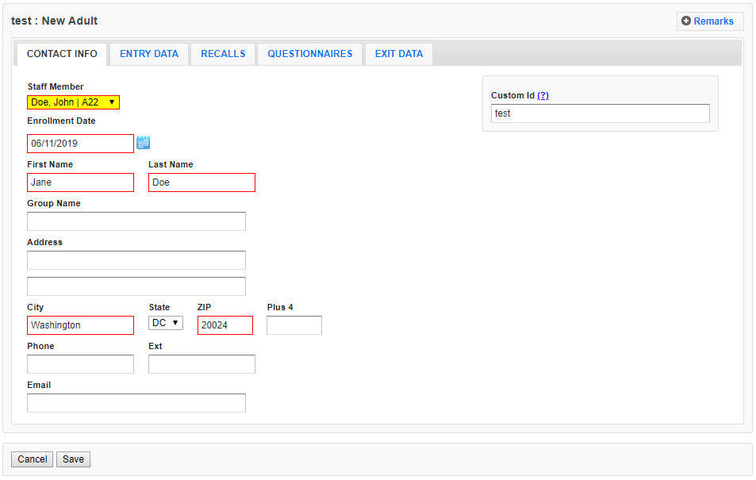

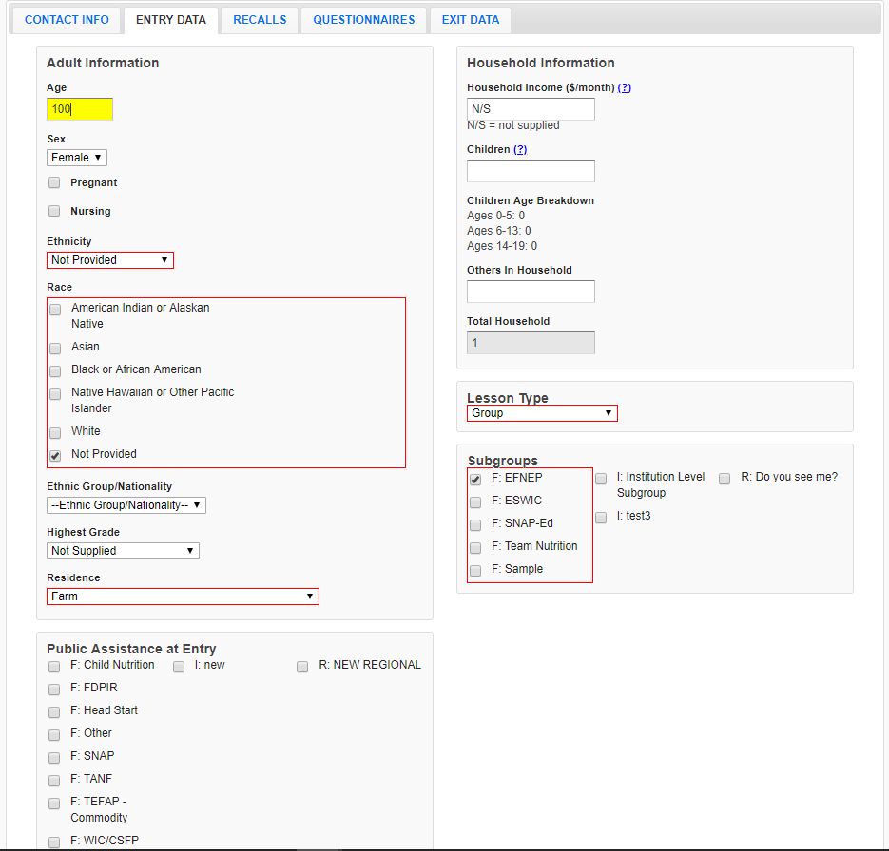

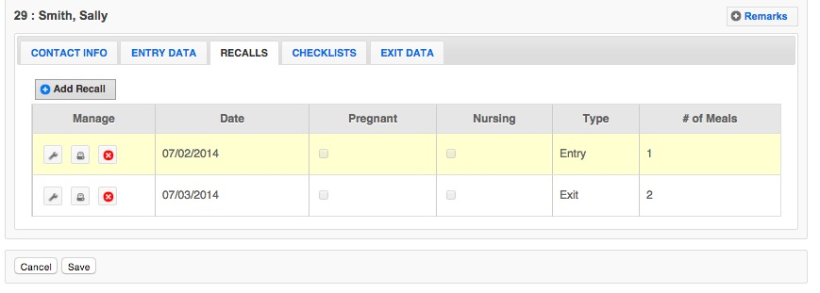

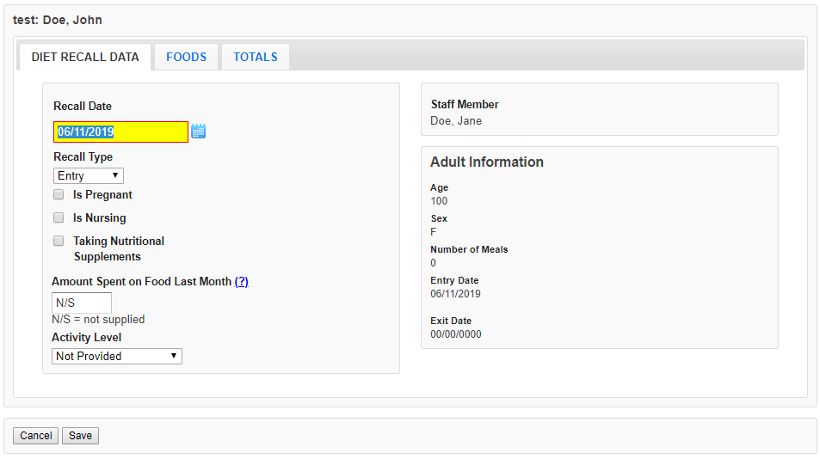

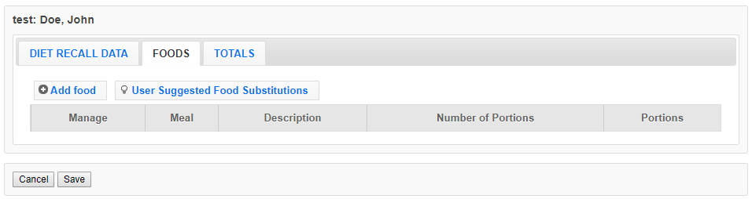
New algorithms have been created to reduce search time and improve the food recall data entry experience.
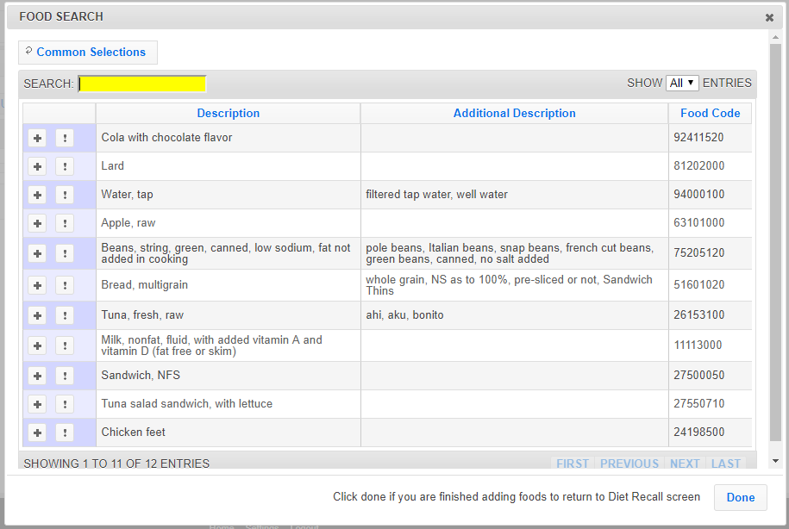

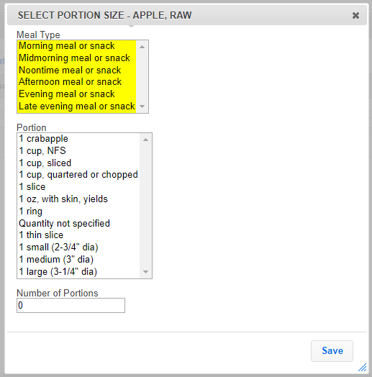
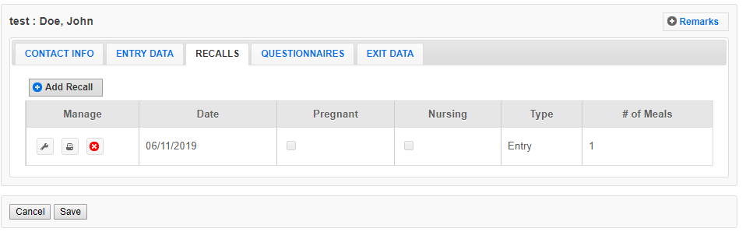

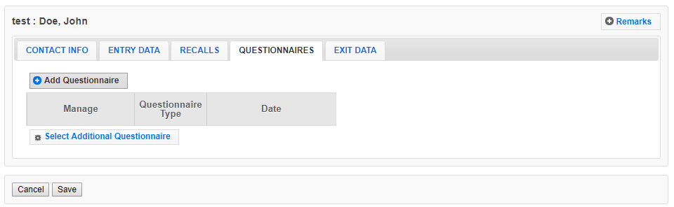
New 20-item evidence-based questionnaire has replaced the 20+ year old10-item behavior checklist. The questionnaire was developed by a multi-state research team and tested with program participants. It is more reflective of what is currently taught in EFNEP.
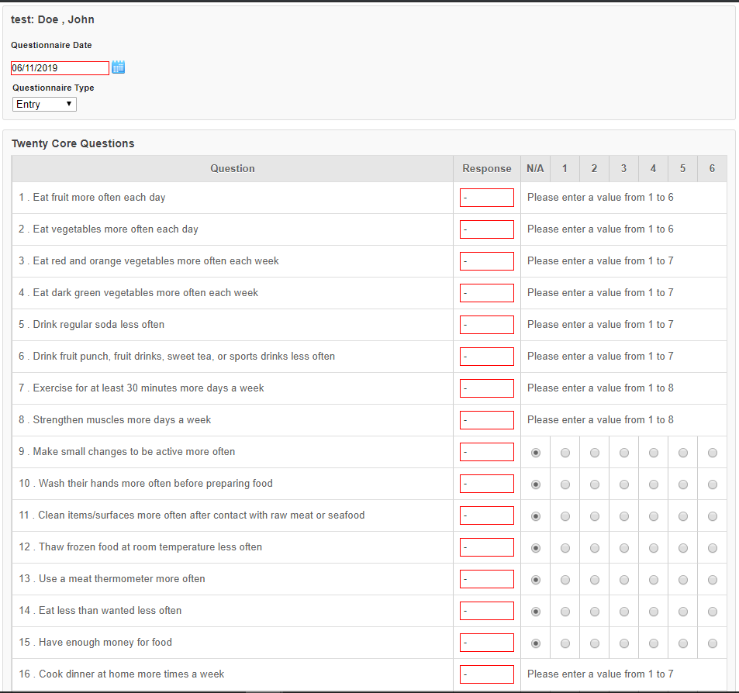
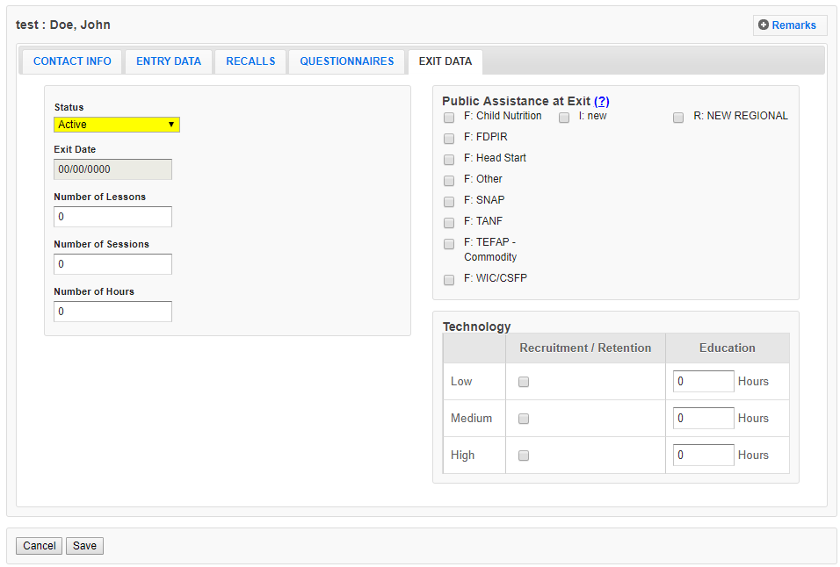

- Youth Data Entry Screens
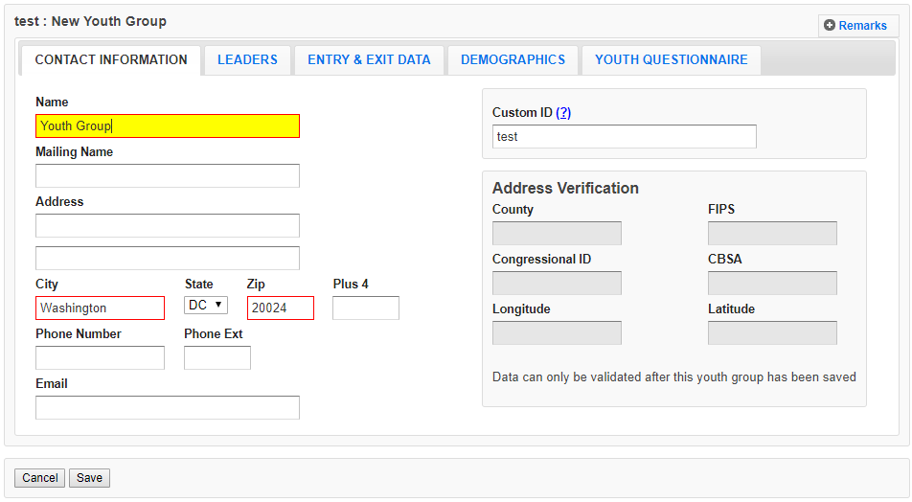

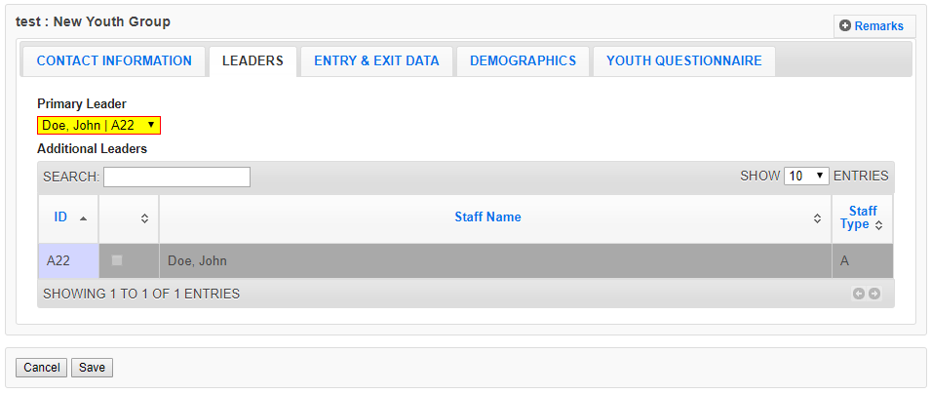

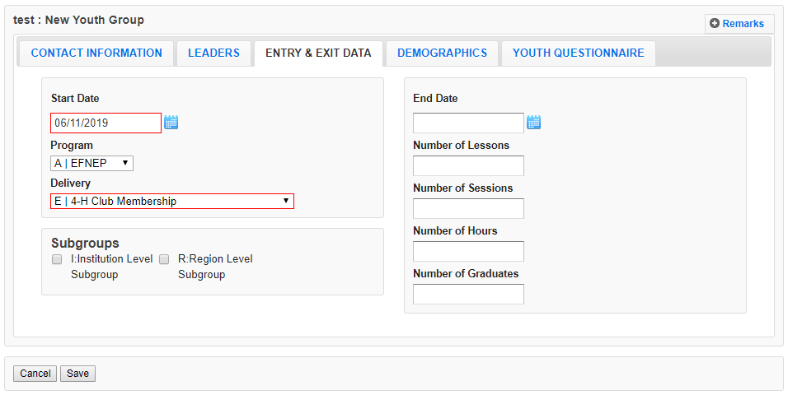

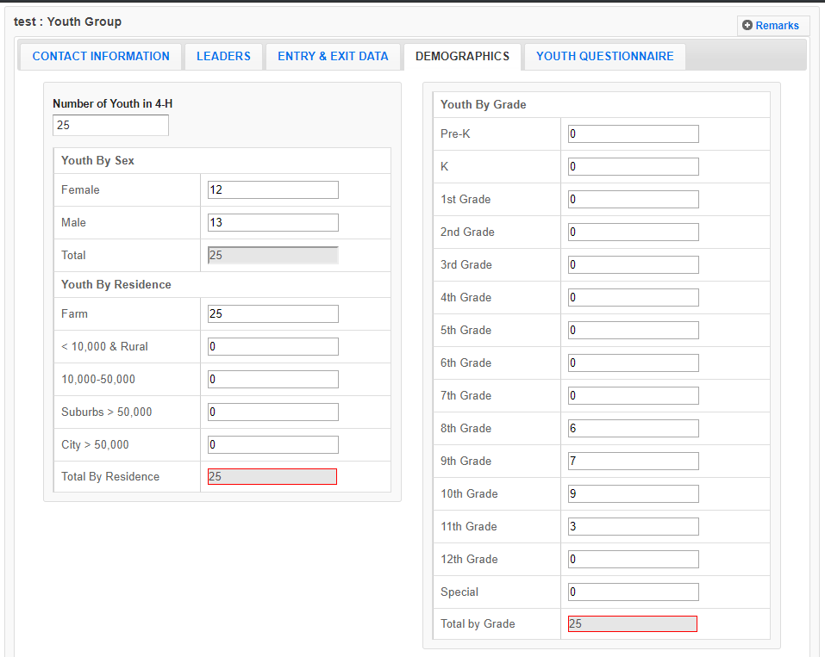

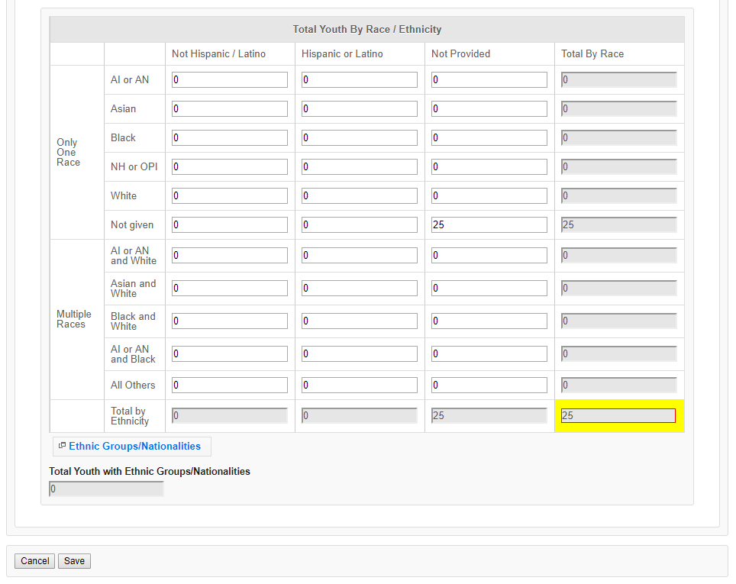

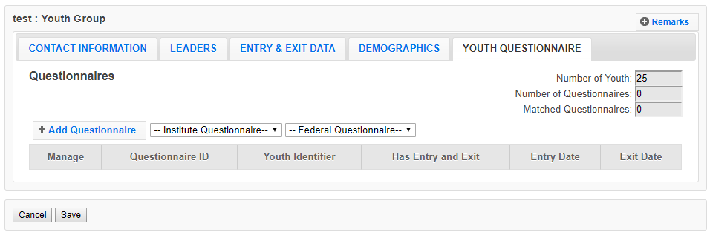

A youth evaluation research team has been reviewing, developing, testing and recommending new questions to replace previous questions used. K-2 questions were updated and implemented between FY 2013 and FY2015; 3-5 questions were updated and implemented between FY 2016 and FY 2019. Review and testing of 6-8 and 9-12 questions are underway at this time. Burden to participants should be the same or less, since the total number of questions has not changed, and since the current question align better with what is taught.

Note: Only one Questionnaire grade range is used for each youth participant. The screenshots below show the respective grade ranges – K-2nd, 3rd-5th, 6th-8th, and 9th-12th

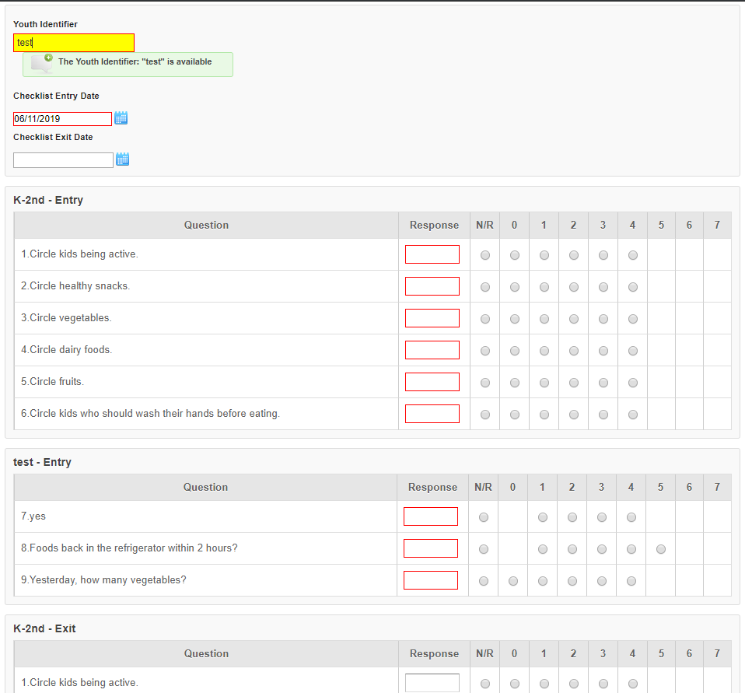
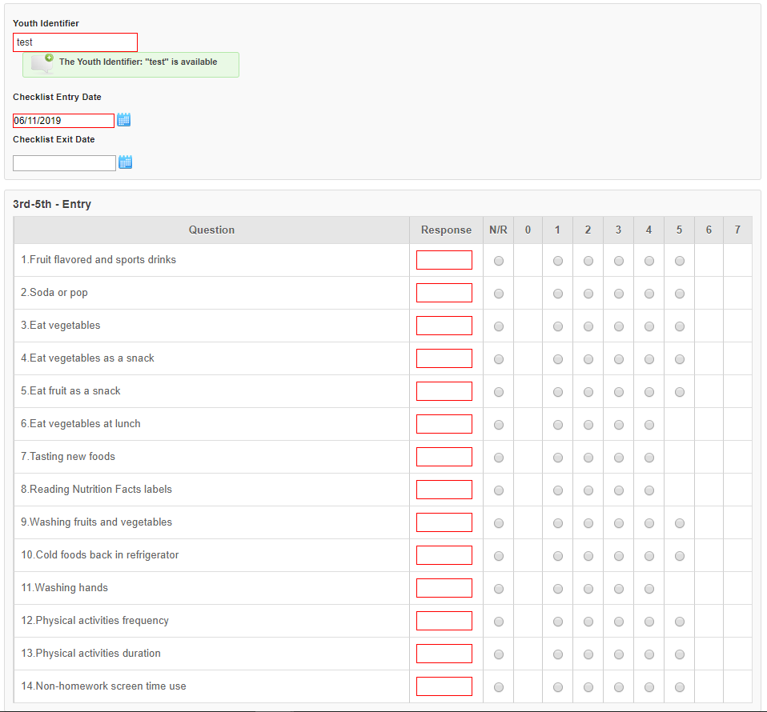
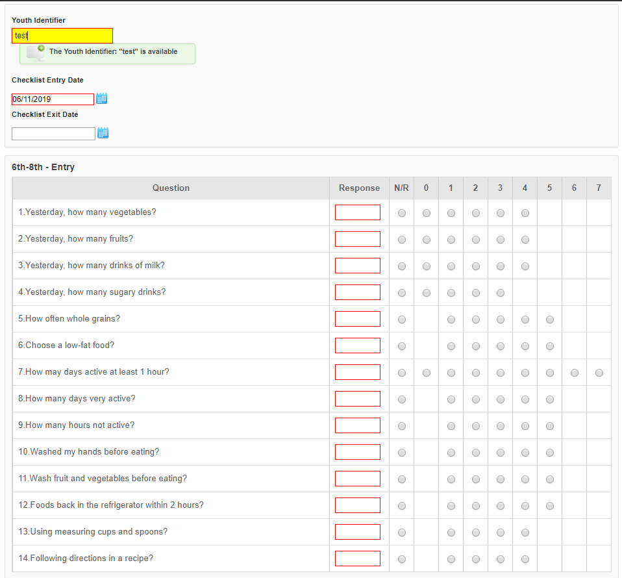
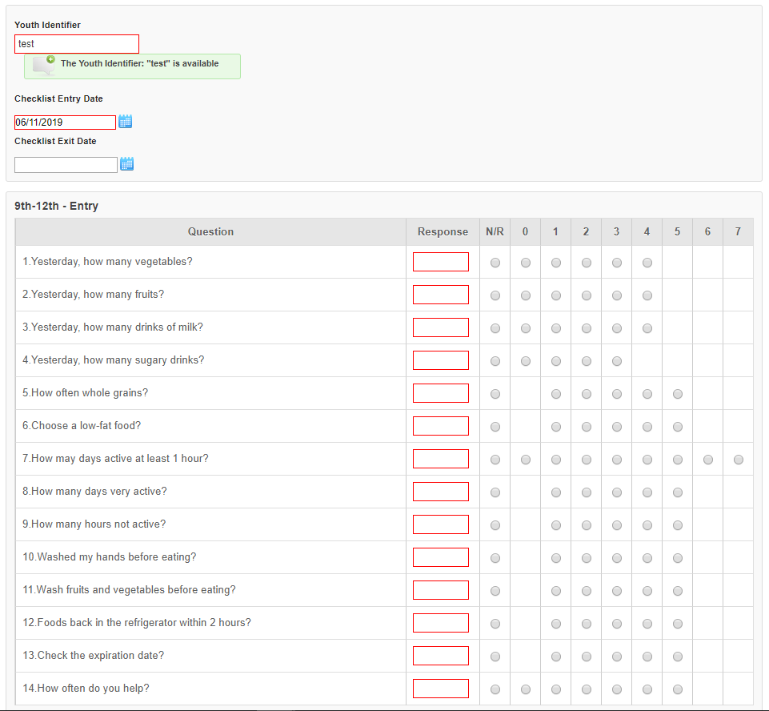

- Staff Data Entry Screens
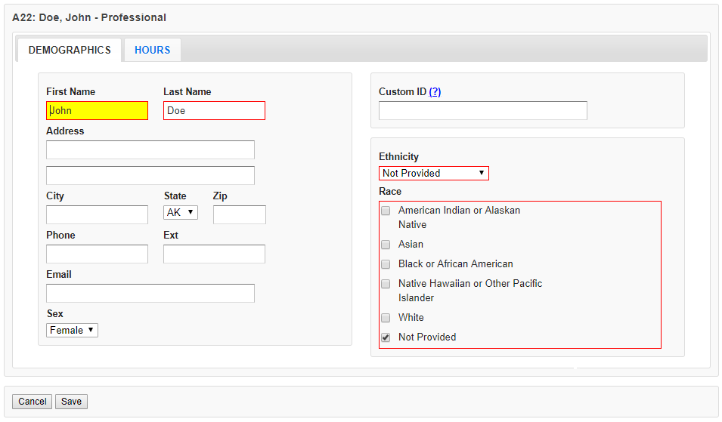

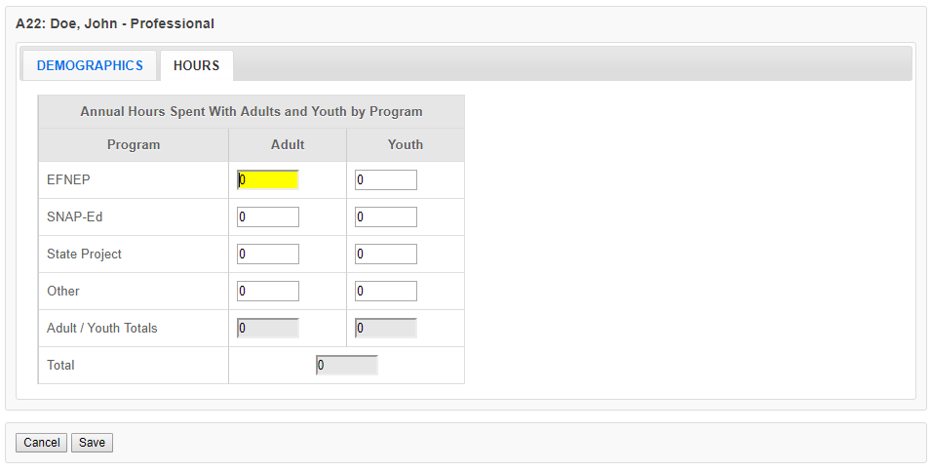

- Annual Budgets Data Entry Screens
Budget sheet and budget justification narrative have been integrated into a single fillable spreadsheet, which is completed in WebNEERS. An automatic message goes to Extension Directors/Administrators to secure their signatures. This process replaces the hardcopy excel spreadsheet, which was signed and then uploaded into a PDF into WebNEERS. This new process was implemented in FY 2018.

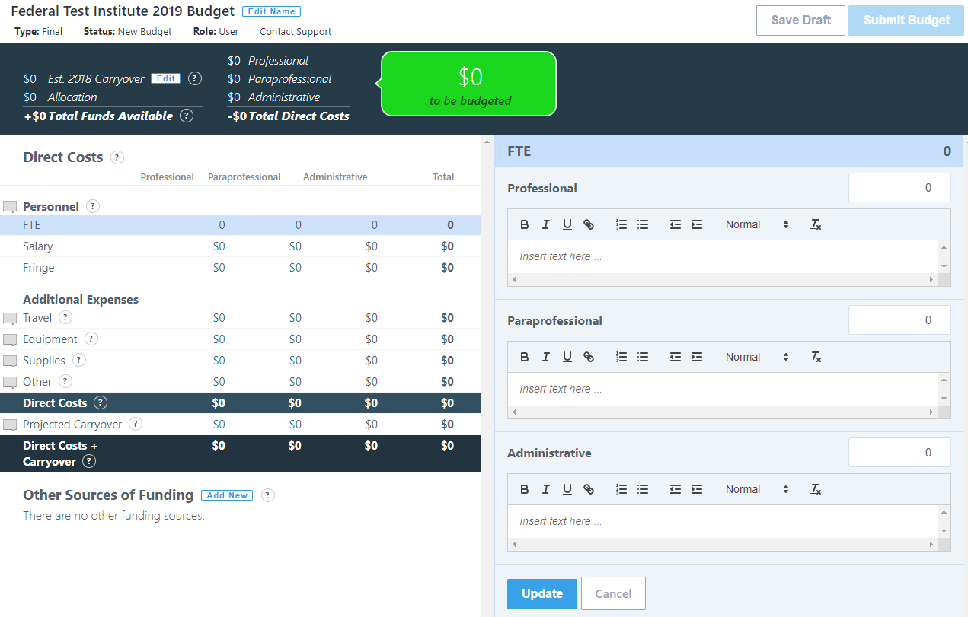

- Annual Program Plans Data Entry Screens
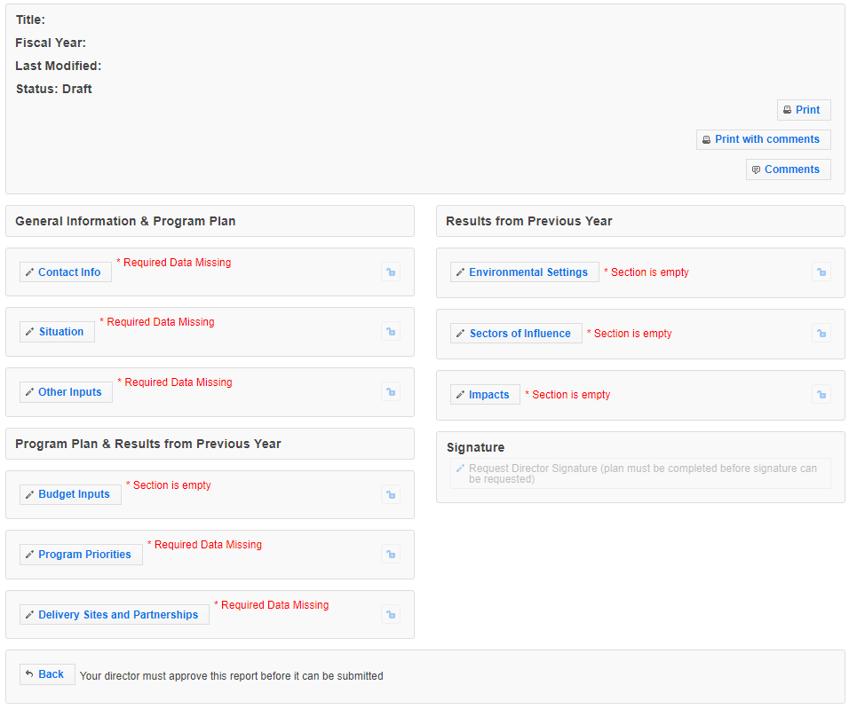

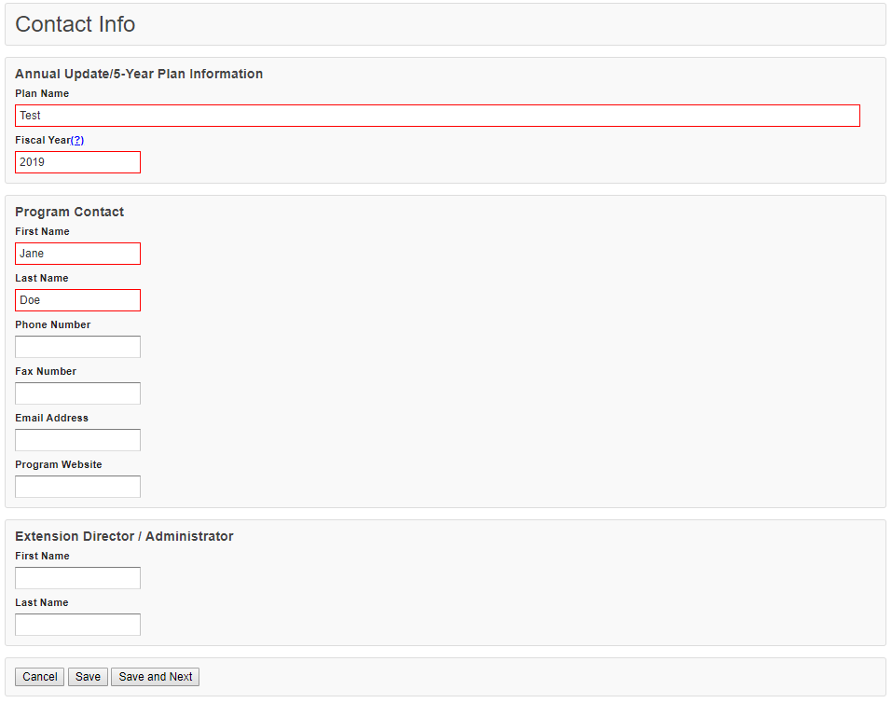

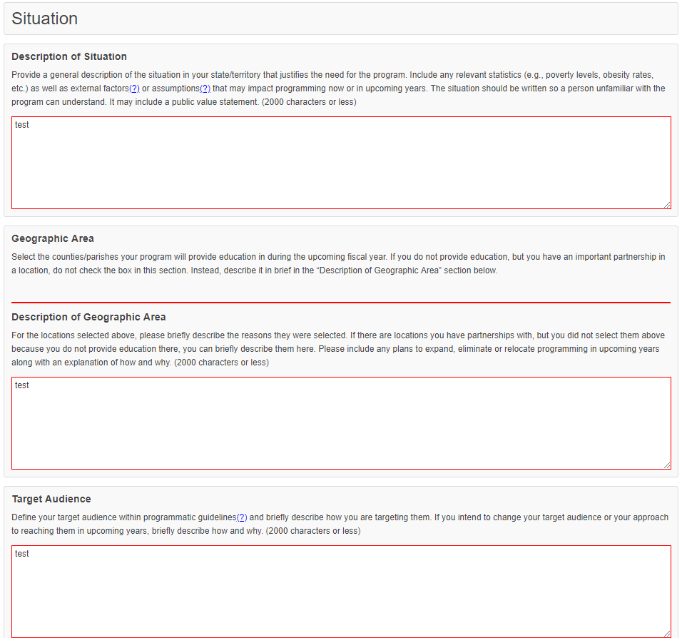

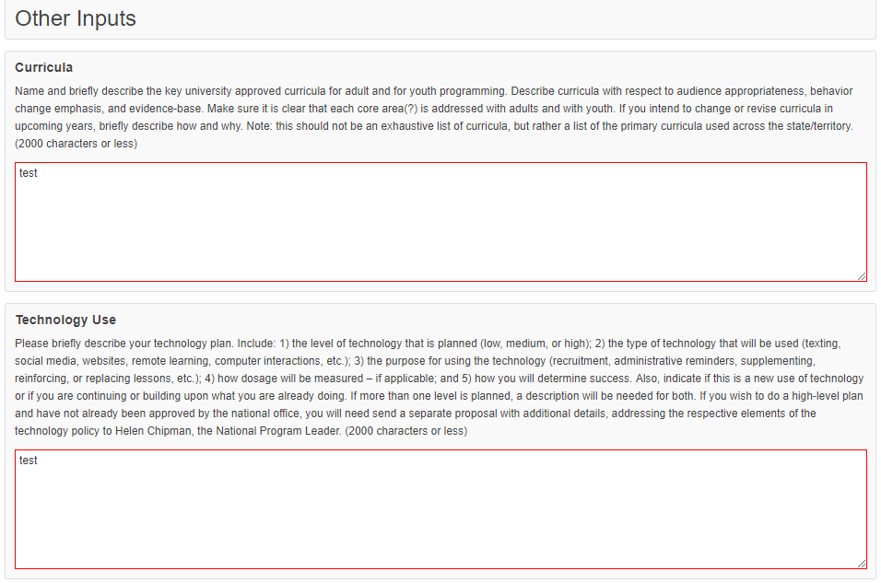

NEW! For FY 2020, a Technology Use text box was added to the Program Plan data. Partners were already reporting this information in different sections of the plan and needed a specific space to put this information. This new textbox will allow for greater consistency and clarity in their responses.

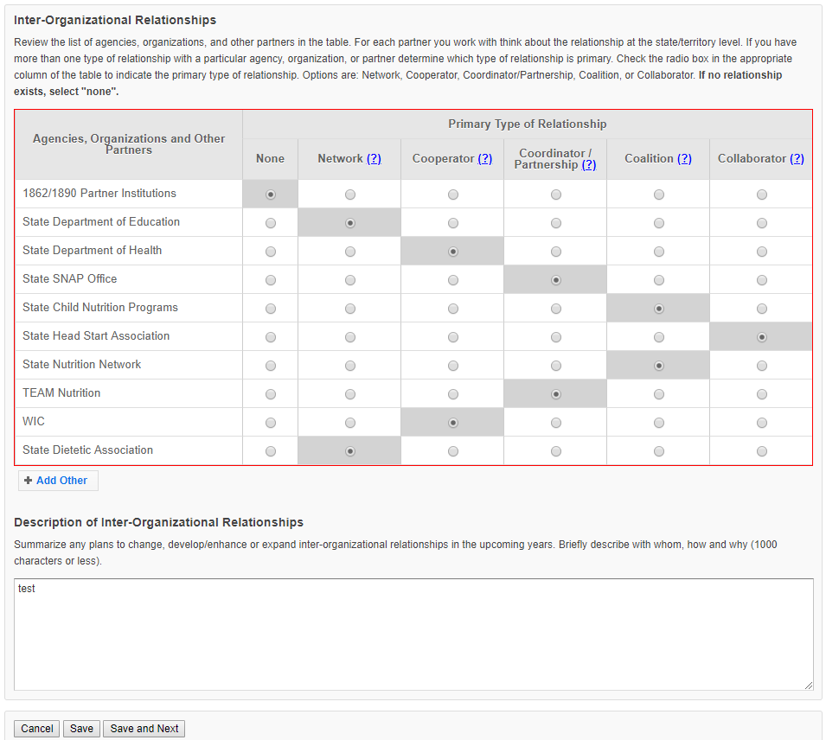
Note: On the Budget Inputs Screen, the Federal Budget with Justification is now simply a quick link to the Budget information (page 16). These are not additional data entry points.

