This set of screen shots captures the FM Translator and FM Booster Station License flow in the LMS application.
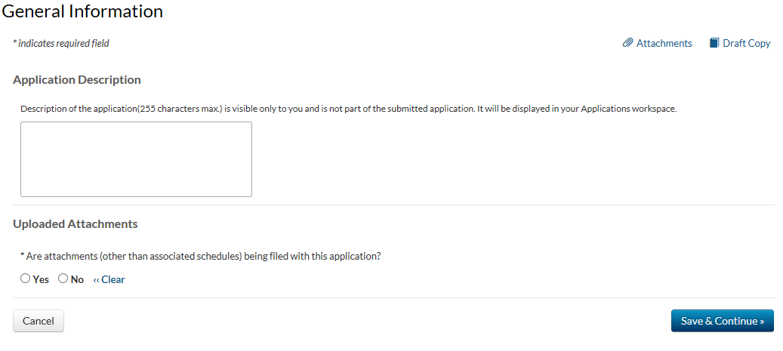

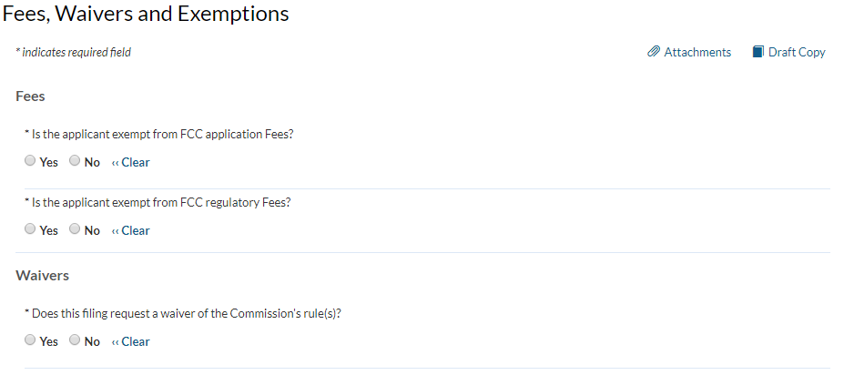
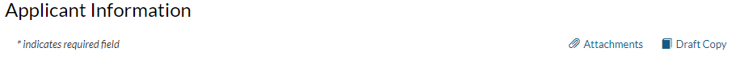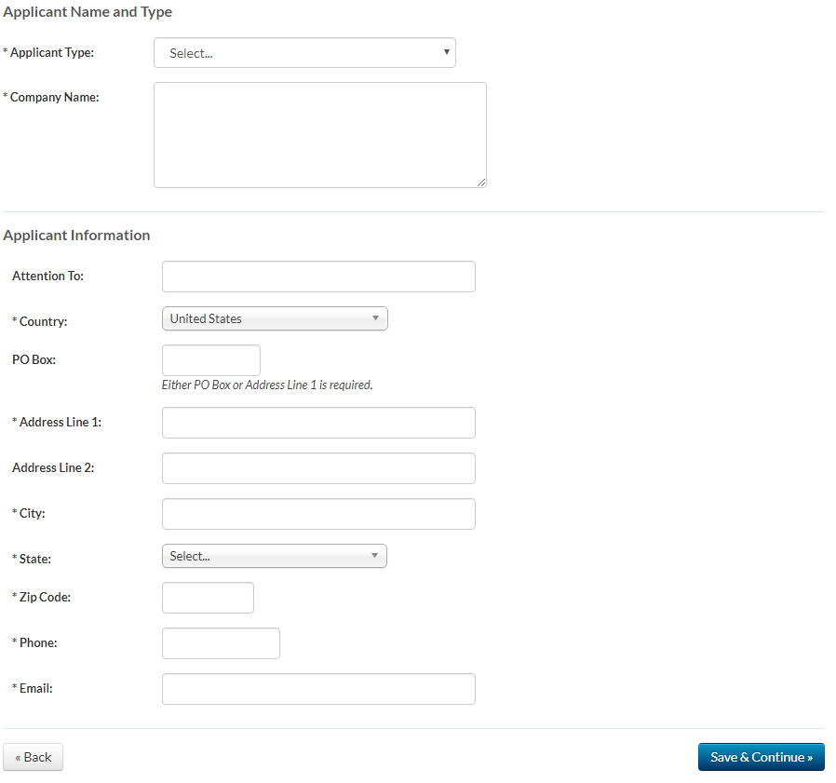

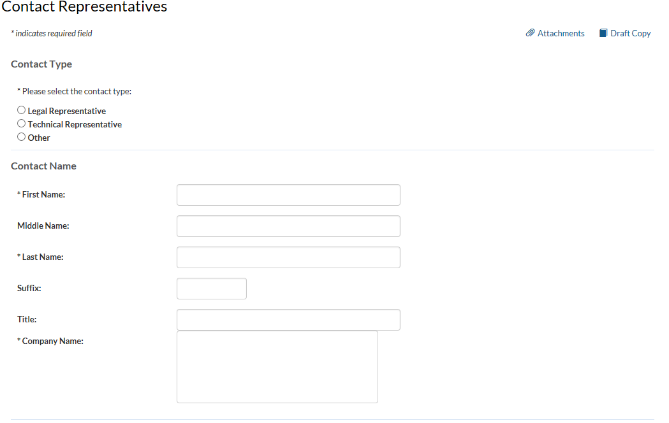
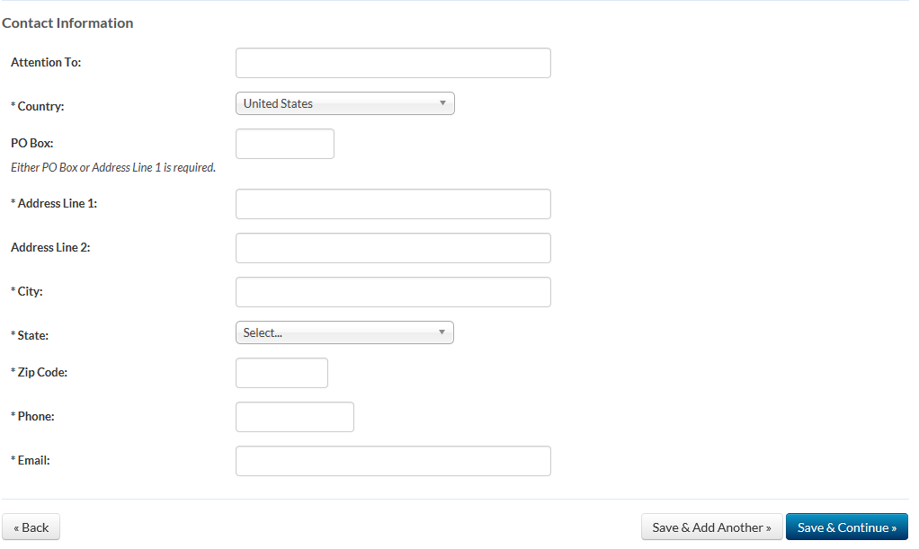
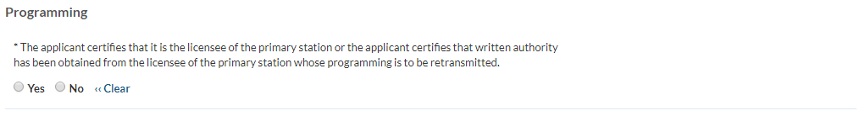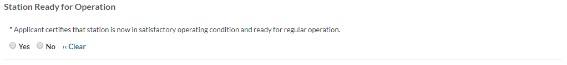* Applicant certifies that neither the applicant nor any party to the application has or had any interest in, or connection with: (a) any broadcast application in any proceeding where character issues were left unresolved or were resolved adversely against the applicant or party to the application; or (b) any pending broadcast application in which character issues have been raised. 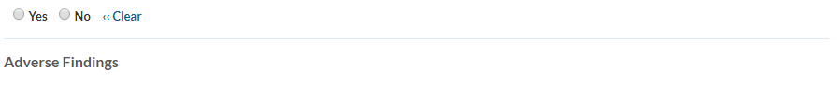* Applicant certifies that, with respect to the applicant and any party to the application, no adverse finding has been made, nor has an adverse final action been taken by any court or administrative body in a civil or criminal proceeding brought under the provisions of any laws related to any of the following: any felony; mass media-related antitrust or unfair competition; fraudulent statements to another governmental unit; or discrimination.

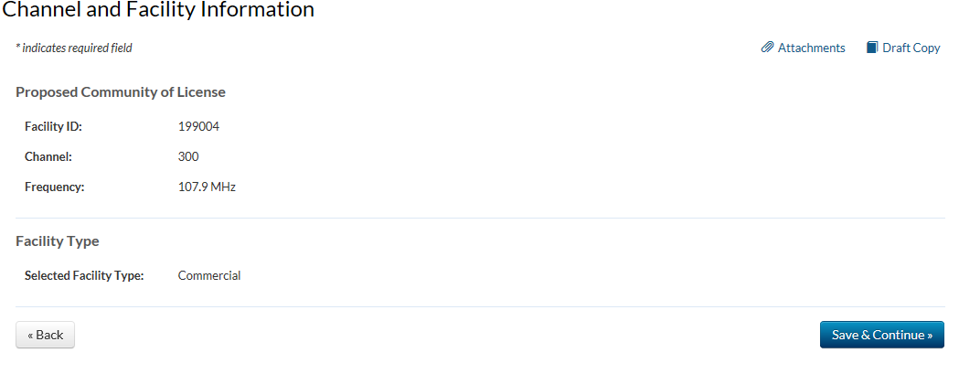

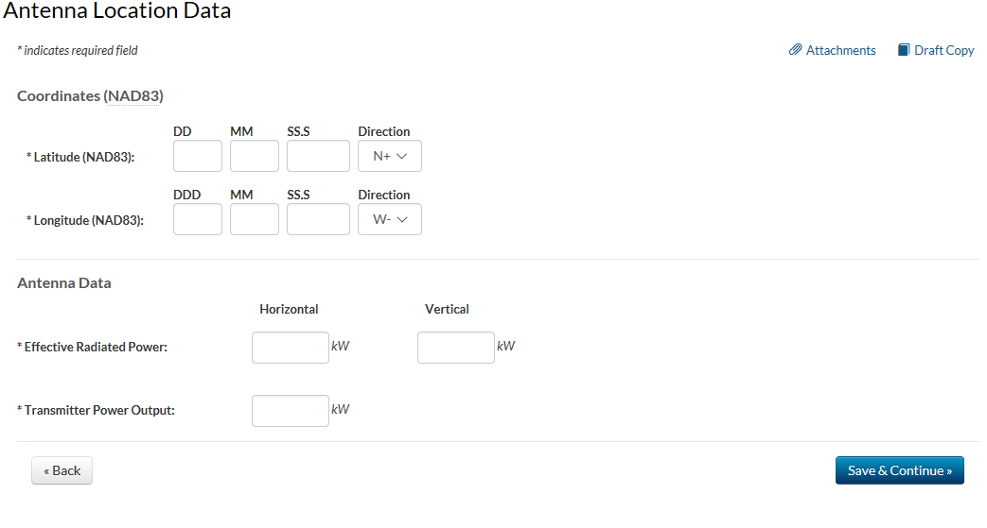

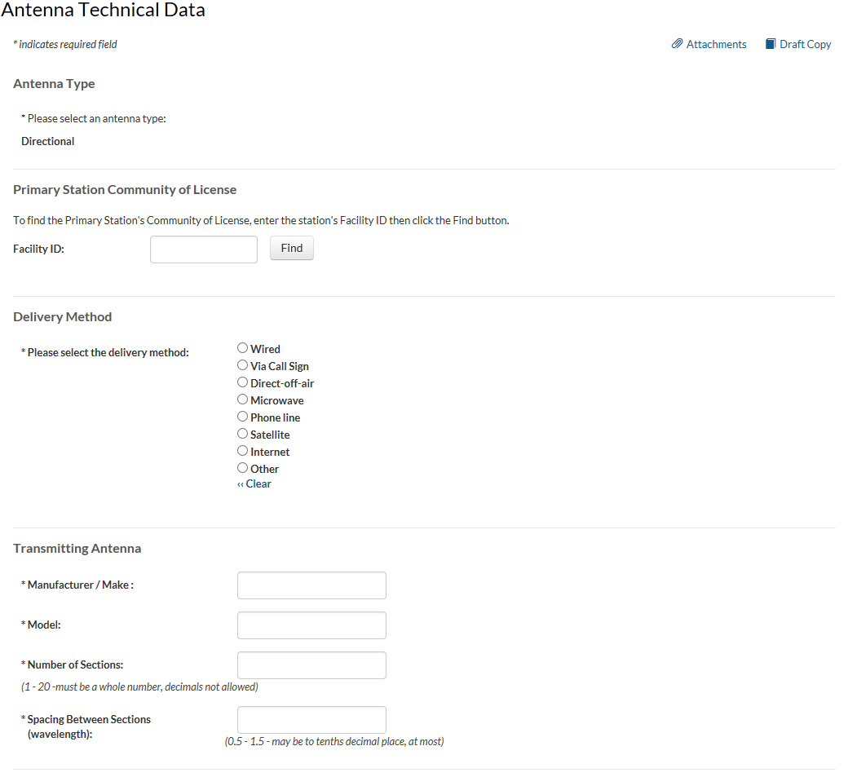

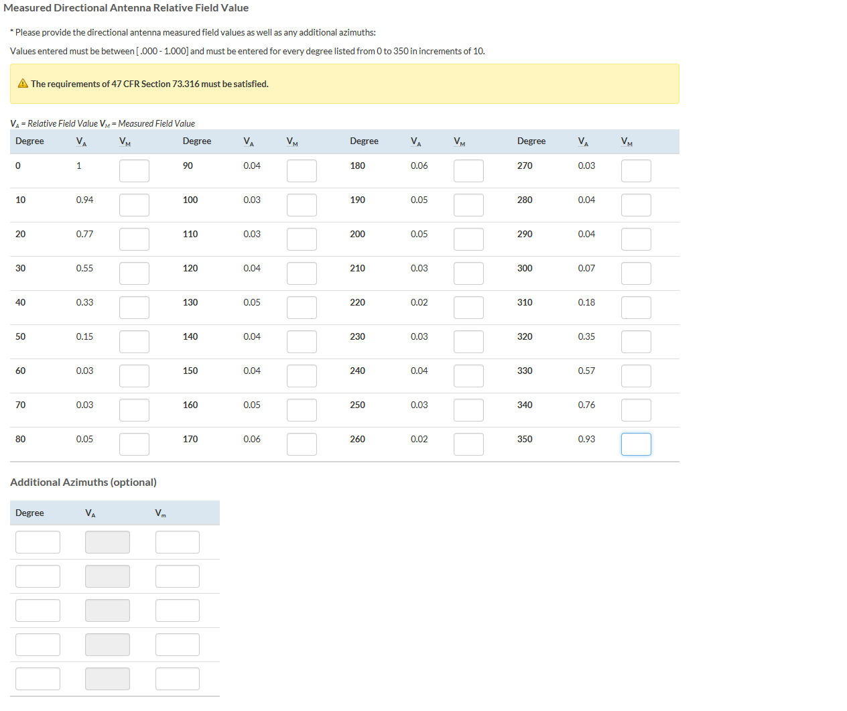

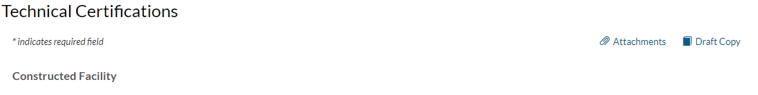* The facility was constructed as authorized in the underlying construction permit or complies with 47 C.F.R. Section 74.1251?
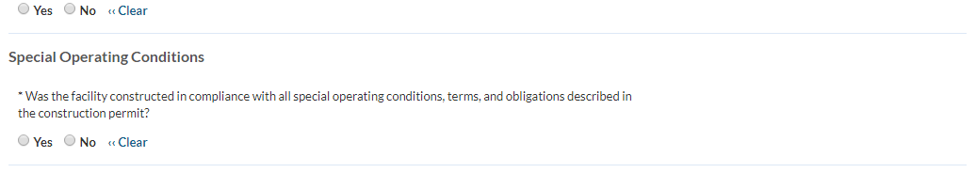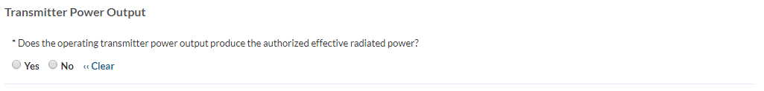*Would a Commission grant of Authorization for this location be an action which may have a significant environmental effect? See 47 C.F.R. Section 1.1306?

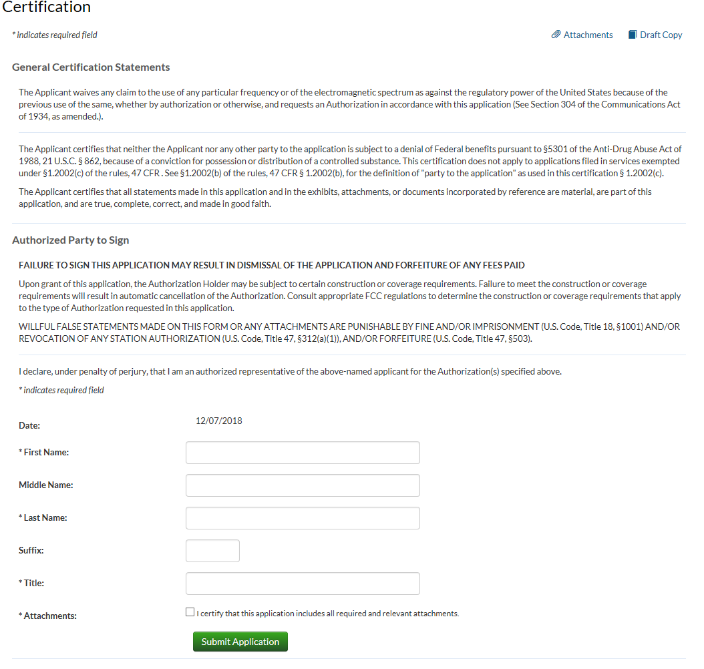

FCC NOTICE REQUIRED BY THE PAPERWORK REDUCTION ACT
We have estimated that each response to this collection of information will take 1 hour. Our estimate includes the time to read the instructions, look through existing records, gather and maintain the required data, and actually complete and review the form or response. If you have any comments on this burden estimate, or on how we can improve the collection and reduce the burden it causes you, please e-mail them to pra@fcc.gov or send them to the Federal Communications Commission, AMD-PERM, Paperwork Reduction Project (3060-0404), Washington, DC 20554. Please DO NOT SEND COMPLETED APPLICATIONS TO THIS ADDRESS. Remember - you are not required to respond to a collection of information sponsored by the Federal government, and the government may not conduct or sponsor this collection, unless it displays a currently valid OMB control number of if we fail to provide you with this notice. This collection has been assigned an OMB control number of 3060-0404.
THE FOREGOING NOTICE IS REQUIRED BY THE PAPERWORK REDUCTION ACT OF 1995, P.L. 104-13, OCTOBER 1, 1995, 44 U.S.C. Section 3507.

