This set of screen shots captures the FM Translator or FM Booster Construction Permit flow in the LMS application.
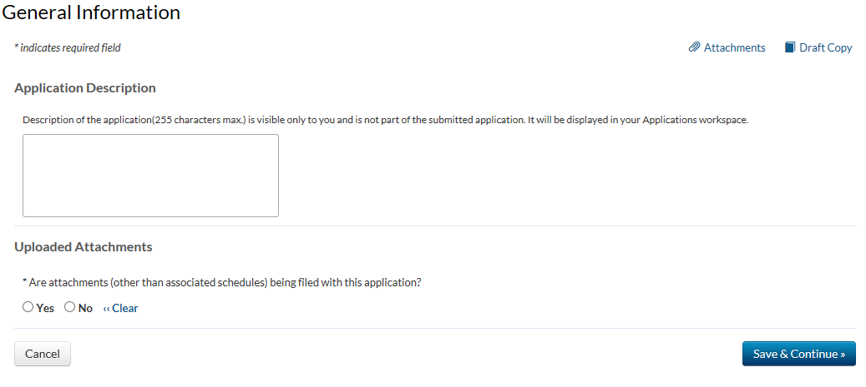

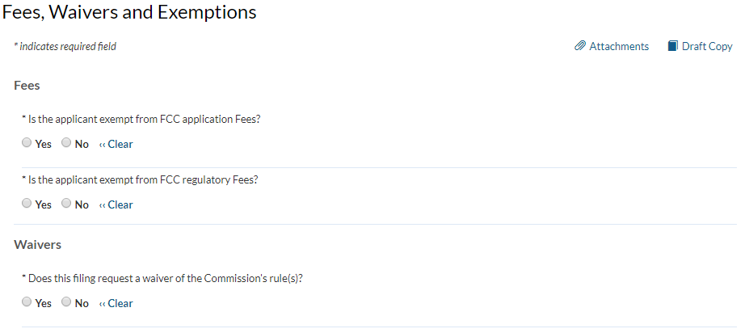

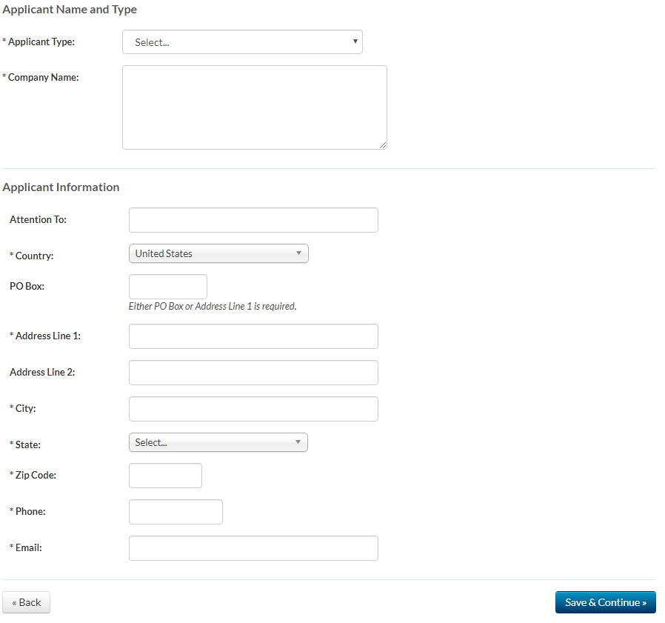

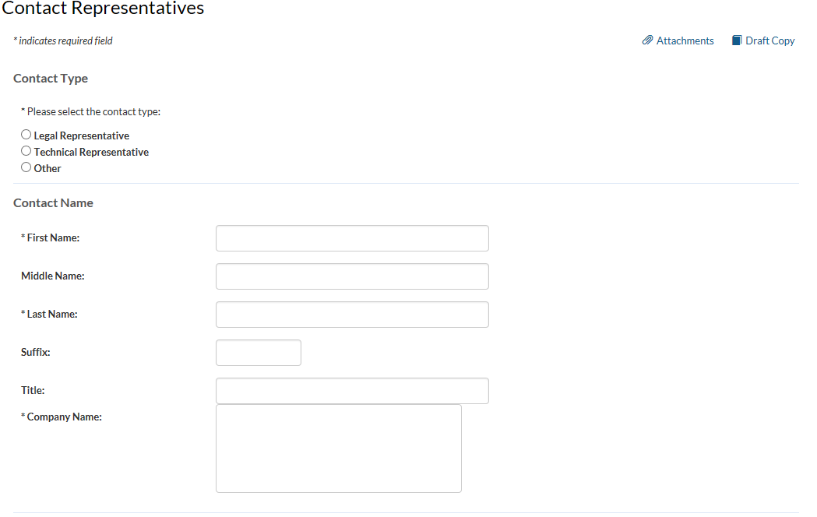
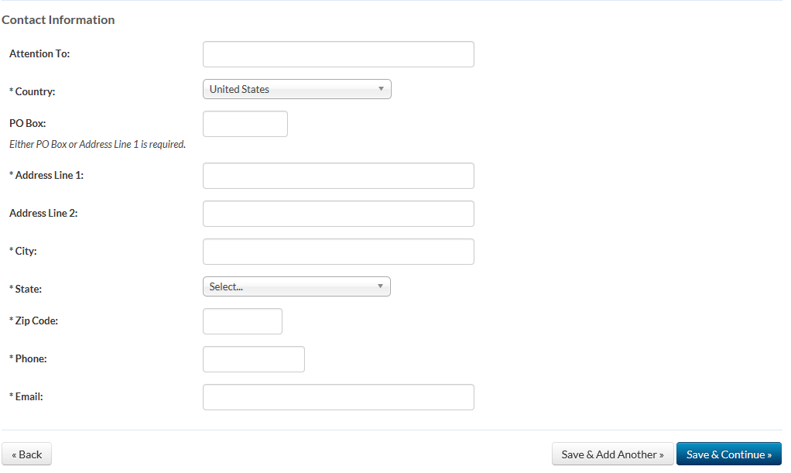

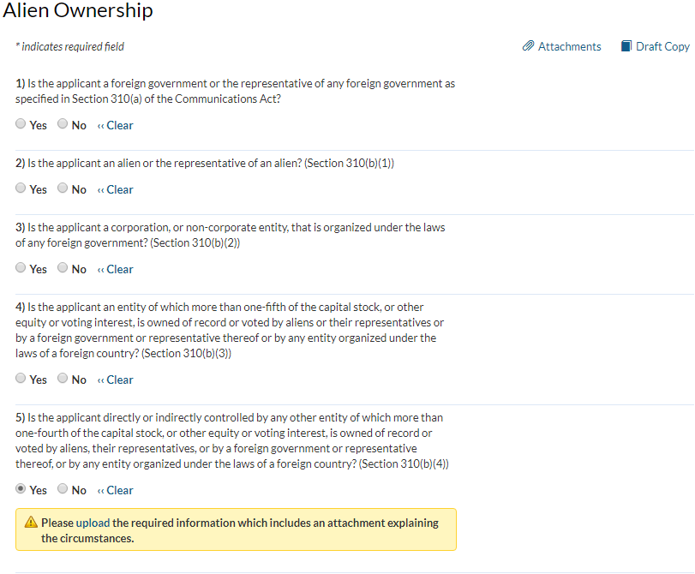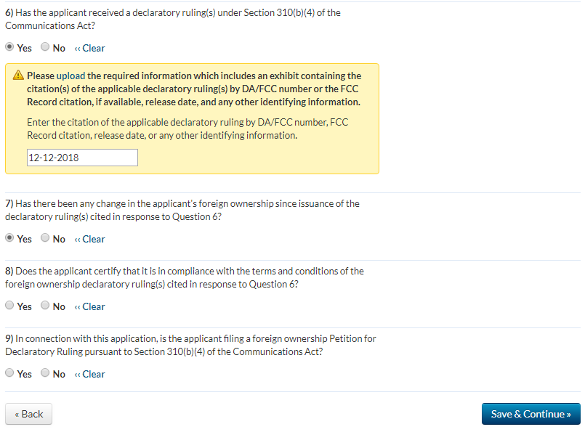

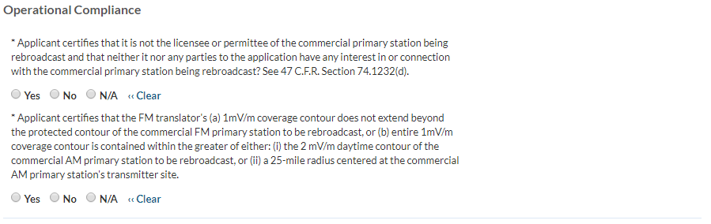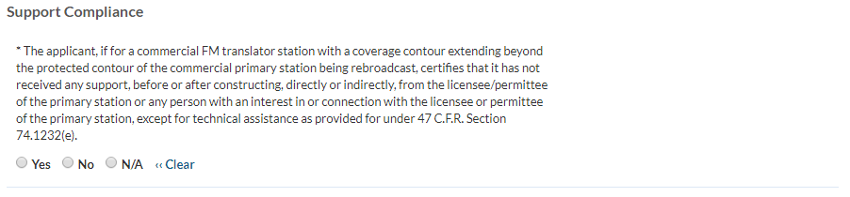* Applicant certifies that neither the applicant nor any party to the application has or had any interest in, or connection with: (a) any broadcast application in any proceeding where character issues were left unresolved or were resolved adversely against the applicant or party to the application; or (b) any pending broadcast application in which character issues have been raised. 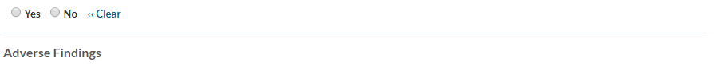
* Applicant certifies that, with respect to the applicant and any party to the application, no adverse finding has been made, nor has an adverse final action been taken by any court or administrative body in a civil or criminal proceeding brought under the provisions of any laws related to any of the following: any felony; mass media-related antitrust or unfair competition; fraudulent statements to another governmental unit; or discrimination.
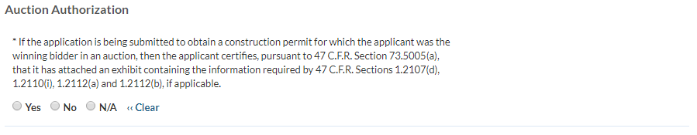

Noncommercial Educational FM Translator Point System Factors/Tie Breakers
Point system factors are used to select among mutually exclusive noncommercial educational FM translator applications for new stations and major modifications on reserved channels only.
Preliminary matter: Does this application provide fill-in service only? Established Local Applicant:
Applicant certifies that for at least the 24 months immediately prior to application, and continuing through the present, it qualifies as a local applicant pursuant to 47 C.F.R. Section 73.7000, that its governing documents require that such localism be maintained, and that it has placed documentation of its qualifications as an established local applicant in a local public inspection file and has submitted to the Commission copies of the documentation. Diversity of Ownership:
Applicant certifies that the principal community (city grade) contour of the proposed station does not overlap the principal community contour of any other authorized station (comparing radio to radio and television to television, including non-fill-in translator stations other than those identified in (b) below) in which any party to the application has an attributable interest as defined in 47 C.F.R. Section 73.3555, that its governing documents require that such diversity be maintained, and that it has placed documentation of its diversity qualifications in a local public inspection file and has submitted to the Commission copies of the documentation. State-wide Network:
Applicant certifies that (a) it has NOT claimed a credit for diversity of ownership above; (b) it is one of the three specific types of organizations described in 47 C.F.R. Section 73.7003(b)(3); and (c) it has placed documentation of its qualifications in a local public inspection file and has submitted to the Commission copies of the documentation. Technical Parameters
Applicant certifies that the numbers in the boxes below accurately reflect the new (increased) area and population that its proposal would serve with a 60 dBu (FM) signal measured in accordance with the standard predicted contours in 47 C.F.R. Section 73.313(c) and that it has documented the basis for its calculations in the local public inspection file and has submitted copies to the Commission. Major modification applicants should include the area of proposed increase only (exclude the station’s existing service area). (Points, if any, will be determined by FCC)
New (increased) area served in square kilometers (excluding areas of water): _____________________________
Population served based on the most recent census block data from the United States: __________________

Tie Breakers
Existing Authorizations

- By placing a number below, the applicant certifies that it and any persons and organizations with attributable interests in the applicant pursuant to 47 C.F.R. Section 73.3555 have, as of the date of filing, existing authorizations for the following number of relevant broadcast stations. FM translator applicants should count all attributable full service radio stations, AM and FM, commercial and noncommercial and FM translator stations other than fill-in stations.

___________ (number of commercial and noncommercial licenses and construction permits)

- (Fill-in Applicants Only.) By placing a number below, the applicant certifies that, in addition to the station identified in (a), it and any persons and organizations with attributable interests in the applicant pursuant to 47 C.F.R. Section 73.3555 have, as of the date of filing, existing authorizations for the following number of FM translators.

____________

Pending Applications

- By placing a number below, the applicant certifies that it and any persons and organizations with attributable interests in the applicant pursuant to 47 C.F.R. Section 73.3555 have, as of the date of filing, pending applications for new or major changes to the following number of relevant broadcast stations. FM translator applicants should count all attributable full service radio stations, AM and FM, commercial and noncommercial and FM translator stations other than fill-in stations.

___________ (number of commercial and noncommercial licenses and construction permits)

- (Fill-in Applicants Only.) By placing a number below, the applicant certifies that, in addition to the station identified in (a), it and any persons and organizations with attributable interests in the applicant pursuant to 47 C.F.R. Section 73.3555 have, as of the date of filing, existing authorizations for the following number of FM translators.

____________

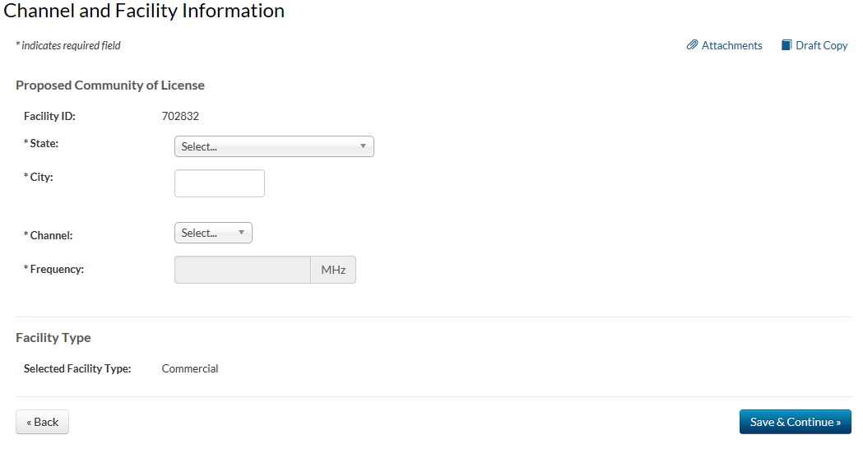

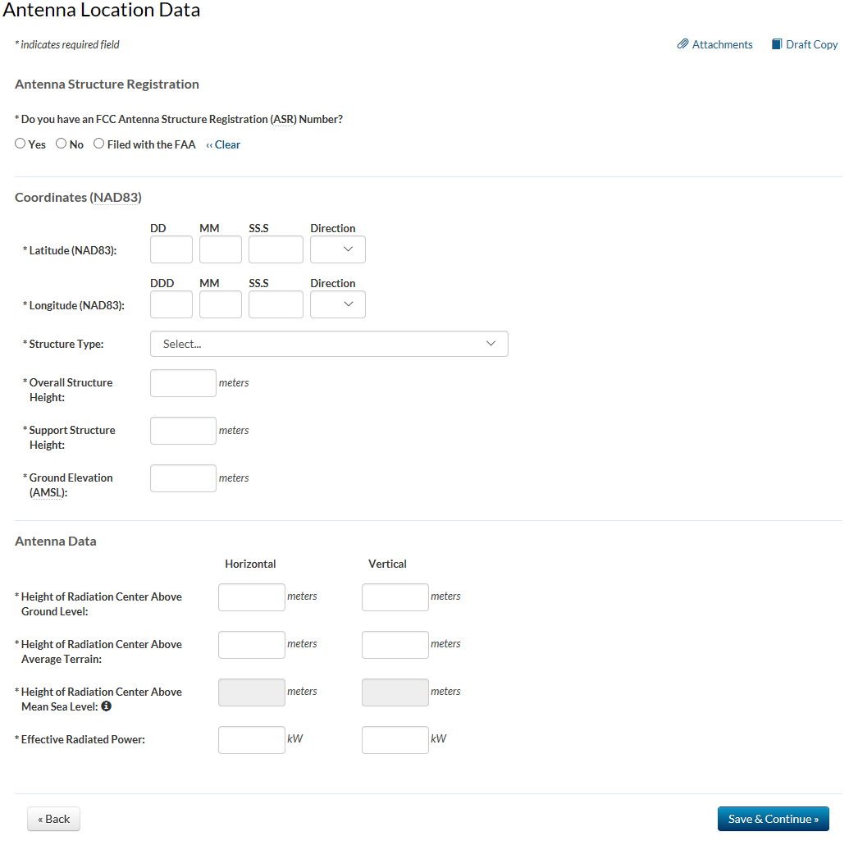

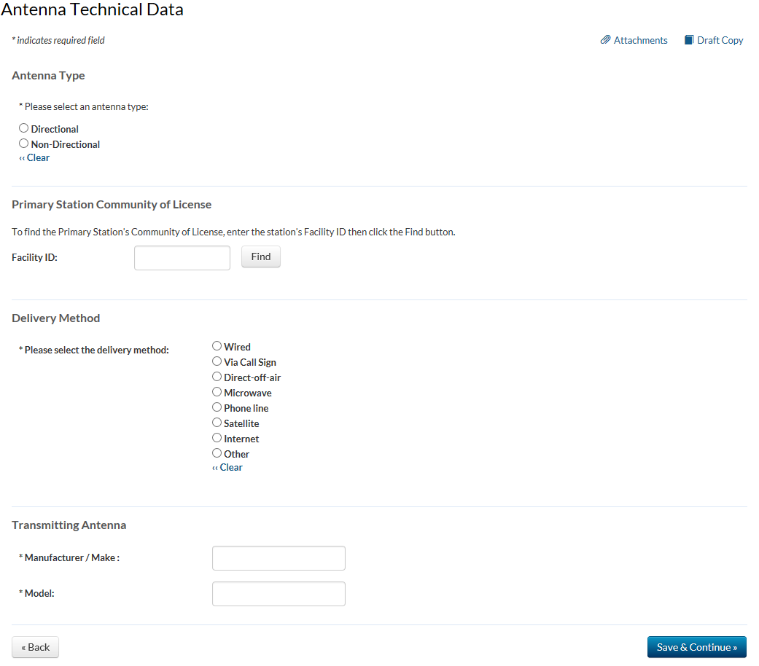

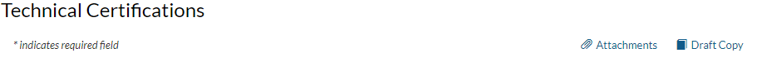
*Would a Commission grant of Authorization for this location be an action which may have a significant environmental effect? See 47 C.F.R. Section 1.1306?

