NHTSA
NCAP Communications Research
Online Survey

DRAFT: May 21, 2019

This collection of information is voluntary and will be used for formative purposes only so that we may develop and evaluate programs designed to reduce the number of traffic-related injuries and deaths. We will not collect any personal information that would allow anyone to identify you. A federal agency may not conduct or sponsor, and a person is not required to respond to, nor shall a person be subject to a penalty for failure to comply with a collection of information subject to the requirements of the Paperwork Reduction Act unless that collection of information displays a current valid OMB Control Number. The OMB Control Number for this information collection is 2127-new. Public reporting for this collection of information is estimated to be approximately 20 minutes per response, including the time for reviewing instructions, completing and reviewing the collection of information. All responses to this collection of information are voluntary. Send comments regarding this burden estimate or any other aspect of this collection of information, including suggestions for reducing this burden to: Information Collection Clearance Officer, National Highway Traffic Safety Administration, 1200 New Jersey Ave, S.E., Washington, DC, 20590

Target Audience: U.S. drivers ages 18 and older who are in the vehicle purchase mindset
Length of Interview: 20 minutes
Data Collection Mode: Online Survey
Draft Date: May 21, 2019

[ON-SCREEN WELCOME AND CONFIDENTIALITY]

Thank you for agreeing to participate in this online study. The survey will take about 20 minutes to complete. All responses are anonymous and will only be viewed in aggregate.
Please note that an agency may not conduct or sponsor, and a person is not required to respond to, a collection of information unless it displays a current valid OMB control number. The OMB control number for this study is 2127-new. This survey is voluntary. We will not collect any personal information that would allow anyone to identify you. Any information you do provide will be kept private to the fullest extent of the law.
Please do not use the back button on your browser at any time while in the survey.

PURCHASE PROCESS
Q10. When purchasing a new vehicle, meaning a new model year vehicle, what are the three most important factors that you consider?

[SELECT UP TO THREE RESPONSES, RANDOMIZE & ANCHOR PUNCH 21]
- Safety ratings
- Price
- Fuel economy
- Standard equipment included
- Optional equipment available
- Advanced safety technology features
- Entertainment or other interior technology features
- Manufacturer reputation
- Appearance/external styling
- Eco-friendly/environmental impact
- Financing options
- Dealer incentives
- Warranty
- Total cost of ownership
- Country of origin
- Comfort
- Type of fuel the vehicle can use
- Utility
- Performance
- Size
- Something else [SPECIFY]

[ASK IF SELECTED SAFETY - Q10/1]
Q11a. You selected Safety as one of your top three most important factors. There are different
ways to promote safety information. Which ONE of the following do you MOST prefer?

[RANDOMIZE]
- A 5-Star rating system that scores a vehicle using 1 to 5 stars
- A safety award based on overall safety of vehicle
- A numeric or percentage score (0%-100%)
- A letter grade (A, B, C, D, F)
- Performance classification (Good vs. Poor)

[ASK IF SELECTED ADVANCED SAFETY TECHNOLOGY FEATURES - Q10/6]
Q11b. You selected Advanced safety technology features as one of your top three most important
factors. There are different ways to promote information related to Advanced safety technology features. Which ONE of the following do you MOST prefer?

[RANDOMIZE]
- A safety technology award based on overall safety technology of vehicle
- A numeric or percentage score (0%-100%)
- A letter grade (A, B, C, D, F)
- Performance classification (Good vs. Poor)

[ASK IF SELECTED SAFETY - Q10/1]
Q12. Now thinking of specific types of safety information, please rate how helpful
the following would be when making a purchase decision.

- Not at all helpful
- Not too helpful
- Somewhat helpful
- Very helpful
- Extremely helpful

[RANDOMIZE]
A. Crashworthiness/crash test rating (How well the car protects passengers in a crash)
B. Crash avoidance rating (How well the car warns or helps the driver avoid a crash)

[ASK IF SELECTED SAFETY - Q10/1]
Q13. Would you prefer separate safety ratings for crashworthiness and crash avoidance or would
you rather have a single rating that combined crashworthiness and crash avoidance?

- Strongly prefer separate ratings
- Somewhat prefer separate ratings
- Somewhat prefer a single combined rating
- Strongly prefer a single combined rating

Q14. Now imagine if the government organization that is responsible for providing safety ratings also gave special recognition and designation to the top performing vehicles in the areas of crashworthiness and crash avoidance. Would having that additional information help you when making a decision to purchase or lease a new vehicle?

[ROTATE TOP TO BOTTOM; BOTTOM TO TOP]
- No – would not help at all
- Yes – would help somewhat
- Yes – would help a great deal
ASK IF HELPS SOMEWHAT/GREAT DEAL
Q15. How would having that additional information help you when making a decision to purchase
or lease a new vehicle? Please select all that apply.

[RANDOMIZE & ANCHOR PUNCH 9]
- Gives me confidence in the vehicle I purchase
- Gives me confidence in my purchase decision process
- Helps me narrow down possible makes/models
- Ensures I can pick the safest vehicle possible
- Ensures I can pick a car with a safety rating I am comfortable with
- Gives me confidence in a specific make/model that I want to purchase
- Makes me feel more comfortable with the MSRP/sales price
- Helps me pick a vehicle that will be easier to insure for cost purposes
- Other

Q16. When looking for information about new vehicles you are considering, how likely are you to seek out the following types of information about the safety of the vehicle?

- Not at all likely
- Somewhat likely
- Likely
- Very likely
- Extremely likely
[RANDOMIZE]
    - Safe driving tips
    - Regulations/laws related to vehicle safety
    - New vehicle safety technologies
    - Crash test ratings

Q17. Based on what you know, what organizations conduct crash tests on
new vehicles?
[OPEN END]

Q18. How important is it to you personally to have access to safety information such as the 5-star Safety Ratings when purchasing a new vehicle?

- Not at all important
- Not too important
- Somewhat important
- Very important
- Extremely important

Q19. How valuable to you personally is the 5-star Safety Rating in helping you to feel like you are making an informed decision when purchasing a new vehicle?

- Not at all valuable
- Not too valuable
- Somewhat valuable
- Very valuable
- Extremely valuable

Q20. How do you use information from the 5-star Safety Rating system? Please select all that apply.

[RANDOMIZE & ANCHOR PUNCH 9]
- Gives me confidence in the vehicle I purchase
- Gives me confidence in my purchase decision process
- Helps me narrow down possible makes/models
- Ensures I can pick a car with a safety rating I am comfortable with
- Gives me confidence in a specific make/model that I want to purchase
- Makes me feel more comfortable with the MSRP/sales price
- Helps me pick a vehicle that will be easier to insure
- Other

Q21. Prior to this survey, were you aware of the NHTSA.gov website run by the National Highway Traffic Safety Administration that provides consumers with educational information on purchasing safe vehicles?

- No
- Yes

SAFETY LABEL
[ASK IF RECENT PURCHASER OR RECENT DEALERSHIP VISITOR (Q7/2 OR Q8/3)]
Q22. During your most recent visits to new vehicle dealerships, to what extent did you pay attention to the window sticker that shows information such as vehicle model information, standard equipment, optional equipment, warranty information, total price, safety technologies, fuel economy, where it was assembled, and safety ratings on the vehicle(s) you were considering?

[ROTATE TOP TO BOTTOM]
  - I did not look at the window sticker
  - I looked at the window sticker but did not read it
  - I skimmed the information on the window sticker
  - I read the information on the window sticker, but not thoroughly
  - I thoroughly read the information on the window sticker

[ASK IF DID NOT THOROUGHLY READ WINDOW STICKER (Q22/1-4)]
Q23. And which of the following reasons best describes why you didn’t read the window sticker thoroughly?

- I knew the information from my preliminary research, before arriving at the dealership
- The salesperson informed me of the information before seeing the car
- I was more interested in the features and getting a feel for the vehicle
- Window sticker information wouldn’t have informed my decision
- Other, please specify: _______________

[ASK IF PLANNED PURCHASER HAS NOT VISITED DEALERSHIP (Q8/1,2)]
Q24. When you go to visit the dealership for your next vehicle purchase, to what extent will you likely pay attention to the window sticker showing vehicle model information, standard equipment, optional equipment, warranty information, total price, safety technologies, fuel economy, where it was assembled, and safety ratings on the vehicle(s) you are considering?

[ROTATE TOP TO BOTTOM]
- I will not look at the window sticker
- I will likely look at the window sticker, but not read it
- I will likely skim the information on the window sticker
- I will likely read the information on the window sticker, but not thoroughly
- I will likely thoroughly read the information on the window sticker

[ASK IF WILL NOT THOROUGHLY READ WINDOW STICKER (Q24/1-4)]
Q25. And which of the following best describes why you wouldn’t read the window sticker thoroughly?

- I would research the information before arriving at the dealership
- I expect the salesman to inform me of the information
- I would be more interested in the features and getting a feel for the vehicle
- Window sticker information wouldn’t inform my decision
- Other, please specify: _______________

Q26. The window sticker on a new vehicle, displays a variety of vehicle information including details the manufacturer chooses to include, as well as information that is mandated to be included by Congress.

On the next screen, you will see a sample window sticker.

[CONTINUE]
[DISPLAY SAMPLE FULL WINDOW STICKER ON A SINGLE SCREEN SIZED TO FIT; APPENDIX E]

[MAXDIFF – INSTRUCTIONS SCREEN]
Q27. Imagine you are making a decision on whether or not to purchase a vehicle. There would certainly be a number of factors that affect your decision, many of which are included on the window sticker.

We want to gain some insight into how you make this decision based on the information provided on the window sticker by asking a series of tradeoff scenarios [FULL RANGE OF SCENARIOS SHOWN IN APPENDIX F]. In each scenario, we’ll show you four possible factors affecting your decision. Please select which factor (among the set of four) is most important to your decision, and which is least important.

We need to ask you repeated tradeoff scenarios (involving different factors each time) so that we can learn what is truly important to you when making your new vehicle purchase decision.

[MAXDIFF – QUESTION SCREENS – WILL DISPLAY SEVEN TIMES SHOWING DIFFERENT COMBINATIONS OF 4 ITEMS FROM THE LIST BELOW]
Q28. Of the factors displayed here, which is the MOST important and which is the LEAST important to your decision?

[VARIABLES; FOR TECHNICAL EXPLANATION OF MAXDIFF METHODOLOGY & ANALYSIS PLEASE SEE APPENDIX G]
- Safety ratings
- Fuel economy
- Price
- Standard equipment
- Optional equipment
- Advanced safety technology features
- Warranty information
- Where the vehicle was assembled
- Vehicle model information (e.g., engine, trim)

Q29. One portion of the window sticker contains the Government 5-Star Safety Ratings. This information is required on the window sticker of the vehicle.

[DISPLAY SCREENSHOT OF GOVERNMENT 5-STAR RATING ON NHTSA.gov; APPENDIX H]
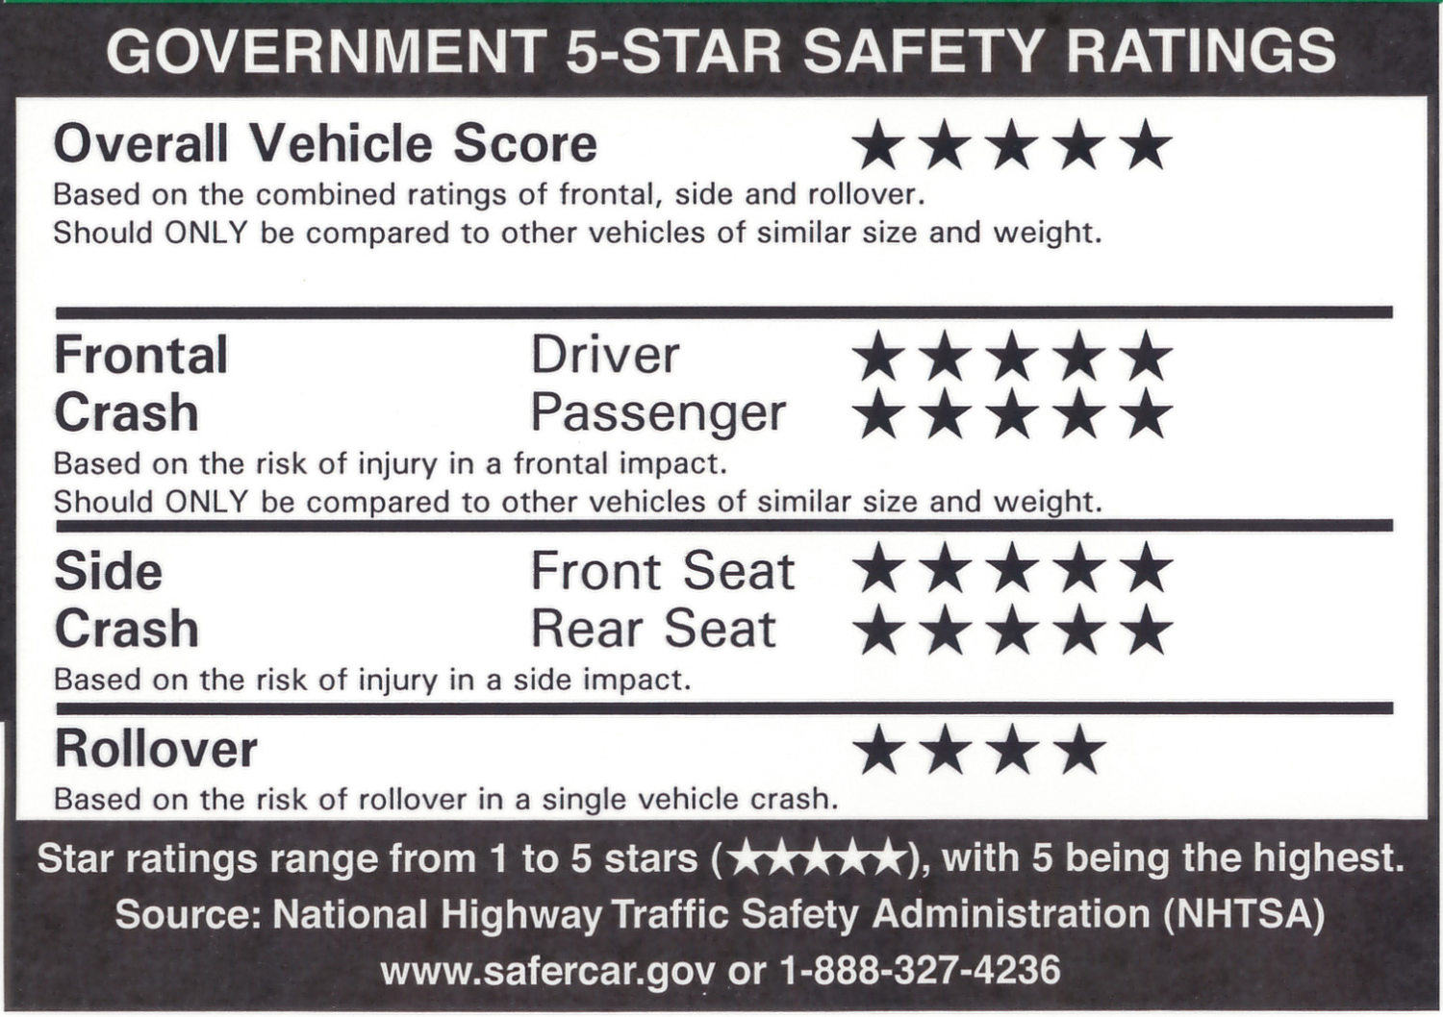

How clear is the information presented in this section?

- Not at all clear
- Not very clear
- Somewhat clear
- Very clear

How helpful the information on the window sticker toward making an informed decision about vehicle safety when purchasing or leasing a new vehicle?
- Not at all helpful
- Not very helpful
- Somewhat helpful
- Very helpful

Q30a. How important is it to include the 5-star safety rating information on the window sticker?

- Not at all important
- Not too important
- Somewhat important
- Very important
- Extremely important

Q30b. How important is it to make the government 5-star safety rating information stand out on the window sticker?

- Not at all important
- Not too important
- Somewhat important
- Very important
- Extremely important

Q31. Please rate how effective the following changes would be in helping make the government 5-star safety rating information stand out on the window sticker?

- Not at all effective
- Not too effective
- Somewhat effective
- Very effective
- Extremely effective
- Displaying the 5-star safety information in a different color
- Make the size of the 5-star safety information larger and easier to read
- Include more white space for legibility
- Fit all rating descriptions on one line
- Add a government seal or NHTSA logo to add credibility

ADVANCED SAFETY TECHNOLOGY FEATURES
For this last section, we’d like to understand what you know and what you are interested in knowing about NHTSA’s recommended safety technologies.

Q32. When you hear the term “recommended safety technologies”, what comes to mind? Please be as specific as possible.

[OPEN END]

Q33. How interested are you in learning about recommended safety technologies that may be available to you when you purchase or lease a new vehicle?

- Not at all interested
- Somewhat interested
- Interested
- Very interested
- Extremely interested

Q33b. Now thinking back about the window sticker, how important is it to include information about advanced safety technology features on the window sticker?

- Not at all important
- Not too important
- Somewhat important
- Very important
- Extremely important

Q33c. How important is it to make information about advanced safety technology features stand out on the window sticker?

- Not at all important
- Not too important
- Somewhat important
- Very important
- Extremely important

Q34. How useful would each of the following be for you personally?

- Not at all useful
- Somewhat useful
- Useful
- Very useful
- Extremely useful

[RANDOMIZE]
- Details on whether or not the advanced safety technologies installed on a particular vehicle meets the government performance criteria
- General recommendations on what advanced safety technologies consumers should consider
- Specific recommendations for advanced safety technologies I should consider for a certain vehicle
- General information on advanced safety technologies that are being developed for vehicles

Q35. How familiar are you with each of the following recommended safety
technologies in vehicles?

- I have never heard of this technology
- I have heard of this technology, but I am not familiar with it
- I am familiar with this technology, but do not currently have it installed on one of my vehicles
- I have this technology on one or more of my vehicles

[RANDOMIZE]
    - A system that is designed to warn a driver when their vehicle begins to move out of its lane (unless a turn signal is on in that direction)
    - A system that is designed to warn a driver when the vehicle is about to rear end another vehicle or object in front of the vehicle, giving the driver more time to react
    - A system that supplements the driver’s braking if the driver does not break hard enough to avoid a front-end crash into another vehicle
    - A system that automatically applies the brakes when the vehicle is about to impact another vehicle or object in front of the vehicle, assisting if the driver is slow to react to prevent a collision or reduce collision speed

Q36. Thinking about your next vehicle purchase, would you say each of the following technologies is a must have, nice to have or not necessary?

- Must have
- Nice to have
- Not necessary

[MAINTAIN Q35 ORDER]
    - A system that is designed to warn a driver when their vehicle begins to move out of its lane (unless a turn signal is on in that direction).
    - A system that is designed to warn a driver when the vehicle is about to rear end another vehicle or object in front of the vehicle, giving the driver more time to react.
    - A system that supplements the driver’s braking if the driver does not break hard enough to avoid a front-end crash into another vehicle
    - another vehicle or object in front of the vehicle, assisting if the driver is slow to react to prevent a collision or reduce collision speed.

Q37. What do you think each of these technologies are called?

[MAINTAIN Q35 ORDER]
[OPEN END FOR EACH, D/K CHECK BOX]

A | A system that is designed to warn a driver when their vehicle begins to move out of its lane (unless a turn signal is on in that direction). | OPEN-END | Don’t Know
B | A system that is designed to warn a driver when the vehicle is about to rear end another vehicle or object in front of the vehicle, giving the driver more time to react. | OPEN-END | Don’t Know
C | A system that supplements the driver’s braking if the driver does not break hard enough to avoid a front-end crash into another vehicle | OPEN-END | Don’t Know
D | A system that automatically applies the brakes when the vehicle is about to impact another vehicle or object in front of the vehicle, assisting if the driver is slow to react to prevent a collision or reduce collision speed. | OPEN-END | Don’t Know

Q38. The National Highway Traffic Safety Administration currently includes information about four technologies as part of the safety ratings section of their website. The images below are from three different vehicles.

2019 Honda Accord
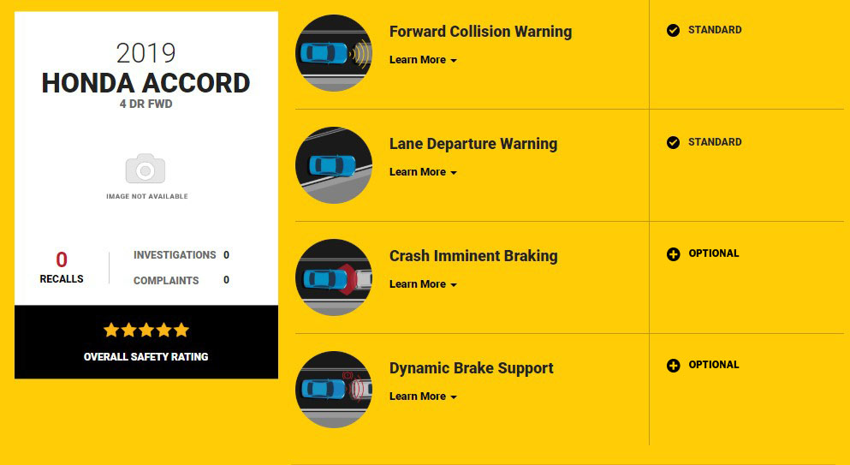

Q39. For the 2019 Honda Accord, are forward collision warning and lane departure warning:
- Standard equipment on this vehicle
- Optional equipment on this vehicle
- Not sure

Q40. For the 2019 Honda Accord, are crash imminent braking and dynamic brake support:
- Standard equipment on this vehicle
- Optional equipment on this vehcile
- Not sure

Q41. What additional information can the National Highway Traffic Safety Administration provide about these technologies that would be helpful for you during your vehicle purchase decisions?

[OPEN END]

DEMOGRAPHICS

These last few questions are demographic and are used to help us ensure that our survey is representative.

Q42. What is the last grade you completed in school?

- Some grade school (1-8)
- Some high school (9-11)
- High school graduate (12)
- Technical or vocational school
- Some college
- College graduate
- Graduate or professional school
- Prefer not to answer

Q43. Are you of Hispanic or Latino origin?

- Yes
- No
Q44. What is your race? Please select one or more.

- American Indian or Alaska Native
- Asian American
- Black or African American
- Native Hawaiian or Other Pacific Islander
- Caucasian
- Other
- Prefer not to answer

Q45. What is your marital status?

- Never married
- Married
- Living together with someone but not married
- Separated
- Divorced
- Widowed
- Prefer not to answer

Q46. What is your current employment status?

- Employed full-time
- Employed part-time
- Not employed
- Retired
- Student
- Homemaker/Caregiver/Stay-at-home parent
- Prefer not to answer

Q47. Which ONE of the following best describes your total household income? [ALLOW FOR NONRESPONSE]

- Under $25,000
- $25,000 to less than $50,000
- $50,000 to less than $75,000
- $75,000 to less than $100,000
- $100,000 to less than $150,000
- $150,000 to less than $200,000
- $200,000 or more
- Prefer not to answer

Q48. How many children under the age of 18, if any, do you currently have living in your household?

- None
- 1
- 2
- 3
- 4
- 5 or more

Thank you for your time and valuable input.

THANK AND RELEASE RESPONDENT

