NHTSA
NCAP Communications Research
Cognitive Research Screener and Testing Discussion Guide

DRAFT: May 21, 2019

This collection of information is voluntary and will be used for formative purposes only so that we may develop and evaluate programs designed to reduce the number of traffic-related injuries and deaths. We will not collect any personal information that would allow anyone to identify you. A federal agency may not conduct or sponsor, and a person is not required to respond to, nor shall a person be subject to a penalty for failure to comply with a collection of information subject to the requirements of the Paperwork Reduction Act unless that collection of information displays a current valid OMB Control Number. The OMB Control Number for this information collection is 2127-new. Public reporting for this collection of information is estimated to be approximately 60 minutes per response (5 minutes for the telephone screener and 55 minutes for the interview), including the time for reviewing instructions, completing and reviewing the collection of information. All responses to this collection of information are voluntary. Send comments regarding this burden estimate or any other aspect of this collection of information, including suggestions for reducing this burden to: Information Collection Clearance Officer, National Highway Traffic Safety Administration, 1200 New Jersey Ave, S.E., Washington, DC, 20590

Screener
Target Audience: U.S. drivers ages 18 and older who are in the vehicle purchase mindset
Recruitment Target: Recruit 12 with expectation of 8 to show and complete interviews
Screener Length: 5 minutes
Data Collection Mode: Telephone Interview

INTRODUCTION: Hello, my name is _____________________ from Heart+Mind Strategies, an independent consumer research firm. We are conducting a brief study among drivers across the United States and would like to ask you just a few questions [DO NOTE PAUSE]. Please be assured that we are not selling anything and that the information we gather from the following questions will remain completely confidential and be used for research purposes only. May I ask you just a few, brief questions?

S1. What is your current age?

  - Under 18 [TERMINATE]
  - 18 to 24
  - 25 to 34
  - 35 to 44 [ACHIEVE A GOOD MIX OF AGE CATEGORIES]
  - 45 to 54
  - 55 to 64
  - 65 or older

S2. BY OBSERVATION: Gender

- Male [RECRUIT 6]
- Female [RECRUIT 6]
S3. Do you currently have a valid driver’s license?

- Yes
- No [TERMINATE]

S4. Do you currently own or lease a car or truck?

[ACCEPT MULTIPLE RESPONSES]
- Yes – OWN
- Yes – LEASE [RECRUIT GOOD MIX OF OWN/LEASE OR BOTH]
- No [EXCLUSIVE]

S5. Which of the following statements best represent your plans for purchasing or leasing a new vehicle for you or your family? By new vehicle, we mean new model year vehicle, not used or previously owned.

- I purchased or leased a new vehicle longer than 6 months ago [TERMINATE]
- I purchased or leased a new vehicle in the past 6 months
- I plan to purchase or lease a new vehicle in the next 6 months
- I plan to purchase or lease a new vehicle 6 to 12 months from now
- I plan to purchase or lease a new vehicle longer than 12 months from now [TERMINATE]
- I have no plans to purchase or lease a new vehicle [TERMINATE]
- Don’t know [TERMINATE]

[ASK IF PLANNING TO PURCHASE/LEASE NEW VEHICLE IN NEXT 12 MONTHS S5/3,4]
S6. And which ONE of the following best describes the stage in the vehicle purchasing or leasing process at which you currently find yourself?

  - I’ve considered purchasing or leasing a new vehicle, but have not sought out information
  - I’ve actively sought out information online or in other sources about vehicles I would consider purchasing or leasing
  - I’ve visited a dealership
  - I’ve test driven a vehicle
  - I’ve decided on the vehicle I’m going to purchase or lease

S7. Thinking about your [QS5_02 = recent/QS5_03-04 = next] vehicle purchase or lease, would you say you [QS5_02 = were/QS5_03-04 = are] the primary decision maker, [QS5_02 = had/QS5_03-04 = have] shared responsibility, or [QS5_02 = did/QS5_03-04 = will] someone else make the decision on which vehicle to purchase or lease?

  - I am the primary decision maker
  - I have shared responsibility with someone else
  - Someone else is the primary decision maker [TERMINATE]
  - Don’t know [TERMINATE]

S8. Do you have any difficulty seeing or reading a computer screen?

- Yes [TERMINATE]
- No

ARTICULATION SCREEN
S9. Now I’d like you to use your imagination. If you could spend the day with any famous person, living or dead, who would you want to spend time with? Why? What would you do during that day?
[TERMINATE IF UNABLE TO FORMULATE A THOUGHTFUL/COHERENT RESPONSE]

INVITATION
Thank you for answering my questions. We are inviting a select number of residents from the Richmond area to participate in a one-on-one research discussion. During this conversation you will be asked to share your thoughts and reactions to an online survey that is being developed for drivers like yourself across the country. The discussion will involve you taking the online survey and providing your feedback on the process to an interviewer who will be observing. Again, this interview is for research purposes only. You will never be asked to purchase anything, and all of your responses and comments will remain strictly confidential.

The interview will take place on [INSERT] at [INSERT RICHMOND LOCATION], a professional opinion research facility. The interview will last about 55 minutes. We’d like to invite you to join us and share your perspective and opinions as part of this important research initiative. As a token of our appreciation, we would like to offer you $75 for your time. There is nothing that you need to do in advance to prepare for this interview.

S10. Would you be available to participate in this interview at [INSERT RICHMOND FACILITY]?

    - Yes [CONTINUE]
    - No [TERMINATE]

S11. Available times for your interview are [REFER TO INTERVIEW SCHEDULE GRID &
PROVIDE PARTICIPANT WITH AVAILABLE TIME SLOTS] Which of these would work best for you?

[RECRUITING NOTE: SCHEDULE INTERVIEWS AT LEAST 15 MINUTES APART]

Just so I can confirm what we just talked about, what is your name and email address?
NAME: ______________________________________________
E-MAIL ADDRESS: [CONFIRM FROM ABOVE]

[THANK, TELL THEM THEY WILL RECEIVE A “REMINDER” CALL AND A VERIFICATION E-MAIL AS THE DATE GETS NEARER AND POLITELY END THE CALL.]

Cognitive Testing Discussion Guide
Target Audience: U.S. drivers ages 18 and older who are in the vehicle purchase mindset
Length of Interview: 55 minutes
Data Collection Mode: In-person in-depth interviews

[Introduction and Instructions]
Thank you for agreeing to participate in this interview. The purpose of our time together today is to evaluate a questionnaire that will be given to people across the country to assess how various factors impact their car purchase decision. During our discussion, you will be completing the questionnaire as I observe and ask you a series of questions about the processes you are going through. Keep in mind, there are no right or wrong answers, and all your feedback is extremely valuable.

My purpose is to find out if the questions make sense to you and if the other participants in our testing understand the questions in the same way. Your interview is critical to helping us find out how the questions are working.

This interview consists of two components and will take 55 minutes total. The interview will primarily be about how you follow the questionnaire and respond to certain activities. Many of my questions may seem repetitive and even somewhat strange or personal. This is because we are testing the question in the questionnaire, and we need to understand what people are considering when they form each answer. Please do you best to answer the questions as you understand them.

Everything that you tell me is confidential and will be kept private. If you do not want to answer a question, please tell me and I will move to the next one. Before we begin, do you have any questions?

[IF YES] Answer questions as needed…
[IF NO] Let’s get started…

[WELCOME SCREEN]
[INTERVIEWER QUESTIONS HIGHLIGHTED IN YELLOW]

Thank you for agreeing to participate in this online study. All responses are anonymous and will only be viewed in aggregate.
Please note that an agency may not conduct or sponsor, and a person is not required to respond to, a collection of information unless it displays a current valid OMB control number. The OMB control number for this study is 2127-new. This survey is voluntary. We will not collect any personal information that would allow anyone to identify you. Any information you do provide will be kept private to the fullest extent of the law.
Please do not use the back button on your browser at any time while in the survey.

A) Is there anything unclear or confusing about these instructions? IF SO, what?
- How could that be made clearer to you?

SCREENING
[INTERVIEWER QUESTIONS HIGHLIGHTED IN YELLOW]

Q1. In which of the following categories is your age?
- Under 18 [TERMINATE]
- 18 to 24
- 25 to 34
- 35 to 44
- 45 to 54
- 55 to 64
- 65 or older

Q2. Are you…?
- Male
- Female

Q3. In what state do you currently reside?
[DROP DOWN OF 50 STATES + D.C.]

Q4. Do you currently have a valid driver’s license?
- Yes
- No [TERMINATE]

Q5. Do you currently own or lease a car or truck?
[ACCEPT MULTIPLE RESPONSES & MAKE PUNCH 3 EXCLUSIVE]
- Yes – OWN
- Yes – LEASE
- No [EXCLUSIVE]

Q6. What make, model and year vehicle is the primary vehicle you drive?
MAKE [OPEN-END TEXT BOX]
MODEL [OPEN-END TEXT BOX]
YEAR [NUMERIC TEXT BOX]
  - Don’t know

Q7. Which of the following statements best represent your plans for purchasing or leasing a new vehicle for you or your family? By new vehicle, we mean new model year vehicle, not used or previously owned.

[ROTATE TOP TO BOTTOM & ANCHOR PUNCH 7]
- I purchased or leased a new vehicle longer than 6 months ago [TERMINATE]
- I purchased or leased a new vehicle in the past 6 months
- I plan to purchase or lease a new vehicle in the next 6 months
- I plan to purchase or lease a new vehicle 6 to 12 months from now
- I plan to purchase or lease a new vehicle longer than 12 months from now [TERMINATE]
- I have no plans to purchase or lease a new vehicle [TERMINATE]
- Don’t know [TERMINATE]

[PLANNING TO PURCHASE/LEASE IN NEXT 12 MONTHS – Q7/3,4]
Q8. And which ONE of the following best describes the stage in the vehicle purchasing or leasing process at which you currently find yourself?

      - I’ve considered purchasing or leasing a new vehicle, but have not sought out information
      - I’ve actively sought out information online or in other sources about vehicles I would consider purchasing or leasing
      - I’ve visited a dealership
      - I’ve test driven a vehicle
      - I’ve decided on the vehicle I’m going to purchase or lease

Q9. Thinking about your [Q7_02 = recent/Q7_03-04 = next] vehicle purchase or lease, would you say you [Q7_02 = were/Q7_03-04 = are] the primary decision maker, [Q7_02 = had/Q7_03-04 = have] shared responsibility, or [Q7_02 = did/Q7_03-04 = will] someone else make the decision on which vehicle to purchase or lease?

      - I am the primary decision maker
      - I have shared responsibility with someone else
      - Someone else is the primary decision maker [TERMINATE]
      - Don’t know [TERMINATE]

B) Were there any questions in this section that you found confusing or difficult to answer?
- Which ones [GO BACK AS NECESSARY]
- What specifically was confusing/difficult about answering that question?
- How could that be changed to make that question easier/better for you personally?

PURCHASE PROCESS
[INTERVIEWER QUESTIONS HIGHLIGHTED IN YELLOW]

Q10. When purchasing a new vehicle, meaning a new model year vehicle, what are the three most important factors that you consider?

[SELECT UP TO THREE RESPONSES, RANDOMIZE & ANCHOR PUNCH 21]
- Safety ratings
- Price
- Fuel economy
- Standard equipment included
- Optional equipment available
- Advanced safety technology features
- Entertainment or other interior technology features
- Manufacturer reputation
- Appearance/external styling
- Eco-friendly/environmental impact
- Financing options
- Dealer incentives
- Warranty
- Total cost of ownership
- Country of origin
- Comfort
- Type of fuel the vehicle can use
- Utility
- Performance
- Size
- Something else [SPECIFY]

C) Looking at this list again, were there any items in this question that were unclear to you or that you didn’t understand? IF SO, which ones?

D) Let’s continue to look at this list. For the items I mention, please tell me, in your own words, what that means to you. [READ SELECTED ITEMS IN LIST TO PARTICIPANT. RECORD DEFINITION OFFERED BY RESPONDENT.]

- Safety ratings [PROBE: Being as specific as you can, what safety ratings are you thinking of here? Who or what organization provides these safety ratings? What type of safety information would be most useful?]
- Fuel economy
- Standard equipment included
- Optional equipment available [PROBE: From your perspective, what is the difference between “Optional equipment available” and “Standard equipment available”?]
- Advanced safety technology features [PROBE: What comes to mind when you see the item “Advanced safety technology features? What types of things are you thinking about when you see that item?] [PROBE ONLY IF SELECTED IN TOP 3:Do you prefer these features to be standard or optional?]
- Entertainment or other interior technology features [PROBE: What comes to mind when you see the item “Entertainment or other interior technology features”? What types of things are you thinking about when you see that item?]
- Eco-friendly/environmental impact
- Financing options
- Dealer incentives
- Warranty
- Total cost of ownership [PROBE: What are the factors that for you would go into “Total cost of ownership”?]
- Utility
- Performance

[ASK IF SELECTED SAFETY - Q10/1]
Q11a. You selected Safety as one of your top three most important factors. There are different
ways to promote safety information. Which ONE of the following do you MOST prefer?

[RANDOMIZE]
- A 5-Star rating system that scores a vehicle using 1 to 5 stars
- A safety award based on overall safety of vehicle
- A numeric or percentage score (0%-100%)
- A letter grade (A, B, C, D, F)
- Performance classification (Good vs. Poor)

[ASK IF SELECTED ADVANCED SAFETY TECHNOLOGY FEATURES - Q10/5]
Q11b. You selected Advanced safety technology features as one of your top three most important
factors. There are different ways to promote information related to Advanced safety technology features. Which ONE of the following do you MOST prefer?

[RANDOMIZE]
- A safety technology award based on overall safety technology of vehicle
- A numeric or percentage score (0%-100%)
- A letter grade (A, B, C, D, F)
- Performance classification (Good vs. Poor)

E) Are the question and responses clear and easy to understand? Do you understand each of the five ways of showing safety information and how it is different from the others? Why did you select the answer that you did?

[ASK IF SELECTED SAFETY - Q10/1]
Q12. Now thinking of specific types of safety information, please rate how helpful
the following would be when making a purchase decision.

- Not at all helpful
- Not too helpful
- Somewhat helpful
- Very helpful
- Extremely helpful

[RANDOMIZE]
A. Crashworthiness/crash test rating (How well the car protects passengers in a crash)
B. Crash avoidance rating (How well the car warns or helps the driver avoid a crash)

[ASK IF SELECTED SAFETY - Q10/1]
Q13. Would you prefer separate safety ratings for crashworthiness and crash avoidance or would
you rather have a single rating that combined crashworthiness and crash avoidance?

- Strongly prefer separate ratings
- Somewhat prefer separate ratings
- Somewhat prefer a single combined rating
- Strongly prefer a single combined rating

F) Are the questions and responses clear and easy to understand?
- When you read/hear “crashworthiness” what comes to mind?
- When you read/hear “crash avoidance” what comes to mind?
- Are these two terms different in your mind? Or the same?

Q14. Now imagine if the government organization that is responsible for providing safety ratings also gave special recognition and designation to the top performing vehicles in the areas of crashworthiness and crash avoidance. Would having that additional information help you when making a decision to purchase or lease a new vehicle?

[ROTATE TOP TO BOTTOM; BOTTOM TO TOP]
- No – would not help at all
- Yes – would help somewhat
- Yes – would help a great deal

ASK IF HELPS SOMEWHAT/GREAT DEAL
Q15. How would having that additional information help you when making a decision to purchase
or lease a new vehicle? Please select all that apply.

[RANDOMIZE & ANCHOR PUNCH 9]
- Gives me confidence in the vehicle I purchase
- Gives me confidence in my purchase decision process
- Helps me narrow down possible makes/models
- Ensures I can pick the safest vehicle possible
- Ensures I can pick a car with a safety rating I am comfortable with
- Gives me confidence in a specific make/model that I want to purchase
- Makes me feel more comfortable with the MSRP/sales price
- Helps me pick a vehicle that will be easier to insure for cost purposes
- Other

G) Still talking about a government organization giving special recognition and designation to top preforming vehicles in the areas of crashworthiness and crash avoidance, are the questions and responses clear and easy to understand?
-How would the additional information impact the process for you?
-What are some ways that they could give recognition and designation?

Q16. When looking for information about new vehicles you are considering, how likely are you to seek out the following types of information about the safety of the vehicle?

- Not at all likely
- Somewhat likely
- Likely
- Very likely
- Extremely likely
[RANDOMIZE]
    - Safe driving tips
    - Regulations/laws related to vehicle safety
    - New vehicle safety technologies
    - Crash test ratings

H) Let’s look at this list of items again. Are there any that are unclear or that you don’t understand? IF SO, which ones?

I) Looking at this list of items again, please tell me in your own words what each means to you:

- Safe driving tips
- Regulations/laws related to vehicle safety
- New vehicle safety technologies
- Crash test ratings

Q17. Based on what you know, what organizations conduct crash tests on new vehicles?
[OPEN END]

J) The question specifically asks about “organizations” that conduct crash tests on new
vehicles. Is that clear from the way the question is worded?
  - What comes to mind when you see that word “organizations”?
  - What types of groups do you think the question is asking about?

Q18. How important is it to you personally to have access to safety information such as the 5-star Safety Ratings when purchasing a new vehicle?

- Not at all important
- Not too important
- Somewhat important
- Very important
- Extremely important

K) Are the question and responses clear and easy to understand? IF NO: How would you ask the question & responses to make it clear and easy to understand?

Q19. How valuable to you personally is the 5-star Safety Rating in helping you to feel like you are
making an informed decision when purchasing a new vehicle?

- Not at all valuable
- Not too valuable
- Somewhat valuable
- Very valuable
- Extremely valuable

L) Are the question and responses clear and easy to understand? IF NO: How would you ask the question & responses to make it clear and easy to understand?

Q20. How do you use information from the 5-star Safety Rating system? Please select all that apply.

[RANDOMIZE & ANCHOR PUNCH 9]
- Gives me confidence in the vehicle I purchase
- Gives me confidence in my purchase decision process
- Helps me narrow down possible makes/models
- Ensures I can pick a car with a safety rating I am comfortable with
- Gives me confidence in a specific make/model that I want to purchase
- Makes me feel more comfortable with the MSRP/sales price
- Helps me pick a vehicle that will be easier to insure
- Other

M) Are the question and responses clear and easy to understand? IF NO: How would you ask the question & responses to make it clear and easy to understand?

N) Can you think of any other ways consumers would possibly use the information from the 5-star rating system?
Q21. Prior to this survey, were you aware of the NHTSA.gov website run by the National Highway Traffic Safety Administration that provides consumers with educational information on purchasing safe vehicles?

- No
- Yes

SAFETY LABEL
[INTERVIEWER QUESTIONS HIGHLIGHTED IN YELLOW]

[ASK IF RECENT PURCHASER OR RECENT DEALERSHIP VISITOR (Q7/2 OR Q8/3)]
Q22. During your most recent visits to new vehicle dealerships, to what extent did you pay attention to the window sticker that shows information such as vehicle model information, standard equipment, optional equipment, warranty information, total price, safety technologies, fuel economy, where it was assembled, and safety ratings on the vehicle(s) you were considering?

[ROTATE TOP TO BOTTOM]
  - I did not look at the window sticker
  - I looked at the window sticker but did not read it
  - I skimmed the information on the window sticker
  - I read the information on the window sticker, but not thoroughly
  - I thoroughly read the information on the window sticker

N) This question specifically asks about the “window sticker.” In your own words, what is the “window sticker?
- Where is it found?
- Do you recall what types of information is found on the window sticker? (YES/NO.) IF YES, can you tell me what types if information you recall from the window sticker?

O) In this question, you were given a choice of five responses:
- I did not look at the window sticker
- I looked at the window sticker but did not read it
- I skimmed the information on the window sticker
- I read the information on the window sticker, but not thoroughly
- I thoroughly read the information on the window sticker

Does at least one of these options fully capture your interaction with the window sticker? (YES/NO.) IF NO, what options do you feel need to be added in order to fully capture your interaction with the window sticker?

P) What does it mean to “thoroughly read” the window sticker? How is that different from just “skimming” the window sticker?

[ASK IF DID NOT THOROUGHLY READ WINDOW STICKER (Q22/1-4)]
Q23. And which of the following reasons best describes why you didn’t read the window sticker thoroughly?

- I knew the information from my preliminary research, before arriving at the dealership
- The salesperson informed me of the information before seeing the car
- I was more interested in the features and getting a feel for the vehicle
- Window sticker information wouldn’t have informed my decision
- Other, please specify: _______________
Q) In this question, you were given a choice of five responses:
- I knew the information from my preliminary research, before arriving at the dealership
- The salesperson informed me of the information before seeing the car
- I was more interested in the features and getting a feel for the vehicle
- Window sticker information wouldn’t have informed my decision
- Other, please specify: _______________
Just looking at the first four options, do these give you the right range of choices to accurately describe why you didn’t read the window sticker thoroughly? (YES/NO.) IF NO, what options should be added?

[ASK IF PLANNED PURCHASER HAS NOT VISITED DEALERSHIP (Q8/1,2)]
Q24. When you go to visit the dealership for your next vehicle purchase, to what extent will you likely pay attention to the window sticker showing vehicle model information, standard equipment, optional equipment, warranty information, total price, safety technologies, fuel economy, where it was assembled, and safety ratings on the vehicle(s) you are considering?

[ROTATE TOP TO BOTTOM]
  - I will not look at the window sticker
  - I will likely look at the window sticker, but not read it
  - I will likely skim the information on the window sticker
  - I will likely read the information on the window sticker, but not thoroughly
  - I will likely thoroughly read the information on the window sticker

[ASK IF WILL NOT THOROUGHLY READ WINDOW STICKER (Q24/1-4)]
Q25. And which of the following best describes why you wouldn’t read the window sticker thoroughly?

- I would research the information before arriving at the dealership
- I expect the salesman to inform me of the information
- I would be more interested in the features and getting a feel for the vehicle
- Window sticker information wouldn’t inform my decision
- Other, please specify: _______________

R) In this question, you were given a choice of five responses:
- I would research the information before arriving at the dealership
- I expect the salesman to inform me of the information
- I would be more interested in the features and getting a feel for the vehicle
- Window sticker information wouldn’t inform my decision
- Other, please specify: _______________

Just looking at the first four options, do these give you the right range of choices to accurately describe why you wouldn’t read the window sticker thoroughly? (YES/NO.) IF NO, what options should be added?

Q26. The window sticker on a new vehicle, displays a variety of vehicle information including details the manufacturer chooses to include, as well as information that is mandated to be included by Congress.

On the next screen, you will see a sample window sticker.

[CONTINUE]
[DISPLAY SAMPLE FULL WINDOW STICKER ON A SINGLE SCREEN SIZED TO FIT; APPENDIX E]

S) Did you have any difficulty viewing the window sticker on the screen? (YES/NO.)
IF YES:
- What made it difficult to view?
- How could that be changed to make it easier for you to see the window sticker?

[MAXDIFF – INSTRUCTIONS SCREEN]
Q27. Imagine you are making a decision on whether or not to purchase a vehicle. There would certainly be a number of factors that affect your decision, many of which are included on the window sticker.

We want to gain some insight into how you make this decision based on the information provided on the window sticker by asking a series of tradeoff scenarios [FULL RANGE OF SCENARIOS SHOWN IN APPENDIX F]. In each scenario, we’ll show you four possible factors affecting your decision. Please select which factor (among the set of four) is most important to your decision, and which is least important.

We need to ask you repeated tradeoff scenarios (involving different factors each time) so that we can learn what is truly important to you when making your new vehicle purchase decision.

T) Is there anything unclear or confusing about what you are going to be asked to do on the next screens? (YES/NO.)
IF YES:
- Being as specific as you can, what is unclear?
- How could that be made more clear for you in these instructions?

[MAXDIFF – QUESTION SCREENS – WILL DISPLAY SEVEN TIMES SHOWING DIFFERENT COMBINATIONS OF 4 ITEMS FROM THE LIST BELOW]
Q28. Of the factors displayed here, which is the MOST important and which is the LEAST important to your decision?

[VARIABLES; FOR TECHNICAL EXPLANATION OF MAXDIFF METHODOLOGY & ANALYSIS PLEASE SEE APPENDIX G]
- Safety ratings
- Fuel economy
- Price
- Standard equipment
- Optional equipment
- Advanced safety technology features
- Warranty information
- Where the vehicle was assembled
- Vehicle model information (e.g., engine, trim)

U) How did you find that exercise? Was there anything difficult or confusing to you in completing it? (YES/NO.) IF YES, what was that?

Q29. One portion of the window sticker contains the Government 5-Star Safety Ratings. This information is required on the window sticker of the vehicle.

[DISPLAY SCREENSHOT OF GOVERNMENT 5-STAR RATING ON NHTSA.gov; APPENDIX H]
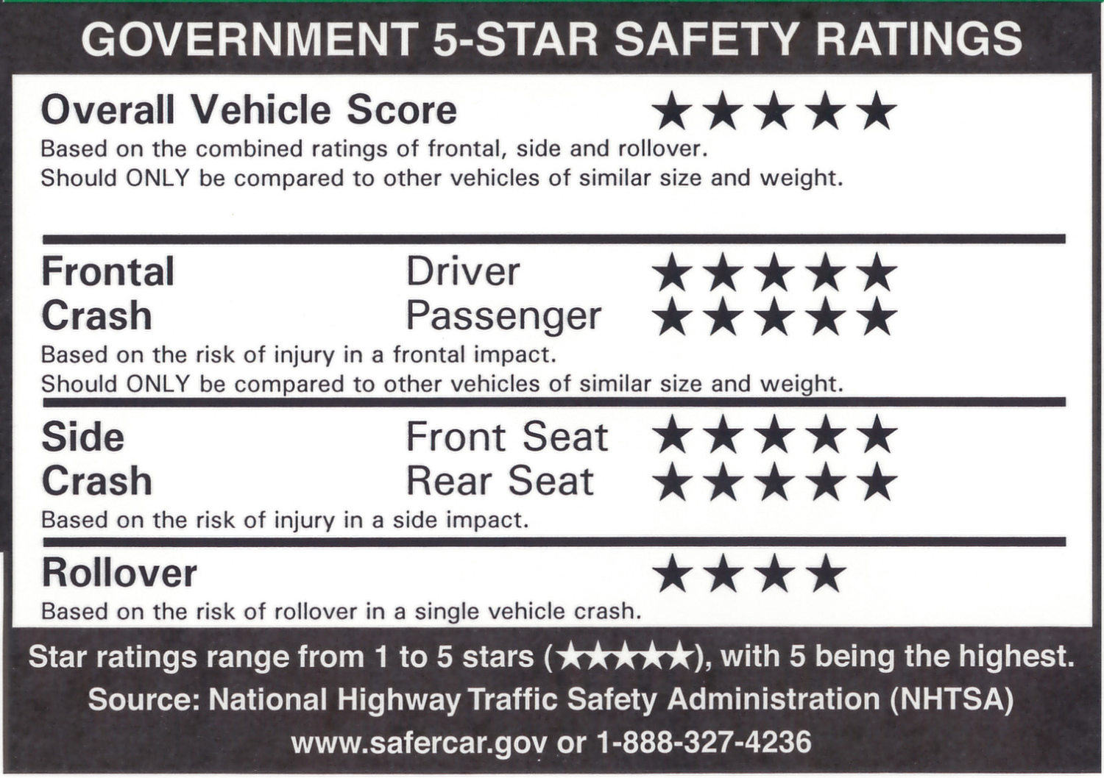

How clear and understandable is the information presented in this section?

- Not at all clear and understandable
- Not very clear and understandable
- Somewhat clear and understandable
- Very clear and understandable
Q30a. How important is it to include the 5-star safety rating information on the window sticker?

- Not at all important
- Not too important
- Somewhat important
- Very important
- Extremely important

Q30b. How important is it to make the government 5-star safety rating information stand out on the window sticker?

- Not at all important
- Not too important
- Somewhat important
- Very important
- Extremely important

V) Are the question and responses clear and easy to understand? IF NO: How would you ask the question & responses to make it clear and easy to understand?

Q31. Please rate how effective the following changes would be in helping make the government 5-star safety rating information stand out on the window sticker?

- Not at all effective
- Not too effective
- Somewhat effective
- Very effective
- Extremely effective
- Displaying the 5-star safety information in a different color
- Make the size of the 5-star safety information larger and easier to read
- Include more white space for legibility
- Fit all rating descriptions on one line
- Add a government seal or NHTSA logo to add credibility

W) Are the question and responses clear and easy to understand? IF NO: How would you ask the question & responses to make it clear and easy to understand?

ADVANCED SAFETY TECHNOLOGY FEATURES
[INTERVIEWER QUESTIONS HIGHLIGHTED IN YELLOW]

For this last section, we’d like to understand what you know and what you are interested in knowing about recommended safety technologies.

Q32. When you hear the term “recommended safety technologies”, what comes to mind? Please be as specific as possible.

[OPEN END]

Q33. How interested are you in learning about recommended safety technologies?

- Not at all interested
- Somewhat interested
- Interested
- Very interested
- Extremely interested

Q33b. Now thinking back about the window sticker, how important is it to include information about advanced safety technology features on the window sticker?

- Not at all important
- Not too important
- Somewhat important
- Very important
- Extremely important

Q33c. How important is it to make information about advanced safety technology features stand out on the window sticker?

- Not at all important
- Not too important
- Somewhat important
- Very important
- Extremely important

X) Are the question and responses clear and easy to understand? IF NO: How would you ask the question & responses to make it clear and easy to understand?

Q34. How useful would each of the following be for you personally?

- Not at all useful
- Somewhat useful
- Useful
- Very useful
- Extremely useful

[RANDOMIZE]
- Details on whether or not the advanced safety technologies installed on a particular vehicle meets the government performance criteria
- General recommendations on what advanced safety technologies consumers should consider
- Specific recommendations for advanced safety technologies I should consider for a certain vehicle
- General information on advanced safety technologies that are being developed for vehicles

Y) Looking at this list again, are there any of these descriptions that are confusing or unclear to you? IF SO, which ones?
- What information could be added to make that clearer to you?
- Details on whether or not the advanced safety technologies installed on a particular vehicle meets the government performance criteria
- General recommendations on what advanced safety technologies consumers should consider
- Specific recommendations for advanced safety technologies I should consider for a certain vehicle
- General information on advanced safety technologies that are being developed for vehicles
Q35. How familiar are you with each of the following recommended safety
technologies in vehicles?

- I have never heard of this technology
- I have heard of this technology, but I am not familiar with it
- I am familiar with this technology, but do not currently have it installed on one of my vehicles
- I have this technology on one or more of my vehicles

[RANDOMIZE]
    - A system that is designed to warn a driver when their vehicle begins to move out of its lane (unless a turn signal is on in that direction)
    - A system that is designed to warn a driver when the vehicle is about to rear end another vehicle or object in front of the vehicle, giving the driver more time to react
    - A system that supplements the driver’s braking if the driver does not break hard enough to avoid a front-end crash into another vehicle
    - A system that automatically applies the brakes when the vehicle is about to impact another vehicle or object in front of the vehicle, assisting if the driver is slow to react to prevent a collision or reduce collision speed

Z) Let’s look at each of these technologies individually, in your own words what does each of these technologies do? How would it work if you were behind the wheel?

- A system that is designed to warn a driver when their vehicle begins to move out of its lane (unless a turn signal is on in that direction)
- A system that is designed to warn a driver when the vehicle is about to rear end another vehicle or object in front of the vehicle, giving the driver more time to react
- A system that supplements the driver’s braking if the driver does not break hard enough to avoid a front-end crash into another vehicle
- A system that automatically applies the brakes when the vehicle is about to impact another vehicle or object in front of the vehicle, assisting if the driver is slow to react to prevent a collision or reduce collision speed

Q36. Thinking about your next vehicle purchase, would you say each of the following technologies is a must have, nice to have or not necessary?

- Must have
- Nice to have
- Not necessary

[MAINTAIN Q35 ORDER]
    - A system that is designed to warn a driver when their vehicle begins to move out of its lane (unless a turn signal is on in that direction).
    - A system that is designed to warn a driver when the vehicle is about to rear end another vehicle or object in front of the vehicle, giving the driver more time to react.
    - A system that supplements the driver’s braking if the driver does not break hard enough to avoid a front-end crash into another vehicle
    - another vehicle or object in front of the vehicle, assisting if the driver is slow to react to prevent a collision or reduce collision speed.

AA) In this question, you were given three possible responses…

- Must have
- Nice to have
- Not necessary
Do you feel that those are the right responses for you to accurately answer this question?
- Should there be other options provided?
- IF SO, what should those be?
- Why do you feel its important to include those options?

Q37. What do you think each of these technologies are called?

[MAINTAIN Q35 ORDER]
[OPEN END FOR EACH, D/K CHECK BOX]

A | A system that is designed to warn a driver when their vehicle begins to move out of its lane (unless a turn signal is on in that direction). | OPEN-END | Don’t Know
B | A system that is designed to warn a driver when the vehicle is about to rear end another vehicle or object in front of the vehicle, giving the driver more time to react. | OPEN-END | Don’t Know
C | A system that supplements the driver’s braking if the driver does not break hard enough to avoid a front-end crash into another vehicle | OPEN-END | Don’t Know
D | A system that automatically applies the brakes when the vehicle is about to impact another vehicle or object in front of the vehicle, assisting if the driver is slow to react to prevent a collision or reduce collision speed. | OPEN-END | Don’t Know

BB) Did you have any difficultly providing a thought on what any of these options should be called?
- IF YES, what was that difficult for you?
- How could that be changed to make that easier for you?

Q38. The National Highway Traffic Safety Administration currently includes information about four technologies as part of the safety ratings section of their website. The images below are from three different vehicles.

2019 Honda Accord
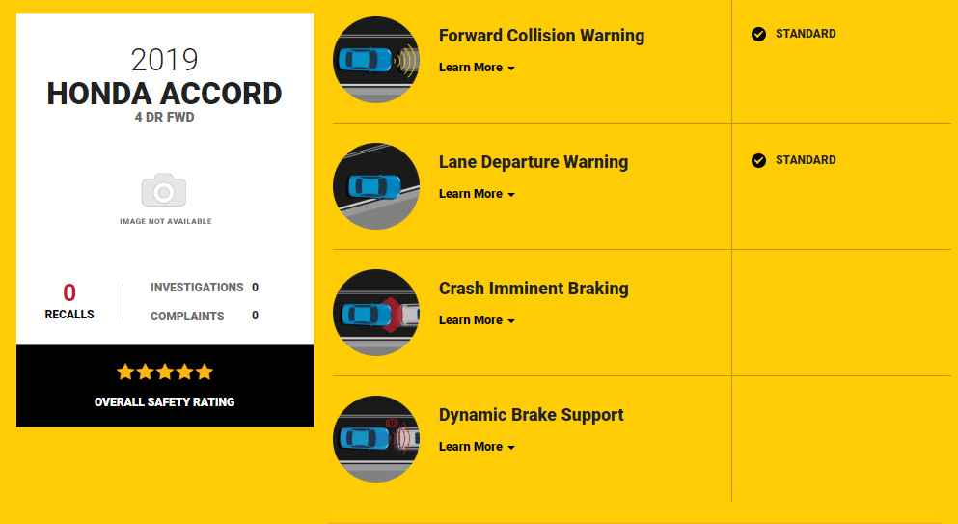

2019 Ford Fusion
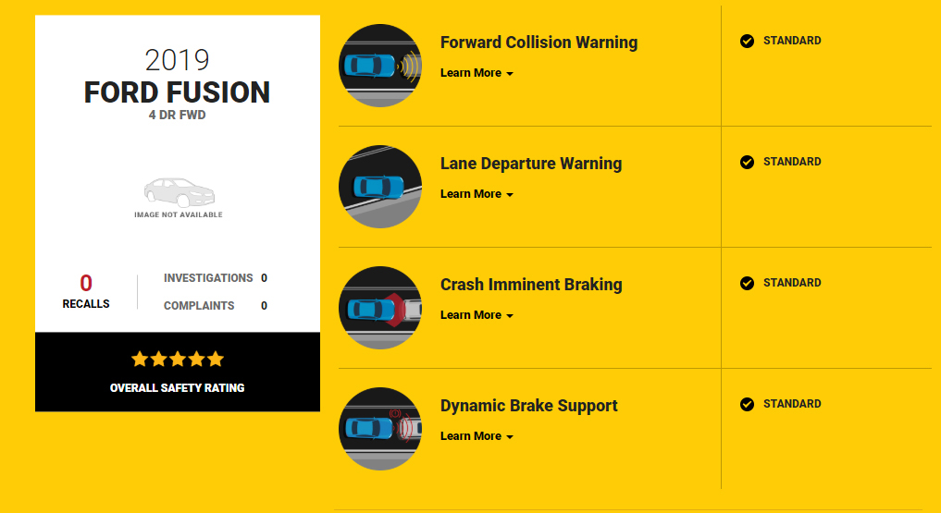

2019 Hyundai Sonata Hybrid
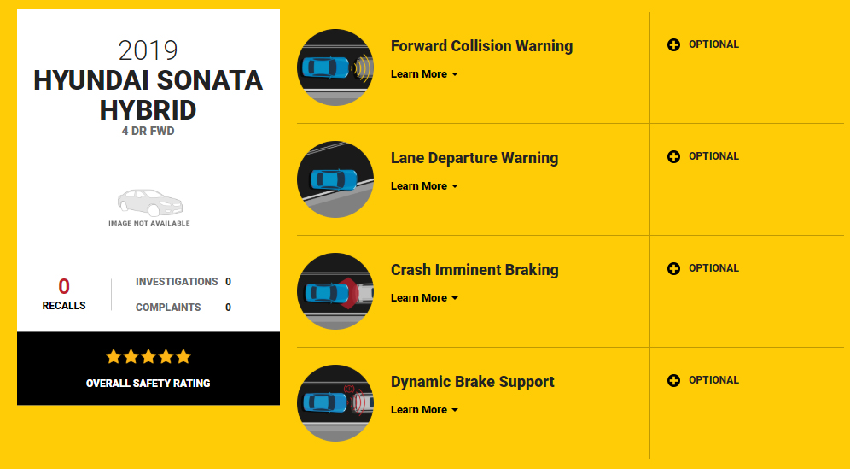

CC) Were you able to clearly see these images on your screen?
- Was there anything about these images that was difficult for you to see or understand? IF SO, what?
- Was it clear that this information is available on the website and NOT on window stickers?

Based on this information, what do you believe the check marks mean? (Select all that apply.)

[ACCEPT MULTIPLE RESPONSE; RANDOMIZE & ANCHOR PUNCH 6 & 7]
- This technology is standard on this vehicle
- This technology is an optional feature available
- This technology is not available on this vehicle
- Consumers should consider adding this technology if they purchase this vehicle
- The technology that’s available for this vehicle as standard equipment meets NHTSA’s performance criteria
- Something else [SPECIFY]
- I don’t know what the check marks mean [EXCLUSIVE]

[DISPLAY IMAGES AGAIN]
Q39. Based on this information, what do you believe the plus marks mean? (Select all that apply.)

[ACCEPT MULTIPLE RESPONSE; RANDOMIZE & ANCHOR PUNCH 6 & 7]
- This technology is standard on this vehicle
- This technology is an optional feature available
- This technology is not available on this vehicle
- Consumers should consider adding this technology if they purchase this vehicle
- The technology that’s available for this vehicle as optional equipment meets NHTSA’s performance criteria
- Something else [SPECIFY]
- I don’t know what the check marks mean [EXCLUSIVE]
[DISPLAY IMAGES AGAIN]
Q40. Based on this information, what do you believe the “x” marks mean? (Select all that apply.)

[ACCEPT MULTIPLE RESPONSE; RANDOMIZE & ANCHOR PUNCH 6 & 7]
- This technology is standard on this vehicle
- This technology is an optional feature available
- This technology is not available on this vehicle
- Consumers should consider adding this technology if they purchase this vehicle
- The technology that’s available for this vehicle meets NHTSA’s performance standard
- Something else [SPECIFY]
- I don’t know what the check marks mean [EXCLUSIVE]
DD) Was there anything confusing about this question or the response options you were given? IF SO, what was confusing to you?
- How could that be made more clear for you?

EE) For these questions, did you have any difficulty distinguishing between the PLUS marks, the CHECK marks, and the ‘X’ marks? IF YES, how could that be made clearer to you?
Q41. What additional information can the National Highway Traffic Safety Administration provide about these technologies that would be helpful for you during your vehicle purchase decisions?

[OPEN END]

DEMOGRAPHICS
[INTERVIEWER QUESTIONS HIGHLIGHTED IN YELLOW]

These last few questions are for classification purposes only.

Q42. What is the last grade you completed in school?

- Some grade school (1-8)
- Some high school (9-11)
- High school graduate (12)
- Technical or vocational school
- Some college
- College graduate
- Graduate or professional school
- Prefer not to answer

Q43. Are you of Hispanic or Latino origin?

- Yes
- No
Q44. What is your race? Please select one or more.

- American Indian or Alaska Native
- Asian American
- Black or African American
- Native Hawaiian or Other Pacific Islander
- Caucasian
- Other
- Prefer not to answer

Q45. What is your marital status?

- Never married
- Married
- Living together with someone but not married
- Separated
- Divorced
- Widowed
- Prefer not to answer
Q46. What is your current employment status?

- Employed full-time
- Employed part-time
- Not employed
- Retired
- Student
- Homemaker/Caregiver/Stay-at-home parent
- Prefer not to answer

Q47. Which ONE of the following best describes your total household income? [ALLOW FOR NONRESPONSE]

- Under $25,000
- $25,000 to less than $50,000
- $50,000 to less than $75,000
- $75,000 to less than $100,000
- $100,000 to less than $150,000
- $150,000 to less than $200,000
- $200,000 or more
- Prefer not to answer

Q48. How many children under the age of 18, if any, do you currently have living in your household?

- None
- 1
- 2
- 3
- 4
- 5 or more

Thank you for your time and valuable input.

FF) Are there any questions in this last section that you would be uncomfortable answering? IF YES, which ones? Why would you be uncomfortable answering those?

GG) Overall, how did you find this experience with this survey?
- Were there any areas that stood out as particularly confusing or difficult to complete? IF SO, which ones? Why do you say that? [RETURN TO SPECIFIC SECTIONS AS NEEDED]

HH) Is there anything in the survey that you think could be changed or modified to make it
easier for people like yourself to compete? IF SO, what? How do you think that should be modified?

II) Are there any final comments you’d like to share about the questionnaire or your
experience here today?
THANK AND RELEASE RESPONDENT.

