
U.S. Department
Of Transportation
Federal Aviation
Administration

FAA Form 7480-1, Notice for Construction, Alteration and Deactivation of Airports

Paperwork Reduction Act Burden Statement
A federal agency may not conduct or sponsor, and a person is not required to respond to, nor shall a person be subject to a penalty for failure to comply with a collection of information subject to the requirements of the Paperwork Reduction Act unless that collection of information displays a currently valid OMB Control Number. The OMB Control Number for this information collection is 2120-0036. Public reporting for this collection of information is estimated to be approximately 60 minutes per response, including the time for reviewing instructions, searching existing data sources, gathering and maintaining the data needed, completing and reviewing the collection of information.
All responses to this collection of information are required if the proponent wishes to have the airport on file with the FAA, as required by Title 14 Code of Federal Regulations Part 157, and entered into the National Airspace System. No assurances of confidentiality are given. Send comments regarding this burden estimate or any other aspect of this collection of information, including suggestions for reducing this burden to: Information Collection Clearance Officer, Federal Aviation Administration, 10101 Hillwood Parkway, Fort Worth, TX 76177-1524.

When to File a Notice for Construction, Alteration and Deactivation of Airports
Title 14 Code of Federal Regulations Part 157 requires all persons to notify the FAA at least 90 days before construction, alteration, activation, deactivation, or change to the status or use of a civil or joint-use (civil/military) airport. (As used herein, the term “airport” means any Landing or Takeoff Area, e.g. Airport, Heliport, Vertiport, Gliderport, Seaplane Base, Ultralight Flightpark, or Balloonport.)
Notice is not required for:
- An airport subject to conditions of a Federal agreement that requires an approved current airport layout plan to be on file with the Federal Aviation Administration.
- Establishment of a temporary airport at which operations will be conducted under visual flight rule(VFR) and will be used for less than 30 days with no more than 10 operations per day
- Intermittent use of a site that is not an established airport, which is used for less than one year and at which flight operations will be conducted only under VFR. (Intermittent use means the useof the site for no more than 3 days in any one week and for no more than 10 operations per day.)
Required notice will be submitted on this form from each person who intends to do the any of the following:
- Construct or otherwise establish a new airport or activate an airport.
- Construct, alter, realign, or activate any runway, or other aircraft landing or takeoff area of an airport.
- Construct, alter, realign, or activate a taxiway associated with a landing or takeoff area on a public-use airport.
- Deactivate, discontinue using, or abandon an airport or any landing or takeoff area of an airport for a period of one year or more.
- Deactivate, abandon, or discontinue using a taxiway associated with a landing or takeoff area on a public-use airport.
- Change the status of an airport from private use (use by the owner or use by the owner and other person authorized by the owner) to an airport open to the public of from public-use to another status.
- Change status from IFR (Instrument Flight Rules) to VFR or from VFR to IFR.
- Establish or change any traffic pattern or traffic pattern altitude or direction.
Section 901 of the Federal Aviation Act of 1958, as amended, provides that any person who violates a rule, regulation, or order issued under Title III of this Act will be subject to a civil penalty not to exceed $1,000 for each violation.

General Instructions – Form Completion
Please contact the local ADO or Regional office for filing instructions.

Section A – Complete this section.
- Provide the name of the Airport Owner.
- Include contact information (phone number, email address, and mailing address) of the Airport Owner.
- Indicate if the Airport Owner owns the airport property,
- Indicate if the Airport Owner’s address is the physical address of the airport. (If the Airport Owner’s address is not the physical address of the airport, provide the physical address of the airport in box C.6. Description.)

Section B – Complete this section if the Airport Manager is not the same person listed in section A.
- If the Airport Owner provided in Section A is the Airport Manager, write “SAME” in box B.1. Airport Manager.
- If the Airport Owner provided in Section A is not the Airport Manager, provide the name of the Airport Manager.
- Include contact information (phone number, email address, and mailing address) of the Airport Manager.
- Indicate if the Airport Manager owns the airport property.
- Indicate if the Airport Manager address is the physical address of the airport. (If the Airport Manager’s address is not the physical address of the airport, provide the physical address of the airport in box C.6. Description.)

Section C – Provide the reason for notification by completing all applicable items in this section.
Report only one action per form
- Section C.1: Select one type of facility.
- Section C.2: Select one. For public-use taxiway, include information in box C.6. Description and depict taxiway layout on airport drawing or sketch.
- Section C.3: Select one. If change is from VFR to IFR, include anticipated IFR procedure in box 6. Description.
- Section C.4: Select standard traffic pattern altitudes and/or the non-standard traffic/multiple pattern altitudes. For non-standard altitudes, check the boxes that apply and provide the altitudes.
- Section C.5: Provide appropriate information and include abandonment date in box 6. Description.

Section D – Provide all applicable information.
- Section D.1: Enter name of landing area.
- Section D.2: Enter the Location Identifier (Loc ID) for an existing Airport.
- Section D.3: Enter principle city or town which the airport serves and with it is normally associated.
- Section D.4: Enter straight-line distance and direction, to the nearest nautical mile, from the Associated City (C.3. above) to the Airport.
- Section D.6: Enter the direction, to the nearest eighth compass point (i.e. E, SE, etc.), from the Associated City to the Airport.
- Section D.7, 8, and 9: Enter the Latitude and Longitude of the Airport Reference Point and the Airport Elevation. The airport reference point can be calculated by using the NGS tool located at http://www.ngs.noaa.gov/AERO/arpcomp/arpframe.html. The Airport elevation is the highest point of an airport's usable runways measured in feet above mean sea level.
- Section D.10: Select one Current Use option.
- Section D.11: Select one Ownership option.
- Section D.12: Select Airport Type.

Section E – Provide all applicable information.
- Section E.1: Address each runway end independently, if applicable. Provide runway end coordinates and elevations; and runway threshold coordinates and elevations for runway threshold displacements, if applicable (see an example Box 1 below).
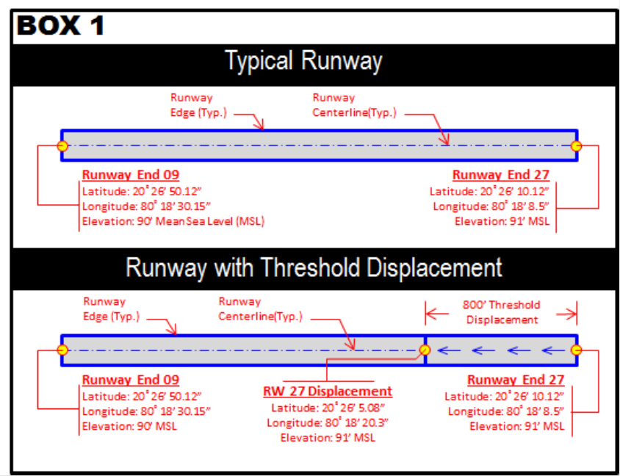
- Section E.2: If helipad is elevated, provide the elevated height above ground level (AGL) and do not add the AGL height to Above Mean Sea Level (AMSL). For Heliports, include the TLOF (Touchdown and Liftoff Area) and FATO (Final Approach and Take Off) dimensions.

Section F – Provide all applicable information.

Section G – All information is required and must be complete.
- For an Airport/Runway: Provide a detailed drawing and/or imagery of the proposed landing area depicting latitude, longitude, length and width. The document(s) must show the runway orientation in relation to known roads, terrain etc. such that the FAA can locate the runway(s) accurately and efficiently. Notate any obstructions (buildings, high-line wires, roads, railroads, towers, etc.) within the vicinity of the runway. You must include runway end coordinates and the runway elevations on the runway centerline.
- For a Heliport: Provide a detailed drawing, imagery or map identifying the exact location of the heliport in red. The document(s) must show the helipad(s) in relation to known roads, terrain etc. such that the FAA can locate the heliport accurately and efficiently. Provide site plan depicting the landing pad in relation to buildings and other obstacles (light poles, fences, trees, bollards, parking lots) in the vicinity of the landing area. Provide dimensions of the landing pad and the height of the buildings/obstacles and their distance from the helipad. Provide a heliport layout plan (in accordance with FAA Advisory Circular 150/5390-2, Heliport Design) identifying the proposed marking, lights, beacon location, windsock(s), the approach/departure paths (if room allows, the heliport layout plan may be shown on the site plan).
Notification to the FAA does not waive the requirements of any other government agency.

Regional Office Addresses
Submit your completed form by mail to the appropriate regional office.
Alaskan Region
AK
U.S. Department of Transportation
Federal Aviation Administration
Alaskan Region Airports Division, AAL-600
222 W. 7th Ave, M/S #14
Anchorage, AK 99513
Tel: (907) 271-5438
Fax: (907) 271-2851
Central Region
IA, KS, MO, NE
U.S. Department of Transportation
Federal Aviation Administration
Central Region Airports Division, ACE-600
901 Locust St., Room 364
Kansas City, MO 64106-2325
Tel: (816) 329-2600
Fax: (816) 329-2610/2611
Eastern Region
DC, DE, MD, NJ, NY, PA, VA, WV
U.S. Department of Transportation
Federal Aviation Administration
Eastern Region Airports Division, AEA-600
1 Aviation Plaza
Jamaica, NY 11434
Tel: (718) 553-3330
Fax: (718) 995-5694
Great Lakes Region
IL, IN, MI, MN, ND, OH, SD, WI
U.S. Department of Transportation
Federal Aviation Administration
Great Lakes Region Airports Division, AGL-600
2300 East Devon Avenue
Des Plaines, IL 60018
Tel: (847) 294-7272
Fax: (847) 294-7036
New England Region
CT, ME, MA, NH, RI, VT
U.S. Department of Transportation
Federal Aviation Administration
New England Region Airports Division, ANE-600
1200 District Avenue
Burlington, MA 01803
Tel: (781) 238-7600
Fax: (781) 238-7608
Northwest Mountain Region
CO, ID, MT, OR, UT, WA, WY
U.S. Department of Transportation
Federal Aviation Administration
Northwest Mountain Region Airports Division, ANM-600
2200 S 216th St
Des Moines, WA 98198
Tel: (206) 231-4100
Fax: (206) 231-EXT
Southern Region
AL, FL, GA, KY, MS, NC, TN, SC, PR, VI
U.S. Department of Transportation
Federal Aviation Administration
Southern Region Airports Division, ASO-600
1701 Columbia Ave., Suite 540
Atlanta, GA 30337
Tel: (404) 305-6700
Fax: (404) 305-6730
Southwest Region
AR, LA, NM, OK, TX
U.S. Department of Transportation
Federal Aviation Administration
Southwest Region Airports Division,
ASW-600
10101 Hillwood Parkway
Fort Worth, TX 76177
Tel: (817) 222-5600
Fax: (817) 222-5987
Western-Pacific Region
CA, NV, AZ, HI
U.S. Department of Transportation
Federal Aviation Administration
Western-Pacific Region Airports Division, AWP-600
777 S Aviation Blvd. Suite 150
El Segundo, CA 90245
Tel: (424) 405-7300

U.S. Department of Transportation OMB CONTROL NUMBER: 2120-0036
Federal Aviation Administration EXPIRATION DATE: 6/30/2019
NOTICE FOR CONSTRUCTION, ALTERATION AND DEACTIVATION OF AIRPORTS
A. Airport Owner Check if this is also the Property Owner |  |  |  |  |  |  |  |  |  |  |  | B. Airport Manager (Complete if different than the Airport Owner)
- Name and Address Check if this is the Airport’s Physical Address |  |  |  |  |  |  |  |  |  |  |  | - Name and Address Check if this is the Airport’s Physical Address
- Phone |  |  |  | - Email |  |  |  |  |  |  |  | - Phone |  |  |  |  |  |  |  | - Email
C. Purpose of Notification (Answer all questions that apply) |  |  |  |  |  |  |  |  |  |  |  | D. Name, Location, Use and Type of Landing Area
- Construct or Establish an: |  | Airport Ultralight Flightpark Balloonport  Heliport Seaplane Base Other |  |  |  |  |  |  |  |  |  | - Name of Landing Area |  |  |  |  |  |  |  |  |  |  |  |  |  |  | - Loc ID (for existing)
- Construct, Alter or Realign a: |  | Runway Helipad(s) Other  Taxiway (Public Use Airports only) |  |  |  |  |  |  |  |  |  | - Associated City and State |  |  |  |  |  |  |  |  |  |  |  |  |  |  | - Distance from City  (nm)
- Change Status From/To: |  | VFR to IFR IFR to VFR  Private Use to Public Use Public Use to Other |  |  |  |  |  |  |  |  |  | - County (Physical Location) |  |  |  |  |  |  |  |  |  |  |  |  |  |  | - Direction from City
- Change Traffic Pattern: |  | Direction _________________________________  Standard Altitudes Non-Standard Altitudes (For non-standard, specify: Turbo _______ Prop_____ Helo _______ Other (Describe in Box C6)) |  |  |  |  |  |  |  |  |  | - Latitude |  |  |  |  |  |  |  |  |  | - Longitude |  |  |  |  |  | - Elevation
 |  |  |  |  |  |  |  |  |  |  |  | ° |  |  | ' |  |  | " |  |  |  | ° | ' |  | "
 |  |  |  |  |  |  |  |  |  |  |  | - Current Use: |  |  |  |  | Private Public Private Use of Public Lands
5. Deactivate: |  |  | Airport RWY _________ TWY ________ |  |  |  |  |  |  |  |  | - Ownership: |  |  |  |  | Private Public Military (Branch) ________________
- Description: |  |  |  |  |  |  |  |  |  |  |  | 12. Airport Type: |  |  |  |  | Airport Ultralight Flightpark Balloonport Heliport (If applicable, select: Ambulance Law Enforcement Fire Protection) Seaplane Base Other
E. Landing Area Data (List any Proposed, New or Unregistered Runways, Helipads etc.)
- Airport, Seaplane Base or Ultralight Flightpark (use second page if needed) |  |  |  |  |  |  |  |  |  |  |  |  | - Heliport, Balloonport or other Landing Area (use second page if needed)
RWY ID |  |  |  |  | / |  |  |  |  | / |  |  | Helipad ID
Lat. & Long. | Show on attachment(s) |  |  |  |  |  | Show on attachment(s) |  |  |  |  |  | Lat. & Long. |  |  |  |  |  | Show on attachment(s) |  |  |  |  |  |  | Show on attachment(s)
Surface Type |  |  |  |  |  |  |  |  |  |  |  |  | Surface Type
Length (feet) |  |  |  |  |  |  |  |  |  |  |  |  | TLOF Dimensions
Width (feet) |  |  |  |  |  |  |  |  |  |  |  |  | FATO Dimensions
Lighting (if any) |  |  |  |  |  |  |  |  |  |  |  |  | Lighting (if any)
Right Traffic (Y/N) |  |  |  |  | / |  |  |  |  | / |  |  | Ingress/Egress (Degrees)
Elevation (AMSL) | Show on attachment(s) |  |  |  |  |  | Show on attachment(s) |  |  |  |  |  | Elevation (AMSL) |  |  |  |  |  | Show on attachment(s) |  |  |  |  |  |  | Show on attachment(s)
VFR or IFR |  |  |  |  | / |  |  |  |  | / |  |  | Elevated Height (AGL)

F. Operational Data (Indicate if the number provided is Actual or Estimated)
 |  |  | Number of Based Aircraft |  |  |  |  |  |  |  |  |  |  |  |  | Average Number of Monthly Landings
 |  |  | Present or Estimated |  |  |  |  |  | Estimated in 5 Years |  |  |  |  |  |  | Present or Estimated |  |  |  |  |  |  |  | Estimated in 5 Years

Single Engine

Multi Engine

Jet

Helicopter

Glider

Military

Ultralight

What is the Most Demanding Aircraft that operates or will operate at the Airport? (Provide approach speed, rotor diameter, etc. if known)

Are IFR Procedures for the Airport Anticipated? Yes No if Yes, within _____________ years

G. CERTIFICATION: I hereby certify that all of the above statements made by me are true and complete to the best of my knowledge.
Name, title of person filing this notice (type or print) |  |  |  |  |  |  |  | Signature (in ink):
 |  |  |  |  |  |  |  | Date |  |  |  |  |  | Phone |  |  |  |  |  |  | - Email
FAA Form 7480-1 (5/19) SUPERSEDES PREVIOUS EDITION

