Attachment 4 – Screen Shots for Modifications and Additions to the Existing FMS Host Site Application Module
OMB CONTROL NUMBER 0920-0765
FELLOWSHIP MANAGEMENT SYSTEM
NON-SUBSTANTIVE CHANGE REQUEST

PROPOSED MODIFICATIONS FOR CDC PREVENTIVE MEDICINE RESIDENCY & FELLOWSHIP (PMR/F)
FMS APPLICATION MODULE
DATE SUBMITTED: APRIL 18, 2019

8.1 Public Health Agency Statement Section
Figure 8.1 a.1 Public Health Agency Statement Page
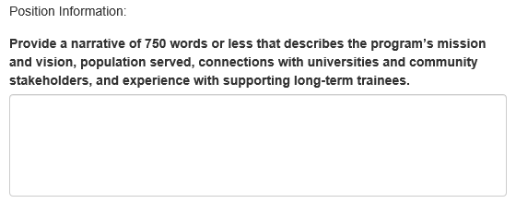
Figure 8.1 a.2 Public Health Agency Statement Page
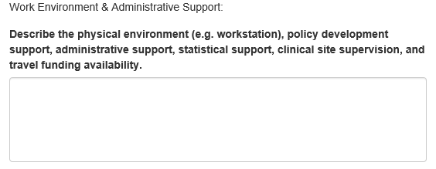
Figure 8.1 a.3 Public Health Agency Statement Page
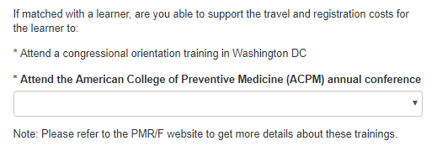
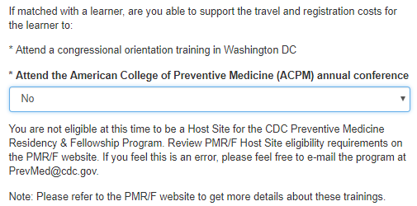
Figure 8.1 a.4 Public Health Agency Statement Page
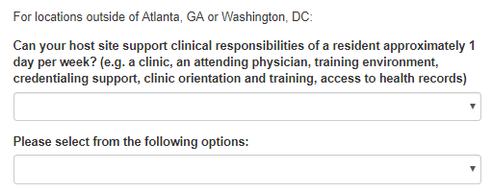
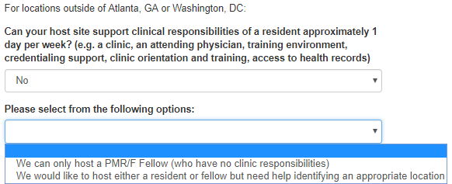

Figure 8.1 a.5 Public Health Agency Statement Page


Program Information Section
Figure 9.2-D. Program Information*
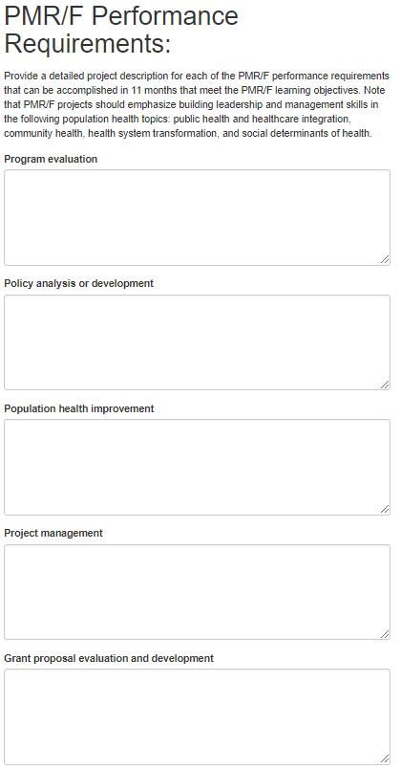
*Note: Only collected by Preventive Medicine Residency & Fellowship (PMR/F) program

