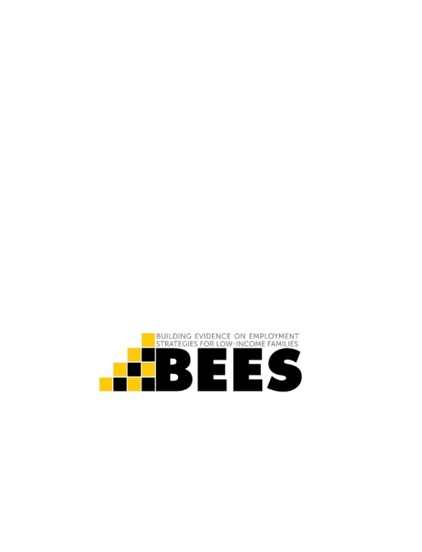 | We have been trying to reach you!  We’re calling about the Building Evidence on Employment Strategies for Low-Income Families, or BEES, study. You agreed to be in this study about [6/12] months ago. At that time you applied to receive training and services through your [BEES program].  This is a very important research study. It is funded by U.S. Department of Health and Human Services.  After you complete the survey, you will receive a gift card worth [$15/$25] to thank you for your help with this important study.  To schedule your survey or to get more information about the BEES Study, please:  Call ___________________________  at _____________________________  Please mention this number: ______________________
The Paperwork Reduction Act Statement: This collection of information is voluntary and will be used to understand programs that aim to improve employment outcomes for low-income adults. An agency may not conduct or sponsor, and a person is not required to respond to, a collection of information unless it displays a currently valid OMB control number. The OMB number and expiration date for this collection are OMB #: XXXX-XXXX, Exp: XX/XX/XXXX.

