SECTION A: YOUR RECREATIONAL SALTWATER FISHING EXPERIENCES
These questions are about you and your recreational saltwater fishing experiences.
Please do not include any information about other people you go fishing with.
- Within the last five years, which of the following species have you gone fishing for, even if you didn’t catch or keep any? Please select all that apply.
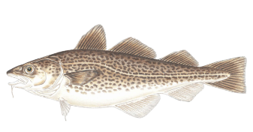
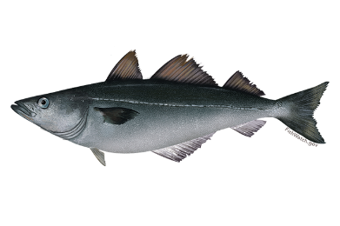
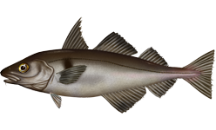
 |  |  | Haddock |  |  |  |  |  |  |  |  |  | Pollock |  |  |  |  |  | Cod
 |  |  |  |  |  |  | None of these species Go to Section B on Page X
- During 2018, which of the following species did you go fishing for, even if you didn’t catch or keep any? Please select all that apply.
 |  |  | Haddock |  |  |  |  |  |  |  |  |  | Pollock |  |  |  |  |  | Cod
- During 2018, on how many trips did you go fishing for haddock, pollock, or cod, even if you didn’t catch or keep any? Please fill in the number of trips by fishing mode.
 |  | Party or head boat (usually 25 or more anglers per boat)…………… |  |  |  |  |  |  |  |  |  |  |  |  |  |  |  | # |  | 2018 trips
 |  | Charter or guide boat (usually 1-6 anglers per boat)…………………… |  |  |  |  |  |  |  |  |  |  |  |  |  |  |  | # |  | 2018 trips
 |  | Private boat (owned or rented by you, a friend, or a relative)…….. |  |  |  |  |  |  |  |  |  |  |  |  |  |  |  | # |  | 2018 trips
- Do you like recreational saltwater fishing more, about the same, or less than
other recreational activities?
 |  |  |  |  |  | More
 |  |  |  |  |  | About the same
 |  |  |  |  |  | Less
NARFS survey instrument

SECTION A: YOUR RECREATIONAL SALTWATER FISHING EXPERIENCES
These questions are about you and your recreational saltwater fishing experiences.
Please do not include any information about other people you go fishing with.
The map below shows two saltwater fishing areas in the North Atlantic.
Please use this map to answer questions 5 and 6.
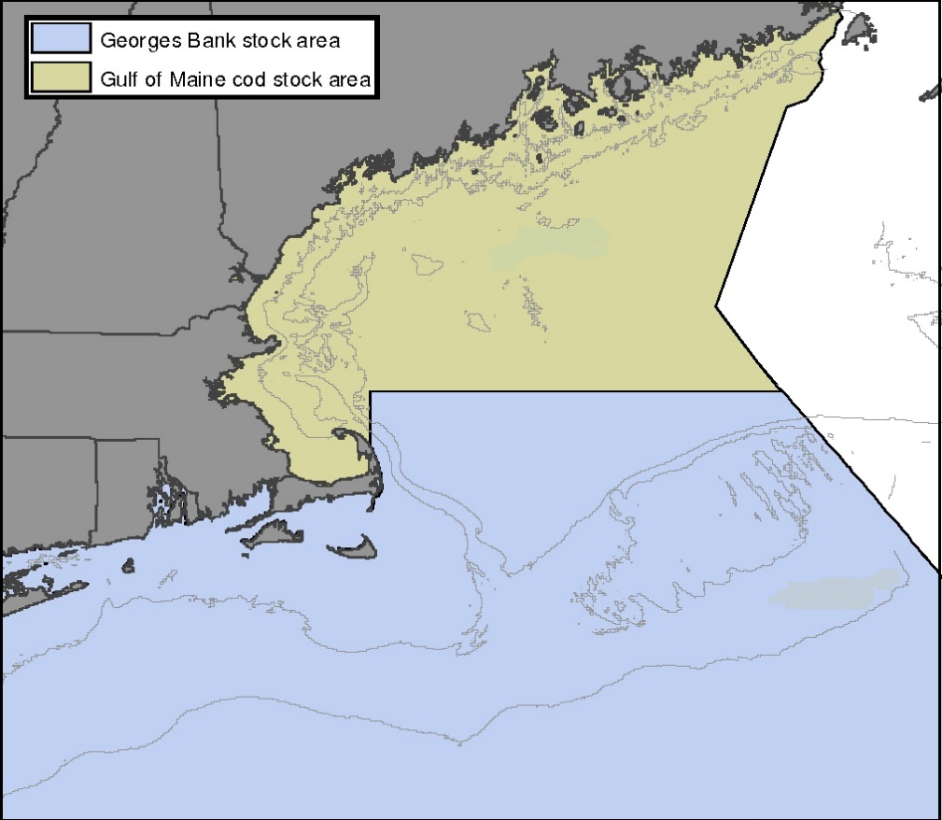
Gulf of Maine

Georges Bank

Gulf of Maine and Georges Bank Stock Areas

- In what area do you go recreational fishing for haddock, pollock, or cod most often?
Gulf of Maine, including Stellwagen Bank
Georges Bank
Both areas about equally
- Prior to 2015, did you ever go recreational fishing for cod in the Gulf of Maine?
Yes
No

SECTION B: YOUR SALTWATER FISHING TRIP PREFERENCES
Your answers to the next six questions are extremely important to the success of the survey because they will be directly incorporated into the policymaking process. Please make your voice heard by answering each of these questions.

Each question will present you with three options, like in the example below. Options 1 and 2 are hypothetical fishing trips with different catch levels, trip lengths, and trip costs. Option 3 is not going recreational saltwater fishing.

After comparing the three options, indicate which ones would be your first and second choice.

Please do the following things to make sure we represent your thinking accurately:
- Answer each question as if you were actually presented with the three options in the real world.
- If you would not pay the amount listed for either fishing trip option, choose Option 3.
- There are no right or wrong answers, we simply want to understand the tradeoffs that anglers like you are willing to make.
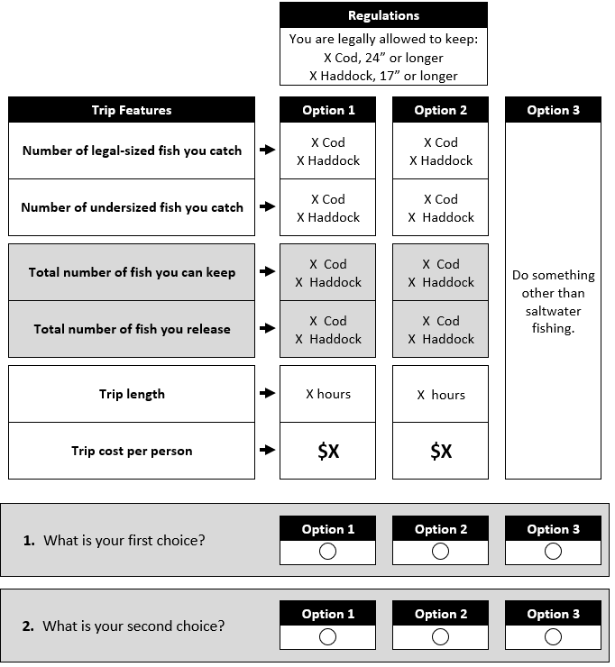
EXAMPLE

SECTION B: YOUR SALTWATER FISHING TRIP PREFERENCES
Suppose that you have the choice between two recreational saltwater fishing trips
(Option 1 or Option 2) and not going recreational saltwater fishing (Option 3). Below the
table, indicate which of these three options would be your first and second choice.
 |  |  |  |  |  | Regulations
 |  |  |  |  |  | You are legally allowed to keep:
3 Cod, 24” or longer
12 Haddock, 17” or longer
 | Trip Features |  |  |  |  |  | Option 1 |  | Option 2 |  |  | Option 3
 | Number of legal-sized fish you catch |  |  |  |  |  | 7 Cod  7 Haddock |  | 2 Cod  2 Haddock |  |  | Do something  other than  saltwater  fishing.
 | Number of undersized fish you catch |  |  |  |  |  | 3 Cod  3 Haddock |  | 3 Cod  1 Haddock
 | Total number of fish you can keep  Based on the regulations and the number of legal-sized fish you catch. |  |  |  |  |  | 3 Cod  7 Haddock |  | 2 Cod  2 Haddock
 | Total number of fish you release  Undersized fish + fish in excess of the  legal limit. |  |  |  |  |  | 7 Cod  3 Haddock |  | 3 Cod  1 Haddock
 | Trip length  Time spent on the water. |  |  |  |  |  | 10 hours |  | 10 hours
 | Trip cost per person  Your share of all fishing-trip related expenses. |  |  |  |  |  | $190 |  | $70
- If you were presented with these
three options, which one would you
choose? (Please select only one.)
 |  |  |  |  |  |  | Option 1 |  | Option 2 |  |  | Option 3
- What would be your second choice? (Please select only one.)
 |  |  |  |  |  |  | Option 1 |  | Option 2 |  |  | Option 3
 |  |  |  |  |  |  |  |  |  |  |  | Block 1, Q1

SECTION B: YOUR SALTWATER FISHING TRIP PREFERENCES
Suppose that you have the choice between two recreational saltwater fishing trips
(Option 1 or Option 2) and not going recreational saltwater fishing (Option 3). Below the
table, indicate which of these three options would be your first and second choice.
 |  |  |  |  |  | Regulations
 |  |  |  |  |  | You are legally allowed to keep:
2 Cod, 24” or longer
9 Haddock, 17” or longer
 | Trip Features |  |  |  |  |  | Option 1 |  | Option 2 |  |  | Option 3
 | Number of legal-sized fish you catch |  |  |  |  |  | 2 Cod  1 Haddock |  | 2 Cod  11 Haddock |  |  | Do something  other than  saltwater  fishing.
 | Number of undersized fish you catch |  |  |  |  |  | 3 Cod  0 Haddock |  | 1 Cod  3 Haddock
 | Total number of fish you can keep  Based on the regulations and the number of legal-sized fish you catch. |  |  |  |  |  | 2 Cod  1 Haddock |  | 2 Cod  9 Haddock
 | Total number of fish you release  Undersized fish + fish in excess of the  legal limit. |  |  |  |  |  | 3 Cod  0 Haddock |  | 1 Cod  5 Haddock
 | Trip length  Time spent on the water. |  |  |  |  |  | 6 hours |  | 8 hours
 | Trip cost per person  Your share of all fishing-trip related expenses. |  |  |  |  |  | $190 |  | $230
- If you were presented with these
three options, which one would you
choose? (Please select only one.)
 |  |  |  |  |  |  | Option 1 |  | Option 2 |  |  | Option 3
- What would be your second choice?
(Please select only one.)
 |  |  |  |  |  |  | Option 1 |  | Option 2 |  |  | Option 3
 |  |  |  |  |  |  |  |  |  |  |  | Block 1, Q2

SECTION B: YOUR SALTWATER FISHING TRIP PREFERENCES
Suppose that you have the choice between two recreational saltwater fishing trips
(Option 1 or Option 2) and not going recreational saltwater fishing (Option 3). Below the
table, indicate which of these three options would be your first and second choice.
 |  |  |  |  |  | Regulations
 |  |  |  |  |  | You are legally allowed to keep:
1 Cod, 24” or longer
6 Haddock, 17” or longer
 | Trip Features |  |  |  |  |  | Option 1 |  | Option 2 |  |  | Option 3
 | Number of legal-sized fish you catch |  |  |  |  |  | 2 Cod  7 Haddock |  | 1 Cod  4 Haddock |  |  | Do something  other than  saltwater  fishing.
 | Number of undersized fish you catch |  |  |  |  |  | 0 Cod  1 Haddock |  | 0 Cod  1 Haddock
 | Total number of fish you can keep  Based on the regulations and the number of legal-sized fish you catch. |  |  |  |  |  | 1 Cod  6 Haddock |  | 1 Cod  4 Haddock
 | Total number of fish you release  Undersized fish + fish in excess of the  legal limit. |  |  |  |  |  | 1 Cod  2 Haddock |  | 0 Cod  1 Haddock
 | Trip length  Time spent on the water. |  |  |  |  |  | 8 hours |  | 10 hours
 | Trip cost per person  Your share of all fishing-trip related expenses. |  |  |  |  |  | $270 |  | $110
- If you were presented with these
three options, which one would you
Choose? (Please select only one.)
 |  |  |  |  |  |  | Option 1 |  | Option 2 |  |  | Option 3
- What would be your second choice?
(Please select only one.)
 |  |  |  |  |  |  | Option 1 |  | Option 2 |  |  | Option 3
 |  |  |  |  |  |  |  |  |  |  |  | Block 1, Q3

SECTION B: YOUR SALTWATER FISHING TRIP PREFERENCES
Suppose that you have the choice between two recreational saltwater fishing trips
(Option 1 or Option 2) and not going recreational saltwater fishing (Option 3). Below the
table, indicate which of these three options would be your first and second choice.
 |  |  |  |  |  | Regulations
 |  |  |  |  |  | You are legally allowed to keep:
2 Cod, 24” or longer
9 Haddock, 17” or longer
 | Trip Features |  |  |  |  |  | Option 1 |  | Option 2 |  |  | Option 3
 | Number of legal-sized fish you catch |  |  |  |  |  | 1 Cod  11 Haddock |  | 7 Cod  4 Haddock |  |  | Do something  other than  saltwater  fishing.
 | Number of undersized fish you catch |  |  |  |  |  | 0 Cod  0 Haddock |  | 1 Cod  0 Haddock
 | Total number of fish you can keep  Based on the regulations and the number of legal-sized fish you catch. |  |  |  |  |  | 1 Cod  9 Haddock |  | 2 Cod  4 Haddock
 | Total number of fish you release  Undersized fish + fish in excess of the  legal limit. |  |  |  |  |  | 0 Cod  2 Haddock |  | 6 Cod  0 Haddock
 | Trip length  Time spent on the water. |  |  |  |  |  | 8 hours |  | 8 hours
 | Trip cost per person  Your share of all fishing-trip related expenses. |  |  |  |  |  | $230 |  | $110
- If you were presented with these
three options, which one would you
choose? (Please select only one.)
 |  |  |  |  |  |  | Option 1 |  | Option 2 |  |  | Option 3
- What would be your second choice?
(Please select only one.)
 |  |  |  |  |  |  | Option 1 |  | Option 2 |  |  | Option 3
 |  |  |  |  |  |  |  |  |  |  |  | Block 1, Q4

SECTION B: YOUR SALTWATER FISHING TRIP PREFERENCES
Suppose that you have the choice between two recreational saltwater fishing trips
(Option 1 or Option 2) and not going recreational saltwater fishing (Option 3). Below the
table, indicate which of these three options would be your first and second choice.
 |  |  |  |  |  | Regulations
 |  |  |  |  |  | You are legally allowed to keep:
3 Cod, 24” or longer
12 Haddock, 17” or longer
 | Trip Features |  |  |  |  |  | Option 1 |  | Option 2 |  |  | Option 3
 | Number of legal-sized fish you catch |  |  |  |  |  | 4 Cod  11 Haddock |  | 4 Cod  11 Haddock |  |  | Do something  other than  saltwater  fishing.
 | Number of undersized fish you catch |  |  |  |  |  | 1 Cod  1 Haddock |  | 3 Cod  0 Haddock
 | Total number of fish you can keep  Based on the regulations and the number of legal-sized fish you catch. |  |  |  |  |  | 3 Cod  11 Haddock |  | 3 Cod  11 Haddock
 | Total number of fish you release  Undersized fish + fish in excess of the  legal limit. |  |  |  |  |  | 2 Cod  1 Haddock |  | 4 Cod  0 Haddock
 | Trip length  Time spent on the water. |  |  |  |  |  | 6 hours |  | 6 hours
 | Trip cost per person  Your share of all fishing-trip related expenses. |  |  |  |  |  | $70 |  | $70
- If you were presented with these three options, which one would you choose? (Please select only one.)
 |  |  |  |  |  |  | Option 1 |  | Option 2 |  |  | Option 3
- What would be your second choice?
(Please select only one.)
 |  |  |  |  |  |  | Option 1 |  | Option 2 |  |  | Option 3
 |  |  |  |  |  |  |  |  |  |  |  | Block 1, Q5

SECTION B: YOUR SALTWATER FISHING TRIP PREFERENCES
Suppose that you have the choice between two recreational saltwater fishing trips
(Option 1 or Option 2) and not going recreational saltwater fishing (Option 3). Below the
table, indicate which of these three options would be your first and second choice.
 |  |  |  |  |  | Regulations
 |  |  |  |  |  | You are legally allowed to keep:
1 Cod, 24” or longer
6 Haddock, 17” or longer
 | Trip Features |  |  |  |  |  | Option 1 |  | Option 2 |  |  | Option 3
 | Number of legal-sized fish you catch |  |  |  |  |  | 2 Cod  4 Haddock |  | 7 Cod  2 Haddock |  |  | Do something  other than  saltwater  fishing.
 | Number of undersized fish you catch |  |  |  |  |  | 1 Cod  0 Haddock |  | 1 Cod  1 Haddock
 | Total number of fish you can keep  Based on the regulations and the number of legal-sized fish you catch. |  |  |  |  |  | 1 Cod  4 Haddock |  | 1 Cod  2 Haddock
 | Total number of fish you release  Undersized fish + fish in excess of the  legal limit. |  |  |  |  |  | 2 Cod  0 Haddock |  | 7 Cod  1 Haddock
 | Trip length  Time spent on the water. |  |  |  |  |  | 8 hours |  | 6 hours
 | Trip cost per person  Your share of all fishing-trip related expenses. |  |  |  |  |  | $190 |  | $230
- If you were presented with these three options, which one would you choose? (Please select only one.)
 |  |  |  |  |  |  | Option 1 |  | Option 2 |  |  | Option 3
- What would be your second choice?
(Please select only one.)
 |  |  |  |  |  |  | Option 1 |  | Option 2 |  |  | Option 3
 |  |  |  |  |  |  |  |  |  |  |  | Block 1, Q6

SECTION C: SALTWATER FISHING TRIP FEATURES
This question will help us understand which features of the saltwater fishing trip options in Section B did not factor into the choices you made.
- When you made your choices in Section B, were there any fishing trip features that you did not consider? Please select the trip features that you did not consider when you made those choices. If all the trip features factored into your choices, just skip this question.
 |  | Trip features from Section B questions that I did not consider. Select all that apply.
 |  | Number of cod you release |  |  |  |  |  |  |  |  |  |  |  |  |  |  |  |  |  |  |  |  |  | I did not consider this feature
 |  | Trip cost per person |  |  |  |  |  |  |  |  |  |  |  |  |  |  |  |  |  |  |  |  |  | I did not consider this feature
 |  | Number of haddock you keep |  |  |  |  |  |  |  |  |  |  |  |  |  |  |  |  |  |  |  |  |  | I did not consider this feature
 |  | Number of haddock you release |  |  |  |  |  |  |  |  |  |  |  |  |  |  |  |  |  |  |  |  |  | I did not consider this feature
 |  | Number of cod you can keep |  |  |  |  |  |  |  |  |  |  |  |  |  |  |  |  |  |  |  |  |  | I did not consider this feature
 |  | Trip length |  |  |  |  |  |  |  |  |  |  |  |  |  |  |  |  |  |  |  |  |  | I did not consider this feature

SECTION D: ABOUT YOU AND YOUR HOUSEHOLD
These questions will help us understand whether our sample is
representative of the angler population.
- Are you male or female?
 |  |  |  |  | Male |  |  |  |  |  |  |  |  |  | Female
- In what year were you born?
 |  |  |  |  |  |  |  | Year born (YYYY)
- What is the highest level of education you have completed?
 |  |  |  | Some high school |  |  |  |  |  |  |  |  |  |  | 4-year degree
 |  |  |  | High school graduate or GED |  |  |  |  |  |  |  |  |  |  | Some graduate school
 |  |  |  | 2-year degree or trade school graduate |  |  |  |  |  |  |  |  |  |  | Master’s degree (ex: MA, MS, MBA)
 |  |  |  | Some college |  |  |  |  |  |  |  |  |  |  | Professional or doctoral degree
- Which of the following categories best describes your household’s
total annual income before taxes in 2018?
 |  |  |  | Less than $20,000 |  |  |  |  |  |  |  |  |  |  | $80,000 to $99,999
 |  |  |  | $20,000 to $39,999 |  |  |  |  |  |  |  |  |  |  | $100,000 to $149,999
 |  |  |  | $40,000 to $59,999 |  |  |  |  |  |  |  |  |  |  | $150,000 to $199,999
 |  |  |  | $60,000 to $79,999 |  |  |  |  |  |  |  |  |  |  | $200,000 or more
- Do you own, or have regular access to a boat used for recreational fishing?
 |  |  |  | Yes |  |  |  |  |  |  |  |  |  |  | No
- How likely or unlikely are you to go recreational fishing for Atlantic cod or haddock
during the next 12 months?
 |  |  |  | Very likely
 |  |  |  | Somewhat likely
 |  |  |  | Somewhat unlikely
 |  |  |  | Very unlikely
THANK YOU FOR PARTICPATING!
If you have any questions regarding the survey, please call XXX-XXX-XXXX
or email andrew.carr-harris@noaa.gov.

