UTANA DEPT OF LABOR
P.O. BOX 12345 CITYVILLE, UT 12345-6789 Phone: (999) 555-1234
UNITED STATES DEPARTMENT OF LABOR
Bureau of Labor Statistics Postal Square Building Suite 4840 2 Massachusetts Ave., NE
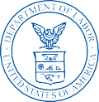

Washington, DC 20212-0001

MANDATORY

JANET JOHNSON ABC CORPORATION ABC CORP
123 MAIN STREET
ANYTOWN UT 12345-1111

September 22, 2018 Dear Employer,
The U.S. Bureau of Labor Statistics (BLS) and the Utana Dept of Labor request that you provide your company’s employment and wages each quarter using the BLS 3020 - Multiple Worksite Report (MWR). You normally receive a paper MWR form that you fill out by hand and return in the mail. This notice is to encourage you to report your MWR data online, which saves your time and saves tax dollars.

Please use the User ID and password below to log into our secure website: https://idcf.bls.gov/

USER ID: 10600012345 PASSWORD: Ab123456

For your convenience, a paper MWR form will still be mailed to your attention this quarter. If you decide to report online, you can disregard this paper form.

This survey is mandatory in accordance with Utana Law 182, and is authorized by 29 U.S. Code, Section 2. It is approved by O.M.B. No. 1220-0134.

Information collected in this report by BLS and State agencies cooperating in its statistical programs will be used for statistical and Unemployment Insurance program purposes, and other purposes in accordance with law. Additional information can be found online: http://www.bls.gov/cew/cewmwr00.htm.

The due date for this report is October 31, 2018. Thank you for your participation. Sincerely,
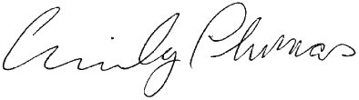

Emily Thomas
U.S. Bureau of Labor Statistics


