High Risk Ads

Paid survey opportunity for adults at high risk for cancer! We are interested in your thoughts on cancer and health. Eligible participants will receive $5 cash. Click the link to participate http://norc.org/survey



483934360


Paid survey opportunity for adults at high risk for cancer! We are interested in your thoughts on cancer and health. Eligible participants will receive $5 cash. Click the link to participate http://norc.org/survey

177556479



Paid survey opportunity for adults at high risk for cancer! We are interested in your thoughts on cancer and health. Eligible participants will receive $5 cash. Click the link to participate http://norc.org/survey

155139420


Paid survey opportunity for adults at high risk for cancer! We are interested in your thoughts on cancer and health. Eligible participants will receive $5 cash. Click the link to participate http://norc.org/survey

462211677
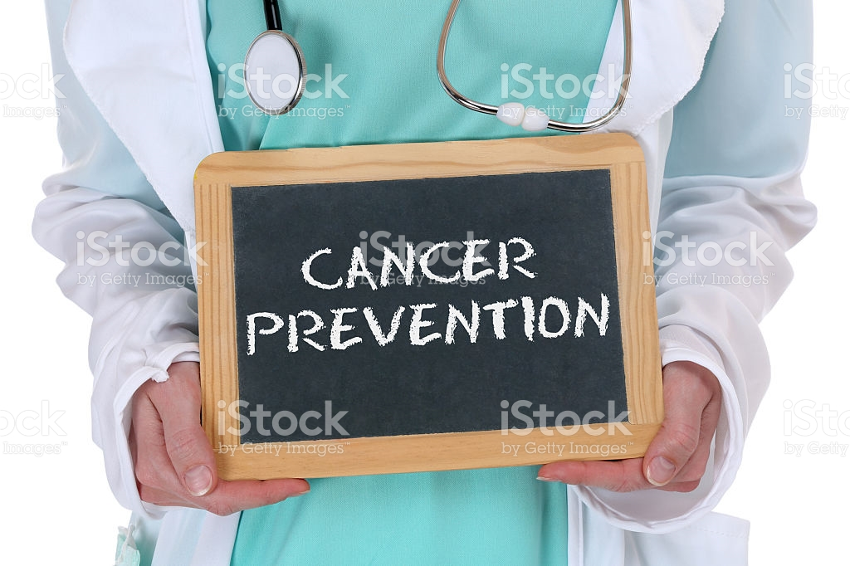

Paid survey opportunity for cancer survivors! We are interested in your thoughts on cancer and health. Eligible participants will receive $5 cash. Click the link to participate http://norc.org/survey

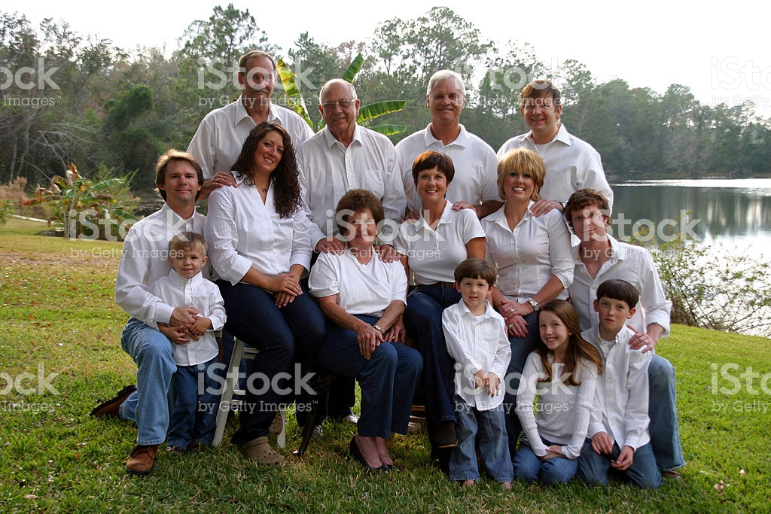
506606616

Paid survey opportunity for adults at high risk for cancer! We are interested in your thoughts on cancer and health. Eligible participants will receive $5 cash. Click the link to participate http://norc.org/survey

144965031


Paid survey opportunity for adults at high risk for cancer! We are interested in your thoughts on cancer and health. Eligible participants will receive $5 cash. Click the link to participate http://norc.org/survey

144965031


511314054

Paid survey opportunity for adults who have had genetic testing! We are interested in your thoughts on cancer and health. Eligible participants will receive $5 cash. Click the link to participate http://norc.org/survey

519332062
Survivorship Ads


Paid survey opportunity for cancer survivors! We are interested in your thoughts on cancer and health. Eligible participants will receive $5 cash. Click the link to participate http://norc.org/survey

171135978



Paid survey opportunity for cancer survivors! We are interested in your thoughts on cancer and health. Eligible participants will receive $5 cash. Click the link to participate http://norc.org/survey

667825020

Paid survey opportunity for cancer survivors! We are interested in your thoughts on cancer and health. Eligible participants will receive $5 cash. Click the link to participate http://norc.org/survey



155440751

Paid survey opportunity for cancer survivors! We are interested in your thoughts on cancer and health. Eligible participants will receive $5 cash. Click the link to participate http://norc.org/survey



525258415
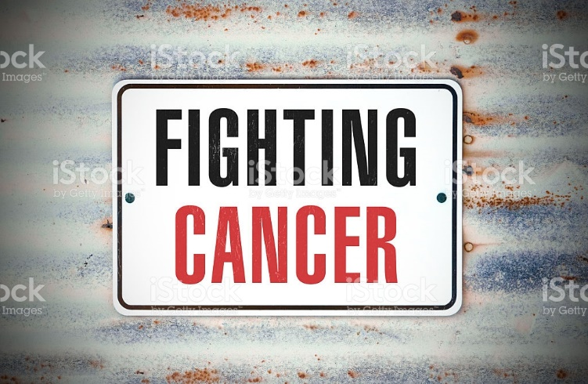

Paid survey opportunity for cancer survivors! We are interested in your thoughts on cancer and health. Eligible participants will receive $5 cash. Click the link to participate http://norc.org/survey

513888324

Paid survey opportunity for cancer survivors! We are interested in your thoughts on cancer and health. Eligible participants will receive $5 cash. Click the link to participate http://norc.org/survey



543070000

Paid survey opportunity for cancer survivors! We are interested in your thoughts on cancer and health. Eligible participants will receive $5 cash. Click the link to participate http://norc.org/survey

501538029

Paid survey opportunity for cancer survivors! We are interested in your thoughts on cancer and health. Eligible participants will receive $5 cash. Click the link to participate http://norc.org/survey

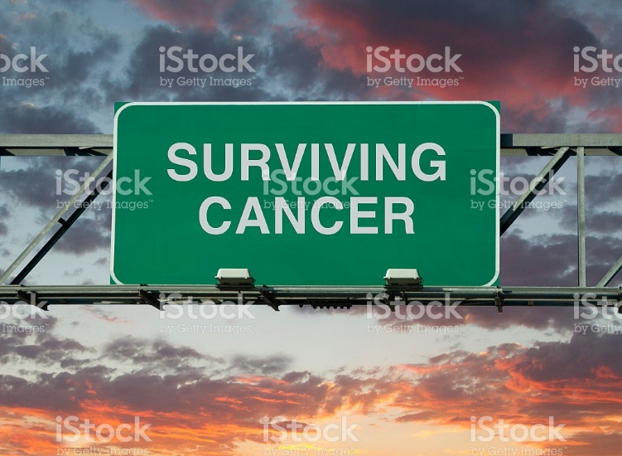

504542641/508275451

High-Risk and Survivorship Ads


Paid survey opportunity for cancer survivors and high-risk individuals! We are interested in your thoughts on cancer and health. Eligible participants will receive $5 cash. Click the link to participate http://norc.org/survey

104258822

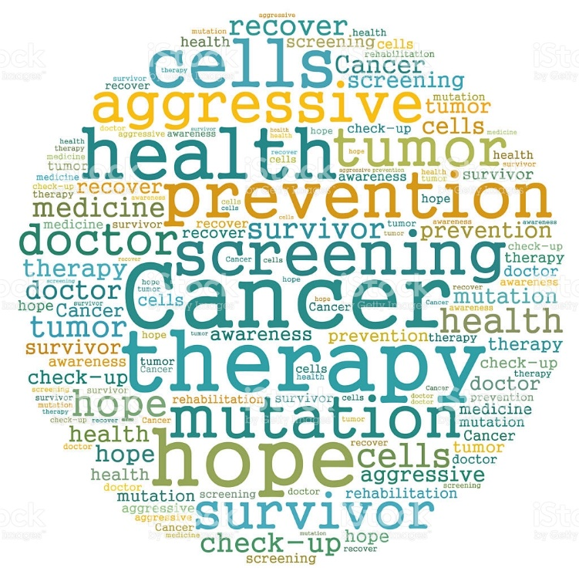

Paid survey opportunity for cancer survivors and high-risk individuals! We are interested in your thoughts on cancer and health. Eligible participants will receive $5 cash. Click the link to participate http://norc.org/survey

503010493

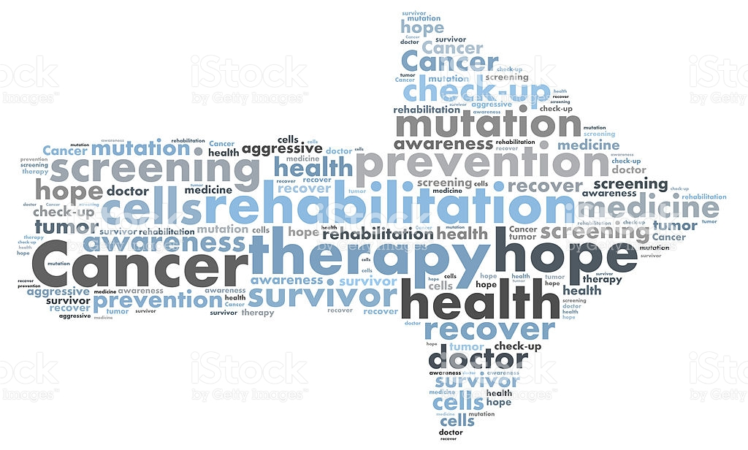

Paid survey opportunity for cancer survivors and high-risk individuals! We are interested in your thoughts on cancer and health. Eligible participants will receive $5 cash. Click the link to participate http://norc.org/survey

505839235

Gen Pop Ads

Paid survey opportunity for adults over 40! We are interested in your thoughts on health. Eligible participants will receive $5 cash. Click the link to participate http://norc.org/survey



585798632



Paid survey opportunity for adults over 40! We are interested in your thoughts on health. Eligible participants will receive $5. Click the link to participate http://norc.org/survey



Paid survey opportunity for adults over 40! We are interested in your thoughts on health. Eligible participants will receive $5 cash. Click
the link to participate http://norc.org/survey

521888499

Paid survey opportunity for adults over 40! We are interested in your thoughts on health. Eligible participants will receive $5 cash. Click the link to participate http://norc.org/survey


529114228
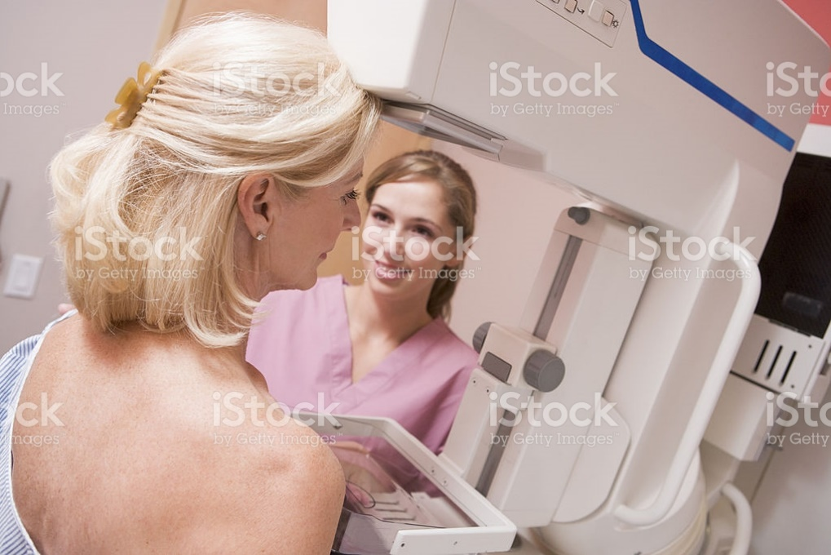

Paid survey opportunity for adults who have had genetic testing! We are interested in your thoughts on cancer and health. Eligible participants will receive $5 cash. Click the link to participate http://norc.org/survey


125556530

Paid survey opportunity for adults over 40! We are interested in your thoughts on health. Eligible participants will receive $5 cash. Click the link to participate http://norc.org/survey

513436592



Paid survey opportunity for adults over 40! We are interested in your thoughts on health. Eligible participants will receive $5 cash. Click the link to participate http://norc.org/survey

5241778100

