OMB Control Number 1905-0186
October 10, 2019

Form EIA-191 Monthly Underground Storage Report and Form EIA-912 Weekly Underground Natural Gas Storage Report
Cognitive Testing Protocol
October 2019

Research Goals:
- Determine whether operators of liquefied natural gas (LNG) marine terminals, satellite LNG storage facilities, and LNG peak shaving facilities are able to report natural gas injections, additions, withdrawals, and end of reporting period inventories on a monthly and weekly basis.

- Determine if LNG storage facilities operators are able to measure the natural gas (and other energy sources) consumed for company operations and their subsequent reporting to EIA;

- Estimate the burden for new respondents to report current inventories and other information on Form EIA-191 and Form EIA-912.

Purpose of Interview:
- Introduce self and observers;
- Your responses are protected as confidential information and results from this study will be aggregated so that no aggregate statistics can be used to identify you or anyone in your organization.

Part A – Reporting Inventories
- Does your company maintain records on the LNG injections and withdrawals in and from your storage facility?
- Do you measure changes in LNG inventories on a weekly and monthly basis?
  - If not, what frequency do you measure your LNG storage levels?
- In what unit of measurement do you measure your LNG storage?
  - If EIA provides conversion values, can you report this information in thousand cubic feet (Mcf)?
  - If not, what units do you use?

- Could you report the amount of natural gas injections and withdrawals to EIA on a monthly basis (internal note, for Form EIA-191)?
  - If not, what problems would you have in reporting this information?
- Do you have LNG facilities in more than one State?
  - If yes, can you report this information for all your facilities?
  - Can you report this information based on the geographic regions in the tables in Parts 3 and 4 of the EIA-912 mockup?
    - If not, what problems would you have to aggregating this information across all of your facilities according to this table?
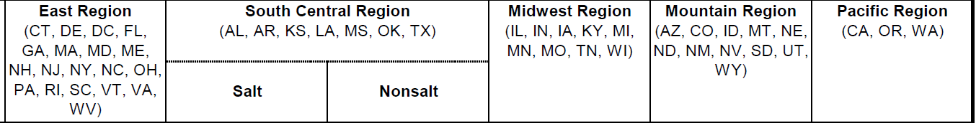

Part B – LNG NG conversion questions
- Does your company use natural gas or electricity as your primary energy source for internal operations to operate the LNG facility?
    - What fuel or energy sources does your company use to liquefy natural gas?
    - What fuel or energy sources does your company use to re-gasify LNG, (meaning, heat it up and turn it into gaseous natural gas)? Do you separately measure the amount of electricity/fuel used for this purpose?

Part C - Burden
- Looking over this form, how much time do you estimate it would take you to complete on a monthly basis?
  - Would your time estimate change if you reported this information on a weekly basis?
    - (If yes) What would cause the increase in time?
- If we broke out your burden estimate into two parts:
  - How much time would it take you to gather the information for this report?
  - Once you have gathered the information needed, how long would it take you to fill out the report and submit your data to EIA?
- Do you track the information requested over the normal course of business?
- Would there be any one-time efforts or costs associated with reporting this information?
  - (If needed) Could you describe/list these efforts and costs?
- Would filling out either form require data or input from anyone else?

- Would reporting this information require any special software, or installation of any technology systems?
- Would the time it takes to complete this form change over time or stay the same?

Thank you for your time today!

