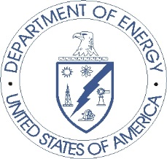
Department of Energy
Washington, DC 20585

Dear Building Owner or Manager:
We need your help on a national energy study.
The U.S. Energy Information Administration (the independent statistical agency of the Department of Energy) has randomly selected this building to be part of a study called the Commercial Buildings Energy Consumption Survey (CBECS). CBECS provides important energy-related information about commercial buildings throughout the United States. This building represents many others with similar characteristics and energy use.
Your participation is very important.
People use the information from this study for many purposes:
- Building owners and managers use it to compare their own energy-related information with other similar buildings through tools like ENERGY STAR®, which is based on this study’s data;
- Energy modelers and forecasters use it to project future energy changes and needs; and,
- Federal, state, and local government agencies use it to formulate energy policies.
You can visit the CBECS website at https://www.eia.gov/consumption/commercial to see what types of data we collect. Your participation in this study is voluntary. Completing this survey takes approximately 50 minutes. The interview will cover topics such as:
- General characteristics of this building, such as its size and use
- Types of energy this building uses and how each type is used
- Equipment and devices in the building that use energy
- How much energy is used and how much it costs
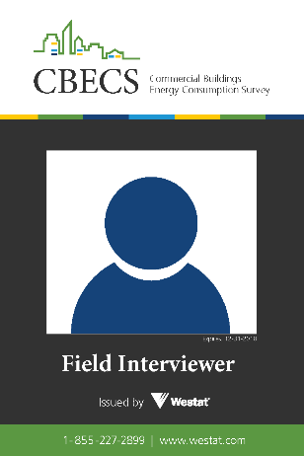
We promise to keep your information confidential.
The information you provide is confidential as a matter of law and will be used for statistical purposes only. We will combine the information you provide with information we collect from other buildings into a summary that we distribute to the public. No information in the summary will allow identification of you or the building individually.
We’ll contact you soon.
Over the next few weeks, an employee from Westat, the company conducting the study on our behalf, will visit your building to help get you started on the study. The interviewer will show you his or her ID badge, which looks like the example on the right. Westat is a national research organization with headquarters located in Rockville, Maryland.
Let us know if you have any questions.
If you have any questions, please call Cindy Good, the CBECS Director of Study Operations at Westat, at 1-800-937-8281, or email her at CindyGood@westat.com. To speak directly with someone at the U.S. Department of Energy, please call Joelle Michaels, the CBECS Manager, at 202-586-8952 or email her at Joelle.Michaels@eia.gov.
We look forward to working with you, and we thank you for participating in this important national energy study.
Sincerely,
Thomas J. Leckey, Director,
Office of Energy Consumption and Efficiency Statistics
U.S. Energy Information Administration,
U.S. Department of Energy

