A. AESDirect Record Formats
Launch Page/Shipment Manager
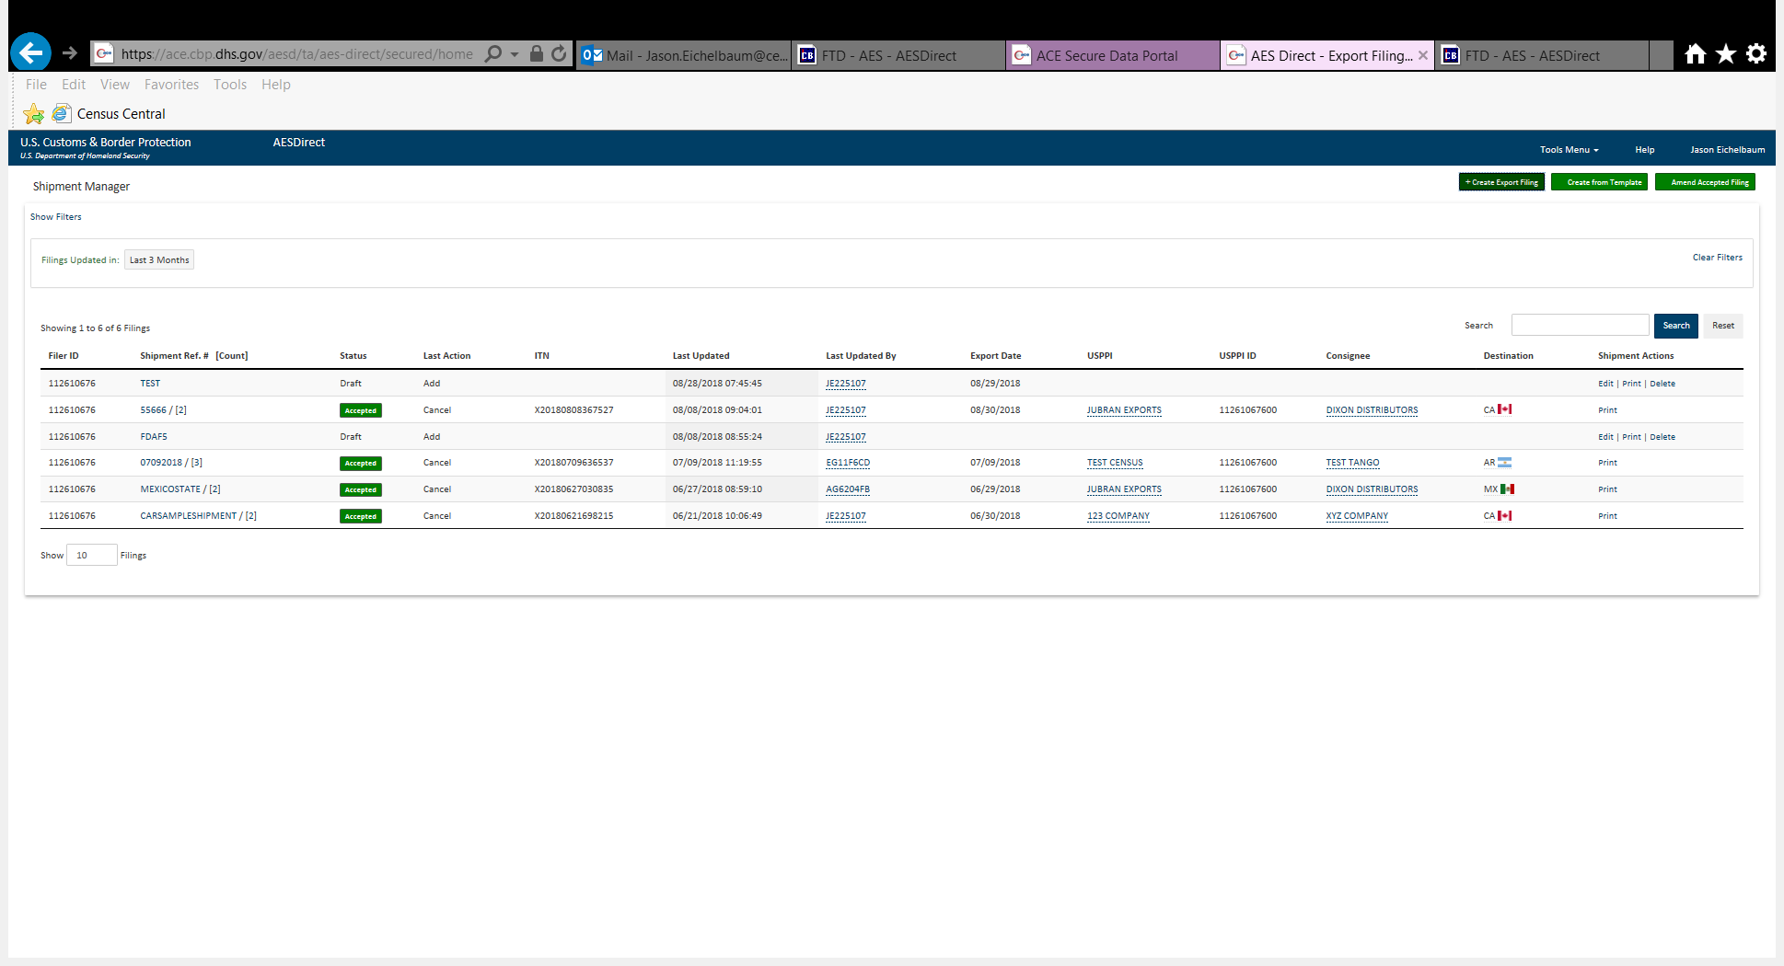

Step 1: Shipment
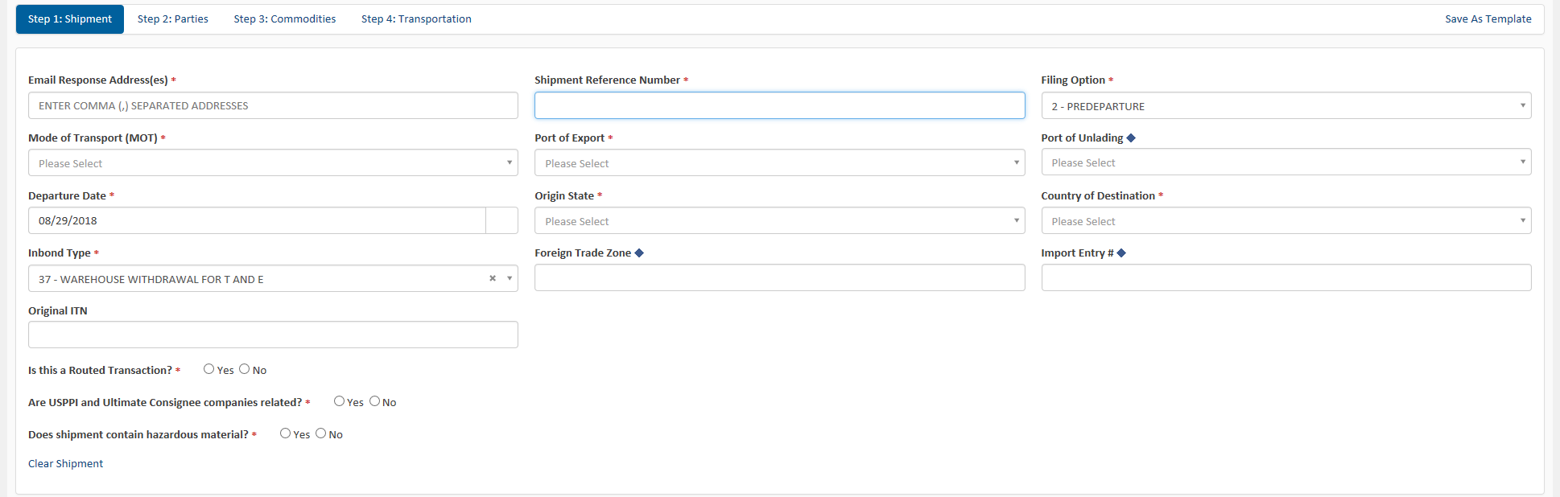

Step 2: Parties Page 1 (first half of screen)
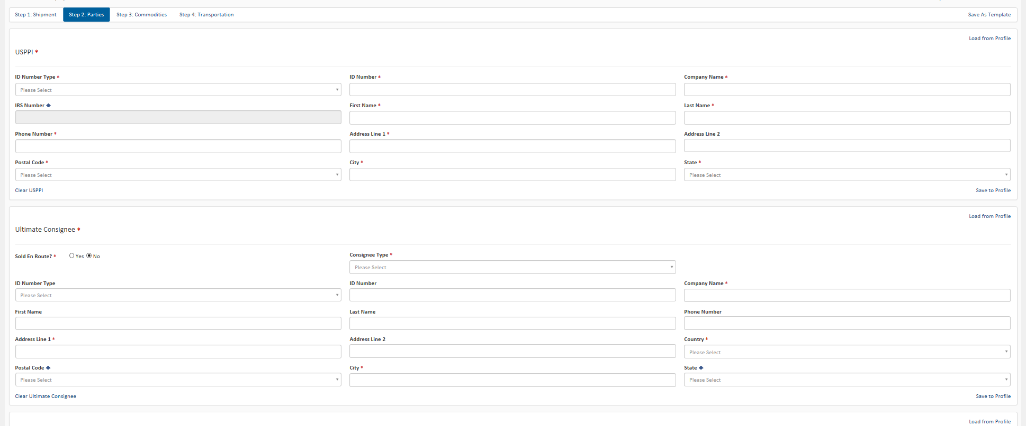
Step 2: Parties Page 2 (second half of screen)
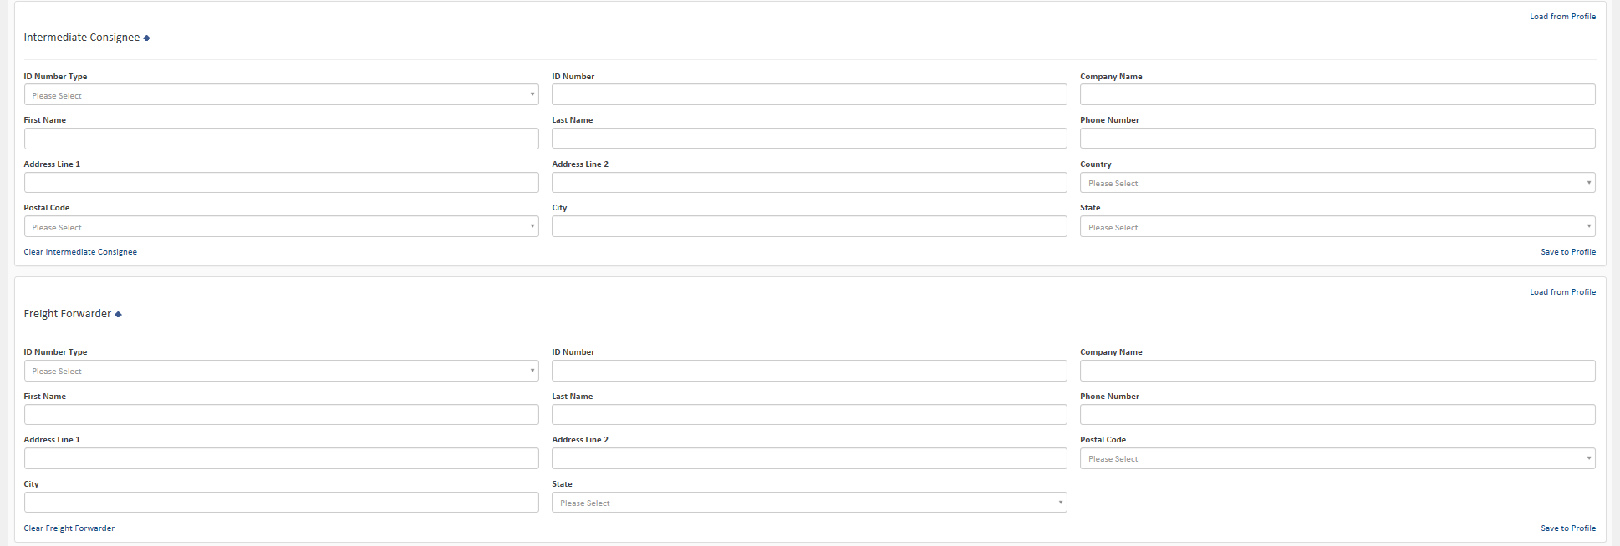

Step 3: Commodities
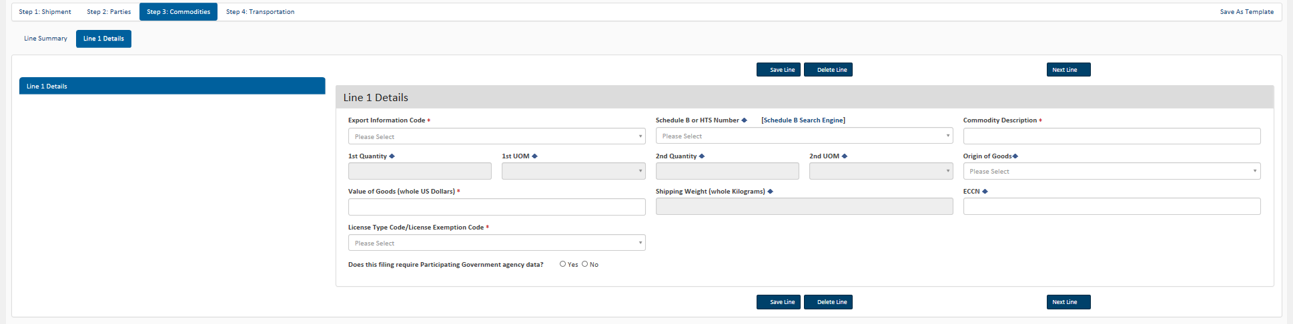

Step 4: Transportation
