APPENDIX AG2. FINI GROCERY STORE SURVEY

 | OMB Number: 0584-0616  Expiration Date: XX/XX/XXXX

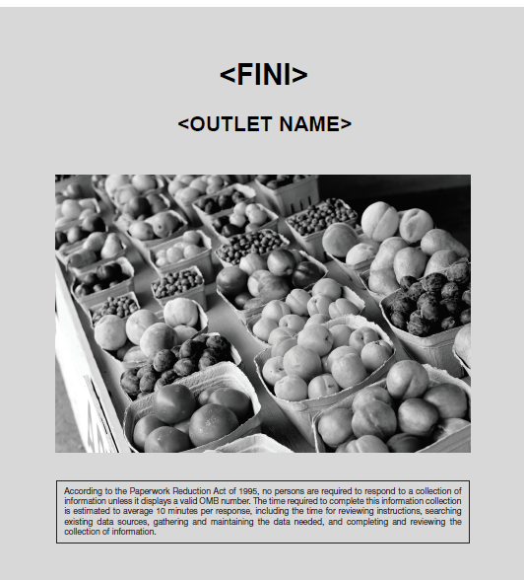

- Why did this store choose to participate in <FINI>?
MARK ALL THAT APPLY
- To bring in new customers
- To benefit customers
- To be part of something new
- <Name of Grantee> asked us to join
- Corporate office asked us to join
- Know other retailers who joined
- To increase sales of fruits and vegetables
- To increase sales of other items
- Other reasons for participating, please specify: ______________________

- Who was involved in the decision to participate in <FINI>?
MARK ALL THAT APPLY
- Corporate office/store owner
- Store manager(s)
- Cashiers
- Other store employees, please specify: _________________________

- How are incentives (i.e., <FINI NAME>) provided to SNAP participants?
- Cash register printed coupon
- Pre-printed coupon
- Loyalty card
- Other, please specify ________________________________________

- Is there an expiration date for the incentives?
- Yes
- No GO TO QUESTION 6

- How long do customers have to redeem the incentives?
  - One month or less after date of issuance
  - 2 to 3 months after date of issuance
  - 4 to 6 months after date of issuance
  - 7 to 12 after date of issuance
  - There is no expiration date for the incentives

6. Did anyone from this store receive training from <NAME OF GRANTEE> to implement <FINI>?
- Yes
- No GO TO QUESTION 8

- Who attended the training provided by <NAME OF GRANTEE??
MARK ALL THAT APPLY
- Corporate staff/store owner(s)
- Store managers (excluding store owner)
- Cashiers (excluding store owner)
- Other attendees, please specify:________________________________

- Did this store provide training to the cashiers?
- Yes
- No

- Which of the following topics were covered in the cashier training?
MARK ALL THAT APPLY
- List of eligible products
- Calculating incentive value
- Ratio of SNAP purchase to incentive value
- Maximum amount of incentive value per customer
- Submitting invoice for reimbursement
- Informing SNAP participants about <FINI>
- Handling refunds associated with incentives
- Handling customer issues
- Other general SNAP rules
- Other, please specify: _________________________
- There was no cashier training

- What types of marketing materials did your store receive from <NAME OF GRANTEE> to inform SNAP participants about <FINI>?
MARK ALL THAT APPLY
- Posters or signs for in-store use
- Shelf tags for in-store use
- Floor stickers for in-store use
- Educational pamphlets for in-store distribution
- Flyers to mail or hand out to community residents
- Other, please specify: ________________
- Did not receive any marketing materials

- What types of marketing materials did the corporate office or store owner develop to inform SNAP participants about <FINI>?
MARK ALL THAT APPLY
- Posters or signs for in-store use
- Shelf tags for in-store use
- Floor stickers for in-store use
- Educational pamphlets for in-store distribution
- Flyers to mail or hand out to community residents
- Other, please specify: ________________
- Did not develop any marketing materials

- What types of questions have store staff asked about <FINI>?
MARK ALL THAT APPLY
- Product eligibility
- Processing sales with incentives
- Calculating incentive value
- Responding to customer questions
- Other, please specify: ______________________________________________
- Employees did not have any questions

- What types of questions have customers asked about <FINI>?
MARK ALL THAT APPLY
- Product eligibility
- Maximum amount of incentive they can receive
- Reimbursements on unused incentives
- Returning items purchased with incentives
- Other general SNAP rules
- Other, please specify: _____________________________________________
- Customers did not have any questions

- Have you contacted <Name of Grantee> or corporate office for clarification on <FINI> implementation?
- YES
- NO GO TO QUESTION 18

- List the topic(s) on which clarification was needed.

___________________________________________________________________

- Did <Name of Grantee> or corporate office provide the clarification in a timely manner?
- Yes
- No

- What was the format in which <Name of Grantee> provided clarification?
MARK ALL THAT APPLY
- Phone call
- Email
- Directed to USDA’s National Institute of Food and Agriculture (NIFA) website
- Directed to USDA’s Supplemental Nutrition Assistance Program (SNAP) Policy Website
- Directed to Westat’s FINI Evaluation Technical Assistance Website
- Directed to someone else, please specify: ______________
- Other format, please specify: ______________________

- How easy or difficult has it been to track and manage <FINI> funds?
- Very easy
- Somewhat easy
- Neither easy nor difficult
- Somewhat difficult
- Very difficult

- How easy or difficult has it been to receive <FINI> reimbursements?
- Very easy
- Somewhat easy
- Neither easy nor difficult
- Somewhat difficult
- Very difficult

- Which of the following best describes your experience with <FINI> reimbursements?
- Received in a reasonable amount of time
- Taken longer than expected to receive
- Varied and unpredictable

- Comparing your current stock to that before you joined <FINI>, would you say that you stock more, the same, or less of the following products?
MARK ONE ANSWER FOR EACH PRODUCT.
Products | Stock more than before | Stock about the same as before | Stock less than before | Not applicable
Fresh fruits
Frozen fruits
Canned fruits
Dried fruits
100 percent fruit juice
Fresh vegetables
Frozen vegetables
Canned vegetables
Dried vegetables
100 percent vegetable juice
- Comparing your current fruit stock to that before you joined <FINI>, would you say that you now stock:
- Different types of fruits that you did not stock before
- The same types of fruits that you stocked before

- Comparing your current vegetable stock to that before you joined <FINI>, would you say that you now stock:
- Different types of vegetables that you did not stock before
- The same types of vegetables that you stocked before

- Because of your participation in <FINI>, have you done any of the following?
MARK ALL THAT APPLY
- Started working with any new produce suppliers
- Received more shipments from any produce suppliers
- Increased stock of State (i.e., local) grown produce
- Increased frequency of restocking produce display floor
- Installed new refrigeration or freezer units for produce
- Increased shelf space for produce
- Changed where produce is located in the store
- Changed where produce is located on the shelves
- Other, please specify: ________________________________________________________

- How did offering <FINI> affect the following at your store?
MARK ONE ANSWER FOR EACH ITEM.
 | Large Increase | Small Increase | No Change | Small Decrease | Large Decrease | Don’t know
Average time to process SNAP purchases
Sale of fruits
Sale of vegetables
Number of non-SNAP shoppers
Number of SNAP shoppers
Store profits

- Did this store reach the following targets?
MARK ONE ANSWER FOR EACH ITEM.
Target | Reached target | Did not reach target | Did not have this as a target | Don’t know
Number of SNAP participants who received incentives
Amount of incentives distributed to SNAP participants
Amount of incentives that were redeemed by SNAP participants

- Which of the following activities were conducted at this store to promote <FINI>?
- Cooking demonstrations
- Store tours
- Customer education on how to buy produce
- Other nutrition education activities
- Other, please specify: ____________________________________________________________
- None

- Which of the following were challenges you experienced in implementing <FINI> at this store?
MARK ALL THAT APPLY
- Informing customers about the <FINI> program
- Scheduling promotional activities when SNAP participants are in the store
- Streamlining checkout process for SNAP participants
- Cashier turnover
- Training new staff
- Offering refresher training(s) for staff
- Other, please specify: __________________________________________________________
- There were no challenges in implementing <FINI> at this store

- Please describe the successes in implementing <FINI> at this store.
________________________________________________________________________________
________________________________________________________________________________
________________________________________________________________________________
________________________________________________________________________________
________________________________________________________________________________

- If you had to do it again, would you join another <FINI> project?
- Yes
- No
- Not sure

Thank you for completing this survey. Please return it in the postage-paid envelope or mail it at the following address:
Attention: FINI PROJECT
1600 Research Blvd
Rockville, MD 20850

