OMB No. 0920-18MY
Expiration Date: XX/XX/XXXX

Public reporting burden of this collection of information is estimated to average 2 minutes per response, including the time for reviewing instructions, gathering and maintaining the data needed, and completing and reviewing the collection of information. An agency may not conduct or sponsor, and a person is not required to respond to a collection of information unless it displays a currently valid OMB control number. Send comments regarding this burden estimate or any other aspect of this collection of information, including suggestions for reducing this burden to CDC/ATSDR Reports Clearance Officer; 1600 Clifton Road NE, MS D-74, Atlanta, Georgia 30333; Attn: OMB-PRA (0920-18MY).

Network Epidemiology of Syphilis Transmission (NEST)
Attachment 5
Smartphone Survey

SMARTPHONE SURVEY: Ecological Momentary Assessment (EMA)

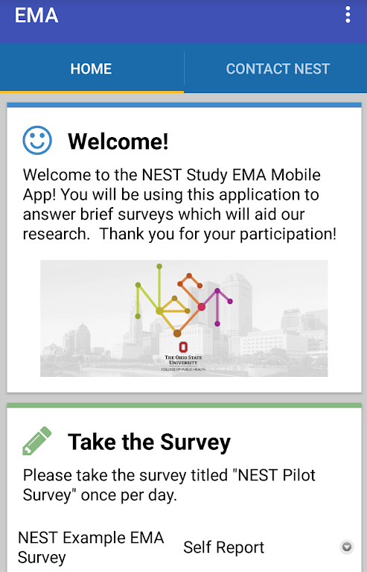

EMA_1. Did you have anal sex in the last 24 hours?
- Yes | 1
- No | 2
- Don’t know or don’t remember | 99
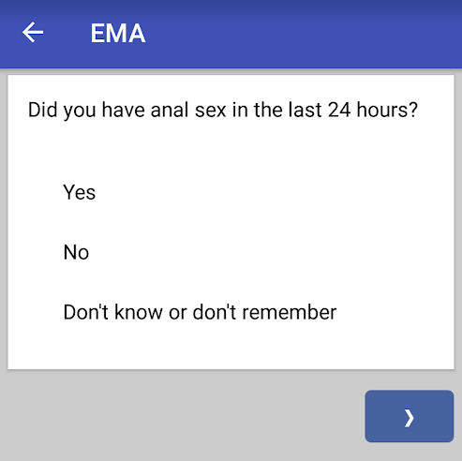
EMA_1a. How many men did you have anal sex with in the last 24 hours?
- 1 | 1
- 2 | 2
- 3 | 3
- 4 | 4
- 5 | 5
- 6+ | 6
- Don’t know or don’t remember | 99
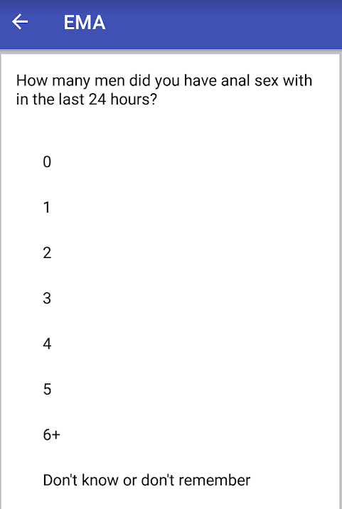
EMA_1b. How many women did you have anal sex with in the last 24 hours?
- 1 | 1
- 2 | 2
- 3 | 3
- 4 | 4
- 5 | 5
- 6+ | 6
- Don’t know or don’t remember | 99
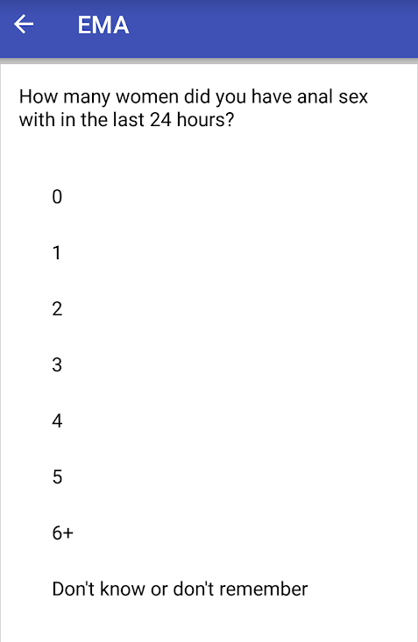
EMA_1c. The last time you had anal sex in the last 24 hours, were you the top or the bottom?
- Yes | 1
- No | 2
- Don’t know or don’t remember | 99
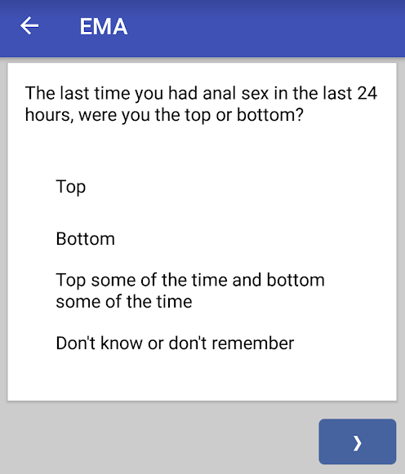

EMA_1d. The last time you had anal sex in the last 24 hours, was a condom used?
- Yes | 1
- No | 2
- Don’t know or don’t remember | 99
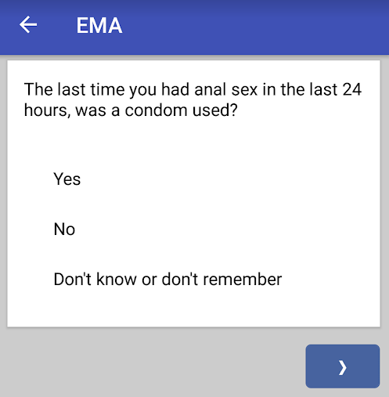
EMA_1e. The last time you had anal sex in the last 24 hours, was lubricant used (for example saliva, semen, commercial lube, or another product?
- Yes | 1
- No | 2
- Don’t know or don’t remember | 99

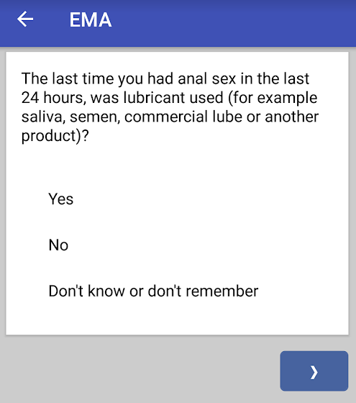
EMA_1f. Which lubricant? (mark all that apply)
- Commercial lubricant | 1
- Saliva | 2
- Semen | 3
- Another product | 4
- No lubricant was used | 5
- Don’t know or don’t remember | 99
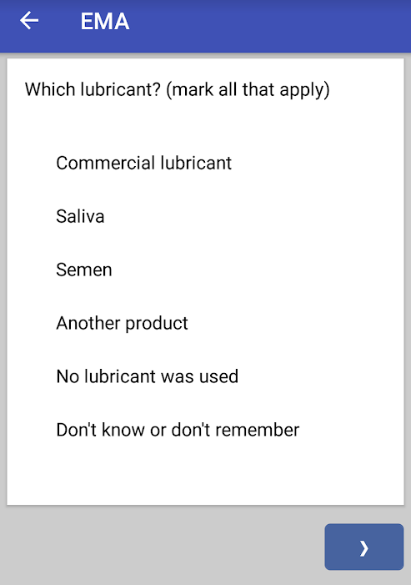
EMA_1g. The last time you had anal sex in the last 24 hours, where were you?
- My home | 1
- In the other person’s home | 2
- In a public indoor place (e.g., bar. club, etc.) | 3
- In a public outdoor place (e.g., park, car, etc.) | 4
- In a private setting (house party, hotel, etc.) | 5
- Other location | 6
- Don’t know or don’t remember | 99
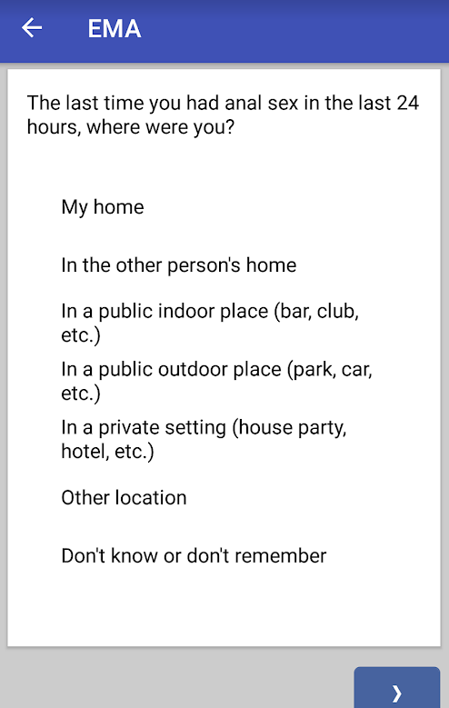
EMA_1h. Thinking about the last person you had anal sex with in the last 24 hours: where did you first meet that person?
- Website or mobile app | 1
- In a public indoor place (bar, club, etc.) | 2
- In a public outdoor place (park, car, etc.) | 3
- In a private setting (house party, hotel, etc.) | 4
- At work | 5
- Through friends | 6
- Other location | 7
- Don’t know or don’t remember | 99

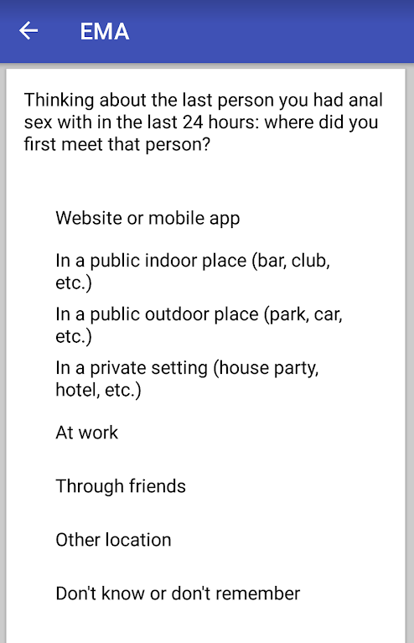
EMA_1i. Thinking about the last person you had anal sex with in the last 24 hours: how long have you known that person?
- I met that person for the first time when we had sex | 1
- Less than 1 week | 2
- More than 1 week, but less than 1 month | 3
- More than 1 month | 4
- Don’t know or don’t remember | 99

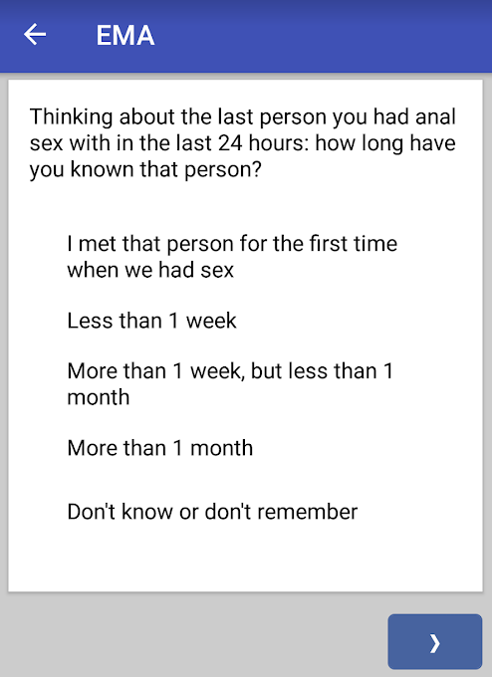
EMA_2. Did you have oral sex in the last 24 hours?
- Yes | 1
- No | 2
- Don’t know or don’t remember | 99

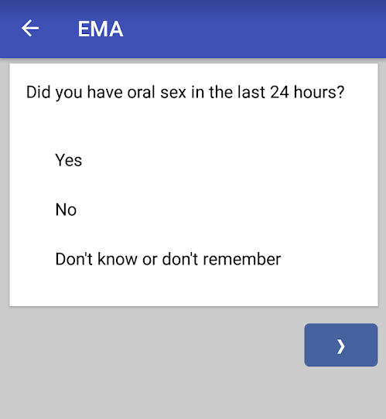

EMA_2a. How many men did you have oral sex with (either giving or getting a blowjob) in the last 24 hours?
- 1 | 1
- 2 | 2
- 3 | 3
- 4 | 4
- 5 | 5
- 6+ | 6
- Don’t know or don’t remember | 99

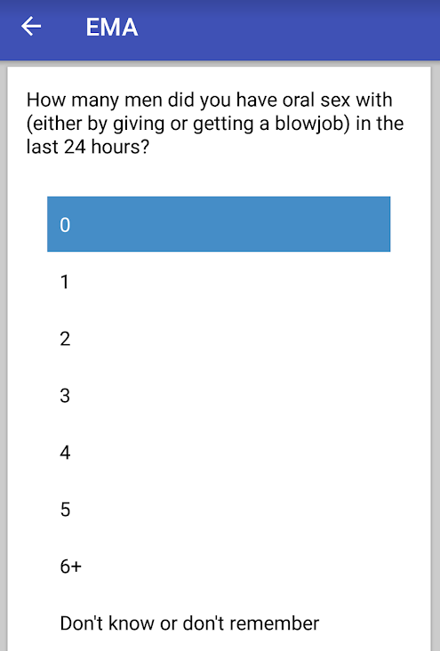
EMA_2b. How many women did you have oral sex with (either giving or getting a blowjob) in the last 24 hours?
- 1 | 1
- 2 | 2
- 3 | 3
- 4 | 4
- 5 | 5
- 6+ | 6
- Don’t know or don’t remember | 99

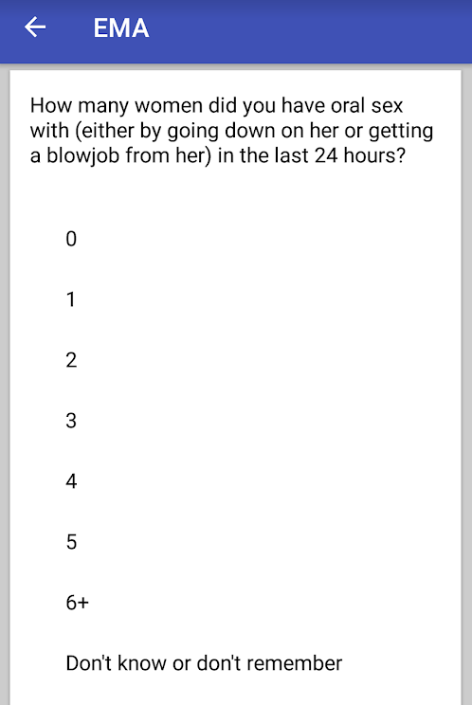

EMA_2c. The last time you had oral sex in the last 24 hours, did you get a blowjob or did you give a blowjob/go down on someone?
- I got a blowjob | 1
- I gave a blowjob/went down on someone | 2
- I got a blowjob and gave a blowjob/ went down on someone | 3
- Don’t know or don’t remember | 99

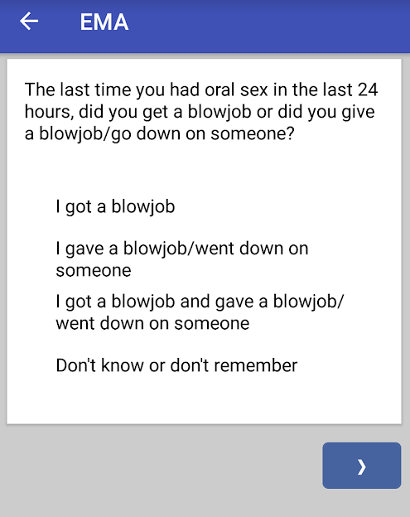
EMA_2d. The last time you had oral sex in the last 24 hours, where were you?
- My home | 1
- In the other person’s home | 2
- In a public indoor place (e.g., bar. club, etc.) | 3
- In a public outdoor place (e.g., park, car, etc.) | 4
- In a private setting (house party, hotel, etc.) | 5
- Other location | 6
- Don’t know or don’t remember | 99

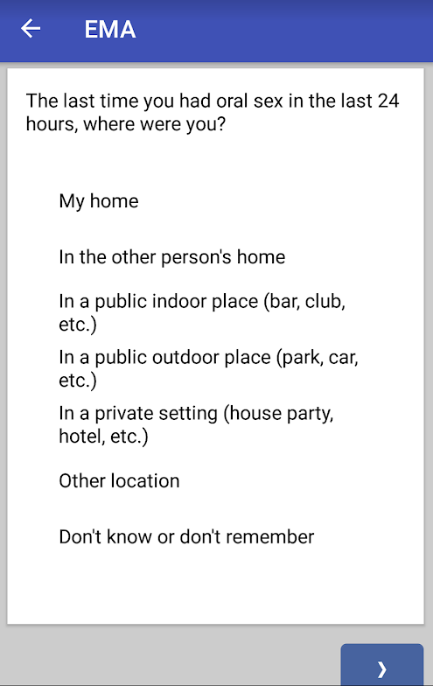
EMA_2e. Thinking about the last person you had oral sex with in the last 24 hours: where did you first meet that person?
- In a public indoor place (bar, club, etc.) | 1
- In a public outdoor place (park, car, etc.) | 2
- In a private setting (house party, hotel, etc.) | 3
- At work | 4
- Through friends | 5
- Other location | 6
- Don’t know or don’t remember | 99

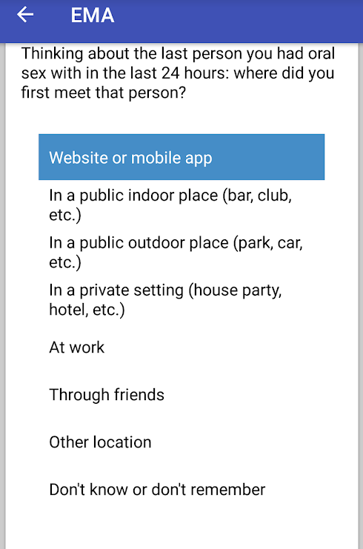
EMA_3. In the past 24 hours, did you take PrEP (a daily pill that prevents people from getting HIV infection)?
- Yes | 1
- No | 2
- Not applicable; I am HIV+ | 3
- Don’t know or don’t remember | 99

