Script for OSTEM Equity Plan Focus Groups
Desired Outcome of Focus Groups:
To solicit input, recommendations and feedback directly from the OSTEM Community to OSTEM leadership about tangible actions to improve OSTEM’s culture of inclusion.
Scope: Internal focus - OSTEM HQ and Centers representing those who officially report to Agency OSTEM management.
Ground Rules:
- Consider this to be safe space.
- Participate actively.
- Speak one at a time.
- Treat everyone's ideas with respect.
- Stay focused on the topic or question.

Key Questions: (Ideally no more than 4-6 open ended questions that focus on the most critical areas. Proposing:

- In what ways is OSTEM welcoming and inclusive?
  - What is an example of OSTEM being welcoming and inclusive?
  - Do you feel a sense of belonging at OSTEM? Why?
- Are there barriers to OSTEM establishing an inclusive environment?
  - If so, what are they and what ideas do you have to address them?
  - Where are opportunities for OSTEM to fill gaps?

- There are many dimensions of diversity (reference the diversity wheel). Diversity representation on our OSTEM team is important.
  - Where opportunities for OSTEM to improve its diversity representation
  - What are your ideas to improve our diversity?

- If you were AA of OSTEM , what is the one change you would make?

*The Diversity Wheel is away to visualize aspects of diversity in an organization.
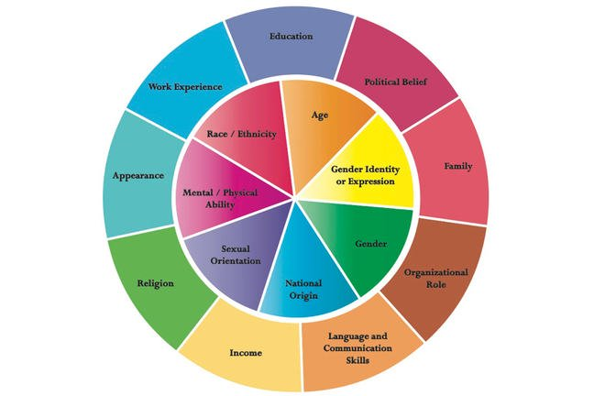

Source: John Hopkins Diversity Wheel from http://web.jhu.edu/dlc/resources/diversity_wheel/
Additional Questions
(Inclusion)
- In what ways is OSTEM welcoming and inclusive?
- What is an example of OSTEM being welcoming and inclusive?
- In what ways is OSTEM not welcoming?
- Are there barriers to establishing an inclusive environment? If so, what are they?
- Does OSTEM have equitable opportunities?
- Do you feel that you have sufficient support to develop your skills and progress your career?
(Diversity)
- What do you wish that OSTEM leadership understood about your own group?
- How can we better value team members’ your unique attributes, traits, characteristics, skills, experience and background?
- What do you think that OSTEM could do to get the best from everyone?
Ending Questions
- Of the diversity, inclusion, and equity issues which is the most important to you?
- Is there anything regarding inclusion, diversity, and equity in OSTEM that we should have talked about today during the focus group, but didn’t?
- If you could tell Mike Kincaid one thing that you would want him to fix about OSTEM, re: Diversity and Inclusion, what would it be?

