QSF18 Post Test Feedback
Table of Contents
QSF18 Post Test Feedback 1
Ease of understanding and completing surveys 2
Clarity of Daily Summary 3
Ease of using Geo-location 4
Helpfulness of Text Notifications 5
End of Survey Thank You 5

Ease of understanding and completing surveys
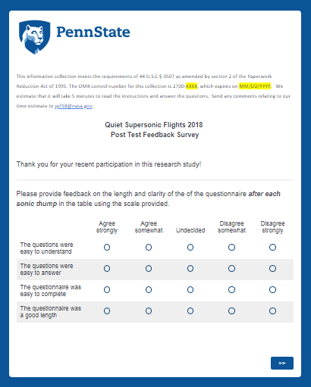

Clarity of Daily Summary
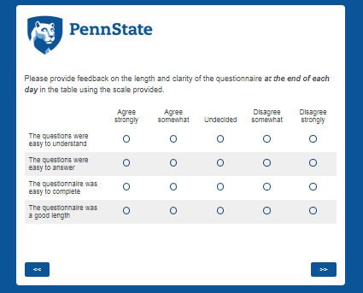

Ease of using Geo-location
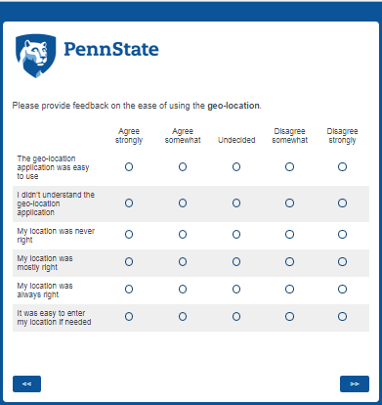

Helpfulness of Reminders
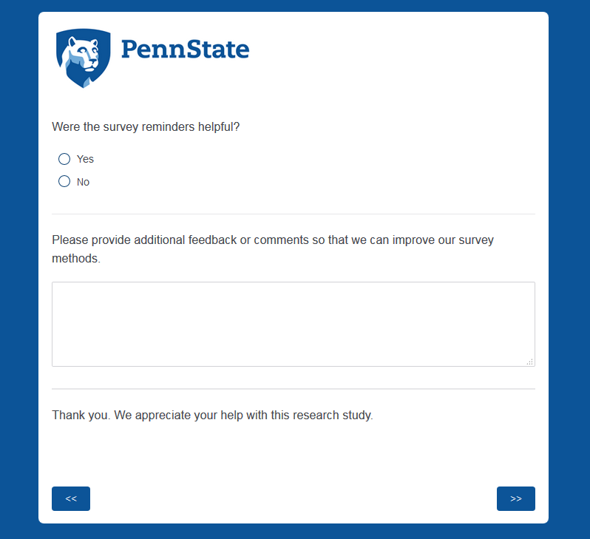

End of Survey Thank You
