Head-Up Displays and Distraction Potential
Research Plan

Submitted to the National Highway Traffic Safety Administration

Introduction
This document presents the research plan for the Head-Up Displays and Distraction Potential Study, National Highway Traffic Safety Administration (NHTSA) contract DTNH22-11-D-00236, Task Order 0019. The primary research objective of this study is to identify potential distraction issues involved with the use of Head-Up Displays (HUDs) and what metrics may be sensitive to this distraction. In addition to providing an overview of the research plan for the on-road study, this document summarizes outcomes of the literature review. Outcomes from the literature review were considered when selecting the methodology for this study.

Background
HUD technology presents many opportunities and challenges for mitigating driver distraction, improving driver comfort, and engaging drivers with their vehicles. On one hand, the reduction of the distance that the eyes need to travel between the road and a display can minimize the amount of time required to view a display relative to a traditional Head-Down Display (HDD). There is also an added benefit in that peripheral roadway information can be processed while viewing a HUD, allowing some aspects of vehicle control, like lane keeping, to be partially supported. On the other hand, humans have difficulty simultaneously processing two displays overlaid on each other. Viewing HUDs while driving may therefore interfere with drivers fully perceiving events in the environment, particularly centrally located hazards such as a braking lead vehicle. There is also a concern that HUDs whose focal depth is less than 22 feet require the eyes to accommodate to be viewed. If some people have difficultly accommodating to view these displays, they may take more time to process the displayed information. There is also a concern that HUDs may negatively alter drivers’ visual scanning behavior. Therefore, the benefits and drawbacks of using a HUD in a vehicle must be fully investigated and properly understood.

Research Questions
The main objective of the project is to contribute data to the question of whether HUD technology changes the driver’s ability to process information on the forward road scene and respond to crash-imminent situations. A supporting objective is to identify candidate surrogate measures of distraction similar to eyes-off-road time for drivers using a HUD versus an HDD in different driving situations. The scope of the project is limited to HUD displays to address the following issues:

- Observe any changes to visual scanning behavior when using HUD versus HDD Human-Machine Interfaces (HMIs).
- Identify candidate metric(s) that are sensitive to potential changes in visual scanning behavior resulting from using a HUD versus an HDD.
- Determine whether a surrogate measure of visual scanning behavior increases when drivers use candidate HUD systems.
- Identify a method to determine or manipulate the driver’s focal distance to near or far displays.
- Observe any unintended consequences associated with HUD systems.
- Describe characteristics of HUD system designs and their advantages and disadvantages.

Methods
The proposed methodology, procedures, and experimental design for the on-road evaluation of HUD and HDD use are presented in this section.

Participants
A total of 48 drivers will be recruited for participation in the study. This sample size exceeds the minimum sample size based on a priori power analyses (alpha = .05, power = .8; estimated reaction time difference 0.5 seconds, SD = 0.3 seconds) using best estimates of response time differences. Participants will be recruited from two different target age groups 20-35 years old and 50-65 years old.
Participants will be recruited from the local population in the New River Valley. Recruitment may take place using social media, flyers posted on bulletin boards, newspaper advertisements, and so on. An example advertisement is included in Appendix A. Advertisements will direct participants to contact the Virginia Tech Transportation Institute (VTTI) via telephone and will be screened by staff using a script (see Appendix A). Note that for recruitment purposes, as well as for initial consent, the project will use a code name that does not reveal the nature of the experiment to the prospective participants. See Appendix B for an example of the information sheet used for the initial informed consent process. It should be noted that this research involves a surprise event, and a second informed consent process will take place immediately after the surprise event (see below for a description of the surprise event). The informed consent document is also included in Appendix B.
Participants will be screened for vision, hearing, and for their dominant eye. Participants must never have participated in a study at VTTI that involves a surprise event.
Participants will be recruited with an equal gender ratio. The Institutional Review Board (IRB) requires that, during screening, any female that is pregnant is requested to meet with a physician to ensure she is medically fit to participate and sign a waiver form.

Materials

Participant Vehicle
The participant vehicle in this study will be a 2010 Buick LaCrosse. Figure 1 shows interior and exterior views (published at http://www.edmunds.com/buick/lacrosse/2010/) of the participant vehicle. This vehicle is a part of the VTTI vehicle fleet. The LaCrosse will serve as the original equipment manufacturer (OEM) HUD and OEM HDD conditions. The LaCrosse will also be used in the conditions testing the aftermarket HUD (see below), with the OEM HUD disabled.
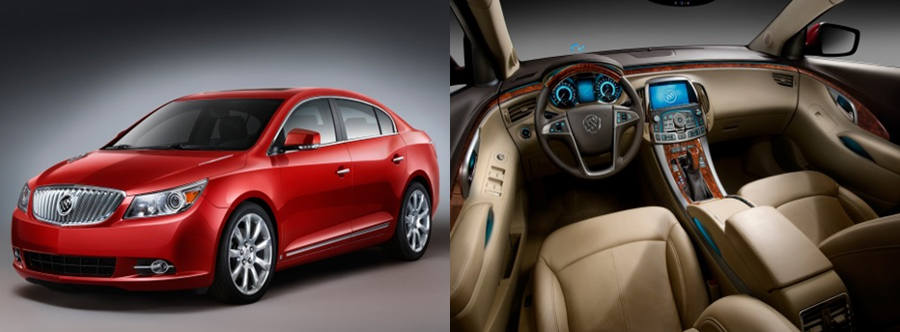
Figure 1. Exterior (Left) and Interior (Right) Press Images of the Participant Vehicle, a 2010 Buick LaCrosse

Lead Vehicle
A VTTI experimenter will drive a lead vehicle during the experiment, an orange Virginia Department of Transportation (VDOT) pickup truck. This vehicle is a part of the VTTI vehicle fleet. Participants will follow the lead vehicle on public roads, and then transition to following the vehicle on the Smart Road. As shown in Figure 2, the truck has been modified to drop a small cardboard box onto the roadway via remote control, which will serve as a surprise event on the Smart Road portion of the experiment (see below).

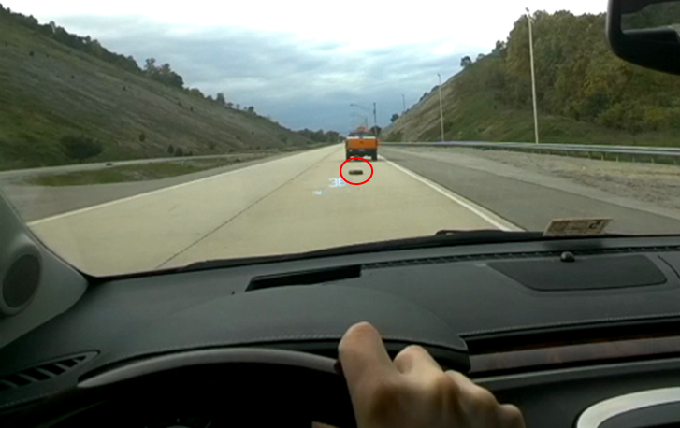
Figure 2. Participant Perspective of the Lead Vehicle with a cardboard box (Box Circled in Red)

Data Acquisition System
The VTTI data acquisition system (DAS) will be the same DAS that served as the collection platform in the Second Strategic Highway Program (SHRP 2) Naturalistic Driving Study (NDS; Dingus et al., 2014). The following data elements are captured by the DAS.
- Video, captured using high-definition video, records the driver’s face and eyes, a wide-angle view of the forward roadway, and the driver’s vantage point using a camera mounted to the driver’s head via safety glasses.
- Accelerometers in the vehicle are used to detect longitudinal and lateral forces.
- Forward Radar is used to monitor the headway to a lead vehicle.
- Lane Tracker Machine Vision is used to estimate the vehicle’s distance to existing lane markings.
- Vehicle network data from the On-Board Diagnostics (OBD-II) port are used to monitor vehicle measures such as vehicle speed, throttle application, and brake application.
- Global Positioning System (GPS) technology indicates the vehicle’s location.

Face Camera
In addition to video collected from the DAS, a GoPro HERO3+ Silver camera (http://shop.gopro.com/cameras/hero3plus-silver/CHDHN-302-master.html) assembly will be used for high-definition, close-up video collection of participants’ faces and eyes. The GoPro HERO3+ Silver camera will be set to record at 720p resolution at 120 frames per second. Furthermore, similar to what is shown in Figure 3, the camera will be modified to accept a zoom lens using the “Ribcage” system from Back-Bone (http://www.back-bone.ca). This setup provides a way to adjust for driver height and seat position while still providing high-quality video to facilitate manual eye-glance reduction.

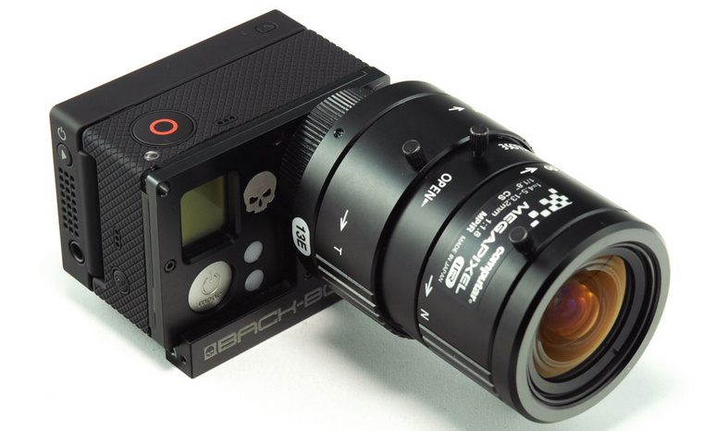
Figure 3. Modified GoPro Camera with Attached Zoom Lens

Displays
The OEM HUD will be the HUD equipped on a 2010 Buick LaCrosse (Figure 4). The two-dimensional (2D) image is optically focused at 2.5 meters, which is just beyond the vehicle’s hood. A button to the left of the steering wheel can control the HUD’s brightness and disengage the HUD altogether, as well as cycle through four displays. Each display presents various information and arrangements. The content presented includes the following:
- Vehicle speed
- Distance to next turn
- Street name of next turn
- Next turn direction
- Engine RPM
- Radio channel

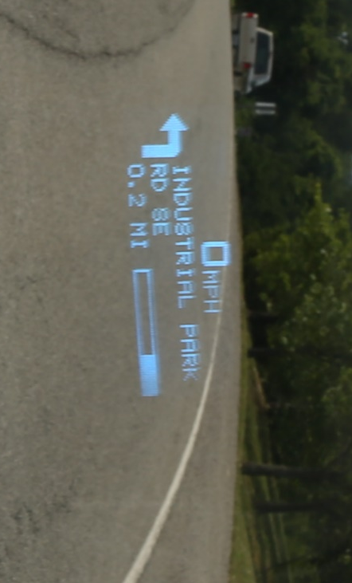
Figure 4. 2010 Buick LaCrosse HUD
The OEM HDD will also be the HDD equipped on the 2010 Buick LaCrosse (Figure 5). The 2D image is presented in the instrument cluster behind the steering wheel. Drivers can press a menu button to cycle through multiple displays. The button is located on the left lever on the steering column, near the headlight controls. The content presented includes the following:
- Vehicle speed
- Distance to next turn
- Street name of next turn
- Next turn direction
- Engine RPM

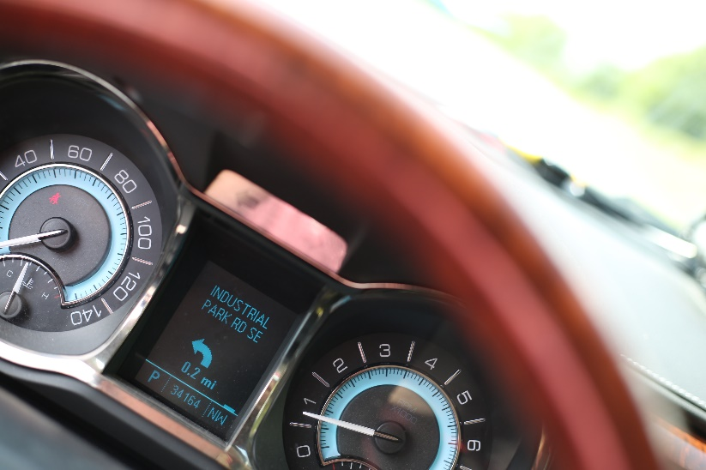
Figure 5. 2010 Buick LaCrosse HDD
The aftermarket HUD will be the Garmin Navigation HUD (Figure 6). This unit sits on the dash and reflects the HUD images onto the windshield via a plastic screen attached to the windshield. The device connects to a smartphone and is operated by the Garmin Streetview application. The HUD only displays information related to navigation, including:
- Vehicle speed (calculated from GPS)
- Distance to next turn
- Street name of next turn
- Next turn direction
- Estimated time of arrival
- Current speed limit
- Over speed limit indicator
- Lane assist arrows
- Safety camera indicator
- Traffic delay indicator

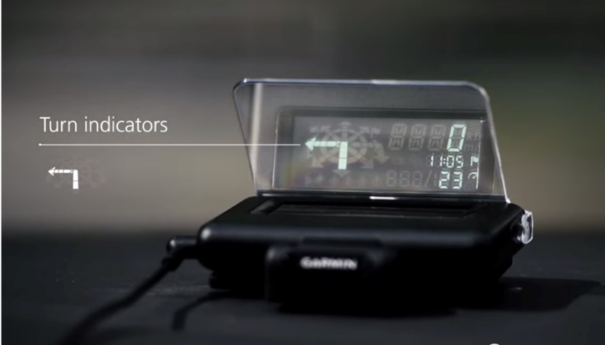
Figure 6. Garmin Aftermarket HUD

Approach
Upon arrival, participants will be greeted and taken to a private screening room. The initial informed consent process will then occur. After completion of the informed consent process, participants will be tested for normal vision, as well as for their dominant eye. Recording the dominant eye should assist in the video-based reduction of visual behavior. General demographic information will be collected via questionnaire (see Appendix C). Participants will then be led to the experiment vehicle, the 2010 Buick LaCrosse, and oriented to the vehicle controls. The HUD displays will then be positioned for each participant.

The initial setup of the OEM HUD will be adopted from Kiefer (1998a). The owner’s manual for the research vehicle advises drivers to adjust the HUD as low as possible in their field of view while the entire HUD image remains fully visible (i.e., so the HUD appears just above the driver’s front hood). At the start of testing, the top of the HUD will be set for each driver at approximately 8 degrees below the driver’s visual horizon. This initial setting may occlude part of the HUD for some drivers, and will be adjusted as needed (i.e., adjusted upward until the entire HUD is visible). This adjustment may cause the HUD to project onto the roadway. The average look-down angle across all drivers will be measured and recorded.

In the aftermarket HUD condition, the Garmin HUD will be positioned in front of the driver, at the same height, but offset slightly to the right of the OEM HUD position. The Garmin HUD projects directly onto a reflector that sticks to the windshield. This positioning allows for the reflector to remain on the windshield even if the Garmin HUD is not in use in a way that does not interfere with the OEM HUD projection. When reflected onto the windshield, the Garmin HUD will also have a look-down angle of approximately 8 degrees.

The HDD is located at approximately 20 degrees below the driver’s visual horizon.
In practice, the HUD and HDD look-down angles will vary somewhat between drivers, depending the height, eye position, seat position, and preference.

Each driver’s test session will take place on public roads and the Virginia Smart Road, a 2.2-mile controlled test track. Testing on public roads will allow the investigation of drivers’ visual behavior, vehicle control, and task completion time under normal traffic demands. Testing on the Virginia Smart Road will allow the controlled investigation of drivers’ emergency response to surprise events when looking at a display. The approach for each component is described below. The variables associated with each are then further discussed in the experimental design section.

The public road component will consist of drivers following an orange VDOT pickup truck at 60 mph. Drivers will experience three conditions that involve reading information displayed on an OEM HUD, aftermarket HUD, and OEM HDD. The public road course consists of a 14-mile stretch of road on a two-lane divided highway in Christiansburg, Virginia (Figure 7). Each driver will experience the OEM HUD, the aftermarket HUD, and the OEM HDD on a separate lap in a counter-balanced order. Their task completion time, eyes-off-road time, eyes-on-display time, mean speed, standard deviation of speed, mean headway, standard deviation of headway, standard deviation of lane position, and subjective opinions of interacting with the display will be measured. Drivers will also wear a lightweight, head-mounted camera that will capture what aspects of the roadway are obstructed by the HUD images.

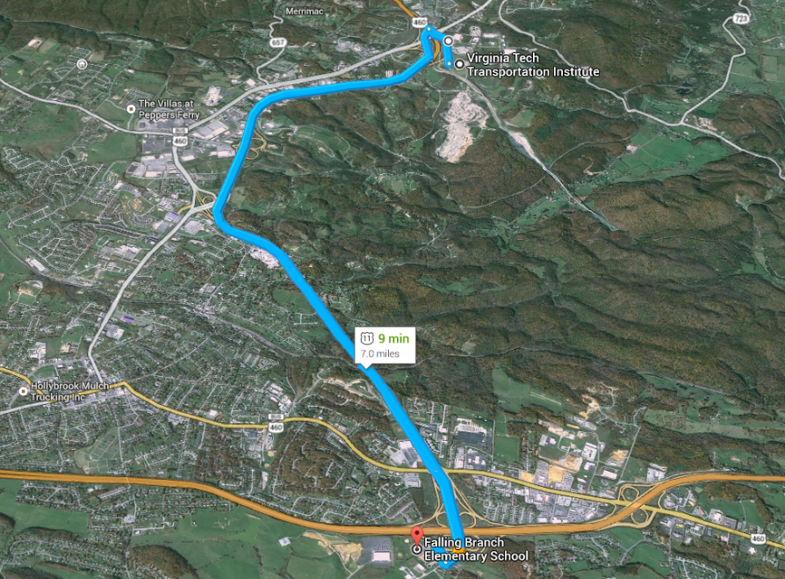
Figure 7. Fourteen-mile Divided Highway Course in Christiansburg, VA
Drivers will then be asked to follow the lead pickup truck onto the Virginia Smart Road. The purpose of this component is to investigate drivers’ emergency response performance to a surprise event in a controlled and safe manner. An example image from the participant’s perspective, including OEM HUD, while following the lead vehicle is shown in Figure 8. Drivers will be asked to perform a task “that is too hard to be performed on public roads” with the display. Unknown to the driver, the lead pickup truck will drop a cardboard box at the command of the in-vehicle experimenter. The box-drop event will be executed as the driver engages in a task with a display. The display the driver is asked to use will either be the OEM HUD, the aftermarket HUD, the OEM HDD, or no display at all (i.e., drivers will not be asked to look at a display during the surprise event). Because the information displayed on the devices used in this study is basic, creativity is required to devise tasks that adequately demand the driver’s visual attention during the surprise event. The proposed approach is to ask the driver to read the display and report the n^{th} character in the display. This task is expected to mimic cognitive capture of the display as it will require counting through the characters on the display. Drivers’ response performance to the surprise event will be measured in terms of gaze response time, throttle response time, brake response time, and swerve response time. Furthermore, the head-mounted camera will capture whether the HUD image obstructed the drivers’ view of the cardboard box. Afterwards, drivers will be debriefed, and if they consent, their response performance across the four display conditions will be investigated using between-subjects statistical analyses.
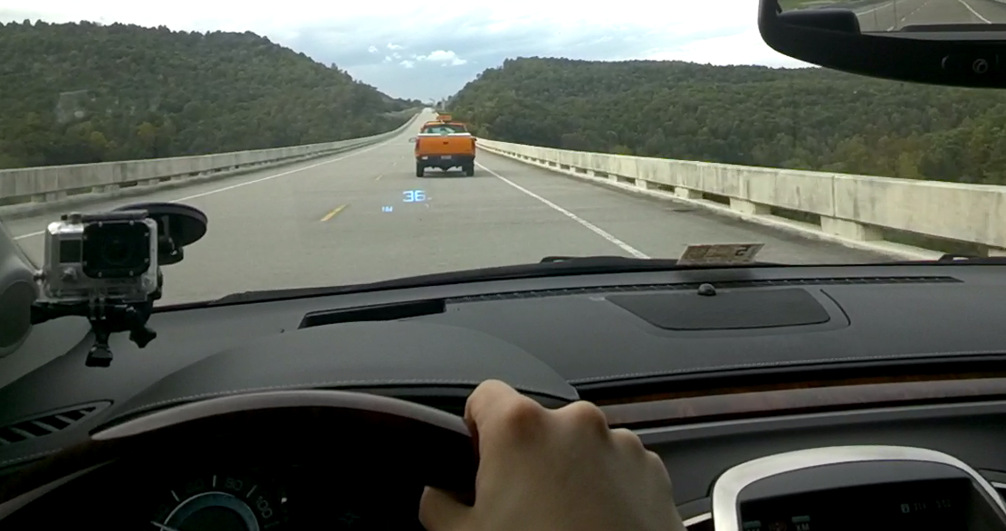
Figure 8. Participant’s Perspective, Following a Lead Vehicle on the Smart Road, with OEM HUD

Experimental Design
The experimental design consists of two different driving components. Two types (OEM and aftermarket) of HUDs and one type of HDD will be tested on public roads (to assess general use) and on the Smart Road (to test distraction potential during surprise events). The public road component will be a three-level, within-subjects design, and will occur first. Immediately following the public road component, participants will transition to the Smart Road. The Smart Road component will be a four-level, between-subjects design. The variables measured in each component are described further below.

This study will use known measures of distraction, notably visual scanning behavior, longitudinal vehicle control, lateral vehicle control, and response time to surprise events. It is believed that these metrics are sensitive to potential distractions resulting from using a HUD versus an HDD. However, investigating driver performance with these measures may also generate insight on new measures of driver interaction with HUDs.
Visual scanning behavior will be ascertained via manual reduction. The close-up video of drivers’ faces and eyes will be viewed by trained reductionists at VTTI to determine the gaze position during the tasks and during baseline driving samples without a task.
For the public road and Smart Road components, drivers will be asked to interact with the display at the experimenter’s prompt. The amount of time spent looking down at the display until the driver reads aloud the information shown will be measured. The experimenter’s cue to begin the task will also help flag the onset of glances to the display. Given the nature of the information displayed on OEM and aftermarket HUDs, the tasks in this experiment will likely be very short in duration.

Public Road Component
The public road component will be a three-level (OEM HUD, OEM HDD, and aftermarket HUD), within-subject study. All 48 drivers will experience the three displays in a counter-balanced order based on a balanced Latin Square design. Drivers will be asked to perform specific display reading tasks at the prompting of the in-vehicle experimenter, and respond verbally with the appropriate response. They will be told that their reading performance will be scored. Participants will complete three laps, completing subjective surveys about the display used in each lap. Baseline measures will be calculated by randomly sampling driving and eye-glance behavior while participants are not performing tasks.

Dependent Variables
The dependent variables will be drivers’ task accuracy, task duration, eyes-on-display-time, eyes-off-road-time (a glance to the HUD will be categorized as off-road because of known deficiencies in selective attention to simultaneously process superimposed and background information; Neisser and Becklen, 1975). In addition, the mean speed, standard deviation of speed, mean headway, standard deviation of headway, and standard deviation of lane position will be dependent variables. Subjective comments about HUD use that are provided by participants during the drive will be recorded for qualitative purposes but will not serve as dependent measures.
Drivers’ visual behavior in between display tasks will be sampled from each condition. This will serve as a baseline condition in the public road scenario. Whether visual behavior changes when a HUD is available will then be investigated. (Note: the HUDs will be disabled during the HDD condition.) This will provide insight on whether HUDs generate unintended consequences on drivers’ visual scanning behavior.

Smart Road Component
The experimental design for the Smart Road portion will be a four-level (OEM HUD, OEM HDD, aftermarket HUD, baseline), between-subjects design. Participants will follow the lead vehicle from the public road portion directly onto the Smart Road. The 48 drivers from the public road component will be equally divided into the three display conditions with a fixation task and one baseline condition (12 drivers total in each condition). The baseline condition will consist of four participants each from the three display conditions.

Dependent Variables
Drivers will encounter a surprise event as they are reading the display in the OEM HUD, OEM HDD, and aftermarket HUD conditions, or just driving if they are in the baseline condition. The baseline condition includes equal numbers of OEM HUD, OEM HDD, and aftermarket HUD participants.
In this scenario, the dependent variables will be drivers’ gaze response time, throttle response time, brake response time, swerve response time, and subjective assessment of how distracted they were during the task. Subjective assessments will be measured via a survey conducted after the surprise event. The survey instrument is presented in Appendix B.

Expected Findings
Overall, this study will allow an investigation of how drivers’ interactions with HUDs of different focal depths and HDDs differ. The public road component will allow the investigation of drivers’ visual scanning behavior and whether HUDs generate any unintended disruptions in this behavior. The Virginia Smart Road component will allow the investigation of potential delays in response performance to surprise events, which can provide insight on the distraction potential of HUDs and their impact on transportation safety. Expected findings are discussed in regard to each research question below, followed by general conclusions.
Observe any changes to visual scanning behavior when using HUD versus HDD Human-Machine Interfaces (HMIs).Visual behavior will be assessed via high-definition recordings of participants’ faces and eyes. If cognitive capture occurs in general driving, it will likely result in a high eyes on display time for HUD conditions compared to HDD conditions. Cognitive capture will be simulated in the Smart Road scenario (via the character-counting task) such that a key result of the present work will be an idea of reaction times in a “worst-case” scenario of cognitive capture by a HUD.

Given the positioning of the HUD, this also is a “worst case” for a HUD occluding an object in the road. Occlusion will be addressed both by subjective question and analysis of the video from the driver’s viewpoint.

Identify candidate metric(s) that are sensitive to potential changes in visual scanning behavior resulting from using a HUD versus an HDD.The current research plan uses measures of longitudinal vehicle control, lateral vehicle control, response time to unexpected events, visual behavior, and task performance, all of which have been used in previous work on distraction. These metrics will be compared between HUD and HDD conditions. It is believed that the performance measures selected for this study will be sensitive to driver interaction with the displays for the surprise event response task.

Determine whether a surrogate measure of visual scanning behavior is sensitive to changes when drivers use candidate HUD systems.Non-visual measures of attention and distraction, such as vehicle control, will be assessed to determine if they are sensitive to the different displays.

Reaction times to surprise events may also serve as a surrogate measure of distraction.

Finally, subjective assessments may also indicate that participants report different levels of distraction among the different displays.

Identify a method to determine or manipulate the driver’s focal distance to near or far displays.
The present work will measure visual behavior for HUDs with known positions and different focal distances. The OEM HUD projects to a distance of 2.5 meters in front of the driver. The Garmin HUD is reflected directly onto the windshield. Any significant differences between the displays will be noted.

Observe any unintended consequences associated with HUD systems..
The proposed work will sample driving and visual behavior for participants from randomly sampled portions of general driving during the public road scenario. This method is expected to reveal any unanticipated differences between display conditions. For example, using a HUD may change general visual scanning behavior such that drivers’ scanning behavior is reduced when a HUD is present, which would suggest cognitive capture. Any delay in response times to the surprise event should also inform this research question.

Describe characteristics of HUD system designs and their advantages and disadvantages.
The meaning of the findings will need to be carefully interpreted. Statistical differences in driving performance do not necessarily translate into changes in crash risk. The specific HUDs presented in this study may provide further specification about HUD position. Should differences be observed based on focal distance, this would also be informative. Any other notable differences will be reported.

        - Advertisements and Screening Materials

Sample Advertisement
Wanted for Research Study

The Virginia Tech Transportation Institute (VTTI) is seeking individuals who:

- are 18 years old and older
- have a valid U.S. driver’s license

- Drive our Research Vehicle on Public roads & the Smart Road during daytime hours
- Total participation time: 1 visit, lasting approximately 2 hours
- This project pays $70 for full participation
- Your data will be kept strictly confidential

If you are interested in learning more,

Please contact us at: 540-231-XXXX or email, drivers@vtti.vt.edu
Reference “the Top Gun Project” in your message

All inquiries welcome!


www.vtti.vt.edu

HUD Distraction Screening Form
Note to Researcher:
Initial contact between participants and researchers may take place over the phone. If this is the case, read the following Introductory Statement, followed by the questionnaire. Regardless of how contact is made, this questionnaire must be administered verbally before a decision is made regarding suitability for this study.

Introductory Statement:
After prospective participant calls or you call them, use the following script as a guideline in the screening interview.

Hello. My name is _____ and I'm with the Virginia Tech Transportation Institute, here at the Smart Rd, in Blacksburg, VA. We are currently recruiting people to participate in a research study. This study involves participating in one session lasting approximately two hours during daytime hours.

VTTI is working on a project on the use of Head-Up Displays for the National Highway Traffic Safety Administration. As part of this project, we are asking people to help evaluate some new technology and drive our research vehicle, which is a Buick LaCrosse, on both public roads as well as the Smart Road, which is our closed to the public test track. The vehicle is instrumented with data collection equipment, including video cameras which will record you while you are in the vehicle.

This study has a few parts to it. First, we would ask you to complete some paperwork; then perform a simple vision and hearing test. Second, you will receive an orientation on Head-Up Displays. A Head-Up Display projects an image onto the windshield and it appears about 6.5 feet in front of the driver. The display shows information about the vehicle, such as current speed. You will then be given an orientation of the research vehicle, and you will drive to US-460 and proceed along a predetermined route. Once the public road portion is completed, we will proceed back to VTTI, to our test track, the Smart Rd. An experimenter would be with you at all times. This project pays $60.

If you are interested in possibly participating, I need to go over some screening questions to see if you meet all the eligibility requirements of this study. Any information given to us will be kept secure and confidential.

Do I have your consent to ask the screening questions?
If yes, continue with the questions. If no, then thank him/her for their time and end the phone call.

- Do you have a valid U.S. driver’s license?
  - Yes If yes, how long have you had a license?____________________
  - No

- What is your current age? _______________(Stop if not 18 years or older)

- Are you a U.S. Citizen?
  - Yes
  - No
If not a U.S. Citizen: Do you have a green card?
    - Yes
    - No
- Are you willing to provide your Social Security # should you participate, as required by the University? (explain they will be asked to complete a W-9 if they ask why)
  - Yes
  - No
Please note that for tax recording purposes, the fiscal and accounting services office at Virginia Tech (also known as the Controller’s Office) requires that all participants provide their social security number to receive payment for participation in our studies. Or if a VT employee they may provide their VT employee #.

- Are you able to drive an automatic transmission vehicle without assistive devices or special equipment?
  - Yes
  - No

- How often do you drive per week (on average)? How many days/week? ______________

- Have you ever been in a driving study or any experiments at the Virginia Tech Transportation Institute? If "yes," please briefly describe the study.
  - Yes ______________________________________________________
  - No (Cannot have been in a type of surprise study)

- Have you had any moving violations in the past 3 years? If so, please explain.
  - Yes ______________________________________________________
  - No

- Have you been involved in any auto accidents in the past 3 years? If so, please explain.
  - Yes ______________________________________________________
  - No
We need to ask a few questions about your medical history…

- Do you have a history of any of the following medical conditions? If yes, please explain.

  - Neck or back pain or injury to these areas
    - Yes
    - No

  - Head injury, stroke, or illness or disease affecting the Brain
    - Yes
    - No

  - Heart condition (cannot be current heart condition, which limits their activity)
    - Yes
    - No

  - Current respiratory disorder or condition which requires oxygen
    - Yes
    - No
  - Epileptic seizures or lapses of consciousness within the past 12 months
    - Yes
    - No

  - Chronic migraines or tension headaches (more than 1/mo during the past year)
    - Yes
    - No

  - Inner ear problems, dizziness, vertigo, or any balance problems (current)
    - Yes
    - No

  - Uncontrolled diabetes
    - Yes
    - No

  - Have you had major surgery in the past 6 months?
    - Yes
    - No

  - Are you taking any substances on a regular basis which could impair your motor skills or your ability to drive?

    - Yes
    - No

- (Females only) Are you currently pregnant? (if “yes,” politely inform the participant: while being pregnant does not disqualify you from participating in this study, you are encouraged to talk to your physician about your participation to make sure that you both feel it is safe. If you like, we can send you a copy of the consent form to discuss with your physician. Answer any questions)
  - Yes
  - No

- Do you have normal, or corrected to normal, hearing and vision? If no, please explain.
  - Yes
  - No ______________________________________________________

- For this study, you will be asked to drive without sunglasses. Will this present a problem should you be eligible to participate?
  - Yes
  - No
Do you wear eyeglasses that tint or darken in the sunlight (while seated in a vehicle)?
    - Yes __________
    - No ___________

- Are you comfortable reading, writing, and speaking English?
  - Yes
  - No

- Are you currently employed in the design, engineering, or development of automotive-related technologies?
  - Yes
  - No

        - Information sheet and informed consent document

Information Sheet

VIRGINIA POLYTECHNIC INSTITUTE AND STATE UNIVERSITY
Information Sheet for Participants of Investigative Projects

Title of Project: Top Gun

Investigators: Greg Fitch, Sheldon Russell, Trevor Richards, and Myra Blanco

- The Purpose of this Research/Project

The purpose of this study is to study the benefit of Head-Up Displays. We are asking you to assist us with this study. If you participate you will be asked to drive a passenger vehicle on public roads as well as on our test track while performing tasks involving Head-Up Displays. The results from this study will be used to inform the design and use of Head-Up Displays.

- Procedures
During the course of this experiment you will be asked to perform the following tasks:

- Read this Information Sheet and sign it if you agree to participate.
- Complete a W-9 form.
- Show your valid driver’s license.
- Complete a vision test.
- Complete a hearing test.
- Drive a passenger vehicle at normal highway speeds on US-460 for about 12 miles, while following an experimenter in a separate vehicle. During the drive, you will be asked to perform tasks that require reading information from the Head-Up Display (i.e., read current speed) while driving. An experimenter will sit in the passenger’s seat while you are driving and provide instructions throughout the public road portion. A video recording with audio will be made to allow for later analyses.
- Afterwards we will proceed to the test track and complete six test trials. Five of the test trials will include performing tasks that require reading information from the Head-Up Display (i.e., read current speed, read cardinal direction) while driving.

We are not evaluating you or your performance in any way. You are helping us evaluate new technology. Any opinions you have will only help us do a better job of designing the systems. Therefore, we ask that you perform to the best of your abilities. Any feedback that you provide is very important to this project. The experiment will last about 2 hours

- Risks

There are risks or discomforts to which you may be exposed in volunteering for this research. They include the following:

- The risk of an accident normally associated while driving a passenger vehicle under normal operating conditions.
- Possible fatigue due to the length of the experiment.

While the risk of participation in this study is considered to be no more than that encountered in everyday driving, if you are pregnant you should talk to your physician and discuss this information sheet with them before making a decision about participation.

Please be aware that events such as conditions on the public road, equipment failure, changes in the test track, stray or wild animals entering the road, and weather changes may require you to respond accordingly.

In the event of an accident or injury in a vehicle owned or leased by Virginia Tech, the vehicle liability coverage for property damage and personal injury is provided. The total policy amount per occurrence is $2,000,000. This coverage (unless the other party was at fault, which would mean all expense would go to the insurer of the other party's vehicle) would apply in case of an accident for all volunteers and would cover medical expenses up to the policy limit. For example, if you were injured in a vehicle owned or leased by Virginia Tech, the cost of transportation to the hospital emergency room would be covered by this policy.

Participants in a study are considered volunteers, regardless of whether they receive payment for their participation; under Commonwealth of Virginia law, worker's compensation does not apply to volunteers; therefore, if not in the vehicle, the participants are responsible for their own medical insurance for bodily injury. Appropriate health insurance is strongly recommended to cover these types of expenses. For example, if you were injured outside of the vehicle owned or leased by Virginia Tech, the cost of transportation to the hospital emergency room would be covered by your insurance.

The following precautions will be taken to ensure minimal risk to you:
- You may take breaks or decide not to participate at any time.
- An experimenter will be present in the passenger’s seat. We ask that you drive as you would normally drive.
- On public roads, we will not ask you to exceed the posted speed limit.
- On public roads, the lead vehicle driver you will be asked to follow is a VTTI employee that has been trained on the experiment protocols and procedures.
- On the test track, we will not ask you to exceed 45 mph.
- All drivers of the other vehicles present on the test track are VTTI employees that have been trained in test track procedures and protocols.
- All data collection equipment is mounted such that, to the greatest extent possible, it does not pose a hazard to you in any foreseeable case.
- You are required to wear a seat belt restraint system while in the passenger vehicle.
- The vehicle is equipped with a fire extinguisher and first aid kit.
- A pre-trip inspection has been performed on the vehicle prior to your test session.
- The experimenter will end the experiment if inclement weather occurs. This includes any weather that results in the use of the windshield wipers, wet or icy road surfaces, and reduced visibility due to fog.
- You do not have any medical condition that would put you at a greater risk, including but not restricted to neck/spine injury, epilepsy, balance disorders, and lingering effects of head injuries and stroke.
- In the event of a medical emergency, or at your request, VTTI staff will arrange medical transportation to a nearby hospital emergency room. You may elect to undergo examination by medical personnel in the emergency room.

- Benefits of this Project

While there are no direct benefits to you from this research, you may find the experiment interesting. No promise or guarantee of benefits is made to encourage you to participate. Participation in this study may contribute to the improvement of in-vehicle systems.

- Extent of Anonymity and Confidentiality

The data gathered in this experiment will be treated with confidentiality. Shortly after participating, your name will be separated from the data and replaced with a number. That is, your data will not be attached to your name, but rather to a number (e.g., Driver 001). It is possible that the Institutional Review Board (IRB) may view this study’s collected data for auditing purposes. The IRB is responsible for the oversight of the protection of human subjects involved in research.

All video and other data recorded in this study will be stored in a secured area at Virginia Tech. Access to the data files will be under the supervision of the Principal Investigator and lead VTTI researchers involved in the project. All data will be encrypted at the time of data collection and will be decrypted only for approved analyses. It is possible that, after data collection is complete one copy of study data will be transferred to the project sponsor (the U.S. Department of Transportation) for permanent storage and oversight. Please note that they will follow the same procedures for protecting participant confidentiality.

Authorized project personnel and authorized employees of the research sponsors will have access to the study data that personally identifies you or that could be used to personally identify you. As explained below, other qualified research partners may also be given limited access to your driver, vehicle, and driving data, solely for authorized research purposes and with the consent of an IRB. This limited access will be under the terms of a data sharing agreement or contract that, at a minimum, provides you with the same level of confidentiality and protection provided by this document. However, even these qualified researchers will not be permitted to copy raw study data that identifies you, or that could be used to identify you, or to remove it from the secure facilities in which it is stored without your consent.

- Compensation

You will be paid $60 for your participation. You will be paid at the end of this session in cash. Expected participation time will be for one visit, lasting approximately two hours. If the session ends early for any reason, you will be paid at the rate of $30 per hour, rounded to the nearest ½ hour, and a minimum of $30.

- Freedom to Withdraw

Participants in this study are free to withdraw at any time. There is no penalty for withdrawing. If you choose to withdraw, you will be compensated for the portion of time of the study for which you participated. Furthermore, you are free not to answer any question or respond to experimental situations without penalty. If you choose to withdraw while you are operating the heavy vehicle, please inform the experimenter of this decision and he/she will direct you off of the test track and have you safely park the heavy vehicle.

- Approval of Research

Before data can be collected, the research must be approved, as required, by the Institutional Review Board for Research Involving Human Subjects at Virginia Polytechnic Institute and State University and by the Virginia Tech Transportation Institute. You should know that this approval has been obtained. This form is valid for the period listed at the bottom of the page.

IX. Subject’s Responsibilities

If you voluntarily agree to participate in this study, you will have the following responsibilities:
1. To follow the experimental procedures as well as you can.
2. To inform the experimenter if you have difficulties of any type.
- To wear your seat belt while operating the heavy vehicle.
- To abstain from any substances that will impair your ability to drive.
- To obey traffic regulations, adhere to the 45mph speed limit, and maintain safe operation of the vehicle at all times.
- To treat the driving task as the primary task and perform other tasks only when it is safe to do so.

Participant’s Acknowledgments

Check all that apply:

o□ I am not under the influence of any substances which may impair my ability to safely participate in this experiment.
o□ If I am pregnant I acknowledge that I have either discussed my participation with my physician, or that I accept any additional risks due to pregnancy
o□ I do not have a history of neck or back injury or pain.
o□ I do not have a history of a heart condition
o□ I have not have had any major surgery in the last 6 months.
o□ I have not had an epileptic seizure or lapses of consciousness within the past 12
months.
o□ I do not have chronic migraines or tension headaches.
o□ I will inform the experimenter of any concerns or questions I have about this study.

Consent to Use Video/Audio Data for Research Reporting Purposes

Digital video cameras will be used to record your driving. These digital video files could be used to clarify the experimental methods and to help report findings at technical conferences and other presentations. We are asking your permission to show portions of video displaying your image when useful for research reporting purposes. If you agree, please make a check mark in the box that represents your opinion. If you do not agree, you will still be able to participate in this study, but your data will not be used for demonstration or presentation purposes.

Check one of the following:

Use of Video Data at Technical Presentations

  - VTTI has my permission to show the digital video including my image for research or research reporting purposes (such as presentations). I understand that VTTI will only use the video data for these purposes. These videos and images will not be made publically available or be provided to any outside party.

- VTTI does not have my permission to show the digital video including my image for research or research reporting purposes. I understand that VTTI will maintain possession of the data for research purposes.

- Participant’s Permission

I have read and understood the Information Sheet and conditions of this project. I have had all my questions answered. I hereby acknowledge the above and give my voluntary consent for participation in this project. If I participate, I may withdraw at any time without penalty. I agree to abide by the rules of this project.

Participant’s Name (Print) Signature Date

Experimenter’s Name (Print) Signature Date

Should I have any questions about this research or its conduct, I may contact:

Sheldon Russell | srussell@vtti.vt.edu | (540) 231-1500

If I should have any questions about the protection of human research participants regarding this study, I may contact: Dr. David Moore, Chair of the Virginia Tech Institutional Review Board for the Protection of Human Subjects, telephone: (540) 231-4991; email: moored@vt.edu; address: Research Compliance Office, 2000 Kraft Drive, Suite 2000 (0497), Blacksburg, VA 24061.

Informed Consent Document

VIRGINIA POLYTECHNIC INSTITUTE AND STATE UNIVERSITY
Informed Consent for Participants of Investigative Projects

Title of Project: Head-Up Display and Distraction Potential

Investigators: Greg Fitch, Sheldon Russell, Trevor Richards, and Myra Blanco

- The Purpose of this Research/Project

We apologize for not being able to tell you the additional purpose of this research prior to your participation. The purpose of this study is to examine the distraction potential of Head-Up Displays.

We deliberately created a situation where the vehicle you were asked to follow would drop an object in the road, requiring an evasive maneuver. The dropping of the object was coordinated to occur as you took your eyes off of the forward roadway. This was done to test if reaction times are different when using Head-Up Displays when compared to Head-Down Displays. The lead vehicle drivers were trained to respond safely in case the distance between this vehicle and their own vehicles was no longer safe, and all drivers were in communication during the event to ensure safety. Furthermore, the object was an empty cardboard box and would pose little to no safety risks if a collision were to occur.

The results of this study will contribute to our understanding of how Head-Up Displays can benefit or distract drivers. This understanding will provide improvements in future system design and guidelines.

Your performance in this test trial is not an indication of your driving ability. We ask that you do not talk about the details of this study to others after your participation because this may invalidate future data that may be collected.

At this point you are free to end the experiment. If you would like to leave we can drive back to the Institute and compensate you for your time. However, if you are willing to continue, we like to ask for your consent to use the data that we have collected so far. All data collected up to this point will be included in our analysis if you decide to continue. Please initial one of the following:  _______ I do not want to continue.  _______ I would like to continue. | Please initial one of the following:  _______ I give my voluntary consent for the data that was collected so far and will be collected to be used in the analysis for this research project.  _______ I do not give my voluntary consent for the data that was collected so far to be used in the analysis for this research project.

Please check one of the following:

Use of Video Data at Technical Presentations

  - VTTI has my permission to show the digital video including my image for research or research reporting purposes (such as presentations). I understand that VTTI will only use the video data for these purposes. These videos and images will not be made publically available or be provided to any outside party.

- VTTI does not have my permission to show the digital video including my image for research or research reporting purposes. I understand that VTTI will maintain possession of the data for research purposes.

All other aspects of the earlier information sheet you signed, including risks, benefits, safety precautions, and your responsibilities, continue to apply to the remainder of this experiment.

- Participant’s Permission

I have read and understood the Informed Consent and conditions of this project. I have had all my questions answered. I hereby acknowledge the above and give my voluntary consent for participation in this project. If I participate, I may withdraw at any time without penalty. I agree to abide by the rules of this project.

Participant’s Name (Print) Signature Date

Experimenter’s Name (Print) Signature Date

Should I have any questions about this research or its conduct, I may contact:

Sheldon Russell | srussell@vtti.vt.edu | (540)231-1500

If I should have any questions about the protection of human research participants regarding this study, I may contact: Dr. David Moore, Chair of the Virginia Tech Institutional Review Board for the Protection of Human Subjects, telephone: (540) 231-4991; email: moored@vt.edu; address: Research Compliance Office, 2000 Kraft Drive, Suite 2000 (0497), Blacksburg, VA

        - Demographic Questionnaire

demographic questionnaire
Virginia Tech Transportation Institute
HUD Questionnaire

General Information:

Date:
Gender:
Age:

- Are you left or right handed? Left______Right___________
- Are you left or right eye dominant (result of test)? Left______Right___________

Driving History:

- At what age did you receive your driver’s license?
__________

- Please estimate the following:

  - Hours driven per week: ___________________________

  - Miles driven per week: ___________________________

References
Ablassmeier, M., Poitschke, T., Wallhoff, F., Bengler, K., & Rigoll, G. (2007). Eye gaze studies comparing head-up and head-down displays in vehicles. Intelligent Vehicles Symposium, 2007 IEEE, 2250–2252. Retrieved from http://www.mmk.ei.tum.de/publ/pdf/07/07abl3.pdf
Burnett, G. E., & Donkor, R.A. (2012). Evaluating the impact of head-up display complexity on peripheral detection performance: A driving simulator study. Advances in Transportation Studies, 28, Section A.
Charissis, V., & Naef, M. (2007). Evaluation of prototype automotive head-up display interface: Testing driver’s focusing ability through a VR simulation. Intelligent Vehicles Symposium, 2007 IEEE, 560–565. Retrieved from http://www.research.navisto.ch/pdf/IEEE-IV07-Charissis.pdf on November 1, 2014.
Crisler, M .C., Brooks, J. O., Riggins, K., Garris, B., Tyler, J., & Dahl, S. (2009). Effects of display location within simulated driving environments. Proceedings of the Fifth International Driving Symposium on Human Factors in Driver Assessment, Training and Vehicle Design. Retrieved from http://drivingassessment.uiowa.edu/DA2009/027_CrislerBrooks.pdf on November 1, 2014.
Dijksterhuis, C., Stuiver, A., Mulder, Brookhuis, K. A., & Waard, D.D. (2012). An adaptive driver support system: User experiences and driving performance in a simulator. Human Factors: The Journal of the Human Factors and Ergonomics Society, 54, 772. Originally published online January 10 , 2012. Retrieved from http://hfs.sagepub.com/content/54/5/772
Dingus, T. A., Hankey, J. M., Antin, J. F., Lee, S. E., Eichelberger, L., Stulce, K., McGraw, D., Perez, M., Stowe, L. (2014). Naturalistic driving study: Technical coordination and quality control (SHRP 2 Report). Web: Transportation Research Board. Retrieved from http://onlinepubs.trb.org/onlinepubs/shrp2/SHRP2_S06Report.pdf
Gish, K. W., & Staplin, L. (1995). Human factors aspects of using head up displays in automobiles: A review of the literature (Interim Report). Washington, DC: National Highway Transportation Saftey Administration (NHTSA). Retrieved from http://ntl.bts.gov/lib/jpodocs/edlbrow/3r_01!.pdf on October 10, 2014.
Hart, S. G., & Staveland, L. E. (1988). Development of NASA-TLX (Task Load Index): Results of empirical and theoretical research. Advances in Psychology, 52, 139–183.
Kiefer, R. J. (1998a). Quantifying head-up display (HUD) pedestrian detection benefits for older drivers. In Proceedings of the 16th International Conference on the Enhanced Safety of Vehicles (pp. 428–437).
Kiefer, R. J. (1998b). Defining the “HUD benefit time window.” Vision In Vehicles – VI: Elsevier (pp. 133–42).

Liu, Y-C., & Wen, M-H. (2004). Comparison of Head-Up Display (HUD) vs. Head-Down Display (HDD): Driving performance of commercial vehicle operators in Taiwan. International Journal of Human-Computer Studies 61, 679–697. Originally published online January 10, 2012, available at http://www.sciencedirect.com/science/article/pii/S1071581904000497
Neisser, U. & Becklen, R. (1975). Selective looking: Attending to visually specified events. Cognitive Psychology, 7(4), 480–494. Retrieved from http://dx.doi.org/10.1016/0010-0285(75)90019-5.
Normark, C. J., Tretten, P., & Garling, A. (2009). Do redundant head-up and head-down display configurations cause distractions? Proceedings of the Fifth International Driving Symposium on Human Factors in Driver Assessment, Training and Vehicle Design. Retrieved from http://drivingassessment.uiowa.edu/DA2009/055_NormarkTretten.pdf on November 1, 2014.
Okabayashi, S., Sakata, M., Furukawa, M., & Hatada, T. (1990). A heads-up display performance in automotive use. Society for Information Display, 31, 255–261.
Rockwell, T. H. (1972). Eye movement analysis of visual information acquisition in driving: An overview. Australian Road Research Board (ARRB) Conference, 6th, 1972, Canberra.
Ward, N. J. & Parkes, A. (1994). Head-up displays and their automotive application: An overview of human factors issues affecting safety. Accident Analysis & Prevention, 26(6), 703–717. Retrieved from http://dx.doi.org/10.1016/0001-4575(94)90049-3
Weinberg, G., Harshman, B., & Medenica, Z. (2011, November). Evaluating the usability of a head-up display for selection from choice lists in cars. In Proceedings of the 3rd International Conference on Automotive User Interfaces and Interactive Vehicular Applications (pp. 39-46). ACM.. Retrieved from http://www.merl.com/publications/docs/TR2011-076.pdf on November 1, 2014.

