U.S. Bureau of Labor Statistics
International Price Program
Import/Export Price Survey website

Login page
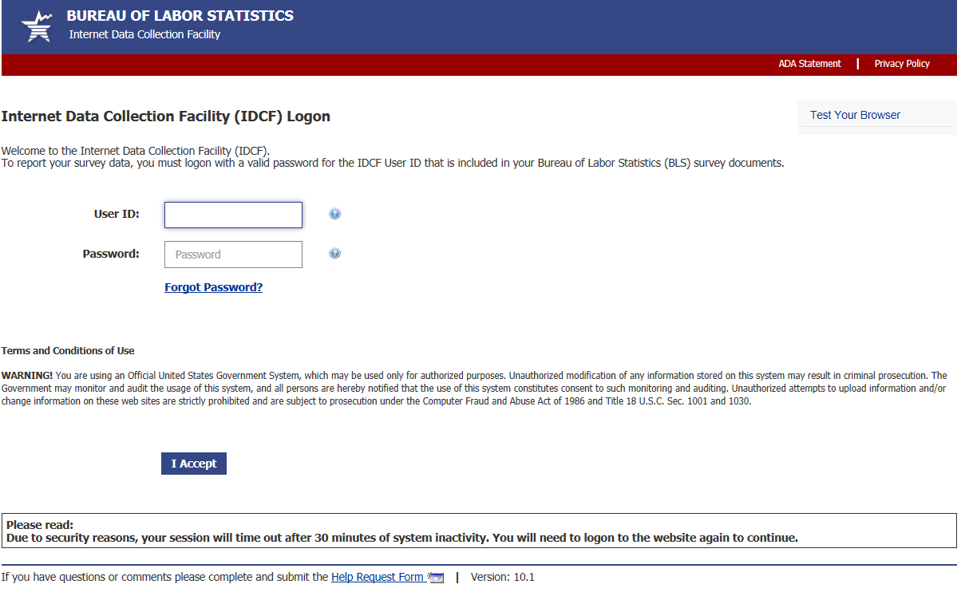

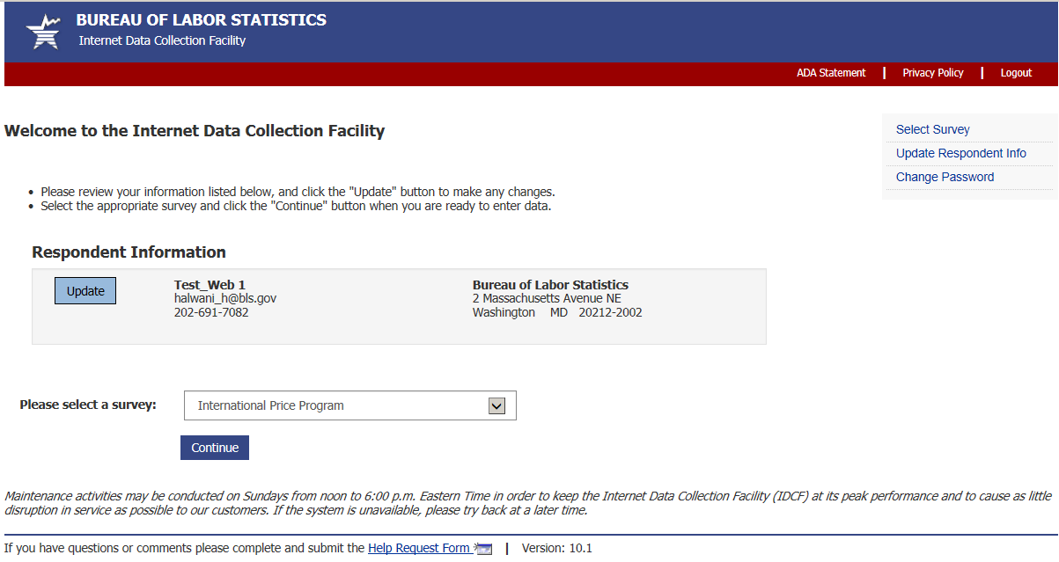

Welcome Screen
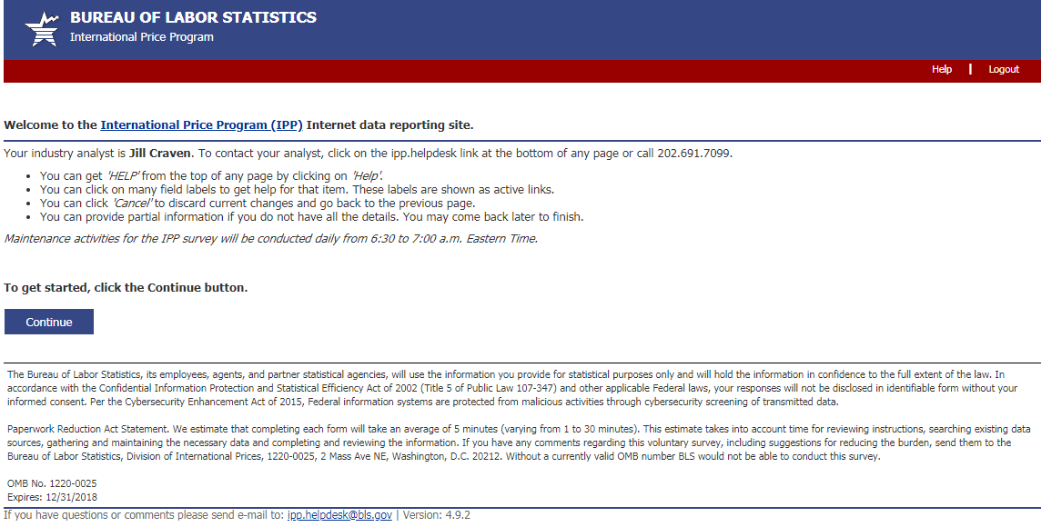

(44 U.S.C. 3572)

Verify Contact Information screen (Step 1)
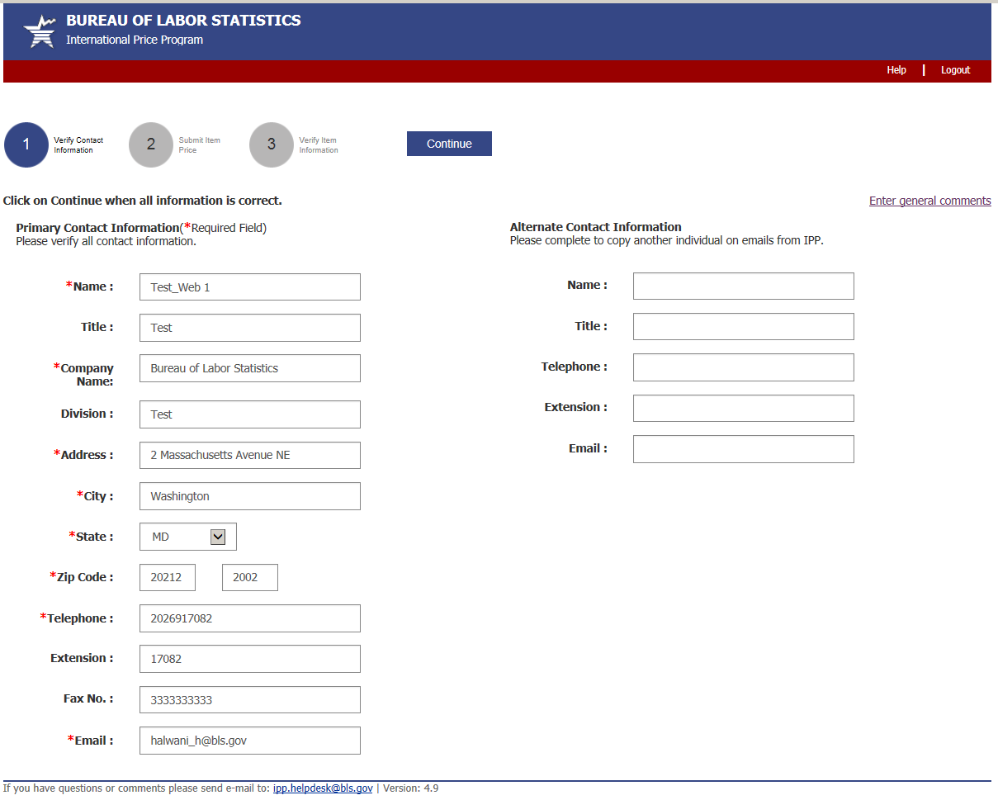

Submit Price Information Screen (Step 2)
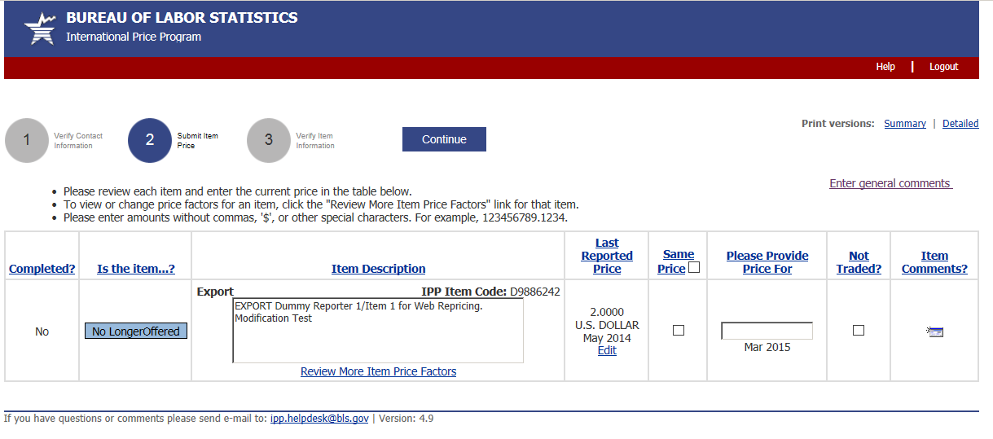

Verify Price Information Screen (Step 3)
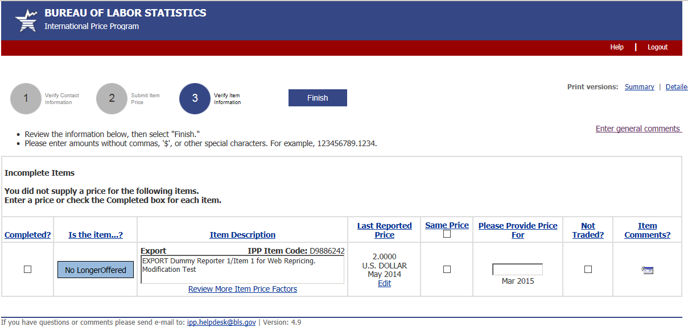
.2
.2

More Item Price Factors screen
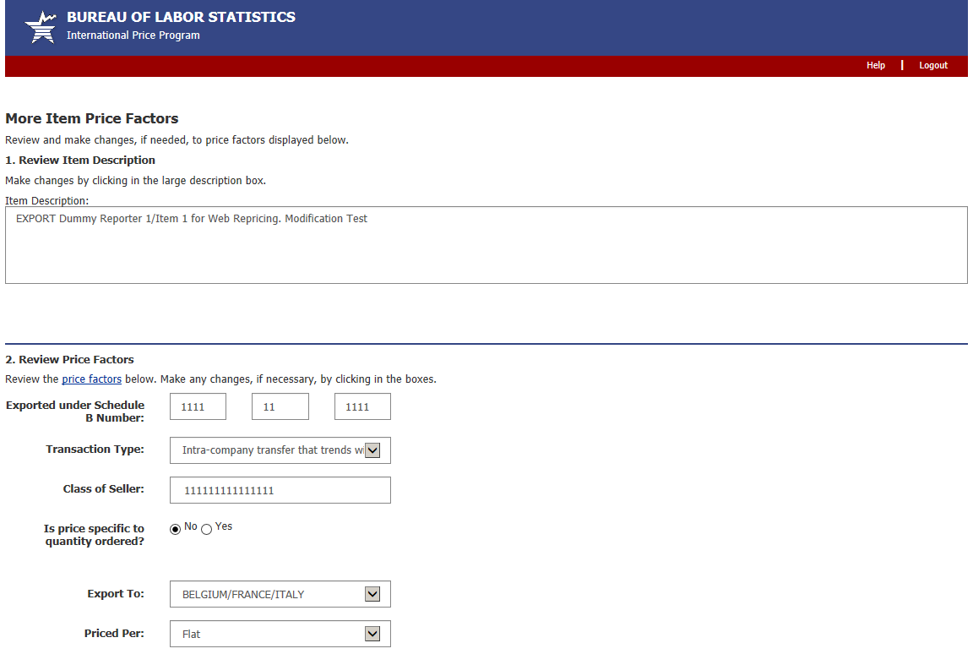
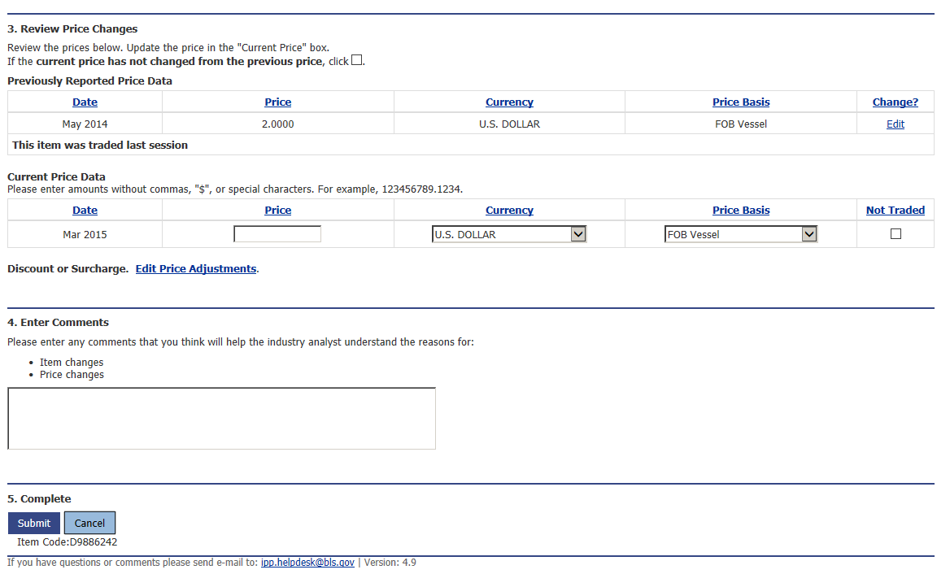
Edit Price Adjustments screen
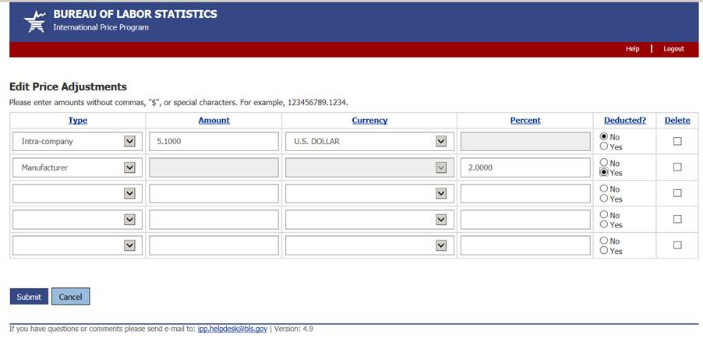

Review/Verify Large Price change screen
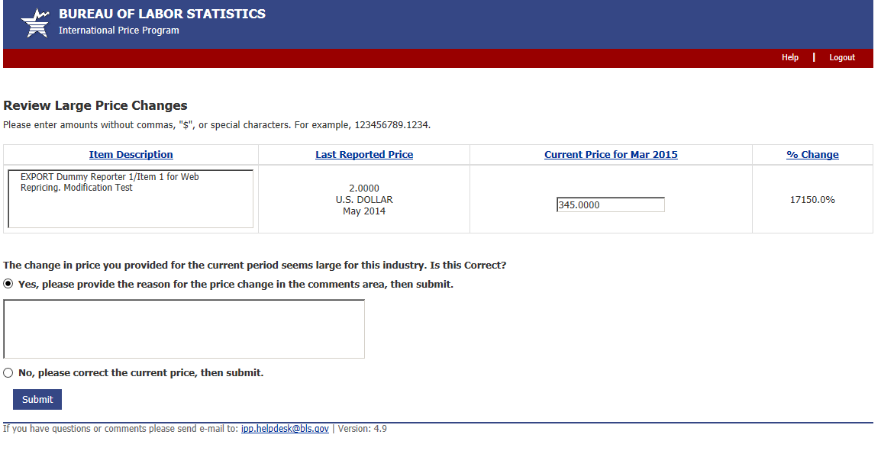

Review/Verify Cost of Modification screen
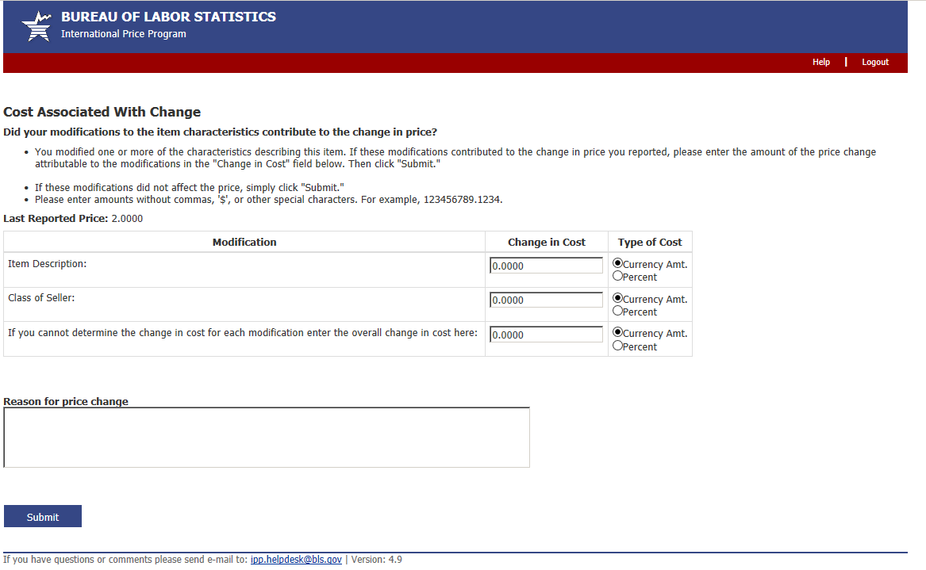

Update Last Reported Price screen
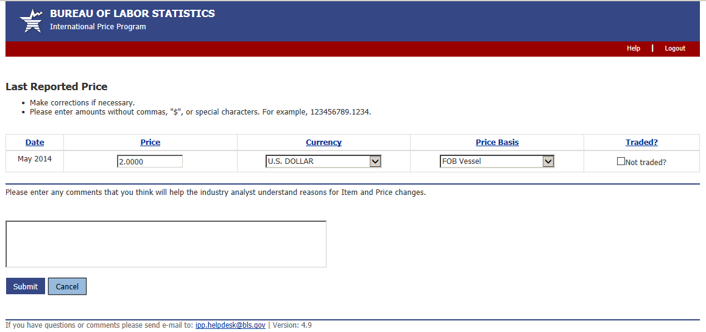

Discontinue/Replace Item screen
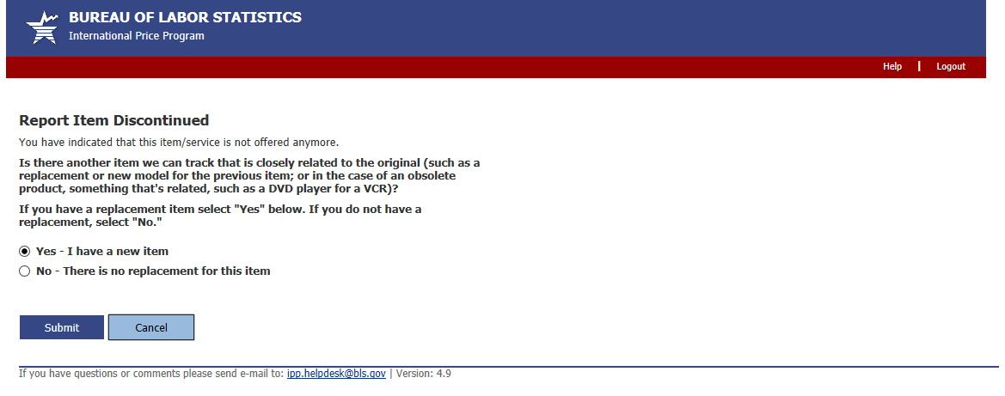

Replaced Item Screen
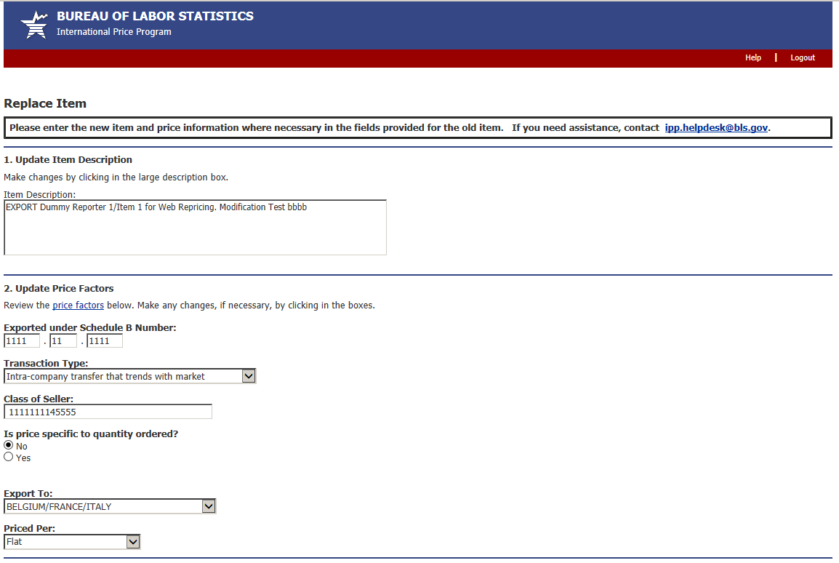
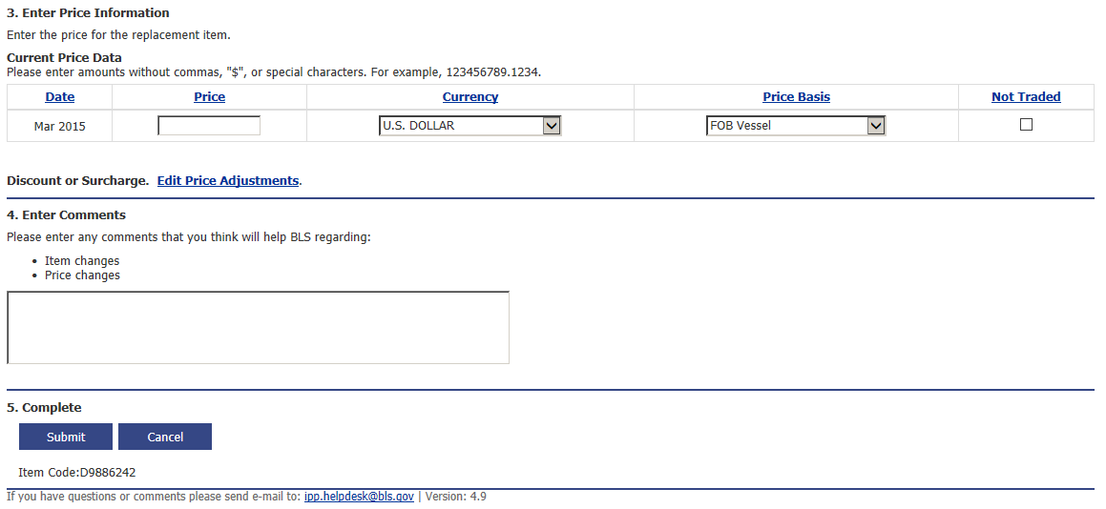

Undo Replacement screen
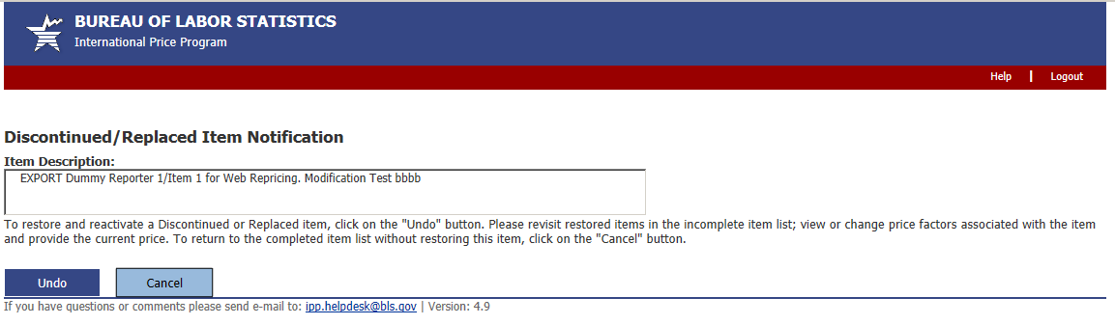

Thank You screen
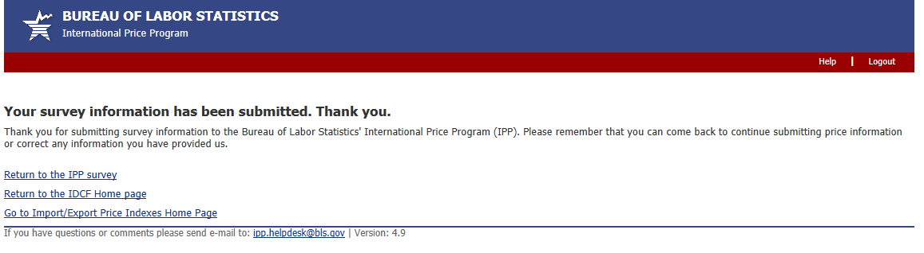
Privacy and Security Statement
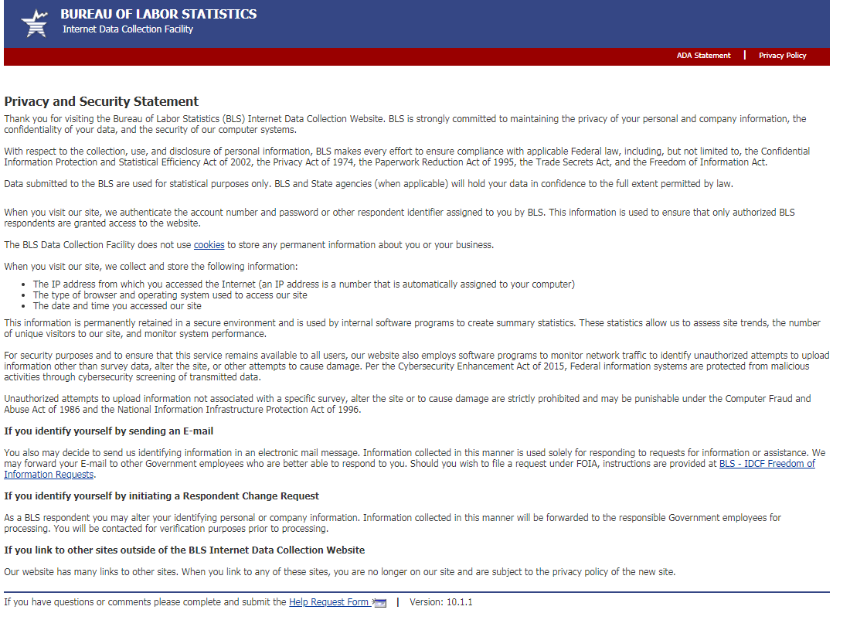

(44 U.S.C. 3572), the Privacy Act of 1974, the Paperwork Reduction Act of 1995, the Trade Secrets Act, and the Freedom Information Act.

