ATTACHMENT F
YOUTH ASSESSMENT FORM

This page intentionally left blank for double sided copying

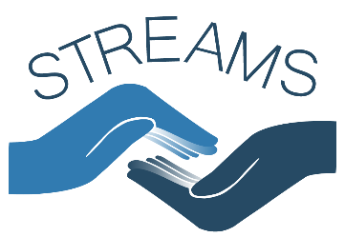
Form approved
OMB Number:
Expiration Date:

STATEMENT OF ASSENT

SURVEY – for youth under 18

Strengthening Relationship Education and Marriage Services (STREAMS) Evaluation

Sponsored by the United States Department of Health and Human Services
An adult from Mathematica Policy Research has explained to me the Strengthening Relationship Education and Marriage Services (STREAMS) Evaluation. I was told that I have been selected to be a part of the study and that my parent or guardian has agreed to my participation. The study was described to me and any questions I had were answered. I understand I will be asked to complete this survey and that the information I provide will be kept private to the extent allowed by law, and will not be provided to people outside of the study or shown to my parents or guardians. I also understand that I do not have to answer any questions that make me feel uncomfortable. I understand that I might be invited to participate in focus groups at a later date, and that the decision about whether or not to participate in focus group is up to me and my parent or guardian.
If I have questions about my rights as a research volunteer or questions about the study, I can call:
- The New England Institutional Review Board, toll-free at 1-800-232-9570.
- Shawn Marsh, Survey Director at Mathematica Policy Research, toll-free at 1-xxx-xxx-xxxx.
I understand that participation is voluntary, and I agree to participate in the study. I understand that I am allowed to stop participating in the study at any time, without punishment.

Name

Signature

Date

Email:
Cell phone: ( ) _________ - ______________
Area code
---------------------------------------------------------------------------------------------------------------------------------------
I certify that the staff members assigned to explain the study to participants were trained to do so in terms participants would understand.

Shawn Marsh, Survey Director Signature Date
NOTE: The Paperwork Reduction Act Statement: This collection of information is voluntary and will be used to examine the effectiveness of healthy marriage and relationship education programs designed to improve intimate relationships.. An agency may not conduct or sponsor, and a person is not required to respond to, a collection of information unless it displays a currently valid OMB control number. The OMB control number for this collection is XXXX-XXXX and it expires on XX/XX/XXXX.

This page intentionally left blank for double sided copying

