CONSUMER LEVEL SETTING MATERIAL
Moderator to show a document on the screen with the information below. The moderator will show the document on the screen and then read it aloud as the respondents read it to themselves. Moderator will probe about any questions or confusion among participants to ensure a baseline level of knowledge. Moderator has the ability to show the document again, if participants need to reference this document during the discussion.
+++
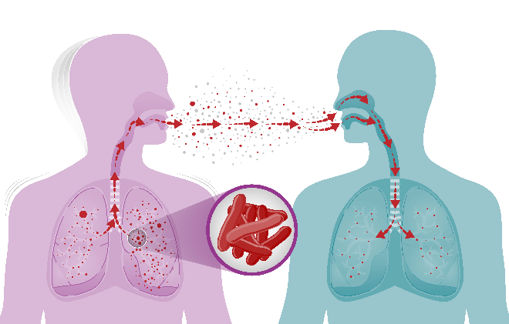
Tuberculosis, also called TB, is a serious disease that usually affects the lungs. Anyone can get it.

It is caused by bacteria and spreads through the air, when a person with TB disease coughs, speaks, or sings.

It can cause death if not treated.

TB bacteria can live in the body without making you sick. This is called latent TB infection (LTBI) or “inactive TB.” | When TB bacteria are active, this is called Tuberculosis (TB) Disease or “active TB disease.” People with active TB disease are sick and can make other people sick.
 | 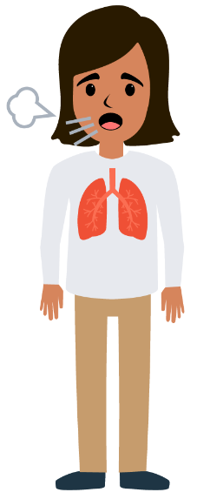

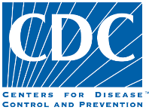
The Centers for Disease Control and Prevention (CDC) is the leading national public health agency of the United States and is a part of the Department of Health and Human Services.

