National Recreation Reservation Service

Field Survey 2018

Introduction
Thank you for taking a minute to answer these 10 questions--your satisfaction is important to us!

Our contract requires that Active Network/ReserveAmerica provide effective, courteous, and timely field and technical support. Please use this survey to rate your satisfaction with Active Network/ReserveAmerica’s field and technical support. The Office of Management and Budget Control Number 1090-0007, which expires September 30, 2021, authorizes this survey.

CFI Group (our survey provider) will send the survey results directly to me and other Recreation.gov agency staff. Please contact me if you have questions.

Sincerely,

Jolene Hall
Recreation.gov Interagency Performance Manager
jolene_hall@nps.gov

Please enter your Case Number below (required). <TEXT BOX>

Reservation Information

Q1.How did you submit your case? New Question (TAG is CASE)

1.1 Through Support Center (on-line)
1.2 By Email
- 1.3 By Phone

Please think about your most recent issue when rating the following items. Use a 10-point scale on which "1" means "Poor" and "10" means "Excellent" to rate:

2.1 The time it took to submit your initial email, phone or on-line request to the Help Desk
2.2 The courtesy and clarity of Help Desk staff communications
2.3 The timeliness of case completion*
2.4 The effectiveness of case completion
2.5 The Help Desk’s overall resolution of your issue

* Support staff will estimate a case completion time when you make your initial request. Active Network/ReserveAmerica’s estimated case completion times appear below in the Support Service Level Agreements table.
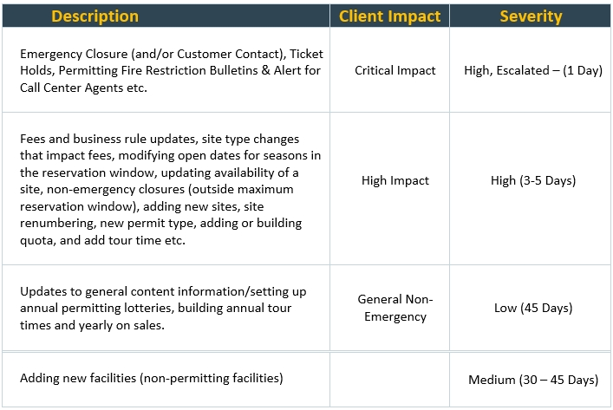

ACSI Benchmark Questions
ACSI1 First, please rate your overall experiences during the past month with ReserveAmerica. Using a 10-point scale on which "1" means "Very dissatisfied" and "10" means "Very satisfied," how satisfied are you with the services ReserveAmerica provides?

ACSI2. To what extent has ReserveAmerica met your expectations in the past month? Again, please use a 10-point scale on which "1" now means "not met your expectations" and "10" means, "Exceeds your expectations."
ACSI3. Now, imagine the ideal field and technical support provider. How well does ReserveAmerica's field and technical support compare with that ideal? Please use a 10-point scale on which "1" means "Not very close to the ideal" and "10" means "Very close to the ideal."

Closing
OE1. Please provide us with any additional comments about ReserveAmerica and the service they provide.

CLOSE1. Would you like an agency representative to contact you? If yes, please provide us with your name and the phone number and the best time to reach you.

