Forest Restoration and Your Watershed

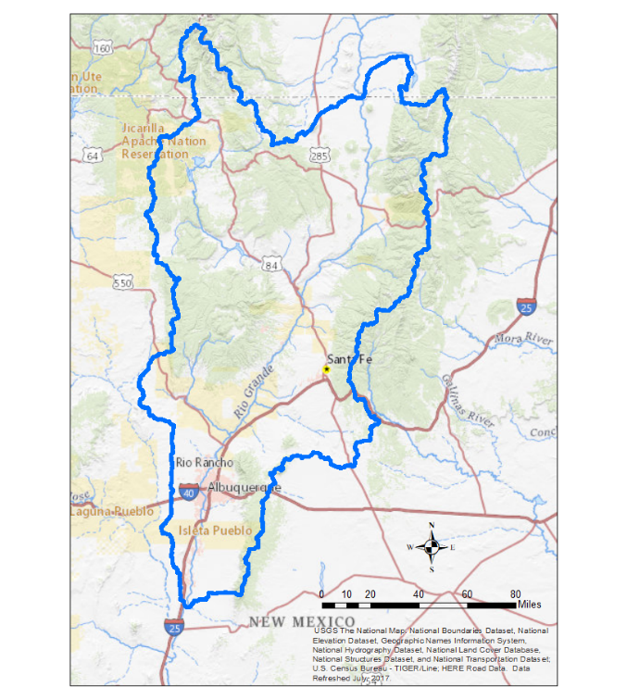
The map above shows a portion of the Rio Grande river basin. For this survey, we call the area shown in the map the Rio Grande watershed. If you live in this area, the majority of your water comes from forests in the mountains in the Rio Grande watershed. Restoring and protecting forests in the Rio Grande watershed is therefore necessary for securing your water resources.

​Please consult the map provided. Do you believe your primary residence is within the boundaries of the Rio Grande watershed?
- Yes
- No
- Not sure
What is the zip code of your primary residence?
________________________________________________________________

Your Municipal Water Source

Water supplied to residents of the Rio Grande watershed is either pumped from the groundwater aquifer that lies below the surface or is dammed and diverted from surface water (rivers). Groundwater and surface water resources are replenished by snowmelt in forested mountains. Streams and rivers bring water to the Rio Grande where it is stored in reservoirs awaiting transport to water treatment facilities.

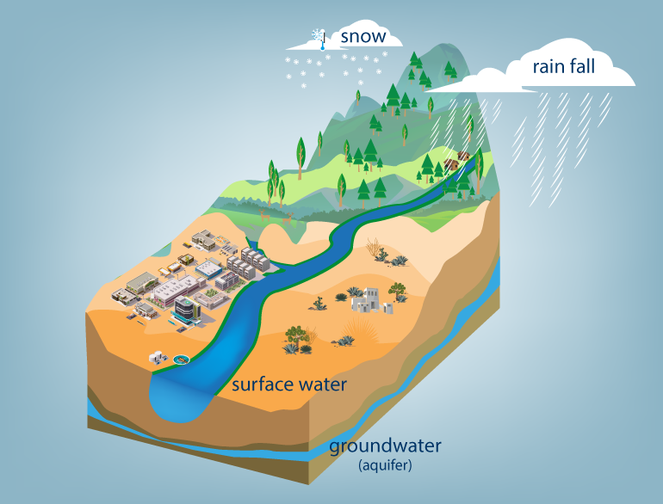

Water resource management currently focuses on using surface water and reducing reliance on limited groundwater. Surface water resources are vulnerable in forests that are susceptible to extreme wildfire. Intense rainfall events after extreme wildfire can produce flood flows. Flood flows transport large amounts of sediment, nutrients, and other contaminants in surface water and can dramatically increase treatment costs.

In 2011, the Las Conchas wildfire brought sediment to Albuquerque’s reservoirs making surface water unsafe to drink. To avoid high treatment costs or an interruption in municipal water supply, Albuquerque consumed 40 days’ worth of groundwater resources.

Extreme Wildfire

The Rio Grande watershed is currently suffering from a prolonged period of drought. Drought, or lack of precipitation, leaves vegetation dry and easily ignited. In the past, it was believed that suppressing all wildfire was in the best interest of New Mexico residents. Past fire suppression left the forested mountains overgrown. The combination of drought and overgrown forests increase the risk of extreme wildfire by providing favorable conditions for wildfire to start and easily spread.
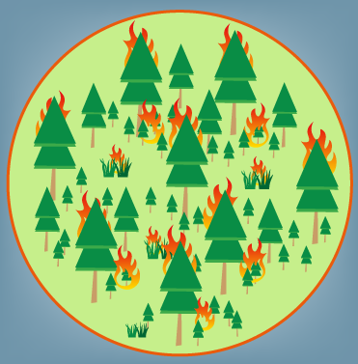
Wildfires commonly start in dry grasses and woody brush from either human (uncared for campfires, burning debris, cigarettes, etc.) or natural (lightning) causes. In overgrown forests or extreme weather conditions, flames can climb to the top of the forest, or the canopy. Once the fire reaches the canopy, it quickly spreads, creating a dangerous and costly scenario for wildland firefighters.

Your Experience with Wildfire
In this first section of the survey, we ask about your property in the Rio Grande watershed.

Do you own or rent your property? (Fill in one circle)
Own and occupy
Own and rent out short term
Own and rent out long term
I am a renter

What is the closest distance (as a crow flies) a wildfire has come to your property? (Fill in one circle)
There has been a wildfire on my property
Less than 2 miles away but not on my property
2 to 10 miles away
More than 10 miles away
Not sure

Has your property ever had smoke or fire damage from a wildfire?
(Fill in one circle)
 | No
 | Yes, my property has had smoke damage
 | Yes, my property has had fire and smoke damage |  | Was your property destroyed by a fire? (Fill in one circle)
 |  |  |  |  | No
 |  |  |  |  | Yes
Have you ever talked about wildfire issues with a neighbor? (Fill in one circle)
 | No
 | Yes

Negative Impacts of Extreme Wildfire​

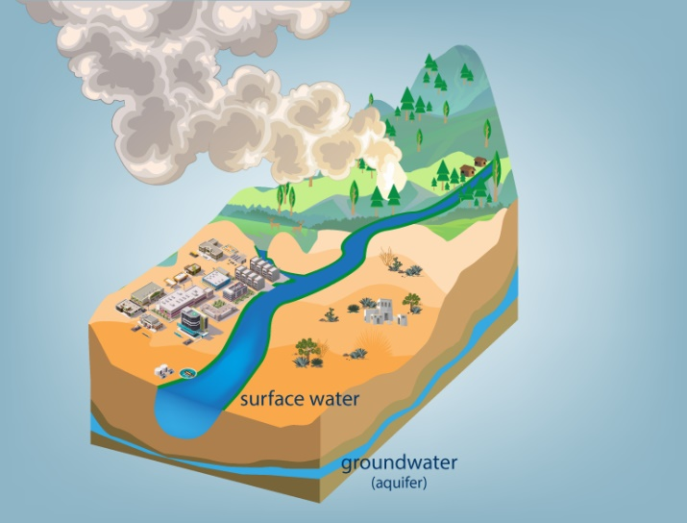
Reduced air quality- As size and intensity of a wildfire increases, the amount of material consumed increases producing more airborne particulates, the main health concern related to air quality issues resulting from extreme wildfires. The finer the particles are the farther they can travel, posing a possible health hazard to those far away from direct threat of the wildfire.

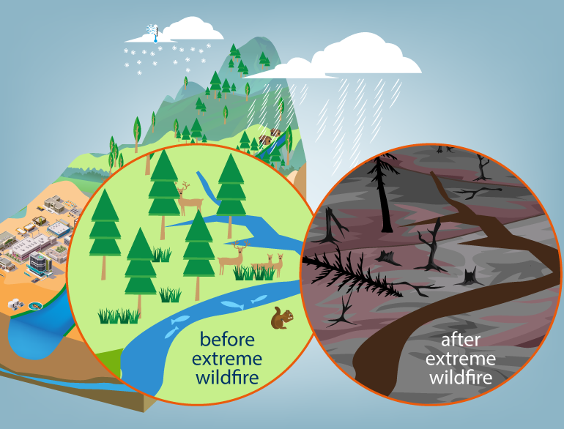
Destruction of wildlife habitat and ecosystem degradation- Extreme wildfire destroys habitats provided by the forest creating overcrowding and increasing competition for survival. Wildfire also degrades ecosystems dependent on the forest. Fish and other aquatic species rely on the water provided by the forests to support their habitat.

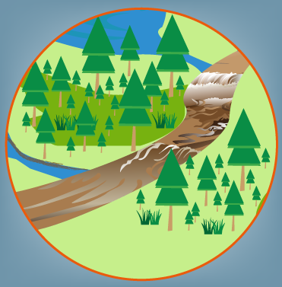
Detriment to water quality- Wildfire eliminates soil’s ability to absorb water. Precipitation falling on recently burned land produces damaging flood flows that collect and transport sediment and debris. Sediment and debris are carried into surface water bodies polluting the water resources utilized to fulfill municipal and agricultural water demand.
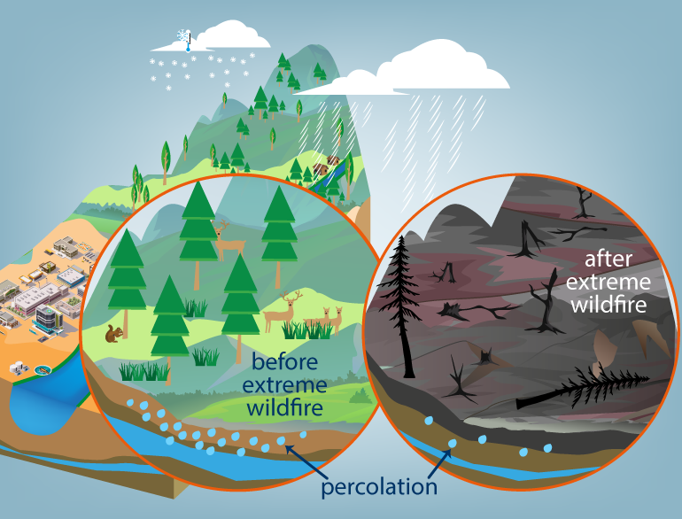

Compromises groundwater resources- The forested mountains of the Rio Grande watershed replenish the groundwater aquifer through percolation, or the slow filtration of water through the soil. Extreme wildfire results in limited percolation of groundwater. After extreme wildfire, it may take years or decades for used groundwater supplies to be replenished.

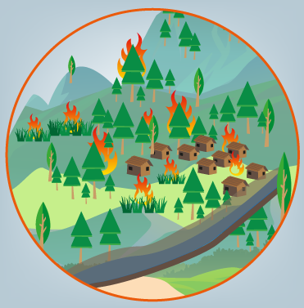
Damage or degrade private property- Extreme wildfire can cause smoke and structural damage to homes or property bordering fire prone forests. Precipitation falling on recently burned areas cannot soak into the ground and water running off the land is not slowed by vegetation. Therefore, an increase in precipitation runoff can also cause flood damage to homes and property by overflowing streams and rivers.
Wildfire in the Rio Grande Watershed

If there were a wildfire in the Rio Grand watershed, how likely do you think it is that the following would occur? (Fill in one circle per row) (Fill in one circle per row)
 | Extremely likely | Very likely | Moderately likely | Slightly likely | Not at all likely | Not applicable
The air quality would become unhealthy. |  |  |  |  |  | 
Wildlife habitat would be severely damaged. |  |  |  |  |  | 
My community water supply would be threatened. |  |  |  |  |  | 
My property would have some physical damage. |  |  |  |  |  | 
My property would be destroyed. |  |  |  |  |  | 
My community water supply would be threatened. |  |  |  |  |  | 

Reducing the Risk of Extreme Wildfires

Historical forest conditions were self-maintained by the natural occurrence of low-intensity, naturally caused wildfire. Current forest restoration strategies focus on returning forests to a state that resembles their historic condition through wildfire risk reduction treatments. Treatments are typically conducted in two phases:
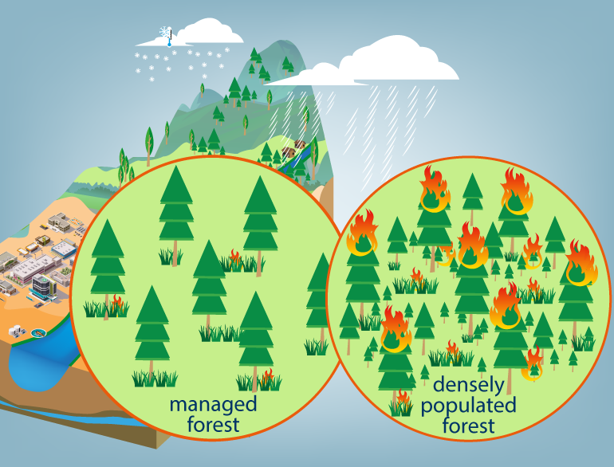
​
Forest thinning reduces the number of trees by removing younger, smaller trees that act as a ladder to the canopy of the forest. Thinning the forest hinders wildfire’s ability to spread from tree to tree.

Low-intensity prescribed burns reduce highly flammable underbrush and small trees in a manner that can be contained and easily controlled. The risk of an extreme wildfire starting is reduced in areas treated with prescribed burns.
Traits of Wildfire Risk Reduction

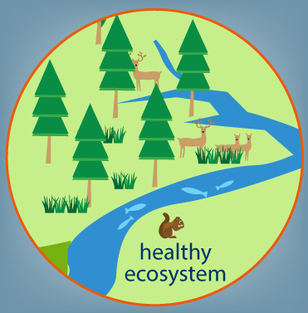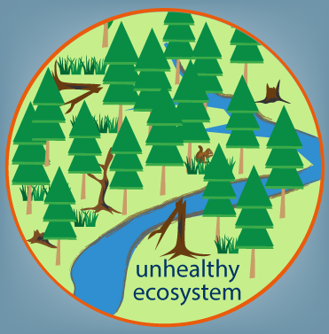

Healthy ecosystems and streams (for fish and wildlife habitat)- Fish and wildlife depend on healthy forests and water sources. Forest restoration enhances forest and downstream water resources and protects habitat from being consumed or degraded by extreme wildfire. Forest restoration can have positive impacts on forests and water beyond the treated area.

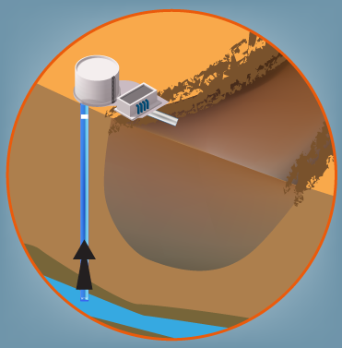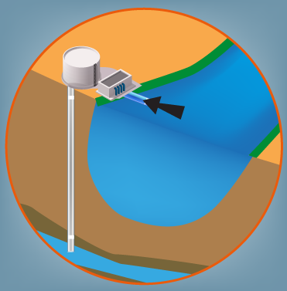
Municipal source water protection- Municipal water can come from either surface water or groundwater supplies. Extreme wildfire can make surface water unavailable and force municipalities to use groundwater, which is a limited resource. Forest restoration can reduce the need for municipalities to rely on groundwater. In 2017, 30% of Albuquerque’s water came from groundwater (approximately 110 days’ worth).

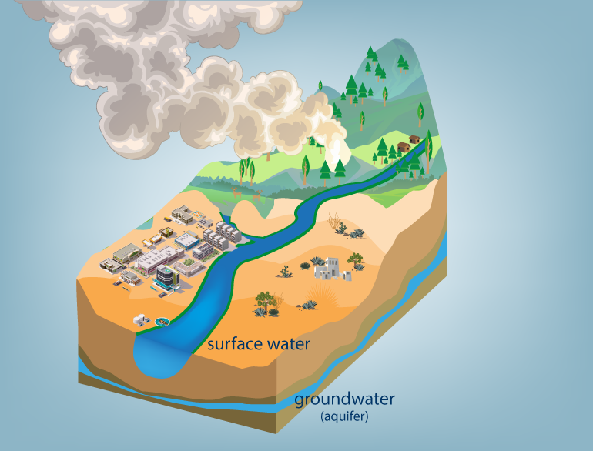
Air quality- The Air Quality Index rates air quality daily and is used notify the public of potentially hazardous conditions. The Index consists of 6 levels.
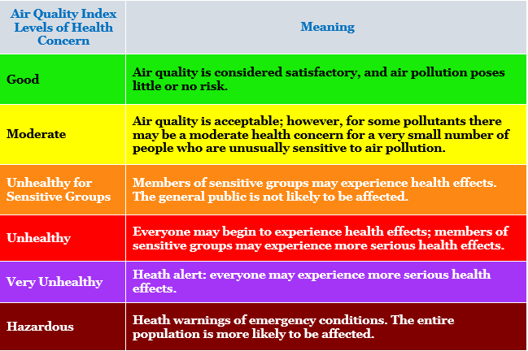
Wildfire smoke can impose adverse health effects, especially in sensitive people. By reducing the frequency of extreme wildfire, forest restoration can reduce the amount of smoke during peak wildfire season. On a typical year, Albuquerque has about 7 unhealthy air quality days during peak wildfire season. Since 2011, individual years have ranged from 0 unhealthy days (without extreme fires) to 21 days (during the Las Conchas Fire).

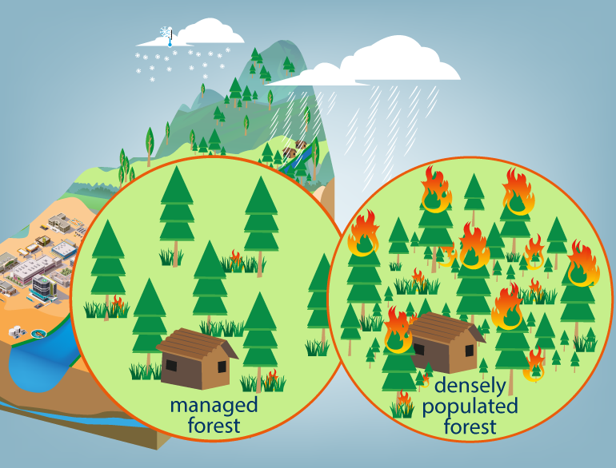

Targets areas adjacent to private property- Forest restoration adjacent to private property reduces the potential for structural damage from wildfires and post-wildfire flooding.

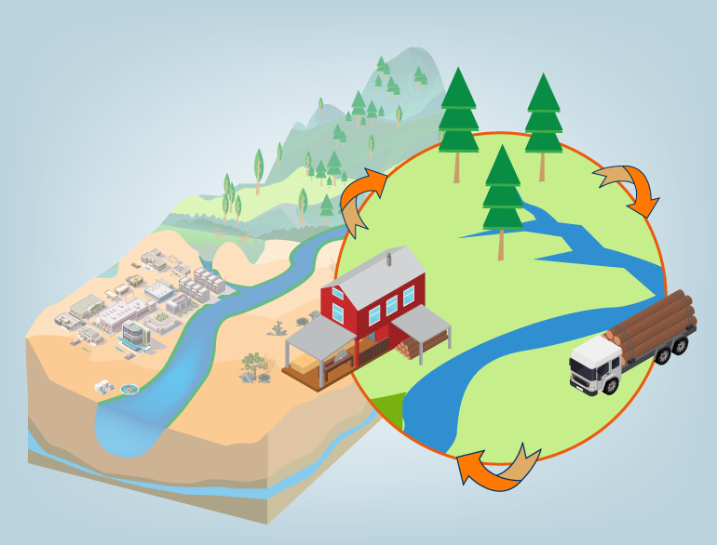
Supports local industry and creates jobs- Forest restoration provides an opportunity to support the local economy by creating jobs and generating local business activity. Depending on contracting, between 2 and 18 local jobs can be created per $1 million spent. Some local jobs directly involve restoration, and some are in supporting industries. Approximately $6 million is currently invested annually in restoration in the Rio Grande watershed.

Funding Healthy Forests in The Rio Grande Watershed

Funding to support wildfire risk reduction in the Rio Grande watershed remains a challenge due to the costly nature of the projects. Some restoration is financed through government funding and contributions made by private investors. However, additional funding alternatives must be explored to support large scale restoration treatments.

The following questions ask you to choose between two potential forest restoration project. Each project has different characteristics. The restoration fee is a one-time payment on your New Mexico state income taxes to support the project. Fees would go directly to a New Mexico Forest Restoration fund used solely for projects within the Rio Grande watershed.

Please consider your household budget when choosing your preferred project. If the cost is higher than what you are willing to pay, please choose to support neither project.

Options A and B are restoration projects in the Rio Grande watershed. Please choose your preferred option, or choose the status quo.
Attribute | Project A | Project B | Status Quo
Healthy ecosystems and streams (for fish and wildlife habitat) | 4 out of 5 forest restoration projects target high-impact areas for fish and wildlife habitat   | 2 out of 5 forest restoration projects target high-impact areas for fish and wildlife habitat   | 0 out of 5 forest restoration projects target high-impact areas for fish and wildlife habitat.  
Municipal source water protection | 200 days of groundwater resources are consumed in a year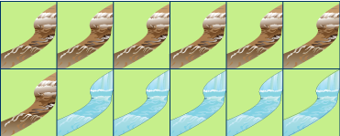 | 110 days of groundwater resources are consumed in a year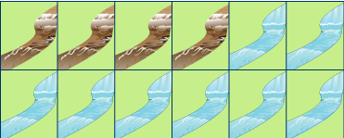 | 110 days of groundwater resources are consumed in a year
Air quality | 0 to 7 days through peak wildfire season exceed moderate 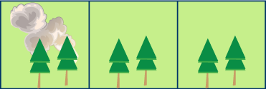 | 0 to 7 days through peak wildfire season exceed moderate | 7 to 14 days through peak wildfire season exceed moderate 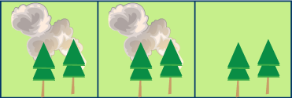
Targets areas adjacent to private property | 2 out of 5 restoration projects target areas adjacent to private property | 2 out of 5 restoration projects target areas adjacent to private property | 0 out of 5 restoration projects target areas adjacent to private property
Supports local industry and creates jobs | 12 local jobs created from $6M in restoration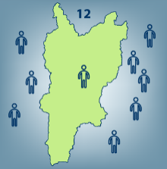 | 108 local jobs created from $6M in restoration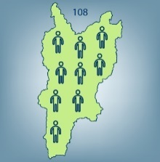 | 12 local jobs created from $6M in restoration
Restoration fee | $150 | $160 | $0
 | I choose Project A | I choose Project B | I choose Neither

Options A and B are restoration projects in the Rio Grande watershed. Please choose your preferred option, or choose the status quo.
Attribute | Project A | Project B | Status Quo
Healthy ecosystems and streams (for fish and wildlife habitat) | 4 out of 5 forest restoration projects target high-impact areas for fish and wildlife habitat | 2 out of 5 forest restoration projects target high-impact areas for fish and wildlife habitat | 0 out of 5 forest restoration projects target high-impact areas for fish and wildlife habitat.
Municipal source water protection | 200 days of groundwater resources are consumed in a year | 55 days of groundwater resources are consumed in a year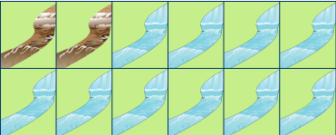 | 110 days of groundwater resources are consumed in a year
Air quality | 21 or more days through peak wildfire season exceed moderate 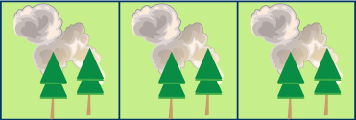 | 0 to 7 days through peak wildfire season exceed moderate | 7 to 14 days through peak wildfire season exceed moderate
Targets areas adjacent to private property | 2 out of 5 restoration projects target areas adjacent to private property | 4 out of 5 restoration projects target areas adjacent to private property 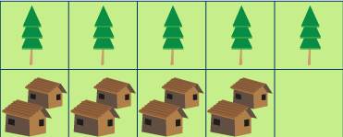 | 0 out of 5 restoration projects target areas adjacent to private property
Supports local industry and creates jobs | 12 local jobs created from $6M in restoration | 108 local jobs created from $6M in restoration | 12 local jobs created from $6M in restoration
Restoration fee | $150 | $200 | $0
 | I choose Project A | I choose Project B | I choose Neither

Options A and B are restoration projects in the Rio Grande watershed. Please choose your preferred option, or choose the status quo.
Attribute | Project A | Project B | Status Quo
Healthy ecosystems and streams (for fish and wildlife habitat) | 0 out of 5 forest restoration projects target high-impact areas for fish and wildlife habitat. | 4 out of 5 forest restoration projects target high-impact areas for fish and wildlife habitat | 0 out of 5 forest restoration projects target high-impact areas for fish and wildlife habitat.
Municipal source water protection | 200 days of groundwater resources are consumed in a year | 55 days of groundwater resources are consumed in a year | 110 days of groundwater resources are consumed in a year
Air quality | 21 or more days through peak wildfire season exceed moderate | 0 to 7 days through peak wildfire season exceed moderate | 7 to 14 days through peak wildfire season exceed moderate
Targets areas adjacent to private property | 4 out of 5 restoration projects target areas adjacent to private property | 4 out of 5 restoration projects target areas adjacent to private property | 0 out of 5 restoration projects target areas adjacent to private property
Supports local industry and creates jobs | 108 local jobs created from $6M in restoration | 108 local jobs created from $6M in restoration | 12 local jobs created from $6M in restoration
Restoration fee | $80 | $200 | $0
 | I choose Project A | I choose Project B | I choose Neither

You and Your Watershed
I rely on the Rio Grande watershed for (select all that apply):
- supporting my field of employment
- recreation
- cultural/ traditional uses
- municipal water supply
- irrigating farm land
- watering livestock
- research
- Other ________________________________________________

I partake in the following recreational activities within the Rio Grande watershed (select all that apply):
- Biking
- Bird watching/Wildlife viewing
- Camping
- Fishing
- Hiking
- Horseback/Trail riding
- Hunting
- Nonmotorized water sports
- Motorized water sports
- ORV access
- Painting/Photography
- Picnicking
- Trail running
- Other ________________________________________________

Approximately how many days do you designate for recreation in the Rio Grande watershed per year? Consider 90 days to be 90+ days.
 | 0 | 30 | 60 | 90

Days | 

Demographic Information

What is your age? (Fill in the blank)
_________ years old

Are you? (Fill in one circle)
 | Male
 | Female
 | Other/Prefer not to specify

What is the highest grade or year of school you completed? (Fill in one circle)
 | Less than high school
 | High school graduate
 | Some college or technical school
 | Technical or trade school
 | College graduate
 | Some graduate work
 | Advanced Degree (M.D., M.A., M.S., Ph.D., etc.)

Which of the following best describes your current employment situation?
(Fill in one circle)
 | Employed full time (including self-employed)
 | Employed part time (including self-employed)
 | Unemployed or do not work outside of the home
 | Retired

Which of the following categories describes your annual household income?
(Fill in one circle)
 | Less than $15,000
 | $15,000 - $24,999
 | $25,000 – $34,999
 | $35,000 - $49,999
 | $50,000 - $74,999
 | $75,000 - $99,999
 | $100,000 - $149,999
 | $150,000 - $199,999
 | More than $200,000

How long have you or your family lived in the Rio Grande watershed?
(Fill in one circle)
 | I recently moved to the area
 | I consider myself a long term resident
 | I was born and raised here
 | My family has lived here for multiple generations

Are you of Hispanic/Latino or a Spanish origin?
- Yes
- No

How would you describe your race?
- American Indian or Alaska Native
- Asian
- Black or African American

- Native Hawaiian or Pacific Islander
- White
- Other

We thank you for your participation. We truly value your opinion. Please use the space below to provide any additional feedback or comments regarding your experience.
________________________________________________________________

