Collection of Qualitative Feedback on Online Banner Ad Concepts for Office of Defects Investigation Recall Campaign Promotion
NHTSA ODI Air Bag Creative Testing Bulletin Board Research
Discussion Guide
DRAFT – December 5th 2019

INTRODUCTION

Thank you for taking part in this online discussion. Your opinions are important to us! Please be honest when answering questions and providing feedback as part of this online discussion. Your answers are anonymous and confidential, and none of your individual information will be shared with any third parties.

[INCLUDE ON ITS OWN SEPARATE SCREEN AFTER THE INTRODUCTION SCREEN] This collection of information is voluntary and will be used for formative purposes only so that we may develop communications programs designed to reduce the number of traffic-related injuries and deaths. A federal agency may not conduct or sponsor, and a person is not required to respond to, nor shall a person be subject to a penalty for failure to comply with a collection of information subject to the requirements of the Paperwork Reduction Act unless that collection of information displays a current valid OMB Control Number. The OMB Control Number for this information collection is 2127-0682. Public reporting for this collection of information is estimated to be approximately 60 minutes per respondent, including the time for reviewing instructions, completing and reviewing the collection of information. All responses to this collection of information are voluntary. Send comments regarding this burden estimate or any other aspect of this collection of information, including suggestions for reducing this burden to: Information Collection Clearance Officer, National Highway Traffic Safety Administration, 1200 New Jersey Ave, S.E., Washington, DC, 20590

Welcome to Day 1 of our Online Discussion Forum! My name is [INSERT MODERATOR NAME] and I’ll be the moderator for our discussion over the next several days. I’m glad you could join us and I’m looking forward to hearing your perspective.

As a reminder, you have agreed to participate in a three (3) day research project. It is very important for you to log into the forum on each of the following dates in order to collect your incentive at the end of the project:

- Tuesday, Date TBD
- Wednesday, Date TBD
- Thursday, Date TBD

There are about 30 participants in this group and each of you is identified by a unique screen name.

There are a few important things to note about this forum:

- It’s secure.
- It’s comprised of participants like yourself who were pre-screened to join by invitation only.
- It’s being held for market research purposes only, not related to sales or sales efforts whatsoever.
- None of your personally identifiable information will be revealed.
- We believe you will find this engaging and that through collaboration with peers you can interact and inform one another. Be as detailed and expressive as you can.
- Because of the nature of the topic matter in this discussion and that this is for research purposes, we ask that you keep all content to yourself rather than discussing it with people outside of the forum.

How It Works
Over the next several days, you’re going to see a series of ideas for online banner ads relating to vehicle air bag safety recalls. These are draft concepts that may eventually be turned into online banner ads in the future. We want you to review several concepts over the next three days and give us feedback on them. We will begin with some questions to help us understand your thoughts on vehicle safety recalls and where you go for information, then review our first concept on Tuesday. We will review two additional concepts on Wednesday and then do an overall review/comparison on Thursday.

The Online Forum works as follows: For the next 3 days, I will post some questions at roughly the same time every day, and then during the rest of the day and night I will read everyone's responses and occasionally respond with my own follow-up questions.

Please be sure to log on multiple times throughout each day—the first time to give your initial response to the posted questions and then later to see what others have said and make follow-up comments or respond to additional posted questions.

Your detailed and candid feedback and insight on all 3 days will be invaluable. Throughout the discussion you will be able to view, react and build on the ideas of others—it is important for you to do so. Sometimes, however, topics may be private so that no one is influenced by the responses or ideas of others.

Ready, Set, Go!
To summarize what you need to do:
- Log on daily. Read and respond to the questions for the day in as much detail as you can.
- Log on again, a few hours later. Read what others have said and respond to any follow-up questions I may have posted and add more comments as appropriate.
- If you have downloaded the mobile app to your smart phone or tablet, you can answer directly from there any time of the day or night.
- Be respectful of your fellow participants. Be open and honest in expressing your thoughts and feelings with respect.
- Log on early. Participate each day as early as you can to give time for the other participants and me to share in what you have said.

OK, let’s get started by clicking on the first activity under Day 1!

Day 1: Baseline Measures & Reactions to Concept #1

  - I’d like to begin our conversation by talking about vehicle safety recalls. A vehicle recall is ordered when a vehicle model has a safety-related defect or does not comply with a federal safety standard.

You may have seen, read or heard things in the news recently about vehicle safety recalls. Despite the fact that vehicle manufacturer dealerships provide vehicle recall service for free, some people never have their vehicle fixed.

Imagine for a moment that there was a safety recall on your vehicle, what would encourage you or make you more likely to take your vehicle in to be fixed? What facts or information would motivate you to take your vehicle in to be fixed? And why is this important to you?

  - Have you seen, read or heard anything about vehicle safety recalls recently? If yes, please tell me what you have seen, read or heard and from where.

  - Next, I’d like to know where you would go to find out information about recalls. Please share the different places you would go and what kind of information you would expect to find. [MODERATOR NOTE: IF THEY SAY ONLINE, PROBE TO FIND EXAMPLES OF WHERE THEY WOULD GO AND WHAT SITES THEY WOULD VISIT].

  - Have you ever heard of the National Highway Traffic Safety Administration (NHTSA)?

- Yes
- No

1.5 How familiar are you with the National Highway Traffic Safety Administration (NHTSA)?

- Not at all familiar
- Not very familiar
- Somewhat familiar
- Very familiar
- Extremely familiar

1.6a Have you ever heard of the website NHTSA.gov?

- Yes
- No

1.6b And, how familiar are you with the website NHTSA.gov?

- Not at all familiar
- Not very familiar
- Somewhat familiar
- Very familiar
- Extremely familiar

1.8 Have you heard, read, or seen anything recently related to the National Highway Traffic Safety Administration (NHTSA) or NHTSA.gov? If yes, what have you heard, read or seen? Please be as specific as possible.

1.9 The National Highway Traffic Safety Administration (NHTSA) is responsible for keeping people safe on America’s roadways. NHTSA’s mission is to save lives, prevent injuries and reduce economic costs due to road traffic crashes, through education, research, safety standards and enforcement activity.

NHTSA.gov offers access to a variety of information including safety ratings, safety issues, and vehicle safety recalls. The site offers a search tool that allows you to look up your vehicle using its VIN (Vehicle Identification Number) and see if your vehicle is affected by a vehicle safety recall in the past 15 calendar years.

Knowing this, how likely are you to visit the NHTSA.gov website?

- Not at all likely
- Not very likely
- Somewhat likely
- Very likely
- Extremely likely

1.10 Have you ever heard of the website safeairbags.com?

- Yes
- No

1.10b And, how familiar are you with the website safeairbags.com?

- Not at all familiar
- Not very familiar
- Somewhat familiar
- Very familiar
- Extremely familiar

1.11 Have you ever heard of the website recallairbag.com?

- Yes
- No

1.11b And, how familiar are you with the website recallairbag.com?

- Not at all familiar
- Not very familiar
- Somewhat familiar
- Very familiar
- Extremely familiar

1.12 Next, you’re going to see a concept for an online banner ad. These are concepts for ads relating to vehicle air bag safety recalls. These concepts are in DRAFT form at the moment, so please don’t worry about the resolution of the images. If/when they are turned into real ads, they will be presented in higher resolution.

Please take a few minutes to review the concept, focusing mainly on the text, before answering the questions that follow.

Let’s take a look at the first one.

[SHOW VISUAL OF BOMB ON BOARD CONCEPT – SEE BELOW FOR REFERENCE; DISPLAY CONCEPT WITH EACH QUESTION]

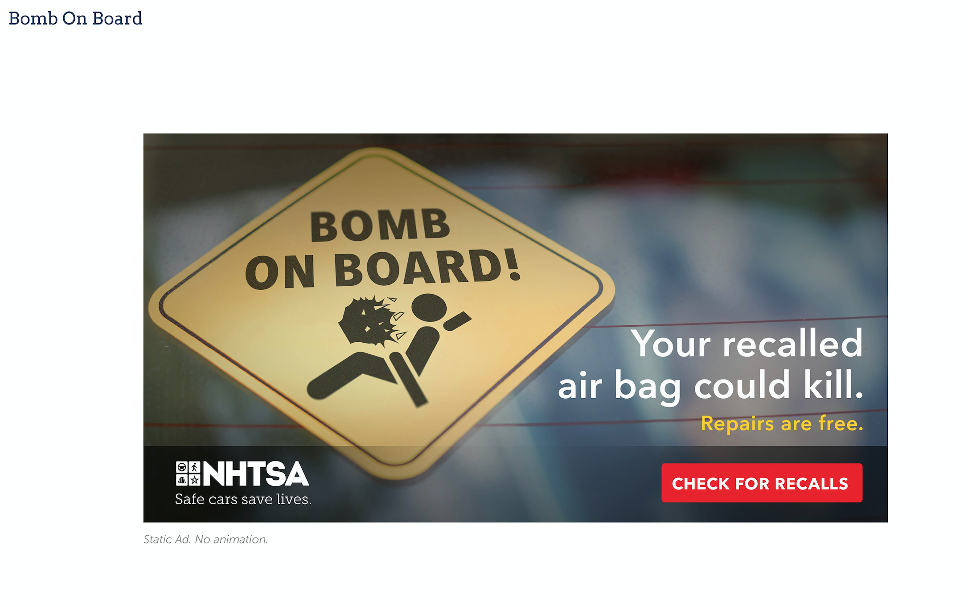

What is the main message of this concept? Please be as specific as possible.

1.13 Is it clear that this ad is about safety recalls for air bags in vehicles?
Please write Yes/No and explain why.

1.14 How well does this concept grab your attention? What are the specific elements (words and/or visuals) that help grab your attention?

1.15 What do you like about this concept? What positive thoughts or feelings do you have about this concept? Please be as specific as possible.

1.16 What do you dislike about this concept? What negative thoughts or feelings do you have about this concept? Is there anything confusing about this concept? Please be as specific as possible.

1.17a. How likely would you be to take some kind of action after seeing this
concept?

- Not at all likely
- Not very likely
- Somewhat likely
- Very likely
- Extremely likely

1.17b. Please tell me what kind of action you would take after seeing this concept. If you are not likely to take any action, please write – WOULD NOT TAKE ANY ACTION – and tell me why you would not take any action.

1.18. Assuming you saw this concept as a banner ad, how likely would you be to visit the NHTSA.gov website to check for a vehicle air bag safety recall?

- Not at all likely
- Not very likely
- Somewhat likely
- Very likely
- Extremely likely

1.19a. Assuming you had an air bag recall on one of your vehicles that needed to be repaired, how likely would you be to schedule a recall repair after seeing this concept?

- Not at all likely
- Not very likely
- Somewhat likely
- Very likely
- Extremely likely

1.19b. Thinking of the response you just shared, please write a sentence or two that explains why you gave the answer you did.

If you are Somewhat, Very or Extremely likely to schedule a recall repair based on seeing this banner ad, what words or visuals motivate you to schedule a recall repair?

If you are Not at all or Not very likely to visit, what words or visuals would you change or add to make you more likely to schedule a recall repair?

End of Day 1 Topics
Thanks! That’s all for today. I am very appreciative of the time you spent answering these questions. New questions will be posted tomorrow.

Until then, be sure to come back later today to review responses from other participants and share your thoughts about their answers. Also answer any follow-up questions I might have for you before tomorrow’s activities or add more ideas to some of your responses and respond to ideas of other participants.

Thanks again, [INSERT MODERATOR NAME]

Day 2 Reactions to Concept #2 and Concept #3

Welcome Back!
Welcome back and thank you again for your time.

Yesterday, we had some discussion around automotive recalls and your reaction to a concept for a possible online banner ad about safety recalls for vehicle air bags.

Today we will be reviewing and discussing 2 more concepts for online banner ads about safety recalls for air bags in vehicles. As a reminder, these concepts are in DRAFT form at the moment, so please don’t worry about the resolution of the images. If/when they are turned into real ads, they will be presented in higher resolution.

2.1 Let’s take a look at the first one.

[SHOW VISUAL OF WHEEL RISK CONCEPT– SEE BELOW FOR REFERENCE; DISPLAY CONCEPT WITH EACH QUESTION]

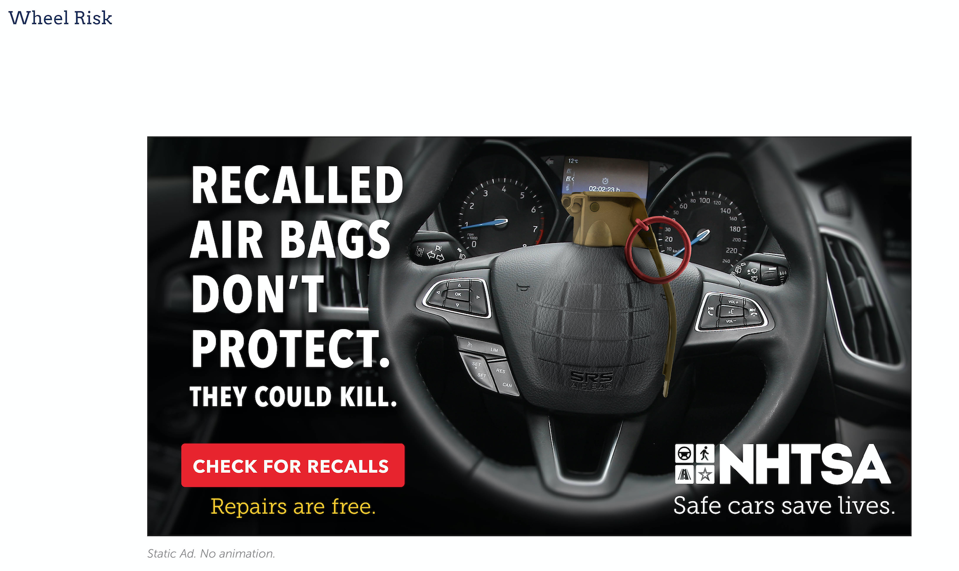

What is the main message of this concept? Please be as specific as possible.

2.2 Is it clear that this ad is about safety recalls for air bags in vehicles?
Please write Yes/No and explain why.

2.3 How well does this concept grab your attention? What are the specific elements (words and/or visuals) that help grab your attention?

2.4 What do you like about this concept? What positive thoughts or feelings do you have about this concept? Please be as specific as possible.

2.5 What do you dislike about this concept? What negative thoughts or feelings do you have about this concept? Is there anything confusing about this concept? Please be as specific as possible.

2.6a. How likely would you be to take some kind of action after seeing this
concept?

- Not at all likely
- Not very likely
- Somewhat likely
- Very likely
- Extremely likely

2.6b. Please tell me what kind of action you would take after seeing this concept. If you are not likely to take any action, please write – WOULD NOT TAKE ANY ACTION – and tell me why you would not take any action.

2.7. Assuming you saw this concept as a banner ad, how likely would you be to visit the NHTSA.gov website to check for a vehicle air bag safety recall?

- Not at all likely
- Not very likely
- Somewhat likely
- Very likely
- Extremely likely

2.8a. Assuming you had an air bag recall on one of your vehicles that needed to be repaired, how likely would you be to schedule a recall repair after seeing this concept?

- Not at all likely
- Not very likely
- Somewhat likely
- Very likely
- Extremely likely

2.8b. Thinking of the response you just shared, please write a sentence or two that explains why you gave the answer you did.

If you are Somewhat, Very or Extremely likely to schedule a recall repair based on seeing this banner ad, what words or visuals motivate you to schedule a recall repair?

If you are Not at all or Not very likely to visit, what words or visuals would you change or add to make you more likely to schedule a recall repair?

2.9 Let’s take a look at another concept. This concept is a little different than
the others. It is a 360 concept, meaning that if you saw this concept on a web page it would move/change based on how you move your mouse/cursor. The video below is an example of what it would look like.

[SHOW VISUAL OF 360 CONSEQUENCES CONCEPT – SEE BELOW FOR REFERENCE; DISPLAY CONCEPT WITH EACH QUESTION]]
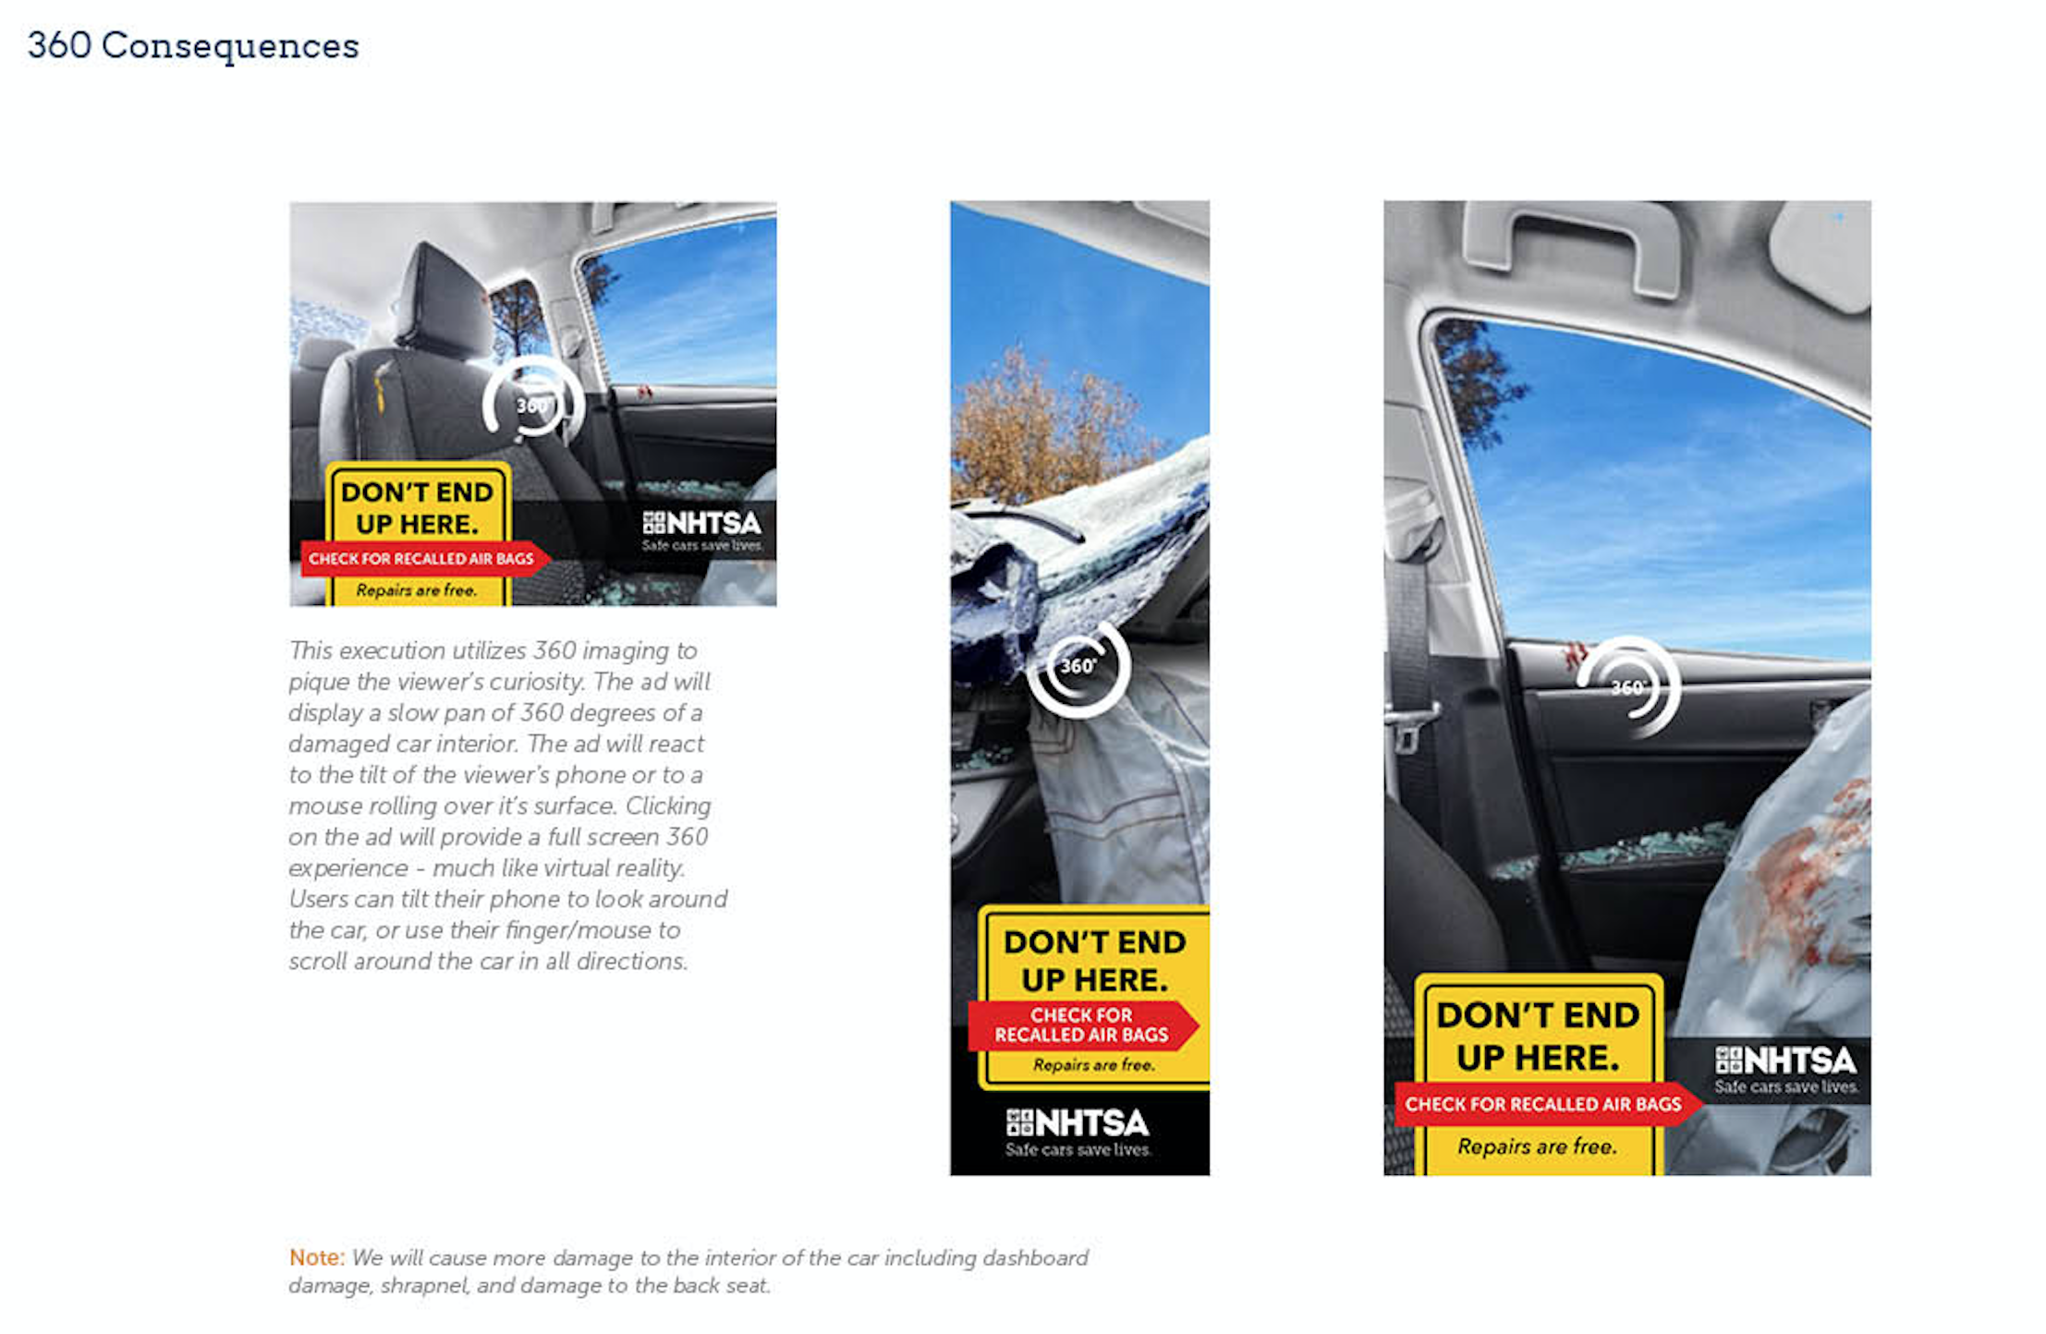
What is the main message of this concept? Please be as specific as possible.

2.10 Is it clear that this ad is about safety recalls for air bags in vehicles?
Please write Yes/No and explain why.

2.11 How well does this concept grab your attention? What are the specific elements (words and/or visuals) that help grab your attention?

2.12 What do you like about this concept? What positive thoughts or feelings do you have about this concept? Please be as specific as possible.

2.13 What do you dislike about this concept? What negative thoughts or feelings do you have about this concept? Is there anything confusing about this concept? Please be as specific as possible.

2.14a. How likely would you be to take some kind of action after seeing this
concept?

- Not at all likely
- Not very likely
- Somewhat likely
- Very likely
- Extremely likely

2.14b. Please tell me what kind of action you would take after seeing this concept. If you are not likely to take any action, please write – WOULD NOT TAKE ANY ACTION – and tell me why you would not take any action.

2.15. Assuming you saw this concept as a banner ad, how likely would you be to visit the NHTSA.gov website to check for a vehicle air bag safety recall?

- Not at all likely
- Not very likely
- Somewhat likely
- Very likely
- Extremely likely

2.16a. Assuming you had an air bag recall on one of your vehicles that needed to be repaired, how likely would you be to schedule a recall repair after seeing this concept?

- Not at all likely
- Not very likely
- Somewhat likely
- Very likely
- Extremely likely

2.16b. Thinking of the response you just shared, please write a sentence or two that explains why you gave the answer you did.

If you are Somewhat, Very or Extremely likely to schedule a recall repair based on seeing this banner ad, what words or visuals motivate you to schedule a recall repair?

If you are Not at all or Not very likely to visit, what words or visuals would you change or add to make you more likely to schedule a recall repair?

END OF DAY 2 TOPICS
That’s all for today. Our final activity and questions will be posted tomorrow.

Until then, be sure to come back later today to review responses from other participants and share your thoughts about their answers. Also answer any follow-up questions I might have for you before tomorrow’s activities or add more ideas to some of your responses and respond to ideas of other participants.

Thanks again for your thoughtful responses!
[INSERT MODERATOR NAME]

Day 3 Concept Comparison

Welcome Back!
Hello, welcome to our third day with our final activity and set of questions. Today we are going to review all three concepts. We really appreciate the thoughtful responses and discussion you all have been having over the last couple days.

3.1 Please take a moment to review all three of the concepts for online banner ads about safety recalls for air bags in vehicles that you’ve been assessing over the past few days. Please thoroughly review the concepts, including all images and written text, before moving to the next question. Please be sure to scroll up and down to be sure you are viewing the entire concept.

[SHOW VISUAL OF ALL CONCEPTS]
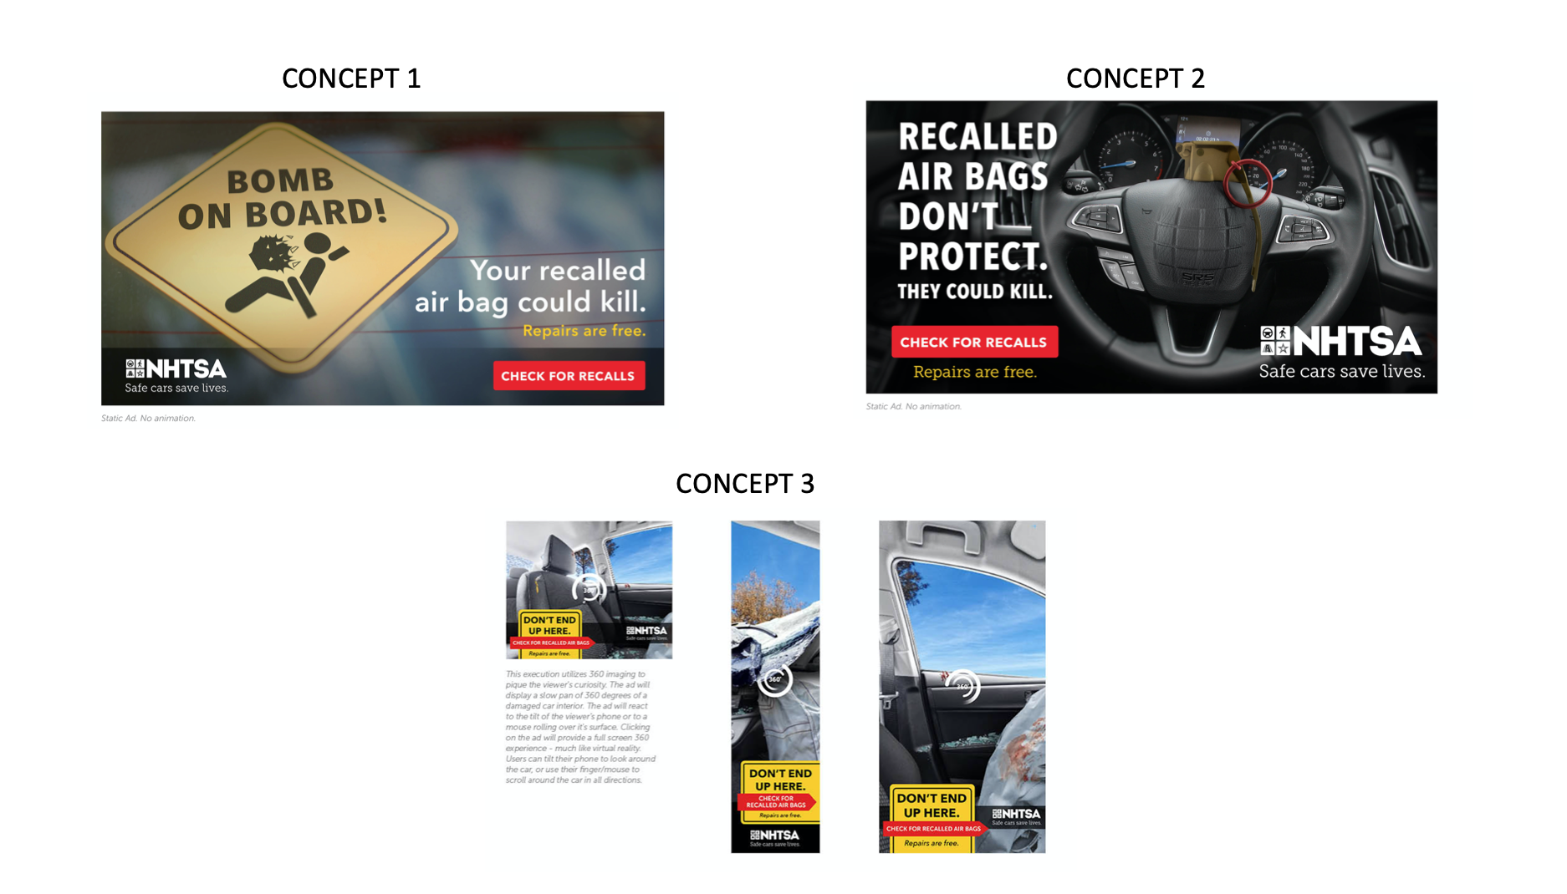

Which concept makes you MOST likely to visit the NHTSA.gov website to check for information about safety recalls for air bags on a vehicle?

- Online Banner Ad Concept 1 – Bomb on Board
- Online Banner Ad Concept 2 – Wheel Risk
- Online Banner Ad Concept 3 – 360 Consequences

3.2 Remind me which concept made you MOST likely to visit the NHTSA.gov website by typing Concept 1, 2, or 3 below. Then tell me why you selected that concept and what makes it most likely to check for information about safety recalls for air bags on a vehicle. Please tell me as many details as you can.

3.3 Please indicate which concept would be 2nd MOST likely to make you visit NHTSA.gov website to check for information about safety recalls on a vehicle by typing Concept 1, 2, or 3 below Then tell me why you selected that concept and what makes it 2nd most likely to check for information about safety recalls for air bags on a vehicle. Please tell me as many details as you can.

3.4 Assuming you had an air bag recall on one of your vehicles that needed to be repaired, which concept would be most effective at motivating you to schedule a recall repair?

[SHOW VISUAL OF ALL CONCEPTS]

- Online Banner Ad Concept 1 – Bomb on Board
- Online Banner Ad Concept 2 – Wheel Risk
- Online Banner Ad Concept 3 – 360 Consequences

3.5 Remind me which concept made was MOST EFFECTIVE at motivating you to schedule a recall repair by typing Concept 1, 2, or 3 below. Then tell me why you selected that concept and what makes it effective. Please tell me as many details as you can.

3.6 Now please indicate which concept would be 2nd MOST EFFECTIVE at motivating you to schedule a recall repair by typing Concept 1, 2, or 3 below. Then tell me why you selected that concept and what makes it effective. Please tell me as many details as you can.

3.7 Finally, over the last few days you have learned a bit more about NHTSA.gov – what it does and what it can do to help save lives.

Your last assignment is to take a few minutes and suggest things that National Highway Traffic Safety Administration (NHTSA) could do to make more people aware of the NHTSA.gov website and to motivate more people to go to the site and check for information about safety recalls for air bags on a vehicle. How do we get more people using the site?

3.8 Is there anything else you’d like to share, regarding vehicle recalls and how to best communicate with consumers about them?

END OF DAY 3 TOPICS
This brings us to the end of our session. Thank you so much for your thorough participation these past few days.

Please plan to come back to the forum a couple more times today to answer any follow-up questions I might have for you and to read what others have posted. You can also comment on each other’s posts by clicking on the reply button under the post.

Thanks again for your engagement and thoughtful answers to my questions!
[INSERT MODERATOR NAME]

