
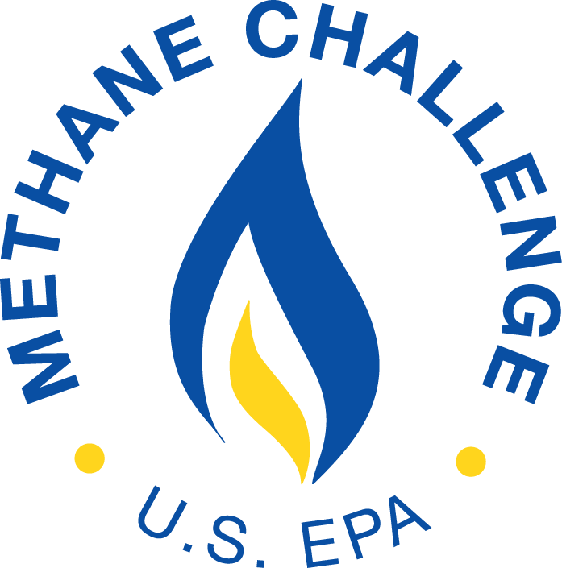
Natural Gas STAR Methane Challenge Program

Implementation Plan Guidelines

Partner Name |  | Date Submitted

Partner Implementation Manager
Name:
Title:
Address:
City/State/Zip:
Telephone/Fax: |  | E-mail:

Partner Methane Challenge Commitments
BMP Commitment Option
Source |  | Start Date | Achievement Year
Onshore Production
 | Pneumatic Controllers
 | Fixed Roof, Atmospheric Pressure Hydrocarbon Liquid Storage Tanks
Gathering and Boosting
 | Pneumatic Controllers
 | Fixed Roof, Atmospheric Pressure Hydrocarbon Liquid Storage Tanks
 | Reciprocating Compressors - Rod Packing Vent
 | Centrifugal Compressors - Venting
Natural Gas (NG) Processing
 | Reciprocating Compressors - Rod Packing Vent
 | Centrifugal Compressors - Venting
NG Transmission & Underground Storage
 | Reciprocating Compressors - Rod Packing Vent
 | Centrifugal Compressors - Venting
 | Transmission Pipeline Blowdowns between Compressor Stations
 | Pneumatic Controllers
NG Distribution
 | Mains – Cast Iron and Unprotected Steel (Commitment Rate: )
 | Services – Cast Iron and Unprotected Steel
 | Distribution Pipeline Blowdowns (Commitment Rate: )
 | Excavation Damages
ONE Future Emissions Intensity Commitment Option
Segment: |  | Intensity Target: |  | Target Year:

Milestones/Timeframes for Meeting Commitments
Provide information on steps for achieving commitments such as anticipated rate of progress, key milestones, or other context (e.g., referencing work to be done during the next planned shutdown of a facility).

Additional Information/Context (optional)
Use this space, if desired, to provide other information about Program participation, such as plans for expanding Methane Challenge commitments, how historical actions informed Methane Challenge commitments, or other information on how the Program will be implemented.
An agency may not conduct or sponsor, and a person is not required to respond to, a collection of information unless it displays a currently valid OMB control number. The public reporting and recordkeeping burden for this collection of information is estimated to average 37 hours per response. Send comments on the Agency's need for this information, the accuracy of the provided burden estimates, and any suggested methods for minimizing respondent burden, including through the use of automated collection techniques to the Director, Collection Strategies Division, U.S. Environmental Protection Agency (2822T), 1200 Pennsylvania Ave., NW, Washington, D.C. 20460. Include the OMB control number in any correspondence. Do not send the completed form to this address.

Commitments should be listed per the Partner’s most recent Partnership Agreement. Partners may delete unused rows within the table, and may duplicate rows and add relevant details as needed (e.g., a corporate parent partner that has different commitments for each LDC can duplicate relevant rows to list the commitments for each LDC).

