Summary: Thank you for participating in this survey. This survey is being conducted by the United States Geological Survey (USGS). The USGS is an agency of the federal government that conducts science for our nation. The USGS does not make regulations or create laws. The goal of this survey is to understand the environmental influences on wild berries in your region. You have been chosen to participate in this survey because you gather wild berries and are considered knowledgeable about wild berries by our partners at your local Tribal Council. This survey should take about 25 minutes to complete depending on how many different kinds of berries you pick. We ask that you provide your name, address, and phone number so that we may follow up with you if we have questions about your responses. We also may wish to provide information about berries to you in the future if we have information to share. Once your survey is received by the USGS your name, address, and phone number will be stored in a locked file cabinet in a locked office. Below you can find more information about how we will protect your privacy and your rights as a participant in this study.

Privacy Act Statement: You are not required to provide your contact information in order to submit your survey response. However, if you do not provide contact information, we may not be able to contact you for additional information to verify your responses. If you do provide contact information, this information will not be shared with any other organization and will only be used to initiate follow-up communication with you if needed. The records for this collection will be maintained in the appropriate Privacy Act System of Records identified as [DOI Social Networks (Interior/USGS-8) published at 76 FR 44033, 7/22/2011].

Paperwork Reduction Act statements: [16 U.S.C. 1a7] authorized collection of this information. This information will be used by the U.S. Geological Survey to better serve the public. Response to this request is voluntary. We estimate that it will take 30 minutes to prepare and respond to this collection. We will not distribute responses associated with you as an individual. We ask you for some basic organizational and contact information to help us interpret the results and, if needed, to contact you for clarification.

The Paperwork Reduction Act of 1995 (44 U.S.C. 3501), states that an agency may not conduct or sponsor, and you are not required to respond to a collection of information unless it displays a currently valid OMB control number and expiration date. You may submit comments on any aspect of this collection. Please note that comments submitted in response to this collection are public record. Comments on this collection should be sent to the Clearance Office at gs-info_collections@usgs.gov.

If you have questions or concerns please call or email:
Nicole Herman-Mercer, 303-236-5031, nhmercer@usgs.gov Rachel Loehman, 406-544-9561, rloehman@usgs.gov
Please tell us some information about you. We will not share this information. We are only collecting it for our records and to contact you in the future concerning this study. We will not contact you for any other reason.

Name:
Phone number:
Email address:
Mailing address:
Today’s Date:

Gender Male Age

Female

How many years have you lived in this community?
How many years have you been picking berries continuously in this community?

Directions: This survey consists of two parts, Part A and Part B. Part A contains statements about different types of berries. For Part A please use your observations and knowledge that you have gained picking berries throughout your life. Part B asks questions about your most recent harvest of berries.

Part A: Please read each statement and select whether you strongly agree, agree, do not agree or disagree, disagree, or strongly disagree with each statement for that type of berry. If you do not know or are unsure please choose do not agree or disagree.

Salmonberry
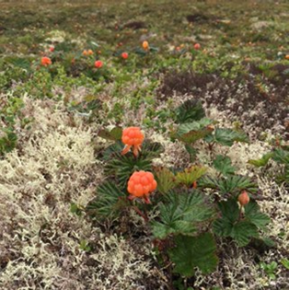
These statements are about salmonberries (please check the picture on the left, this berry may have a different name in your community)

Please write in other names for this berry:

 | Strongly Agree | Agree | Do not Agree or disagree | Disagree | Strongly Disagree
Salmonberries are important in my household.
My family travels a further distance now than in the past to gather salmonberries.
My family travels a shorter distance now than in the past to gather salmonberries.
If winter snowpack is low (not a lot of snow) there will be fewer salmonberries in the summer.
If there is a lot of rain in the summer there will be fewer salmonberries.
Salmonberries are smaller than they were ten years ago.
We find more brown, dead salmonberry plants than we found ten years ago.
Smoke from fires does not impact salmonberries.

 | Strongly Agree | Agree | Do not Agree or disagree | Disagree | Strongly Disagree
Cold temperatures in the spring do not impact how many salmonberries there will be.
Hot temperatures in the summer do impact how many salmonberries there will be.
There are fewer salmonberries than there were ten years ago.
How many salmonberries there are each year is more variable than ten years ago.
We travel less than twenty miles to pick salmonberries.
Salmonberries are impacted by ATV trails.

Salmonberries are ripe earlier in the season than ten years ago.
High wind events do not impact how many salmonberries there are.
The landscape where we pick salmonberries has changed.
Salmonberries are not impacted when there is a flood.
The location where we can pick salmonberries has changed over the last ten years.
These statements are about salmonberries (please check the picture on the left, this berry may have a different name in your community)
Salmonberry, continued

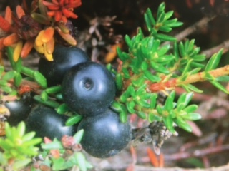
Blackberry
These statements are about blackberries (please check the picture on the left, this berry may have a different name in your community)

Please write in other names for this berry:
 | Strongly Agree | Agree | Do not Agree or disagree | Disagree | Strongly Disagree
Blackberries are important in my household.

My family travels a further distance now than in the past to gather blackberries.
My family travels a shorter distance now than in the past to gather blackberries.
If winter snowpack is low (not a lot of snow) there will be fewer blackberries in the summer.
If there is a lot of rain in the summer there will be fewer blackberries.
Blackberries are smaller than they were ten years ago.
We find more brown, dead blackberry plants than we found ten years ago.
Smoke from fires does not impact blackberries.
Cold temperatures in the spring do not impact how many blackberries there will be.
Hot temperatures in the summer do impact how many blackberries there will be.
There are fewer blackberries than there were ten years ago.
Blackberry, continued
These statements are about blackberries (please check the picture on the left, this berry may have a different name in your community)

 | Strongly Agree | Agree | Do not Agree or disagree | Disagree | Strongly Disagree
How many blackberries there are each year is more variable than ten years ago.
We travel less than twenty miles to pick blackberries.
Blackberries are impacted by ATV trails.

Blackberries are ripe earlier in the season than ten years ago.
High wind events do not impact how many blackberries there are.
The landscape where we pick blackberries has changed.
Blackberries are not impacted when there is a flood.
The location where we can pick blackberries has changed over the last ten years.

<please continue to the next page>

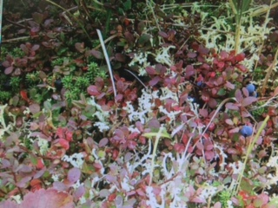
Blueberry
These statements are about blueberries (please check the picture to the left, this berry may have a different name in your community)

Please write in any other names for this berry:

 | Strongly Agree | Agree | Do not Agree or disagree | Disagree | Strongly Disagree
Blueberries are important in my household.

My family travels a further distance now than in the past to gather blueberries.
My family travels a shorter distance now than in the past to gather blueberries.
If winter snowpack is low (not a lot of snow) there will be fewer blueberries in the summer.
If there is a lot of rain in the summer there will be fewer blueberries.
Blueberries are smaller than they were ten years ago.
We find more brown, dead blueberry plants than we found ten years ago.
Smoke from fires does not impact blueberries.
Cold temperatures in the Spring do not impact how many blueberries there will be.
Hot temperatures in the Summer do impact how many blueberries there will be.
Blueberry, continued
These statements are about blueberries (please check the picture to the left, this berry may have a different name in your community)

 | Strongly Agree | Agree | Do not Agree or disagree | Disagree | Strongly Disagree
There are fewer blueberries than there were ten years ago.
How many blueberries there are each year is more variable than it was ten years ago.
We travel less than twenty miles to pick blueberries.
Blueberries are impacted by ATV trails.

Blueberries are ripe earlier in the season than they were ten years ago.
High wind events do not impact how many blueberries there are.
The landscape where we pick blueberries has changed.
Blueberries are not impacted when there is a flood.
The location where we can pick blueberries has changed over the last ten years.

<please continue to the next page>

Wineberries
These statements are about wineberries (please check the picture to the left, this berry may have a different name in your community)
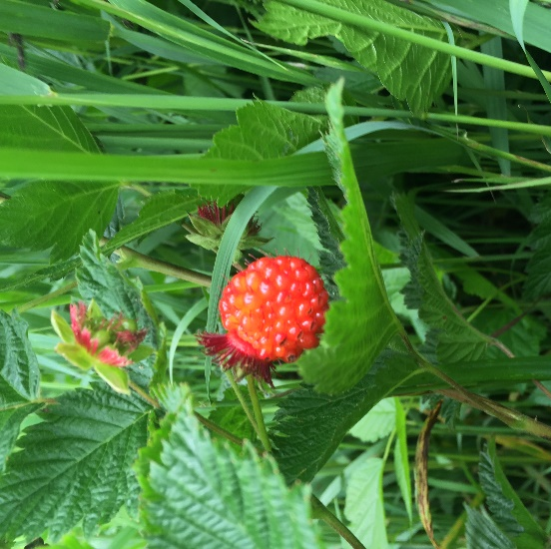

Please write in other names for this berry:

 | Strongly Agree | Agree | Do not Agree or disagree | Disagree | Strongly Disagree
Wineberries are important in my household.

My family travels a further distance now than in the past to gather wineberries.
My family travels a shorter distance now than in the past to gather wineberries.
If winter snowpack is low (not a lot of snow) there will be fewer wineberries in the summer.
If there is a lot of rain in the summer there will be fewer wineberries.
Wineberries are smaller than they were ten years ago.
We find more brown, dead wineberry plants than we found ten years ago.
Smoke from fires does not impact wineberries.
Cold temperatures in the spring do not impact how many wineberries there will be.

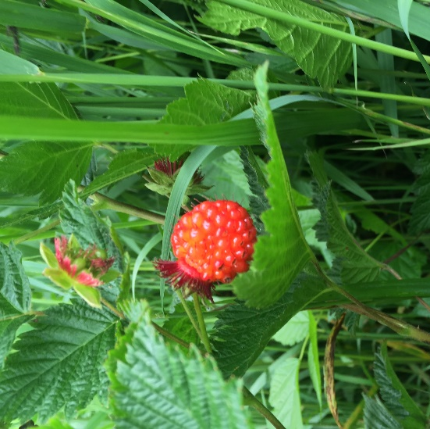
Wineberries
These statements are about wineberries (please check the picture to the left, this berry may have a different name in your community)

 | Strongly Agree | Agree | Do not Agree or disagree | Disagree | Strongly Disagree
Hot temperatures in the summer do impact how many wineberries there will be.
There are fewer wineberries than there were ten years ago.
How many wineberries there are each year is more variable than ten years ago.
We travel fewer than twenty miles to pick wineberries.
Wineberries are impacted by ATV trails.

Wineberries are ripe earlier in the season than ten years ago.
High wind events do not impact how many wineberries there are.
The landscape where we pick wineberries has changed.
Wineberries are not impacted when there is a flood.
The location where we can pick wineberries has changed over the last ten years.

<please continue to Part B>
Part B: Please answer the following questions about your most recent harvest of each type of berry.
Salmonberry
These questions are about your most recent harvest of salmonberries (please check the picture on the left, this berry may have a different name in your community)

1. Did you pick salmonberries this year?  (please circle your response)  <if yes move to question 2> |  |  | YES |  | NO
 |  | a. If you answered NO, please tell us why: | No berries available/could not find any.
 |  | (check all boxes that apply or write in the reason and then move to questions about the next berry) | Conflict with other subsistence activities.
 |  |  | Conflict with other non-subsistence activities.
 |  |  | Could not travel to berry picking location.
 |  | Other:
2.When did you pick salmonberries?
(please write in the month and approximate day(s))
 | a. Was this the same time that you picked salmonberries in previous years?  (please circle your response)  <if yes move to question 3> |  |  | YES | NO
 |  | b. If you answered NO, was it earlier or later in the season?  (please circle your response) | Earlier |  | Later
 |  | c. Please tell us why you picked earlier or later: (please write in your response)
Salmonberry, continued
These questions are about your most recent harvest of salmonberries (please check the picture on the left, this berry may have a different name in your community)

3. How many salmonberries did you pick?
(please write in your response and circle whether your response is in liters, gallons, or pounds)
 |  |  | liters | gallons | pounds
 | a. Is this the same amount you picked in previous years? (please circle your response)  <if yes move to question 4> |  |  | YES | NO
 | b. If NO, did you pick more berries or fewer berries? (please circle your response) |  |  | MORE | FEWER
 | c. Please tell us why you picked more or fewer:
4. How much time did you spend picking salmonberries? For example, 2 hours, 4 days, 1 week?
(please write in your response)
 | a. Is this the same amount of time you spent in previous years? (please circle your response)  <if yes move to question 5> |  |  | YES | NO
 | b. If your answered NO, did you spend more time or less time? (please circle your response) |  |  | MORE | LESS
 | c. Please tell us why you spent more or less time:
5. Did you pick salmonberries at the same location as in previous years? (please circle your response) |  |  |  | YES | NO
 | a. If you answered NO, please tell us why:
6. How did you travel to the location you picked salmonberries? (please write in your response)
Blackberry
These questions are about your most recent harvest of blackberries (please check the picture on the left, this berry may have a different name in your community)

1. Did you pick blackberries this year?  (please circle your response)  <if yes move to question 2> |  |  | YES |  | NO
 |  | a. If you answered NO, please tell us why: | No berries available/could not find any.
 |  | (check all boxes that apply or write in the reason and then move to questions about the next berry) | Conflict with other subsistence activities.
 |  |  | Conflict with other non-subsistence activities.
 |  |  | Could not travel to berry picking location.
 |  | Other:
2.When did you pick blackberries?
(please write in the month and approximate day(s))
 | a. Was this the same time that you picked blackberries in previous years?  (please circle your response)  <if yes move to question 3> |  |  | YES | NO
 |  | b. If you answered NO, was it earlier or later in the season? (please circle your response) | Earlier |  | Later
 |  | c. Please tell us why you picked earlier or later: (please write in your response)

Blackberry, continued
These questions are about your most recent harvest of blackberries (please check the picture on the left, this berry may have a different name in your community)

3. How many blackberries did you pick?
(please write in your response and circle whether your response is in liters, gallons, or pounds)
 | a. Is this the same amount you picked in previous years? (please circle your response) |  | YES | NO
 | b. If NO, did you pick more berries or fewer berries? (please circle your response)  <if yes move to question 4> |  | MORE | FEWER
 | c. Please tell us why you picked more or fewer:
4. How much time did you spend picking blackberries? For example, 2 hours, 4 days, 1 week?
(please write in your response)
 | a. Is this the same amount of time you spent in previous years? (please circle your response)  <if yes move to question 5> |  | YES | NO
 | b. If your answered NO, did you spend more time or less time? (please circle your response) |  | MORE | LESS
 | c. Please tell us why you spent more or less time:
5. Did you pick blackberries at the same location as in previous years? (please circle your response) |  |  | YES | NO
 | a. If you answered NO, please tell us why:
6. How did you travel to the location you picked blackberries? (please write in your response)

Blueberry
These questions are about your most recent harvest of blueberries (please check the picture to the left, this berry may have a different name in your community)

1. Did you pick blueberries this year?  (please circle your response)  <if yes move to question 2> |  |  | YES |  | NO
 |  | a. If you answered NO, please tell us why: | No berries available/could not find any.
 |  | (check all boxes that apply or write in the reason and then move to questions about the next berry) | Conflict with other subsistence activities.
 |  |  | Conflict with other non-subsistence activities.
 |  |  | Could not travel to berry picking location.
 |  | Other:
2.When did you pick blueberries?
(please write in the month and approximate days)
 | a. Was this the same time that you picked blackberries in previous years?  (please circle your response)  <if yes move to question 3> |  |  | YES | NO
 |  | b. If you answered NO, was it earlier or later in the season? (please circle your response) | Earlier |  | Later
 |  | c. Please tell us why you picked earlier or later: (please write in your response)

Blueberry, continued
These questions are about your most recent harvest of blueberries (please check the picture to the left, this berry may have a different name in your community)

3. How many blueberries did you pick?
(please write in your response and circle whether your response is in liters, gallons, or pounds)
 | a. Is this the same amount you picked in previous years? (please circle your response)  <if yes move to question 4> |  | YES | NO
 | b. If NO, did you pick more berries or fewer berries?  (please circle your response) |  | MORE | FEWER
 | c. Please tell us why you picked more or fewer:
4. How much time did you spend picking blueberries? For example, 2 hours, 4 days, 1 week?
(please write in your response)
 | a. Is this the same amount of time you spent in previous years? (please circle your response)  <if yes move to question 5> |  | YES | NO
 | b. If your answered NO, did you spend more time or less time? (please circle your response) |  | MORE | LESS
 | c. Please tell us why you spent more or less time:
5. Did you pick blueberries at the same location as in previous years? (please circle your response) |  |  | YES | NO
 | a. If you answered NO, please tell us why:
6. How did you travel to the location you picked
blueberries? (please write in your response)

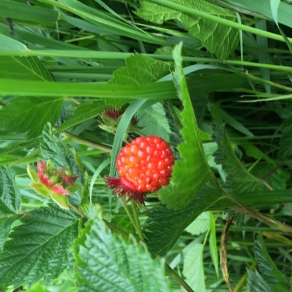
Wineberries
These questions are about your most recent harvest of wineberries (please check the picture to the left, this berry may have a different name in your community)

1. Did you pick wineberries this year?  (please circle your response)  <if yes move to question 2> |  |  | YES |  | NO
 |  | a. If you answered NO, please tell us why: | No berries available/could not find any.
 |  | (check all boxes that apply or write in the reason and then move to questions about the next berry) | Conflict with other subsistence activities.
 |  |  | Conflict with other non-subsistence activities.
 |  |  | Could not travel to berry picking location.
 |  | Other:
2.When did you pick wineberries?
(please write in the month and approximate day(s))
 | a. Was this the same time that you picked blackberries in previous years?  (please circle your response)  <if yes move to question 3> |  |  | YES | NO
 |  | b. If you answered NO, was it earlier or later in the season? (please circle your response) | Earlier |  | Later
 |  | c. Please tell us why you picked earlier or later: (please write in your response)
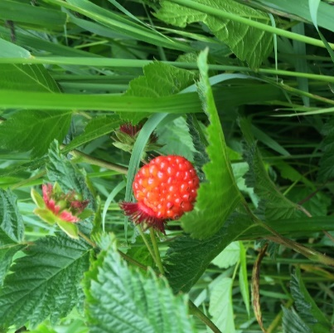
Wineberries, continued
These questions are about your most recent harvest of wineberries (please check the picture to the left, this berry may have a different name in your community)

3. How many wineberries did you pick?
(please write in your response and circle whether your response is in liters, gallons, or pounds)
 | a. Is this the same amount you picked in previous years? (please circle your response)  <if yes move to question 4> |  | YES | NO
 | b. If NO, did you pick more berries or fewer berries?  (please circle your response) |  | MORE | FEWER
 | c. Why? (please write in your response)
4. How much time did you spend picking wineberries? For example, 2 hours, 4 days, 1 week?
(please write in your response)
 | a. Is this the same amount of time you spent in previous years? (please circle your response)  <if yes move to question 5> |  | YES | NO
 | b. If your answered NO, did you spend more time or less time? (please circle your response) |  | MORE | LESS
 | c. Please tell us why you spent more or less time:
5. Did you pick wineberries at the same location as in previous years? (please circle your response) |  |  | YES | NO
 | a. If you answered NO, please tell us why:
6. How did you travel to the location you picked wineberries? (please write in your response)

Is there anything else you would like to tell us about berries in your community?
Salmonberries:
Blackberries:
Blueberries:
Wineberries:

Thank you for participating in this survey! We will share the results of this survey with your Tribal Council and you once we have analyzed the results. Feel free to contact us if you have any questions or concerns.
Quyana, Nicole Herman-Mercer 303-236-5031, nhmercer@usgs.gov
and Rachel Loehman 406-544-9561, rloehman@usgs.gov

