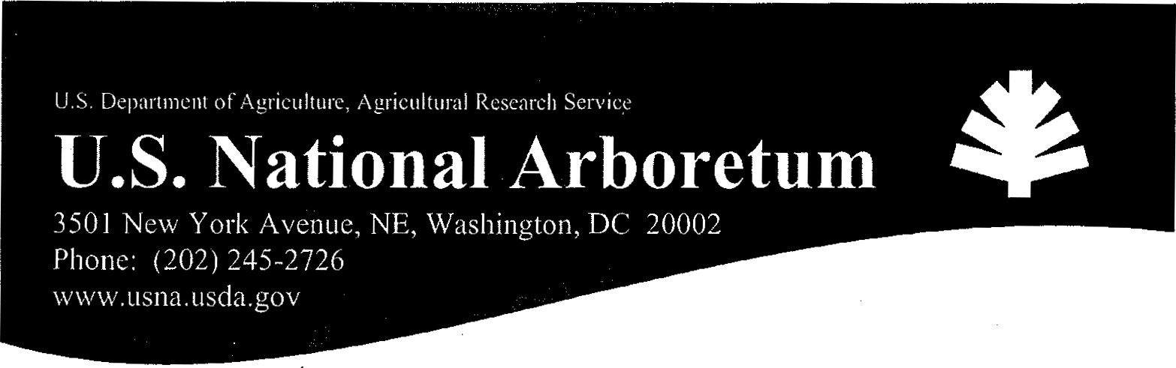
Photography at the U.S. National Arboretum Policies, Permit, and Fee Scale
The mission of the U.S. National Arboretum (USNA) is to conduct research, provide education, and conserve and display trees, shrubs, flowers, and other plants to enhance the environment. In accordance with these objectives, the USNA grounds are open to the public. All visitors are subject to the USNA rules and regulations.
It is the policy of the USNA to permit and encourage photography within the USNA to the fullest extent possible consistent with the protection of its gardens and plant collections and the enjoyment of visitors.
USNA cannot endorse or be made to appear as if it is endorsing a product or a political view.
Photographic exercises 'nay not disrupt the flow of vehicles and pedestrians on the grounds of the USNA.
Noncommercial Photography
Noncommercial photography does not require a permit; you are welcome to explore any of the USNA's public areas. (For Wedding Photography, see below.)
Commercial Photography
Commercial Photography requires a permit and a may incur a fee. All requests for commercial photography must be submitted as far in advance as possible (at least two weeks) and must include a detailed statement of the purpose of the photography. If the request is approved and a fee is assigned, the fee must be received prior to the permit being issued.
Wedding Photography
All wedding commercial/professional wedding photography require a permit and a fee. Wedding pictures may be taken in the Capitol Columns area be within the mowed area) and the Dogwood Collection. No services, parties, or receptions •are permitted. Only the immediate wedding party and photographer are allowed. Nothing may be attached to historic structures (e.g., columns, steps, etc.).

Important Information
DAMAGES: Care must be given to ensure plant materials, grounds, or facilities are not damaged in any way. Full restitution for damage to plants, grounds, or facilities is required. The USNA is not responsible for lost or damaged personal property. Please do not leave valuables in your car.
OPERATING HOURS: The USNA grounds are open 8:00 a.m. to 5:00 p.m. every day except December 25. Prior approval will be required for visitation or photography outside these hours.
NON-PUBLIC AREAS: A permit is required for access to any non-public area. A verbal permit may be provided in cases of bona fide news-gathering activities.
REFUSE: The Photographer is responsible for removing on a daily basis any refuse generated.
CANCELLATIONS: At his sole discretion, the Director of the USNA reserves the right to cancel any reservation, In such cases, all fees for the canceled day will be fully refunded,
PARKING: Parking is allowed only in designated areas. AIL roads must be kept open at all times for vehicle traffic. Park only on paved roads as far to the right edge of the road as possible, but not on the grass. Trailers with steps must park so that the steps face away from the roadway. All vehicles and equipment must be kept off the lawn and planted areas.
PLANT MATERIAL: Digging or planting of any plant material on the grounds is strictly prohibited unless prior authorization is received from the Administrative Officer. Absolutely NO cutting of any arboretum plant material is permitted. Nothing is to be trimmed for any reason whatsoever. Equipment may not be set up within garden beds without USNA approval.
Plant tags are not to be removed for any reason.
VISITORS: Visitors to the grounds may not be prevented from viewing an area being used by a photographer. They may be asked, politely, not to approach during filming, but once the shot has been completed; the visitors may proceed. No public area may be closed to visitor access.
DRESSING ROOMS: Changing rooms are not available. Limited restroom facilities are available, but are not designed to handle changing activities. Use by the public of these facilities may not be restricted.
NUDITY: Under no circumstances will nudity or scantily clad persons be permitted on the grounds of the arboretum. Articles of clothing which are indecent may not be worn by an employee of the production company.
ALCOHOL: Alcoholic beverages are not allowed on the grounds and observation of the presence of such by permittee's cast or crew will result in cancellation of the shoot without any refund of fees.
PHOTO CREDIT: Proper photo credit must be awarded to the USNA. Copies and press uses of all photographs of the grounds of the USNA must be submitted to: Education & Visitor Services/U.S. National Arboretum, 3501 New York Avenue, NE, Washington, DC 20002.
NON-COMPLIANCE: Cancellation of the filming and denial of future filming privileges may result if the tenns and conditions stated herein are not fully adhered to.
Revised March 2010
OMB No. 0518-0024
Application/Permit for Commercial Photography/Cinematography U.S. National Arboretum
Applicant Name: Date:

Contact Name:

Name of Company/Organization:

Address:

Phone No. Fax No.
Please provide the name, address and phone number of the organization or company that has contracted for your photographic or cinemagraphic services, if applicable:

Date requested for photographic/cinemagraphic services:
Rain Date:

Entry time: Exit time:
Number of people working on the project: in vehicles
Identify all site(s) to be used (list at least one specific site).
Itemize equipment to be used (type of camera, size, sound equipment, lights, screens, etc.).
Provide detailed description of the project (what you are proposing to photograph, the purpose of the project, the audience of the project, the number of cast and crew, etc. Be as specific and detailed as possible). Attach additional pages if required.
Describe the manner in which the linages or pictures will be used. Identify where they are to be aired or published.
Security of equipment is provided by the pemittee.
All U.S. National Arboretum regulations must be obeyed. Falsification of any of the above information will result in immediate cancellation of permission to photograph with no refund. Permission is granted for the date and time indicated only and is not Locations other than those approved may not be used.
According to the Paperwork Reduction Act of 1995, an agency map not conduct or sponsor, and a person is not required to respond to, a collection of information unless it displays a valid OMB control number. The valid OMB control number of this information collection is 0518-0024. The time required to complete this information collection is estimated to average 30 minutes per response, including the time for reviewing instructions, searching existing data sources, gathering and maintaining the data needed, and completing and reviewing the collection.
I understand and agree to the conditions above and have not falsified any information about this project.
Signature: Date:

FOR OFFICIAL USE ONLY
Approved / Denied Approving Official Date: Reason for Denial:
Notification: Director, Security, Facilities Manager, Events Coordinator, Scheduling Coordinator, Front Desk, Aker, Curator
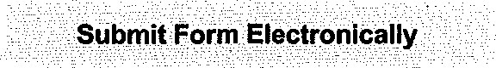
FEE CALCULATION
pieces of equipment members of cast and crew day(s) of set preparation at $250 per day
day(s) filming at $per day
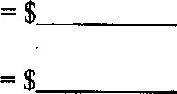
day(s) strike set at $250 per day day(s) still photography at $500 per day

Still photography at $250 per half day 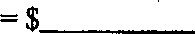day(s) wedding photography at $250 per half day hour(s) supervision at $45 per hour slides at $100 per image
TOTAL FEE DUE:
Fees are paid by credit card only and must be paid at least one week prior to date requested. Please contact:
Linda Houston
Administrative Technician
(202) 245-4599
Linda.Houston@ars.usda.gov

