System Screenshots
Grants Management Solutions Suite (GMSS)

TABLE OF CONTENTS
Highway Safety Plan Contents 2
Summary Information (HSP form section) 3
Highway safety planning process (HSP form section) 4
Performance report (HSP form section) 7
Performance plan (HSP form section) 10
Program Area (HSP form section) 14
Evidence-based traffic safety enforcement program (TSEP) (HSP form section) 36
High-visibility enforcement (HSP form section) 39
S. 405b Occupant Protection Incentive Grant Contents 43
High seat belt use rate State (included in low seat belt use rate State as well) 44
Low seat belt use rate State (additional criteria) 51
S. 405c Traffic Record System Improvement Incentive Grant Contents 64
Traffic records coordinating committee (TRCC) (405c section) 65
State traffic records strategic plan (405c section) 67
Quantitative improvement (405c section) 69
State highway safety data and traffic records system assessment (405c section) 70
Requirement for maintenance of effort (405c section) 71
S. 405d Impaired Driving Incentive Grant Contents 72
405(d) Impaired driving countermeasures grant 73
405(d) Alcohol-ignition interlock law grant 88
405(d) 24-7 Sobriety programs grant 91
S. 405e Distracted Driving Incentive Grant Contents 99
S. 405f Motorcyclist Safety Incentive Grant Contents 106
Motorcycle safety information (405f section) 107
Motorcycle rider training course (405f section) 108
Motorcycle awareness program (405f section) 110
Reduction of fatalities and crashes involving motorcycles (405f section) 112
Impaired driving program (405f section) 115
Reduction of fatalities and accidents involving impaired motorcyclists (405f section) 117
Use of fees collected from motorcyclists for motorcycle programs (405f section) 120
S. 405g Graduated Drivers Licensing (GDL) Incentive Grant Contents 124
Graduated driver information (405g section) 125
S. 405h Nonmotorized Incentive Grant Contents 130
Non-motorized information (405h section) 131
S. 1906 Racial Profiling Data Collection Incentive Grant Contents 132
Racial profiling data collection grant (1906 section) 133
Assurance (1906 section) 134
Official documents (1906 section) 135

Highway Safety Plan Contents

Summary Information (HSP form section)
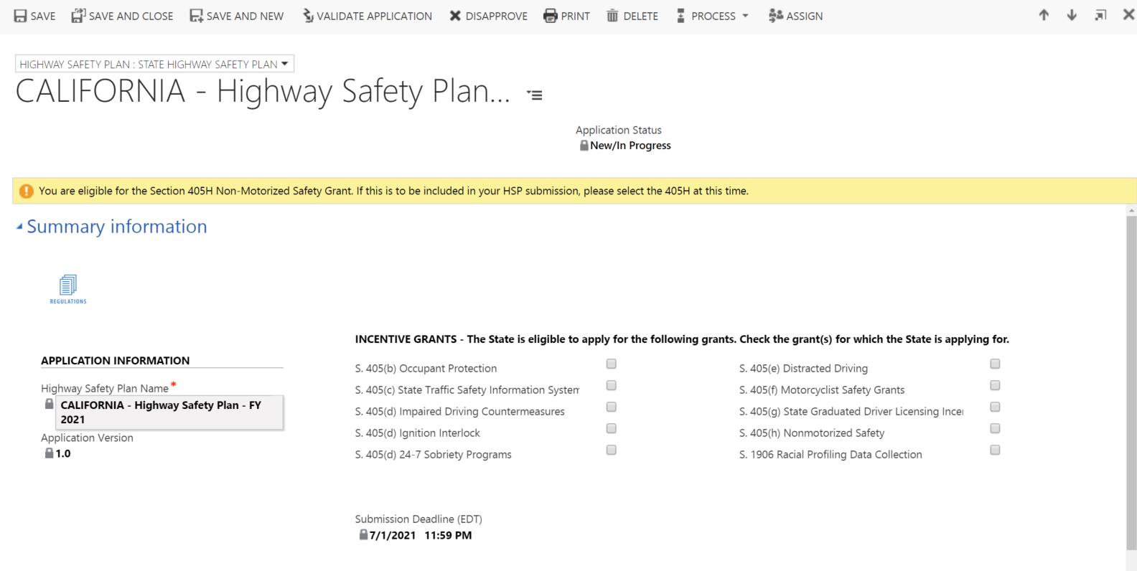

Highway safety planning process (HSP form section)
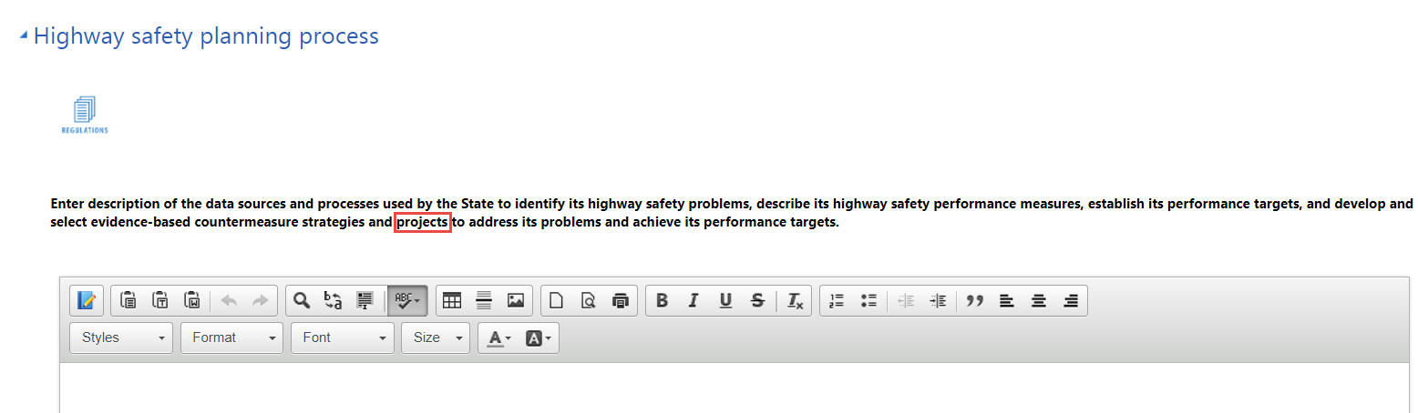
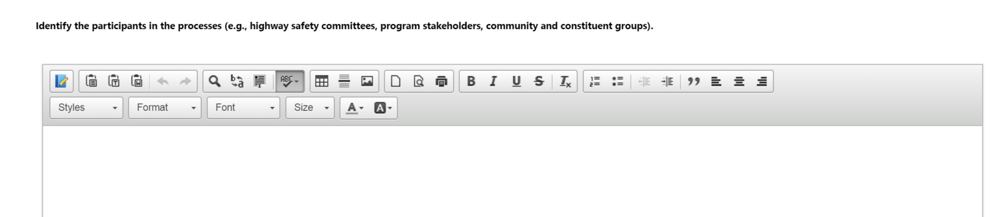
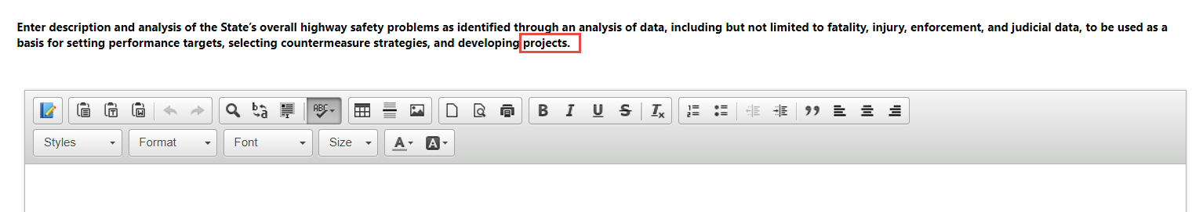
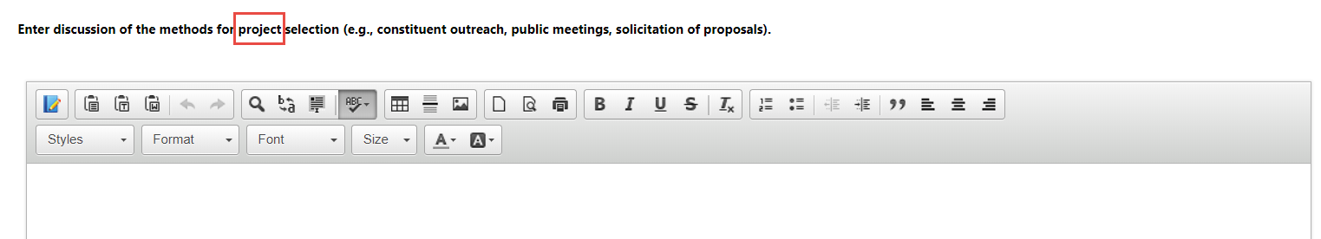
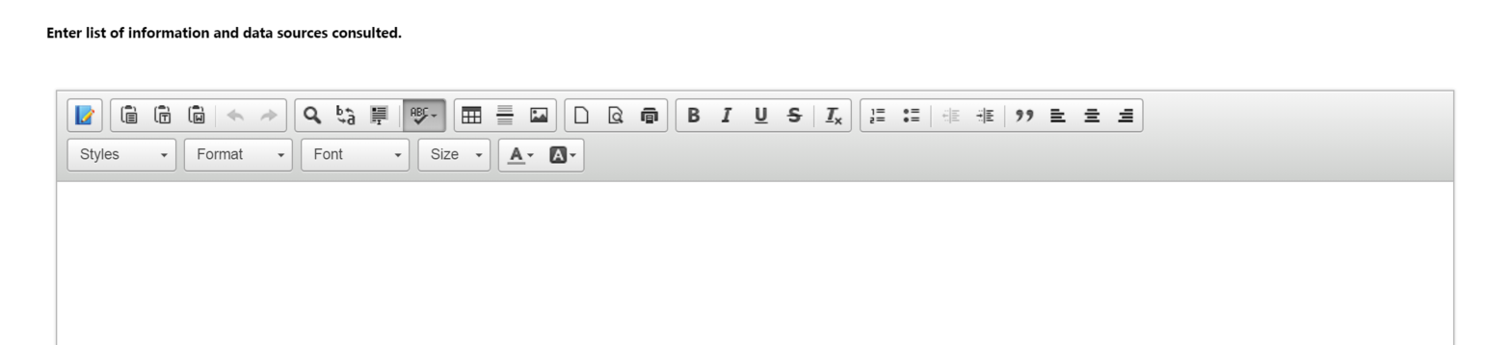
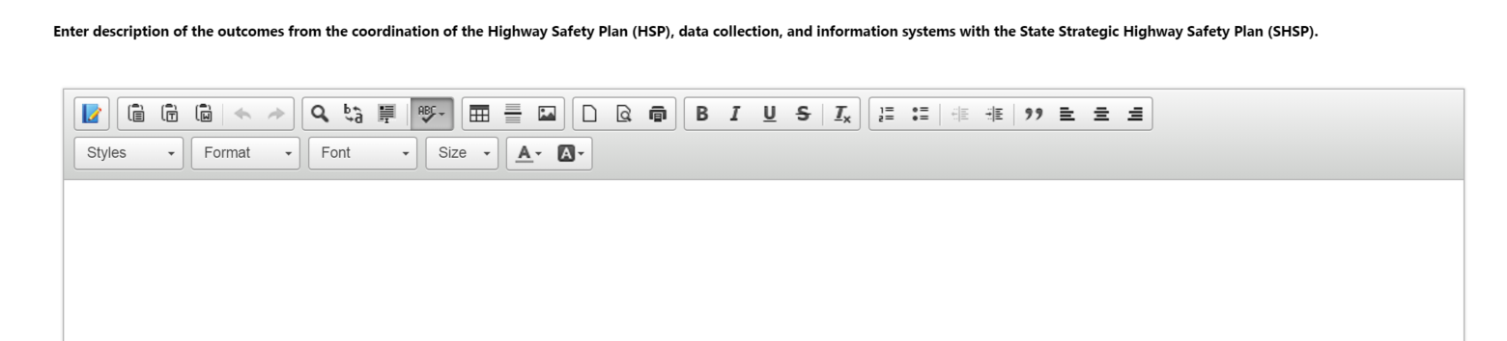

Performance report (HSP form section)
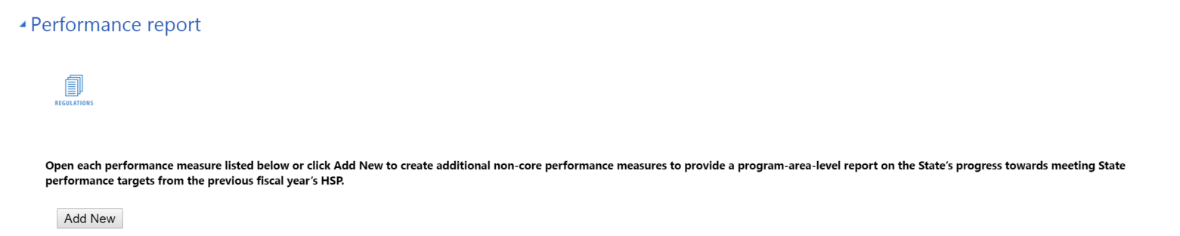
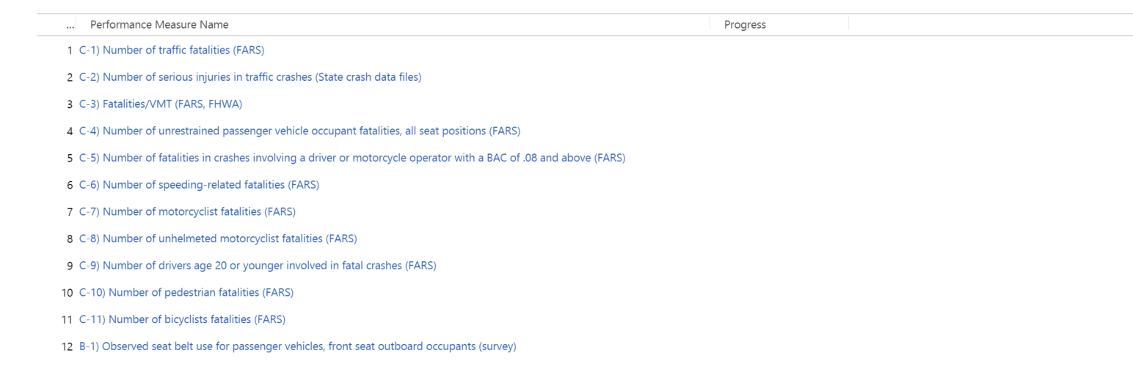

Add New Performance Report Performance Measure (Quick create form)
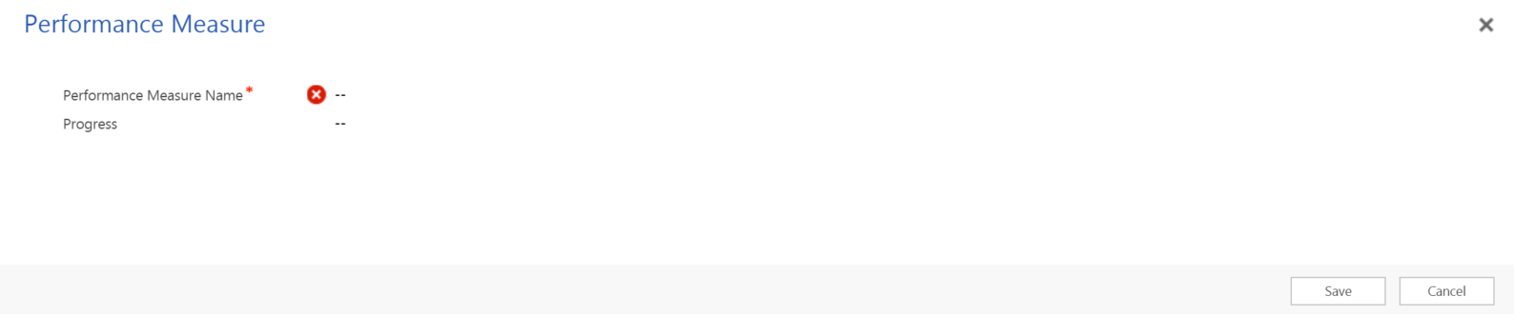

Update Performance Report Performance Measure (Performance Measure form for each performance report measure)
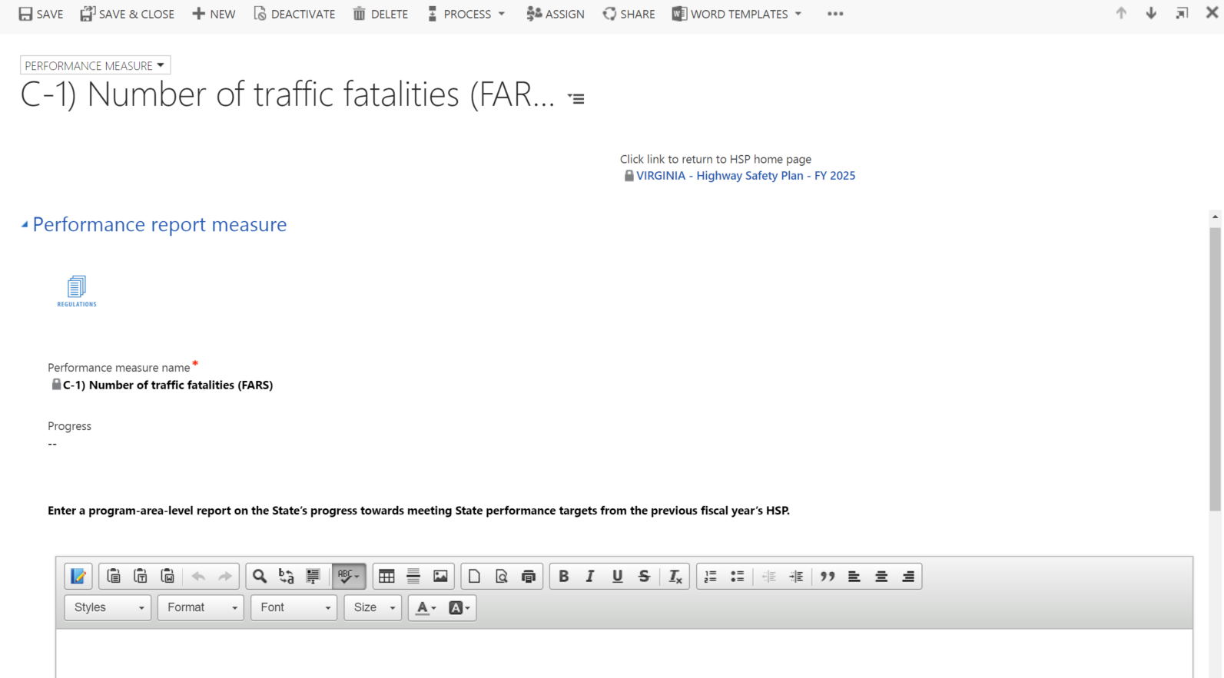

Performance plan (HSP form section)
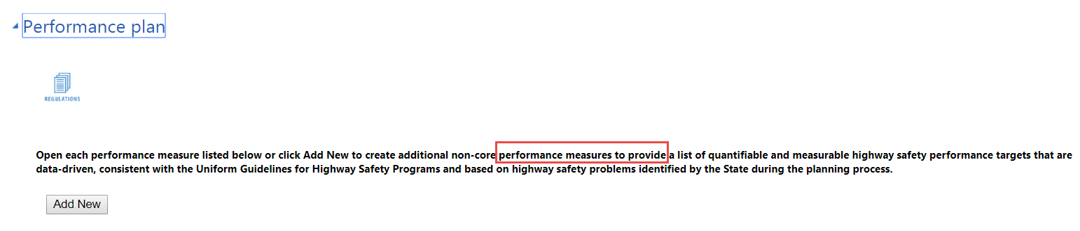
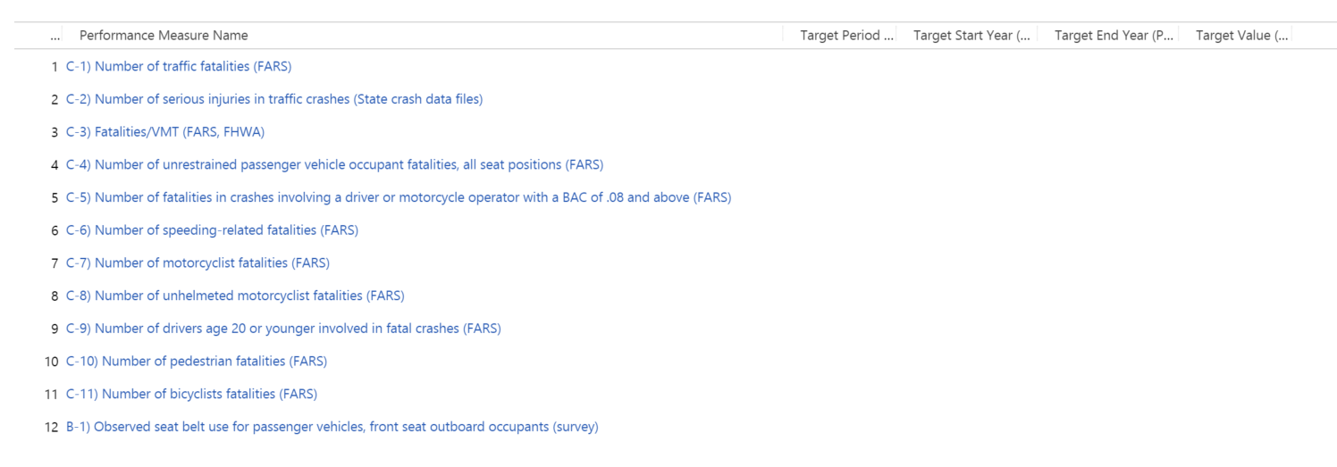
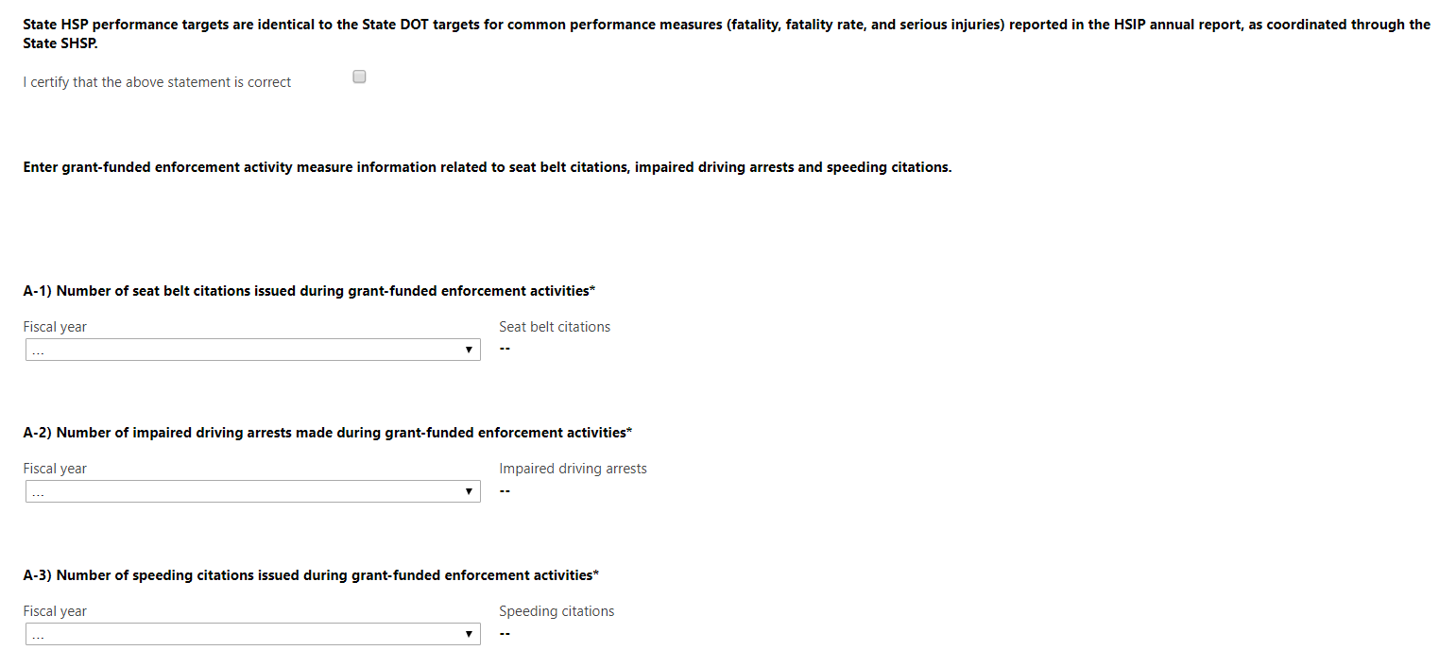

Add New Performance Plan Performance Measure (Quick create form)
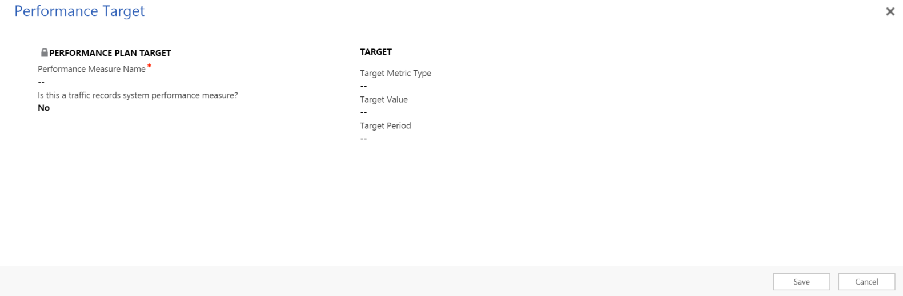

Update Performance Plan Performance Measure (Performance Measure form for each performance plan measure)
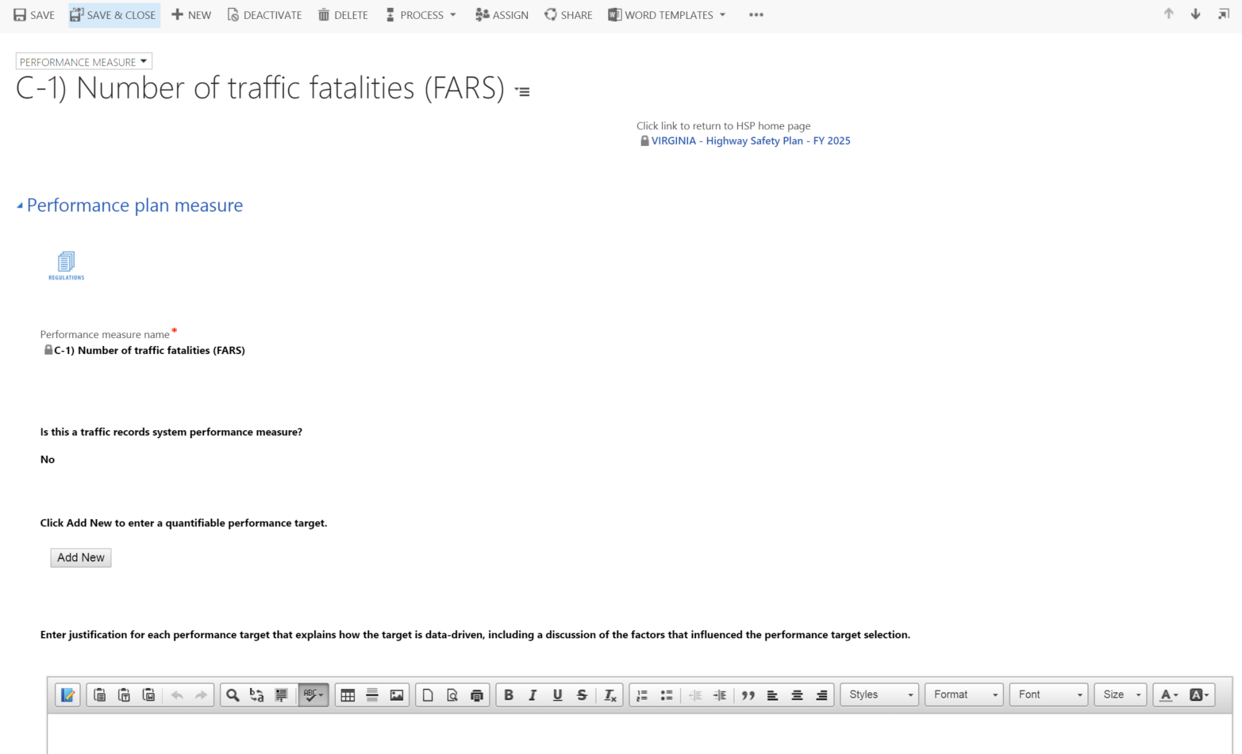

Program Area (HSP form section)
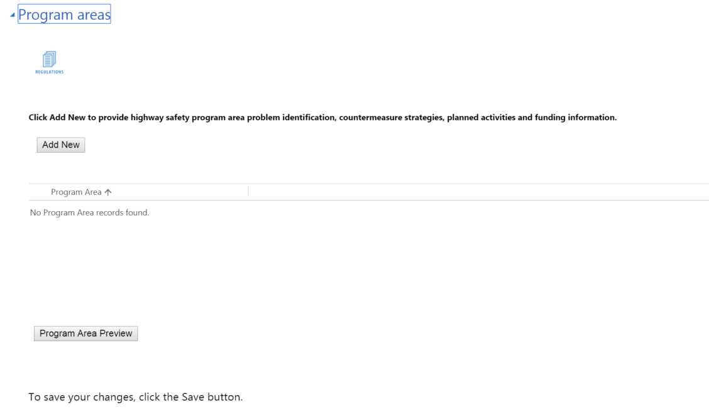

Add New Program Area (Quick create form)
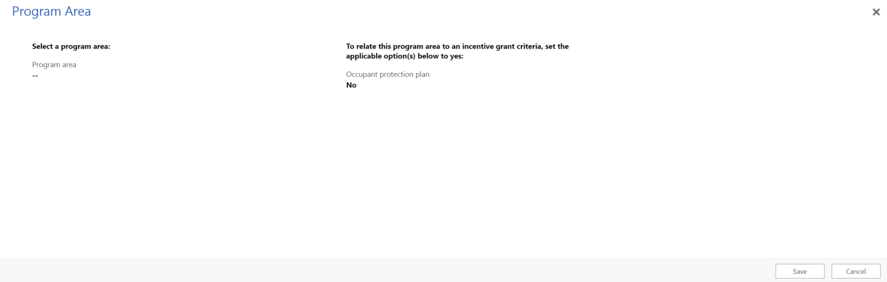

Update Program Area (Program Area form for each program area)

Program area information (Program Area form section)
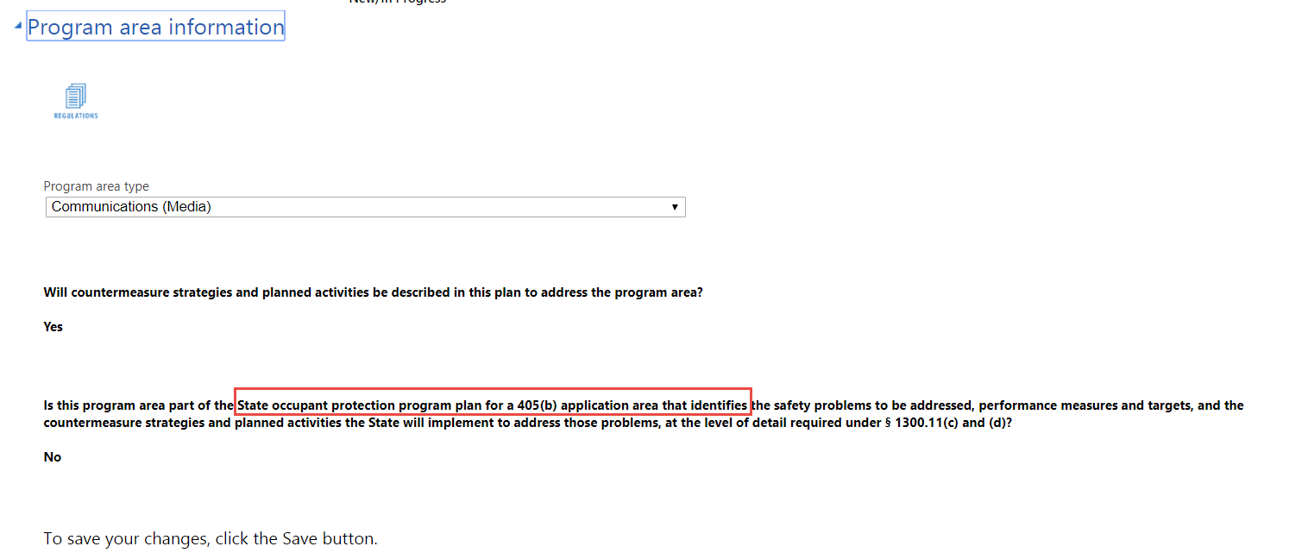

Problem identification (Program Area form section)
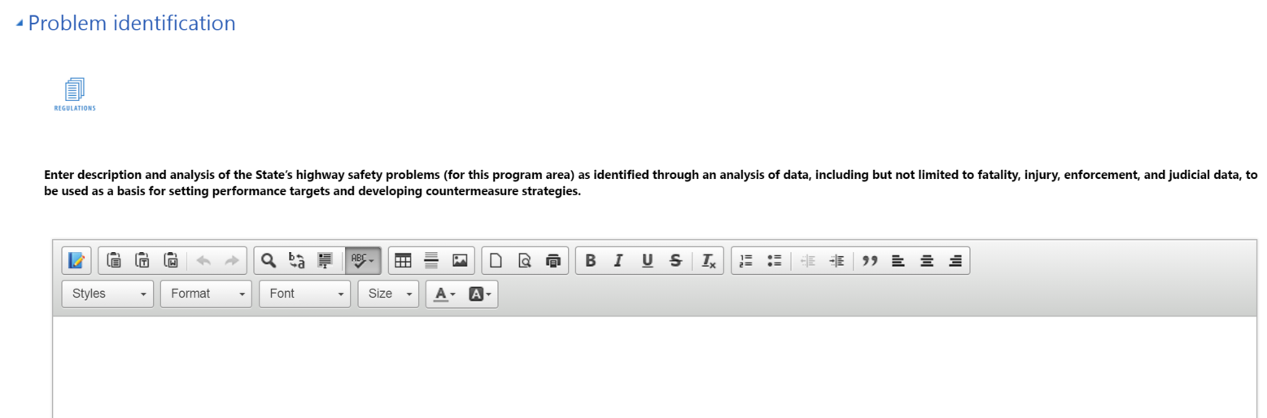

Performance measures (Program Area form section)
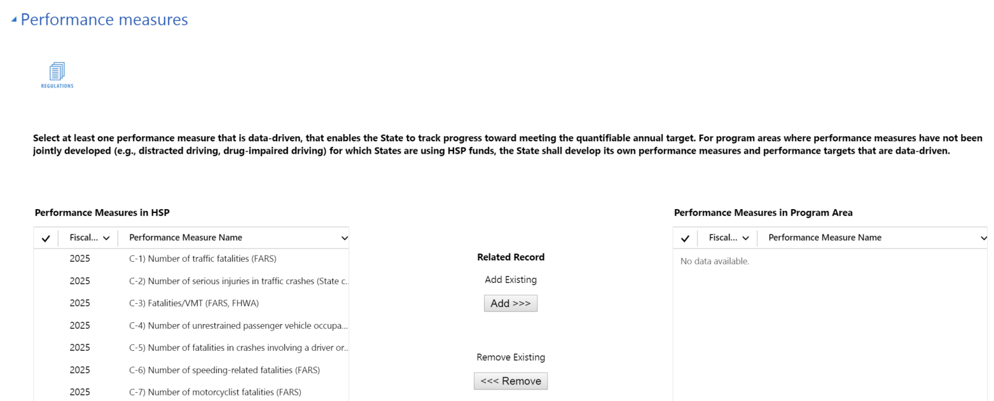

Countermeasure strategies (Program Area form section)
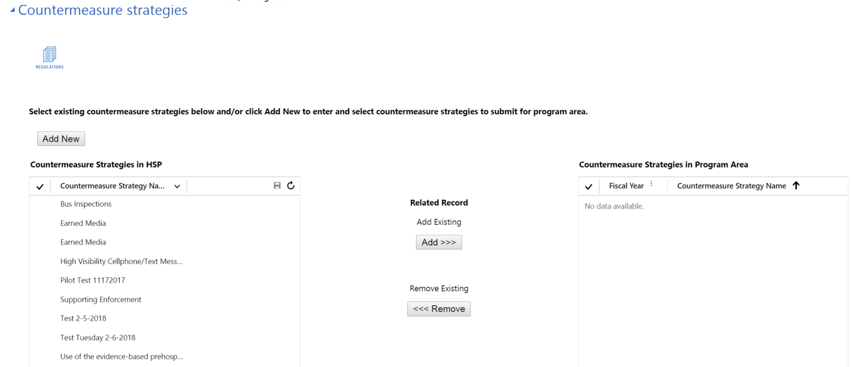

Add New Countermeasure Strategy (Quick create form)
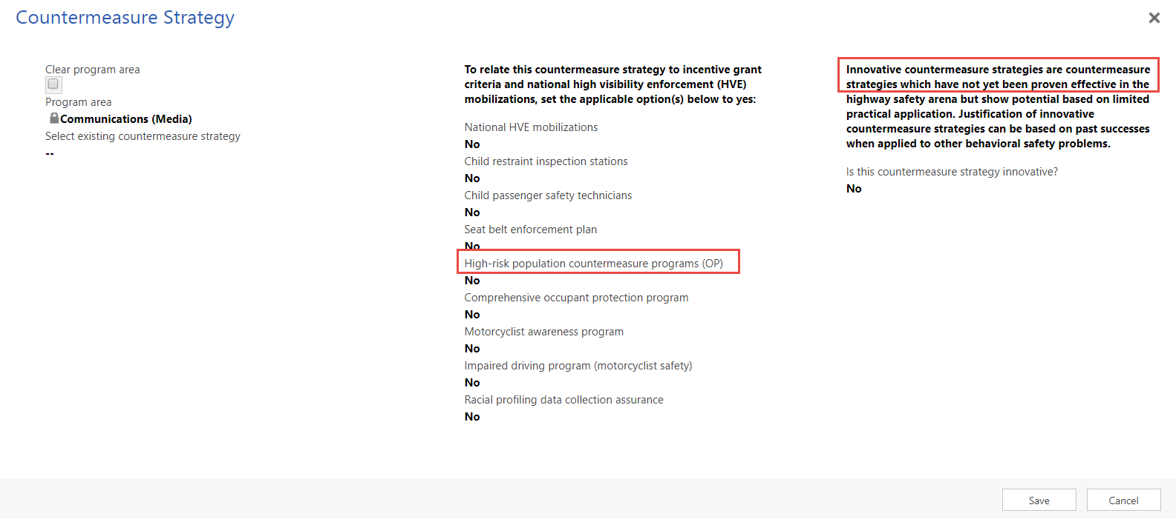

Update Countermeasure Strategy (Countermeasure Strategy form for each countermeasure strategy)

Countermeasure strategy information (Countermeasure Strategy form section)
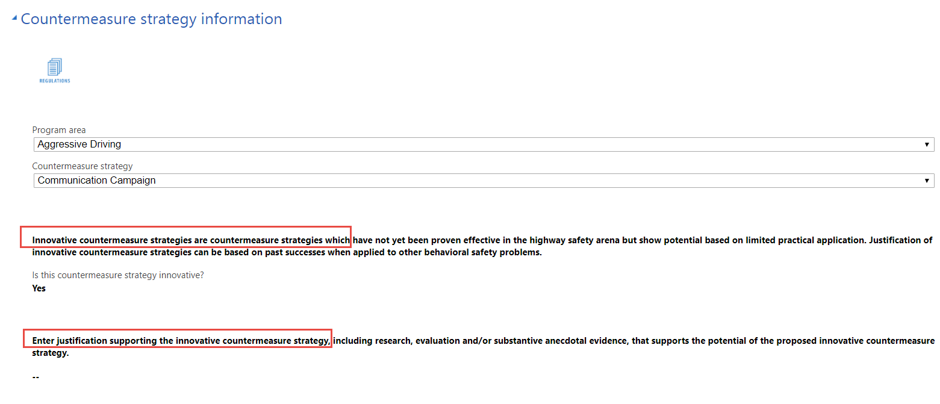
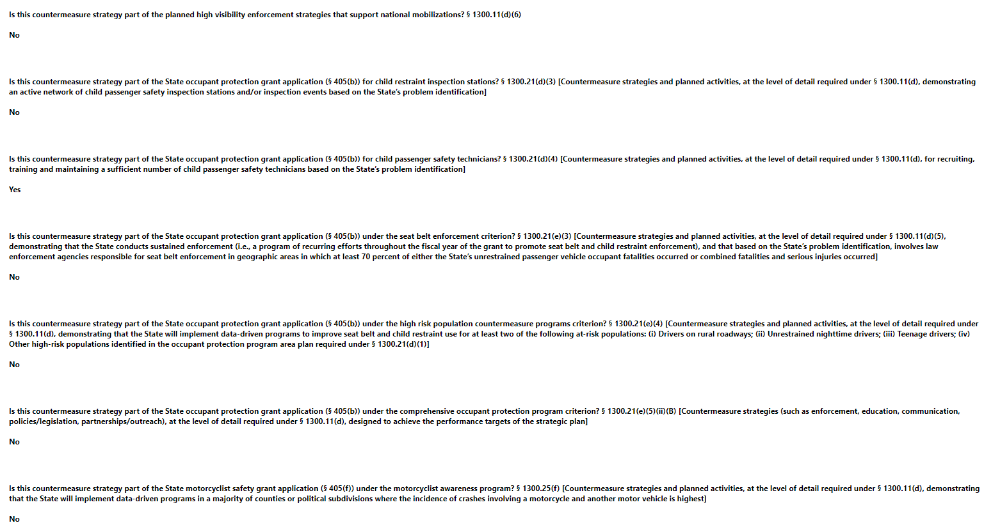
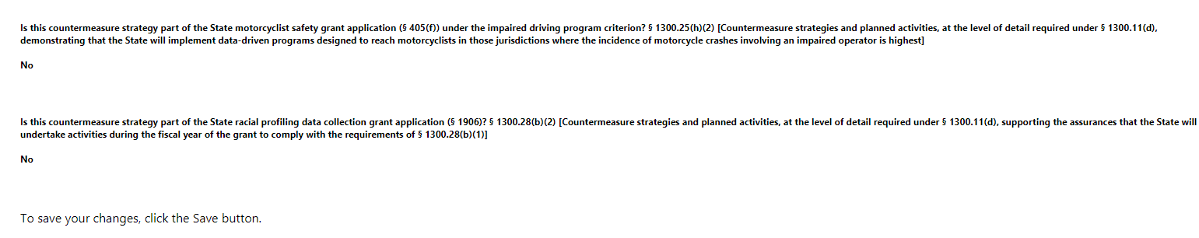

Countermeasure strategy description (Countermeasure Strategy form section)
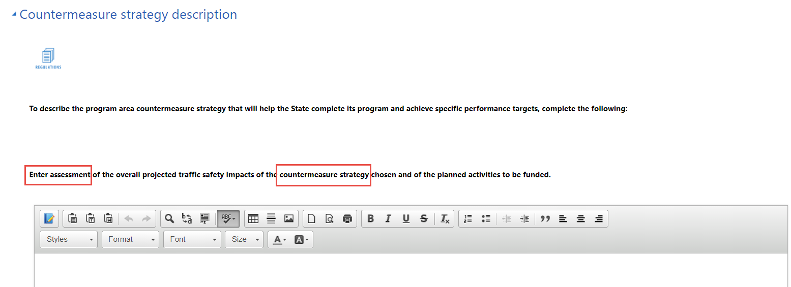
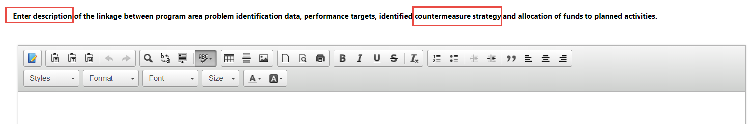

Evidence of effectiveness (Countermeasure Strategy form section)
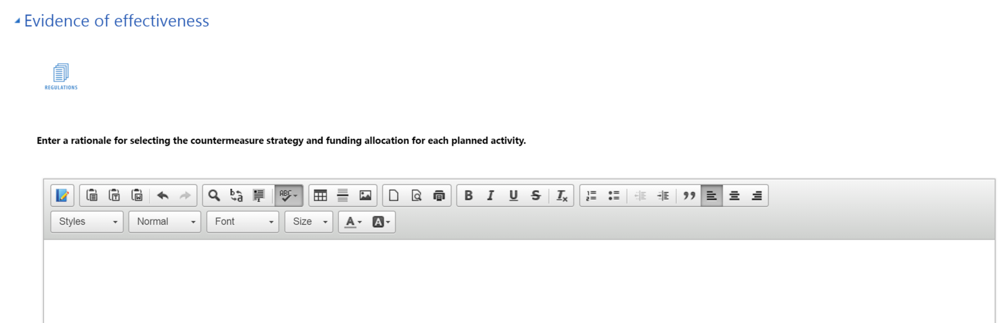

Planned activities (Countermeasure Strategy form section)
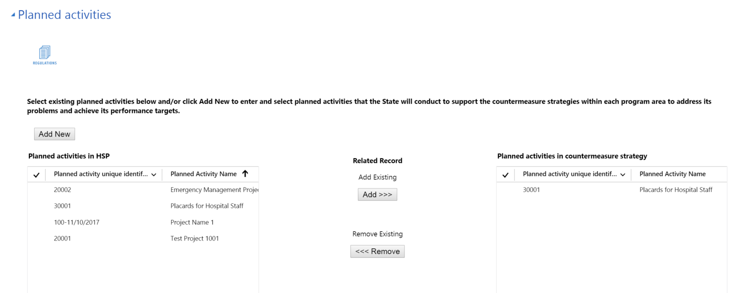

Add New Planned Activity (Quick Create form)
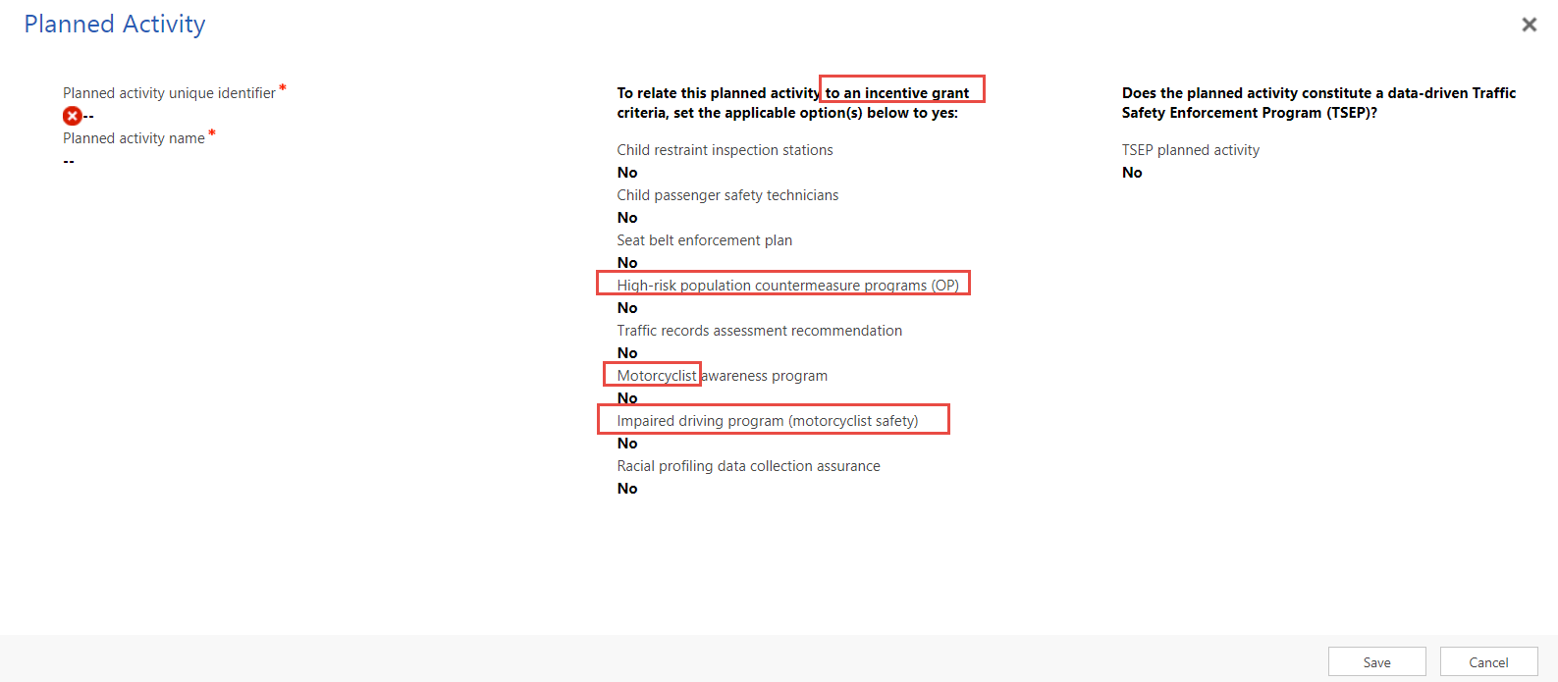

Update Planned Activity (Planned Activity form for each planned activity)

Planned activity information (Planned Activity form section)
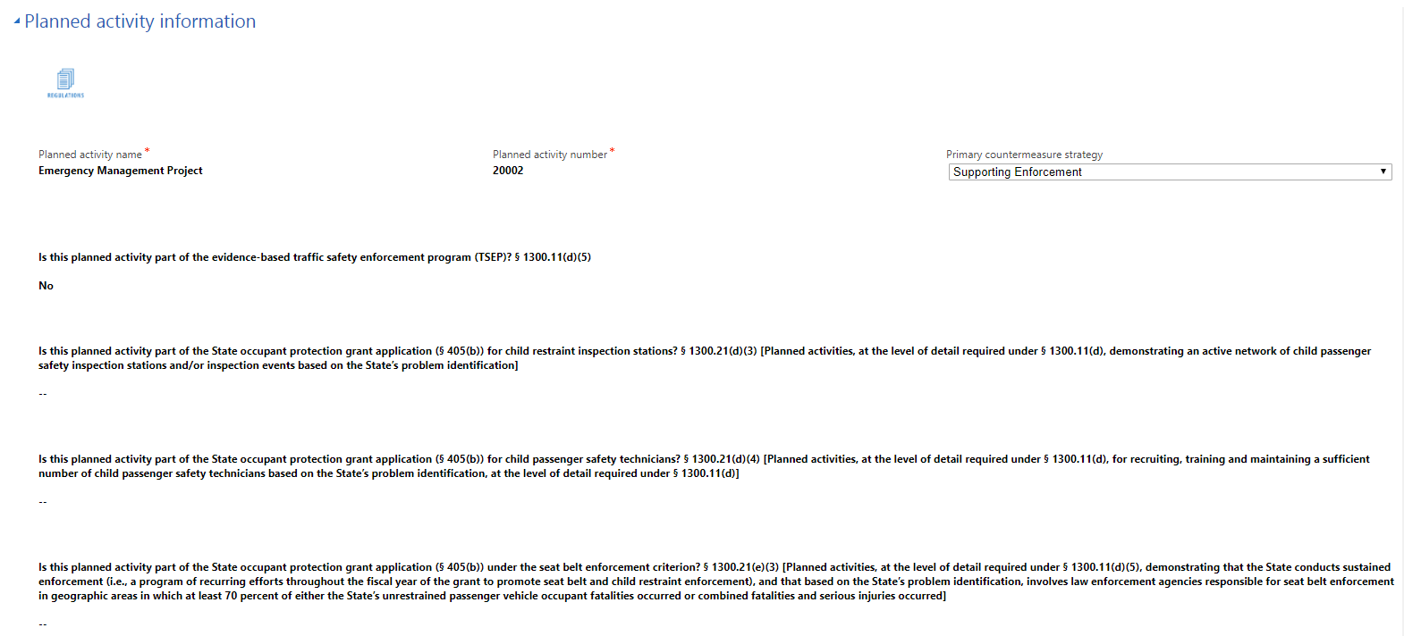
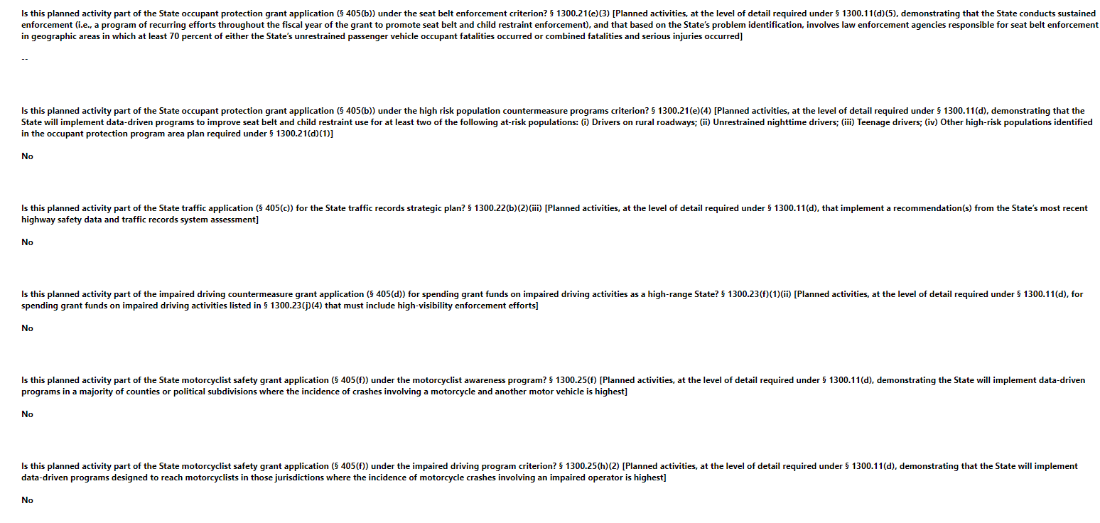
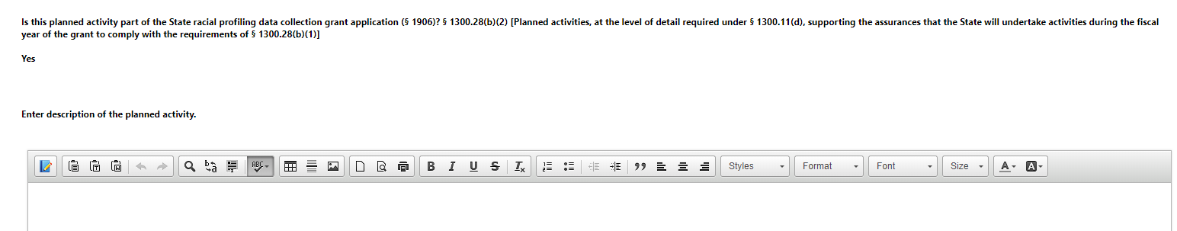
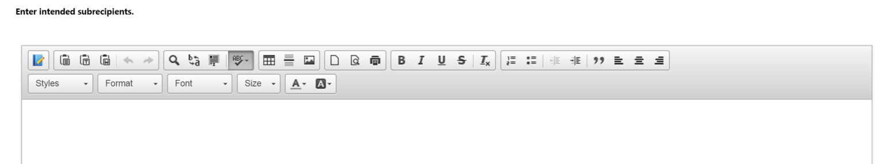

Countermeasure strategies (Planned Activity form section)
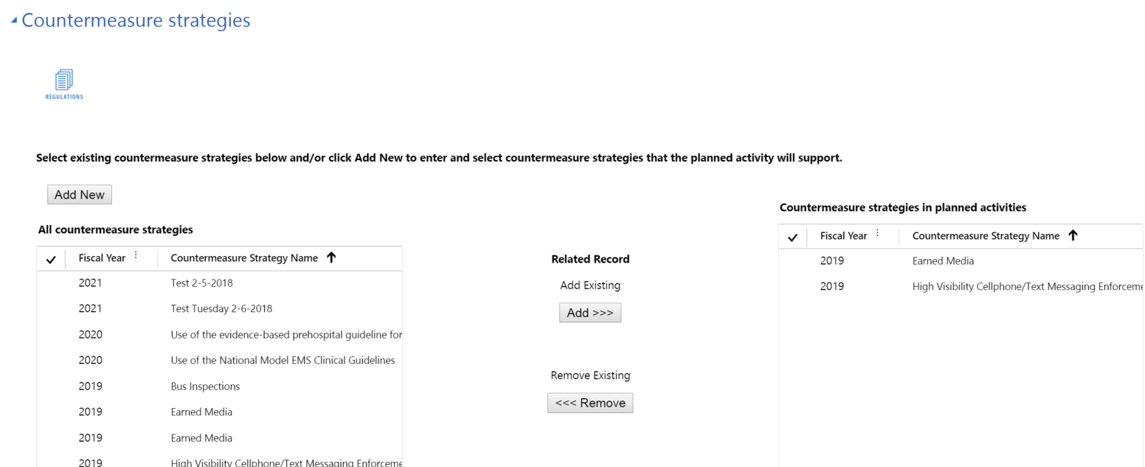

Funding sources (Planned Activity form section)
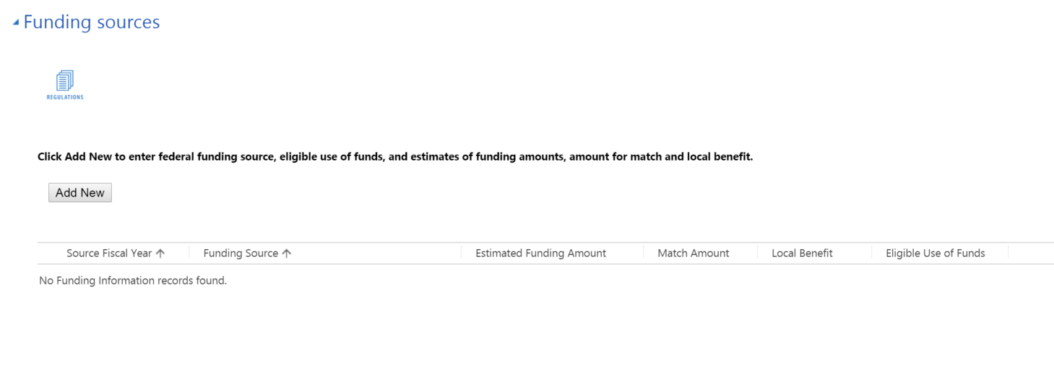

Add New Funding Source (Quick Create form)
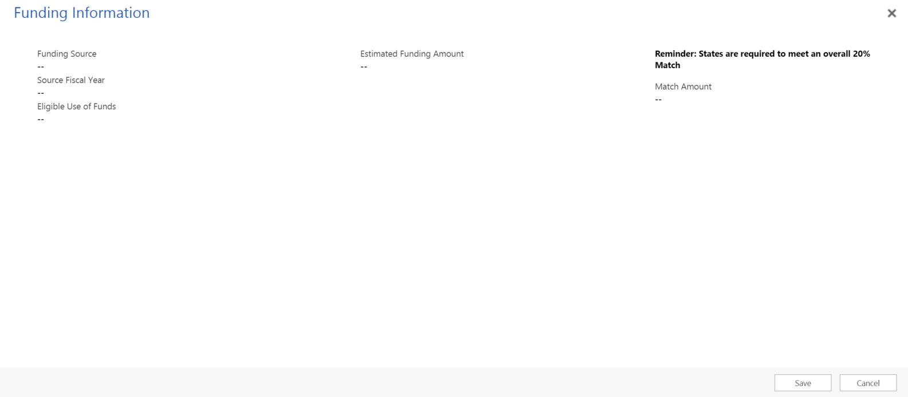

Major purchases and dispositions (Planned Activity form section)
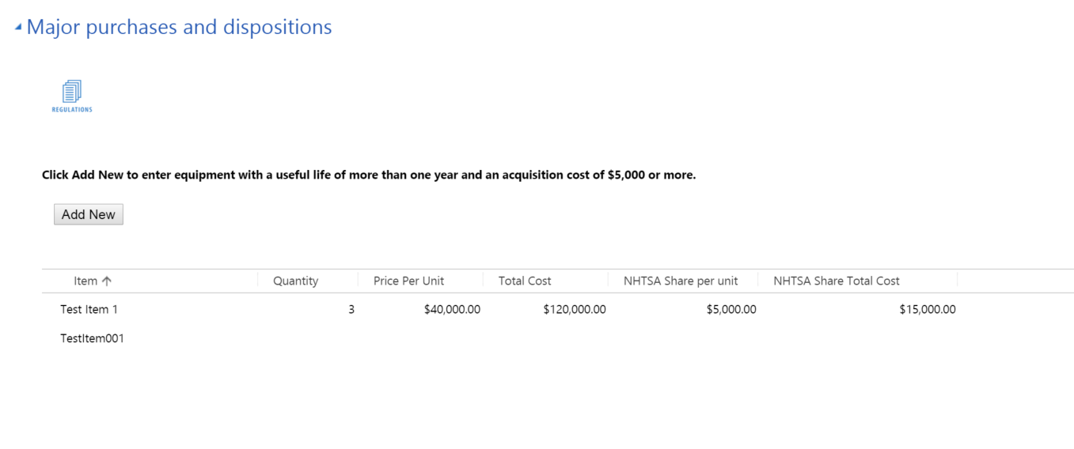

Add New Major Purchase and Disposition (Quick Create form)
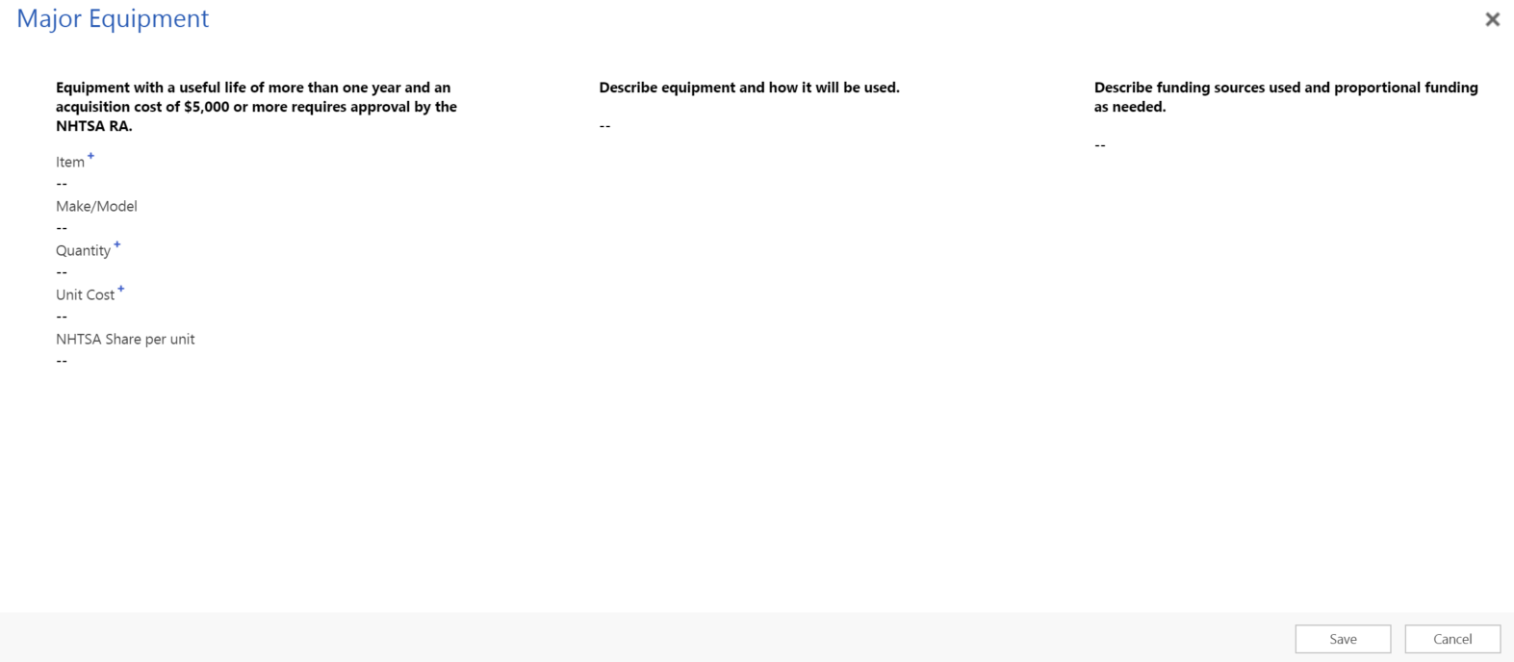

Evidence-based traffic safety enforcement program (TSEP) (HSP form section)
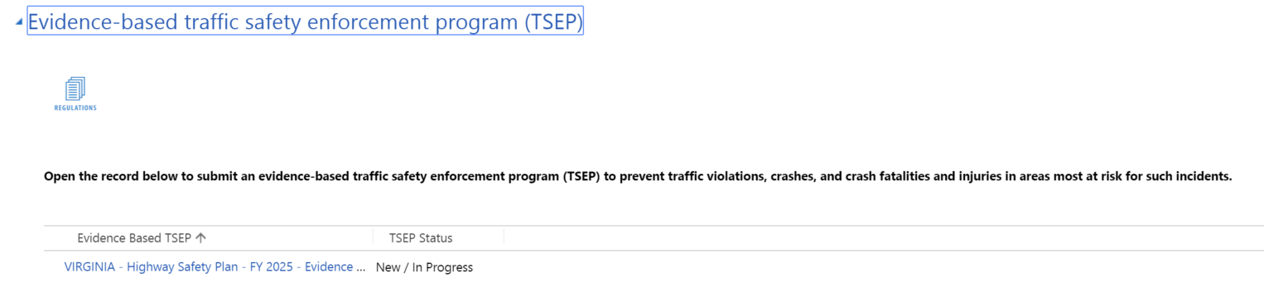

Update Evidence-based traffic safety enforcement program (TSEP) (TSEP form)

Evidence-based traffic safety enforcement program (TSEP) information (TSEP form section)
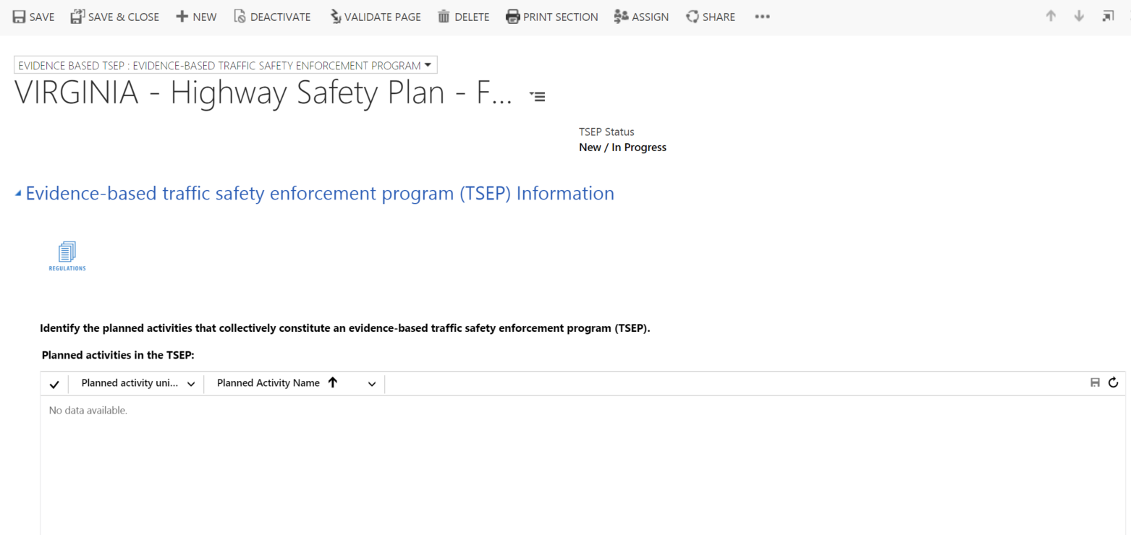

Analysis (TSEP form section)
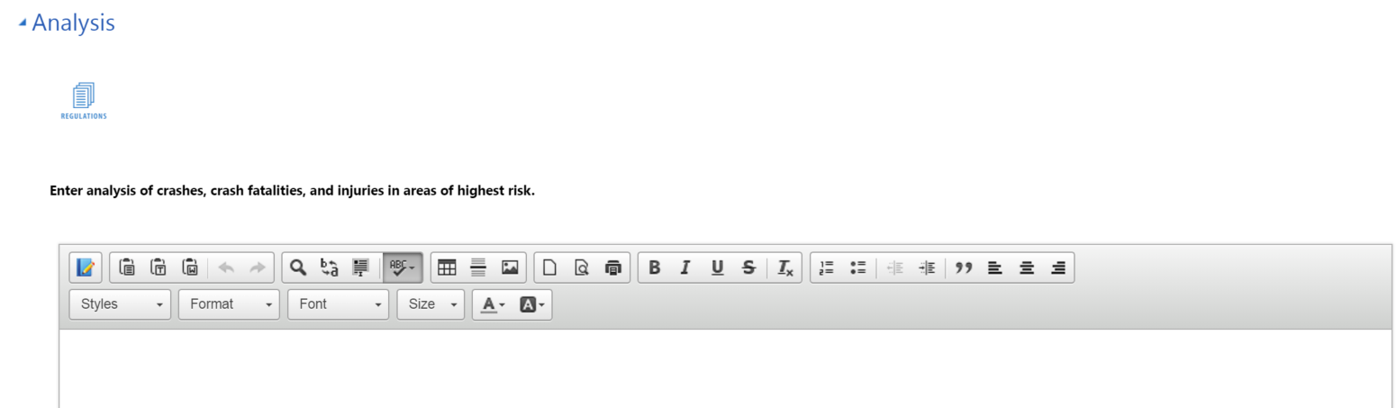
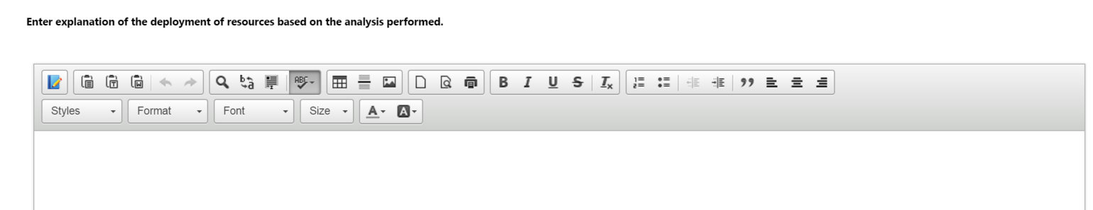
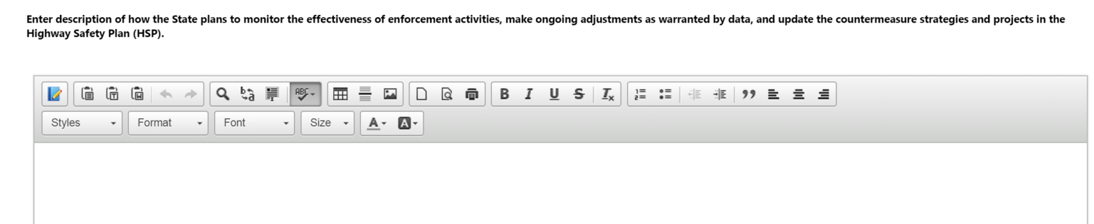

High-visibility enforcement (HSP form section)
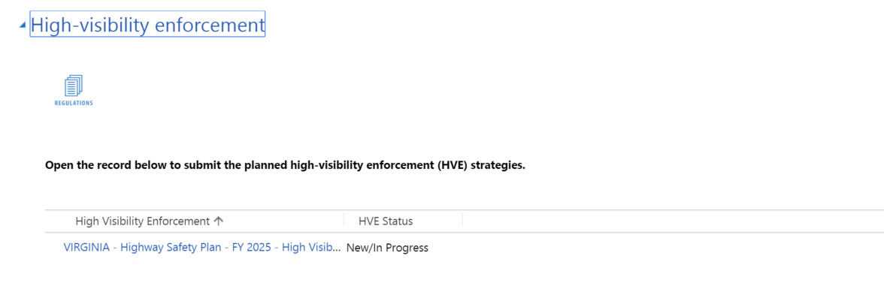

Update High-visibility Enforcement (HVE form)

High-visibility enforcement (HVE) strategies (HVE form section)
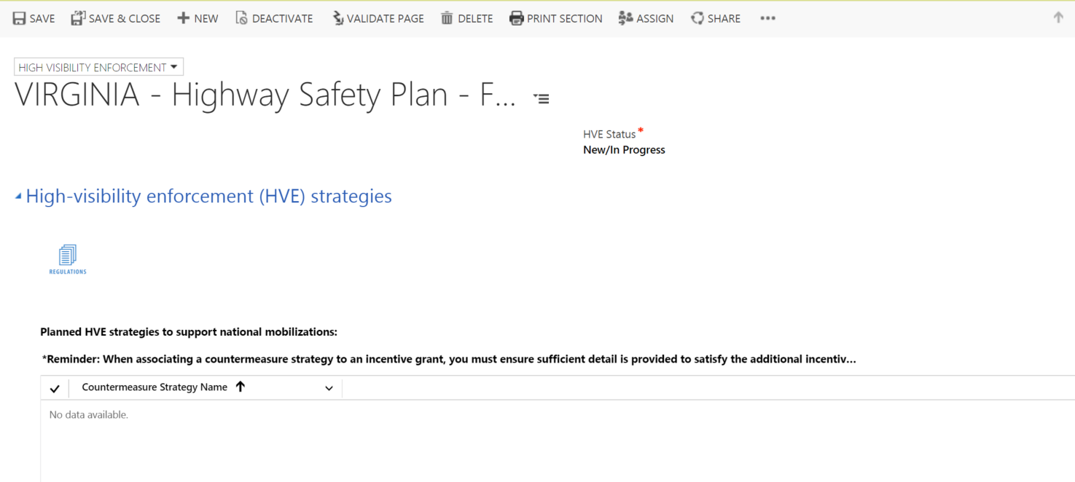

HVE activities (HVE form section)
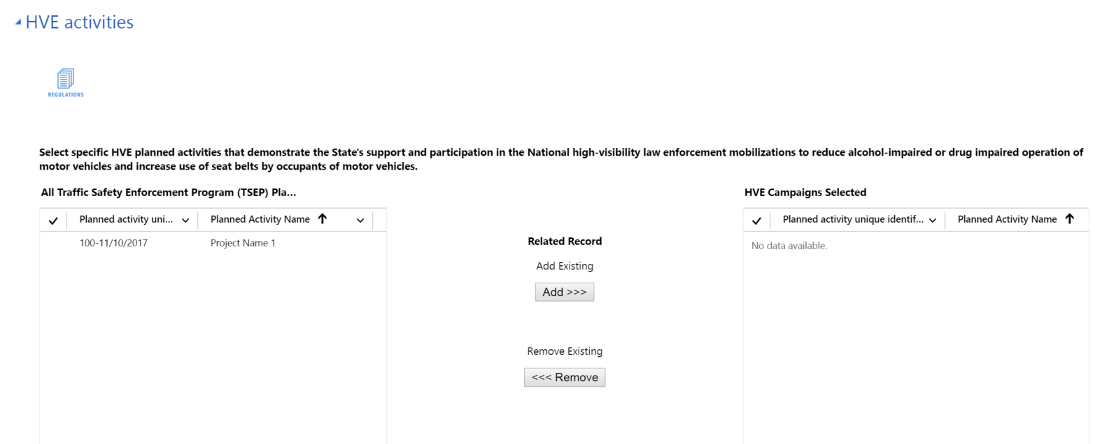

Certifications, Assurances, and Highway Safety Plan PDFs (HVE form section)
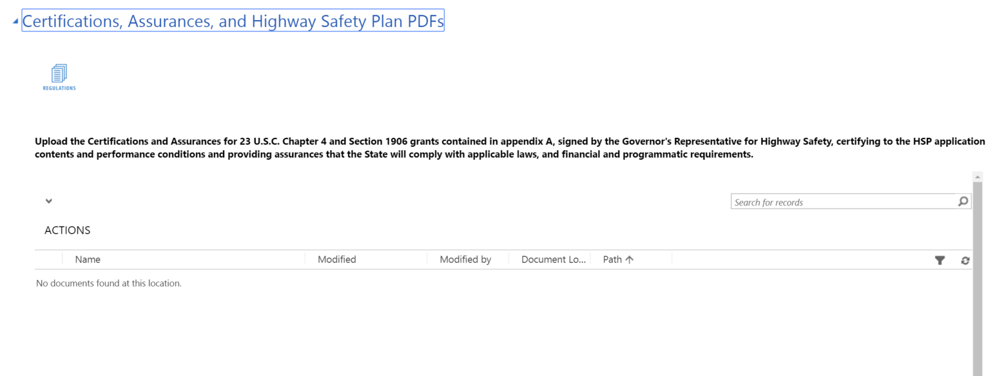

S. 405b Occupant Protection Incentive Grant Contents

High seat belt use rate State (included in low seat belt use rate State as well)

Occupant protection information (405b section)
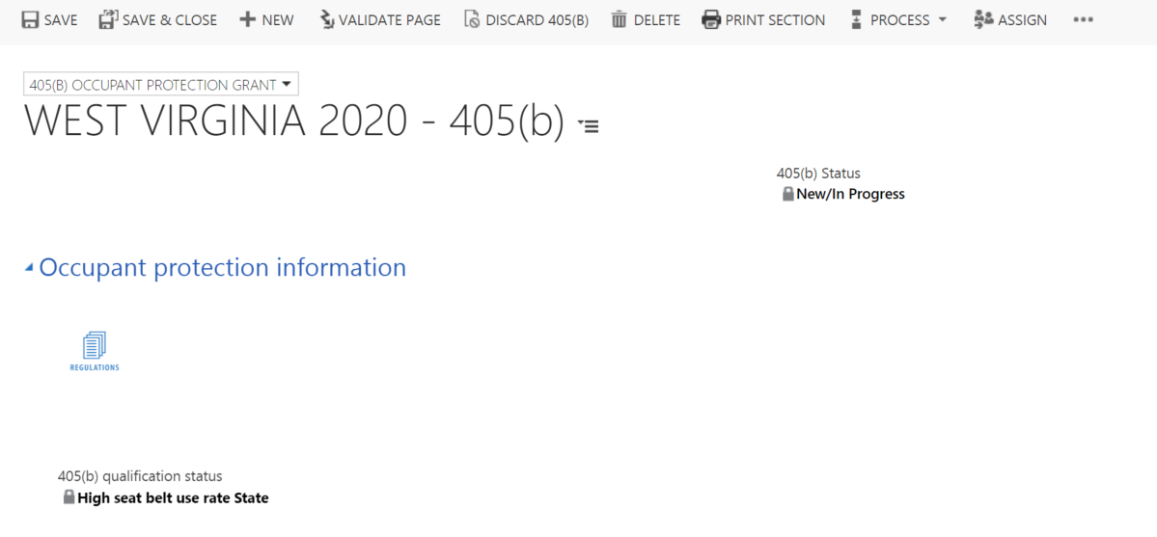

Occupant protection plan (405b section)
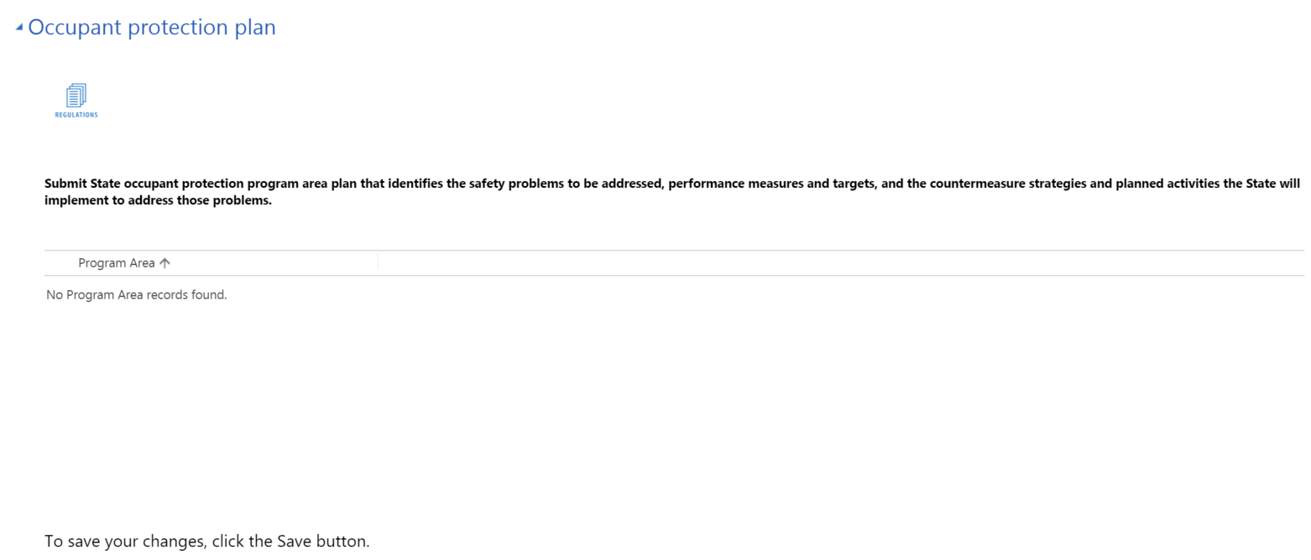

Participation in Click-it-or-Ticket (CIOT) national mobilization (405b section)
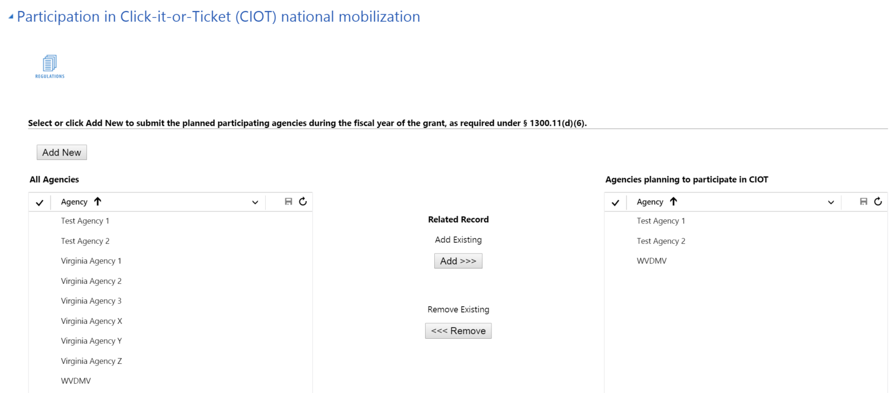

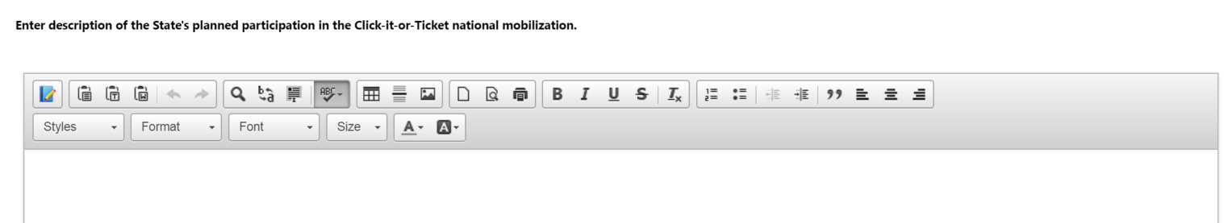

Add New Agency (Quick create form)
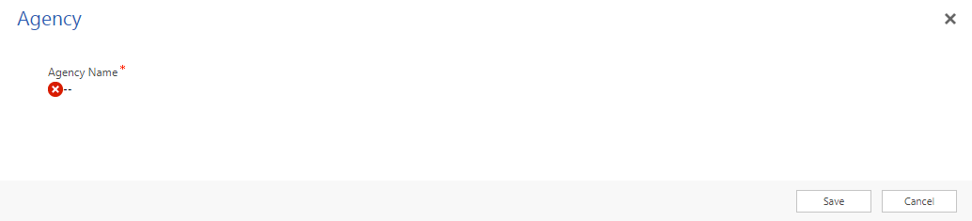

Child restraint inspection stations (405b section)
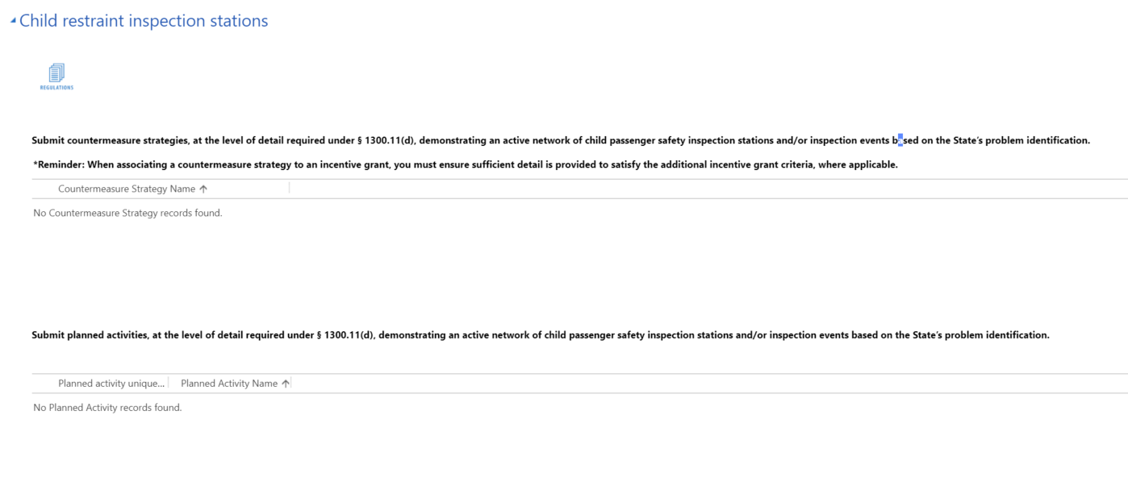
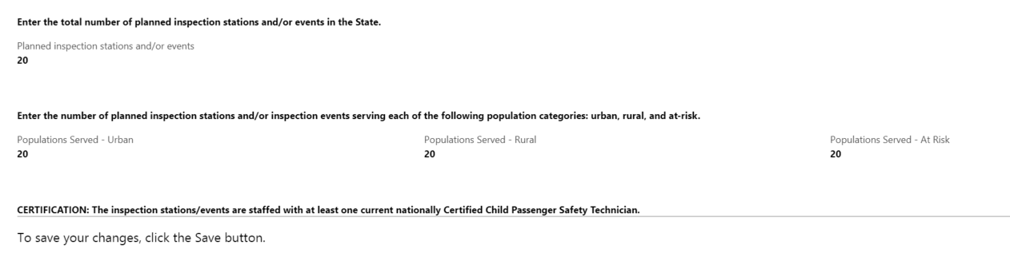

Child passenger safety technician (405b section)
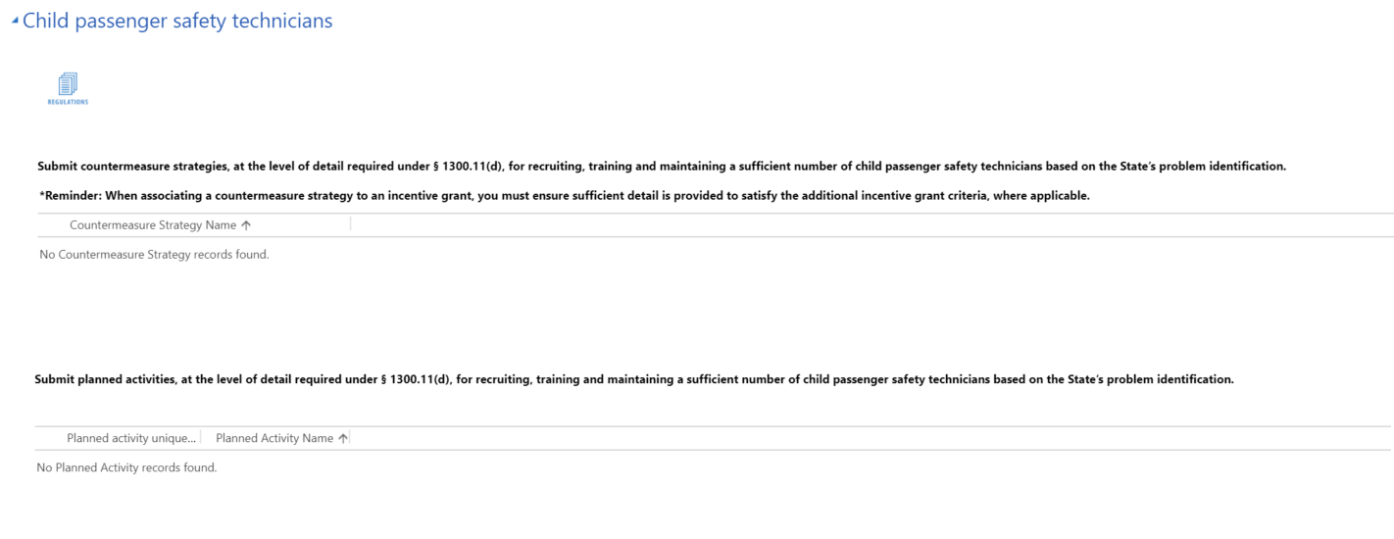
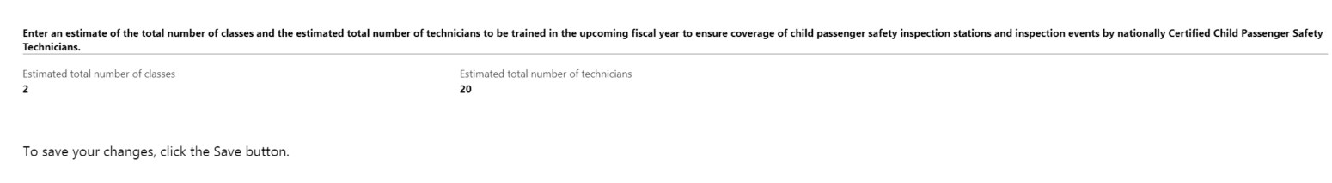

Maintenance of effort
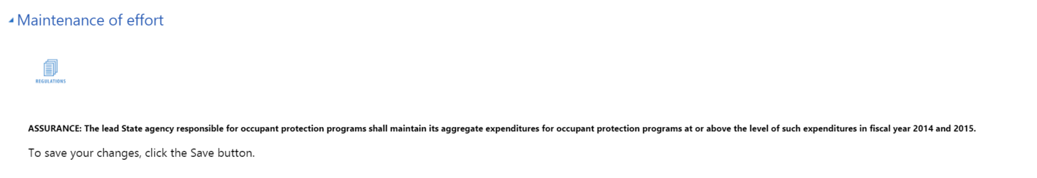

Low seat belt use rate State (additional criteria)

Qualification criteria for a lower seat belt use rate State (405b low section)
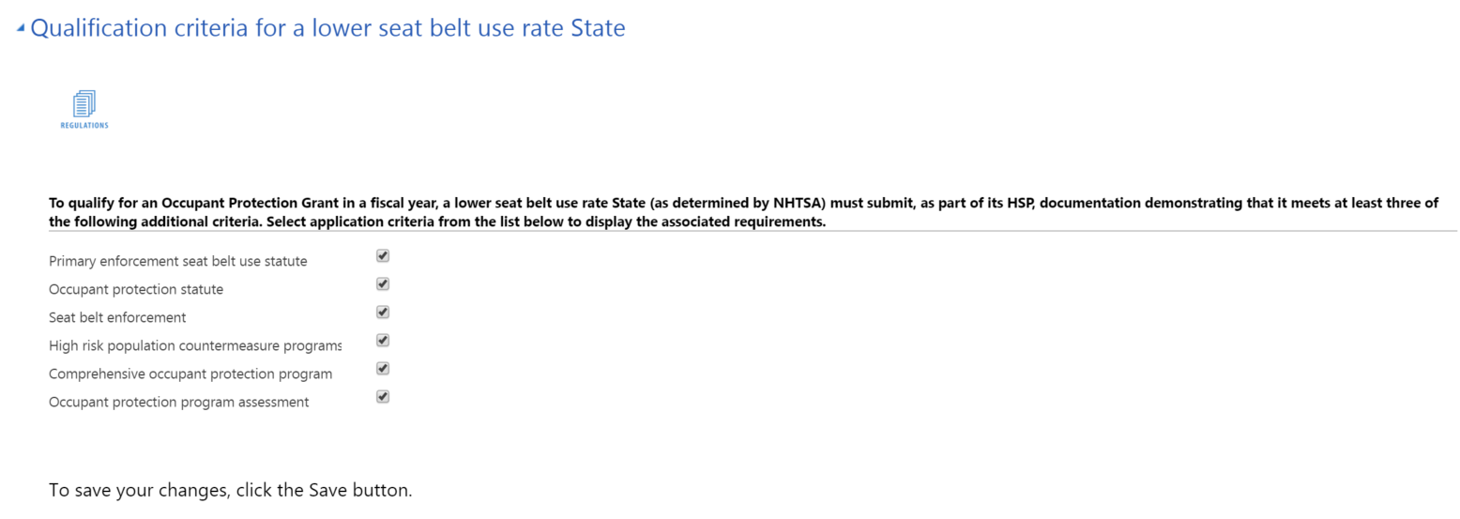

Primary enforcement seat belt use statute (405b low section)
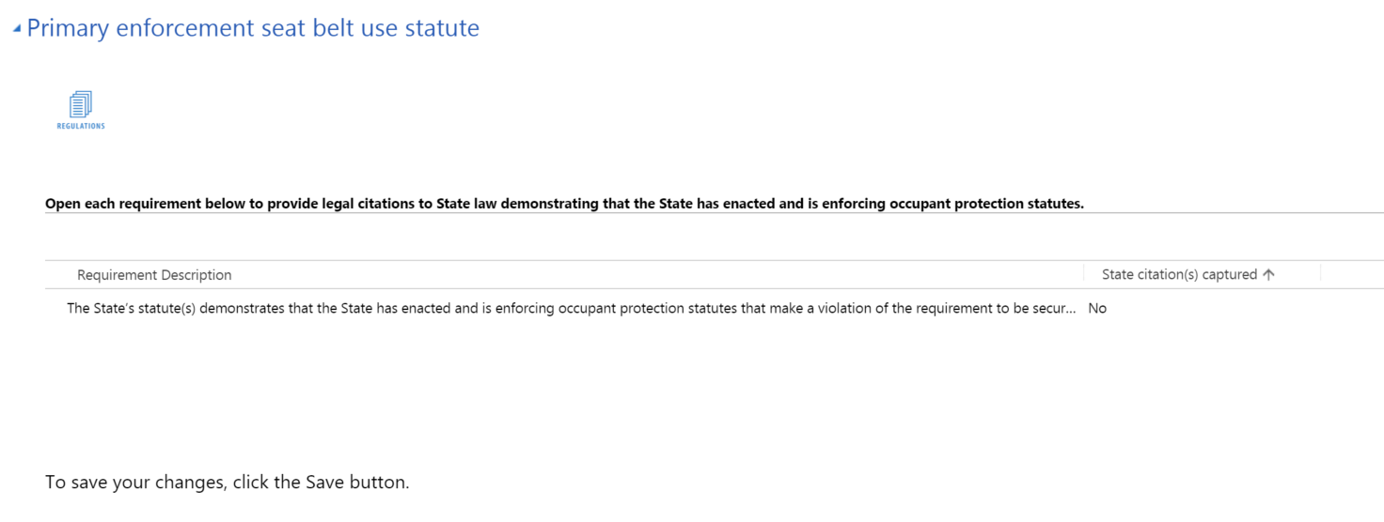

Legal Requirement Description Text
The State’s statute(s) demonstrates that the State has enacted and is enforcing occupant protection statutes that make a violation of the requirement to be secured in a seat belt or child restraint a primary offense.

Address Legal Requirement (Legal Requirement form)
To address a legal requirement with citations, a user must first open a requirement line (by double clicking), which will launch the following form:
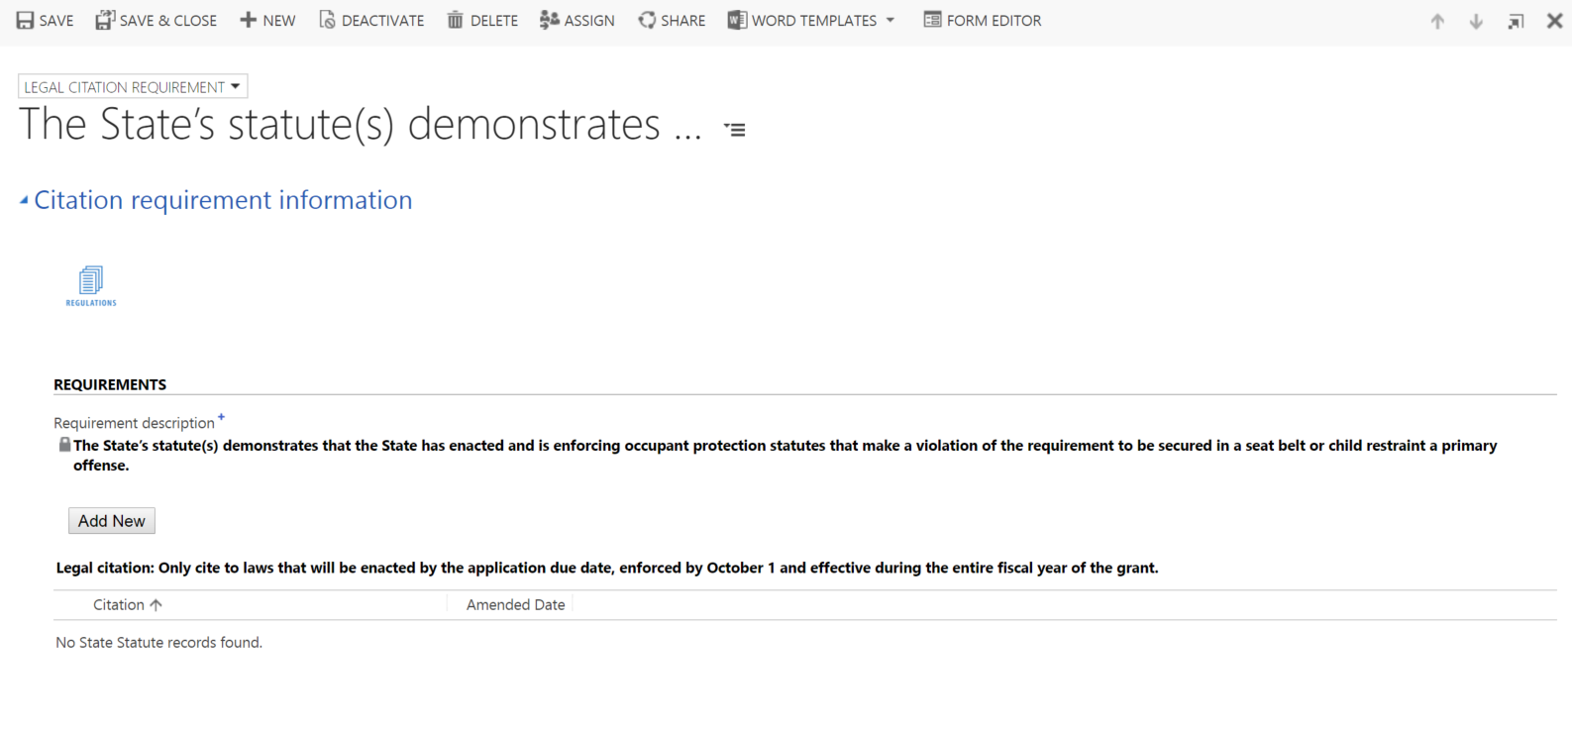

Add New Citation (Quick create form)
On the legal requirement form, users will click the Add New button to add as many citations as necessary to meet the requirement. They will complete this for each requirement listed.
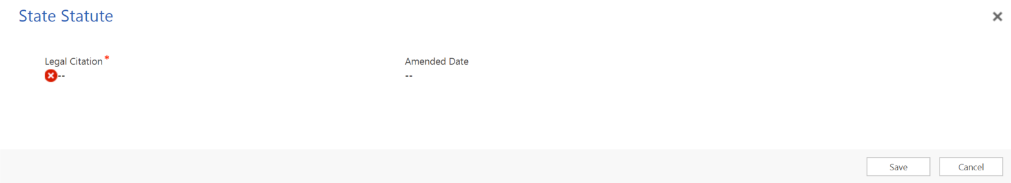

Occupant protection statute (405b low section)
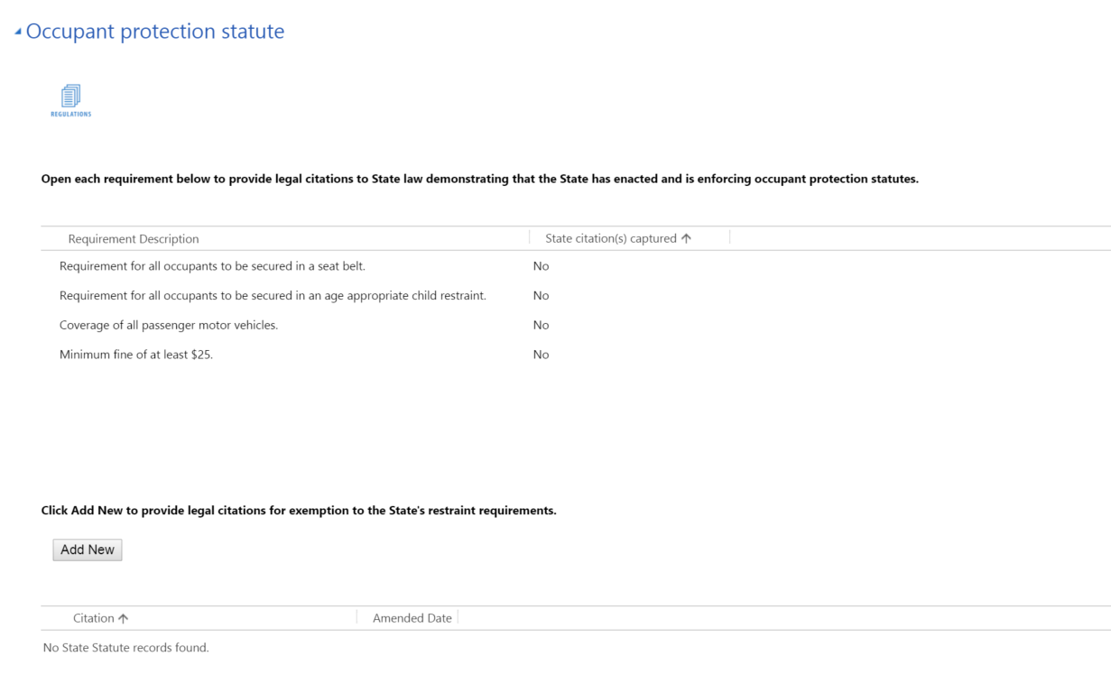

Legal Requirement Description Text
Coverage of all passenger motor vehicles.
Minimum fine of at least $25.
Requirement for all occupants to be secured in a seat belt or age appropriate child restraint.

Address Legal Requirement (Legal Requirement form)
To address a legal requirement with citations, a user must first open a requirement line (by double clicking), which will launch the following form:

Add New Citation (Quick create form)
On the legal requirement form, users will click the Add New button to add as many citations as necessary to meet the requirement. They will complete this for each requirement listed.

Note for the exemption area, when users click Add New to capture a new exemption, this quick create form will also be displayed.

Seat belt enforcement (405b low section)
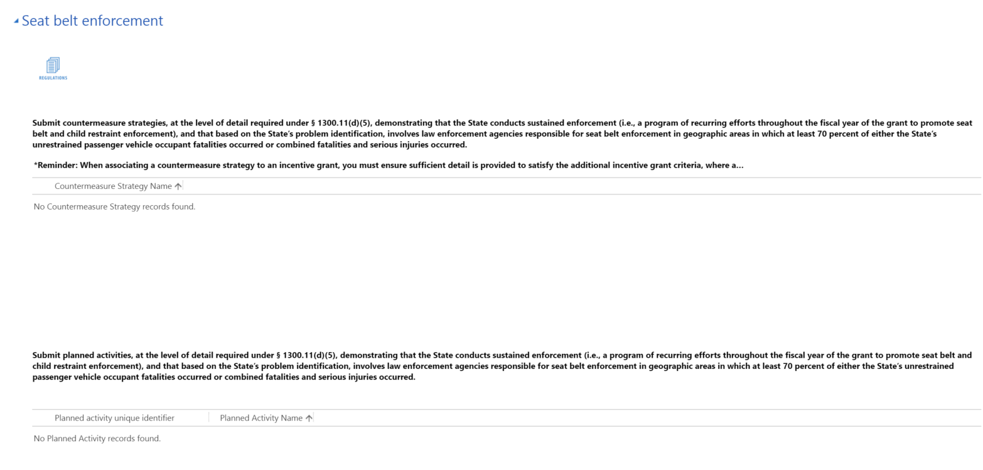

High risk population countermeasure programs (405b low section)
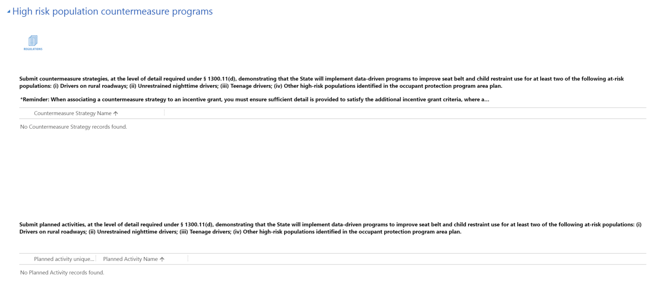

Comprehensive occupant protection program (405b low section)
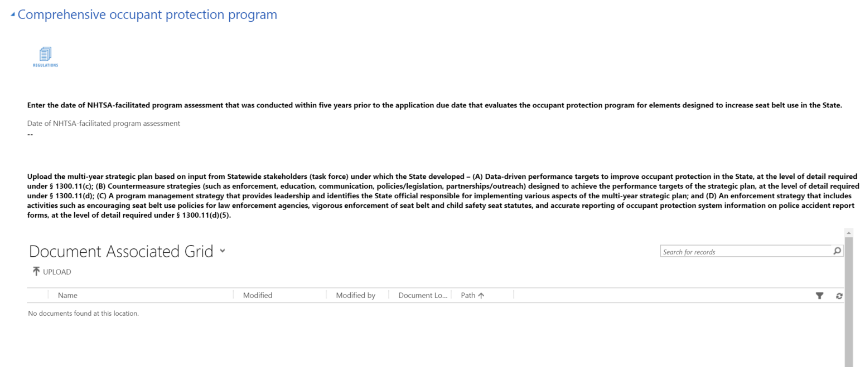
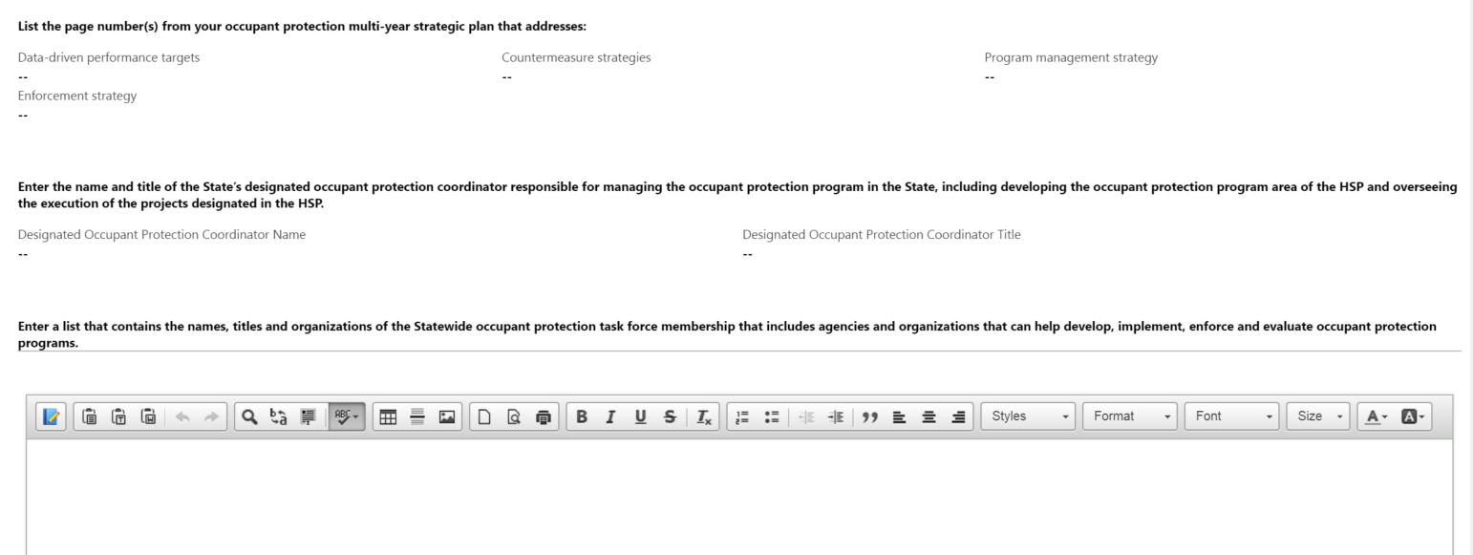
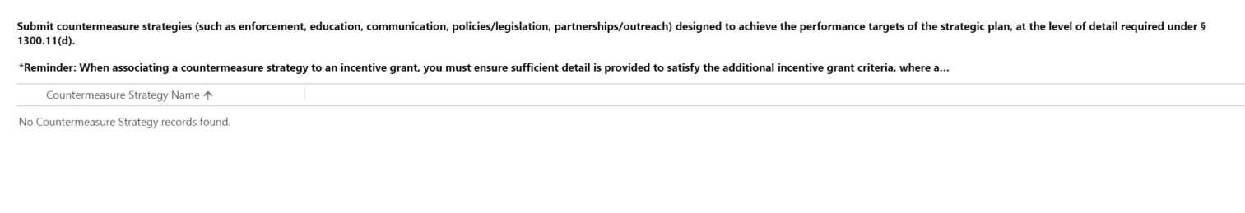

Occupant protection program assessment (405b low section)
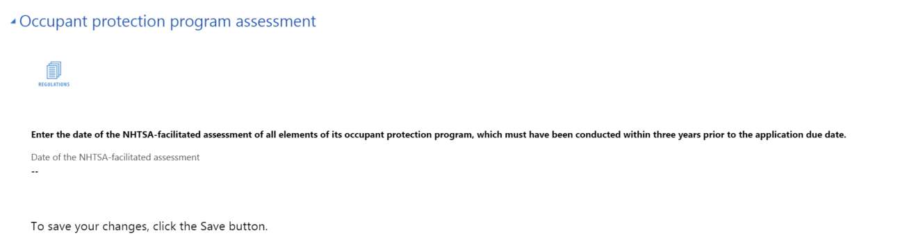

S. 405c Traffic Record System Improvement Incentive Grant Contents

Traffic records coordinating committee (TRCC) (405c section)
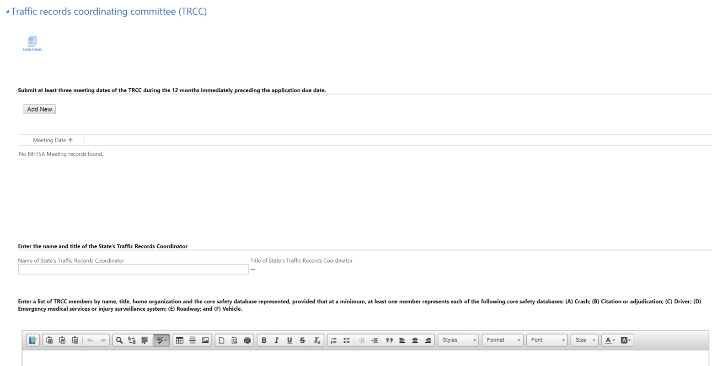

Add New Meeting Date (Quick create form)
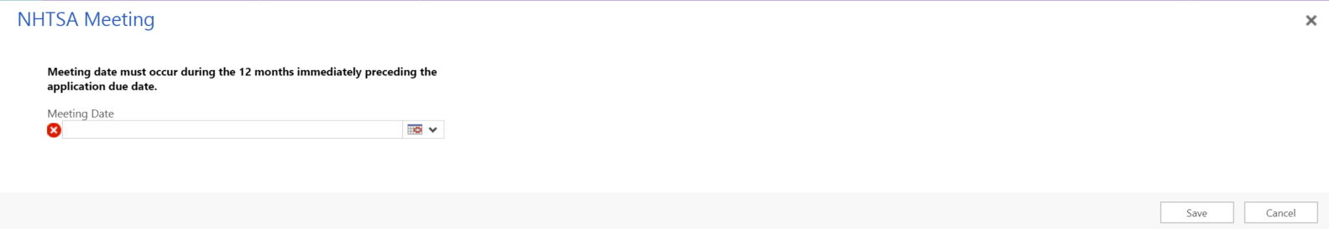

State traffic records strategic plan (405c section)
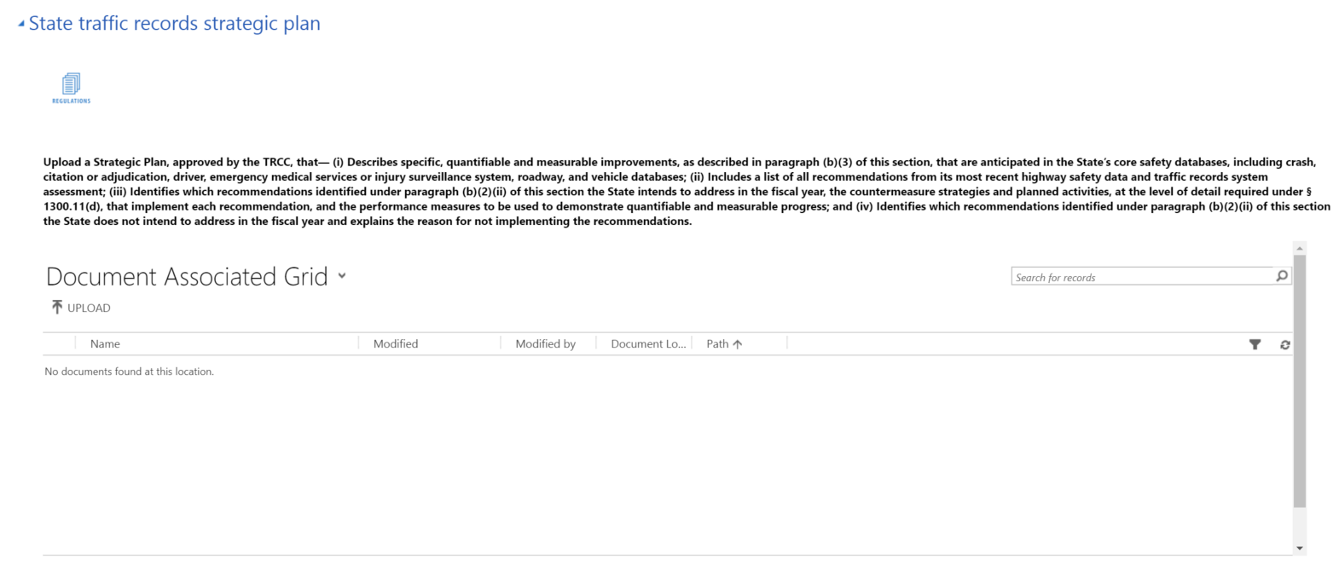
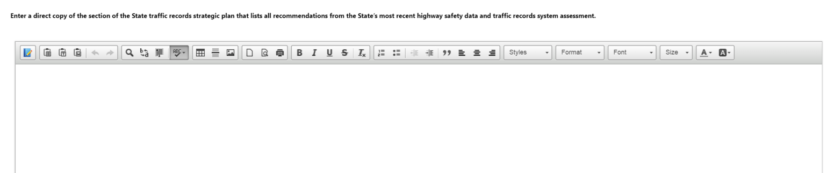

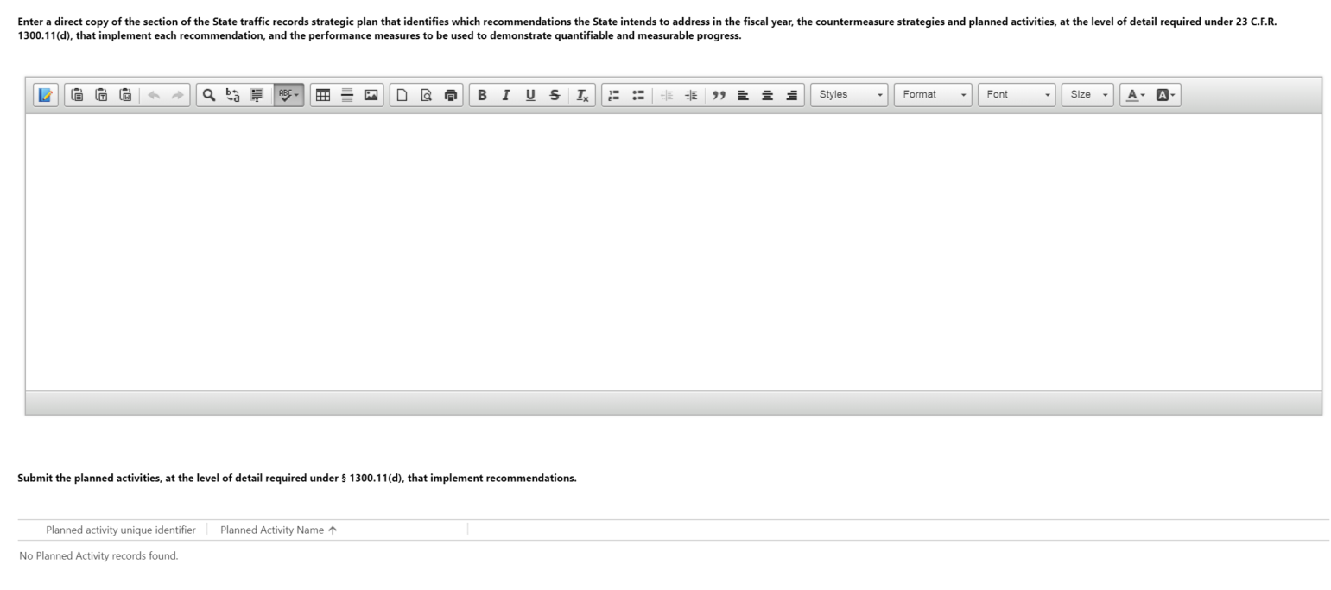
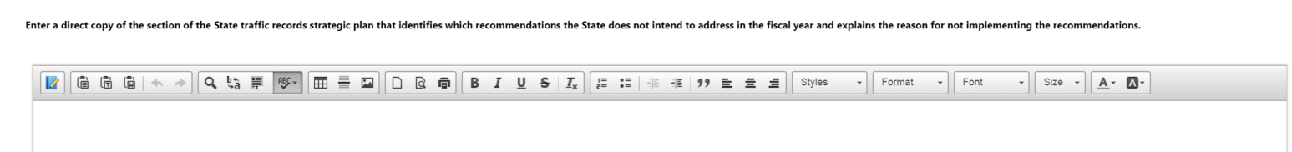

Quantitative improvement (405c section)
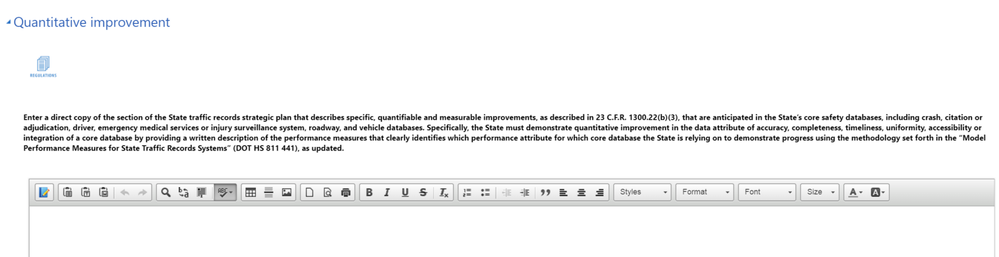
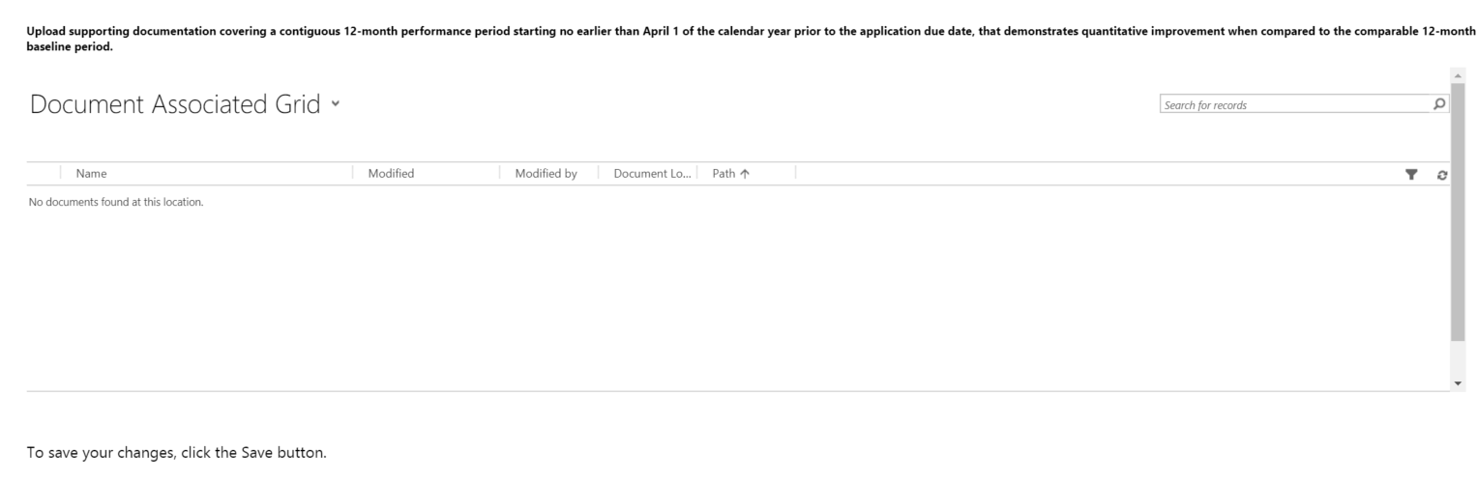

State highway safety data and traffic records system assessment (405c section)
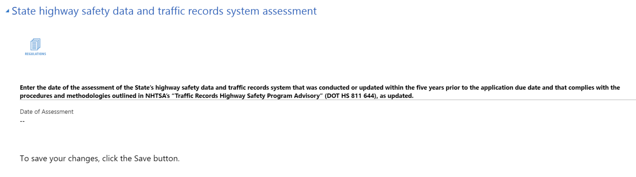

Requirement for maintenance of effort (405c section)
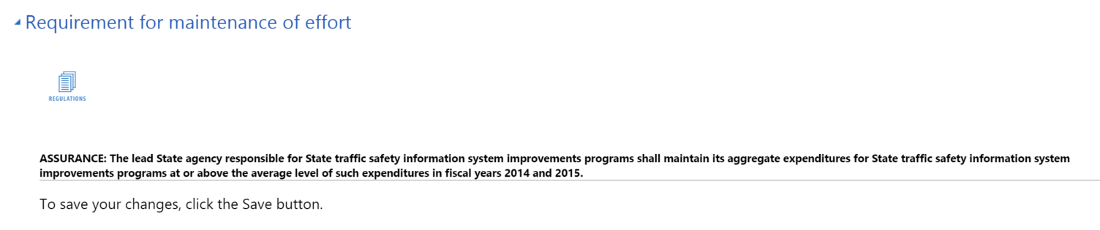

S. 405d Impaired Driving Incentive Grant Contents

405(d) Impaired driving countermeasures grant

Low-Range State

Impaired driving assurances (405d Impaired-low section)
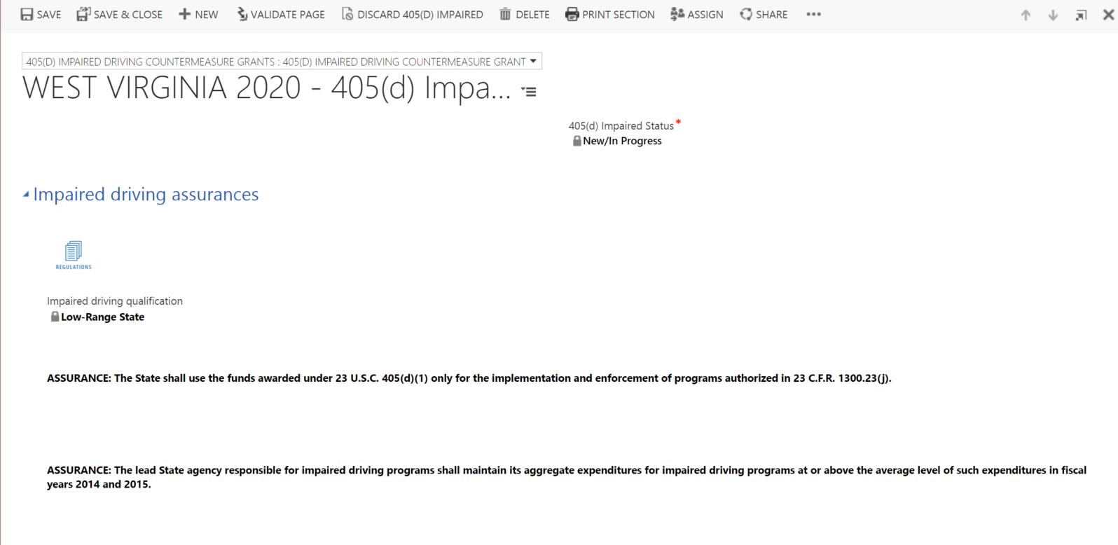

Mid-Range State

Impaired driving assurances (405d Impaired-mid section)
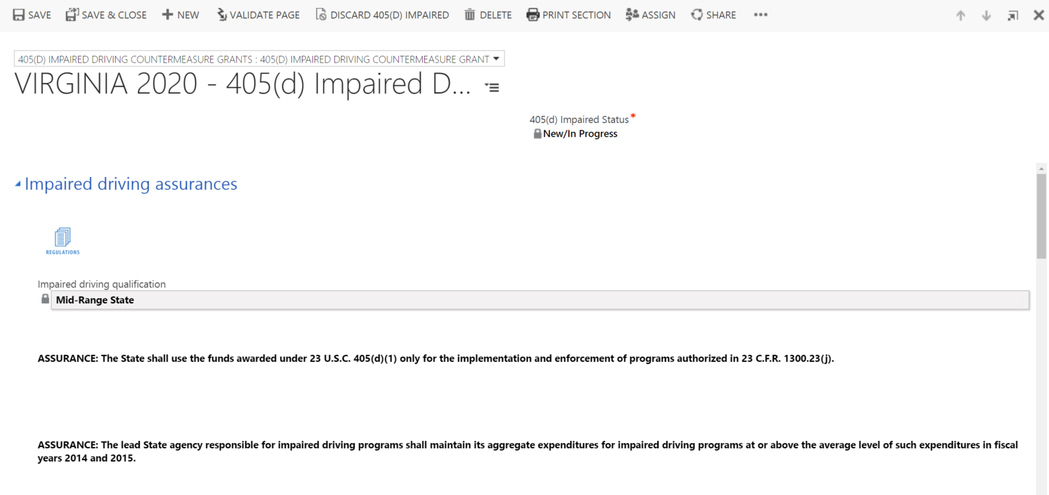

Authority to operate (405d Impaired-mid section)
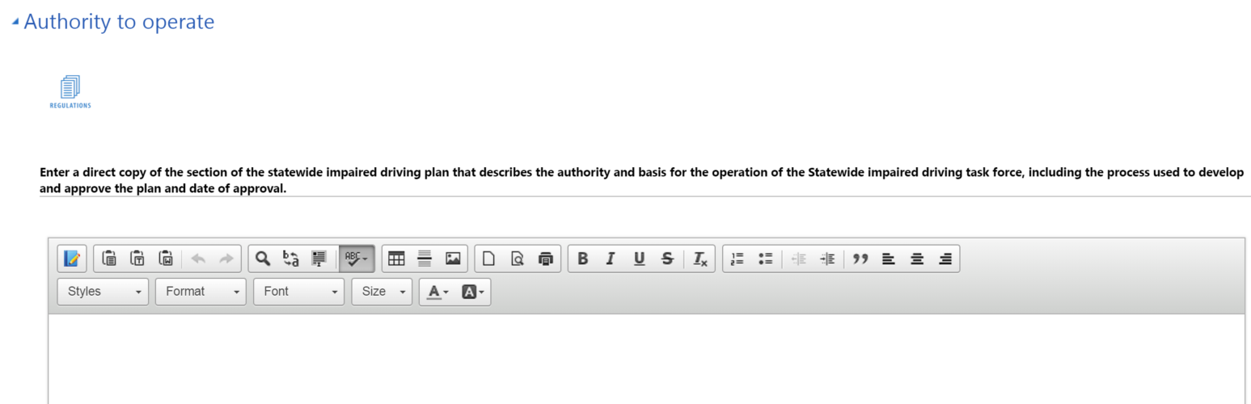
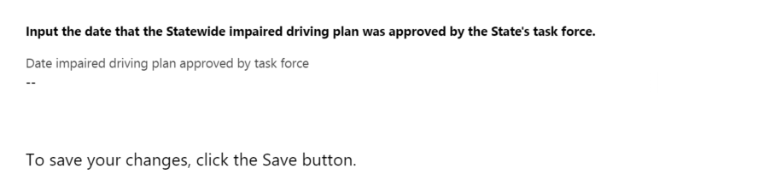

Task force member information (405d Impaired-mid section)
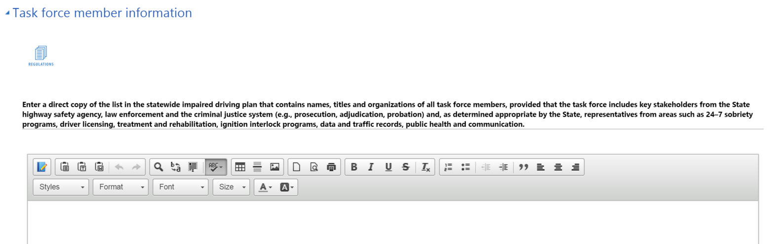

Strategic plan details (405d Impaired-mid section)
If “Continue to use previously submitted plan” = Yes, the following is displayed:
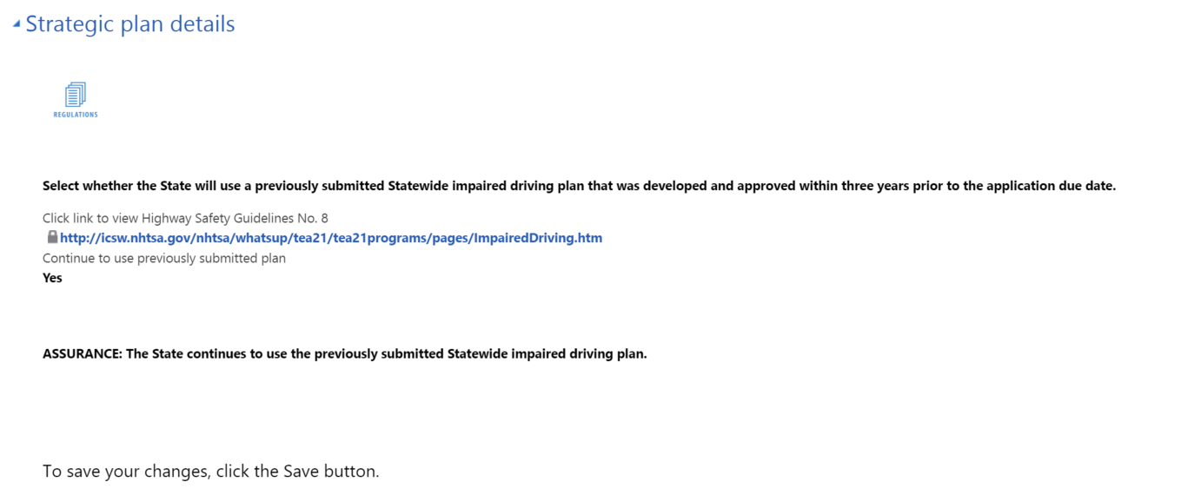

If “Continue to use previously submitted plan” = No, the following is displayed:
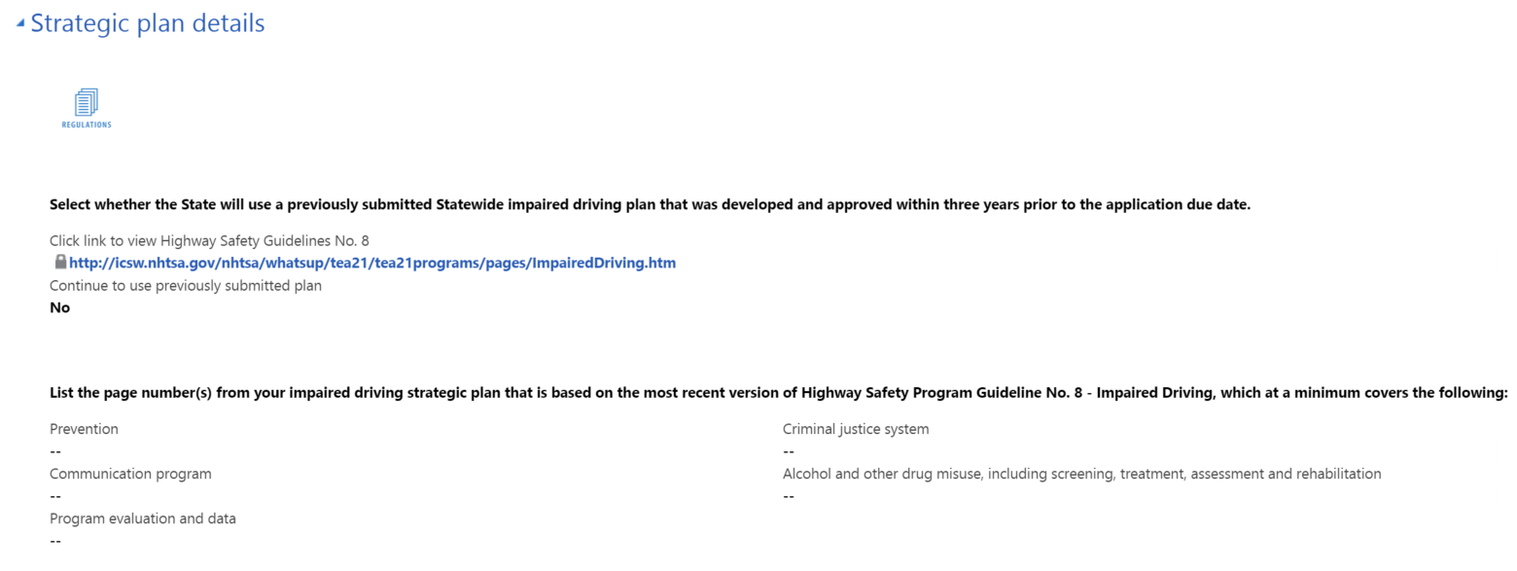
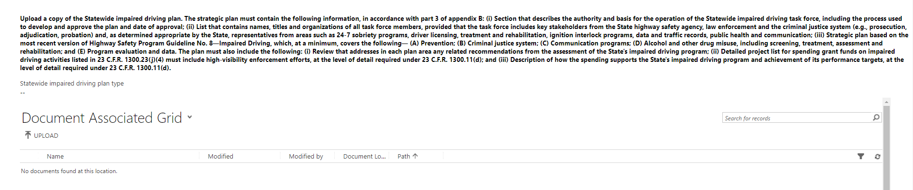

High-Range State

Impaired driving assurances (405d Impaired-high section)
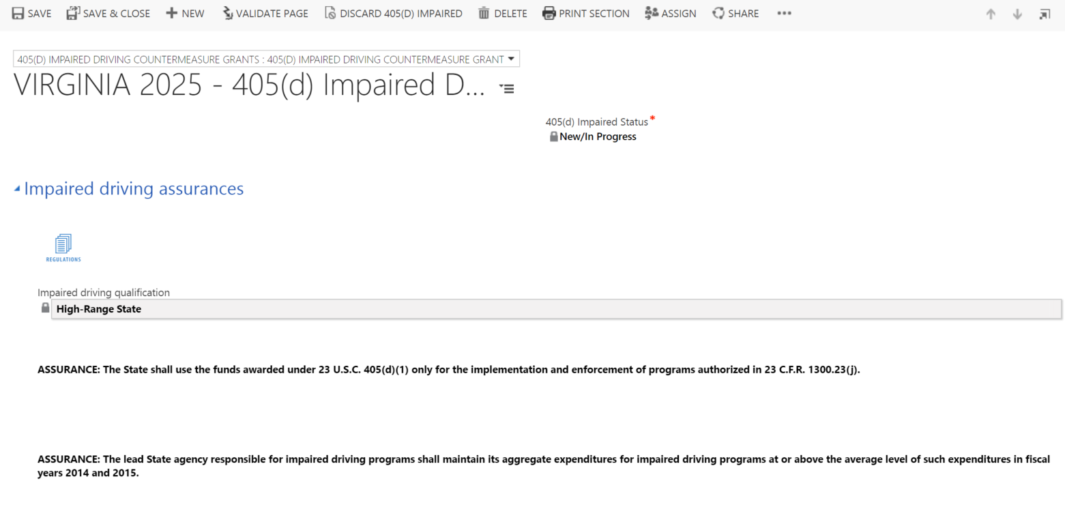

Impaired driving program assessment (405d Impaired-high section)
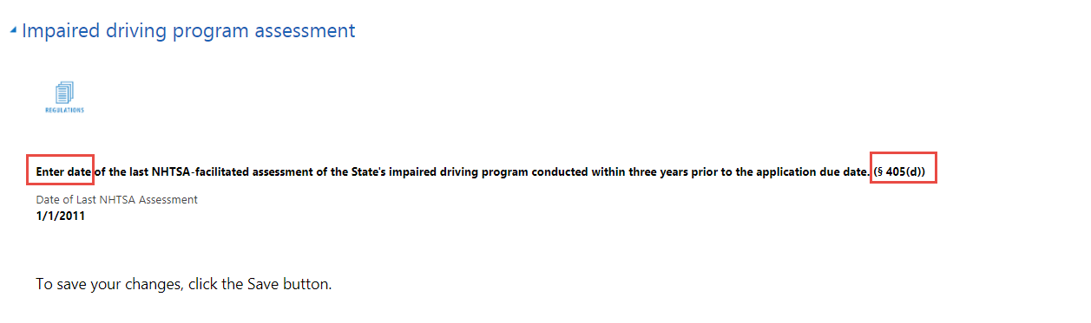

Authority to operate (405d Impaired-high section)
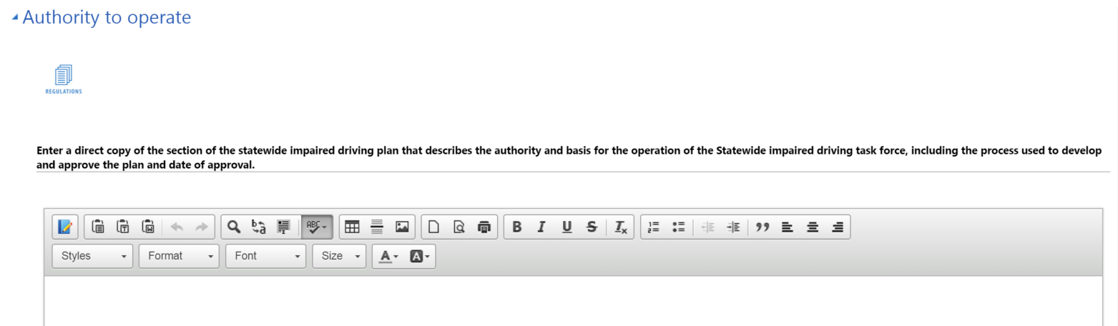
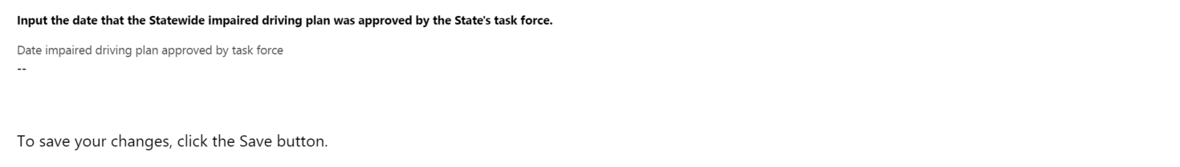

Task force member information (405d Impaired-high section)

Strategic plan details (405d Impaired-high section)
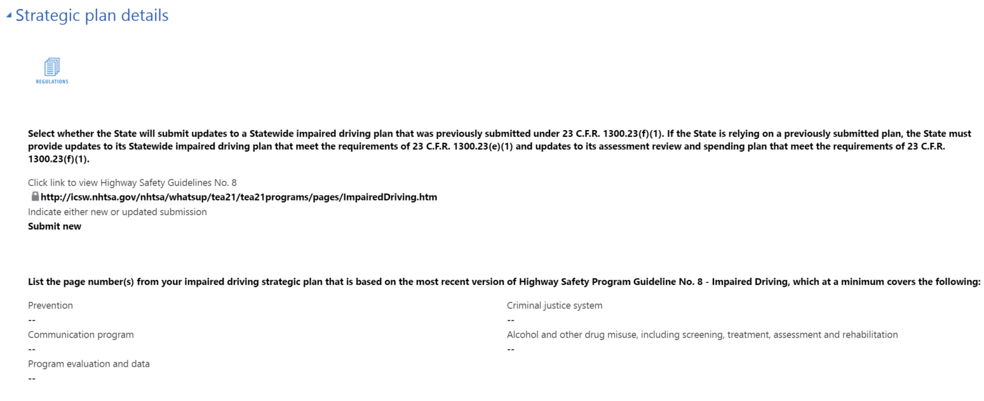
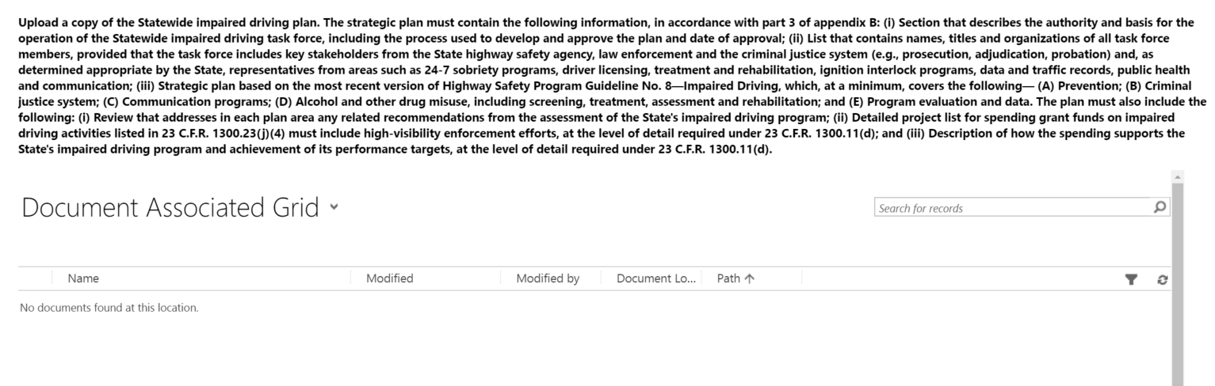

Assessment recommendations (405d Impaired-high section)
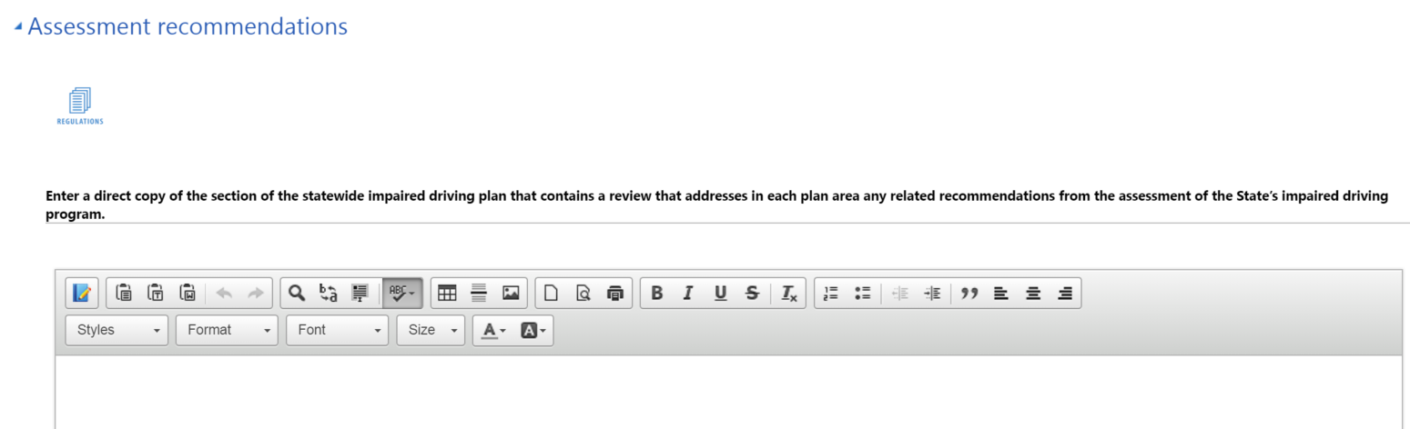

Planned activities (405d Impaired-high section)
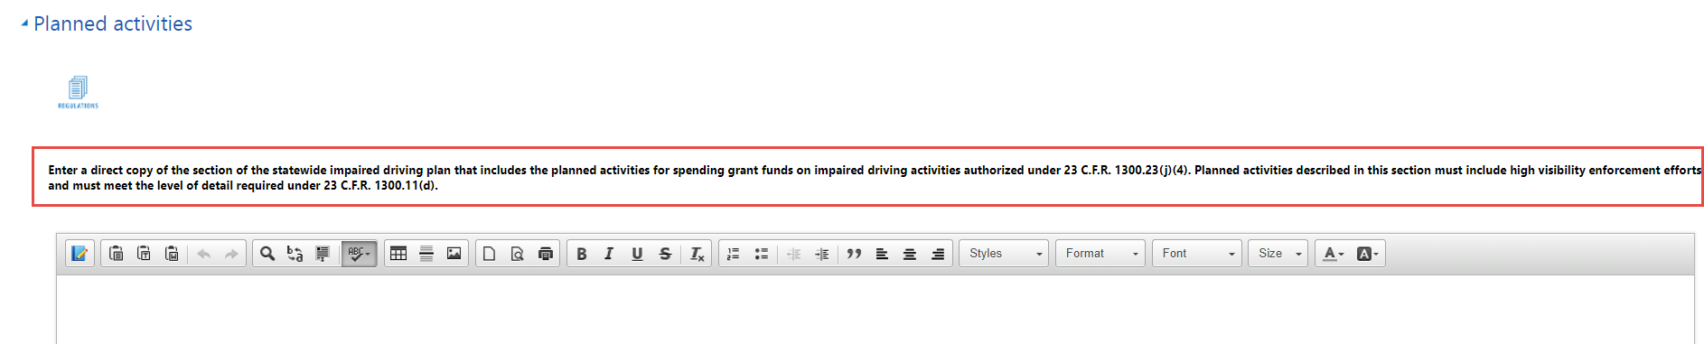

Planned activity support (405d Impaired-high section)
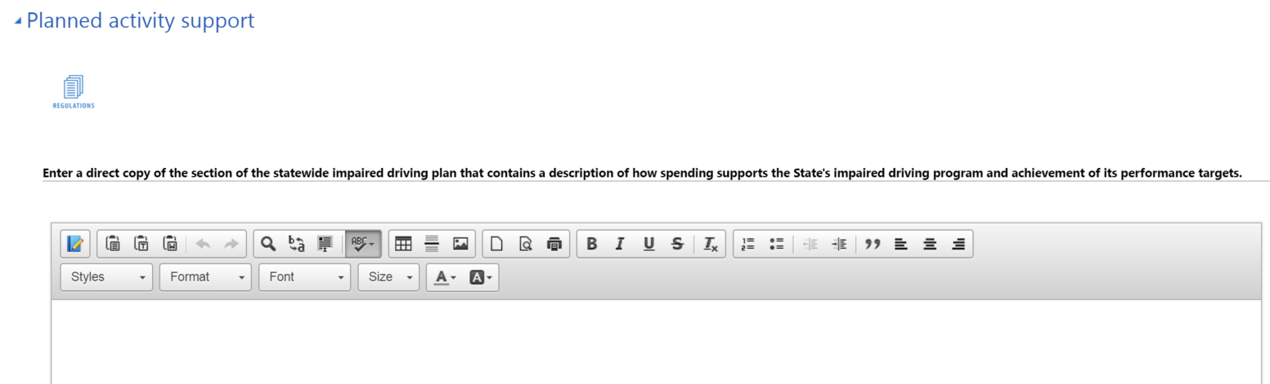

405(d) Alcohol-ignition interlock law grant

Alcohol-ignition interlock laws (405d Alcohol-ignition section)
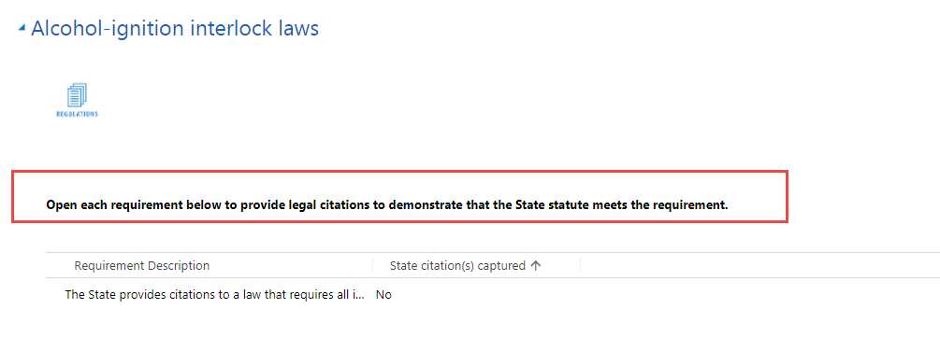

Legal Requirement Description Text
The State has enacted and is enforcing a law that requires all individuals convicted of driving under the influence or of driving while intoxicated to drive only motor vehicles with alcohol-ignition interlocks for an authorized period of not less than 6 months.

Address Legal Requirement (Legal Requirement form)
To address a legal requirement with citations, a user must first open a requirement line (by double clicking), which will launch the following form:

Add New Citation (Quick create form)
On the legal requirement form, users will click the Add New button to add as many citations as necessary to meet the requirement. They will complete this for each requirement listed.

405(d) 24-7 Sobriety programs grant

Mandatory license restriction requirement (405d 24-7 section)
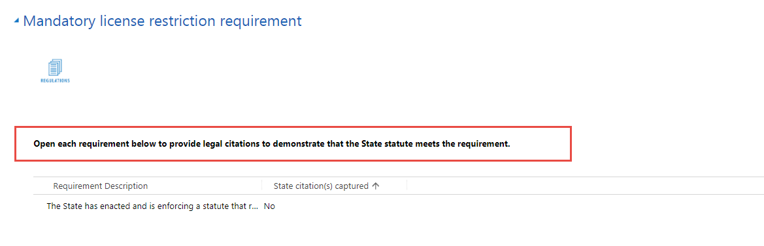

Legal Requirement Description Text
The State has enacted and is enforcing a statute that requires all individuals convicted of driving under the influence of alcohol or of driving while intoxicated to receive a restriction on driving privileges for a period of not less than 30 days.

Address Legal Requirement (Legal Requirement form)
To address a legal requirement with citations, a user must first open a requirement line (by double clicking), which will launch the following form:

Add New Citation (Quick create form)
On the legal requirement form, users will click the Add New button to add as many citations as necessary to meet the requirement. They will complete this for each requirement listed.

24/7 Sobriety program information (405d 24-7 section)
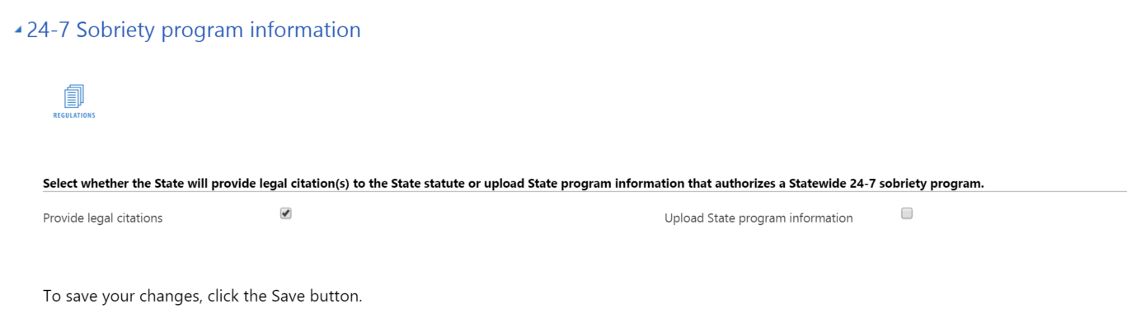

Provide legal citations (405d 24-7 section)
Only displayed if Provide legal citations is checked.
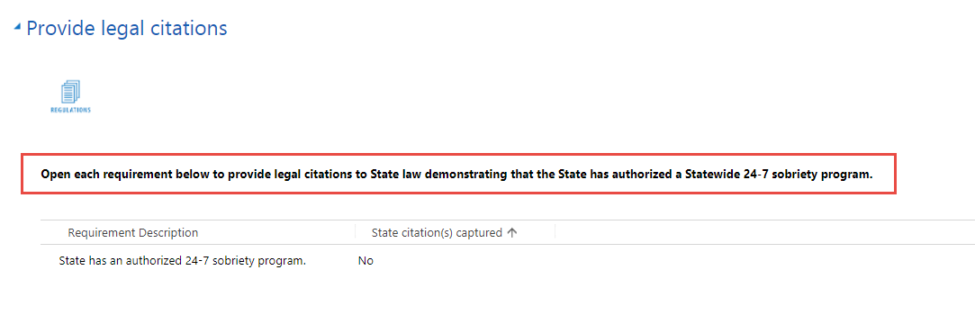

Legal Requirement Description Text
State law authorizes a Statewide 24-7 sobriety program.

Address Legal Requirement (Legal Requirement form)
To address a legal requirement with citations, a user must first open a requirement line (by double clicking), which will launch the following form:

Add New Citation (Quick create form)
On the legal requirement form, users will click the Add New button to add as many citations as necessary to meet the requirement. They will complete this for each requirement listed.

Upload program information (405d 24-7 section)
Only displayed if Upload State program information is checked.
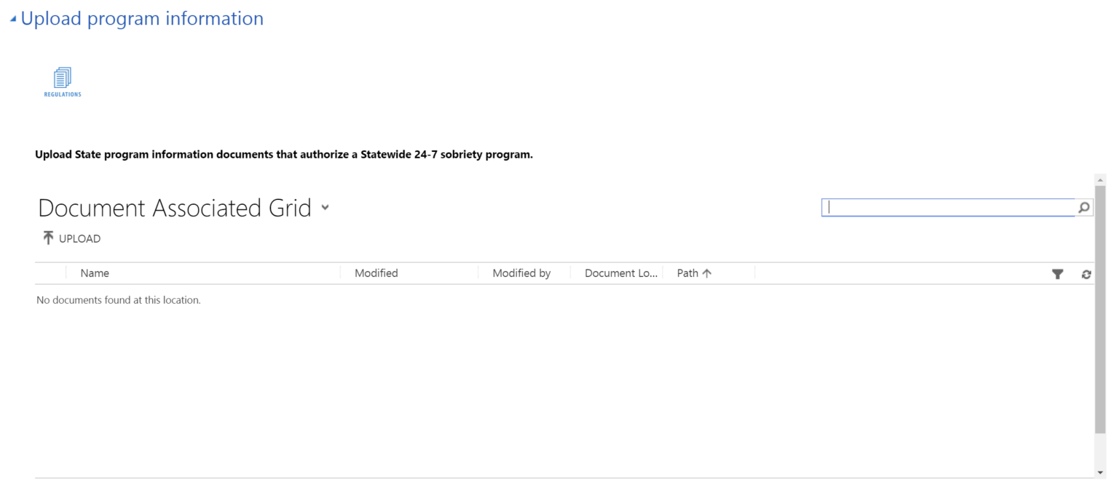

S. 405e Distracted Driving Incentive Grant Contents

Driver’s license exam questions (405e section)
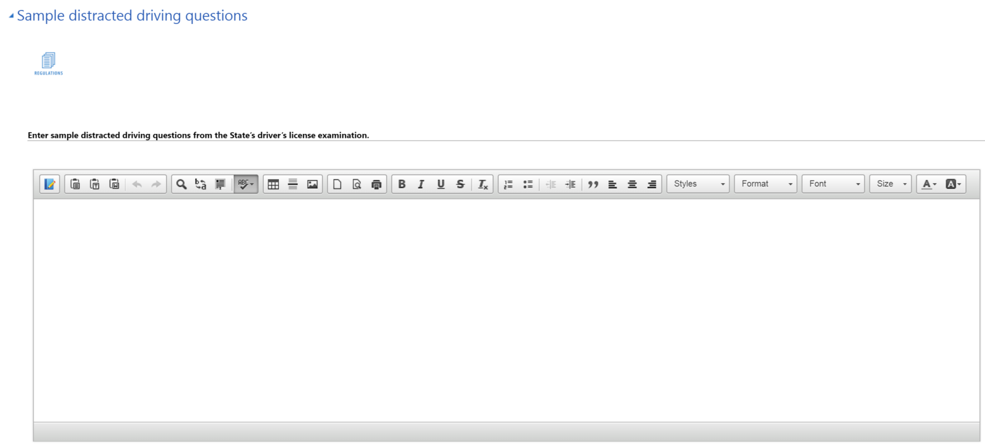

Legal citations (405e section)
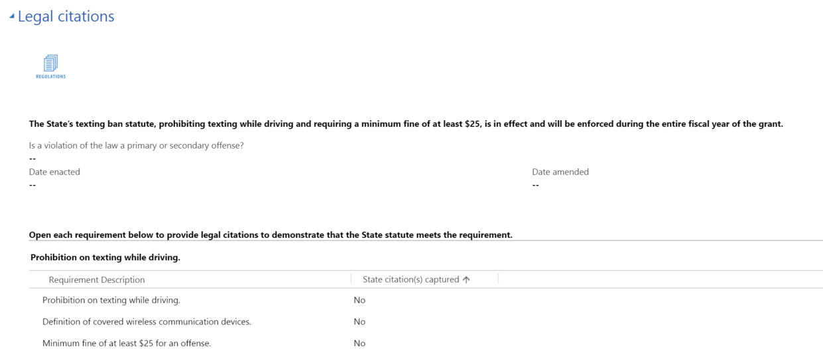
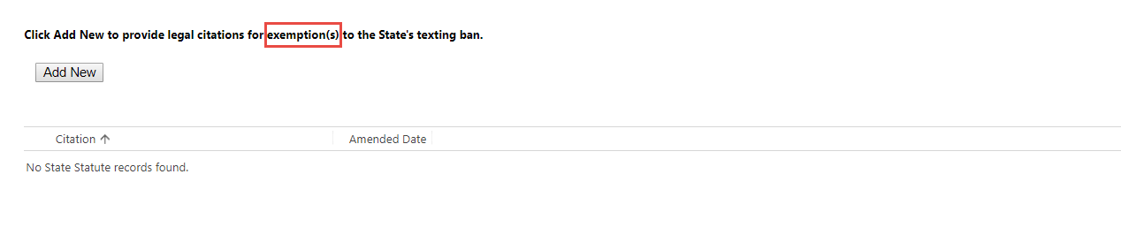
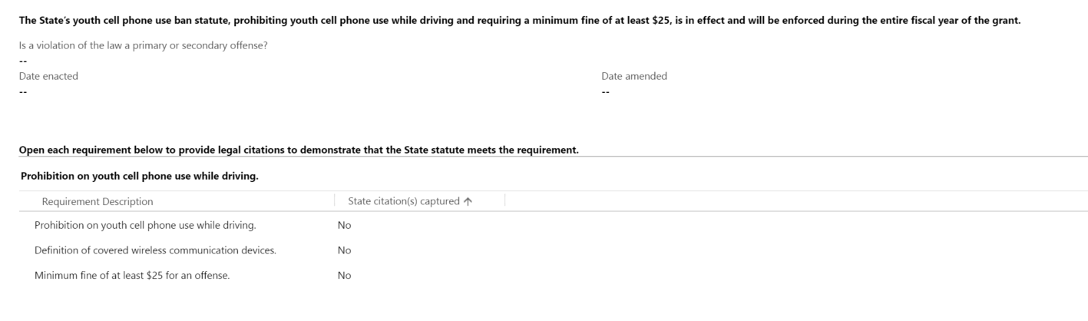
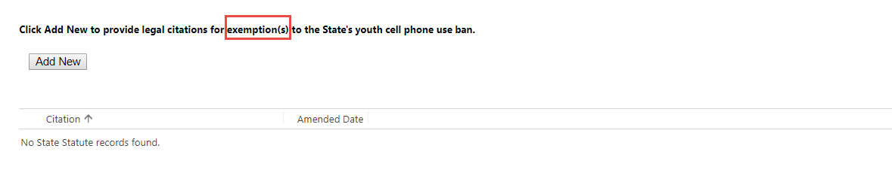

Legal Requirement Description Text
Definition of covered wireless communication devices. | Prohibition on Texting While Driving
Prohibition on texting while driving. | Prohibition on Texting While Driving
Minimum fine of at least $25 for an offense. | Prohibition on Texting While Driving
Definition of covered wireless communication devices. | Prohibition on Youth Cell Phone Use While Driving
Minimum fine of at least $25 for an offense. | Prohibition on Youth Cell Phone Use While Driving
Prohibition on youth cell phone use while driving. | Prohibition on Youth Cell Phone Use While Driving

Address Legal Requirement (Legal Requirement form)
To address a legal requirement with citations, a user must first open a requirement line (by double clicking), which will launch the following form:

Add New Citation (Quick create form)
On the legal requirement form, users will click the Add New button to add as many citations as necessary to meet the requirement. They will complete this for each requirement listed.

S. 405f Motorcyclist Safety Incentive Grant Contents

Motorcycle safety information (405f section)
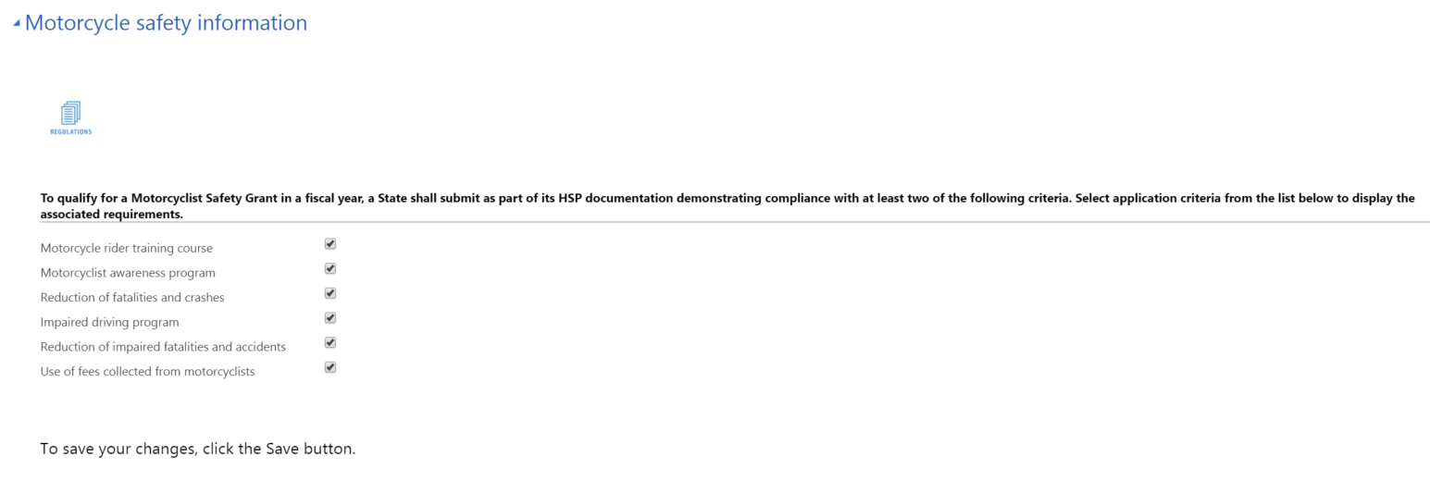

Motorcycle rider training course (405f section)
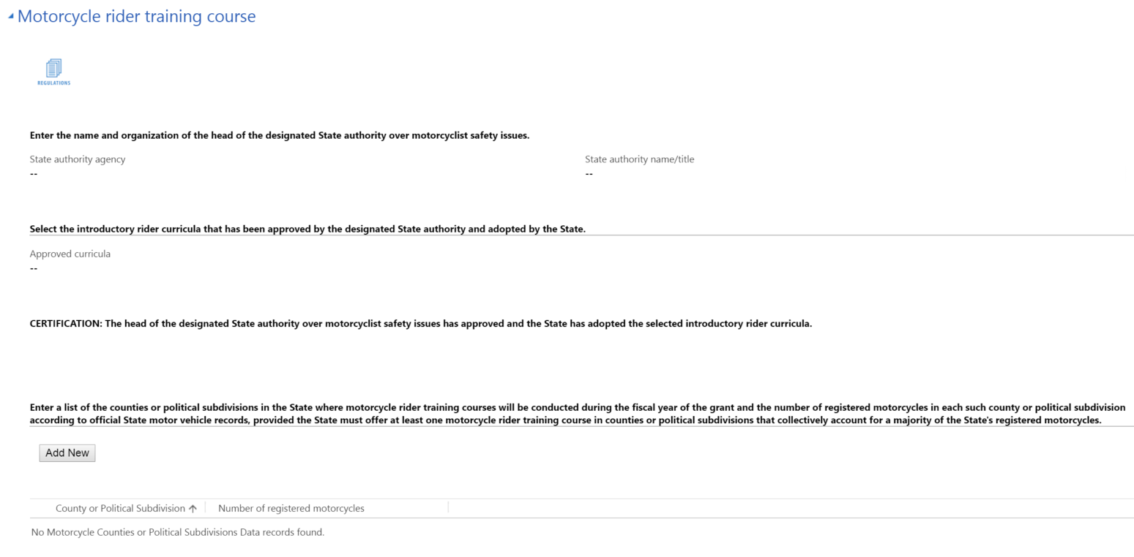
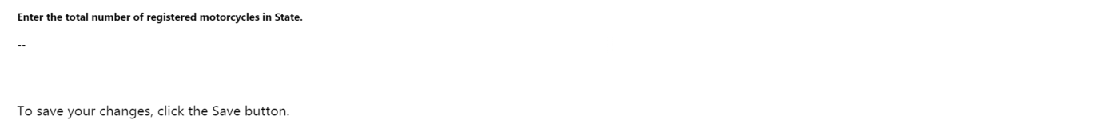

Add New Motorcycle county or political subdivision (Quick create form)
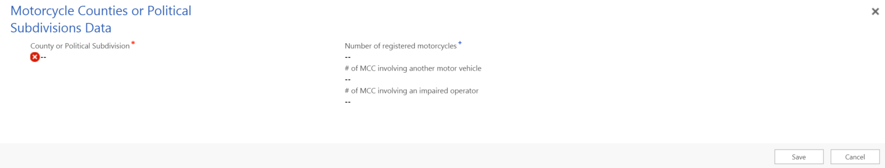

Motorcycle awareness program (405f section)
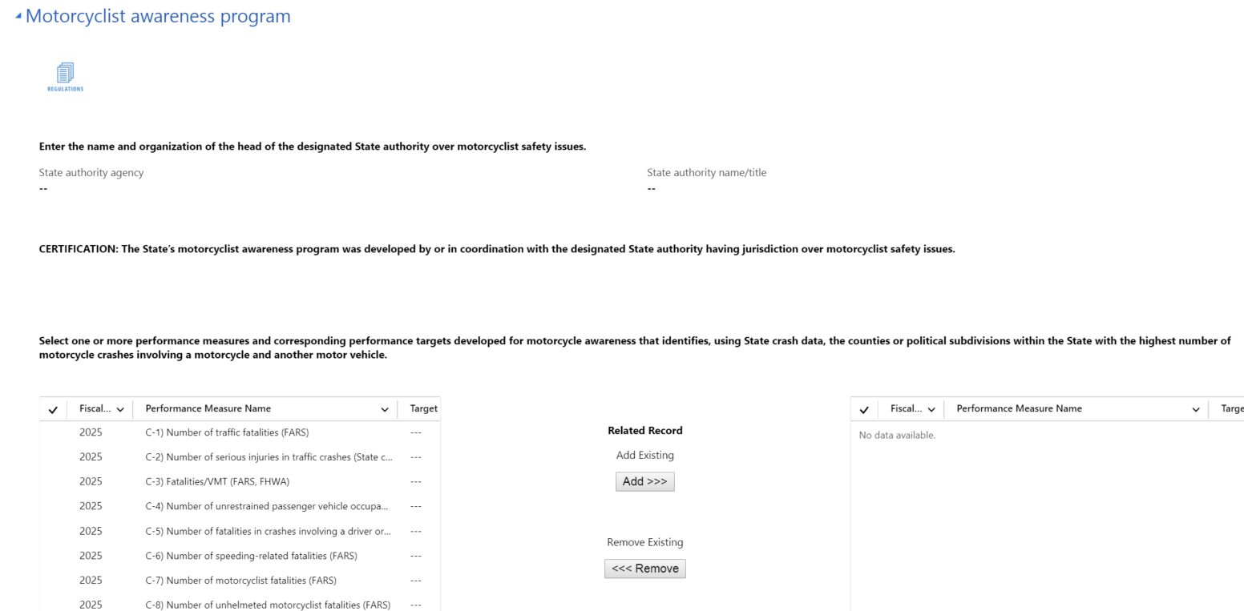
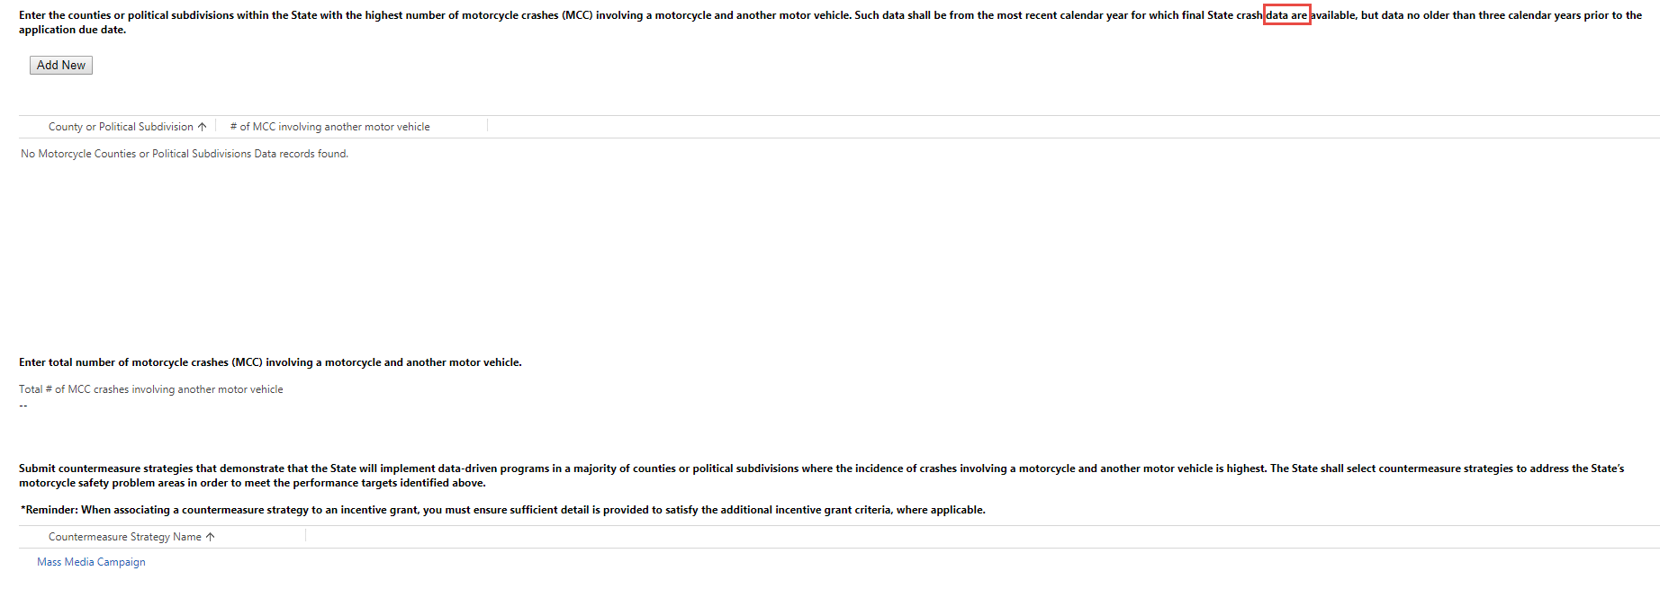
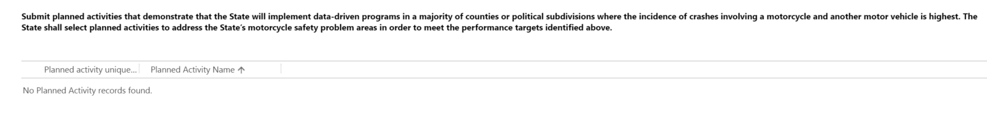

Reduction of fatalities and crashes involving motorcycles (405f section)
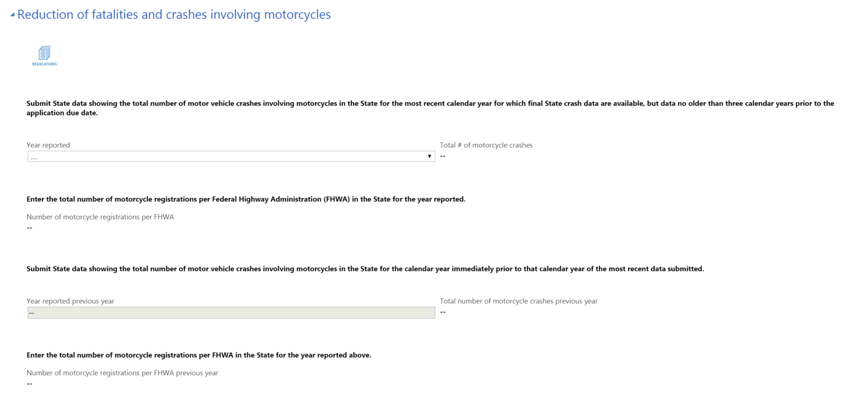
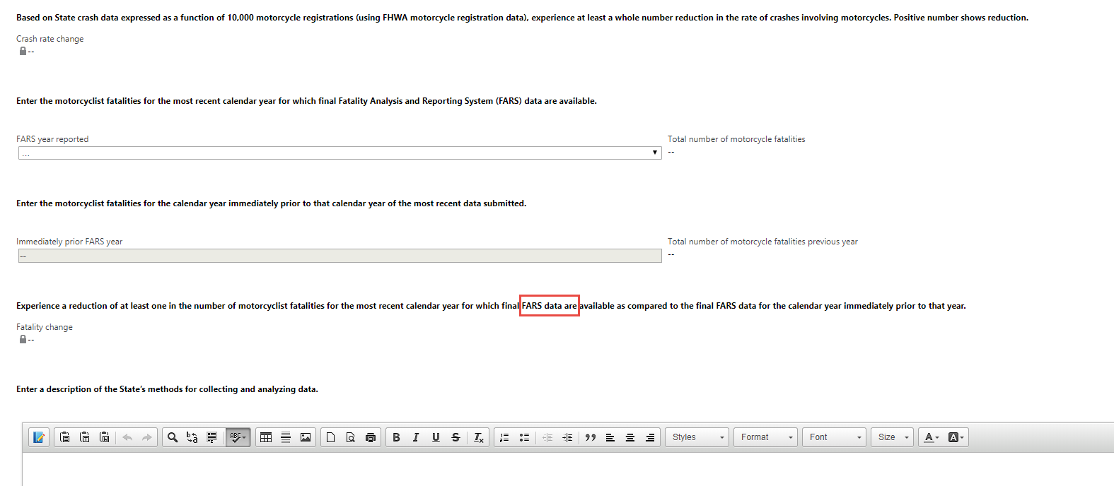

Impaired driving program (405f section)
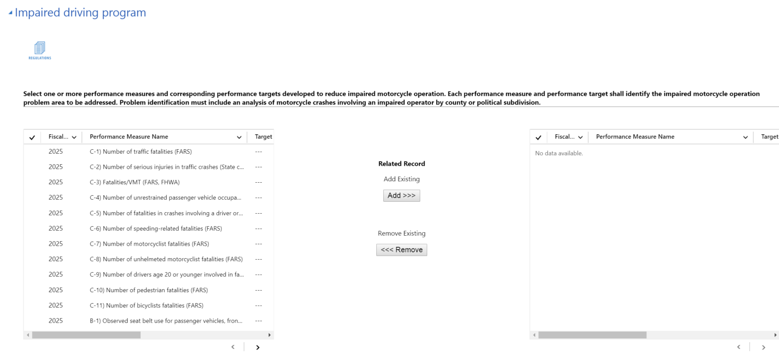

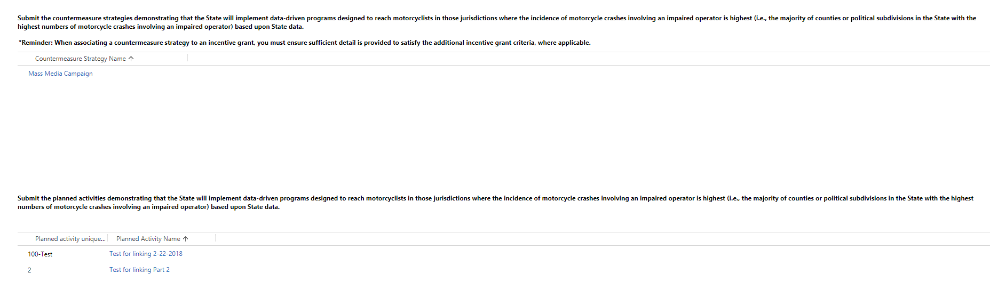
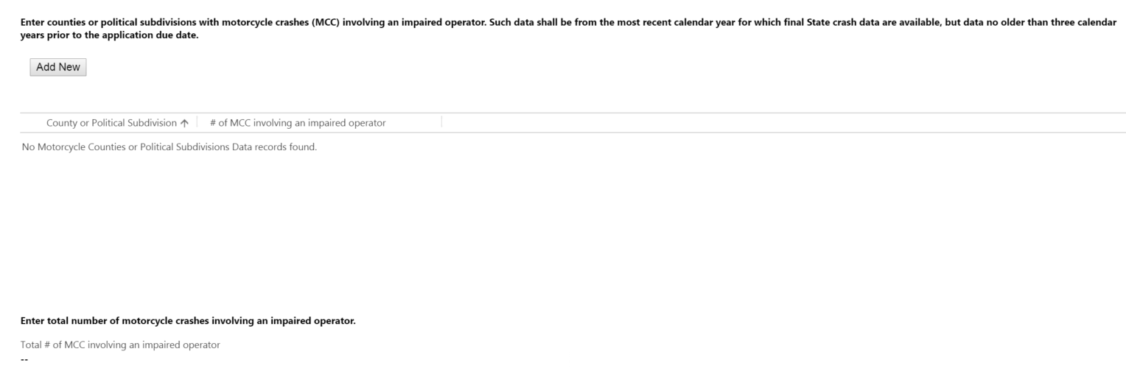

Reduction of fatalities and accidents involving impaired motorcyclists (405f section)
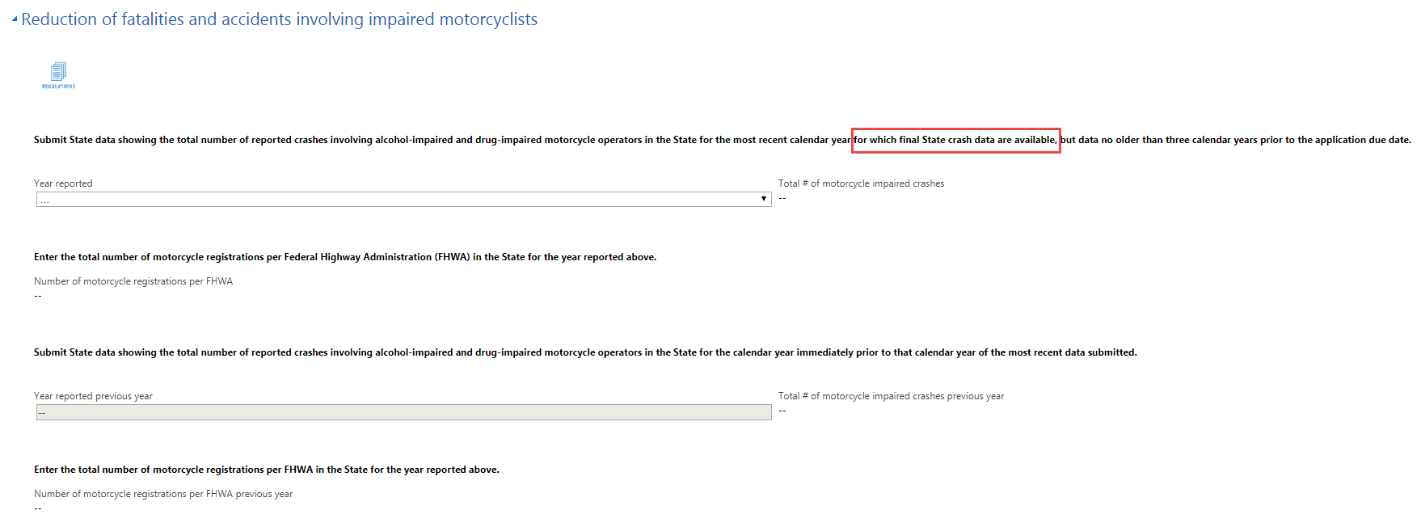
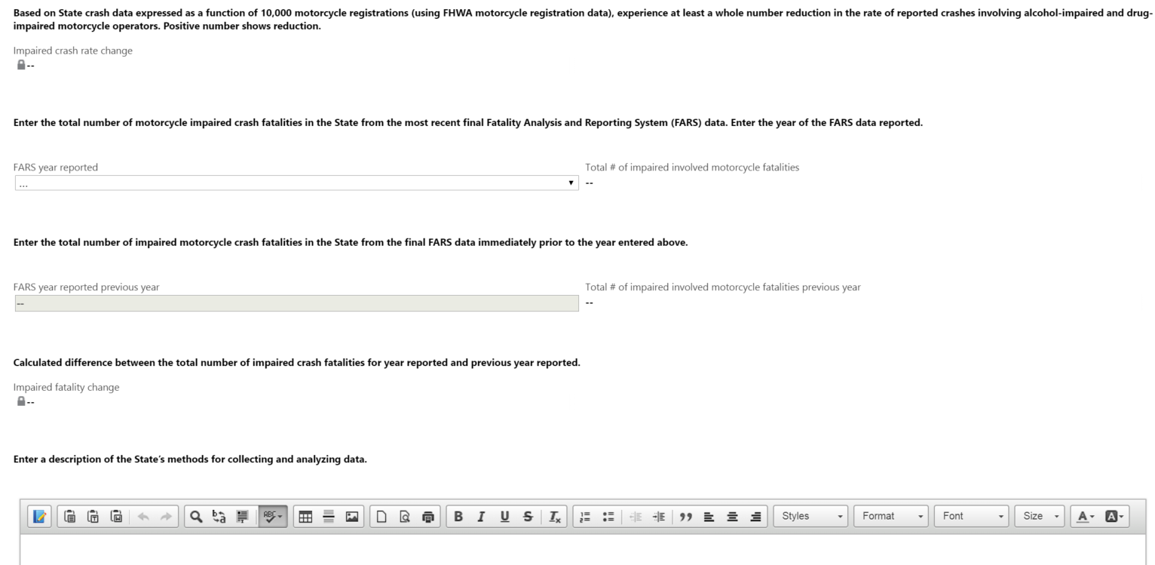
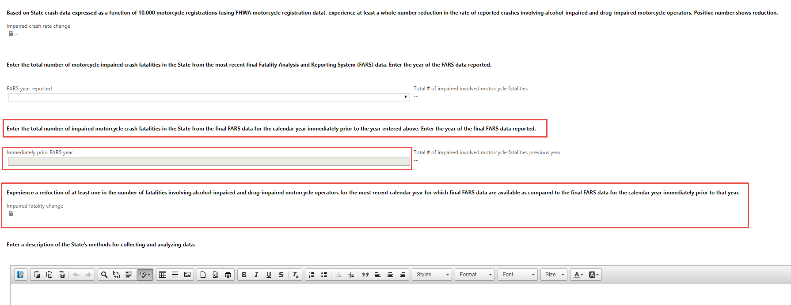

Use of fees collected from motorcyclists for motorcycle programs (405f section)

Use of fees criterion = Data State
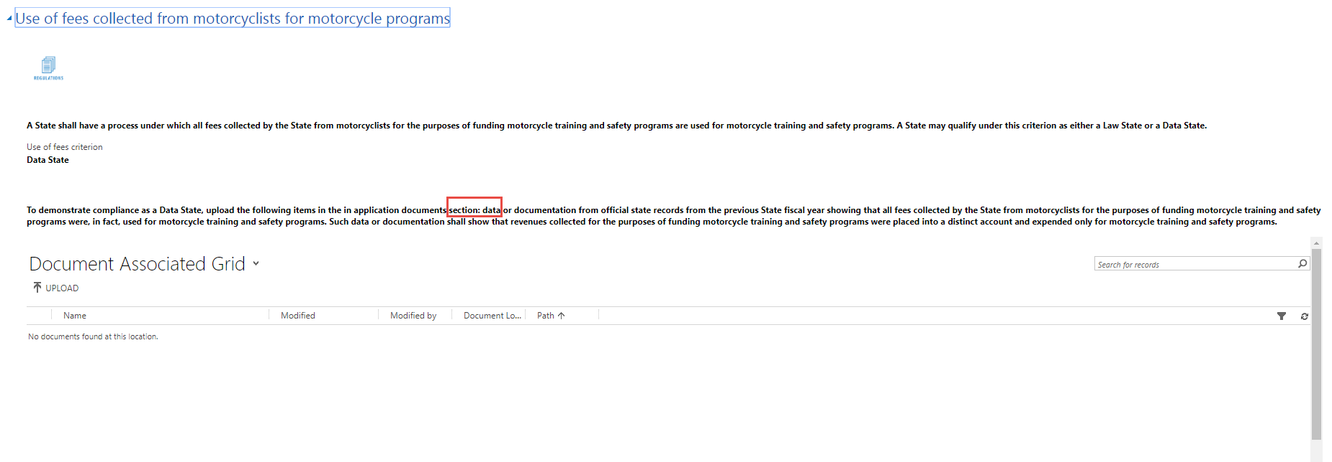

Use of fees criterion = Law State
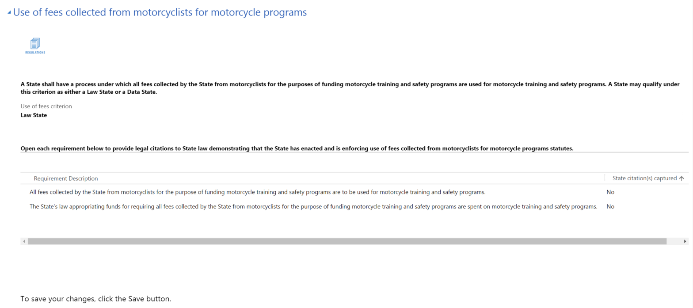

Legal Requirement Description Text
The State law or regulation requiring that all fees collected by the State from motorcyclists for the purpose of funding motorcycle training and safety programs are to be used for motorcycle training and safety programs.
The State law appropriating funds demonstrates that for the current fiscal year, for requiring all fees collected by the State from motorcyclists for the purpose of funding motorcycle training and safety programs are spent on motorcycle training and safety programs.

Address Legal Requirement (Legal Requirement form)
To address a legal requirement with citations, a user must first open a requirement line (by double clicking), which will launch the following form:

Add New Citation (Quick create form)
On the legal requirement form, users will click the Add New button to add as many citations as necessary to meet the requirement. They will complete this for each requirement listed.

Note for the exemption area, when users click Add New to capture a new exemption, this quick create form will also be displayed.

S. 405g Graduated Drivers Licensing (GDL) Incentive Grant Contents

Graduated driver information (405g section)
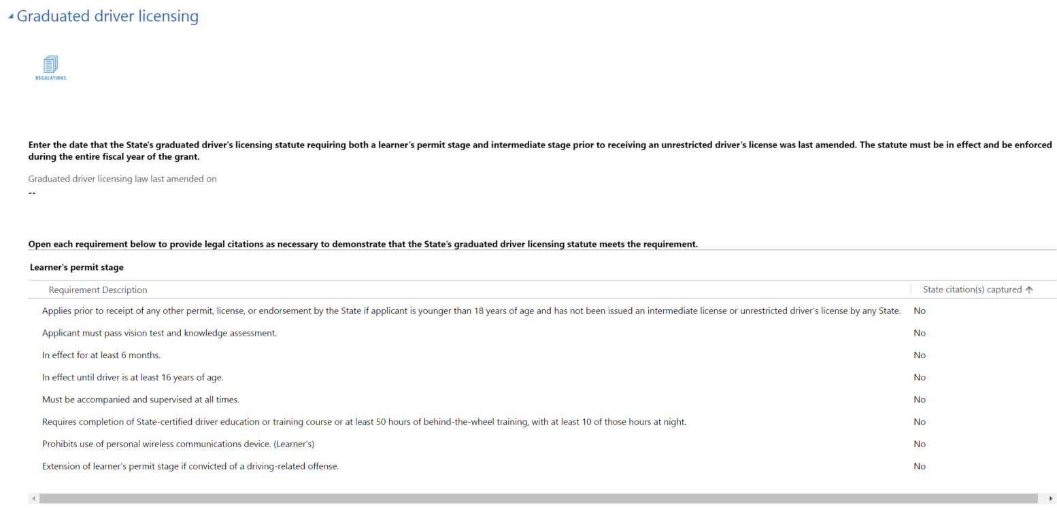
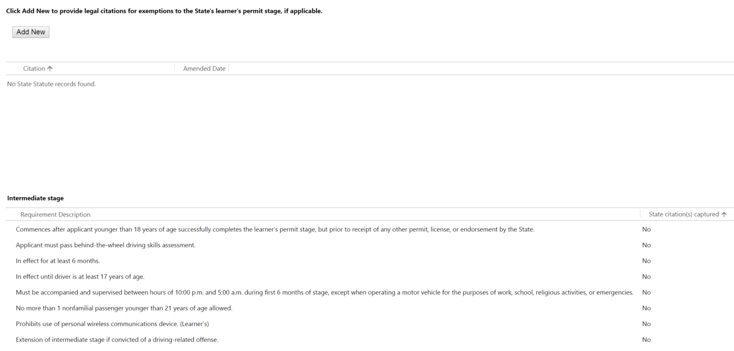
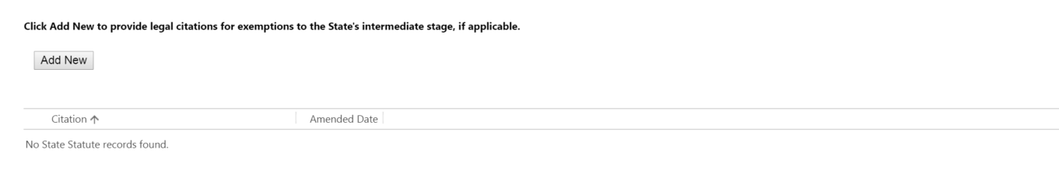

Legal Requirement Description Text
Commences after applicant younger than 18 years of age successfully completes the learner’s permit stage, but prior to receipt of any other permit, license, or endorsement by the State. | Intermediate Stage
Applicant must pass behind-the-wheel driving skills assessment. | Intermediate Stage
In effect for at least 6 months. | Intermediate Stage
In effect until driver is at least 17 years of age. | Intermediate Stage
Must be accompanied and supervised between hours of 10:00 p.m. and 5:00 a.m. during first 6 months of stage, except when operating a motor vehicle for the purposes of work, school, religious activities, or emergencies. | Intermediate Stage
No more than 1 nonfamilial passenger younger than 21 years of age allowed. | Intermediate Stage
Prohibits use of personal wireless communications device. | Intermediate Stage
Extension of intermediate stage if convicted of a driving-related offense. | Intermediate Stage
Applies prior to receipt of any other permit, license, or endorsement by the State if applicant is younger than 18 years of age and has not been issued an intermediate license or unrestricted driver's license by any State. | Learner's Permit Stage
Applicant must pass vision test and knowledge assessment. | Learner's Permit Stage
In effect for at least 6 months. | Learner's Permit Stage
In effect until driver is at least 16 years of age. | Learner's Permit Stage
Must be accompanied and supervised at all times. | Learner's Permit Stage
Requires completion of State-certified driver education or training course or at least 50 hours of behind-the-wheel training, with at least 10 of those hours at night. | Learner's Permit Stage
Prohibits use of personal wireless communications device. | Learner's Permit Stage
Extension of learner’s permit stage if convicted of a driving-related offense. | Learner's Permit Stage

Address Legal Requirement (Legal Requirement form)
To address a legal requirement with citations, a user must first open a requirement line (by double clicking), which will launch the following form:

Add New Citation (Quick create form)
On the legal requirement form, users will click the Add New button to add as many citations as necessary to meet the requirement. They will complete this for each requirement listed.

Note for the exemption area, when users click Add New to capture a new exemption, this quick create form will also be displayed.

S. 405h Nonmotorized Incentive Grant Contents

Non-motorized information (405h section)
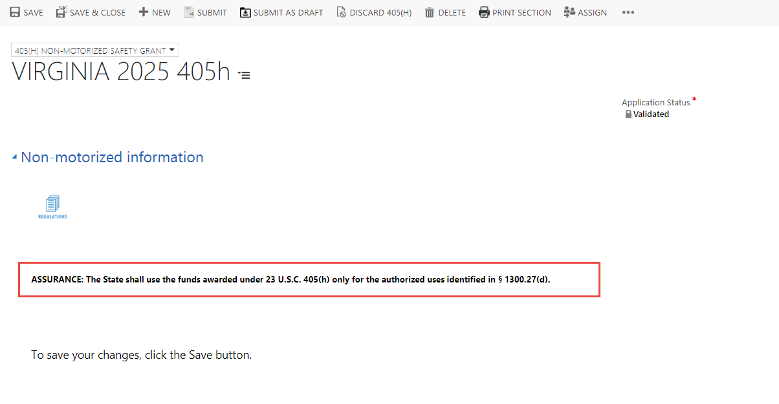

S. 1906 Racial Profiling Data Collection Incentive Grant Contents

Racial profiling data collection grant (1906 section)
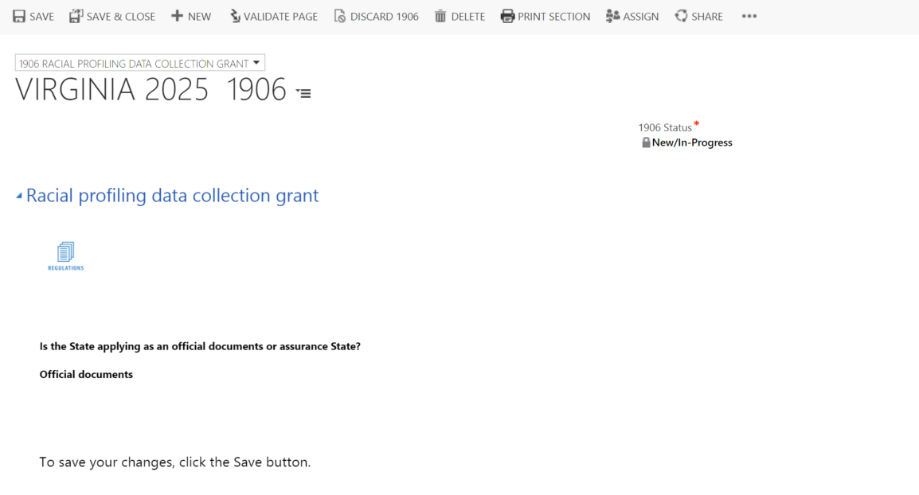

Assurance (1906 section)
Only displayed if State is applying as Assurance State.
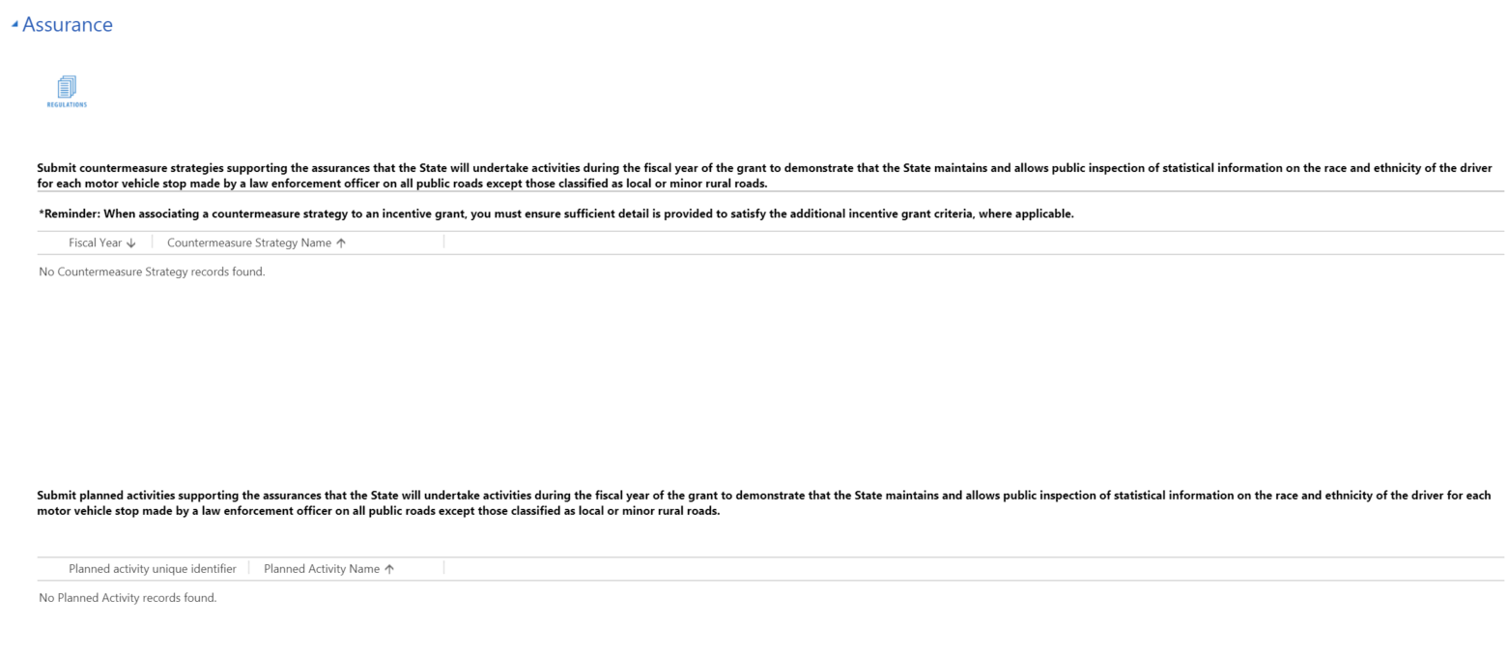

Official documents (1906 section)
Only displayed if State is applying as Official Documents State.
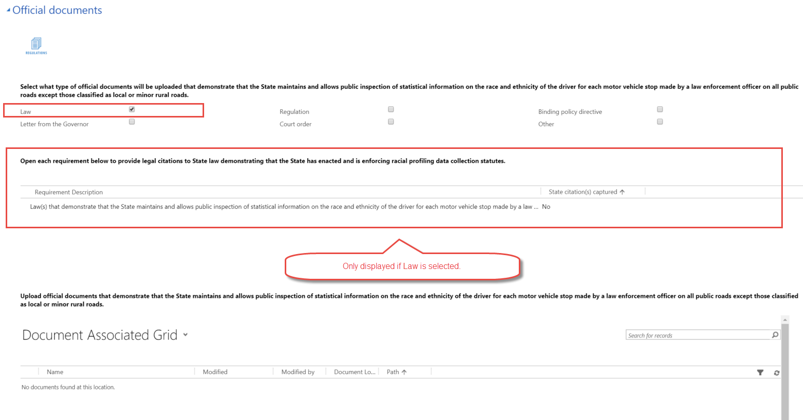

Legal Requirement Description Text
Law(s) that demonstrate that the State maintains and allows public inspection of statistical information on the race and ethnicity of the driver for each motor vehicle stop made by a law enforcement officer on all public roads except those classified as local or minor rural roads.

Address Legal Requirement (Legal Requirement form)
To address a legal requirement with citations, a user must first open a requirement line (by double clicking), which will launch the following form:

Add New Citation (Quick create form)
On the legal requirement form, users will click the Add New button to add as many citations as necessary to meet the requirement. They will complete this for each requirement listed.

Note for the exemption area, when users click Add New to capture a new exemption, this quick create form will also be displayed.

