NIEHS CareerTrac Screenshots

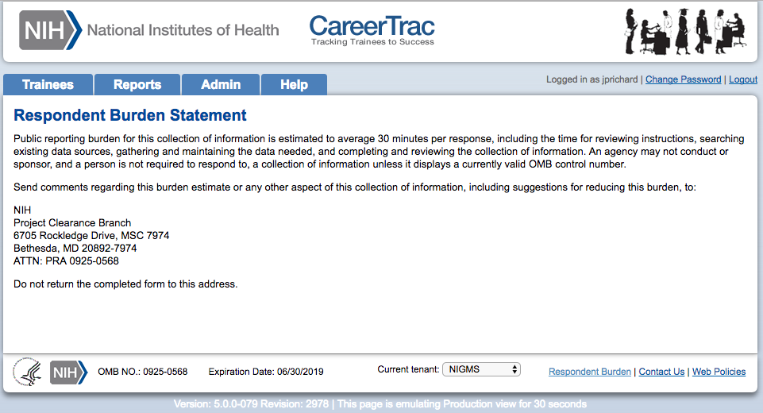
Burden Statement Page

Contact Info Page 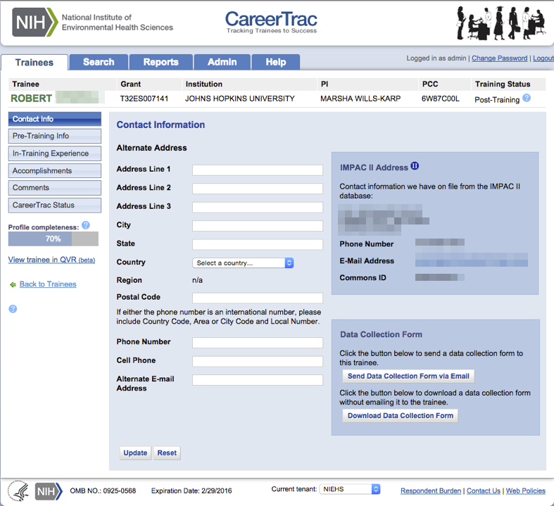

Pre-Training Info 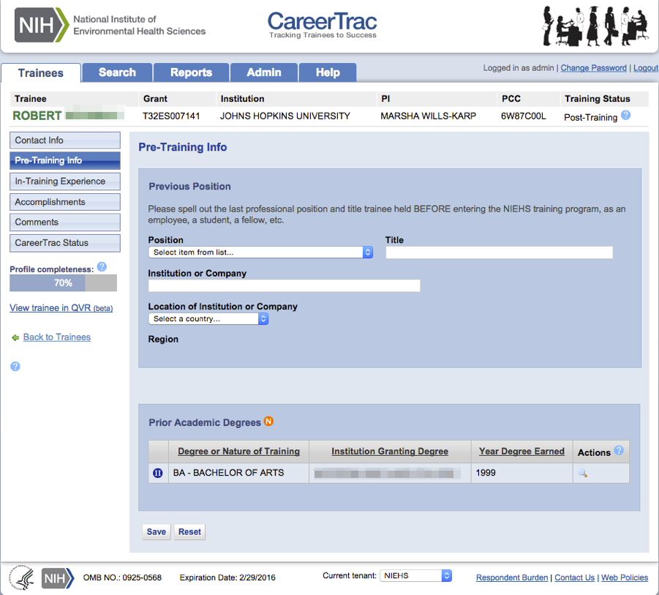

In-Training Experience 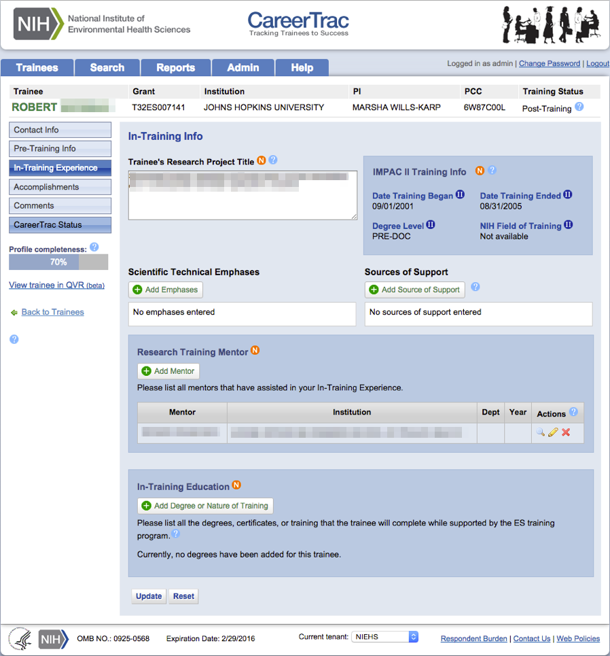

In-Training Experience – Scientific Technical Emphases 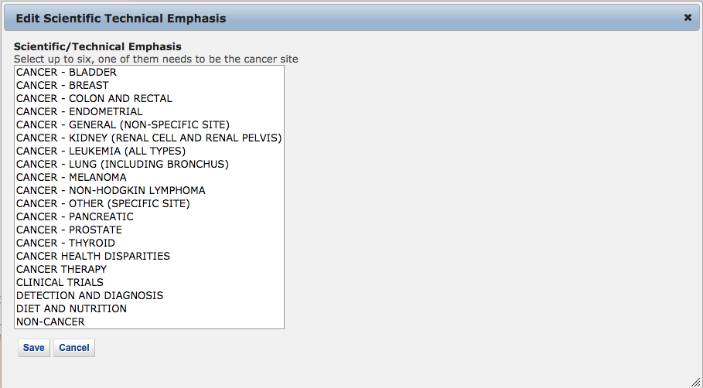

In-Training Experience – Source of Support 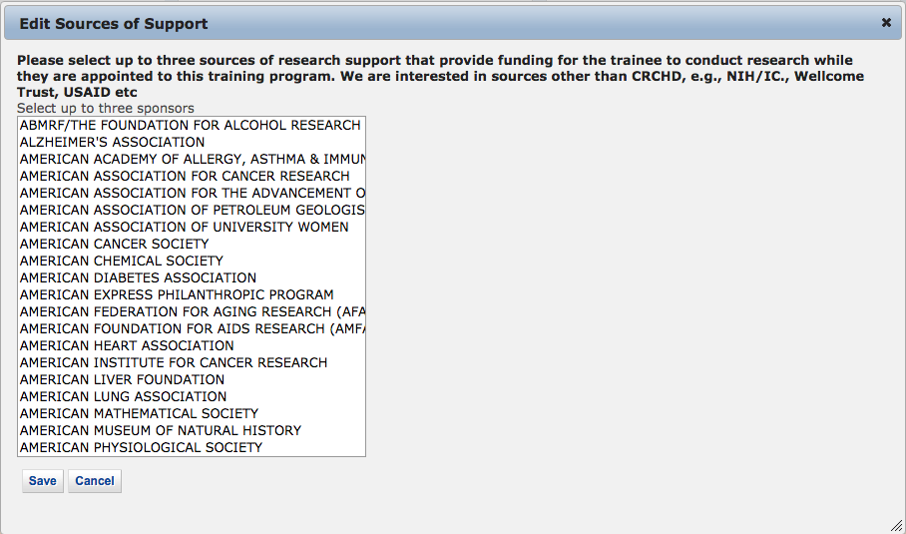

In-Training Info Page – New Mentor (Search)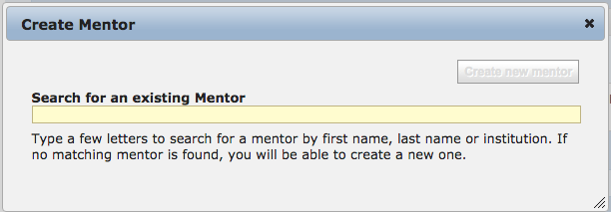

In-Training Info Page – New Mentor (Maunally Enter) 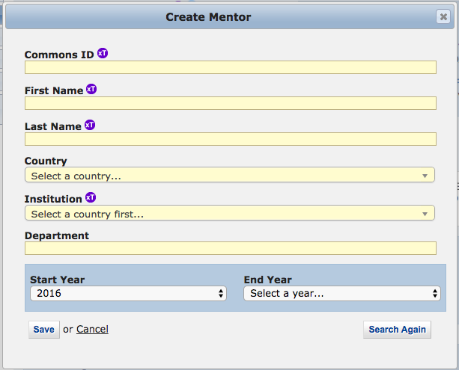

In-Training Info Page – Create Education (Trainees with Commons ID) 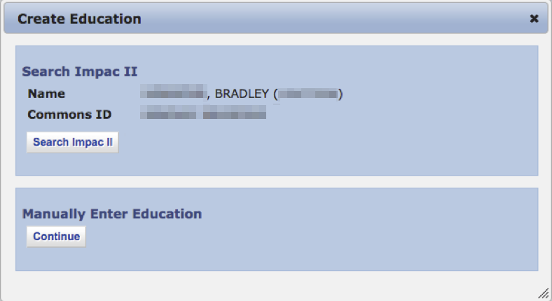

In-Training Info Page – Create Education (Manually Enter)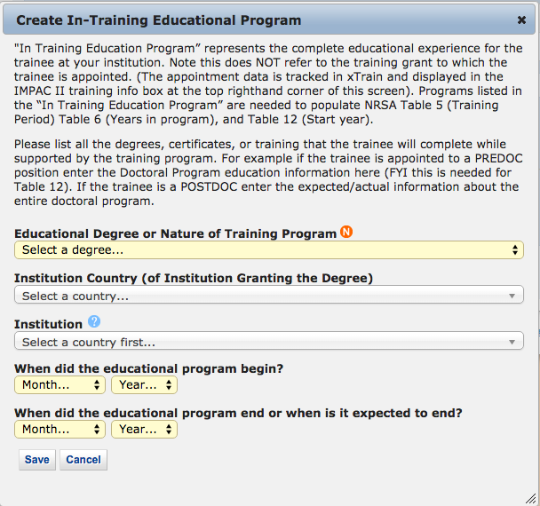

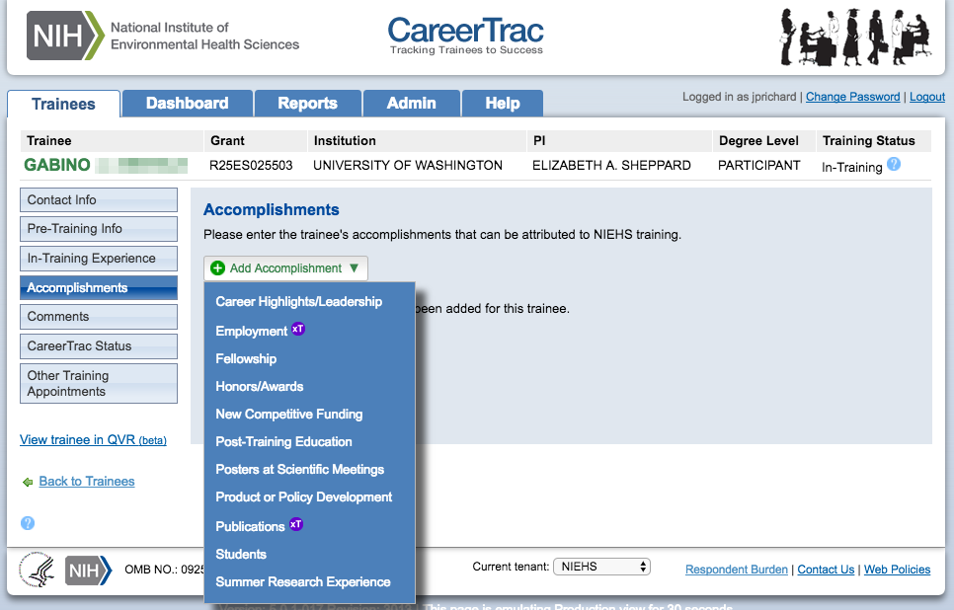
Accomplishments

Accomplishments – Career Highlights/Leadership 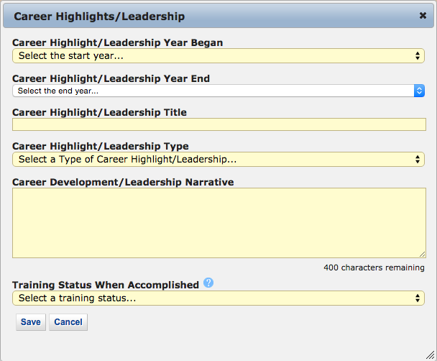

Accomplishments – Employment (Commons Trainee) 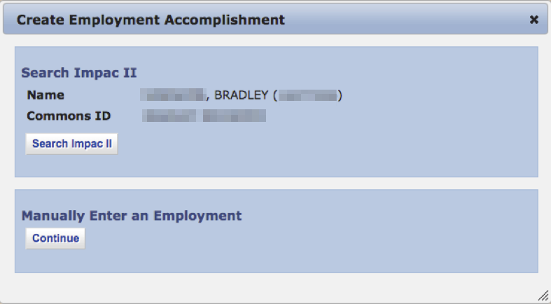

Accomplishments – Employment (Manually Enter) 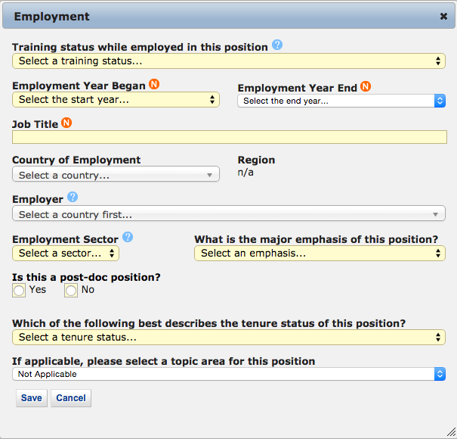

Accomplishments – Fellowship 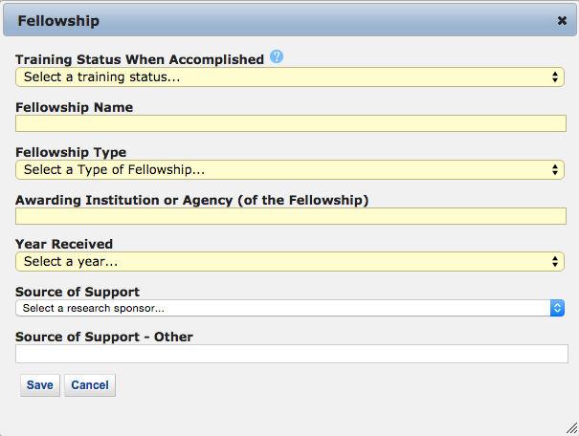

Accomplishments – Honors/Awards 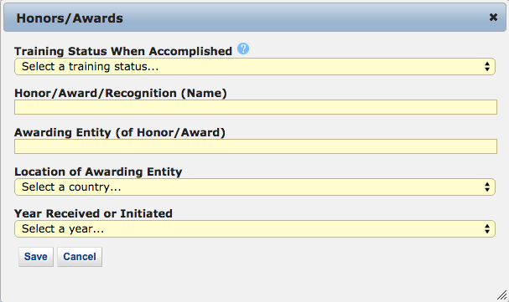

Accomplishments – New Competitive Funding 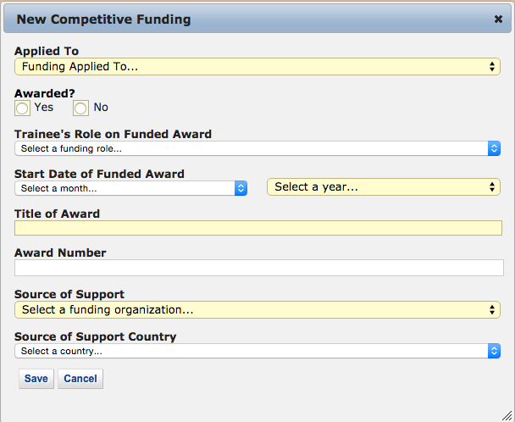

Accomplishments – Post Training Education (Commons Trainees)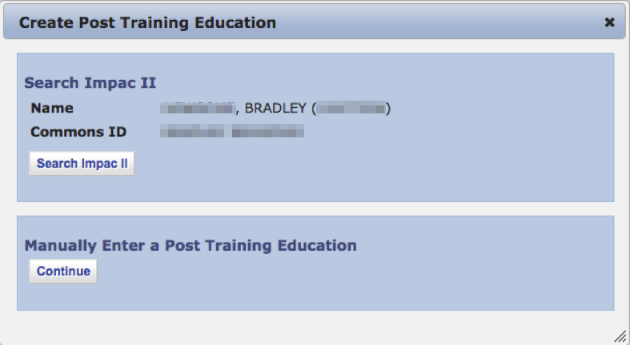

Accomplishments - Post Training Education (Manually Enter)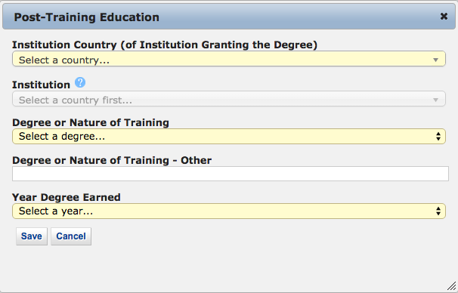

Accomplishments – Posters at Scientific Meetings 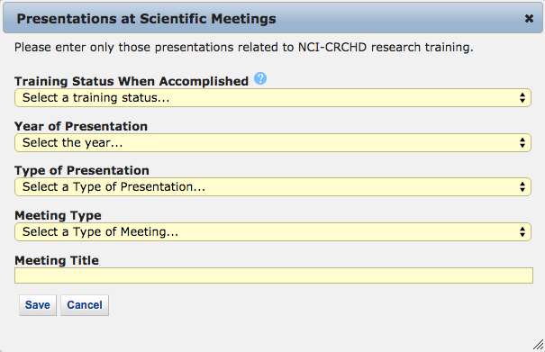

Accomplishments – Product or Policy Development 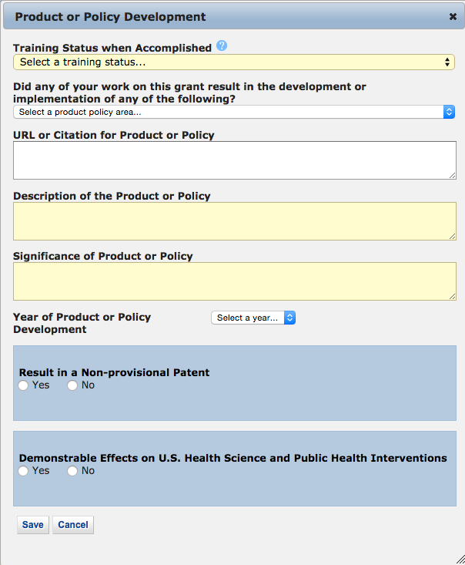

Accomplishments – Publications (Search)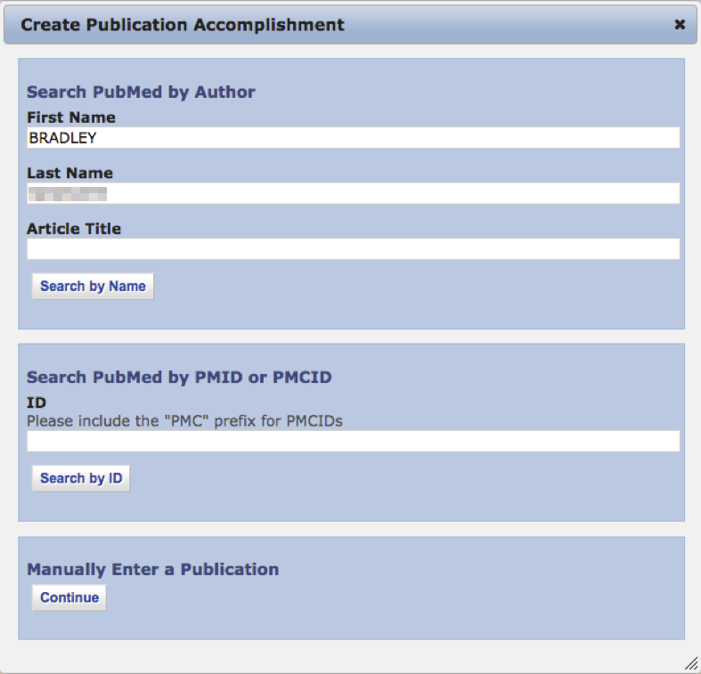

Accomplishments – Publications (Maunally Enter)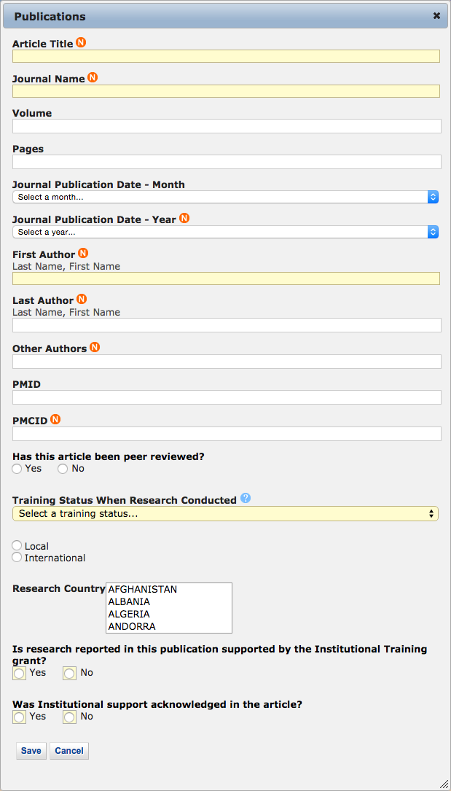

Accomplishments – Students 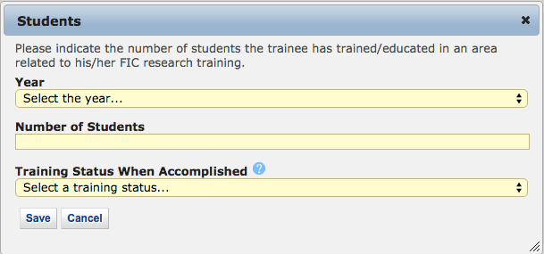

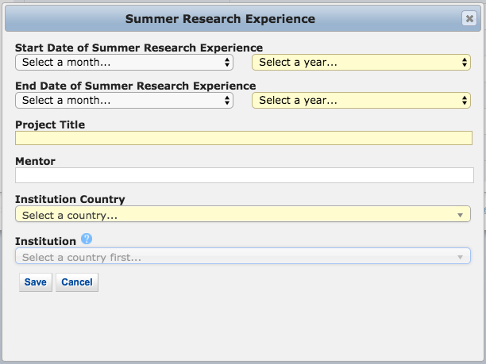
Accomplishments – Summer Research Experience

Comments
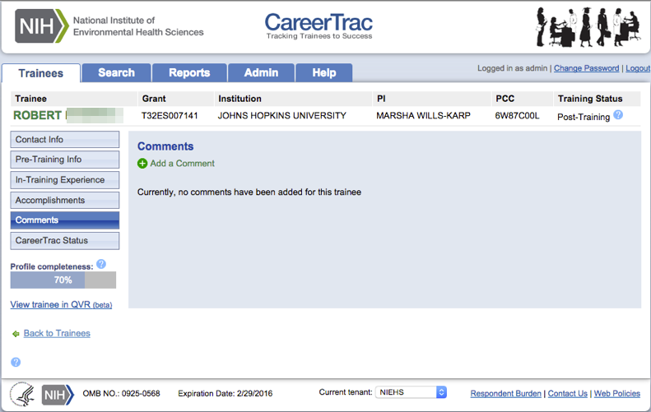

Comments – Add Comments 