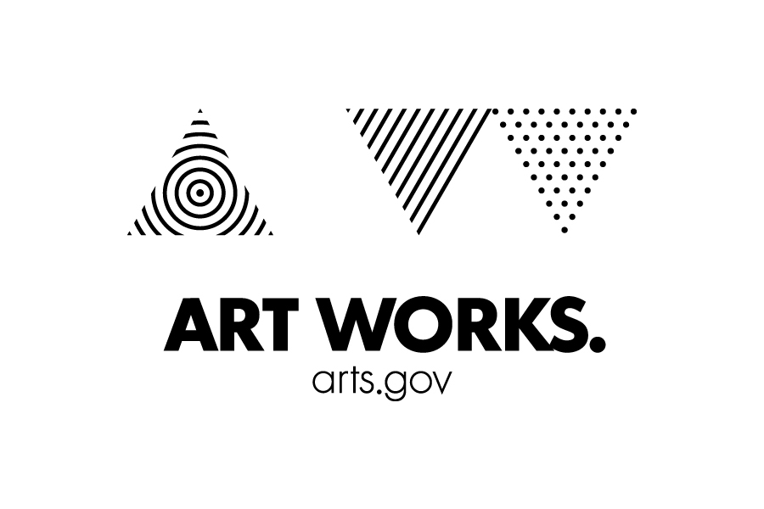

National Endowment for the Arts
Translation Fellowship – Acknowledgment of Rights-holder
Rights-holder: _______________________________________
Rights-holder’s Country of Origin: _______________________________________
Title of Work to be Translated (the “Work”): _______________________________________
Translator: _______________________________________
I, _______________________________________, acting as the Rights-holder or as an authorized representative of the Rights-holder, and warranting that I have the capacity to act as such, do acknowledge, understand, and affirm the following:
- The Translator is seeking funds in the form of a grant from the National Endowment for the Arts (“NEA”) to create an English-language translation of the Work (the “Translation”).
- The NEA is an agency of the United States Government.
- The terms of the NEA grant do not authorize or consent to the Translator publishing the Translation without first obtaining all proper rights. The NEA specifically does not authorize or consent to any activity that infringes on any valid rights of the Rights-holder under the laws and treaties of the United States or the Rights-holder’s Country of Origin.
- The Rights-holder possesses and controls all rights to the Work necessary to allow the Translator to create the Translation.
- The rights to translate the Work are presently available.
- Although the Rights-holder does not object to the Translator’s creation of the Translation, the Rights-holder has not yet entered into a final publishing rights agreement with the Translator or any individual or entity acting in concert with the Translator to publish the Work (such as an English-language publisher). Neither the NEA nor the United States Government will be party to any such publishing rights agreement(s) between the Publisher and the Translator and/or any individual or entity acting in concert with the Translator.
- If the author(s) of the Work and the Rights-holder are not the same individual or entity, I am aware of no objection by the author(s) to the creation of this or any English-language translation of the Work. The Rights-holder will promptly give written notice to the NEA if it subsequently learns of any such objection, or if it transfers its right to allow an English-language translation of the Work to any other person or entity prior to publication of the Translation.

I am eighteen years of age or older, and by signing below I warrant that I have read, acknowledged and affirmed the above on behalf of the Rights-holder. I understand that this acknowledgement does not mean I have given up any rights that the Rights-holder may have in the work.

Accepted and agreed:

________________________________________
Signature

________________________________________
Print Name and Position

________________________________________ _____________________________________
Date Address

_________________________________________ _____________________________________ E-mail Phone

Privacy Act

The following notice is furnished in accordance with the Privacy Act of 1974, 5 U.S.C. 552a:

This information is solicited under the authority of the National Foundation on the Arts and the Humanities Act, 20 U.S.C. 951 et seq. and is used to for the purpose of application review. Personal data including home address and home telephone number will not be released and is exempt from disclosure under FOIA exemption (b)(6). Failure to provide the requested information could result in rejection of your application.

Paperwork Reduction Act Statement

The public reporting burden for this collection of information is estimated at an average of one hour per response. This includes the time for reviewing instructions, searching existing data sources, gathering and maintaining the data needed, and completing and reviewing the collection of information. We welcome any suggestions that you might have on improving the guidelines and making them as easy to use as possible. Send comments regarding this burden estimate or any other aspect of this collection of information, including suggestions for reducing this burden, to: webmgr@arts.gov, attention: Reporting Burden. Note: Applicants are not required to respond to the collection of information unless it displays a currently valid U.S. Office of Management and Budget (OMB) control number.

