ATTACHMENT D
YOUTH ASSENT FORM


Form approved
OMB Number:
Expiration Date:

STATEMENT OF ASSENT

EVALUATION OF PERSONAL RESPONSIBILITY EDUCATION PROGRAM (PREP)

Sponsored by the United States Department of Health and Human Services

An adult at _______________has explained to me the EVALUATION OF PERSONAL RESPONSIBILITY EDUCATION PROGRAM (PREP). I was told that I have been selected to be a part of the study and that my parent or guardian has agreed to my participation. The study was described to me and any questions I had were answered. I understand I will be asked to complete several surveys and that the information I provide is private and will not be provided to people outside of the study or shown to my parents. I also understand that I do not have to answer any questions that make me feel uncomfortable.

If I have questions about my rights as a research volunteer or questions about the study, I can call:

- [INSERT NAME]at the Public/Private Ventures institutional Review Board, toll-free at 1-800-XXX-XXXX
- Melissa Thomas, Survey Director at Mathematica Policy Research, toll-free at 1-888-XXX-XXXX.

I understand that participation is voluntary, and I agree to participate in the study. I understand that I am allowed to stop participating in the study at any time, without punishment.

______________________________ ____________________________________ _______________
Name Signature Date

Email: __________________________________________

Cell phone: ( ) _________ - ______________
Area code
------------------------------------------------------------------------------------------------------------------------------------------
I certify that the staff members assigned to explain the study to participants were trained to do so in terms participants would understand.

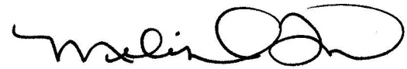
_______________________________________
Melissa Thomas
Survey Director
Signature Date

