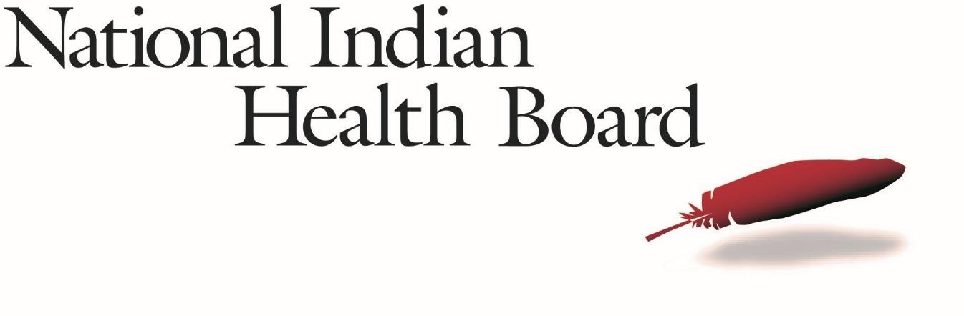
Public Health in Indian Country Capacity Scan: NIHB Pre-Launch Webinar
Stephen Valliere, MPH
Public Health Projects Coordinator
<<DATE>>

2017/18 NIHB Scan - Key Dates
•Scan launch: <<TBD>>
•Scan closes: <<3 months from launch>>
Overview
- Background
- Current Project
- Benefit to Tribes
- Scan (Assessment)
- Administration
- Launch
- Logistics
- Submission
•FAQ
- Questions?

Background & Current Project
- NIHB 2009 Tribal Public Health Profile – only national level information on Tribal public health capacity
- NIHB 2018 Tribal Public Health Profile – will provide parity for Indian Country information needs with states, cities and counties
- Profile of State Health Department Data - Association of State and Territorial Health Officials
- Profile of Local Health Department Data Health - National Association of County and City Health Officials
- Funded by CDC 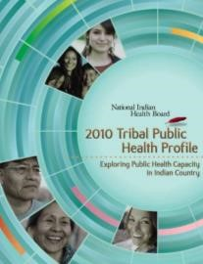 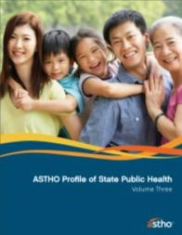 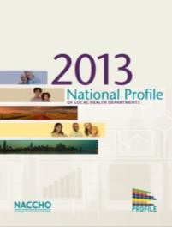
Benefits to Tribes & Tribal Organizations
•Identification of Tribal public health system:
- Needs • Priorities
- Opportunities for technical assistance
•Establish baseline information that can be used to gauge progress over time

Scan Administration
•Administered online through Qualtrics web assessment platform (www.Qualtrics.com)
•An email containing a link to the scan will be sent from NIHB on <<DATE TBD>> to Directors of:
- Tribal Health Departments
- Tribal Public Health Departments
- Tribal Health Organizations/Consortiums 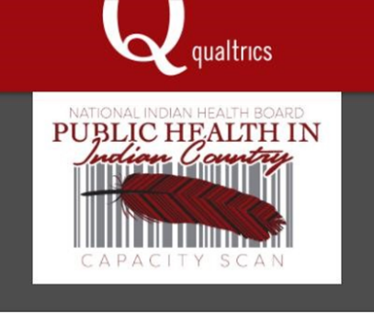

Scan Table of Contents
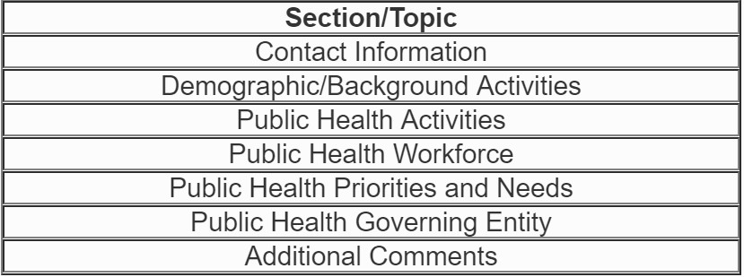

Scan Launch
•Respondents:
- Tribal Health Department Directors, Tribal Public Health
Department Directors, Alaska Native Health Consortium Directors
•Scan response by web
- By request, NIHB can provide hard copy OR walk through via telephone
•One-on-one technical assistance, as needed, from
NIHB

Logistics
•Scan can be completed in multiple sittings

Saving the Data
•To save responses and progress through each section, respondents will click the “Save and Continue” button at the bottom of the web page


Scan Navigation
•Respondents can return to the previous section

•However, data will not be recorded until the page is submitted 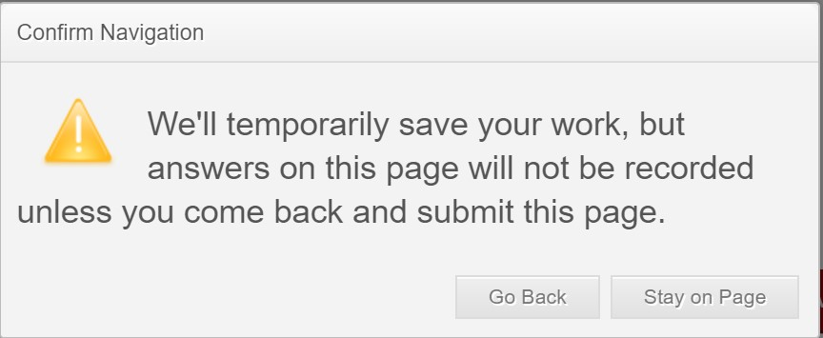

Scan Navigation
•Scan progress is displayed at the bottom of the web page 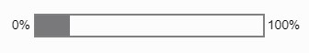
•The Table of Contents and completed sections (indicated by ✔) can be viewed via the top left corner dropdown menu 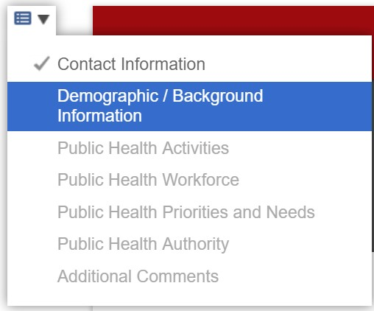

Scan Submission
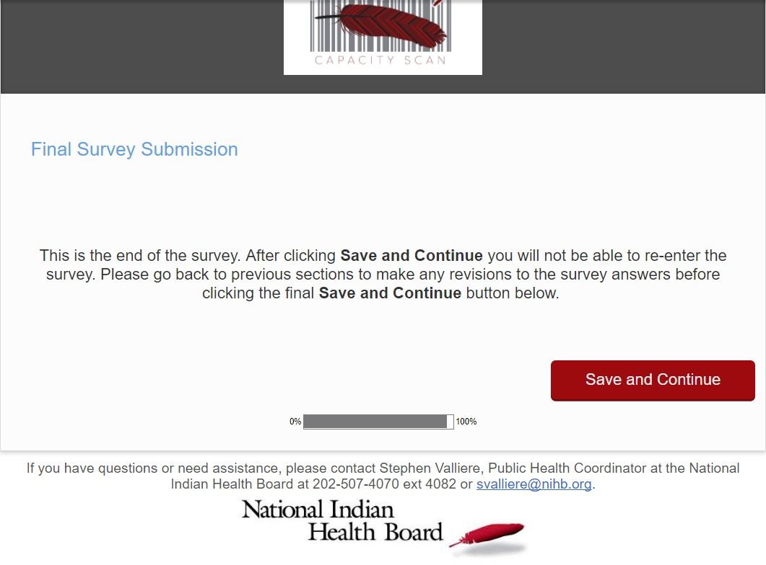
•After the clicking the final “Save and Continue” button, respondents will not be able to re-enter the scan

Scan Submission
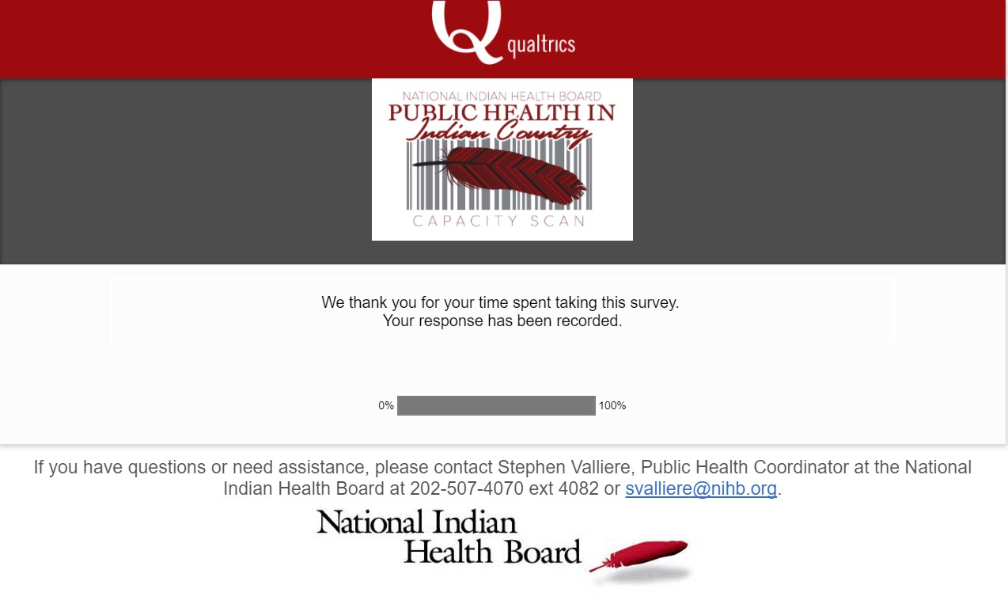

FAQs
•Do I need any log-in information in order to fill out the scan?
•No log-in information is required to access the scan
•Each respondent will receive a unique, trackable link to the scan

FAQs
•Can I get a Word version of the scan?
•Yes—please contact NIHB to request a hard copy of the scan, svalliere@nihb.org
•Who do I contact with questions about the scan?
•Stephen Valliere, 202-507-4082 svalliere@nihb.org

FAQs
•What about public health work that occurs outside of my department?
•Respondents completing the scan should take into account any and all public health work occurring within the Tribal community

FAQs
•How long will completing the scan take?
•The estimated response time based on pilot testing is 60 minutes
•How will the data and my information be shared?
•NIHB will house all the data on a secure server.
Questions?

NIHB Contacts
- Stephen Valliere, MPH
Public Health Projects Coordinator svalliere@nihb.org
- Breannon Babbel, PhD
Research Manager bbabbel@nihb.org
- Carolyn Angus-Hornbuckle, JD
Deputy Director & Director of Public Health Policy and Programs chornbuckle@nihb.org

Thank you!
Stephen Valliere
Public Health Projects Coordinator svalliere@nihb.org www.nihb.org

