Attachment C – Announcement

Shigellosis Prevention and Control Needs Assessment
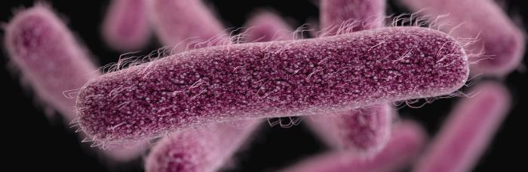
The Shigella prevention and control program at CDC is conducting a series of phone-based, in-depth interviews, as part of a shigellosis prevention and control needs assessment.
For us to develop materials and resources that are useful locally, this needs assessment will help us understand local shigellosis prevention and control activities, challenges associated with shigellosis prevention and control, and the needs of local stakeholders for prevention and control materials or support.
As part of this needs assessment we are speaking with health department staff (e.g., epidemiologists, medical officers, and communicable disease investigators) about their experiences with shigellosis prevention and control efforts.
Results of these discussions will help us to understand state and local needs, identify the types of materials CDC could develop to support local prevention and control efforts, and to prioritize and shape our future prevention and control work to ensure technical assistance and resources are more useful to state and local stakeholders. Anonymized and aggregated results may also be shared with stakeholders through internal and external presentations, reports, and/or publications, and qualitative findings may be published in a peer-reviewed journal article.
The phone-based interviews should take no longer than 60 minutes and participation is completely voluntary.
If this is something you would be interested in participating in, or would like to learn more about, please contact Amanda Garcia-Williams at GVL8@cdc.gov or at 770-488-3936.

