(Prenotice)
United States Department of Commerce
National Oceanic and Atmospheric Administration
NOAA Fisheries Service
Silver Spring, MD 20910

<Date>
<FULLNAME>
<STREET ADDRESS>
<CITY>, <ST> <ZIPCODE>

Dear <insert name>,

In a few days you will be receiving a questionnaire from the National Marine Fisheries Service. This is a voluntary questionnaire asking a sample of stakeholders about seafood processing and fisheries management. We are conducting this survey to improve our model that estimates economic impacts for regional economies. Results of the survey will be used to determine the impacts to seafood processing companies from regulatory changes.

We have found that many people like to know ahead of time that they will be receiving a questionnaire, so we are sending this notice to you in advance. Understanding this information will help fisheries managers in their decision-making, and we look forward to receiving your completed questionnaire.

Sincerely,
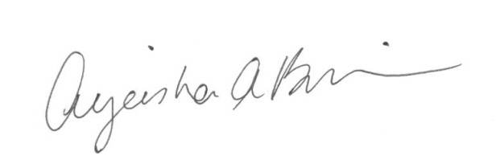

Ayeisha Brinson, Ph.D.
Office of Science and Technology
NOAA Fisheries Service
301-427-8198



(1st mailing cover letter)
United States Department of Commerce
National Oceanic and Atmospheric Administration
NOAA Fisheries Service
Silver Spring, MD 20910

<Date>
<FULLNAME>
<STREET ADDRESS>
<CITY>, <ST> <ZIPCODE>

Dear <insert name>,

You may recall from an earlier letter that you will be receiving a voluntary questionnaire about seafood processing and fisheries management. That questionnaire accompanies this letter, and is part of an effort by the National Marine Fisheries Service to understand economic impacts for regional economies in regards to current and future fisheries management.

Your opinions are important. You have been selected to participate because we identified you as either a seafood processor or dealer. Please take a few minutes to share by completing the questionnaire. It should take about 30 minutes, and all responses are completely confidential.

Please do not hesitate to call or email if you have any questions concerning this effort. We appreciate your time and look forward to your completed questionnaire. A report containing the survey results will be available at:
https://www.st.nmfs.noaa.gov/economics/index

Sincerely,
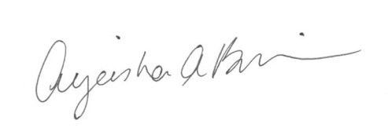

Ayeisha Brinson, Ph.D.
Office of Science and Technology
NOAA Fisheries Service
301-427-8198



(Postcard)

<Date>
<FULLNAME>
<STREET ADDRESS>
<CITY>, <ST> <ZIPCODE>

Dear <insert name>,

You were recently sent a questionnaire concerning seafood processing. If you have returned the questionnaire, thank you. If you have not yet completed the questionnaire, please take a few minutes to do so now. Your input is important in helping fisheries management meet your needs.

Sincerely,

Ayeisha Brinson, Ph.D.
Office of Science and Technology
NOAA Fisheries Service
301-427-8198

(2nd mailing cover letter)
United States Department of Commerce
National Oceanic and Atmospheric Administration
NOAA Fisheries Service
Silver Spring, MD 20910

<Date>
<FULLNAME>
<STREET ADDRESS>
<CITY>, <ST> <ZIPCODE>

Dear <insert name>,

We recently sent you a questionnaire about seafood processing. Although we have received completed questionnaires from many of the fisheries stakeholders that were selected to participate, to date we have not heard from you. Your opinions and concerns are very important, as they will help fisheries managers understand the needs and concerns of a variety of stakeholder interests.

Please do not hesitate to call or email if you have any questions concerning this effort. We appreciate your time and look forward to your completed questionnaire. A report containing the survey results will be available at:
https://www.st.nmfs.noaa.gov/economics/index

Sincerely,

Ayeisha Brinson, Ph.D.
Office of Science and Technology
NOAA Fisheries Service
301-427-8198
nmfs.RecAttitudes2013@noaa.gov

