JUSTIFICATION FOR CHANGE
Quantitative Assessment of Spatially-Explicit Social Values Relative to Wind Energy Areas: Outer Continental Shelf Offshore North Carolina
OMB Control NO. 0648-0744

We conducted a pretest of the survey instrument and survey administration protocol. We mailed out 320 packets to 283 eligible addresses, receiving 59 completes for a response rate of 20.8%. Our sample was not representative of the population. Survey non-responders tended to be younger and from our two inland coastal bands (band 3 – 4). To determine the possible causes for the low response rate, we conducted a post-collection follow-up of survey non-responders. Reasons cited for failure to participate were lack of interest in the offshore wind development issue and/or lack of knowledge about the issue. In an effort to address the low response rate, with limited financial resources, we have made the following adjustments for the final collection:
- Revised the survey instrument to reduce length, simplify language/questions, and address the lack of knowledge/awareness issue.
- Revised correspondence to simplify and make more general, so as not to intimidate potential respondents who do not have knowledge/awareness of the wind energy issue.
- Created an online version of the survey to invite potential respondents to complete, and provided on the final reminder mailing.
- Restructured the sampling geography to reduce the size of the target population (see maps below for comparison of pretest and final collection geographies):
  - Drop coastal band 4 (the coastal band furthest inland).
  - Redistribute the remaining three coastal bands (1 – 3) to capture the requisite remaining population per band.
  - Sample households within the three coastal bands.
We anticipate that the above changes will result in an increased response rate. In terms of impact to the study, the proposed changes will reduce the extent of inland coastal population that can be assessed for geographical differences in dependent variables. More specifically stated, our “inland population” will not extend as far inland as during the pretest. However, this change will not dramatically reduce our ability to answer the research questions or provide information to meet study objectives. Despite a reduction in study site geography, we will have a wide enough range of geographical variation (i.e., distance from shoreline) to adequately test the influence of geography on dependent variables.
There will be no increase to burden or cost.

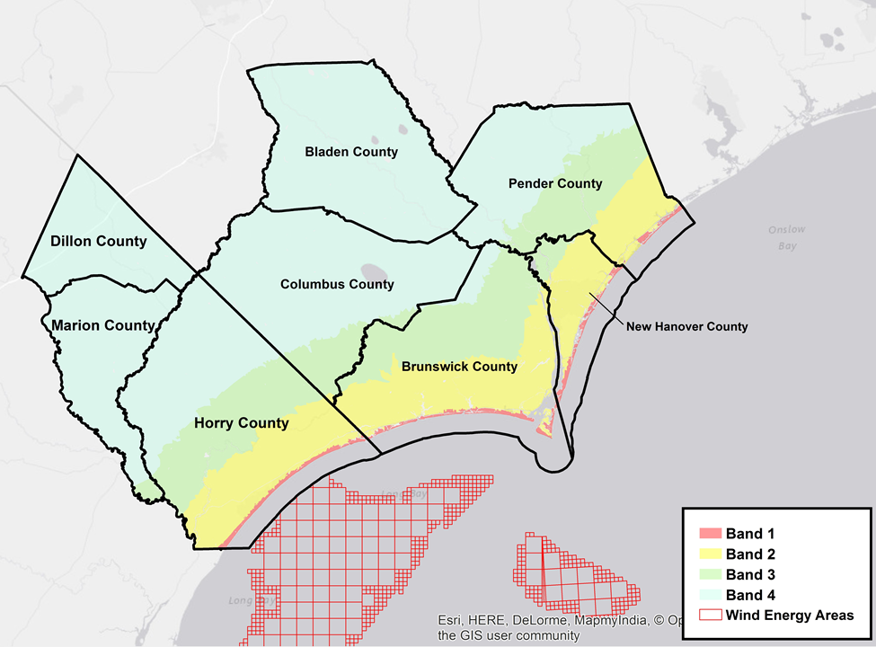
Figure 1: Pretest Coastal Band Geography

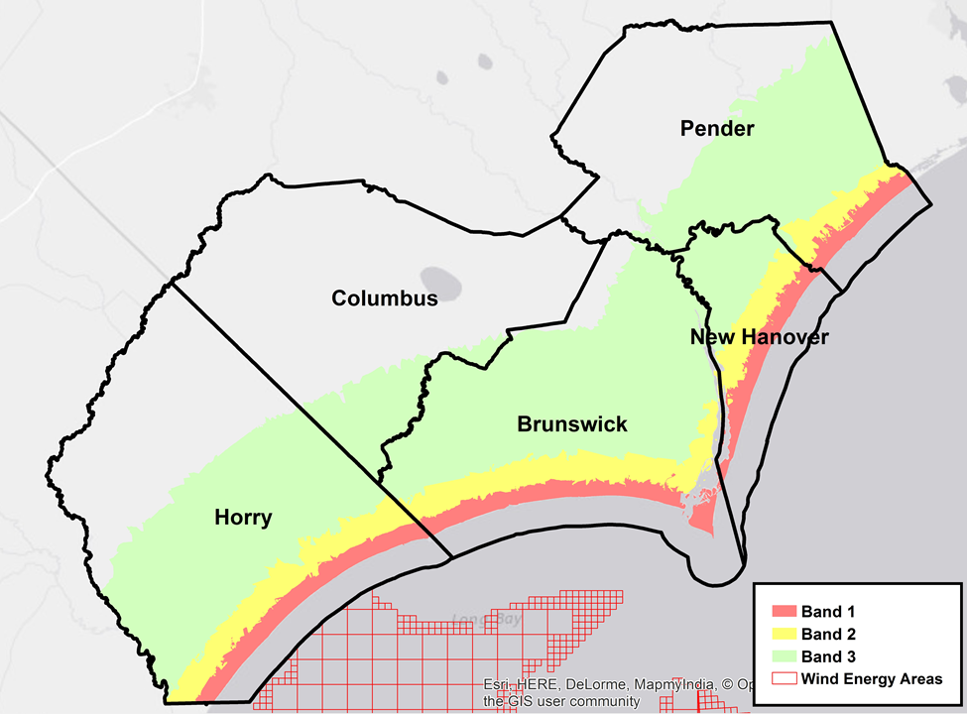
Figure 2: Final Collection Coastal Band Geography

