Attachment 1 – The complete, simplified ATUS lexicon

Sleeping or own personal care
Sleeping
Sleeplessness
Washing, dressing, or grooming oneself
Health-related self care
Personal, private activities
Household (things you do in and around your home) activities
Interior cleaning
Laundry, ironing, or mending textiles
Storing, moving, or unpacking items, including groceries
Food or drink preparation or presentation
Kitchen or food clean-up
Home decoration, maintenance, or repair
Lawn, garden, or houseplant care
Pet care including general care for animals or pets (not veterinary care)
Walking, exercising, or playing with animals
Vehicle, appliance, tool, or toy maintenance or setup
Household or personal organization, planning, or finances
Other household activities
Caring for or helping others
Caring for or helping children
Physical care for children
Reading to or with children
Playing or doing arts, crafts, or sports with children
Talking with or listening to children
Follow-up Probe:
- Who live in your household
- Who do not live in your household
Supervising children (as a primary activity)
Attending children's events
Picking up or dropping off children
Activities related to children's education
Activities related to children's health
Other care for children

Caring for or helping adults
Physical care for adults
Providing or obtaining medical care for adults
Follow-up Probe:
- Who live in your household
- Who do not live in your household

Picking up or dropping off adults
Other caring or helping activities for adults
Animal or pet care assistance for adults
Vehicle or appliance maintenance or repair assistance for adults
Household or financial management assistance for adults
Picking up or dropping off adults
Other caring or helping activities for adults
Working or related activities
Working at main job
Working at other job
Making money at main job by providing a service or through hobbies or performances
Taking breaks at work
Eating and drinking
Relaxing
Socializing
Other
Job searching or interviewing
Other work activities
Educational activities/Classes
Taking a class for a degree, certificate, or license
Taking a class for personal interest
Homework for a class for a degree, certificate, or license
Homework for a class for personal interest
Extracurricular school activities (except sports)
Other educational activities
Shopping
Grocery shopping
Purchasing prepared food (not groceries)
Other shopping
Medical services or professional services
Banking, financial consultations
Medical appointments or consultations
Real estate, veterinary, or other professional services
Haircuts, massages, manicures, or other personal services
Haircuts
Massages
Manicures/pedicures
Other personal services
Cleaning or repair services for vehicles or the home
Using government services or voting
Using government services
Voting
Other civic obligations
Eating or drinking
Storing, moving, or unpacking items, including groceries
Food or drink preparation or presentation
Kitchen or food clean-up
Socializing, relaxing, or leisure
Eating or drinking
Socializing or communicating for leisure (in person)
Attending or hosting parties, receptions, or ceremonies
Relaxing, thinking, taking breaks
Watching TV, movies, videos
Listening to radio, podcasts, music
Playing musical instruments, singing
Playing video games
Playing other games
Using social media (Facebook, Twitter, Instagram, etc.)
Using a computer—other uses; not for TV, games, reading, social media
Arts and crafts as a hobby
Reading for personal interest, listening to audiobooks
Attending movies, performing arts, zoos, museums
Other leisure
Exercise, sports, or recreation
Attending sports or recreation events
Bicycling
Golfing
Hiking, hunting, fishing, or other outdoor recreational activities
Playing basketball, soccer, or other team sports
Running
Swimming or other water sports
Walking for exercise
Walking with animals/pets or playing with animals
Weight lifting, strength training
Yoga
Other exercise
Other sports
Religious or spiritual activities
Attending religious services
Religious or spiritual practices or education
Other religious or spiritual activities
Volunteering through an organization
Volunteering in administrative or support activities
Volunteering in social service or care activities
Volunteering in building, maintenance, or clean-up activities
Volunteering at performances or events
Other volunteering
Communications, not in-person (phone, video calls, messaging, e-mails, mail)
With friends or family
With others
Driving or other travel

Attachment 2 - 35 time-use activities that will be coded by participants
Took a nap (01)
Got dressed for work (01)
Vacuumed and dusted my apartment (02)
Cleaned up the kitchen after supper (02)
Gave my dog a bath (02)
Worked on my taxes (02)
Watched my kids on the playground (03)
Did arts and crafts with my kids (03)
Read books to my children (03)
Provided pills to my elderly mother who lives with us (03)
Cooking dinner for my elderly father who lives nearby (04)
Watched my friend's child (04)
Walked my friend's child to school (04)
Mowed my neighbor's lawn (04)
Repaired my cousin's toilet (04)
Teleworked for my primary job (05)
Out of personal interest, watched a video on how to program on YouTube (06)
Had my a guitar lesson (06)
Bought groceries (07)
Had an online doctor's appointment (08)
My dog had an appointment with the Vet (08)
Got my car inspected (annual inspection) (09)
Voted at my local school (10)
Ate dinner at a restaurant (11)
Watched a streaming movie (12)
Played online video games (12)
Read a book (12)
Took a walk (13)
Went for a jog (13)
Played basketball (13)
Did yoga (13)
Attended church (14)
Acted as a chaperone for my daughter's school trip (15)
Called my sister on the phone (16)
Texted a friend (16)

Attachment 3 – Instructions for Amazon’s Mechanical Turk (MTurk) Participants

1. Navigation Task

a. Recruitment criteria: This task is open to adults aged 18-65.

b. Description of Navigation Task on the MTurk Site: We are conducting this research to understand how people think about their use of time. You will read an activity and pick a category that best describes the activity from a list of categories. For example, an activity might be “dozed off for a few minutes” so a good category to select would be “Sleeping.” There are 35 items to assign to a list of categories.

This task is estimated to take about 20 minutes, and you will be paid $3 for completing it.

c. Keywords: Organizing or classifying information, navigation task, research

d. Instructions for the Navigation Task:

Welcome to this study, and thank you for agreeing to participate!

In this study, you will first read descriptions of how people spend their time. Then you will assign each activity to the best selection from a list (menu) of categories.

You will be presented with 35 activities. Classifying them shouldn't take longer than 20 minutes.

Our goal is to determine how well the list of categories covers typical activities that people do.
Your participation will also help us find out how people think about how they spend their time.

Find out how on the next page ...

e. How the Tasks Will Appear On the Optimal Workshop Website (TreeJack Tool)
There are multiple screens in the TreeJack testing tool. Some key screens are shown below. Since this is a free demo instrument, only three tasks could be included.

Welcome Screen
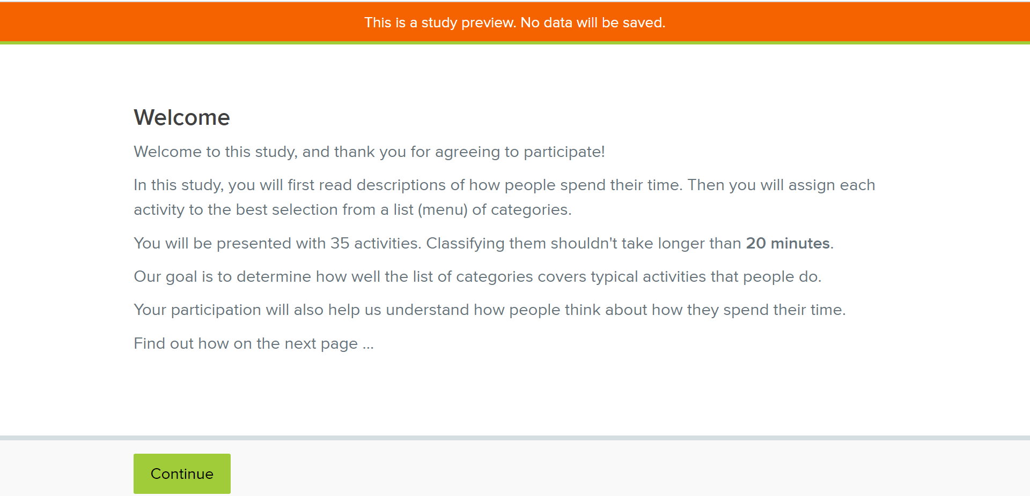

Instructions Screen
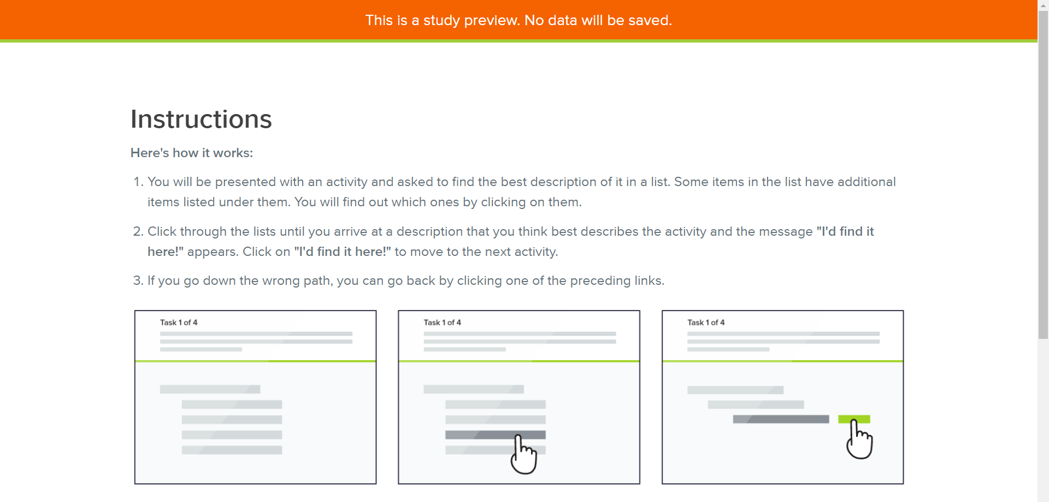

Task Screen
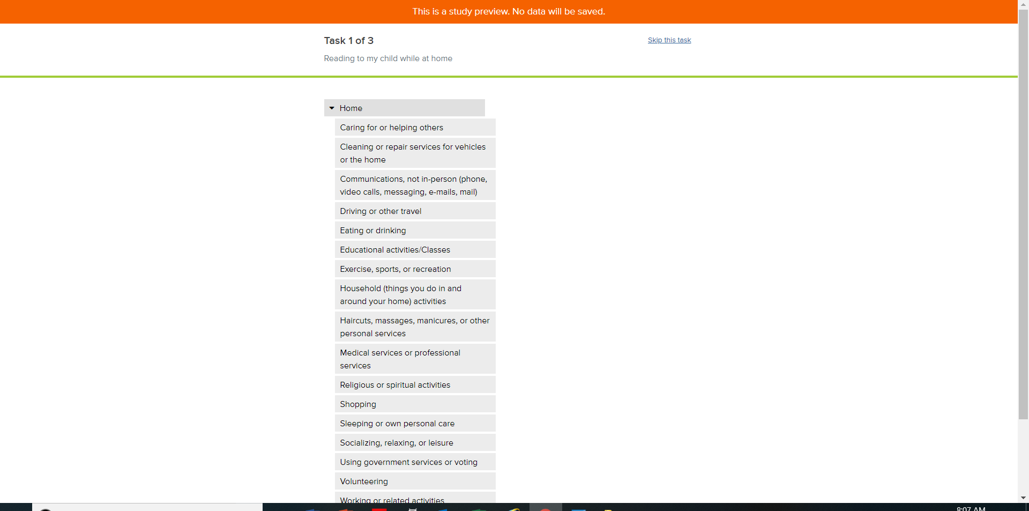
Each task is shown here

f. Actual menu that will be tested in Navigation Test #1
Home
Caring for or helping others
Cleaning or repair services for vehicles or the home
Communications, not in-person (phone, video calls, messaging, e-mails, mail)
Driving or other travel
Eating or drinking
Educational activities/Classes
Exercise, sports, or recreation
Household (things you do in and around your home) activities
Haircuts, massages, manicures, or other personal services
Medical services or professional services
Religious or spiritual activities
Shopping
Sleeping or own personal care
Socializing, relaxing, or leisure
Using government services or voting
Volunteering
Working or related activities
Other

2. Card Sorting Task - Instructions for the Card Sorting Task

a. Recruitment criteria: This task is open to adults aged 18-65.

b. Description of task on the MTurk Site: For some context, we are conducting this research as part of an effort to develop an online diary that captures how people use their time. In this task you will be asked to sort 35 activities that a person might have done during the day into some predefined categories. If you believe none of the existing categories are appropriate, you can create and name new categories.

This task is estimated to take about 20 minutes, and you will be paid $3 for completing it.

c. Keywords: Card sorting, sorting information, organization of information

d. Instructions for the Card-Sorting Task in the Optimal Workshop Card-Sorting Tool

Welcome Screen

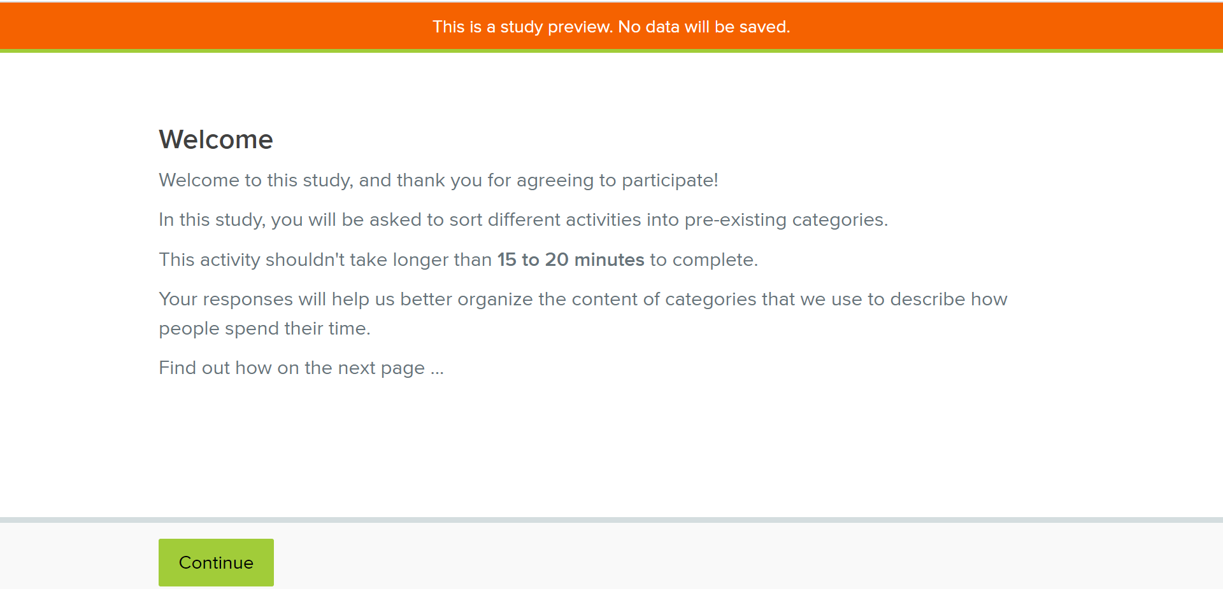

Instructions Screen
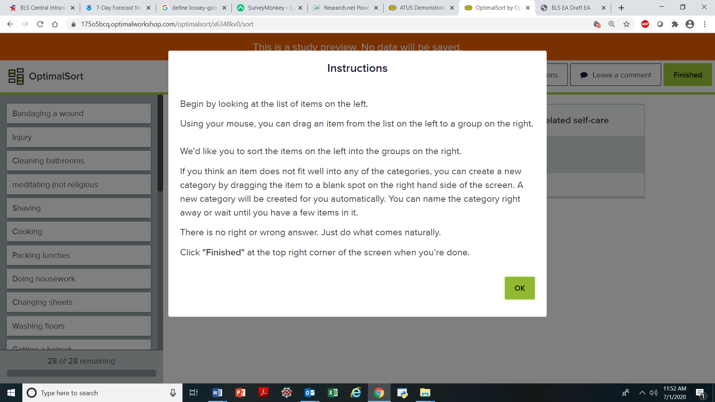

Initial Setup
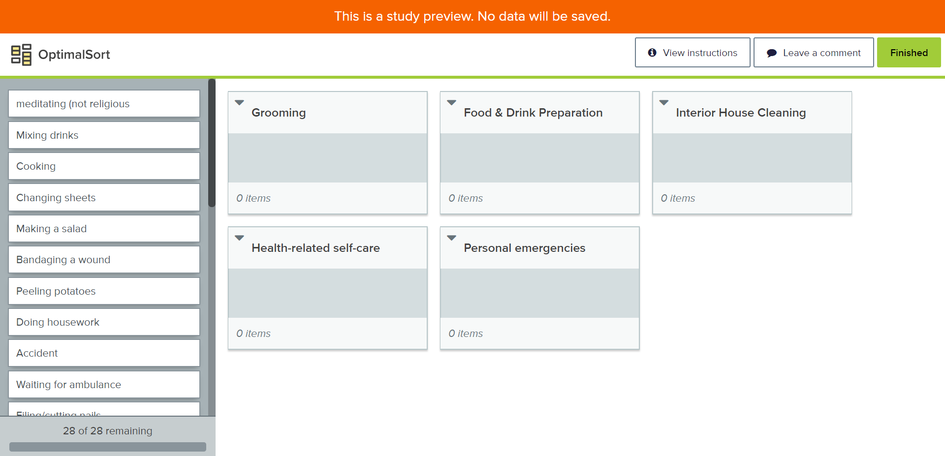

Attachment 4 – Activities to be coded in Focused Navigation Testing – The correct category is shown in parentheses (approximately 19 activities are shown. A similar 16 activities will be added depending on results from preceding navigation tests)

Attended an alcoholics anonymous meeting (01)
Attended a business meeting (05)

Got my car its annual inspection (09)
Met with the representative of a landscaping company to get an estimate for some work (09)
Voted at my local school (10)
Waited at motor vehicles to get plates for a used car purchase (10)

Read my daily newspaper (12)
Read an online blog (12)
Checked Facebook (12) - example of “using social media”
Read my Twitter feed (12) - example of “using social media”

Played a game of softball (13)
Went boating (13)
Went bowling (13)
Did step aerobics (13)

Wrote a letter to my grandmother (16)
Talked to my brother on the phone (16)
Sent emails to members of my book club (16)
Texted with my daughter (16)
Skyped (online video call) with my son who is overseas (16)

Attachment 5 – Instructions for the MTurk Screening Survey

a. Description of the Screening Survey on the MTurk Site:
You will be asked to complete a 2-minute survey to determine if you qualify for a follow-up study. You will be paid 20 cents for this 4-question survey.

b. Instructions and Questions in SurveyMonkey
The following screens show how the survey will appear in SurveyMonkey.

