SUPPORTING JUSTIFICATION – Part A
Workforce Development (WFD) Survey; OMB No. 2130-NEW
Form Number FRA F 6180.158

Summary of Submission

  - This information collection request is a new submission. The proposed qualitative study is intended to survey a select group of railroad industry personnel to gain insight into the current workforce development practices and challenges.

  - The total number of burden hours requested for this submission is 30 hours.

  - The total number of responses requested for this submission is 91.

- Circumstances that make collection of the information necessary.

The Federal Railroad Administration (FRA) has statutory responsibility to ensure the safety of railroad operations as prescribed in the Federal Railroad Safety Act of 1970 (49 U.S.C. § 20103). In order to conduct safe railroad operations, the workforce must have the requisite skills to operate equipment and technologies. Therefore, it is the responsibility of the FRA to promote workforce development policy and standards to ensure the workforce has the necessary skills and talent to conduct safe railroad operations. Due to an increasingly dynamic and maturing workforce combined with changing skills requirements imposed by newly introduced technologies, there is an increasing risk in not having the necessary talent pools to fill critical railroad operational positions.

In 2011, the Department of Transportation’s (DOT) Federal Railroad Administration (FRA) published the first Railroad Industry Modal Profile: An Outline of the Railroad Industry Workforce Trends, Challenges, and Opportunities, which provided a comprehensive overview of the railroad industry workforce as of December 31, 2008. This document is available to the public through the FRA Web site at Modal Profile Report

The Railroad Industry Modal Profile was a response to the DOT National Transportation Workforce Development Initiative that required each DOT Operating Administration (OA), also referred to as modes, to produce an analysis of its industry workforce.

The prevailing workforce concerns during the early stages of the DOT National Transportation Workforce Development Initiative were the large number of retirement-eligible employees in transportation related fields and the national shortage of science, technology, engineering, and math (STEM) graduates. Since the railroad industry had done very little hiring in the late 1980s and throughout most of the 1990s, the retirement-eligible population became quite large, even beyond that of most other industries and transportation modes (each of which were also grappling with similar retirement population concerns).
These concerns create risk in maintaining a viable workforce, and in order to take effective and efficient action to minimize these risks, FRA requires trustworthy information on current Work Force Development (WFD) strategies and challenges. Initial data collected for the modal profile established a baseline understanding of the risks and status. However, in an effort to validate and further develop the understanding of the risks this survey is being proposed. With this submission, FRA is requesting permission to acquire the needed knowledge regarding the workforce.

- How, by whom, and for what purpose the information is to be used.

The Department of Transportation (DOT) Research and Innovative Technology Administration (RITA) commenced the National Transportation Workforce Development Strategy Initiative in 2009 in partnership with representatives from each DOT OA. The intent of the partnership was to establish an analytical foundation outlining a collaborative cross-modal approach for identifying and addressing transportation workforce challenges on a national platform. As a result, the FRA identified a team to support the DOT initiative, and to develop a Railroad Industry Modal Profile.

From 2010 to 2011, the Federal Railroad Administration Workforce Development Team (FRA-WDT) conducted extensive research and dialogues with railroad industry stakeholders (e.g. Class I freight and passenger railroads, short line and regional railroads, labor unions, major associations, academia and specialty experts) in order to develop the Railroad Industry Modal Profile, which was initially published in October 2011. The purpose of the initial publication was to identify workforce issues facing the railroad industry at that time in addition to outlining possible solutions to address the issues.

The proposed survey is an effort to update the modal profile and establish a methodology for systematically collecting the data every two years. Primary users of the information will be personnel within FRA Workforce Development Team (WDT) whose charge it is to promote and standardize workforce development practices to address the railroad industry’s workforce talent requirements and ensure safe operations.

A second set of users will be staff within FRA’s Office of Human Resources who will have access to summarized data to inform strategic workforce development policies to improve talent development. A third set of users will be the railroad industry in general. Both management and labor in the industry are challenged in finding and developing talent for continuing railroad operations. The summarized data can assist industry stakeholders in better understanding the challenges the industry faces.

Finally, the public, including academia and railroad associations, have an interest in knowing the collective status of workforce development across the industry. As new technologies are introduced, public concerns about safety arise. This summary information should provide assurances as to how the railroad industry is developing the necessary skills in their workforce.

The purpose of this data collection effort is to learn about workforce development activities, attitudes about these activities, concerns about talent acquisition and training and recommendations to address workforce development challenges. FRA is conducting this survey as a qualitative rather than quantitative data collection effort. To that end, the qualitative data will be used to gain a specific information regarding the status of workforce development programs and activities. FRA intends to collect this data every two years so the data points will represent the current state of workforce development in the rail industry.

This effort has been progressing since 2009 and is expected to establish an Analytical Foundation outlining a collaborative cross-modal approach for identifying and addressing transportation workforce challenges on a national platform. The FRA–WDT has served as the FRA delegate in support of the DOT initiative, and has developed the Railroad Industry Modal Profile, which was initially published in October 2011 and outlined the workforce issues facing the railroad industry at that time in addition to proposed solutions to address the challenges.

Considering the overwhelming success of the initial collection of workforce data, compiled in the Modal Profile, the FRA desires to incrementally standardize and improve the data collection effort to provide more consistency and value to the profile. First, FRA intends to collect the same data every two years. A survey instrument will allow for consistent data collection across years. Secondly, the information FRA is interested in collecting can be collected most efficiently with the use of a survey instrument.

This report serves as an update to the 2011 Railroad Industry Modal Profile publication and uses the latest available employment data possible, and suggests that the state of the rail workforce has steadily improved since the last Railroad Industry Modal Profile publication. This is consistent with both the rail workforce analysis and stakeholder dialogues. Following the same methodology used in the 2011 study, the FRA Office of Research, Development & Technology discussed this subject with industry stakeholders from the following segments.

Mode/Group
Class 1 Passenger
Class 1 Freight
Labor Unions
Short Line and Regional
Academia
Railroad Industry Associations

- Extent of automated information collection.

All data collected will be via web based survey. This method of administration is possible as most questions in the survey will be fixed choices and with an option for additional response.

Human resource and workforce development personnel representing organizations from across the railroad industry and associated organizations comprise the sample population for this data collection effort. Contact information for this subset has been identified for each of the individuals within the survey population of interest. E-mail addresses (and introductions) will invite respondents to reply to the web-based survey form.

FRA intends to collect 100% of the survey data electronically. Understanding that some individuals may be more comfortable completing a paper version of the survey, the email invitation to participate will also include information regarding how to request and complete a paper survey for those who are uncomfortable or unable to complete the survey online. Participants who receive an email invitation to complete the survey online but would prefer to do so via paper will receive instructions in that email invitation.

Considering the limited survey population and their respective positions related to support of workforce related policies and issues, it is expected that all participants will be familiar with technology to facilitate the ease of survey data collection. The electronic survey collection will provide a range of response opportunities to provide more context for each survey item.

Historically web-based surveys have a higher item non-response rate. To mitigate this risk, FRA has designed the web survey to require answers to all questions before moving to the next section of the survey. This will reduce non-responses due to carelessness or unintentional error. Each survey question will have a “prefer not to answer” option for those questions in which the respondent chooses not to respond.

- Efforts to identify duplication.

Prior to the collection of data for the initial Modal Profile, this data was not collected and consolidated in a similar report format. The survey team has been in constant communication with the leadership of FRA, and knows for certain that no similar efforts are being undertaken within the Administration and the need to update the data is highly desired.

Additionally, relevant labor and industry groups have shown interest in the existing Modal Profile data. Although they are very interested in the updated data to be obtained by the survey, we are not aware of any similar data collection efforts or plans at present to undergo a workforce data collection effort.

- Efforts to minimize the burden on small businesses.

Respondents will be individuals in railroad industry organizations (e.g. labor unions, academia associations, and railroad workers). Individuals invited to respond to the survey will be identified through the industry research and the organizations’ management referrals to pinpoint the appropriate expertise. Consisting of 30 questions the survey can be completed in approximately 20 minutes so the burden to businesses should be negligible.

- Impact of less frequent collection of information.

FRA has considered a less frequent data collection period from the proposed two-year survey cycle. Two years is considered optimal based on the importance of the data in shaping policy and priorities for the workforce development community. Taking into account the time needed to develop and implement workforce strategies, updating the profile data every other year will provide the inputs necessary to identify areas for improvement while simultaneously providing the time necessary to measure effectiveness of ongoing strategies in meeting the industry challenges. Should the surveys be conducted less frequently, shifting trends and new challenges to workforce development would not be identified as quickly, potentially compounding corrective actions to meet these challenges. Additionally, data reflecting progress with implemented programs will be outdated and limit the ability to assess data in context of when it was originally captured.

Furthermore, decreasing the frequency of data collection could lead to a delay in identifying safety related indicators that would have the potential for increased numbers of rail accidents/incidents caused by railroad workers and train crew members who lacked quality training or were understaffed due to critical shortages in key skillsets. Taking appropriate and effective action to address workforce issues requires that timely data is captured in the survey. This data will assist the FRA and key stakeholders across the railroad industry to develop and adapt strategies in a timely manner to address workforce challenges and improve collaboration of best practices.

Currently the Modal Profile is the only known resource for the aggregated qualitative and quantitative data to provide the railroad industry information to respond to workforce development challenges. Trustworthy qualitative data collected over a period of years are needed to ascertain the status of the workforce and identify strategies to address problems and to design potentially effective programs, and to redesign efforts as needed. Considering the time needed to design and implement programs, and budgeting and planning cycles, data collection every two years is appropriate.

7. Special circumstances.

The survey contains no special circumstances. Survey participation is entirely voluntary. Respondents will not be required to participate; if they do choose to engage in the survey effort, they will not be required to respond more than every two years. Nor will they be required to provide a written response in fewer than 30 days, to submit any documentation in association with the survey, to provide confidential/proprietary information, to provide a pledge of confidentiality, or to retain any records associated with the survey.

Respondents will be invited to respond via an e-mail containing a hyperlink to an electronic form. FRA is asking for response by survey respondents within a few days of receipt of the information as e-mails tend to get lost and respondents may forget about the survey invitation. Reminder notices will be sent one week, two weeks, three weeks, one month, and 45 days after the initial invitation is sent. Respondents will be given the flexibility to respond at any time up to 60 days after the initial survey invitation is sent.

8. Compliance with 5 CFR 1320.8.

As required by the Paperwork Reduction Act of 1995, FRA published a 60-day notice in the Federal Register on 3/28/2017, soliciting comment on the proposed data collection; no comments were received. See 82 FR 15417. FRA published a 30-day notice in the Federal Register on 7/25/2017 and received comments from the Association of American Railroads (AAR). See 82 FR 34569.

AAR requested a delay in the administration of this survey. They cited existing requirements to develop training programs established by 49 CFR, Part 243, Training, Qualifications and Oversight for Safety-Related railroad employees. Referencing the training specific questions in the survey, they requested a delay until organizations have time to submit training program plans and they have been approved by FRA.

FRA responded directly to AAR on October 19, 2017, acknowledging the Part 243 requirement to develop Safety-Related training programs, and the ongoing effort being made across the industry. However, the ARR training program development requirement referenced by AAR is not related or connected to this Workforce Development Survey. This survey seeks to gain information regarding all aspects of workforce development and is not specific to training. Additionally, the FRA contends that the timing of the survey could prove beneficial in capturing and sharing challenges and innovative approaches as organizations are developing their training programs. Therefore, no changes to the survey were made by on the comments received.

Background

In 2007, FRA’s Office of Policy and Program Development conducted a study entitled An Examination of Employee Recruitment and Retention in the U.S. Railroad Industry which identified the recruitment and retention challenges that the U.S. freight railroad industry faced, given the increase in the retirement-eligible population and growth in freight railroad transportation. After conducting structured interviews and focus groups with several industry stakeholders, it was determined that the lack of work-life balance was a primary challenge to recruitment efforts, due to demanding work schedules, the incremental pay rate system for particular craft positions, and the lack of an available pipeline to train and develop qualified talent. The study also determined that relocation, furloughs, misperceptions of job functions, and demanding work schedules made it difficult for the industry to retain talent.

In early 2009, FRA was requested to support the DOT National Transportation Workforce Development Strategy Initiative, led by DOT’s Office of the Secretary of Transportation (OST). This initiative’s goal was to develop an Analytical Foundation to outline the need for a national cross-modal approach to addressing transportation workforce development challenges. Each DOT OA was asked to support the development of the Analytical Foundation by developing a modal profile for its respective industry; this profile identified the current state of the industry from a workforce perspective and it included challenges as well as potential solutions. In response to OST’s request, Ms. Monique Stewart was designated as the FRA Workforce Development Lead and the FRA-Workforce Development Team (WDT) was formed (see Figure 1). The FRA-WDT consists of representatives from the FRA Office of Research and Development, FRA Office of Railroad Safety, railroad academia, and a Subject Matter Expert (SME) in Human Capital Planning.

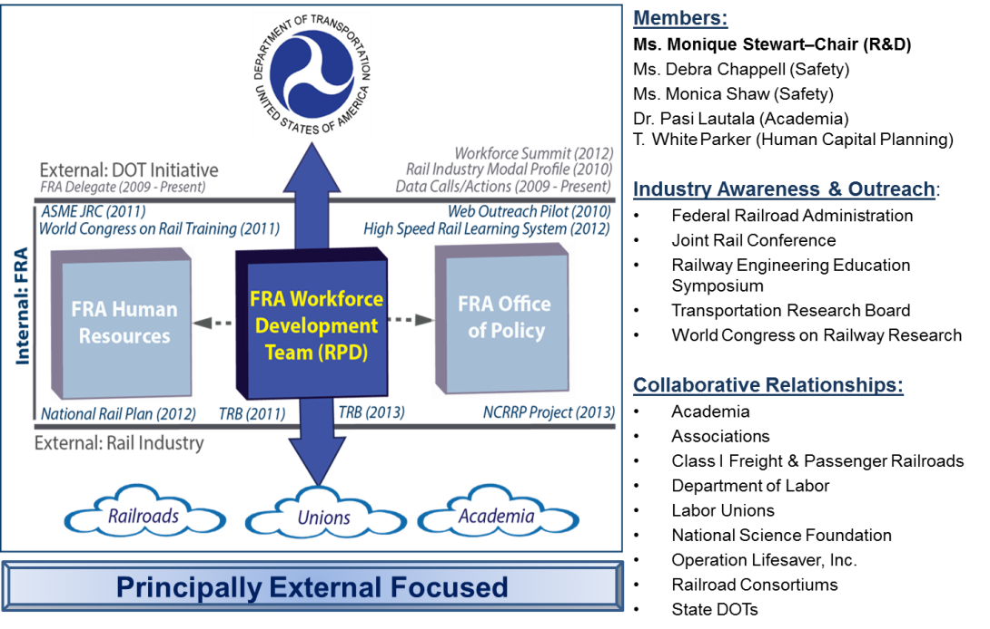
Figure 1: FRA-WDT Focus, Scope, and Accomplishments

The FRA-WDT focuses on external (non-FRA) industry perspectives and convenes regularly to discuss FRA industry related workforce development data calls and actions. Additionally, several projects have been initiated to expand the outreach function of the FRA-WDT, some of which are highlighted in Table 1. The FRA-WDT is continuously considering innovative projects that may improve the industry’s awareness of workforce issues, heighten the level of perception regarding the nuances of the rail industry workforce, or otherwise contribute to promoting the interest of the broader rail industry across the active labor force.

Table 1: FRA-WDT Program Activities Summary
Project Name | Project Description
Web-based PreK – 12 Outreach Portal | A prototype STEM-based outreach portal for elementary school-aged students and their teachers to learn about railroad technology, occupations, and community importance.
High Speed Rail Learning System (HSRLS) | A prototype online learning system to deliver high-speed rail and other rail related courses to the public in an effort to develop the skills needed to support and sustain the U.S. high-speed rail system.
Railway Engineering Education Symposium (REES) Scholarship | A collegiate sponsorship for faculty to participate in the annual REES where railroad engineering education is highlighted.

With the FRA-WDT established, efforts to develop the Railroad Industry Modal Profile commenced in 2010. Expanding upon the recruitment and retention study conducted by FRA three year’s prior, the FRA-WDT conducted focused discussions with several industry stakeholders representing academia, associations, Class I freight railroads, labor unions, and state Departments of Transportation, among others, to fully understand the railroad industry workforce. Each industry stakeholder participated in an informal dialog about the current state of the railroad industry and the railroad industry workforce, as well as their thoughts on the future of the railroad workforce. The information from the collected dialogs is presented in Table 2. Once the key challenges had been identified, the FRA-WDT defined the workforce development program’s areas of focus (depicted in Figure 2), which serves as the action framework for which industry workforce development efforts can be aligned. Elements can be added or removed from the conceptual action framework, as the nature of the railroad industry continues to evolve.

Table 2: Top Railroad Industry Challenges – 2011 Report
# | Workforce  Challenge | Academia | Associations | Class I Railroads | FRA | Labor Unions | Short Lines & Regionals
1 | Aging Workforce – Knowledge Transfer | ■ | ■ | ■ | ■ | ■ | ■
2 | Workforce Diversity (Women, Minorities, Other) |  |  | ■ | ■
3 | Overall Image of the Industry | ■ | ■ | ■ | ■ | ■
4 | National Training Standards for Freight Rail Trade and Craft Positions |  |  |  |  | ■
5 | Work-Life Balance (Attrition in the 0-5 Year Population of Rail Employees) |  |  | ■ |  | ■
6 | Quality of Data and Metrics Available to Monitor Rail Industry Workforce Trends | ■ | ■ |  | ■

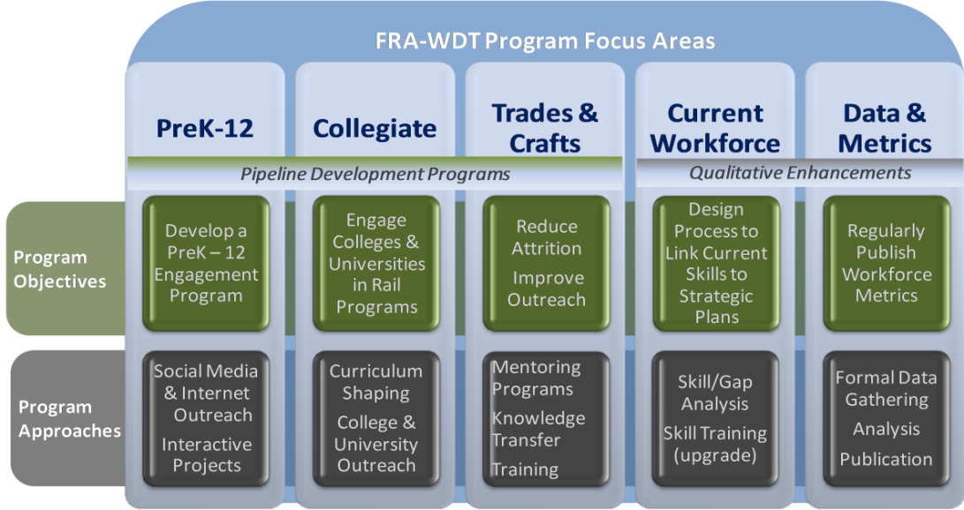
Pipeline Development Programs - Programs geared toward reshaping the public image of the railroad industry and emphasizing the multitude of railroad career options available.

Qualitative Enhancements - Initiatives to help improve the information and data available from which to gauge and monitor the health of the railroad industry workforce.

Figure 2: FRA-WDT Roadmap for Improving 2011 Workforce Challenges

Each workforce challenge was then aligned with one or more of the FRA-WDT program focus areas. This mapping allowed the team to maintain focus on each challenge while workforce activities and projects were executed. Table 3 shows how the program elements were aligned to the key challenges.

Table 3: FRA Workforce Development Program Element
Mapping to 2011 Railroad Industry Challenges
# | Workforce  Challenge | FRA Workforce Development Program Element
1 | Aging Workforce – Knowledge Transfer | Pipeline Programs: PreK-12; Collegiate; Trade & Craft
2 | Workforce Diversity (Women, Minorities, Other) | Pipeline Programs: PreK-12; Collegiate; Trade & Craft
3 | Overall Image of the Industry | Pipeline Programs: PreK-12; Collegiate; Trade & Craft
4 | National Training Standards for Freight Rail Trade and Craft Positions | Qualitative Enhancements: Current Workforce Development
5 | Work-Life Balance (Attrition in the 0-5 Year Population of Rail Employees) | Pipeline Programs: PreK-12; Collegiate; Trade & Craft
6 | Quality of Data and Metrics Available to Monitor Rail Industry Workforce Trends | Qualitative Enhancements: Data & Metrics

The FRA–WDT did not attempt to directly solve railroad workforce challenges; instead, the group encouraged industry-wide collaboration that: 1) fosters broader industry dialog and 2) brings cohesion to the efforts of individual organizations expended on workforce development.

The 2011 publication of the Railroad Industry Modal Profile was well received by the railroad community and the general public. In fact, the document was cited by the industry workforce related publications and initiatives shown in Table 4.

Table 4: 2011 Railroad Industry Modal Profile References in Industry
Date | Event/Organization | Publication/Initiative
March 2011 | American Society of Mechanical Engineers (ASME) Joint Rail Conference (JRC) | “Railroad Industry Workforce Assessment – Next Steps: Working Together To Shape the Rail Workforce of the 21st Century” publication
April 2011 | 1st World Congress on Rail Training | “Railroad Industry Workforce Assessment – Next Steps: Working Together to Shape the Rail Workforce of The 21st Century” publication
April 2012 | National Transportation Workforce Summit | “Railroad Industry Workforce Assessment – Next Steps: Working Together to Shape the Rail Workforce of the 21st Century” publication
2013 | Transportation Research Board (TRB) | National Cooperative Rail Research Program (NCRRP) Project 06-01: Building and Retaining Workforce Capacity for the Railroad Industry
2013 | U. S. Department of Labor Employment and Training Administration | Transportation, Distribution, and Logistics Competency Model

As a continuation of efforts, FRA–WDT is establishing an industry survey of workforce related issues that will be conducted every two years. The results of this survey and the collection of other industry data will be an update to the Modal Profile and serve as a basis for industry-wide collaboration regarding workforce activities.

9. Payments or gifts to respondents.

There are no monetary payments provided or gifts made to respondents associated with this proposed collection of information.

10. Assurance of confidentiality.

FRA fully complies with all laws pertaining to confidentiality, including the Privacy Act of 1974. Thus, information obtained or acquired by FRA in this survey will be used exclusively to compile data to describe the status and challenges of workforce issues among railroad employees throughout the United States.

To ensure confidentiality for respondents, no individual survey responses will be released and data will only be reported as group means or aggregate summaries. Participants will be advised before commencing the survey that the survey is anonymous. However, as FRA does not currently have a formal rule or official policy which provides an assurance of confidentiality, participants will be advised that FRA cannot assure confidentiality.

11. Justification for any questions of a sensitive nature.

This survey will not ask respondents questions regarding sexual behavior and attitudes, religious beliefs, or other matters that would be considered private or of a sensitive nature. Participation in this proposed study by railroad employees is completely voluntary. The survey will ask respondents questions tapping into their experience and expertise related to workforce development policies and activities. Although these questions will only focus on workforce issues, each question has a “prefer not to answer” option, so respondents may choose not to answer any questions for which they would feel uncomfortable providing information.

12. Estimate of burden hours for information collected.

The chart below provides a breakdown on the estimated burden for participants to respond to the survey.
Table 5: Estimated Burden
Stakeholder Segment | # invited to Survey | Burden Hours @ 1/3 hr./survey
Class 1 Passenger | 5 | 1.65
Class 1 Freight | 10 | 3.3
Short Line & Regional | 50 | 16.5
Labor Unions | 7 | 2.3
Associations | 10 | 3.3
Academia | 9 | 3
Total | 91 | 30.05

Based on pre-testing, it will take approximately 20 minutes for a respondent to complete the survey.

13. Estimate of total annual costs to respondents.

There will be no additional cost burden to respondents beyond any customary and usual expenses associated with private practices. There will be no need for respondents to keep any records associated with this data collection effort.

14. Estimate of Cost to Federal Government.

Resources | Estimated Hours | $/Hour | Total
FRA Supervisor | 8 | $120 | 960
FRA Specialist | 24 | $100 | 2,400
Contractor | 80 | $150 | 12,000
Total Cost/Survey |  |  | $15,360

* Contractor to develop survey questions and on-line resource for hosting the survey leveraging a Survey Monkey account.

15. Explanation of program changes and adjustments.

This proposed survey is an update to previously collected information documented in the Model Profile. Therefore, this is not considered a program change. The collection method, an electronic survey, is the principle change for this data collection.

There is no additional cost to respondents.

16. Publication of results of data collection.

The survey data will be published in an update to the Modal Profile Report. The update is estimated for publication approximately 6-9 months after the completion of data collection.

Data collection will begin as soon as possible after the date of OMB approval, and continue every two years thereafter. Data collection will be completed within 120 days of commencement. Current plans call for analysis to be completed within two months of the end of data collection.

17. Approval for not displaying the expiration date for OMB approval.

Once OMB approval is received, the FRA will publish the approval number for these information collection requirements in the Federal Register.

18. Exception to certification statement.

No exceptions are taken at this time.

