Recruitment Advertisements

Exhibit 1. Example Facebook Post (Schlesinger)
Schlesinger Group is looking for (INSERT TARGET/ RESPONDENT TYPE NEEDED) to participate in a study on (INSERT TOPIC), taking place in our (INSERT OFFICE LOCATION) office on (INSERT DATE).
If qualified and asked to participate, you will be paid (INSERT INCENTIVE) for your time and opinions.
Please call (INSERT PHONE NUMBER) and ask for (INSERT RECRUITER AND EXT #) to see if you qualify.

Exhibit 2. Example Facebook Post (Shugoll)
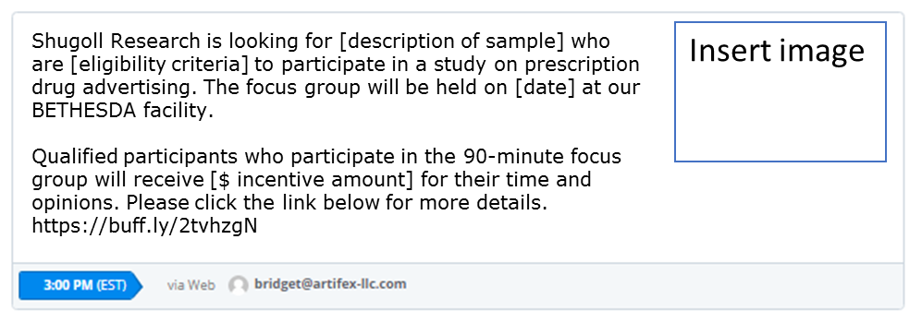

Exhibit 3. Email Invitation to Database Panel for Online Screening (Shugoll)

Dear (insert first name),

Shugoll Research is looking for (insert limited basic demographic information – i.e. men and women between the ages of 22-64 year old) to participate in a study on (insert job topic and job #).
The focus group will be held on (insert date) at our BETHESDA facility during the evening.

Qualified participants who participate in the [insert time, e.g., 90-minute] focus group will receive (insert $ amount) for their time and opinions.

If you are interested, please click on the link below to take a brief
survey. If the link does not work, please copy and paste the link directly into your browser.
(insert survey link)
Please do not share this email or link as it is associated with your database entry. The person you forward it to will end up taking the survey as you and delete you from our database.

To see other available surveys, please visit your portal at https://participate.shugollresearch.com

Thank you!
Shugoll Research

