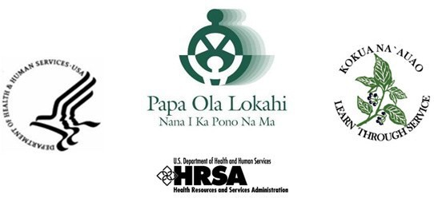

As an applicant to the Native Hawaiian Health Scholarship Program (NHHSP), I, (print) First Name Middle Initial Last Name
Form D - AUTHORIZATION TO RELEASE INFORMATION

hereby authorize the College/University where I am/was enrolled, to disclose information to NHHSP, Papa Ola Lokahi, Inc. (POL) and the U.S. Department of Health and Human Services (DHHS), pertaining to my enrollment while participating in NHHSP. “Information pertaining to my school enrollment” includes, but not limited to, my college transcript and grades, academic standing, enrollment and degree status, curriculum and examination requirements for graduation, tuition and fees, and leave-of-absence, withdrawal, or dismissal from school.

If I become a participant in the NHHSP, I also authorize any post-degree training program for which I received a deferment from the NHHSP to disclose to POL and DHHS information pertaining to my participation in the post-degree program including, but not limited to, my curriculum, status in the program, completion date, examination requirements, and my leave- of-absence, withdrawal or dismissal from the program.

The above authorizations take effect on the date indicated below with my signature.

In addition, I hereby authorize POL and DHHS, to release my name, addresses and social security number to see if I appear on the Excluded Parties List System. This authorization takes effect on the date I sign this release form. If I do not become an NHHSP participant, this authorization shall remain in effect until November 30, 2017.

If I become an NHHSP participant, all of the above authorizations shall remain in effect until the date my NHHSP scholarship commitment has been fulfilled or these authorizations have been revoked by me in writing.

Applicants’ Signature Date

