Enclosure 3
The following documents will be cognitively tested as the planned draft 2020 Census mail materials. These materials will be used in 2020 for households in the Internet First, English Only strata.

First Mailing to Households for the 2020 Census
This mail package will contain the following items:
- Invitation Letter
- Language Assistance Sheet
- Package Envelope

Invitation Letter, front
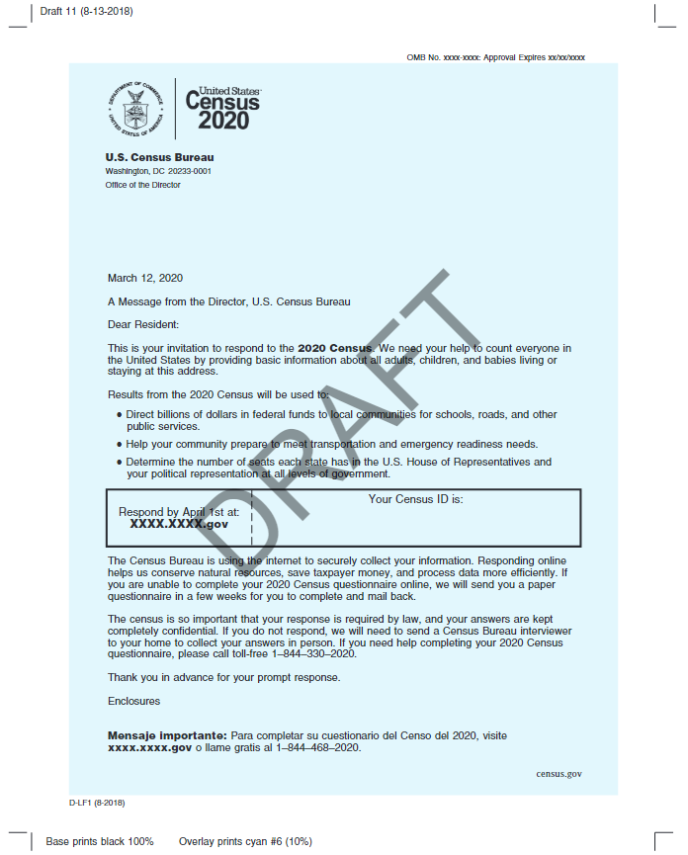

Invitation Letter, back
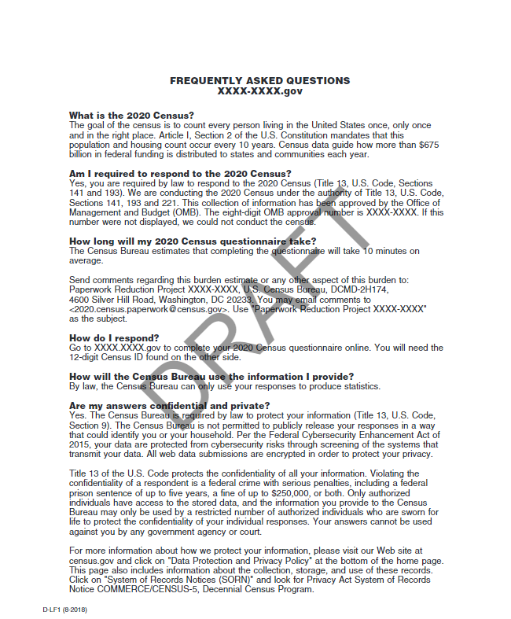

Language Assistance Sheet, front
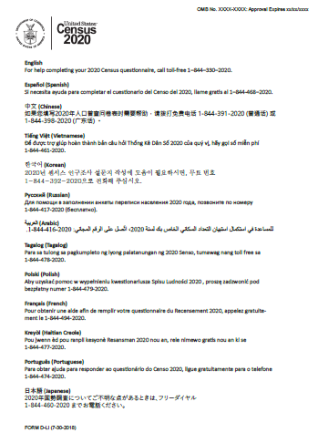

Language Assistance Sheet, back
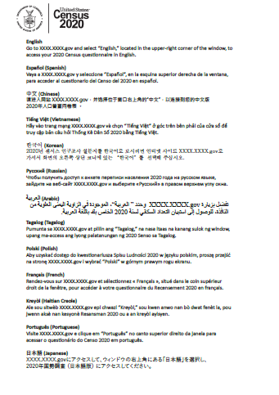

Outbound envelope, front
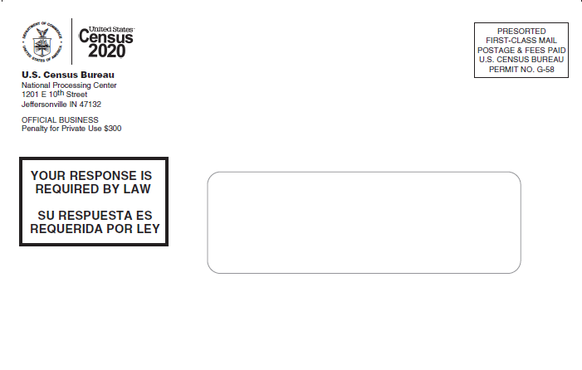

Outbound envelope, back
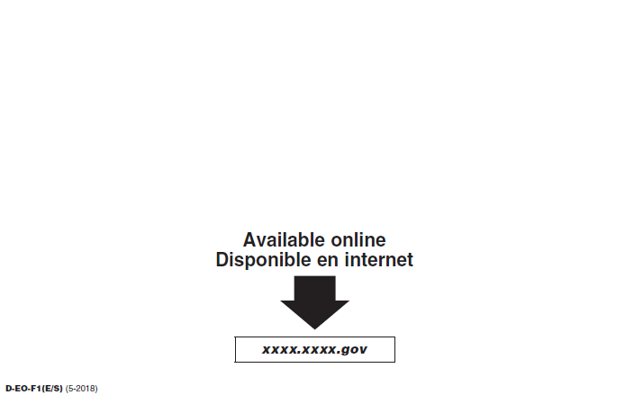

Second Mailing to Households for the 2020 Census
This mail package will contain the following items:
- Reminder Letter
- Letter Envelope

Reminder Letter
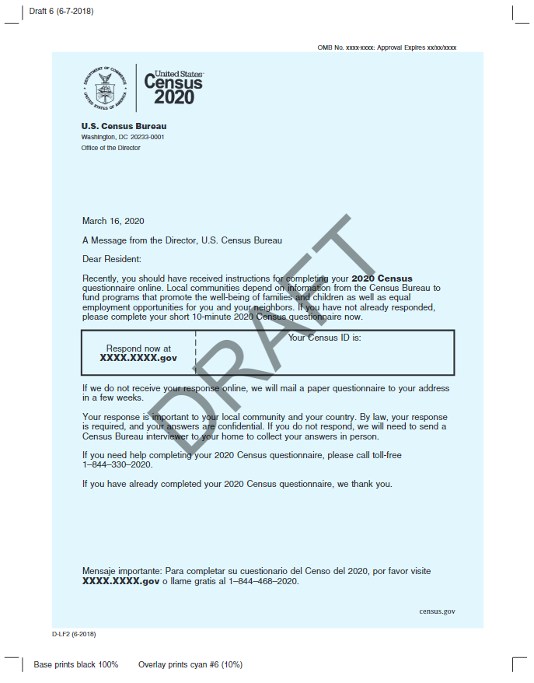

Letter envelope, front
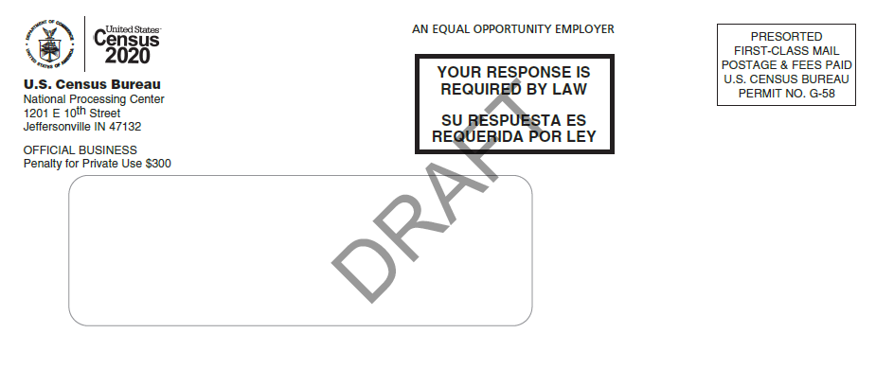

Letter envelope, back
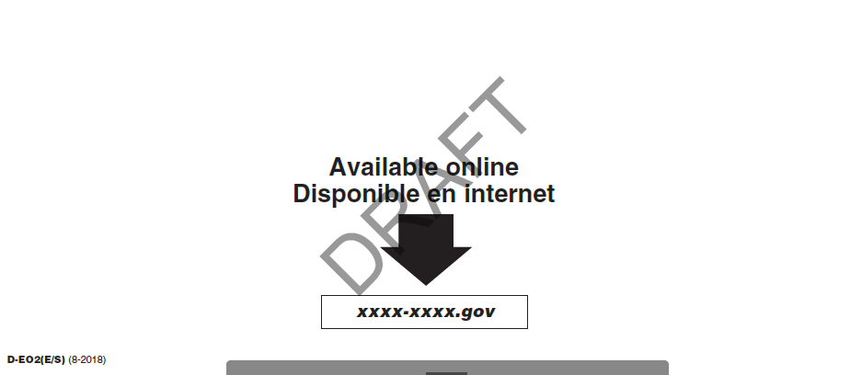

Third Mailing to Households for the 2020 Census
This mailing will be a postcard.

Postcard, front
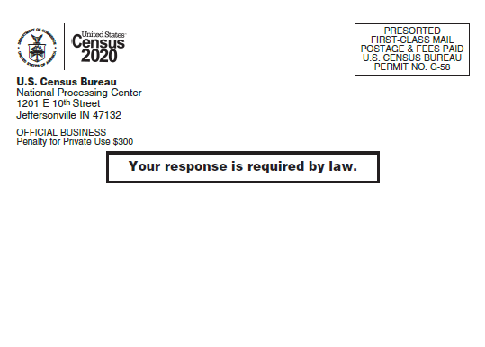

Postcard, back
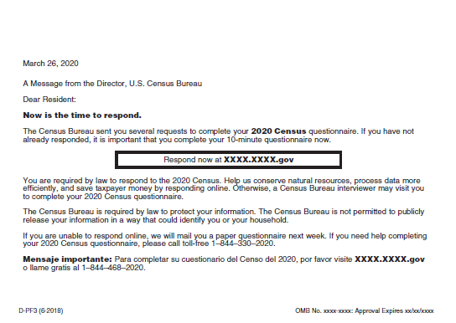

Fourth Mailing to Households for the 2020 Census
This mail package will contain the following items:
- Package Envelope
- Reminder Letter
- Language Assistance Sheet – same document as shown in Mailing 1
- Questionnaire – in separate attachment
- Return Envelope

Outbound package envelope, front
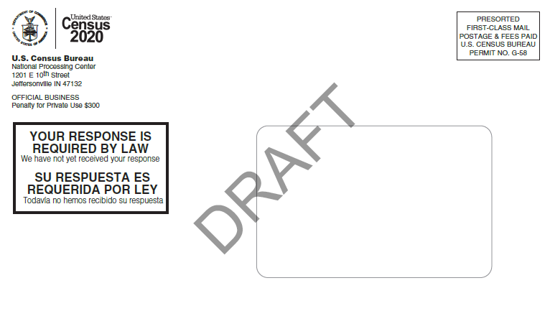

Outbound package envelope, back
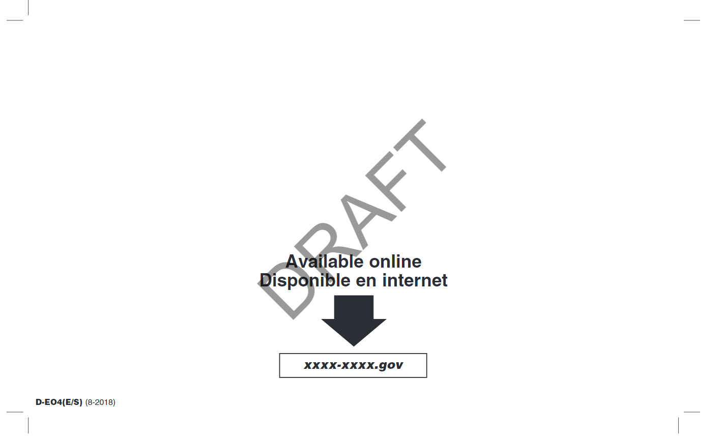

Reminder Letter
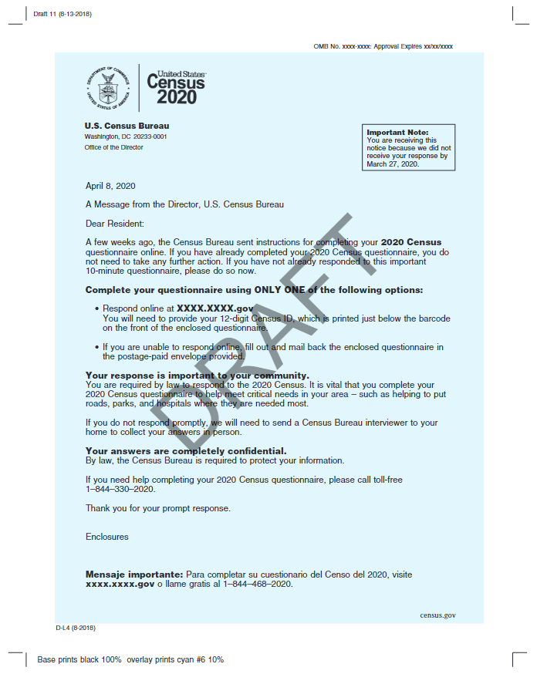

Return envelope
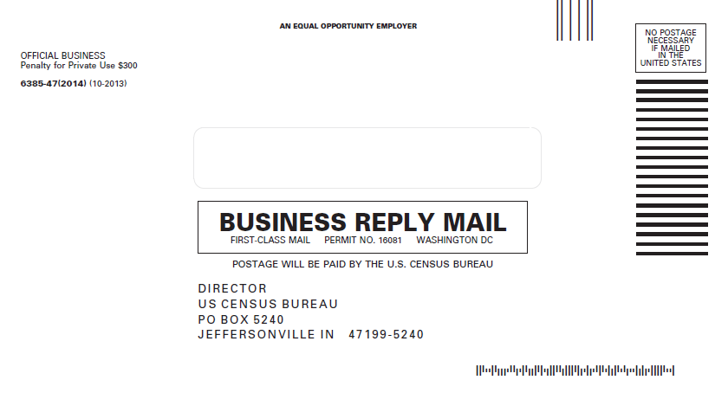

Fifth Mailing to Households for the 2020 Census
This mailing will be a postcard.

Postcard, front
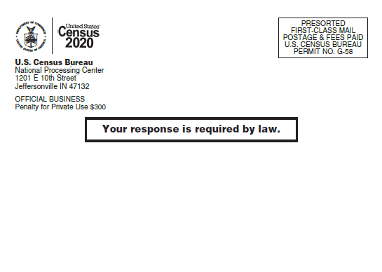

Postcard, back
