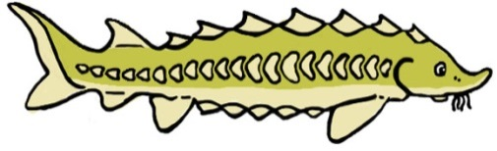
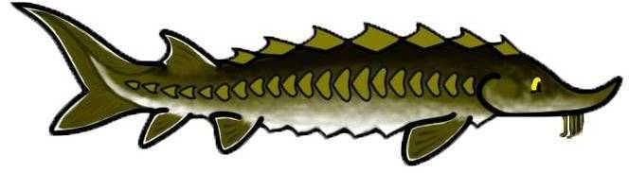
SCUTES Elementary – Middle School Educational Kit Evaluation

Dear Educator,
We hope you and your students enjoyed the activities and lessons on Atlantic and shortnose sturgeon in the SCUTES educational kit. We would greatly appreciate your feedback about the activities you used and your experience with the kit. Your input will help us improve the SCUTES kit.

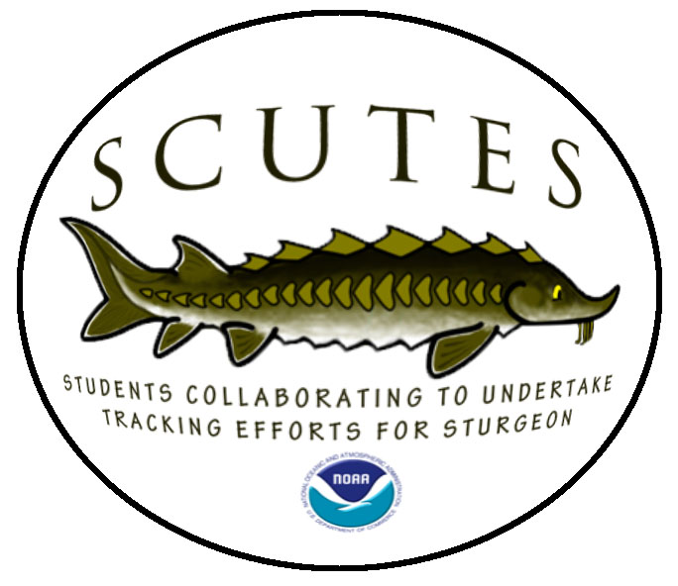
1. The following activities/lessons are part of the SCUTES educational kit. Check all the activities that you used with your students.

Activities  - Food Webs & Harmful Algal Blooms  - Natal Homing  - Scute Fossil Casting  Science  - Sturgeon Litter Tag  - Adaptation  - Sturgeon Classification  - Food Chain  - Sturgeon Life Cycle  - Climate Change  - Ecosystem in Danger | - Food Chain Skit  - Migration  - Classifying Organisms  - A Body of Knowledge  - Adaptation to Life  - Beating Extinction  - Nets  - Dichotomous Keys  - Catch Restrictions  - Sturgeon/Striped Bass Life Cycle  - Children’s Story | Math  - Data Analysis  History, Social Studies & Geography  - Chesapeake Bay Sturgeon  - Charting Sturgeon  - Tracking Sturgeon  Language Arts  - Wampanoag/ MCAS Practice  - Acrostic Poetry  - Onomatopoeia | - Similes  - Synonyms & Antonyms ABC Book  - Grammar/Editing  - Myths  - Open Response  - Spelling & Punctuation  - Fishing for a Meaning  - Implications & Inferences  - Endangered Species Act Mock Public Hearing  - Humans and Sturgeon: Great Debate

2. Did the activities you used meet the required curriculum standards for your school/organization?

Yes No Not Sure

If no, which activities or lessons failed to meet the standards and why?

3. Did you modify any of the activities/ lessons to fit your audience’s (i.e. students) needs?

Yes No

If yes, how did you modify the activities or lessons?

4. In what class/grade(s) did you use SCUTES educational kit? ___________________

5. About how many students did you use the SCUTES learning kit with? # __________

6. Please rate your level of agreement with the following statements based on your experience with the SCUTES educational kit:

The SCUTES educational kit activities and lesson plans… | Strongly Disagree | Disagree | Neither | Agree | Strongly Agree
Had clear, easy to follow instructions. | 1 | 2 | 3 | 4 | 5
Contained an adequate number of supplies I needed to complete the activities with my students. | 1 | 2 | 3 | 4 | 5
Were written at an appropriate reading level for students. | 1 | 2 | 3 | 4 | 5
Had accurate estimated time frames (if applicable). | 1 | 2 | 3 | 4 | 5
Aligned well with my curriculum. | 1 | 2 | 3 | 4 | 5
Kept the students’ interest. | 1 | 2 | 3 | 4 | 5
Increased my confidence in teaching students about sturgeon. | 1 | 2 | 3 | 4 | 5

SCUTES Website

7. Did you and your students visit the SCUTES website (http://www.greateratlantic.fisheries.noaa.gov/scutes) for information on sturgeon while conducting activities from the educational kit?

Yes No

If yes, which web pages did you incorporate into your lessons?

- Student’s Page
- Teacher’s Page
- Sturgeon Information Page
- Activities, Games, Videos Page

8. Please share which activities or information from the web pages you found to be most useful in conducting the SCUTES activities.

9. Do you have any suggestions for how to improve the SCUTES website?

Student/Participant Outcomes

The following questions are related to the impact of SCUTES on your students:

10. To what extent did the SCUTES activities...

 | No Extent | Some Extent | Great Extent
increase the students’ knowledge about sturgeon? | 1 | 2 | 3
increase the students’ interest in sturgeon? | 1 | 2 | 3
increase the students’ value on the importance of protecting Atlantic and shortnose sturgeon? | 1 | 2 | 3

11. Please describe an example of an event that supports the answer to one of the questions in question #10.

12. How did you find out about the SCUTES educational kit? Check all that apply

Colleagues Web Site Workshop
NOAA representative NMEA conference Other__________________

13. Will you request a SCUTES educational kit in the future? Yes No
14. Would you recommend a SCUTES educational kit to other educators? Yes No

15. What were the strengths of the SCUTES educational kit?

16. How can we improve the SCUTES educational kit?

17. What other SCUTES topics would you like to see included in future educational kits?

1._______________________________________________________________
2._______________________________________________________________
3._______________________________________________________________

School/Organization: __________________________________________________________________

Dates Kit Used: _______________________________________________________________________

Please return this evaluation sheet along with your kit or mail it to:
The Office of Protected Resources
NOAA Fisheries, Greater Atlantic Regional Fisheries Office
55 Great Republic Drive, Gloucester, MA 01930-2276
Thanks for Participating in SCUTES!

